Supplementary Materials
Supplementary Table S1
Supplementary Table S1 Baseline characteristics of patients stratified into Man group and Woman group
Characteristic | Overall  N = 3941 | Man  N = 2671 | Woman  N = 1270 | p-value
TyG index | 8.85 [8.38, 9.37] | 8.82 [8.34, 9.33] | 8.92 [8.46, 9.46] | <0.001
TyG-BMI index | 216 [189, 240] | 216 [188, 239] | 218 [192, 242] | 0.028
Age (years) | 66 [58, 73] | 64 [57, 72] | 68 [63, 75] | <0.001
TG (mg/dl) | 137 [97, 202] | 133 [95, 198] | 144 [100, 210] | <0.001
BMI (kg/m²) | 23.9 [22.2, 25.8] | 23.9 [22.2, 25.7] | 23.8 [22.1, 25.9] | 0.945
HbA1c (%) | 6.10 [5.70, 7.00] | 6.10 [5.70, 6.90] | 6.20 [5.80, 7.30] | <0.001
Scr (mg/dl) | 0.9 [0.8, 1.1] | 1.0 [0.9, 1.1] | 0.8 [0.6, 0.9] | <0.001
LDL-c (mg/dl) | 104 [83, 127] | 103 [82, 125] | 105 [84, 128] | 0.012
HDL-c (mg/dl) | 45 [38, 54] | 43 [37, 52] | 50 [42, 59] | <0.001
PIV | 323 [192, 594] | 359 [215, 677] | 258 [161, 455] | <0.001
SBP | 130 [117, 143] | 128 [116, 142] | 133 [119, 148] | <0.001
DBP | 78 [70, 86] | 78 [70, 86] | 77 [69, 85] | 0.003
Hypertension | 2265 (57.5) | 1419 (53.1) | 846 (66.6) | <0.001
Diabetes | 1283 (32.6) | 799 (29.9) | 484 (38.1) | <0.001
CKD | 1385 (35.1) | 1014 (38.0) | 371 (29.2) | <0.001
Antihypertensive medications | 3626 (92.0) | 2460 (92.1) | 1166 (91.8) | 0.754
Antiplatelet medications | 3796 (96.3) | 2595 (97.2) | 1201 (94.6) | <0.001
Hypolipidemic medications | 1701 (43.2) | 1099 (41.1) | 602 (47.4) | <0.001
Insulin | 575 (14.6) | 358 (13.4) | 217 (17.1) | 0.002
Non-insulin antidiabetic drugs | 754 (19.1) | 452 (16.9) | 302 (23.8) | <0.001
Nicotine use | 1127 (28.6) | 1126 (42.2) | 1 (0.1) | <0.001
Alcohol consumption | 175 (4.4) | 172 (6.4) | 3 (0.2) | <0.001
Manual worker | 722 (18.3) | 450 (16.8) | 272 (21.4) | <0.001
Married | 3913 (99.3) | 2653 (99.3) | 1260 (99.2) | 0.692
Severity of CAD |  |  |  | 0.030
Single-vessel | 1291 (32.8) | 845 (31.6) | 446 (35.1)
Multi-vessel | 2650 (67.2) | 1826 (68.4) | 824 (64.9)
Continuous variables are presented as median [interquartile ranges], and categorical variables are presented as n (%). TyG: Triglyceride-Glucose Index; TyG-BMI: Triglyceride-Glucose-BMI Index; GLU: Glucose; TG: Triglycerides; BMI: Body Mass Index; HbA1c: Glycated Hemoglobin; Scr: Serum Creatinine; LDL-c: Low-Density Lipoprotein Cholesterol; HDL-c: High-Density Lipoprotein Cholesterol; PIV: pan-immune-inflammation value; SBP: Systolic Blood Pressure; DBP: Diastolic Blood Pressure; CKD: Chronic Kidney Disease; CAD: Coronary Artery Disease.

Females exhibited a significantly higher TyG index (Triglyceride-Glucose Index) than males (median 8.92 vs. 8.82, p < 0.001), along with elevated triglycerides (TG: 144 vs. 133 mg/dL, p < 0.001), low-density lipoprotein cholesterol (LDL-c: 105 vs. 103 mg/dL, p = 0.012), and glycated hemoglobin (HbA1c: 6.20% vs. 6.10%, p < 0.001). Conversely, females had superior high-density lipoprotein cholesterol (HDL-c: 50 vs. 43 mg/dL, p < 0.001). Males demonstrated markedly higher systemic inflammation, reflected in the pan-immune-inflammation value (PIV: 359 vs. 258, p < 0.001). Females were older (68 vs. 64 years, p < 0.001), had higher systolic blood pressure (SBP: 133 vs. 128 mmHg, p < 0.001), and lower diastolic blood pressure (DBP: 77 vs. 78 mmHg, p = 0.003). Hypertension (66.6% vs. 53.1%, p < 0.001) and diabetes mellitus (38.1% vs. 29.9%, p < 0.001) were more prevalent in females, while chronic kidney disease (CKD: 38.0% vs. 29.2%, p < 0.001) was more common in males. Females had higher utilization rates of lipid-lowering agents (47.4% vs. 41.1%, p < 0.001), insulin (17.1% vs. 13.4%, p = 0.002), and non-insulin antidiabetic drugs (23.8% vs. 16.9%, p < 0.001). Males showed greater use of antiplatelet medications (97.2% vs. 94.6%, p < 0.001). Substantial disparities existed in behavioral risks: males had significantly higher rates of nicotine dependence (42.2% vs. 0.1%, p < 0.001) and alcohol dependence (6.4% vs. 0.2%, p < 0.001). Females reported a higher proportion of manual labor occupations (21.4% vs. 16.8%, p < 0.001). Females had a higher prevalence of single-vessel disease (35.1% vs. 31.6%), while multi-vessel disease was more frequent in males (68.4% vs. 64.9%, p = 0.030). No statistically significant differences were observed in body mass index (BMI: 23.9 vs. 23.8 kg/m², p = 0.945), antihypertensive medication utilization (92.1% vs. 91.8%, p = 0.754), or marital status (married: 99.3% vs. 99.2%, p = 0.692). The TyG-BMI index, though marginally higher in females (218 vs. 216), showed weaker statistical significance (p = 0.028). These findings highlight sex-specific cardiometabolic risk patterns, emphasizing the need for gender-tailored clinical management strategies in cardiovascular disease.

Supplementary Figure S2
Age-Sex Pyramid in Whole Populations
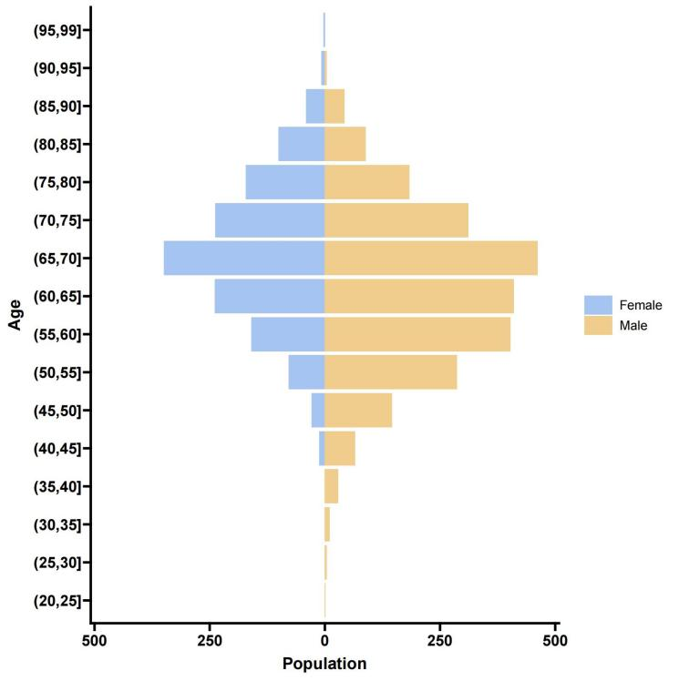
Population Distribution
The horizontal axis shows the population size. The vertical axis shows age groups. Light yellow is for males, and light blue is for females.
Overall Trend
The graph has a pyramid shape. The population is most significant in younger age groups and gets smaller in older age groups. This is a typical pattern in natural population structures, with more young and fewer older adults.
Gender Differences
In younger age groups (20–50 years), the number of males is slightly higher than that of females. However, in middle-aged and elderly groups (over 50 years), the number of females is slightly higher than that of males. This might be because females tend to live longer on average.
Specific Age Groups
Male and female populations are relatively small in the 20 - 30 age group. This could be due to population migration or specific sampling methods.
In the 40 - 60 age group, both male and female populations are relatively large, with the male population reaching its peak in this range.
In age groups over 60 years, the female population gradually surpasses the male population, especially in those over 70 years old.

Supplementary Table S3
Comparison of TyG-BMI, TyG Index, and BMI in Diagnostic Performance Across Genders and Significance Analysis
TyG: Triglyceride-glucose; BMI：Body mass index; AUC: area under the curve; CI: confidence
 | AUC | 95% CI |  |  | Optimal cut-off value
 | Overall patients |  |  | TyG-BMI | Overall patients | Woman | Man
TyG-BMI | 0.647 | 0.629 - 0.665 |  |  | 211 | 212 | 212
TyG index | 0.578 | 0.557 - 0.595 |  | Sensitivity | 65.4% | 69.9% | 62.9%
BMI | 0.633 | 0.615 - 0.651 |  | Specificity | 62.0% | 63.0% | 62.0%
Pairwise comparison | DeLong test (AUC)  TyG-BMI vs. TyG index P <0.001  Tyg-BMI vs. BMI P =0.002

Supplementary Figure S4
TyG-BMI: triglyceride-glucose-body mass index
CAD: coronary artery disease
Supplementary Figure4a
The RCS of the TyG-BMI and the severity of CAD in Man Group
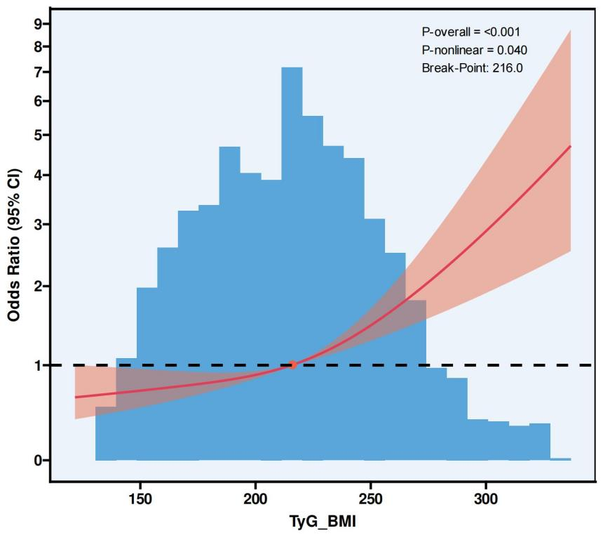
Supplementary Figure S4b
The RCS of the TyG-BMI and the severity of CAD in Women Group
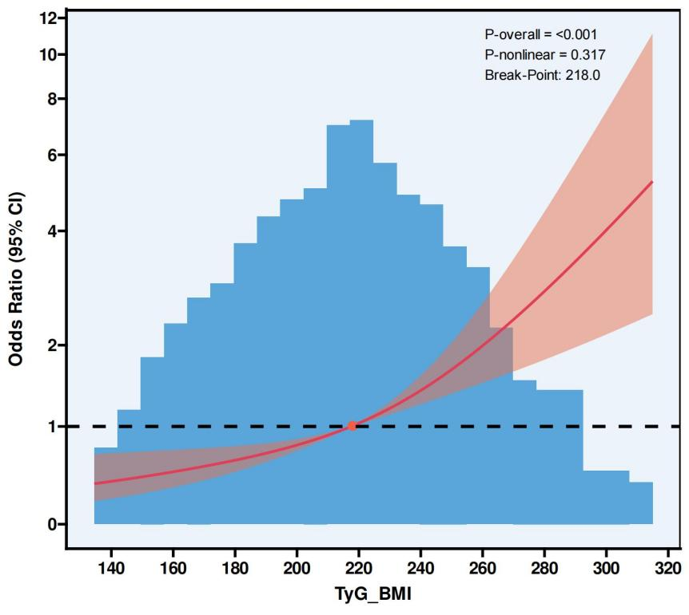
Supplementary Figure S5
TyG-BMI: triglyceride-glucose-body mass index
CAD: coronary artery disease
Supplementary Figure S5a
The RCS of interaction between age and TyG-BMI on the severity of CAD in Man Group
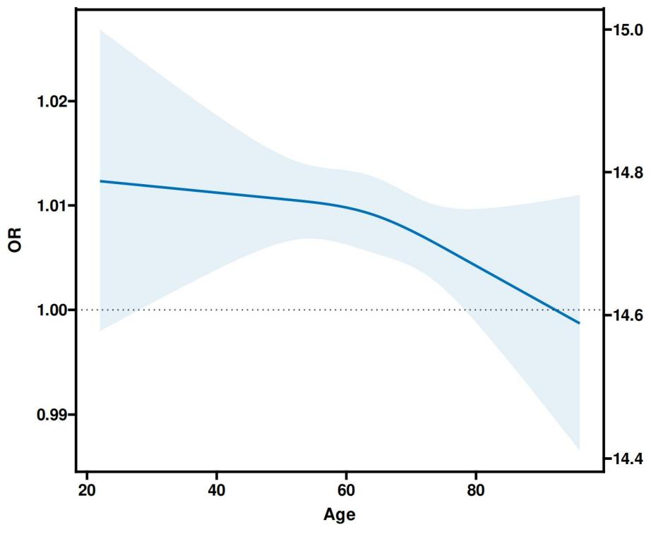
Supplementary Figure S5b
The RCS results of interaction between age and TyG-BMI in Woman Group
