Appendix
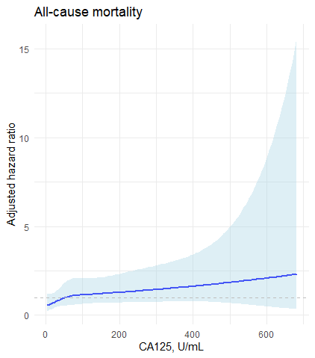 | 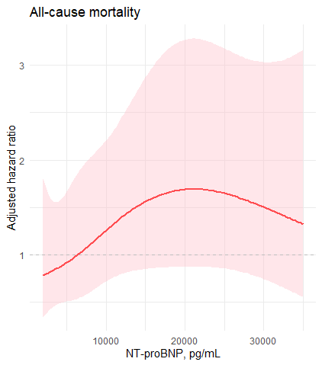
CA125 | NT-proBNP levels
Figure A1: Adjusted hazard ratio of all-cause mortality according to CA125 and NT-proBNP levels (modeled as a continuous variable)
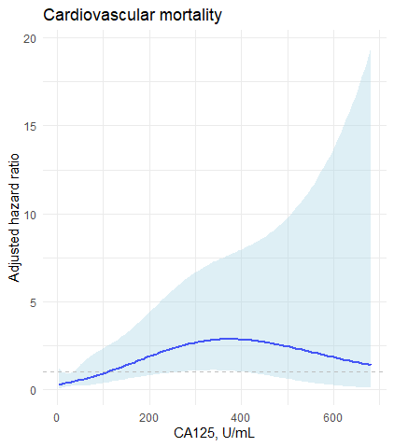 | 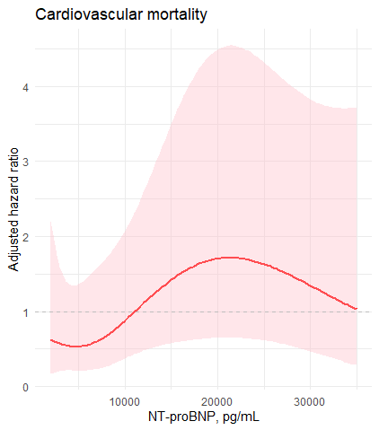
CA125 | NT-proBNP levels
Figure A2: Adjusted hazard ratio of cardiovascular mortality according to CA125 and NT-proBNP levels (modeled as a continuous variable)
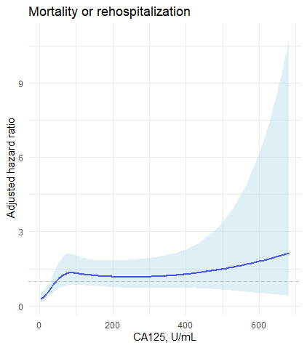 | 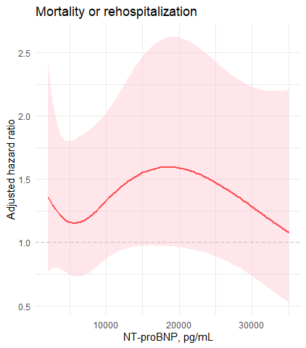
CA125 | NT-proBNP levels
Figure A3: Adjusted hazard ratio of all-cause mortality or rehospitalization according to CA125 and NT-proBNP levels (modeled as a continuous variable)

