Original blot images of western blots
In our western blot experiments, before the protein transferred to the polyvinylidene difluoride membrane, the gel was cut into two parts at around 25kDa. The protein on the above half of the gel was transferred at 400mA and the running time was 1 hour. The protein on the lower half of the gel was transferred at 200mA and the running time was 20 minutes. The original pictures of blots are presented below. The picture in Supplement figure 1 presents the blots on the whole membrane transferred from uncut gel at 200mA in 20 minutes.

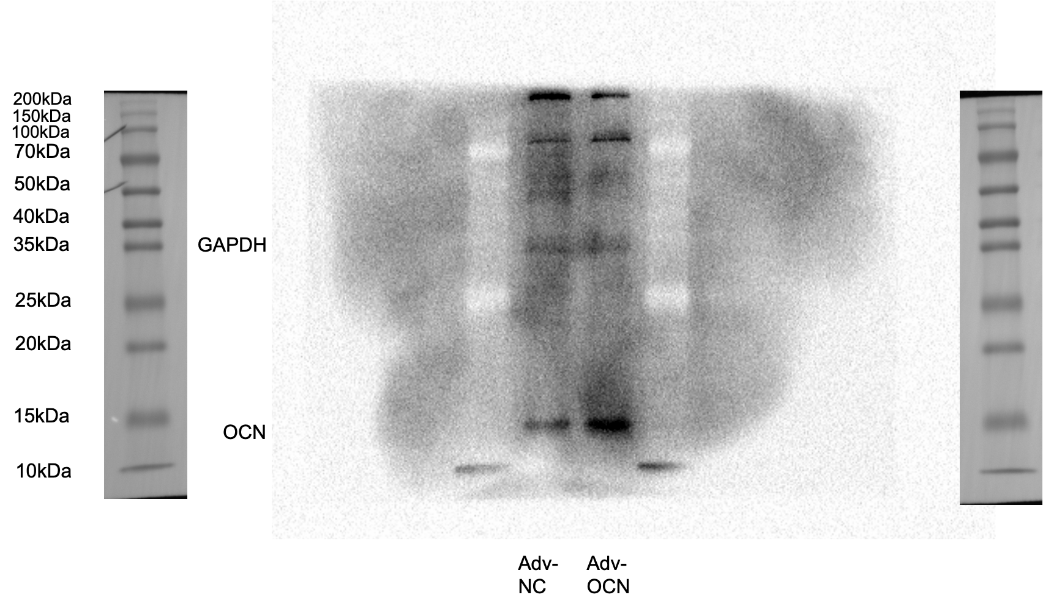
The picture with fuller-length, original, unprocessed blot. The protein on the western blot gel was transferred at 200mA and the running time was 20 minutes. After the protein was blocked with 5% nonfat milk in TBST, the membrane was incubated with OCN antibody and GAPDH antibody mixed primary antibody solution at 4°C overnight. Then the membrane was incubated in secondary antibody at room temperature foe an hour. The immuno-reactive bands were visualized using Millipore Immobilon Western Chemiluminescent HRP Substrate and imaged by Image Laboratory software v. 3.0. Adv-NC: VSMCs infected with control adenovirus; Adv-OCN: VSMCs infected with OCN overexpressing adenovirus.

Figure 1B
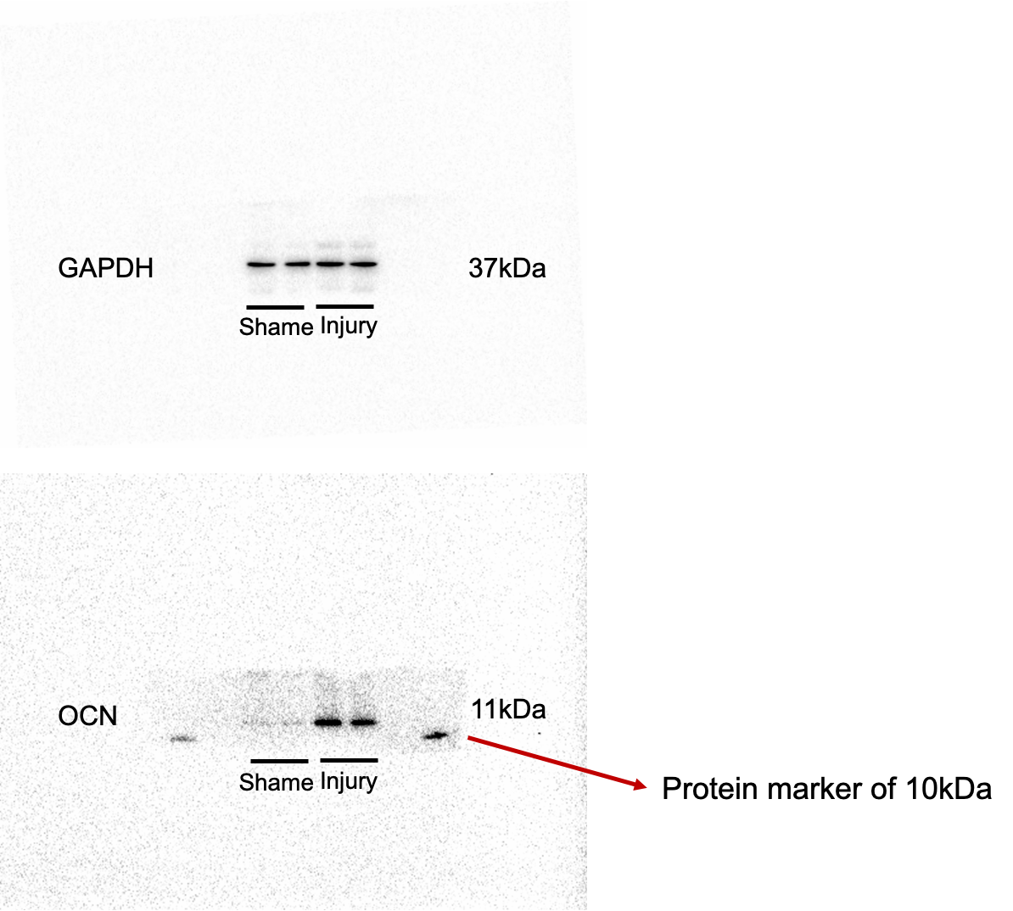

Figure 2A
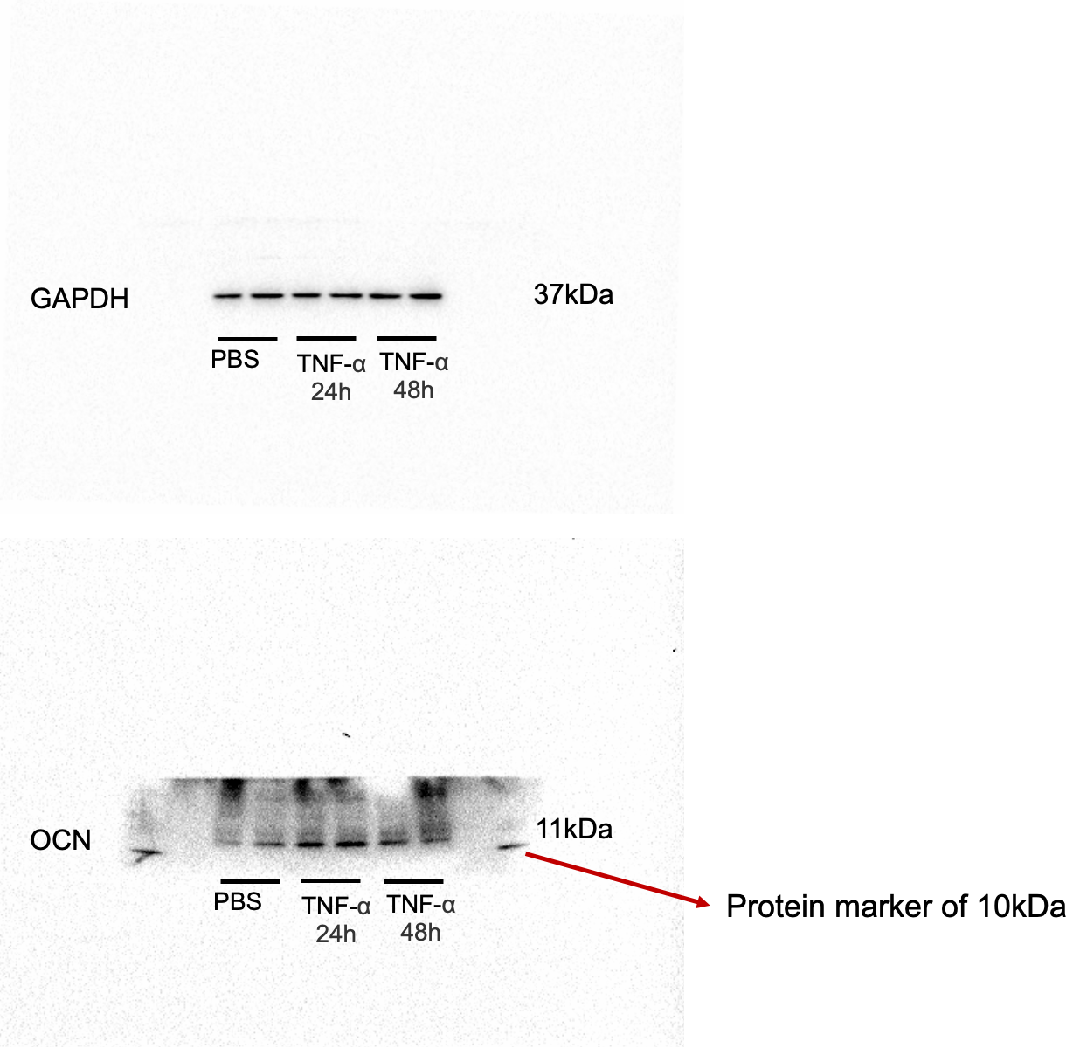

Figure 2B
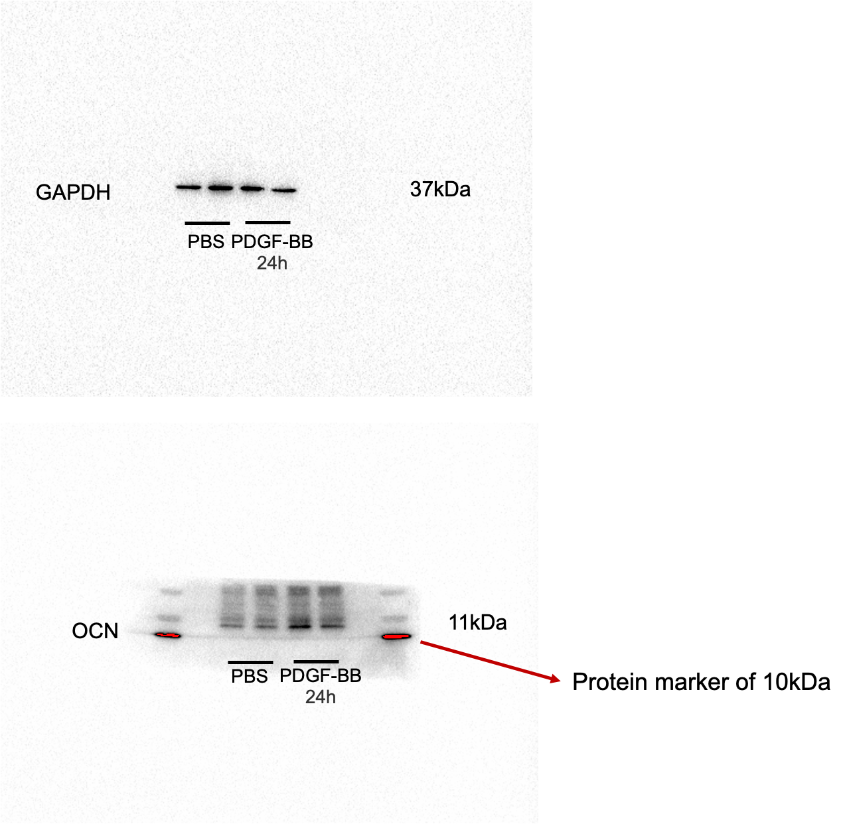

Figure 3B

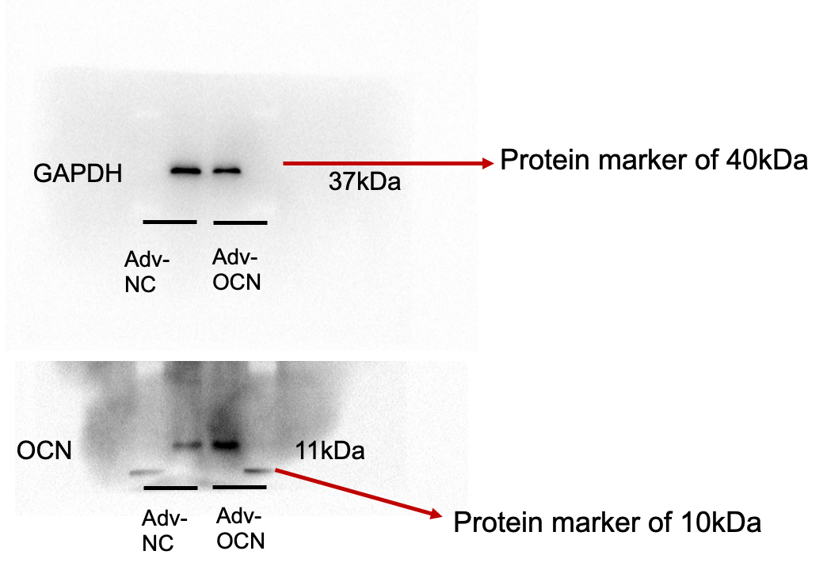

Figure 4B
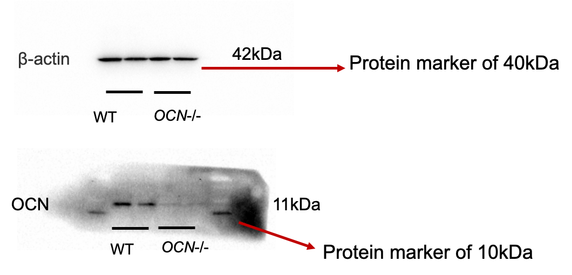

Figure 4D
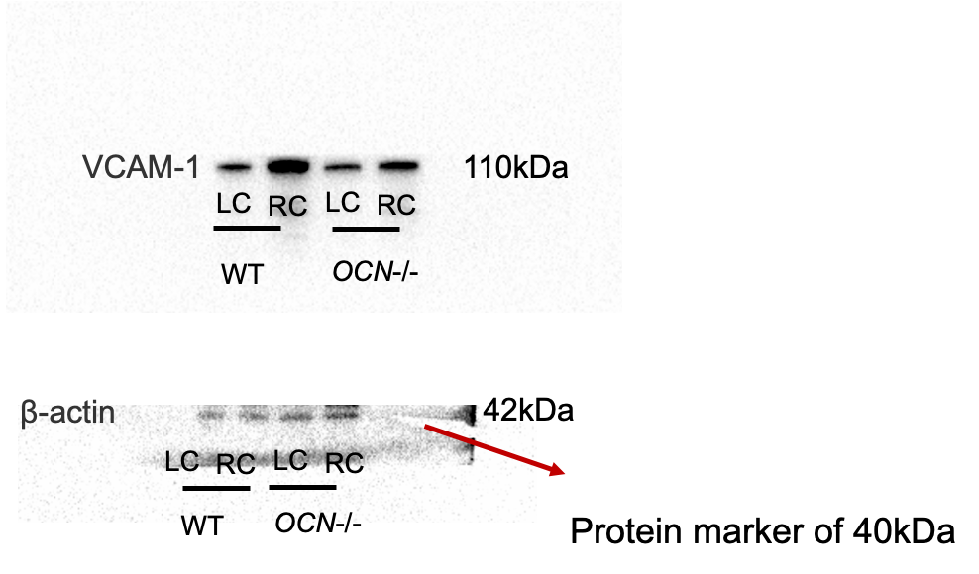

Figure 4E


