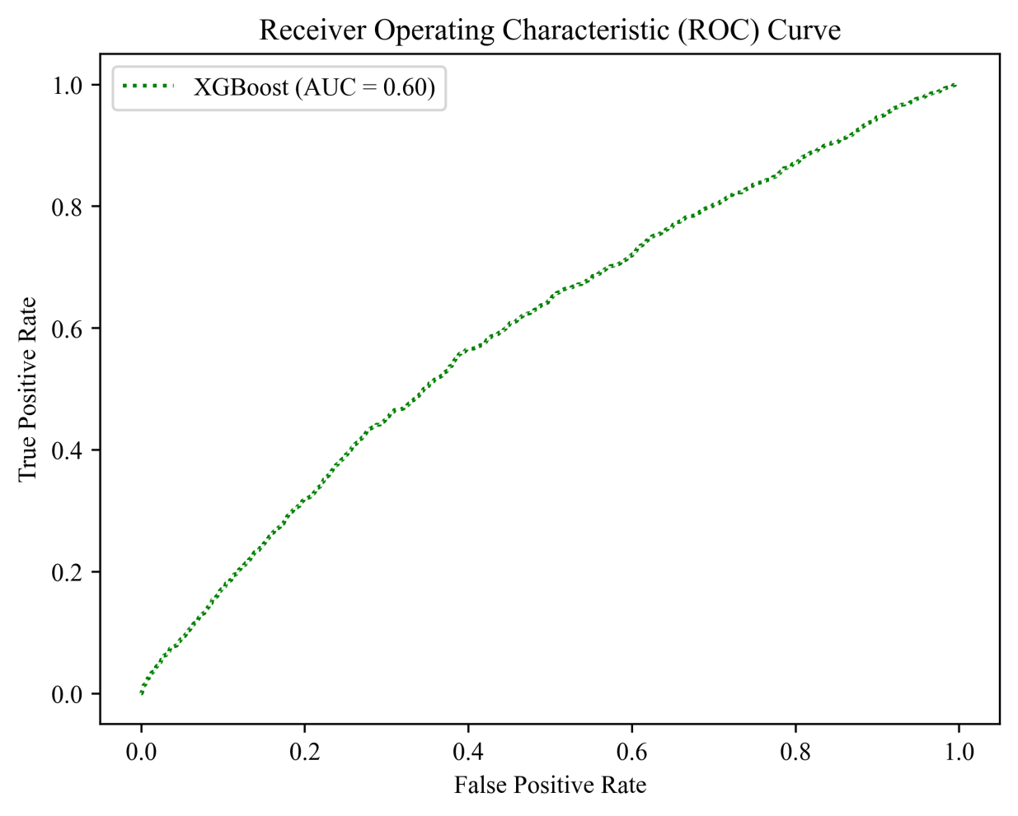

Figure S1. ROC curve for the XGBoost model predicting high IBPV. The Receiver Operating Characteristic (ROC) curve of the model built using the XGBoost algorithm on an independent test set.
The test set comprises 11,333 patients, accounting for 30% of the total study cohort. The area under the ROC curve (AUC) is 0.60, indicating a moderate level of discriminative ability of the model.

