Table S1 Association Between the IMH Risk Score and MACEs: Univariate and Multivariate Logistic Regression Analysis
Characteristics | Univariate Logistic Regression |  |  | Multivariate Logistic Regression
 | OR | 95%CI | P | OR | 95%CI | P
Age | 1.02 | 0.99-1.05 | 0.14
Hypertension | 0.78 | 0.41-1.48 | 0.443
SBP | 1.00 | 0.98-1.03 | 0.908
DBP | 0.99 | 0.95-1.04 | 0.766
*cTnT | 1.15 | 0.93-1.41 | 0.191
*CKMB | 0.91 | 0.75-1.11 | 0.359
*CRP | 1.12 | 0.88-1.42 | 0.363
LDL-C | 1.08 | 1-1.16 | 0.044 | 1.06 | 0.99-1.16 | 0.139
SCr | 0.99 | 0.97-1.01 | 0.419
Beta-blocker | 2.38 | 0.55-10.4 | 0.248
ACEI/ARB | 1.49 | 0.66-3.37 | 0.336
Heart rate | 1.00 | 1.00-1.01 | 0.789
Killip | 2.7 | 0.67-10.85 | 0.162
Mutivessel Disease | 1.73 | 0.88-3.37 | 0.109
Thrombus Aspiration | 1.43 | 0.59-3.48 | 0.433
IRA（LAD vs LCX） | 1.72 | 0.77-3.84 | 0.186
IRA（LAD vs RCA） | 0.54 | 0.24-1.21 | 0.134
IMH Risk score | 14.30 | 4.95-41.35 | <0.001 | 12.79 | 4.39-38.05 | <0.001
*Variables were first transformed to their natural logarithm (ln) values for comparability. Abbreviations: IMH, intramyocardial hemorrhage; MACEs, major adverse cardiovascular events; SBP, systolic blood pressure; DBP, diastolic blood pressure; IRA, infarction related artery; LAD, left anterior descending; LCX, left circumflex; RCA, right coronary artery; ACEI/ARB, angiotensin-converting enzyme inhibitors/angiotensin receptor blockers; cTnT, cardiac troponin T; CKMB, creatine kinase-MB; CRP, C-reactive protein; LDL-C, low-density lipoprotein cholesterol; SCr, serum creatinine; LVEF, left ventricular ejection fraction; caIMR, coronary angiography-derived index of microcirculatory resistance.
Supplementary Figures and Tables

Supplementary Table 2.Association Between the IMH Risk Score and MACE: Univariate and Multivariate Logistic Regression

Table S2 Association Between the IMH Risk Score and in-hospital HF: Univariate and Multivariate Logistic Regression Analysis
Characteristics | Univariate Logistic Regression |  |  | Multivariate Logistic Regression
 | OR | 95%CI | P | OR | 95%CI | P
Age | 1.03 | 1.01-1.05 | 0.005 | 1.04 | 1.02-1.07 | <0.001
Hypertension | 1.24 | 0.78-1.97 | 0.365
SBP | 0.99 | 0.98-1.01 | 0.554
DBP | 1.00 | 0.96-1.03 | 0.772
*cTnT | 1.66 | 1.35-2.03 | <0.001 | 1.55 | 1.15-2.1 | 0.004
*CKMB | 1.30 | 1.11-1.53 | 0.001 | 0.96 | 0.73-1.26 | 0.776
*CRP | 1.10 | 0.93-1.31 | 0.278 | 1.23 | 0.99-1.53 | 0.063
LDL-C | 1.17 | 1.02-1.35 | 0.029 | 1.06 | 0.99-1.16 | 0.139
SCr | 1.00 | 0.98-1.01 | 0.927
Beta-blocker | 1.18 | 0.53-2.64 | 0.686
ACEI/ARB | 1.17 | 0.68-2.03 | 0.566
Heart rate | 1.00 | 0.99-1.00 | 0.597
Killip | 4.00 | 1.01-15.78 | 0.048 | 2.71 | 0.57-12.87 | 0.21
Mutivessel Disease | 1.04 | 0.65-1.66 | 0.858
Thrombus Aspiration | 1.56 | 0.79-3.09 | 0.203
IRA（LAD vs LCX） | 0.61 | 0.31-1.21 | 0.156 | 0.85 | 0.39-1.85 | 0.676
IRA（LAD vs RCA） | 0.45 | 0.26-0.78 | 0.004 | 0.54 | 0.28-1.03 | 0.060
IMH Risk score | 18.19 | 7.09-46.69 | <0.001 | 11.41 | 3.82-34.08 | <0.001
*Variables were first transformed to their natural logarithm (ln) values for comparability. Abbreviations: IMH, intramyocardial hemorrhage; HF, heart failure; SBP, systolic blood pressure; DBP, diastolic blood pressure; IRA, infarction related artery; LAD, left anterior descending; LCX, left circumflex; RCA, right coronary artery; ACEI/ARB, angiotensin-converting enzyme inhibitors/angiotensin receptor blockers; cTnT, cardiac troponin T; CKMB, creatine kinase-MB; CRP, C-reactive protein; LDL-C, low-density lipoprotein cholesterol; SCr, serum creatinine; LVEF, left ventricular ejection fraction; caIMR, coronary angiography-derived index of microcirculatory resistance.

Table S3 Association Between the CMR-IMH and MACE: Univariate and Multivariate Logistic Regression Analysis
Characteristics | Univariate Logistic Regression |  |  | Multivariate Logistic Regression
 | OR | 95%CI | P | OR | 95%CI | P
Age | 1.02 | 0.99-1.05 | 0.140
Hypertension | 0.78 | 0.41-1.48 | 0.443
SBP | 1.00 | 0.98-1.03 | 0.908
DBP | 0.99 | 0.95-1.04 | 0.766
*cTnT | 1.15 | 0.93-1.41 | 0.191
*CKMB | 0.91 | 0.75-1.11 | 0.359
*CRP | 1.12 | 0.88-1.42 | 0.363
LDL-C | 1.08 | 1.00-1.16 | 0.044 | 1.08 | 1.01-1.17 | 0.063
SCr | 0.99 | 0.97-1.01 | 0.419
Beta-blocker | 2.38 | 0.55-10.4 | 0.248
ACEI/ARB | 1.49 | 0.66-3.37 | 0.336
Heart rate | 1.00 | 1.00-1.01 | 0.789
Killip | 2.7 | 0.67-10.85 | 0.162
Mutivessel Disease | 1.73 | 0.88-3.37 | 0.109
Thrombus Aspiration | 1.43 | 0.59-3.48 | 0.433
IRA（LAD vs LCX） | 1.72 | 0.77-3.84 | 0.186
IRA（LAD vs RCA） | 0.54 | 0.24-1.21 | 0.134
IMH | 2.12 | 1.10-4.08 | 0.025 | 1.99 | 1.01-3.87 | 0.043
*Variables were first transformed to their natural logarithm (ln) values for comparability. Abbreviations: CMR, cardiac magnetic resonance; IMH, intramyocardial hemorrhage; MACEs, major adverse cardiovascular events; SBP, systolic blood pressure; DBP, diastolic blood pressure; IRA, infarction related artery; LAD, left anterior descending; LCX, left circumflex; RCA, right coronary artery; ACEI/ARB, angiotensin-converting enzyme inhibitors/angiotensin receptor blockers; cTnT, cardiac troponin T; CKMB, creatine kinase-MB; CRP, C-reactive protein; LDL-C, low-density lipoprotein cholesterol; SCr, serum creatinine; LVEF, left ventricular ejection fraction; caIMR, coronary angiography-derived index of microcirculatory resistance.

Table S4 Association Between the CMR-IMH and In-Hospital HF: Univariate and Multivariate Logistic Regression Analysis IMH and MACE: Univariate and Multivariate Logistic Regression Analysis
Characteristics | Univariate Logistic Regression |  |  | Multivariate Logistic Regression
 | OR | 95%CI | P | OR | 95%CI | P
Age | 1.03 | 1.01-1.05 | 0.005 | 1.04 | 1.02-1.07 | <0.001
Hypertension | 1.24 | 0.78-1.97 | 0.365
SBP | 0.99 | 0.98-1.01 | 0.554
DBP | 1.00 | 0.96-1.03 | 0.772
*cTnT | 1.66 | 1.35-2.03 | <0.001 | 1.68 | 1.25-2.27 | 0.001
*CKMB | 1.30 | 1.11-1.53 | 0.001 | 0.87 | 0.67-1.13 | 0.290
*CRP | 1.10 | 0.93-1.31 | 0.278
LDL-C | 1.17 | 1.02-1.35 | 0.029 | 1.08 | 1.01-1.17 | 0.063
SCr | 1.00 | 0.98-1.01 | 0.927
Beta-blocker | 1.18 | 0.53-2.64 | 0.686
ACEI/ARB | 1.17 | 0.68-2.03 | 0.566
Heart rate | 1.00 | 0.99-1.00 | 0.597
Killip | 4.00 | 1.01-15.78 | 0.048 | 4.26 | 0.93-19.6 | 0.063
Mutivessel Disease | 1.04 | 0.65-1.66 | 0.858
Thrombus Aspiration | 1.56 | 0.79-3.09 | 0.203
IRA（LAD vs LCX） | 0.61 | 0.31-1.21 | 0.156 | 0.75 | 0.34-1.62 | 0.460
IRA（LAD vs RCA） | 0.45 | 0.26-0.78 | 0.004 | 0.43 | 0.23-0.81 | 0.008
IMH | 3.61 | 2.15-6.07 | <0.001 | 2.75 | 1.53-4.95 | 0.001
*Variables were first transformed to their natural logarithm (ln) values for comparability. Abbreviations: IMH, intramyocardial hemorrhage; HF, heart failure; SBP, systolic blood pressure; DBP, diastolic blood pressure; IRA, infarction related artery; LAD, left anterior descending; LCX, left circumflex; RCA, right coronary artery; ACEI/ARB, angiotensin-converting enzyme inhibitors/angiotensin receptor blockers; cTnT, cardiac troponin T; CKMB, creatine kinase-MB; CRP, C-reactive protein; LDL-C, low-density lipoprotein cholesterol; SCr, serum creatinine; LVEF, left ventricular ejection fraction; caIMR, coronary angiography-derived index of microcirculatory resistance.

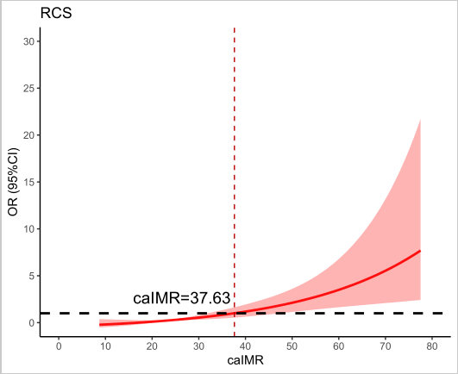

Figure S1. Restricted cubic spline analysis of the nonlinear relationship between caIMR and IMH risk. The solid line represents the odds ratio (OR) estimates, with shaded area indicating 95% confidence intervals. The dashed vertical line marks the 37.63 U threshold, showing significantly steeper risk escalation beyond this inflection point. The dotted horizontal line indicates the reference level (OR=1 at caIMR=37.63 U, the optimal statistical cutoff).

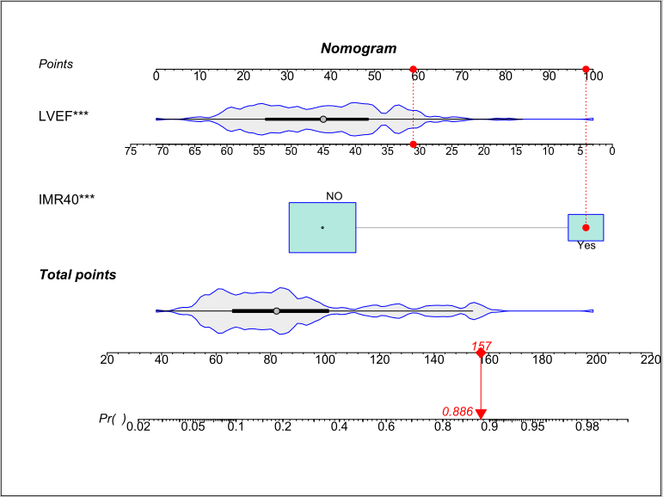
A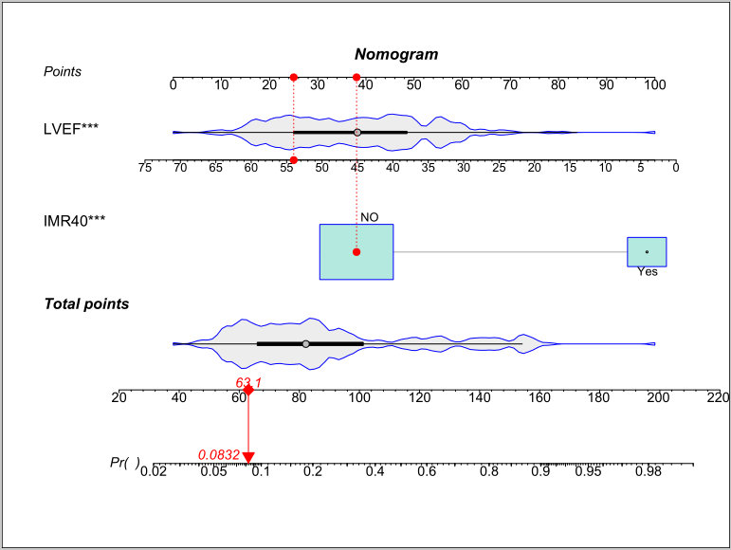 B
Figure S2. Nomogram application example: A. Low-risk case.Schematic demonstration of the nomogram's clinical implementation in a patient with preserved LVEF (54%) and caIMR<40. B. High-risk case. Clinical application of the nomogram in a patient with reduced LVEF (31%) and caIMR≥40. The stepwise process: (1) Plotting LVEF value on the corresponding axis, (2) Plotting caIMR value, (3) Summing the derived points, and (4) Projecting the total score to obtain the predicted IMH risk probability (8.3%).

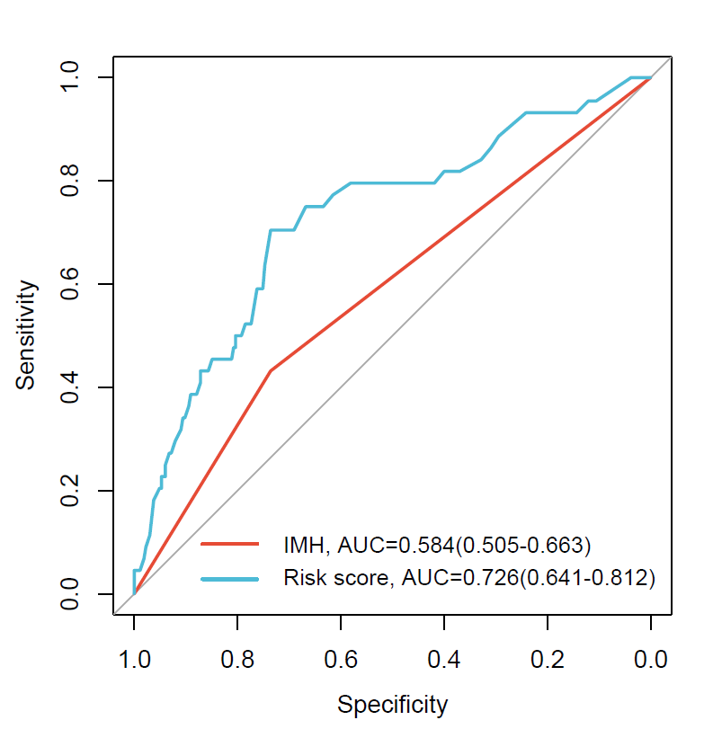
Figure S3. Comparing different risk models based on CMR-IMH (red) and nomogram-derived IMH Risk score (blue) on the predictive accuracy of MACE using the ROC curves. AUC indicates an area under the curve. CMR, cardiac magnetic resonance; IMH, intramyocardial hemorrhage; MACE, major adverse cardiovascular events.
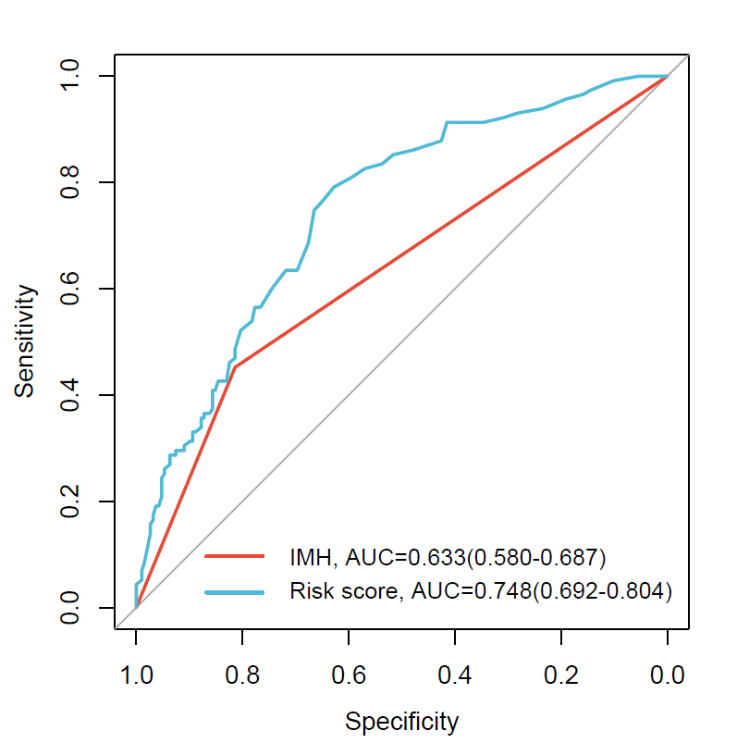
Figure S4. Comparing different risk models based on CMR-IMH (red) and nomogram-derived IMH Risk score (blue) on the predictive accuracy of in-hospital HF using the ROC curves. AUC indicates an area under the curve. HF, heart failure; IMH, intramyocardial hemorrhage.

