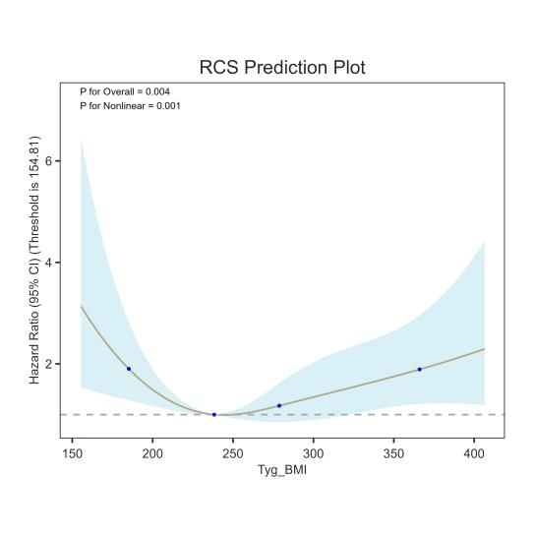
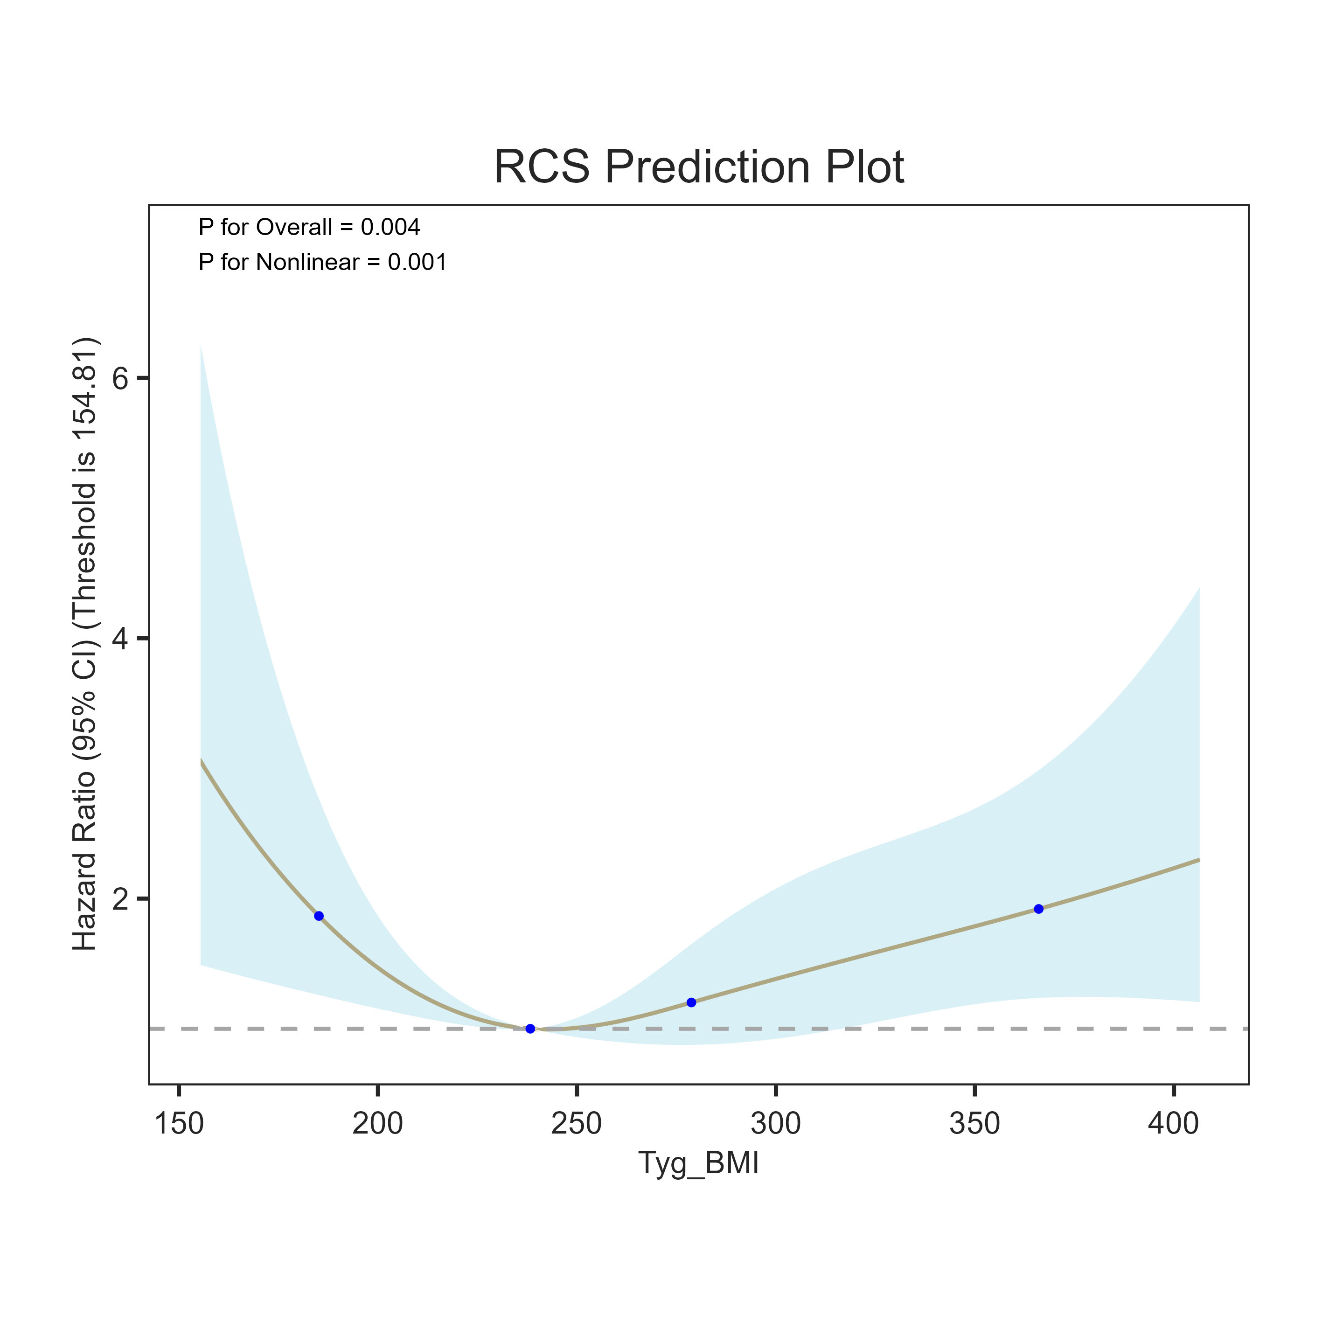
C
D
Supplementary Fig. 3 Restricted cubic spline regression analysis of TyG-BMI index with
90-day (C) and 180-day (D) all-cause mortality

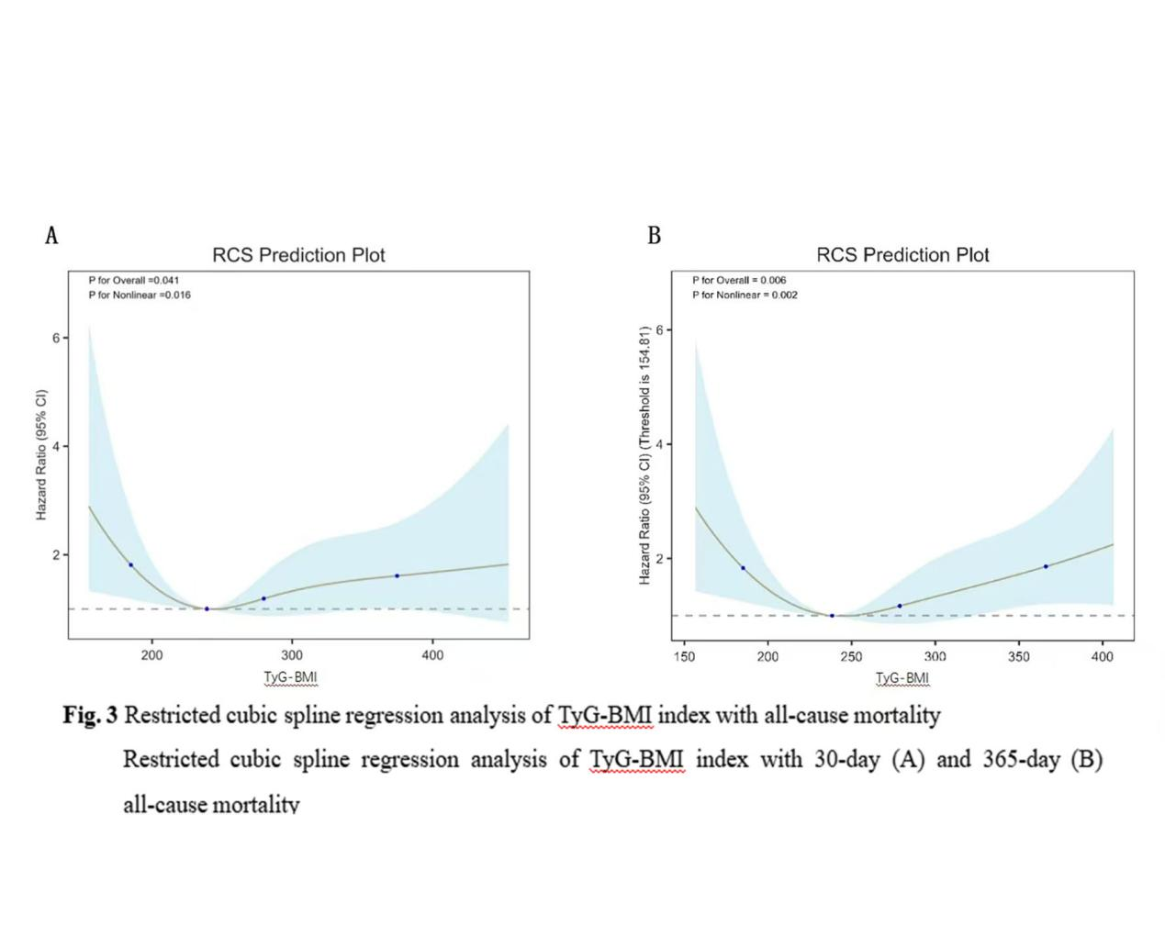
Fig. 3 Restricted cubic spline regression analysis of TyG-BMI index with 30-day (A) and 365-day (B) all-cause mortality

