Supplementary Appendix
Supplemental Methods
Up-titration of ACEi/ARB and beta blockers in the clinics were undertaken as follows. Titration was attempted from the first clinic appointment. Patients were followed up until their care could be handed over to their primary care physician, however, in many cases they had ongoing engagement with the specialist team, and in many other cases the clinic visits stopped due to other comorbidities, change in health, or patient preference. This is consistent with the results being from a real-life specialist public service. ACEi/ARB and beta blockers were titrated individually. The order of up-titration was expected to have reflected guideline recommendations at the time; for example, to titrate the beta-blockers first in case of ischemia, arrhythmias or other co-indication, and to titrate ACEi/ARB in case of fluid overload. Otherwise order of up-titration was at the discretion of the treating clinician and patient preference. Data on the order of up-titration of ACEi/ARB versus beta blockers were not available for our study. Similarly, in case of hypotension the expected preference would have been to reduce the dose of diuretics or other antihypertensives (such as calcium channel blockers) before adjusting the dose of ACEi/ARB or beta blockers. Renal impairment was defined if the treating clinician had documented that they had renal impairment. As per the guideline recommendations the decision regarding whether the ACEi/ARB should be stopped with deterioration of renal function was based on clinician and patient preference, and the baseline renal function and degree of deterioration with dose escalation.

Supplementary Table 1. Initial and target doses of ACEi, ARB, and beta-blockers.
Medication | Initial dose | Target dose
Angiotensin Converting Enzyme inhibitor
Captopril | 6.25mg three times per day | 50mg three times per day
Enalapril | 2.5mg daily | 10-20mg daily
Lisinopril | 2.5mg daily | 20-40mg daily
Ramipril | 2.5mg twice a day | 10mg daily
Trandolapril | 1mg daily | 4mg daily
Perindopril arginine salt | 2.5mg daily | 5mg daily
Perindopril erbumine salt | 2mg daily | 4mg daily
Fosinopril | 5mg daily | 10-40mg daily
Angiotensin Receptor Blocker
Candesartan | 4mg daily | 32mg daily
Valsartan | 40mg twice a day | 160mg twice a day
Losartan | 50mg daily | 100mg daily
Telmisartan | 40mg daily | 80mg daily
Eprosartan | 400mg daily | 600mg daily
Irbesartan | 75mg daily | 300mg daily
Beta-blocker
Bisoprolol | 1.25mg daily | 10mg daily
Carvedilol | 3.125mg twice a day | 25mg twice a day
Metoprolol succinate (CR/XL) | 23.75mg daily | 190mg daily
Metoprolol | 12.5mg twice a day | 100mg twice a day
Nebivolol | 1.25mg daily | 10mg daily
Atenolol | 25mg daily | 100mg daily
Supplementary Table 2. Multivariable Cox regression model of predictors of mortality, complete cases only.
Variable | Hazard Ratio | 95% CI | p-value*
Percentage of maximum ACE inhibitor or ARB dose (increase from 50% to 100%) | 0.77 | 0.65 – 0.91 | 0.00236
Percentage of maximum Beta-blockers dose  (increase from 50% to 100%) | 0.78 | 0.65 – 0.94 | 0.00963
Age (increase of 10 years from referent 60 years) | 1.56 | 1.35 – 1.80 | <.00001
Weight at the first appointment  (increase of 10 kg from referent 60 kg) | 1.047 | 0.98 – 1.12 | 0.194
Last recorded diastolic blood pressure  (increase of 10 mmHg from referent 80 mm Hg) | 1.13 | 0.98 – 1.30 | 0.102
Last recorded systolic blood pressure  (increase of 20 mmHg from referent 90 mm Hg) | 0.40 | 0.29 – 0.56 | <.00001
Last recorded systolic blood pressure  (increase of 20 mmHg from referent 110 mm Hg) | 0.88 | 0.65 – 1.19 | <.00001
Last recorded systolic blood pressure  (increase of 20 mmHg from referent 130 mm Hg) | 1.013 | 0.80 – 1.29 | <.00001
Atrial Fibrillation (presence versus absence) | 1.19 | 0.91 – 1.54 | 0.200
Chronic Renal Failure (presence versus absence) | 1.42 | 1.098 – 1.84 | 0.00754
Peripheral Vascular Disease (presence versus absence) | 1.77 | 1.26 – 2.49 | 0.00112
Clinic Type (multidisciplinary ambulatory specialist clinic versus cardiology heart failure clinic) | 0.73 | 0.56 – 0.95 | 0.0177
Ischemic Heart Disease (presence versus absence) | 1.086 | 0.83 – 1.42 | 0.543
CI: confidence interval.

Supplementary Figure 1. Trace lines for the three multiply imputed variables (weight, systolic blood pressure, and diastolic blood pressure).
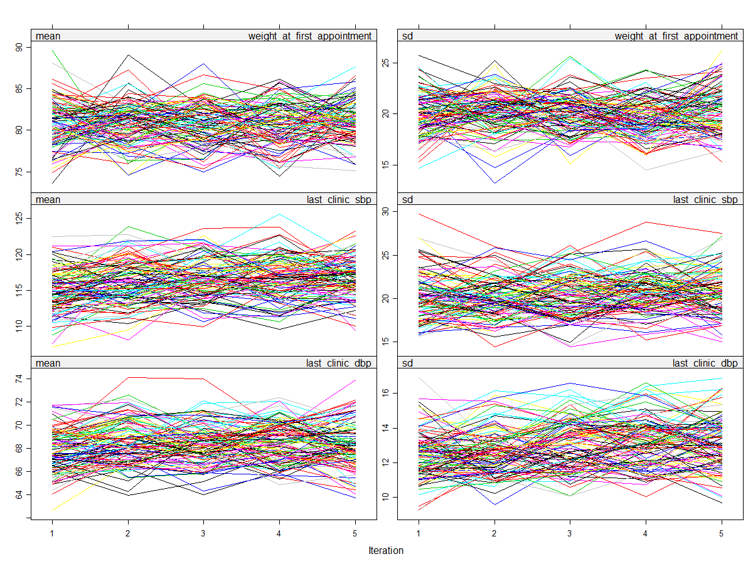

Supplementary Figure 2. Multivariable Cox regression model of predictors of mortality, complete cases only.
