Supplementary material

Supplementary Table 1: Search strategy

Database | Code | Search formula | Findings | Last update
Pubmed | #1 | ("patch*"[title/abstract] OR "Exosomes"[Mesh] OR "Exosome*"[title/abstract] OR "Extracellular vesicle*"[title/abstract] OR "Exovesicle*"[title/abstract] OR "Collagen*"[title/abstract] OR "Collagen"[Mesh]) | 492931 | (1/8/2025)
 | #2 |  | 93887 | (1/8/2025)
 | #3 | #1 AND #2 | 845 | (1/8/2025)
Scopus | #4 | ( TITLE-ABS-KEY ( "Exosome*" ) OR TITLE-ABS-KEY ( "Collagen" ) ) | 433907 | (1/8/2025)
 | #5 | ( ( TITLE-ABS-KEY ( "PCI" ) OR TITLE-ABS-KEY ( "Percutaneous Coronary Intervention" ) OR TITLE-ABS-KEY ( "Coronary Stent*" ) OR TITLE-ABS-KEY ( "Percutaneous Transluminal Coronary Angioplast*" ) OR TITLE-ABS-KEY ( "PTCA" ) OR TITLE-ABS-KEY ( "Angioplasty" ) OR TITLE-ABS-KEY ( "Percutaneous Coronary Revascularization*" ) OR TITLE-ABS-KEY ( "Coronary Artery Bypass*" ) OR TITLE-ABS-KEY ( "CAB" ) OR TITLE-ABS-KEY ( "Coronary Artery Bypass Graft*" ) OR TITLE-ABS-KEY ( "CABG" ) OR TITLE-ABS-KEY ( "Coronary Bypass Surgery" ) OR TITLE-ABS-KEY ( "Coronary Artery Surgery" ) OR TITLE-ABS-KEY ( "Coronary Artery Anastomosis" ) OR TITLE-ABS-KEY ( "Coronary Graft" ) OR TITLE-ABS-KEY ( "Arterial Bypass Surgery" ) OR TITLE-ABS-KEY ( "Aortocoronary Bypass*" ) ) ) | 285361 | (1/8/2025)
 | #6 | #4 AND #5 | 1804 | (1/8/2025)
Web of Science | #7 | "Exosome*" (Topic) or "Collagen" (Topic) | 344367 | (1/8/2025)
 | #8 | "PCI" (Topic) or "Percutaneous Coronary Intervention" (Topic) or "Coronary Stent*" (Topic) or "Percutaneous Transluminal Coronary Angioplasty" (Topic) or "PTCA" (Topic) or "Angioplasty" (Topic) or "Percutaneous Coronary Revascularization" (Topic) or "Coronary Artery Bypass" (Topic) or "CAB" (Topic) or "Coronary Artery Bypass Graft" (Topic) or "CABG" (Topic) or "Coronary Bypass Surgery" (Topic) or "Coronary Artery Surgery" (Topic) or "Coronary Artery Anastomosis" (Topic) or "Coronary Graft*" (Topic) or "Arterial Bypass Surgery" (Topic) or "Aortocoronary Bypass" (Topic) | 225280 | (1/8/2025)
 | #9 | #7 AND #8 | 1566 | (1/8/2025)
Embase | #10 | 'exosome*':ab,ti OR 'collagen':ab,ti | 345501 | (1/10/2025)
 | #11 |  | 250065 | (1/10/2025)
 | #12 | #10 AND #11 | 1449 | (1/10/2025)

Total included studies: 5664
Duplicates: 2055
Remaining: 3609

Supplementary Figure 1. Forest plot comparing the neointimal area in patients who received exosomes with controls. Standardized mean difference using Hedges’ g was applied
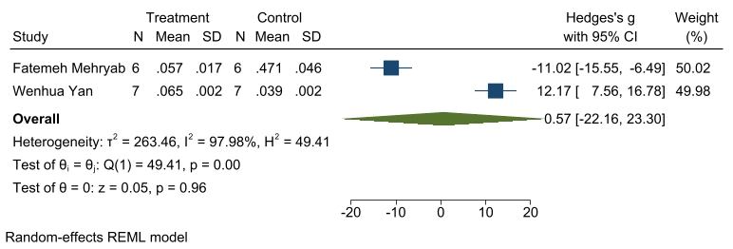
Supplementary Figure 2. Funnel plot assessing publication bias of the analysis
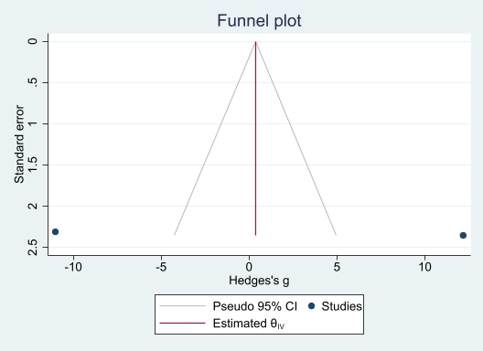

Supplementary Figure 3. Forest plot comparing the media area in patients who received exosomes with controls. Standardized mean difference using Hedges’ g was applied
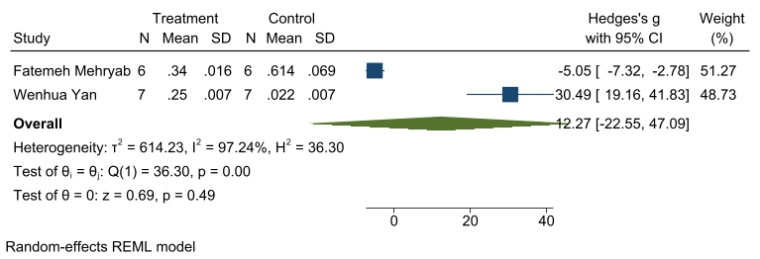
Supplementary Figure 4. Funnel plot assessing publication bias of the analysis
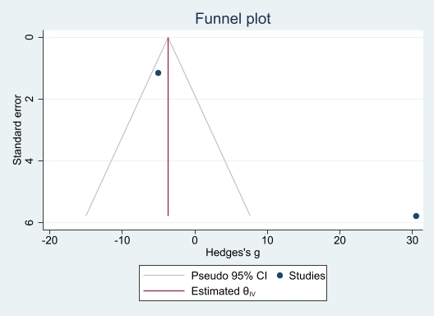

Supplementary Figure 5. Forest plot comparing the lumen area in patients who received exosomes with controls. Standardized mean difference using Hedges’ g was applied
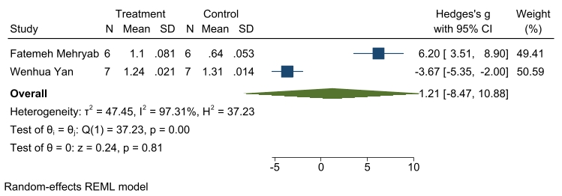
Supplementary Figure 6. Funnel plot assessing publication bias of the analysis
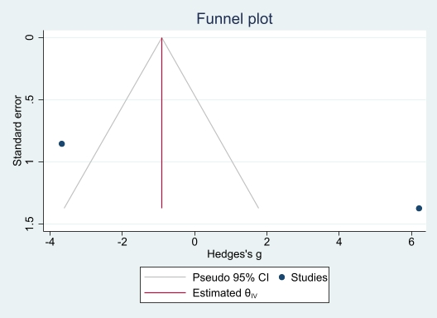

Supplementary Figure 7. Forest plot comparing the N/M ratio in patients who received exosomes with controls. Standardized mean difference using Hedges’ g was applied
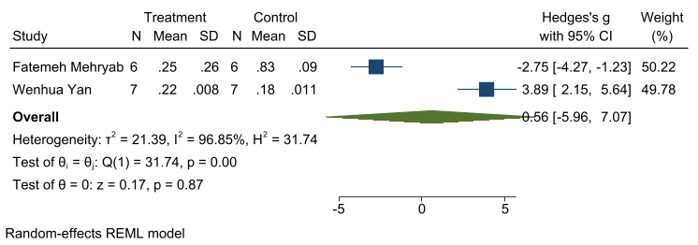
Supplementary Figure 8. Funnel plot assessing publication bias of the analysis
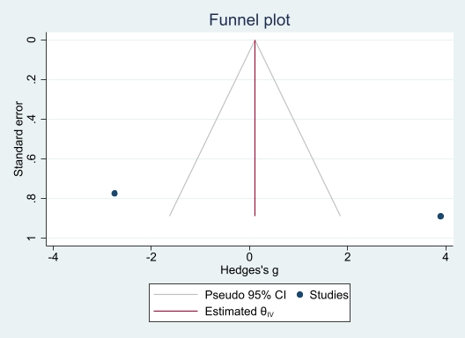

Supplementary Figure 9. Forest plot comparing the stenosis percentage in patients who received exosomes with controls. Standardized mean difference using Hedges’ g was applied
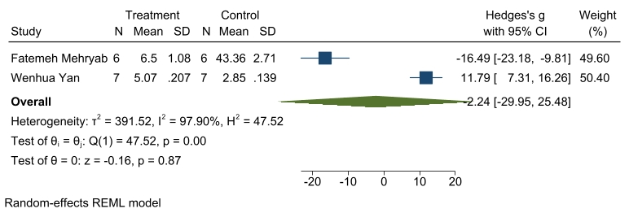
Supplementary Figure 10. Funnel plot assessing publication bias of the analysis
