Table S1. Baseline characteristics of study population before PS matching.
 | Prasugrel  (N=3744) | Clopidogrel  (N=9588) | P value
Age-yrs. | 59.8 ± 10.2 | 64.2 ± 12.8 | <.001
Female Sex (%) | 593 (15.8) | 2866 (29.9) | <.001
Weight (kg) | 70.2 ± 11.0 | 64.6 ± 11.9 | <.001
ELB – no. (%) | 694 (18.5) | 3906 (40.7) | <.001
Prasugrel dose – no. (%) |  |  | NA
5mg | 811 (21.7)
10mg | 2933 (78.3)
Hypertension – no. (%) | 1907 (50.9) | 5115 (53.3) | .013
Diabetes Mellitus - no. (%) | 1098 (29.3) | 3053 (31.8) | .005
Dyslipidemia – no. (%) | 1201 (32.1) | 1443 (15.1) | <.001
History of Smoking – no. (%) | 1832 (59.8) | 0 (0.0) | <.001
eGFR ≤ 60 -no. (%) | 55 (1.5) | 222 (2.3) | .003
Previous MI – no. (%) | 159 (4.2) | 410 (4.3) | .978
Previous PCI – no. (%) | 390 (10.4) | 688 (7.2) | <.001
Previous CABG – no. (%) | 10 (0.3) | 50 (0.5) | .068
Diagnosis – no. (%) |  |  | <.001
STEMI | 1202 (32.1) | 5174 (54.0)
NSTEMI/UA | 2542 (67.9) | 4414 (46.0)
Disease Extent – no (%) |  |  | <.001
1 | 1892 (50.5) | 4342 (45.3)
2 | 1153 (30.8) | 3097 (32.3)
3 | 699 (18.7) | 2149 (22.4)
Culprit (%) |  |  | <.001
LAD | 1696 (45.3) | 4588 (47.9)
LCX | 568 (15.2) | 1579 (16.5)
LM | 166 (4.4) | 312 (3.3)
RCA | 1028 (27.5) | 3088 (32.2)
DES - no (%) | 3411 (91.1) | 8310 (86.7) | <.001
Number of Treated vessels | 1.4 ± 0.7 | 1.3 ± 0.5 | <.001
Total Stent length (mm) | 24.0 ± 13.0 | 34.1 ± 20.7 | <.001
IVUS - no (%) | 1191 (31.8) | 1976 (20.6) | <.001
LVEF (%) | 49.9 ± 20.6 | 52.9 ± 11.5 | <.001

* Abbreviations: PS, Propensity score; ELB, Elderly or low-body weighted; MI, Myocardial infarction; PCI, Percutaneous coronary intervention; CABG, Coronary artery bypass grafting; (N)STEMI, (Non) ST-segment elevation myocardial infarction; UA, Unstable angina; LM, Left main coronary artery; LAD, Left anterior descending artery; LCX, Left circumflex artery; RCA, Right coronary artery; DES, Drug-eluting stent; IVUS, Intravascular ultrasound; LVEF, Left ventricular ejection fraction.

Table S2. 1-year clinical outcomes according to treatment arms in PS matched ELB and non-ELB cohort
 | Non-ELB cohort |  |  |  | ELB cohort
 | Clopidogrel  (n = 3036) | Prasugrel  (n = 3036) | HR (95% CI) | P value | Clopidogrel  (n = 689) | Prasugrel  (n = 689) | HR (95% CI) | P value
Primary ischemic outcome
MACCE (Composite of all-cause death, MI, stroke, stent thrombosis and any revascularization) | 251 (8.3) | 82 (2.7) | 0.36 (0.28 - 0.46) | <.001 | 59 (8.6) | 30 (4.4) | 0.56 (0.36 - 0.86) | .009
All cause of death | 25 (0.8) | 13 (0.4) | 0.58 (0.30 - 1.14) | .113 | 17 (2.5) | 11 (1.6) | 0.71 (0.33 - 1.51) | .371
Cardiovascular cause death | 25 (0.8) | 5 (0.2) | 0.21 (0.08 - 0.56) | .002 | 14 (2.0) | 3 (0.4) | 0.22 (0.06 - 0.78) | .018
MI | 51 (1.7) | 23 (0.8) | 0.48 (0.29 - 0.79) | .004 | 14 (2.0) | 7 (1.0) | 0.56 (0.23 - 1.39) | .212
Stent thrombosis | 17 (0.6) | 19 (0.6) | 1.19 (0.62 - 2.29) | .610 | 8 (1.2) | 6 (0.9) | 0.79 (0.27 - 2.27) | .658
Revascularization | 184 (6.1) | 29 (1.0) | 0.18 (0.12 - 0.26) | <.001 | 38 (5.5) | 11 (1.6) | 0.33 (0.17 - 0.65) | .001
Stroke | 31 (1.0) | 11 (0.4) | 0.37 (0.19 - 0.74) | .005 | 11 (1.6) | 3 (0.4) | 0.28 (0.08 - 1.01) | .052
Primary safety outcome
TIMI major or minor bleeding | 81 (2.7) | 80 (2.6) | 1.04 (0.76 - 1.41) | .816 | 40 (5.8) | 25 (3.6) | 0.66 (0.40 - 1.10) | .111
Net adverse clinical outcomes
Composite of MACCE, TIMI major or minor bleeding | 316 (10.4) | 155 (5.1) | 0.52 (0.43 - 0.64) | <.001 | 90 (13.1) | 51 (7.4) | 0.60 (0.43 - 0.85) | .004

Abbreviations: PS, Propensity score; ELB, Elderly or low-body weighted; HR, hazard ratio; CI, confidence interval; MACCE, major adverse cardiac and cerebrovascular events; MI, myocardial infarction; TIMI, Thrombolysis in Myocardial Infarction.
Table S3. 1-year clinical outcomes according to prasugrel dose in in PS matched cohort
 | Non-ELB cohort |  |  |  | ELB cohort
 | Prasugrel  5 mg  (n = 456) | Prasugrel  10 mg  (n = 2580) | *Adjusted HR (95% CI) | P value | Prasugrel  5 mg  (n = 350) | Prasugrel  10 mg  (n = 339) | *Adjusted HR (95% CI) | P value | P _{interaction}
Primary ischemic outcome
MACCE (Composite of all-cause death, MI, stroke, stent thrombosis and any revascularization) | 7 (1.5) | 75 (2.9) | 1.50 (0.68 - 3.32) | .313 | 10 (2.9) | 20 (5.9) | 1.83 (0.76 - 4.44) | .179 | .856
All cause of death | 1 (0.2) | 12 (0.5) | 1.57 (0.19 - 12.6) | .673 | 7 (2.0) | 4 (1.2) | 0.45 (0.08 - 2.39) | .348 | .288
Cardiovascular cause death | 0 (0.0) | 5 (0.2) | NA | .999 | 1 (0.3) | 2 (0.6) | NA | .841 | .998
MI | 2 (0.4) | 21 (0.8) | 1.37 (0.31 - 6.03) | .673 | 2 (0.6) | 5 (1.5) | 1.74 (0.30 - 10.1) | .536 | .771
Stent thrombosis | 2 (0.4) | 17 (0.7) | 1.28 (0.28 - 5.81) | .745 | 0 (0.0) | 6 (1.8) | NA | .999 | .996
Revascularization | 2 (0.4) | 27 (1.0) | 1.66 (0.38 - 7.19) | .499 | 1 (0.3) | 10 (2.9) | 7.99 (0.88 - 72.9) | .065 | .248
Stroke | 1 (0.2) | 10 (0.4) | 1.81 (0.22 - 14.6) | .579 | 1 (0.3) | 2 (0.6) | 4.78 (0.12 - 183.9) | .401 | .926
Primary safety outcome
TIMI major or minor bleeding | 5 (1.1) | 75 (2.9) | 2.34 (0.93 - 5.88) | .069 | 11 (3.1) | 14 (4.1) | 1.57 (0.63 - 3.92) | .338 | .252
Net adverse clinical outcomes
Composite of MACCE, TIMI major or minor bleeding | 11 (2.4) | 144 (5.6) | 1.99 (1.07 - 3.71) | .031 | 19 (5.4) | 32 (9.4) | 1.72 (0.89 - 3.33) | .105 | .527

*Multivariable models adjusted for: Age ≥75, female sex, body weight < 60kg, hypertension, diabetes mellitus, smoking status, dyslipidemia, eGFR < 60, prior history of PCI, clinical presentation, LAD culprit vessel, stent length, and LVEF < 40%.
Abbreviations: PS, Propensity score; HR, hazard ratio; CI, confidence interval; MACCE, major adverse cardiac and cerebrovascular events; MI, myocardial infarction; TIMI, Thrombolysis in Myocardial Infarction, eGFR, estimated glomerulus filtration rate, PCI, percutaneous coronary intervention, LAD, left anterior descending coronary artery, DES, drug eluting stent, LVEF, left ventricular ejection fraction.
Figure S1. 1-year clinical outcomes stratified by treatment arm among PS matched non-ELB patient
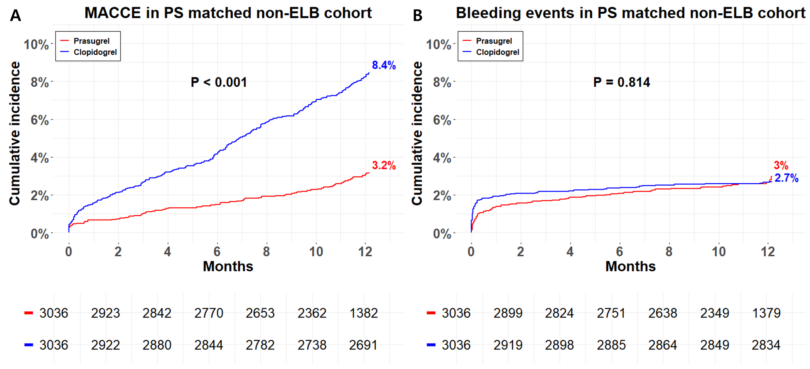
Kaplan–Meier curves for (A) MACCE and (B) TIMI major or minor bleeding events.
* Abbreviations: PS, Propensity score; ELB, Elderly or lower-body weighted; MACCE, major adverse cardiac and cerebrovascular events; TIMI, Thrombolysis in Myocardial Infarction.

Figure S2. Subgroup analyses comparing antiplatelet strategy on ischemic or bleeding events in the PS matched ELB or non-ELB cohorts
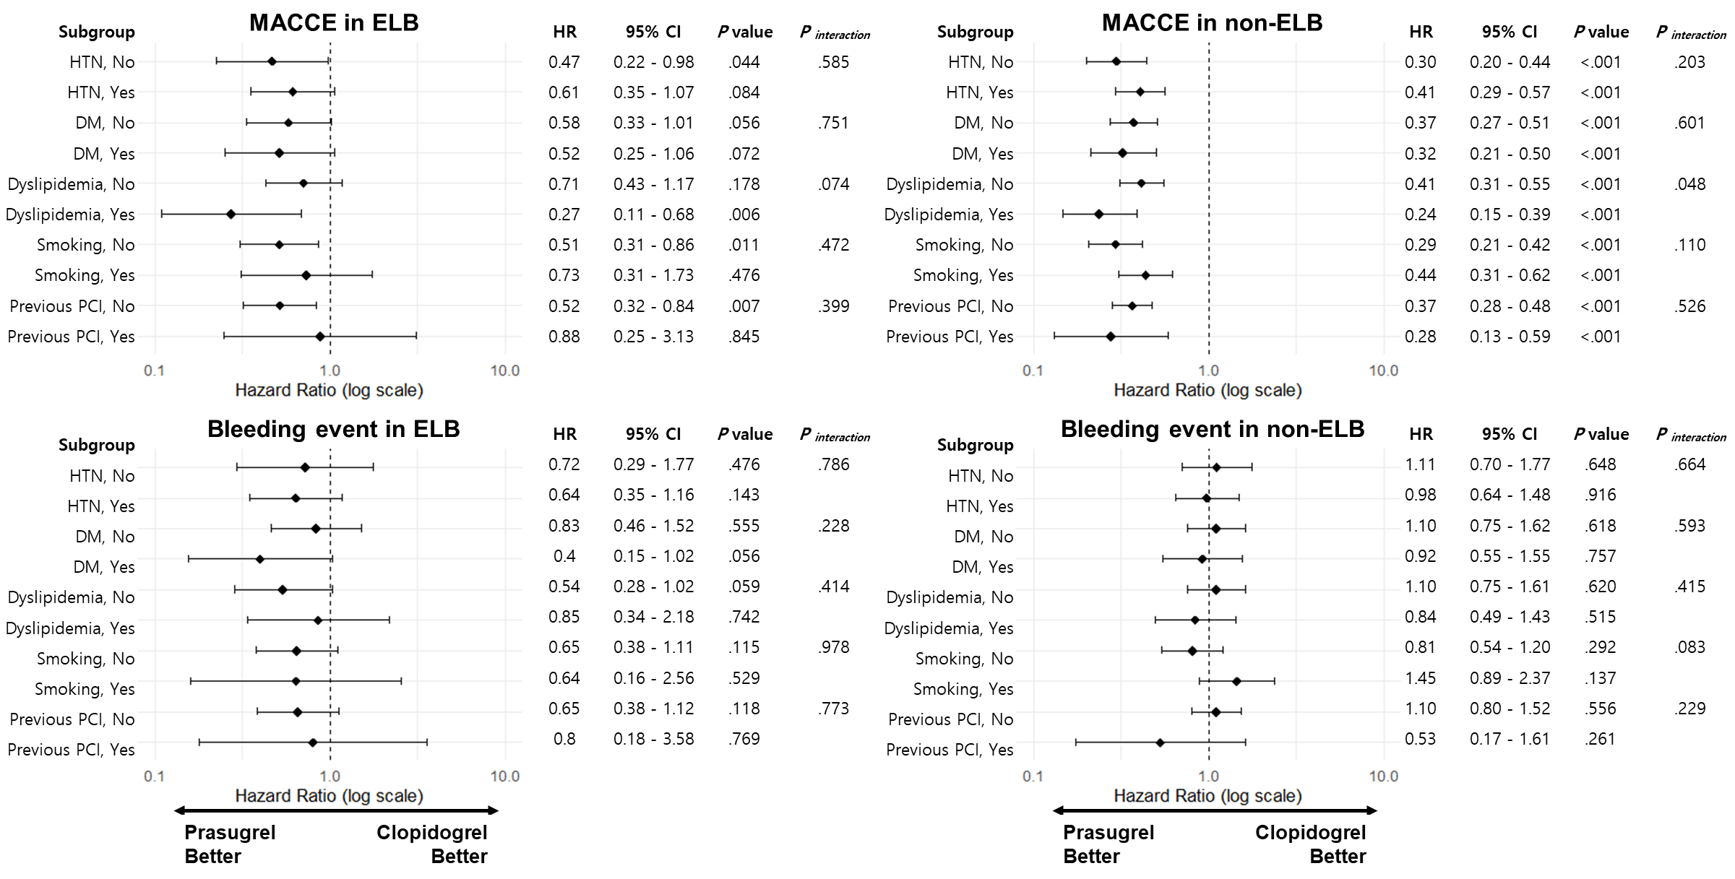
* Abbreviations: PS, Propensity score; ELB, Elderly or low-body weighted; HR, Hazard Ratio; CI, Confidential interval; MACCE, major adverse cardiac and cerebrovascular events; HTN, Hypertension; DM, diabetes mellitus; PCI, percutaneous coronary intervention.

