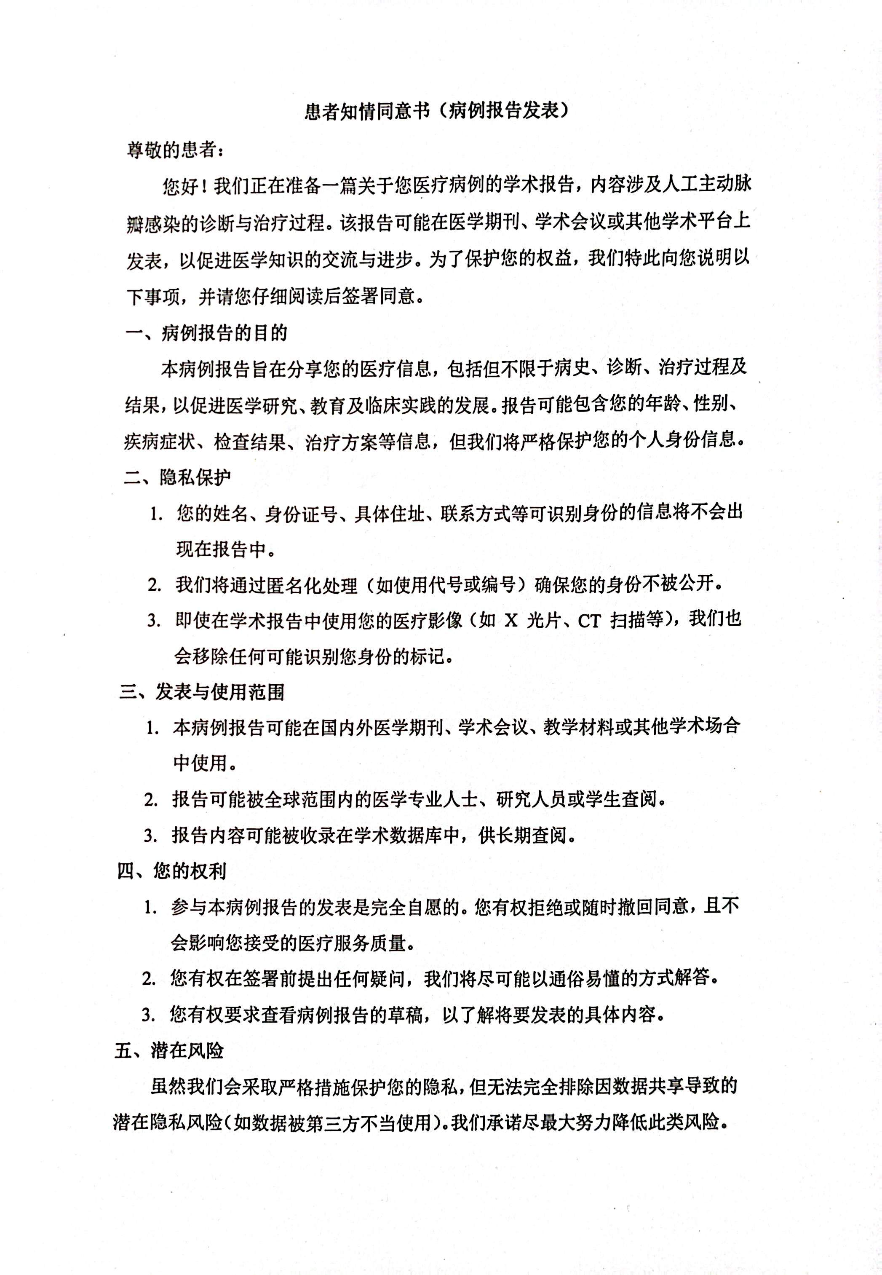

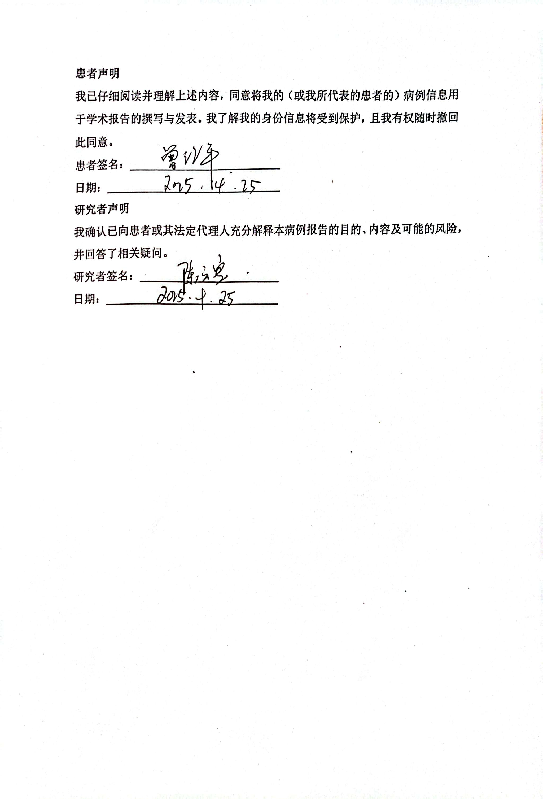

Patient Informed Consent Form (Case Report Publication)
Dear Patient,
We are preparing an academic case report regarding your medical condition, specifically related to prosthetic aortic valve infection, including its diagnosis and treatment. This report may be published in medical journals, presented at academic conferences, or used in other scholarly platforms to advance medical knowledge and practice. To protect your rights, we kindly ask you to carefully read the following information and provide your consent.
1. Purpose of the Case Report
The purpose of this case report is to share your medical information, including but not limited to medical history, diagnosis, treatment process, and outcomes, to contribute to medical research, education, and clinical practice. The report may include details such as your age, gender, symptoms, test results, and treatment plans, but your personal identifying information will be strictly protected.
2. Privacy Protection
- Your name, ID number, specific address, contact information, or other identifiable details will not be included in the report.
- We will use anonymization techniques (e.g., pseudonyms or codes) to ensure your identity remains confidential.
- If medical images (e.g., X-rays, CT scans) are included, any identifiable markers will be removed.
3. Scope of Publication and Use
- The case report may be published in medical journals, presented at academic conferences, used in teaching materials, or shared in other academic settings, both domestically and internationally.
- The report may be accessed by medical professionals, researchers, or students worldwide.
- The report may be included in academic databases for long-term access.
4. Your Rights
- Participation in this case report is entirely voluntary. You have the right to refuse or withdraw consent at any time without affecting the quality of your medical care.
- You may ask any questions before signing this form, and we will explain in clear, understandable language.
- You have the right to review a draft of the case report to understand the content to be published.
5. Potential Risks
While we will take strict measures to protect your privacy, there is a minimal risk of privacy breach due to data sharing (e.g., unauthorized use by third parties). We are committed to minimizing such risks to the greatest extent possible.
Patient Statement
I have carefully read and understood the above information and consent to the use of my medical information for the preparation and publication of the case report. I understand that my identity will be protected, and I have the right to withdraw this consent at any time.
Patient Signature: ______________________
Date: _________________________________
Investigator’s Statement
I confirm that I have fully explained the nature, purpose, and potential risks of this study to the patient or their legal representative and have answered any questions. I will ensure the patient’s information is anonymized as described and handled in accordance with applicable laws and ethical guidelines.
Investigator Signature: ___________________________
Date: _______________________________

