Supplementary material 4: MD trajectory analysis.

Table S1 The α-helix formation frequencies for residues 366-376 taken over the last 100 ns of the MD simulation for the 3 simulation trajectories, the average starting residues for the α-helix, and the statistics for the residue 371 contact area against calmodulin.
 | MD simulation trajectoriesª
 | W.T.(1) | W.T.(2) | W.T.(3) | A371P(1) | A371P(2) | A371P(3) | A371T(1) | A371T(2) | A371T(3)
Res.№ | α-helix occupancies for the indicated residues^{c}
366 | 0.00 | 0.00 | 0.00 | 0.00 | 0.00 | 0.00 | 0.00 | 0.00 | 0.00
367 | 0.95 | 0.98 | 0.90 | 0.00 | 0.00 | 0.00 | 0.00 | 0.96 | 0.68
368 | 1.00 | 1.00 | 1.00 | 0.00 | 0.00 | 0.00 | 1.00 | 1.00 | 1.00
369 | 1.00 | 1.00 | 1.00 | 1.00 | 0.09 | 0.57 | 1.00 | 1.00 | 1.00
370 | 1.00 | 1.00 | 1.00 | 1.00 | 1.00 | 1.00 | 1.00 | 1.00 | 1.00
371^{b} | 1.00 | 1.00 | 1.00 | 1.00 | 1.00 | 1.00 | 1.00 | 1.00 | 1.00
372 | 1.00 | 1.00 | 1.00 | 1.00 | 1.00 | 1.00 | 1.00 | 1.00 | 1.00
373 | 1.00 | 1.00 | 1.00 | 1.00 | 1.00 | 1.00 | 1.00 | 1.00 | 1.00
374 | 1.00 | 1.00 | 1.00 | 1.00 | 1.00 | 1.00 | 1.00 | 1.00 | 1.00
375 | 1.00 | 1.00 | 1.00 | 1.00 | 1.00 | 1.00 | 1.00 | 1.00 | 1.00
376 | 1.00 | 1.00 | 1.00 | 1.00 | 1.00 | 1.00 | 1.00 | 1.00 | 1.00
 | The average starting residue of the α-helix
 | 367.05 | 367.02 | 367.1 | 369 | 369.91 | 369.43 | 368 | 367.04 | 367.32
 | The contact area^{d} between residue 371 and chain C statistics, Å²
Average | 35.01 | 32.37 | 37.72 | 42.16 | 46.70 | 45.45 | 44.11 | 49.55 | 44.67
Std.dev. | 2.97 | 1.93 | 2.34 | 2.39 | 3.29 | 4.31 | 2.88 | 3.06 | 2.90
ªThe data were collected over the 400ns-500ns trajectory snapshots; ^{b}The mutated residue; ^{c}Structural elements were computed using DSSP program [1]; ^{d}Contact areas were computed using Voronota software [2].

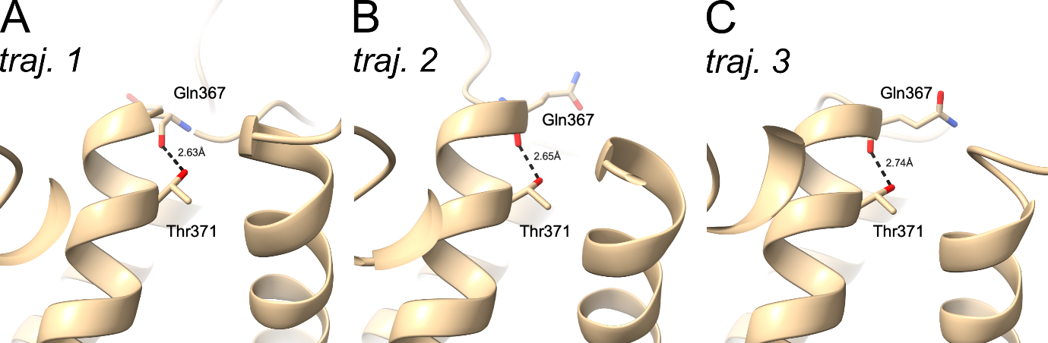
Fig. S1 The 500ns snapshots of the simulation of A371T variant, showing the environment of the residue 371. Trajectories 1, 2 and 3 are in plates (A), (B) and (C), correspondingly. Shown in dashed black line is the hydrogen bond that is formed between the side chain of Thr371 and the backbone of Gln367.

Bibliography (Suppl. Mat. 4)
1. Kabsch W, Sander C. Dictionary of protein secondary structure: pattern recognition of hydrogen-bonded and geometrical features. Biopolymers. 1983 m.;22:2577–637. https://doi.org/10.1002/bip.360221211
2. Olechnovič K, Venclovas C. Voronota: A fast and reliable tool for computing the vertices of the Voronoi diagram of atomic balls. J Comput Chem. 2014 m.;35:672–81. https://doi.org/10.1002/jcc.23538

