Supplementary material

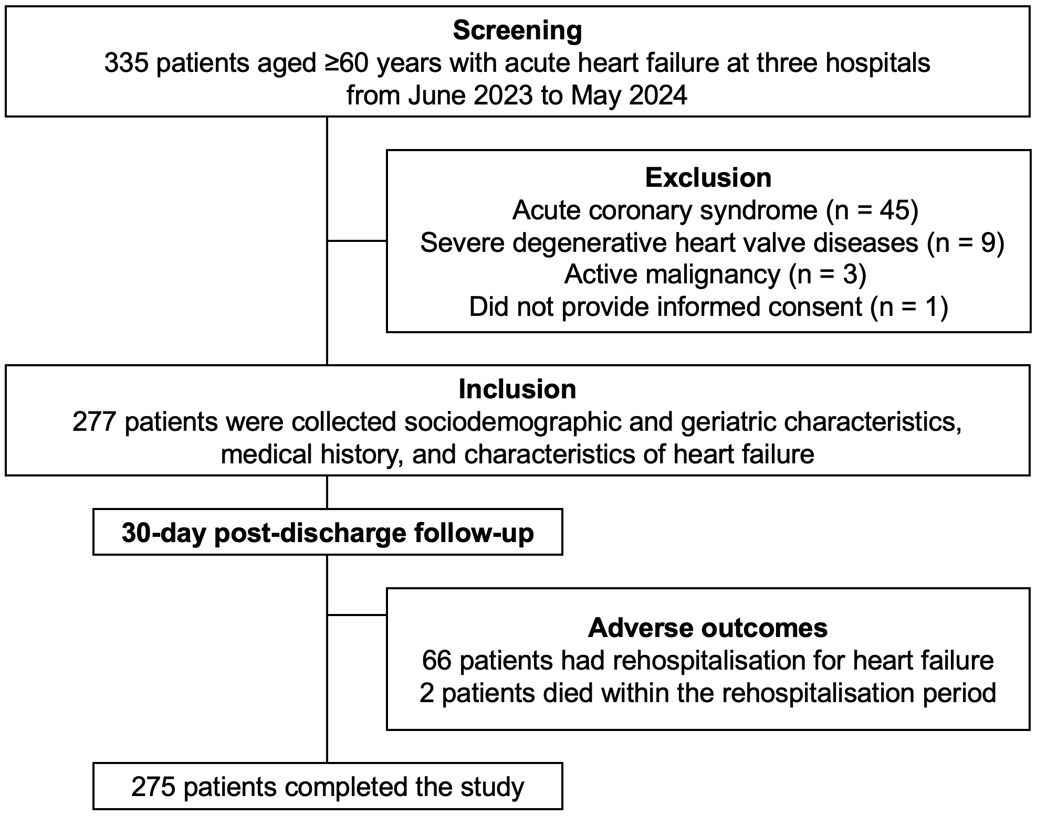

Supplementary Figure S1. Flow diagram of patient enrollment and follow-up process.

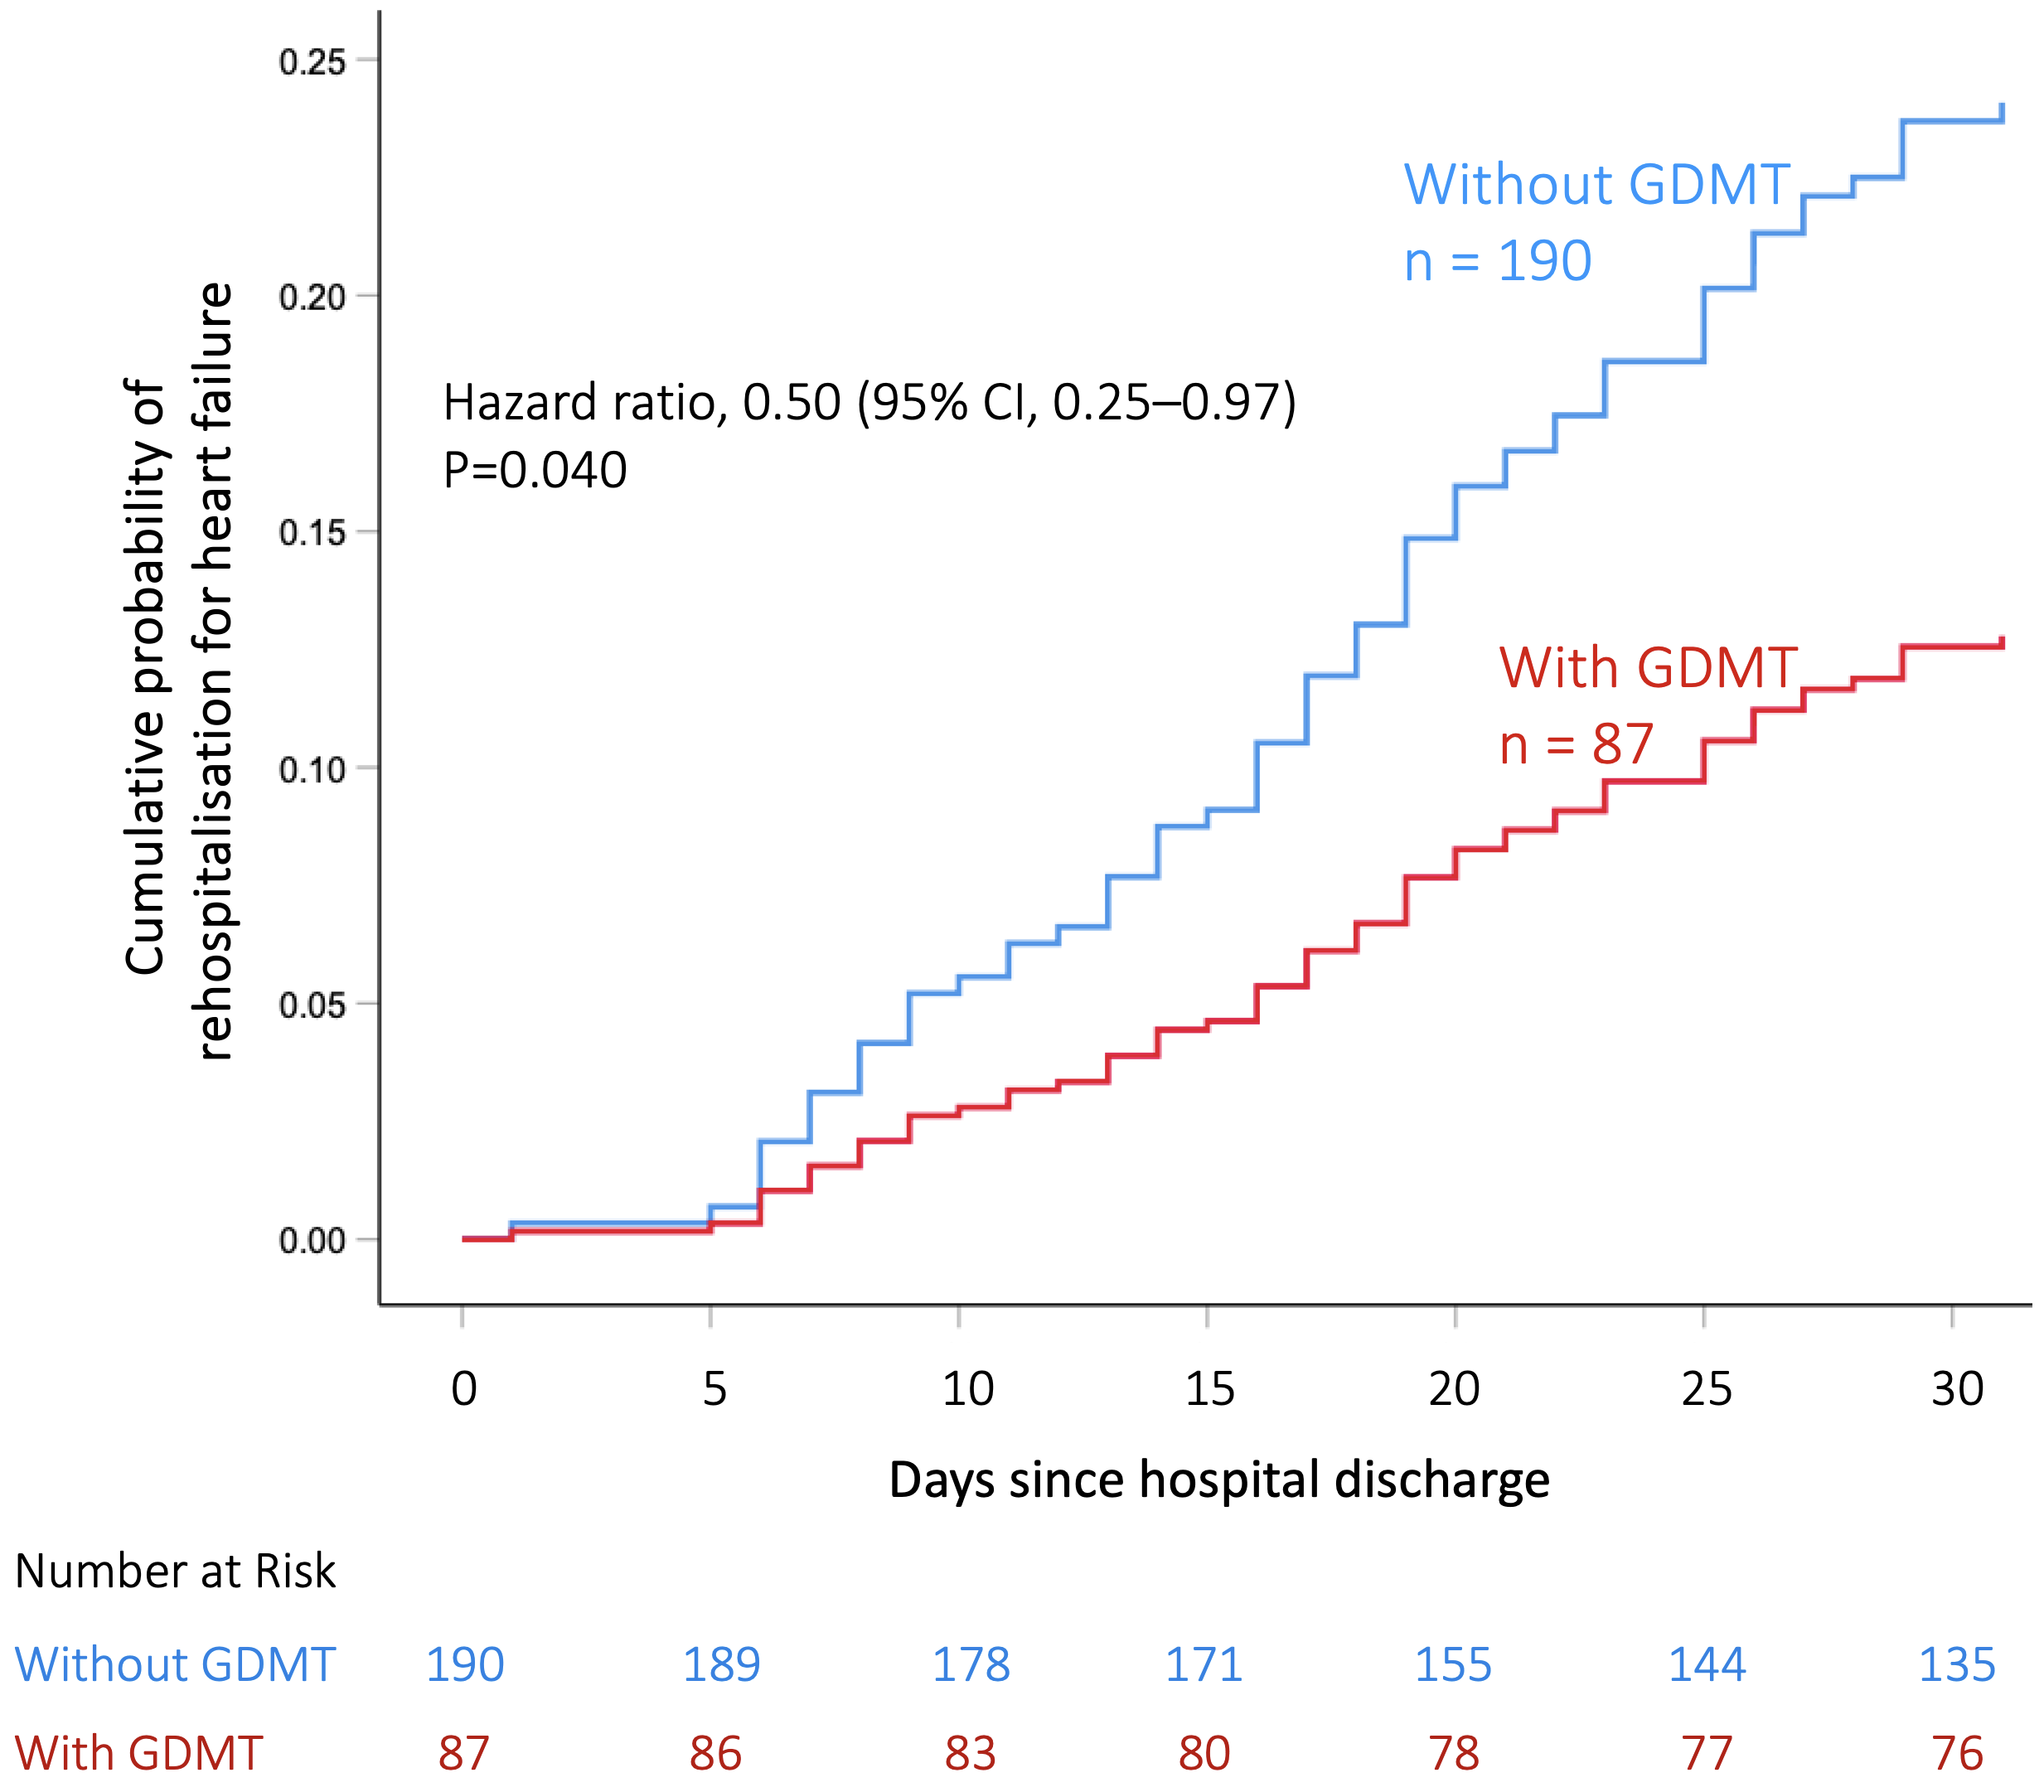
Supplementary Figure S2. Kaplan–Meier curves for the time to first rehospitalisation for heart failure among patients with and without guideline-directed medical therapy (GDMT).

