Supplementary Figure S1. Receiver Operating Characteristic Curves for RC in Predicting IDH
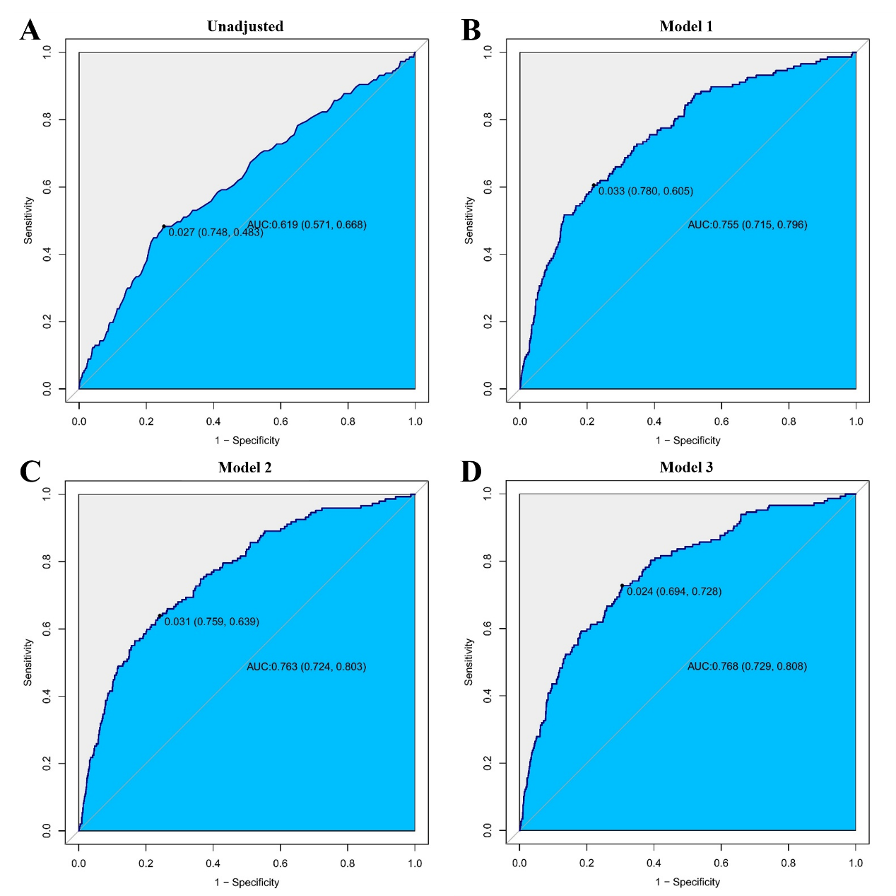
Figure Legend
This figure depicts the receiver operating characteristic (ROC) curves evaluating the discriminative performance of remnant cholesterol (RC) for isolated diastolic hypertension (IDH). The solid line represents the ROC curve, and the diagonal line indicates the reference line for no discrimination. The area under the curve (AUC) with corresponding 95% confidence intervals is shown in each panel. Panels represent different adjustment models: (A) unadjusted, (B) Model 1, (C) Model 2, and (D) Model 3.
Supplementary Results
Receiver operating characteristic (ROC) curve analyses were conducted to assess the discriminative performance of remnant cholesterol for isolated diastolic hypertension under different adjustment models. The unadjusted model yielded an AUC of 0.619 (95% CI: 0.571–0.668). After adjustment for sex, age, and body mass index, the AUC increased to 0.755 (95% CI: 0.715–0.796). Further adjustment for metabolic comorbidities resulted in an AUC of 0.763 (95% CI: 0.724–0.803), while the fully adjusted model yielded an AUC of 0.768 (95% CI: 0.729–0.808). The corresponding ROC curves are shown in Supplementary Figure S1.

