Table S1. Systolic blood pressure criteria for study treatment dose modification.
Blood Pressure Assessment | Dose Modification
SBP ≥100 mm Hg AND not on 10 mg target dose | Increase dose
SBP ≥100 mm Hg AND on 10 mg target dose | Maintain dose
SBP ≥90 and <100 mm Hg | Maintain dose
SBP <90 mm Hg, asymptomatic | • If currently on 5 or 10 mg, decrease dose  • If currently on 2.5 mg, interrupt dose
SBP <90 mm Hg, symptomatic | Interrupt dose

Table S2. The number of cardiac death and hospitalization for heart failure in both groups.
 | Vericiguat | GDMT | HR  (95%CI) |  | P value
Before PSM | 75 | 74
Composite outcome | 5 (6.67%) | 13 (17.57%) | 0.31  [0.10, 0.96] |  | 0.041
cardiac death | 1 (1.33%) | 4 (5.41%)
hospitalization for heart failure | 4 (5.33%) | 9 (12.16%)
After PSM | 61 | 61
Composite outcome | 4 (6.56%) | 13 (21.31%) | 0.24  [0.07, 0.77] |  | 0.016
cardiac death | 1 (1.64%) | 4 (6.56%)
hospitalization for heart failure | 3 (4.92%) | 9 (14.75%)

Table S3. Univariable and multivariable analysis before PSM.
Variables  （N=149） | Univariable Analysis |  |  | Multivariable Analysis
Variables  （N=149） | HR | 95%CI | P value | HR | 95%CI | P value
Group | 0.35 | 0.13-0.99 | 0.048 | 0.31 | 0.10-0.96 | 0.041
NT-proBNP | 1.00 | 1.00-1.00 | 0.006 | 1.00 | 1.00-1.00 | 0.008
LVEF | 0.93 | 0.87-1.01 | 0.079
Age | 1.09 | 1.04-1.15 | <0.001 | 1.10 | 1.04-1.15 | 0.001
Gender | 0.71 | 0.24-2.17 | 0.553
CABG | 2.23 | 0.73-6.78 | 0.157
SBP | 0.99 | 0.96-1.02 | 0.465
MRAs | 2.69 | 0.62-11.69 | 0.188
ARNI | 0.41 | 0.16-1.03 | 0.058
SGLT2i | 0.43 | 0.17-1.07 | 0.071
Beta-blocker | 0.47 | 0.17-1.31 | 0.150
Aspirin/Indobufen | 0.40 | 0.13-1.21 | 0.106
Smoking | 0.53 | 0.20-1.42 | 0.207
NYHA
III | 3.29 | 1.20-9.06 | 0.021 | 3.08 | 1.11-8.57 | 0.031
IV | 6.61 | 1.34-32.86 | 0.021 | 11.44 | 1.98-66.24 | 0.007
AF | 1.28 | 0.37-4.42 | 0.696
CAD | 1.81 | 0.71-4.59 | 0.211
NSTEMI/STEMI | 1.13 | 0.45-2.87 | 0.791
NT-proBNP, N-terminal B-type natriuretic peptide; LVEF, left ventricular ejection fraction; SBP, systolic blood pressure; MRAs, mineralocorticoid receptor antagonists; ARNI, angiotensin receptor-neprilysin inhibitor; SGLT2i, sodium-glucose co-transporter 2 inhibitor; NYHA, New York Heart Association; AF, atrial fibrillation; CAD, coronary disease; STEMI, ST-elevation myocardial infarction; NSTEMI, non-ST-elevation myocardial infarction.

Table S4. Changes in the absolute values of secondary outcomes from baseline to 12-month follow-up in the vericiguat group compared to the GDMT group before PSM.
Parameters | Vericiguat (N=75) |  |  | GDMT (N=74)
Parameters | Baseline | 12 month | P value | Baseline | 12 month | P value
LVEF | 37.31  (5.51) | 46.96  （8.35） | <0.001 | 38.92  (5.54) | 44.33  （8.42） | 0.002
NT-proBNP | 2284.00  [1349.00, 4724.55] | 315.20  [194.00, 951.00] | <0.001 | 2717.80  [937.35, 6491.95] | 1010.05  [401.20, 2855.48] | <0.001
KCCQ-QoL | 66.67  [66.67, 73.33] | 80.00  [73.33, 86.67] | <0.001 | 66.67  [60.00, 73.33] | 73.33  [73.33, 80.00] | <0.001

Table S5. The proportion of patients achieving a MCID between the two groups.
 |  | Vericiguat | GDMT | P Value |  | χ² | OR  (95%CI) |  |  | ARR
Before PSM |  | 71 | 67
MCID ≥ 5 |  | 55  (77.5%) | 48  (71.7%) | 0.432 |  | 0.62 | 1.36  [0.59, 3.17] |  |  | 5.8%
MCID < 5 |  | 16  (22.5%) | 19  (28.3%)
After PSM | 58 |  | 56
MCID ≥ 5 |  | 43  (74.1%) | 40  (71.4%) | 0.745 |  | 0.11 | 1.15  [0.46, 2.85] |  |  | 2.7%
MCID < 5 |  | 15  (25.9%) | 16  (28.6%)
MCID, minimally important clinical change
OR, odds ratio
ARR, absolute risk reduction
Table S6. Exploratory analysis on ACS-related endpoints during a 12-month follow-up between the two groups.
 | Vericiguat (75) | GDMT (74) | P value
new‑onset AMI | 2 (2.7%) | 1(1.4%) | >0.999
new revascularization | 4 (5.3%) | 5 (6.8%) | 0.745
hospitalizations for angina | 7 (9.3%) | 5 (6.8%) | 0.563
AMI: acute myocardial infarction

Table S7. SMD of covariates before and after PSM.
Variables | SMD
Variables | Before PSM | After PSM
NT-proBNP | -0.120 | -0.180
LVEF | -0.292 | -0.023
NYHA
II | -0.127 | 0.000
III | 0.047 | 0.000
IV | 0.177 | 0.000
eGFR | 0.144 | 0.034
Age | -0.168 | -0.006
Gender
Female | -0.158 | 0.093
Male | 0.158 | -0.093
eGFR: estimated glomerular filtration rate

Table S8. Univariable and multivariable analysis after PSM.
Variables  （N=149） | Univariable Analysis |  |  | Multivariable Analysis
Variables  （N=149） | HR | 95%CI | P value | HR | 95%CI | P value
Group | 0.28 | 0.09-0.86 | 0.026 | 0.24 | 0.07-0.77 | 0.016
NT-proBNP | 1.00 | 1.00-1.00 | 0.005 | 1.00 | 1.00-1.00 | 0.105
LVEF | 0.92 | 0.86-1.00 | 0.050 | 0.93 | 0.84-1.02 | 0.121
Age | 1.10 | 1.04-1.17 | <0.001 | 1.13 | 1.06-1.21 | <0.001
Gender | 0.60 | 0.20-1.85 | 0.378
CABG | 2.04 | 0.66-6.25 | 0.213
SBP | 0.99 | 0.96-1.02 | 0.479
MRAs | 2.48 | 0.57-10.85 | 0.227
ARNI | 0.50 | 0.19-1.31 | 0.159
SGLT2i | 0.43 | 0.17-1.11 | 0.081
Beta-blocker | 0.50 | 0.17-1.41 | 0.189
Aspirin/Indobufen | 0.44 | 0.13-1.52 | 0.195
Smoking | 0.41 | 0.14-1.16 | 0.093
NYHA
III | 3.28 | 1.19-9.04 | 0.021 | 3.32 | 1.13-9.71 | 0.028
IV | 6.38 | 0.77-53.02 | 0.086 | 10.67 | 1.04-109.23 | 0.046
AF | 1.53 | 0.44-5.34 | 0.502
CAD | 1.56 | 0.60-4.03 | 0.363
NSTEMI/STEMI | 1.01 | 0.39-2.61 | 0.987
NT-proBNP, N-terminal B-type natriuretic peptide; LVEF, left ventricular ejection fraction; SBP, systolic blood pressure; MRAs, mineralocorticoid receptor antagonists; ARNI, angiotensin receptor-neprilysin inhibitor; SGLT2i, sodium-glucose co-transporter 2 inhibitor; NYHA, New York Heart Association; AF, atrial fibrillation; CAD, coronary disease; STEMI, ST-elevation myocardial infarction; NSTEMI, non-ST-elevation myocardial infarction.

Table S9. Covariance analysis for secondary outcomes（LVEF、NT-proBNP）from baseline to 12-month follow-up after PSM.
Parameters | Time, | GDMT  (N=61) | Vericiguat  (N=61) | Difference vs. GDMT | P value
LVEF  (%) | 1 | 36.69  (31.32, 42.06) | 39.51  (33.72, 44.04) | 2.19  (-0.83, 5.21) | 0.154
 | 3 | 38.90  (33.52, 44.27) | 40.60  (35.47, 45.72) | 1.70  (-1.32, 4.71) | 0.268
 | 6 | 39.64  (34.25, 45.03) | 42.91  (37.79, 48.04) | 3.28  (0.24, 6.32) | 0.035
 | 12 | 39.90  (34.50, 45.30) | 44.30  (39.15, 49.45) | 4.40  (1.29, 7.50) | 0.003
Lg (NT-proBNP)  (pg/ml) | 1 | 3.06  (2.79, 3.33) | 2.85  (2.59, 3.11) | -0.207  (-0.37, -0.05) | 0.012
 | 3 | 3.03  (2.76, 3.31 | 2.83  (2.58, 3.09) | -0.20  (-0.36, -0.04) | 0.014
 | 6 | 2.97  (2.69, 3.24) | 2.65  (2.39, 2.91) | -0.32  (-0.48, -0.15) | 0.002
 | 12 | 2.86  (2.59, 3.13) | 2.56  (2.31, 2.82) | -0.30  (-0.46, -0.13) | 0.007
Adjusting for age, LVEF, NT-proBNP and NYHA class
†Based on a linear mixed-effects model; LS indicates least squares.
‡Difference in least square means.

Table S10. Changes in the absolute values of secondary outcomes from baseline to 12-month follow-up in the vericiguat group compared to the GDMT group after PSM.
Parameters | Vericiguat (N=61) |  |  | GDMT (N=61)
Parameters | Baseline | 12 months | P value | Baseline | 12 months | P value
LVEF | 38.22  (5.16) | 47.13  （8.47） | <0.001 | 38.35  (5.80) | 43.73  （8.43） | <0.001
NT-proBNP | 2284.00  [1365.60, 4856.10] | 324.12  [154.92, 975.75] | <0.001 | 2447.00  [1038.00, 6573.80] | 1023.40  [443.70, 3030.50] | 0.006
KCCQ-QoL | 66.67  [60.00, 73.33] | 80.00  [73.33, 86.67] | <0.001 | 66.7  [66.67, 73.33] | 73.33  [73.33，80.00] | <0.001

Table S11. Safety analysis.
Parameters | Time, month | GDMT | Vericiguat | Absolute change | P value
Parameters | Time, month | Difference¶ | Difference¶ | 95%CI
Hb  (g/L) | 1 | -2.04  (16.73) | -3.28  (23.16) | -1.24  (-5.00, 7.00) | 0.714
Hb  (g/L) | 3 | -3.75  (24.38) | -2.03  (25.24) | 1.72  (-9.00, 8.00) | 0.678
Hb  (g/L) | 6 | 0.60  (23.80) | -0.63  (22.48) | -1.23  (-6.00, 8.00) | 0.752
Hb  (g/L) | 12 | 3.94  (22.80) | 0.57  (22.63) | -3.37  (-4.11, 10.86) | 0.374
SBP  (mmHg) | 1 | -4.75  (21.54) | -7.39  (20.59) | -2.64  (-4.30, 9.58) | 0.454
SBP  (mmHg) | 3 | -3.92  (21.11) | -9.89  (19.84) | -5.97  (-0.78, 12.72) | 0.082
SBP  (mmHg) | 6 | -2.68  (19.22) | -8.75  (19.66) | -6.07  (-0.33, 12.47) | 0.063
SBP  (mmHg) | 12 | -3.38  (21.08) | -9.51  (19.82) | -6.13  (-0.60, 12.88) | 0.074
¶ Data are the arithmetic mean differences between each follow-up time point and the baseline level.

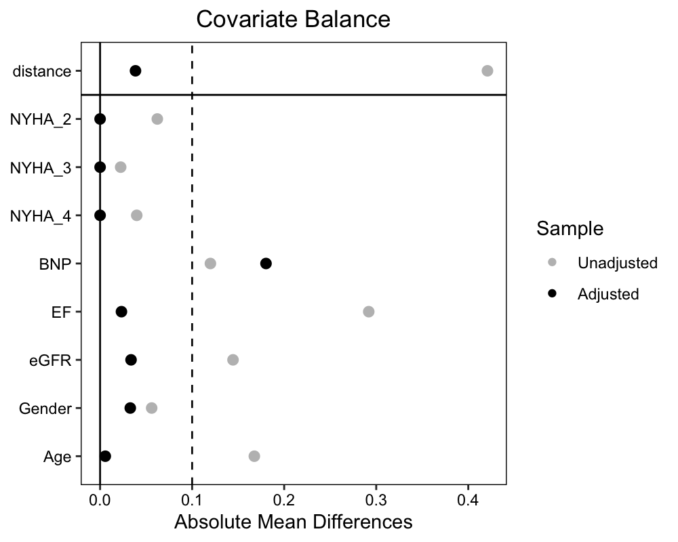

Figure S1. Love Plot. Love plot displays covariate balance before and after PSM.

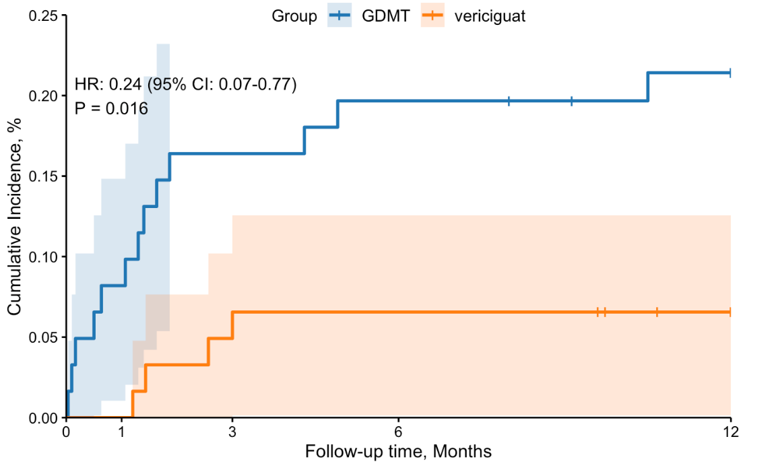
Figure S2. Kaplan-Meier curve for the primary endpoint after PSM. HR is calculated by multivariable Cox model by adjusting for baseline age, NYHA class, NT-proBNP, and LVEF.

Supplementary Methods

- Definition of GDMT and Usage Descriptions
GDMT was defined based on the prescription of guideline-recommended medication classes, including beta-blockers (BB), angiotensin-converting enzyme inhibitors/angiotensin receptor blockers/angiotensin receptor-neprilysin inhibitors (ACEI/ARB/ARNI), mineralocorticoid receptor antagonists (MRA), and sodium-glucose cotransporter 2 inhibitors (SGLT2i), in accordance with contemporary heart failure guidelines. Specific administration details were as follows:
- SGLT2 inhibitor (Dapagliflozin): Dapagliflozin (Forxiga®, 10 mg tablet) was administered orally once daily at a dose of 10 mg.
- ARNI (Sacubitril/Valsartan): For patients previously on an ACEI, sacubitril/valsartan was initiated after a 36-hour washout period. For those previously on an ARB, it was initiated after a 24-hour washout period. Treatment was started with sacubitril/valsartan (100 mg strength tablet) at a dose of 50 mg twice daily. The dose was then adjusted according to the patient's tolerance: if no significant hypotension, angioedema, hyperkalemia, or impairment of liver/renal function was observed during a 2-week period, the dose was increased by 50 mg twice daily. Subsequent titrations occurred weekly, with a target maintenance dose of 200 mg twice daily or the maximum tolerated dose.
- Beta-blocker (Metoprolol Succinate): Metoprolol succinate extended-release tablets (AstraZeneca, 23.75–190.00 mg) were administered orally once daily, with the dose titrated to achieve a resting heart rate between 55 and 70 beats per minute.
- MRA (Spironolactone): Spironolactone (20 mg tablet) was administered orally at a dose ranging from 10 to 40 mg daily, given in one or two divided doses, with adjustments based on the patient's blood pressure and electrolyte levels.

