Supplementary Table 1. Definitions of diseases in this study based on ICD-10.
Variables | ICD-10 code
Alcohol liver | K70
Cardiomyopathy | I42, I43
Chronic hepatitis | K73
Chronic kidney disease | N18
Diabetes | E10-E14
Heart failure | I50
Hepatic failure | K72
Hypertension | I10
Ischemic heart disease | I20-I25
Liver fibrosis | K74
Pericardial disease | I30, I31
Rheumatic heart disease | I01-02, I05-I09
Rheumatoid arthritis | M05, M06
Stroke | I60-I64
Atrial fibrillation | I48
Systemic lupus erythematosus | M32
Valvular heart disease | I34-I38

Supplementary Table 2. Measurement methods of blood biochemistry in this study
Variables | Methods
ALT | Measured by the enzymatic rate method on a Beckman Coulter AU5800
AST | Measured by the enzymatic rate method on a Beckman Coulter AU5800
Cholesterol | Measured by CHO-POD analysis on a Beckman Coulter AU5800
GGT | Measured by the enzymatic rate method on a Beckman Coulter AU5800
HDL-C | Measured by enzymatic protective selection analysis on a Beckman Coulter AU5800
hs-CRP | Measured by immunoturbidimetric - high sensitivity analysis on a Beckman Coulter AU5800
LDL-C | Measured by enzymatic protective selection analysis on a Beckman Coulter AU5800
Triglyceride | Measured by enzymatic protective selection analysis on a Beckman Coulter AU5800
ALT, alanine aminotransferase; AST, aspartate aminotransferase; GGT, gamma-glutamyl transferase; HDL-C, high-density lipoprotein cholesterol; LDL-C, low-density lipoprotein cholesterol; hs-CRP, high-sensitivity C-reactive protein.

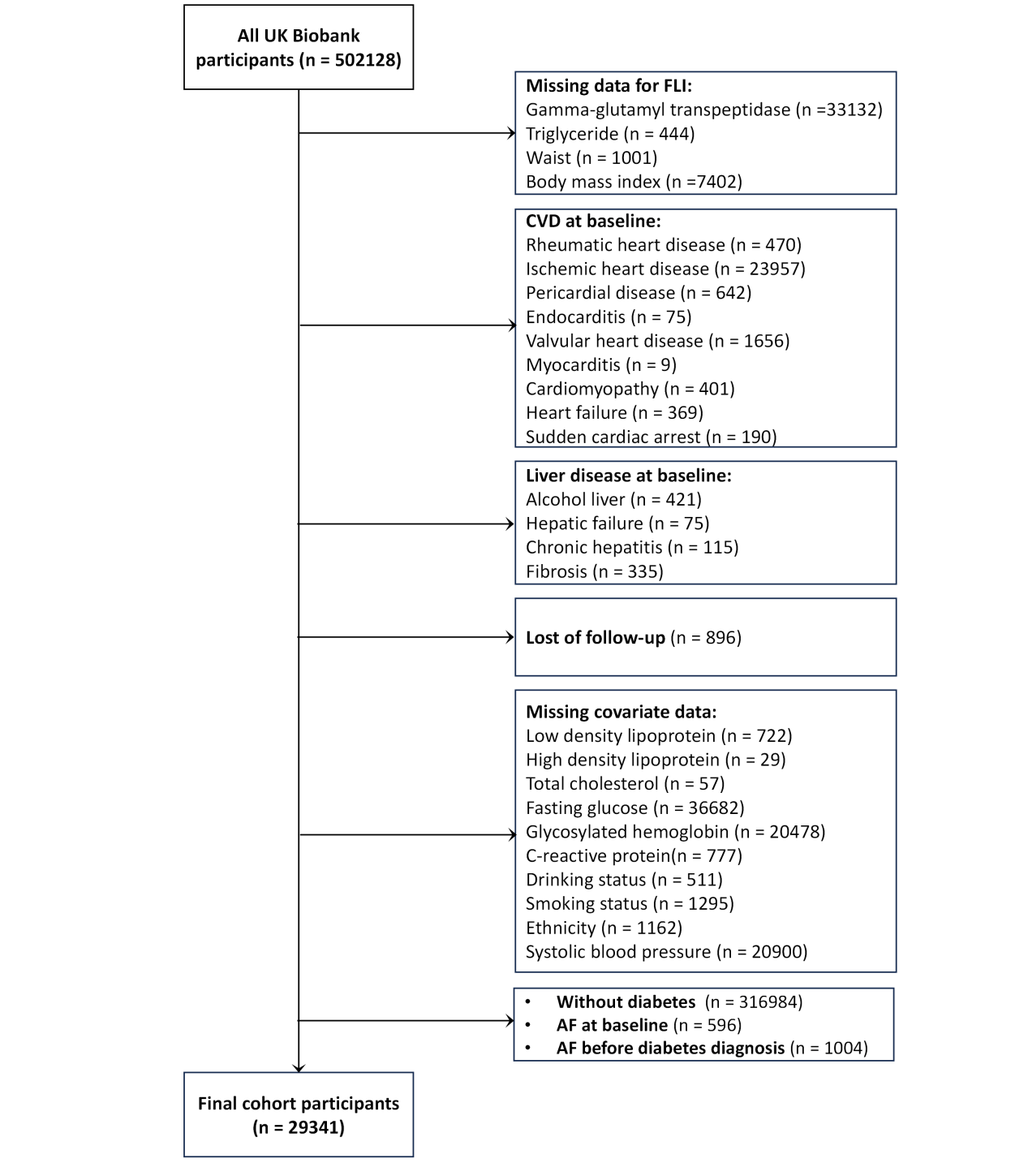

Supplementary Figure 1. Flow diagram. AF, atrial fibrillation; FLI, fatty liver index; CVD, cardiovascular disease
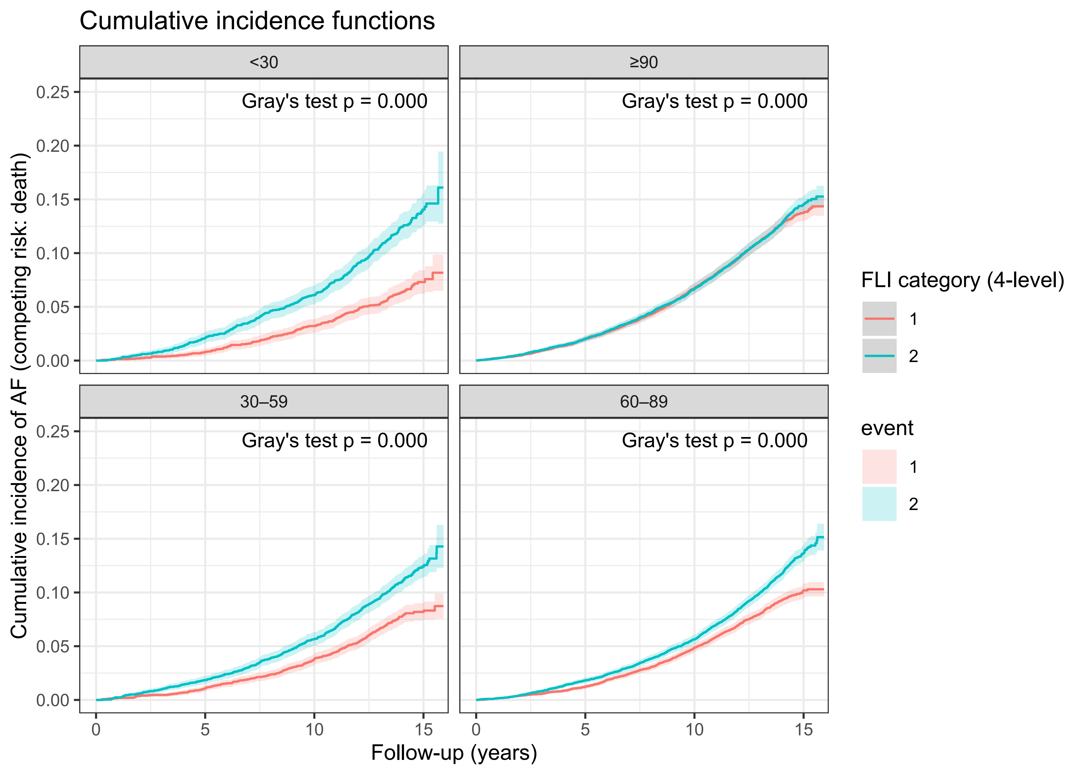

Supplementary Figure 2. Cumulative Incidence of Atrial Fibrillation by FLI Category with Death as a Competing Risk. AF, atrial fibrillation; FLI, fatty liver index
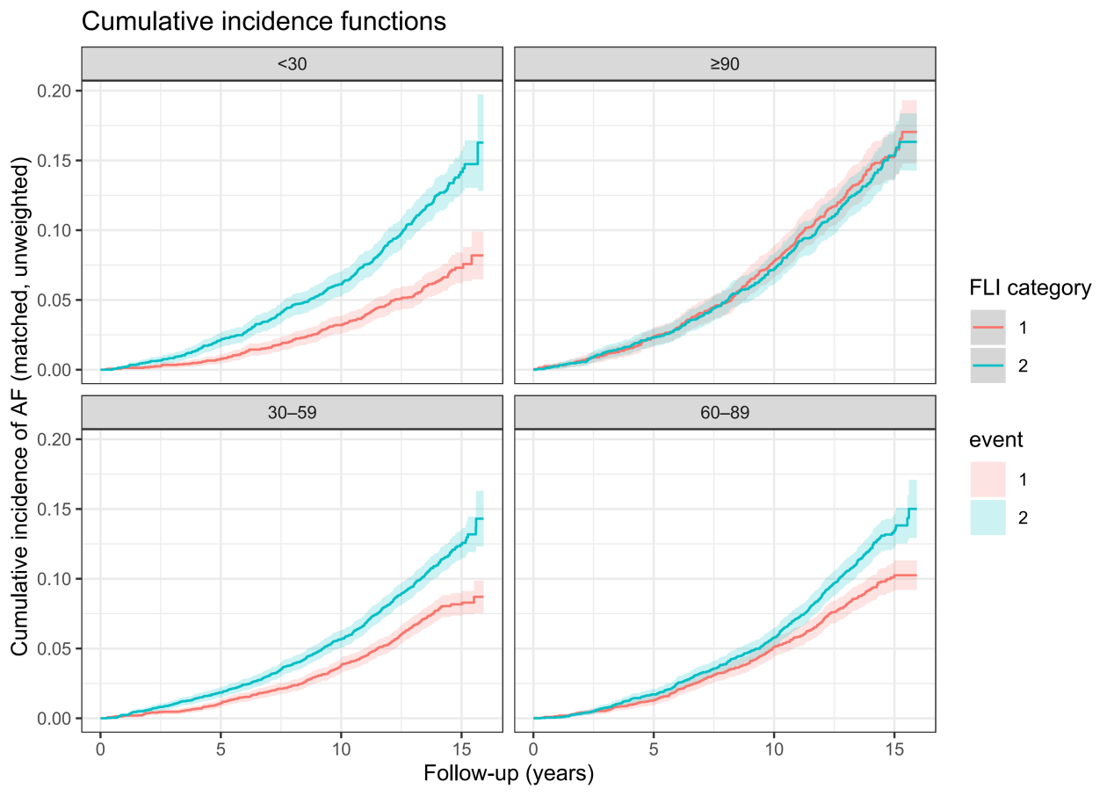
Supplementary Figure 3. Cumulative Incidence of Atrial Fibrillation by FLI Category After Propensity Score Matching. AF, atrial fibrillation; FLI, fatty liver index
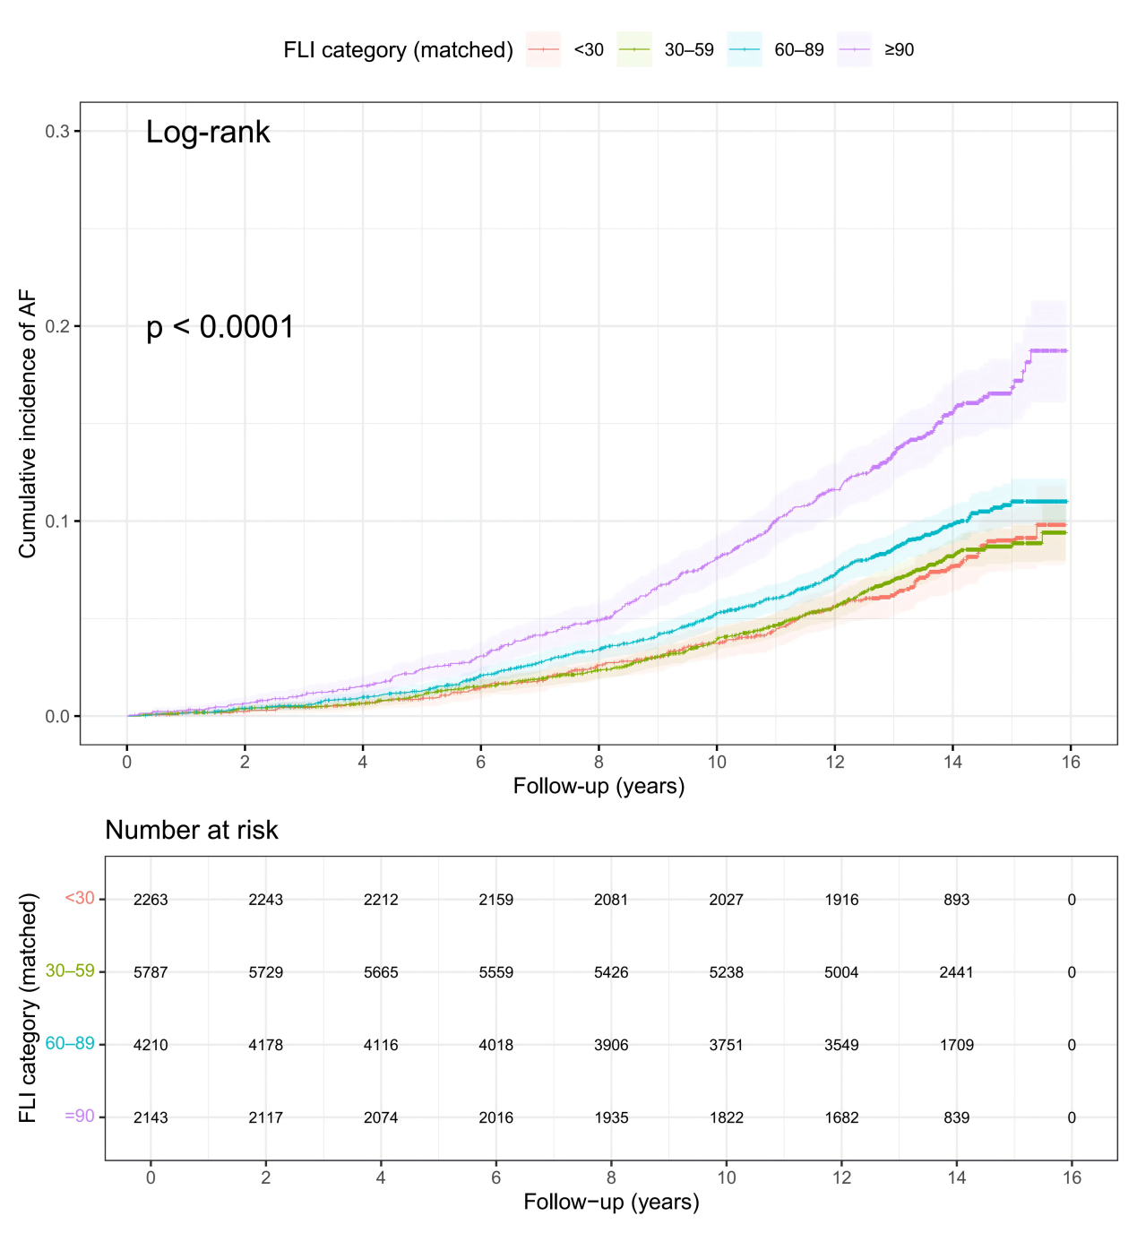
Supplementary Figure 4. Cumulative Incidence of Atrial Fibrillation by FLI Category in the Propensity Score Matching. AF, atrial fibrillation; FLI, fatty liver inde

