Supplementary Appendix 1. PRISMA 2020 Flow Diagram
Identification of studies via databases and registers

Records removed before screening:
Duplicate records removed (n = 127)
Records marked as ineligible by automation tools (n = 0)
Records removed for other reasons (n = 0)
Records identified from*:
Databases (n = 387)
Registers (n = 20)
Hand-searching prominent Scopus-indexed cardiology journals (n = 12)

Identification

Records screened
(n = 292)
Records excluded**
(n = 287)

Reports sought for retrieval
(n = 5)
Reports not retrieved
(n = 0)

Screening

Reports assessed for eligibility
(n = 5)
Reports excluded (n = 1):
• Wrong population; prespecified subgroup from same study included (n = 1)

Studies included in review
(n = 4)

Included

*Consider, if feasible to do so, reporting the number of records identified from each database or register searched (rather than the total number across all databases/registers).
**If automation tools were used, indicate how many records were excluded by a human and how many were excluded by automation tools.
Source: Page MJ, et al. BMJ 2021;372:n71. doi: 10.1136/bmj.n71.
This work is licensed under CC BY 4.0. To view a copy of this license, visit https://creativecommons.org/licenses/by/4.0/

Appendix 2. Full Search Strategy
Date of Search: November 2025
Objective of Search Strategy:
To identify all randomized controlled trials evaluating GLP-1 receptor agonists and dual GLP-1/GIP receptor agonists in patients with HFpEF, The search was limited to two core concepts: (1) GLP-1 receptor agonists and dual GLP-1/GIP receptor agonists, and (2) HFpEF. No filters for outcomes, obesity, or study design were applied at the search stage to maximize sensitivity; these were applied during screening.
Search Strings by Source:
1.PubMed / MEDLINE:
("Glucagon-Like Peptide 1 Receptor Agonists"[Mesh] OR semaglutide[tiab] OR tirzepatide[tiab] OR GLP-1[tiab] OR "GLP-1 receptor agonist*"[tiab])
AND
("Heart Failure, Diastolic"[Mesh] OR HFpEF[tiab] OR "heart failure with preserved ejection fraction"[tiab] OR "diastolic heart failure"[tiab])
2. Cochrane CENTRAL:
("GLP-1 receptor agonist*" OR "glucagon-like peptide 1" OR semaglutide
OR tirzepatide):ti,ab,kw
AND
(HFpEF OR "heart failure with preserved ejection fraction"):ti,ab,kw
3. Journal Websites (e.g., Circulation, European Heart Journal, Nature Reviews
Cardiology, Journal of the American College of Cardiology, JAMA Cardiology):
(GLP-1 OR semaglutide OR tirzepatide OR liraglutide) AND (HFpEF OR "heart failure with preserved
ejection fraction")
4.Clinical Trials Registries (ClinicalTrials.gov / ICTRP):
(GLP-1 OR semaglutide OR tirzepatide) AND (HFpEF OR "heart failure with preserved ejection fraction")
5. Epistemonikos:
("GLP-1" OR semaglutide OR tirzepatide) AND (HFpEF OR "heart failure with preserved ejection fraction")

Appendix 3. Risk of Bias Assessment (RoB 2)
Risk of bias was assessed using the Cochrane Risk of Bias 2 (RoB 2) tool across five domains: (1) randomization process, (2) deviations from intended interventions, (3) missing outcome data, (4) measurement of the outcome, and (5) selection of the reported result.
Trial | D1  Randomization | D2  Deviations | D3  Missing data | D4  Measurement | D5  Reported result | Overall RoB
SUMMIT | Some concerns | Low risk | Low risk | Low risk | Some concerns | Some concerns
STEP-HFpEF | Some concerns | Low risk | Low risk | Low risk | Low risk | Some concerns
STEP-HFpEF DM | Some concerns | Low risk | Low risk | Low risk | Low risk | Some concerns
SELECT HFpEF subgroup | Low risk | Low risk | Low risk | Low risk | Low risk | Low risk
Note: "Some concerns" in the randomization domain for SUMMIT and STEP trials reflects limited reporting of sequence generation and allocation concealment in the primary publications, despite generally balanced baseline characteristics and double-blind design. SELECT was judged low risk in all domains.

Appendix 3B. Risk of Bias Justification (RoB 2)

SUMMIT
D1: Randomization sequence generation and allocation concealment not fully described in main NEJM article. Supplementary materials mention centralized randomization but without methodological detail → Some concerns.
D2: Double-blind, identical injections → Low risk.
D3: Low missing data; follow-up >95% → Low risk.
D4: Blinded adjudication of HF outcomes → Low risk.
D5: Primary/secondary endpoints prespecified but SAP partially summarized only → Some concerns.

STEP-HFpEF
D1: Randomization described as centralized/stratified but without details → Some concerns.
D2: Double-blind, consistent exposure → Low risk.
D3: Minimal missing data for primary outcomes → Low risk.
D4: Standardized measurement (KCCQ, 6MWD) → Low risk.
D5: Prespecified endpoints, hierarchy respected → Low risk.

STEP-HFpEF DM
D1: Same limitations as STEP-HFpEF regarding incomplete reporting → Some concerns.
D2: Double-blind, consistent intervention → Low risk.
D3: Missing data minimal → Low risk.
D4: Validated outcome measures, blinded adjudication for HF → Low risk.
D5: No selective reporting detected → Low risk.

SELECT HFpEF subgroup
D1: Large RCT with robust central randomization described fully → Low risk.
D2: Double-blind design, strict protocol adherence → Low risk.
D3: Excellent completeness of follow-up → Low risk.
D4: Independent event adjudication → Low risk.
D5: Prespecified HF endpoints in subgroup → Low risk.

Appendix 4. Extracted Outcome Data from Included Trials

This appendix summarizes the key extracted outcome data used in the quantitative synthesis. Effect estimates are presented as reported in the trials
Trial |  | Outcome | Measure | Effect estimate (95% CI) | Notes
SUMMIT |  | First HF hospitalization | HR | 0.44 (0.22–0.87) | Tirzepatide vs placebo; HFpEF with obesity
SUMMIT |  | KCCQ-CSS change | MD (points) | +6.9 (3.3–10.6) | Change from baseline at ~52 weeks
SUMMIT |  | 6MWD change | MD (m) | +18.3 (9.9–26.7) | Change from baseline at ~52 weeks
SUMMIT |  | Weight (% change) | MD (%) | −11.6 (−12.9 to −10.4) | Placebo-corrected % change
SUMMIT |  | All-cause mortality | HR | 1.25 (0.63–2.45) | Few events; wide CI
SUMMIT |  | Composite CV death or worsening HF | HR | 0.62 (0.41–0.95) | Primary composite endpoint
STEP-HFpEF |  | KCCQ-CSS change | MD (points) | +7.8 (4.8–10.9) | Semaglutide 2.4 mg vs placebo; 52 weeks
STEP-HFpEF | 6MWD change |  | MD (m) | +20.3 (8.6–32.1) | Change from baseline at 52 weeks
STEP-HFpEF | Weight (% change) |  | MD (%) | −10.7 (−11.9 to −9.4) | Placebo-corrected % change
STEP-HFpEF | HF events (hospitalization/urgent visit) |  | HR (composite) | Not used for HHF meta-analysis | Reported as composite and hierarchical win-ratio
STEP-HFpEF DM | KCCQ-CSS change |  | MD (points) | +7.3 (4.1–10.4) | Semaglutide 2.4 mg vs placebo; 52 weeks
STEP-HFpEF DM | 6MWD change |  | MD (m) | +14.3 (3.7–24.9) | Change from baseline at 52 weeks
STEP-HFpEF DM | Weight (% change) |  | MD (%) | −6.4 (−7.6 to −5.2) | Placebo-corrected % change
STEP-HFpEF DM | HF events (hospitalization/urgent visit) |  | HR (composite) | Not used for HHF meta-analysis | Reported as composite and hierarchical win-ratio
SELECT HFpEF subgroup | First HF hospitalization |  | HR | 0.59 (0.31–1.06) | Semaglutide 2.4 mg vs placebo; HFpEF subgroup
SELECT HFpEF subgroup | HF composite (CV death or HF event) |  | HR | 0.75 (0.52–1.07) | HFpEF-specific composite outcome
SELECT HFpEF subgroup | All-cause mortality |  | HR | 0.83 (0.59–1.16) | HFpEF subgroup
SELECT HFpEF subgroup | Cardiovascular death |  | HR | 0.87 (0.56–1.34) | HFpEF subgroup

Appendix 5A. GRADE Summary of Findings Table
Outcome | Effect (95% CI) | No. of Trials | Certainty (GRADE) | Comments
First HF hospitalization | HR 0.52 (0.33–0.83) | 2 | Moderate | Downgraded for imprecision; consistent direction of effect.
Composite CV death/HF events | HR 0.69 (0.53–0.91) | 2 | Moderate | Driven mainly by HF events; robust effect.
KCCQ-CSS change | MD +7.4 points | 3 | High | Consistent, precise, clinically significant.
6MWD improvement | MD +17.6 m | 3 | High | Consistent across diabetic and non-diabetic HFpEF.
Weight change (%) | MD −9.5% | 3 | High | Large, consistent effect.
All-cause mortality | HR 0.90 (0.67–1.22) | 2 | Moderate | Downgraded for imprecision; no harm.
Cardiovascular mortality | HR 0.93 (0.64–1.34) | 2 | Low–Moderate | Imprecision + low event count.

Appendix 5B. Detailed GRADE Evidence Profile

First HF hospitalization
risk: No serious concerns
inconsistency: No serious inconsistency (I²≈0%)
indirectness: Direct evidence in obese HFpEF
imprecision: Some imprecision (event counts modest)
publication: No concerns
certainty: Moderate

Composite CV death/HF
risk: Low risk of bias trials
inconsistency: Low heterogeneity
indirectness: Direct evidence
imprecision: Moderate
publication: No concerns
certainty: Moderate

KCCQ-CSS
risk: Low
inconsistency: Consistent across trials
indirectness: Direct
imprecision: None (tight CI)
publication: No concerns
certainty: High

6MWD
risk: Low
inconsistency: Minimal
indirectness: Direct
imprecision: Low
publication: No concerns
certainty: High

Weight change
risk: Low
inconsistency: Some (diabetes subgroup attenuated effect)
indirectness: Direct
imprecision: Low
publication: No concerns
certainty: High

All-cause mortality
risk: Low
inconsistency: Low
indirectness: Direct
imprecision: Serious (wide CI)
publication: No concerns
certainty: Moderate

CV mortality
risk: Low
inconsistency: Low
indirectness: Direct
imprecision: Serious
publication: No concerns
certainty: Low–Moderate

Appendix 6. Forest Plots

Figure S1. HF Hospitalization

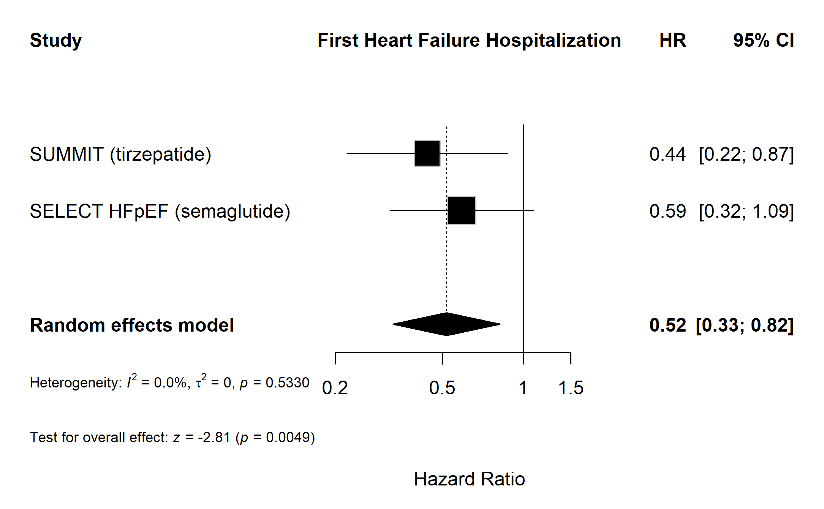
Figure.S2 .KCCQ-CSS
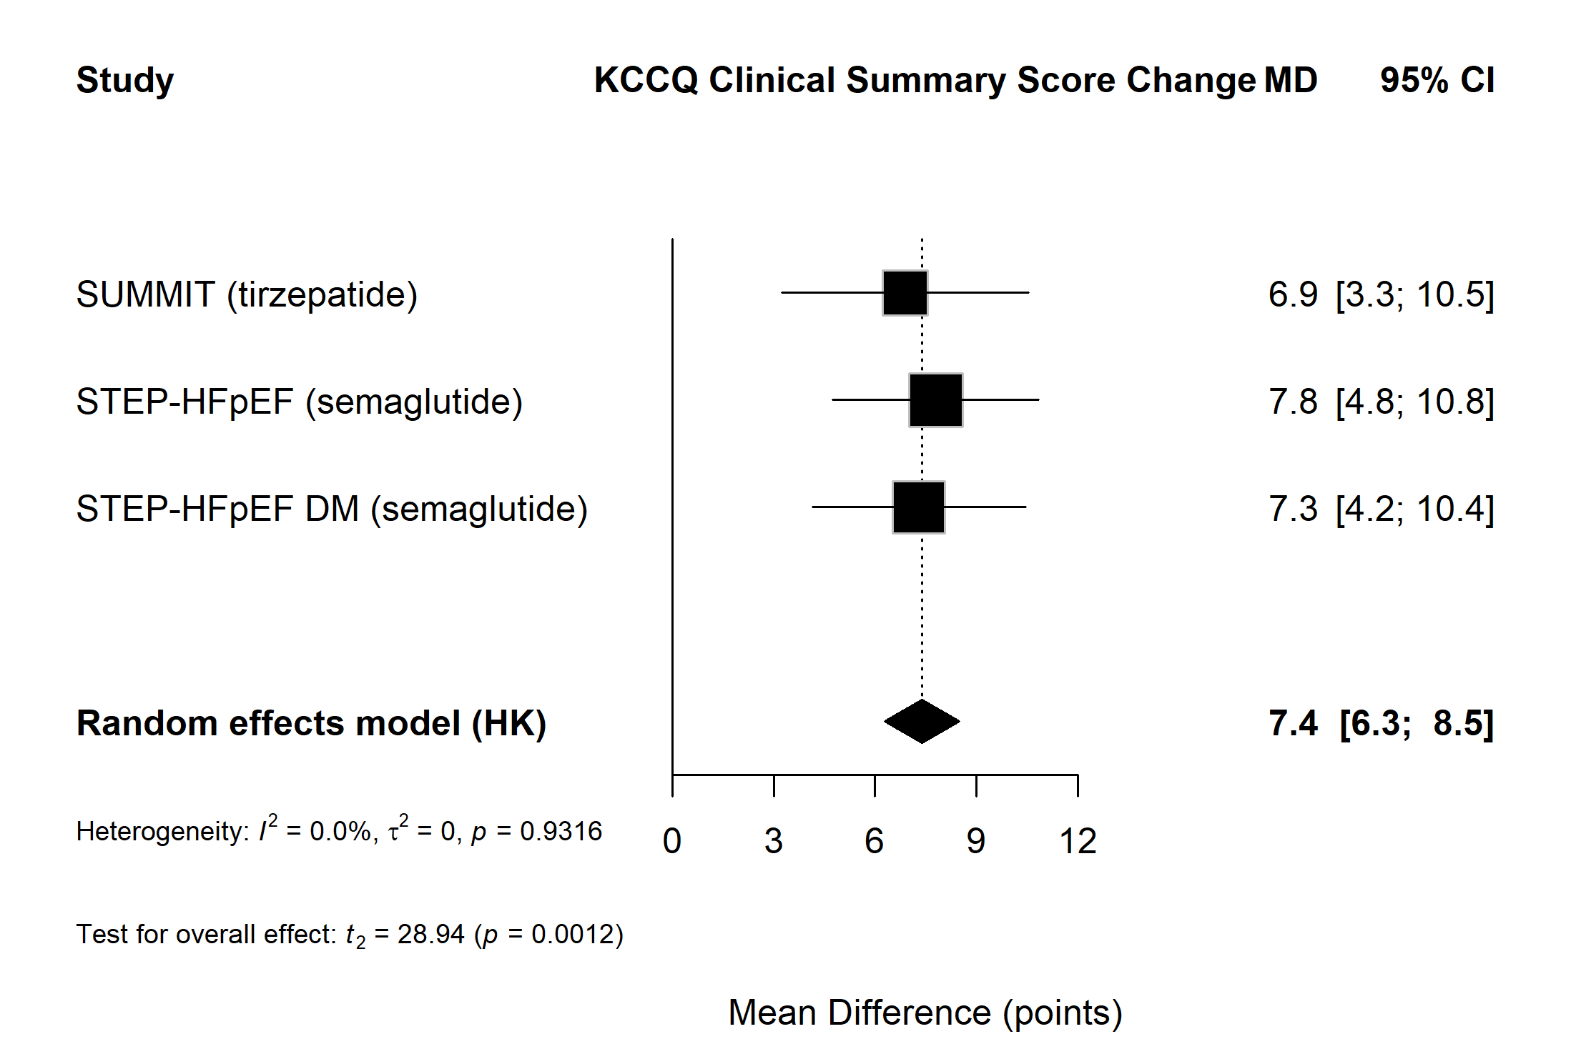

Figure S3. 6MWD
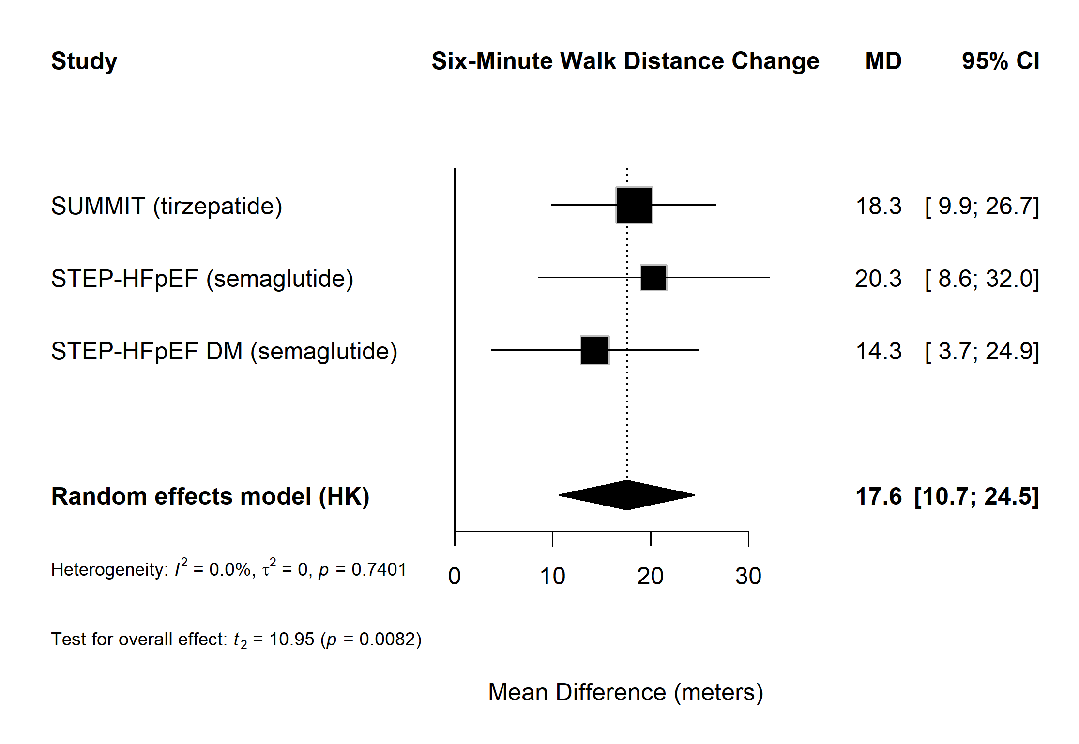
Figure S4. Weight
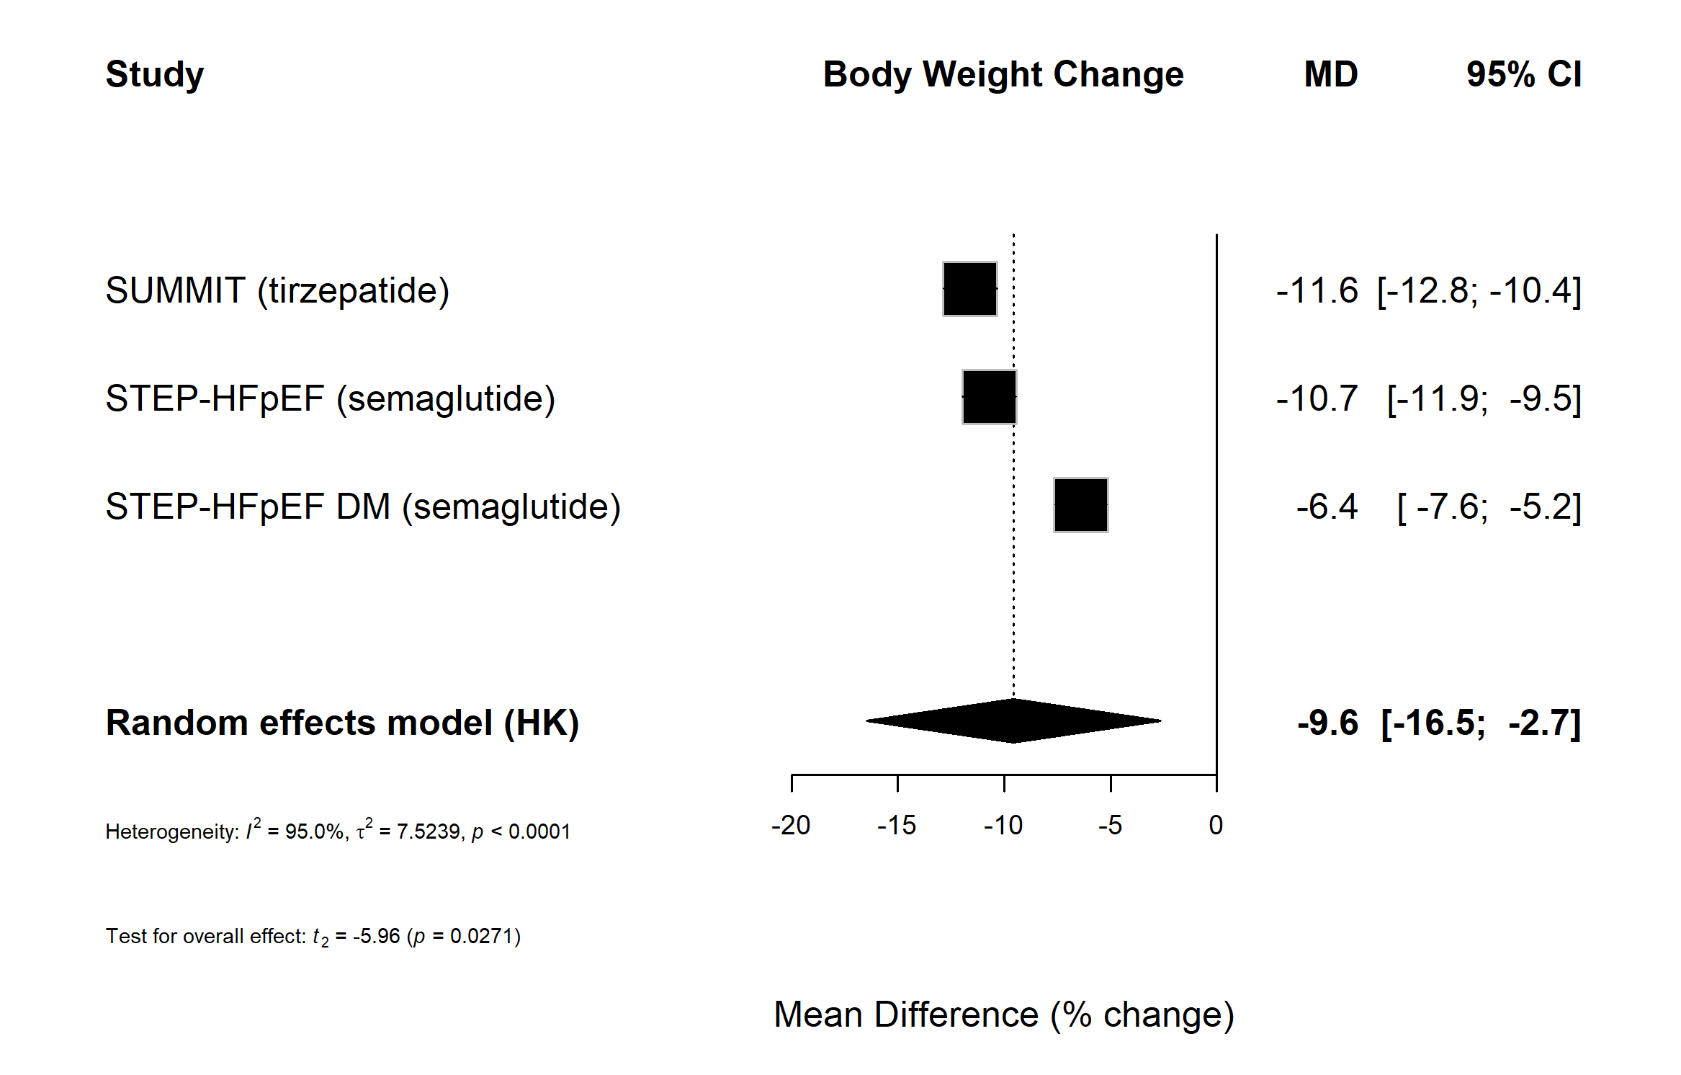

Figure S5. All-Cause Mortality
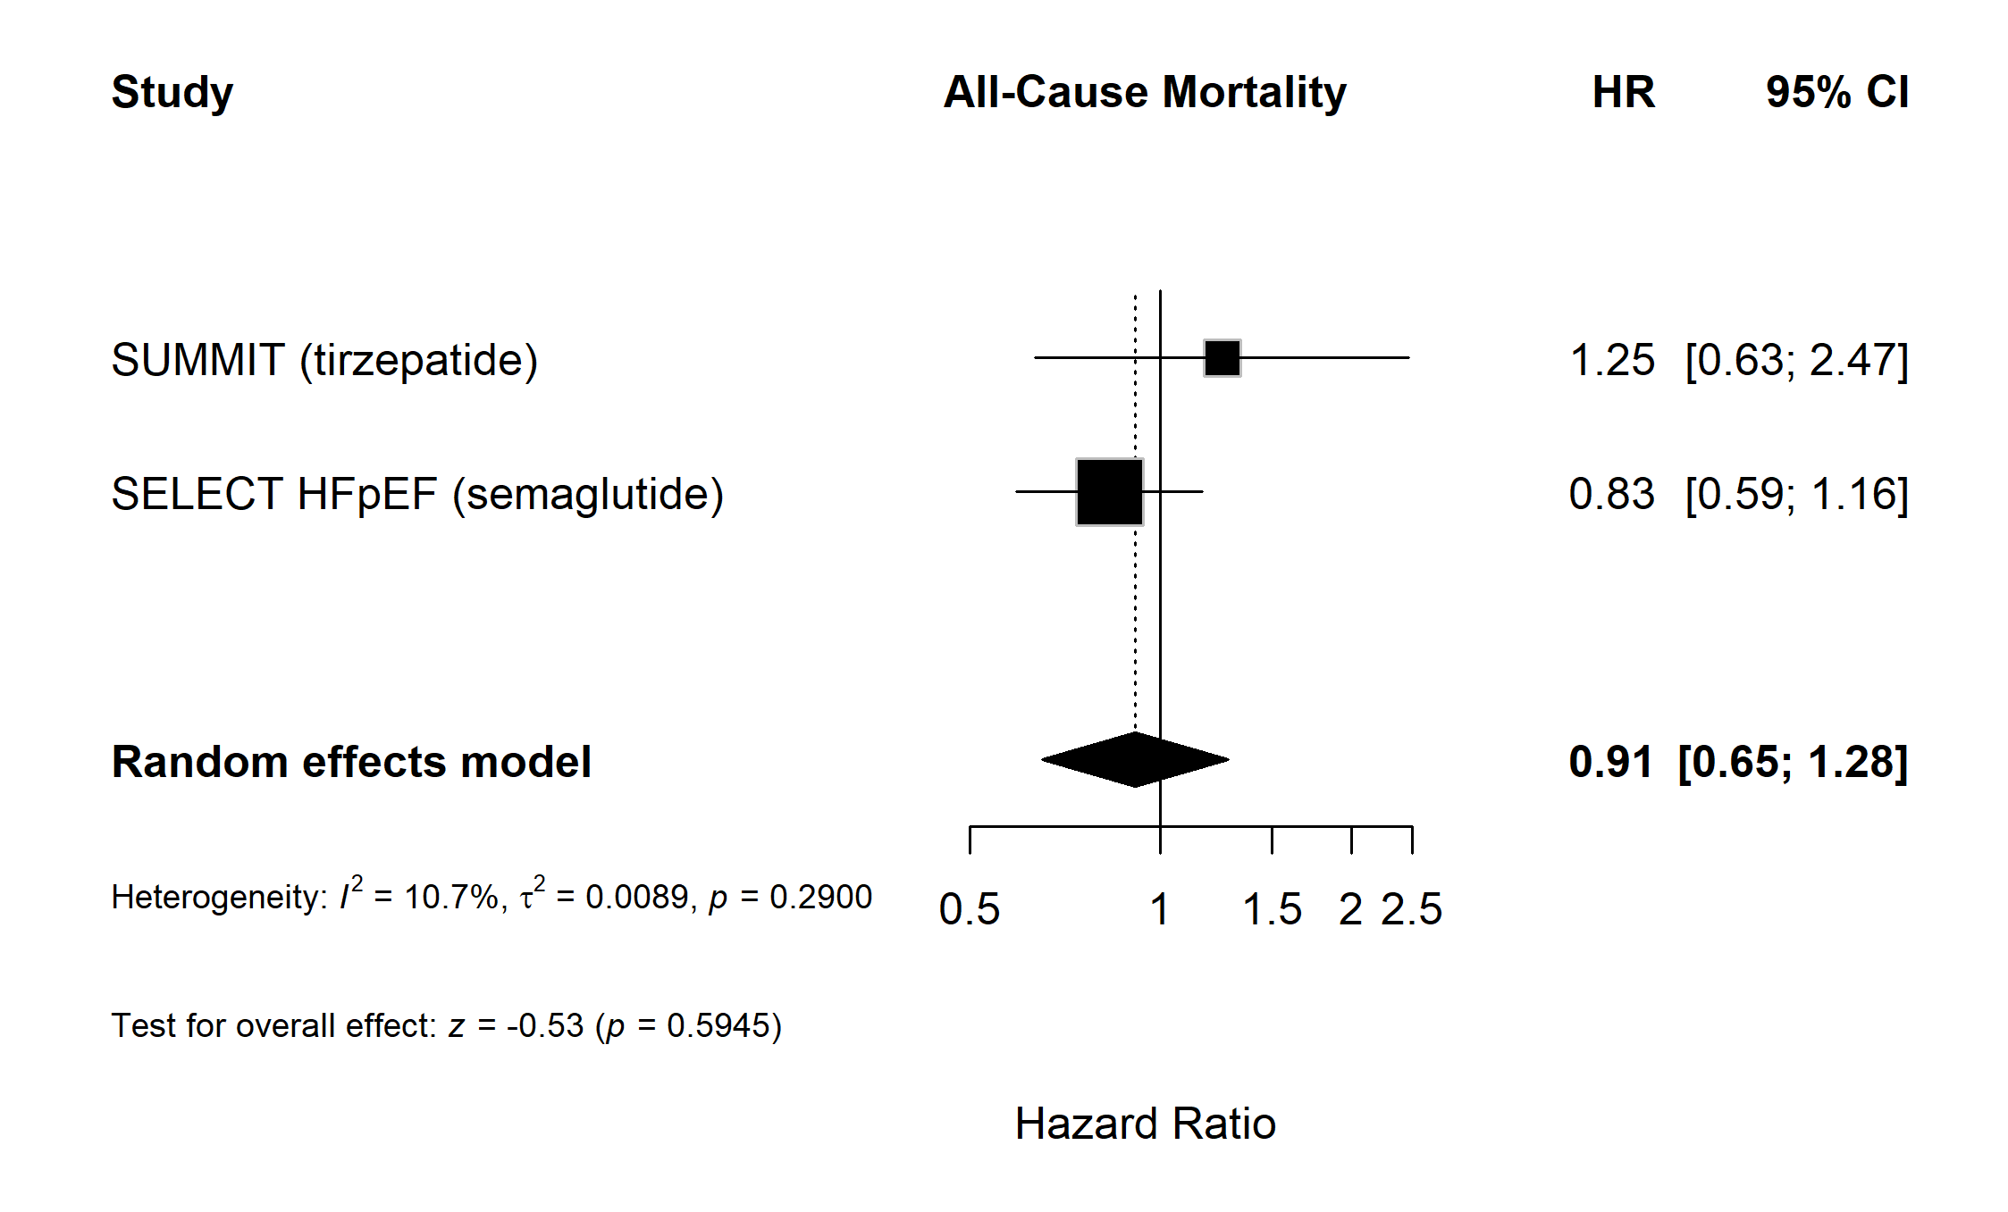

Figure S6. Composite CV Death/HF Events
