Supplementary Materials
1. Table S1 Multivariate Cox Regression After Excluding Covariates with Missing Values
Exposure | Crude Model | P | ModelⅠ | P | ModelⅡ | P | ModelⅢ | P
Exposure | HR (95%CI) | P | HR (95%CI) | P | HR (95%CI) | P | HR(95%CI) | P
sodium-to-chloride ratioª | 1.11 (1.06~1.16) | <0.001 | 1.12 (1.07~1.17) | <0.001 | 1.07 (1.03~1.12) | 0.001 | 1.06 (1.02~1.11) | 0.006
sodium-to-chloride ratio tertiles
Tertile 1 | Reference |  | Reference |  | Reference |  | Reference
Tertile 2 | 1.1 (0.62~1.95) | 0.736 | 1.24 (0.7~2.19) | 0.46 | 1.38 (0.78~2.45) | 0.266 | 1.25 (0.7~2.22) | 0.45
Tertile 3 | 1.8 (1.08~3.01) | 0.025 | 2.11 (1.26~3.53) | 0.005 | 1.98 (1.18~3.33) | 0.01 | 1.78 (1.04~3.04) | 0.037
P for trend |  | 0.017 |  | 0.003 |  | 0.009 |  | 0.032
Note: Sodium-to-chloride ratioª was entered as continuous variable per 0.01 increase; Crude Model: didn’t adjusted for covariates; ModelⅠ: adjusted for age, gender; ModelⅡ: ModelⅠ+ myocardial infarction, congestive heart failure, cerebrovascular disease, chronic pulmonary disease, diabetes, renal disease, CCI, and APSⅢ; Model Ⅲ: ModelⅡ+heart rate, MBP, RR, SPO2, WBC, platelet count, hemoglobin, potassium, urea nitrogen, and glucose.

2. Table S2. Multivariable cox regression to assess the association between the sodium-to-chloride ratio and 30-Day mortality (Including lactate)
Exposure | Crude Model | P | Model Ⅰ | P | Model Ⅱ | P | Model Ⅲ | P
Exposure | HR (95%CI) | P | HR (95%CI) | P | HR (95%CI) | P | HR(95%CI) | P
sodium-to-chloride ratioª | 1.11 (1.06~1.16) | <0.001 | 1.12 (1.07~1.17) | <0.001 | 1.07 (1.03~1.12) | 0.001 | 1.07 (1.02~1.12) | 0.003
sodium-to-chloride ratio tertiles
Tertile 1 | Reference |  | Reference |  | Reference |  | Reference
Tertile 2 | 1.15 (0.65~2.02) | 0.632 | 1.29 (0.74~2.27) | 0.373 | 1.44 (0.82~2.53) | 0.208 | 1.12 (0.63~2.01) | 0.696
Tertile 3 | 1.81 (1.08~3.03) | 0.023 | 2.13 (1.27~3.56) | 0.004 | 1.99 (1.18~3.34) | 0.009 | 1.77 (1.03~3.05) | 0.038
P for trend |  | 0.017 |  | 0.003 |  | 0.009 |  | 0.031
Note: sodium-to-chloride ratioª was entered as continuous variable per 0.01 increase; Crude Model: didn’t adjusted for covariates; Model Ⅰ: adjusted for age, gender; Model Ⅱ: Model Ⅰ+myocardial infarction, congestive heart failure, cerebrovascular disease, chronic pulmonary disease, diabetes, renal disease, CCI, and APSⅢ; Model Ⅲ: Model Ⅱ+heart rate, MBP, RR, SPO₂, WBC, platelet count, hemoglobin, potassium, urea nitrogen, and glucose, lactate.

3. Table S3. Association between sodium-to-chloride ratio tertiles and 30-day mortality across three analytical models
Exposure | Crude Model | P | Multivariable HR | P | Doubly Robust HR | P
Exposure | HR (95%CI) | P | HR (95%CI) | P | HR  (95%CI) | P
sodium-to-chloride ratio tertiles
Tertile 1 | Reference |  | Reference |  | Reference
Tertile 2 | 1.15 (0.65~2.02) | 0.632 | 1.3 (0.74~2.3) | 0.364 | 1.25 (0.97~1.62) | 0.472
Tertile 3 | 1.81 (1.08~3.03) | 0.023 | 1.78 (1.04~3.05) | 0.036 | 1.79 (1.41~2.27) | 0.044
P for trend |  | 0.017 |  | 0.003 |  | 0.039
Note: Crude: unadjusted; Multivariable: adjusted for all covariates; Doubly Robust: doubly robust estimation using inverse probability of treatment weighting (IPTW) and multivariable Cox regression.

4. Figure S1 Kaplan-Meier Survival Curves After Excluding Covariates with Missing Values
5. Table S4. Multivariable cox regression to assess the association between serum sodium and 30-Day mortality
Exposure | Crude Model | P | Model Ⅰ | P | Model Ⅱ | P | Model Ⅲ | P
Exposure | HR (95%CI) | P | HR (95%CI) | P | HR (95%CI) | P | HR(95%CI) | P
sodium | 1.16 (1.08~1.24) | <0.001 | 1.14 (1.07~1.22) | <0.001 | 1.10 (1.04~1.17) | 0.001 | 1.09 (1.02~1.15) | 0.008
sodium tertiles
Tertile 1 | Reference |  | Reference |  | Reference |  | Reference
Tertile 2 | 1.06  (0.57~2.00) | 0.845 | 1.10 (0.59~2.07) | 0.76 | 1.33 (0.71~2.50) | 0.375 | 1.41 (0.74~2.66) | 0.296
Tertile 3 | 1.82 (1.08~3.08) | 0.025 | 1.79 (1.06~3.03) | 0.029 | 1.84 (1.09~3.11) | 0.023 | 1.75 (1.03~3.00) | 0.04
P for trend |  | 0.013 |  | 0.017 |  | 0.019 |  | 0.038
Note: Crude Model: didn’t adjusted for covariates; Model Ⅰ: adjusted for age, gender; Model Ⅱ: Model Ⅰ+myocardial infarction, congestive heart failure, cerebrovascular disease, chronic pulmonary disease, diabetes, renal disease, CCI, and APSⅢ; Model Ⅲ: Model Ⅱ+heart rate, MBP, RR, SPO₂, WBC, platelet count, hemoglobin, potassium, urea nitrogen, and glucose.

6. Figure S2. Restricted cubic spline analysis for serum sodium
Restricted cubic spline (RCS) analysis demonstrated a significant association between serum sodium and 30-day mortality (P for overall = 0.001), with evidence of a non-linear relationship (P for non-linearity = 0.007).

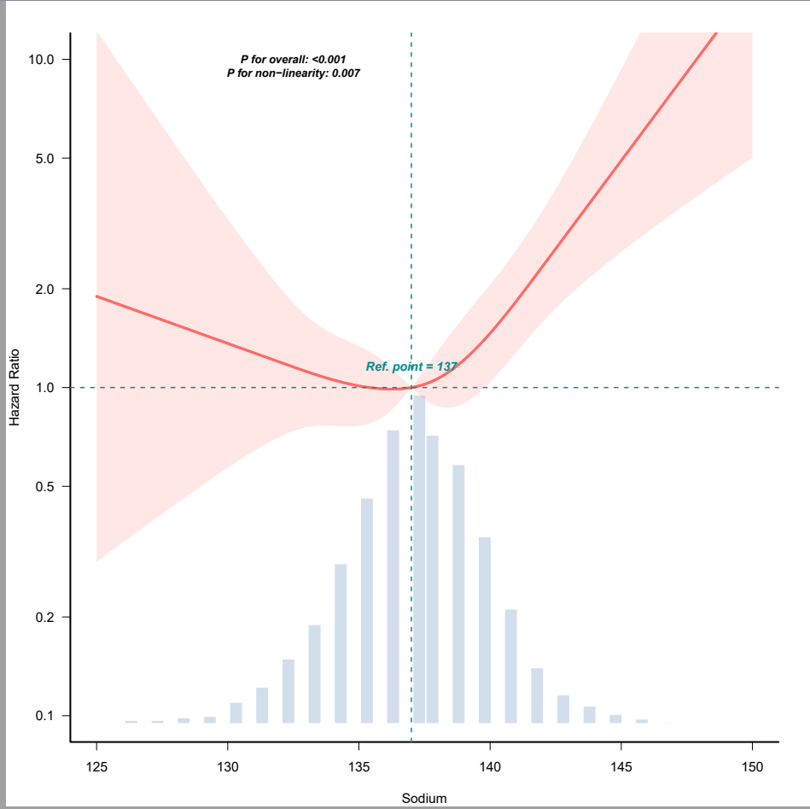

7. Table S5. Multivariable cox regression to assess the association between serum chloride and 30-Day mortality
Exposure | Crude Model | P | Model Ⅰ | P | Model Ⅱ | P | Model Ⅲ | P
Exposure | HR (95%CI) | P | HR (95%CI) | P | HR (95%CI) | P | HR(95%CI) | P
chloride | 0.98 (0.93~1.03) | 0.484 | 0.97 (0.92~1.02) | 0.212 | 0.98 (0.94~1.03) | 0.522 | 0.99 (0.94~1.04) | 0.662
chloride tertiles
Tertile 1 | Reference |  | Reference |  | Reference |  | Reference
Tertile 2 | 0.68  (0.40~1.17) | 0.166 | 0.67 (0.39~1.16) | 0.151 | 0.85 (0.49~1.48) | 0.569 | 0.85 (0.49~1.49) | 0.576
Tertile 3 | 0.84 (0.52~1.34) | 0.458 | 0.74 (0.46~1.19) | 0.216 | 0.91 (0.56~1.47) | 0.699 | 0.93 (0.57~1.53) | 0.781
P for trend |  | 0.532 |  | 0.259 |  | 0.728 |  | 0.817
Note: Crude Model: didn’t adjusted for covariates; Model Ⅰ: adjusted for age, gender; Model Ⅱ: Model Ⅰ+myocardial infarction, congestive heart failure, cerebrovascular disease, chronic pulmonary disease, diabetes, renal disease, CCI, and APSⅢ; Model Ⅲ: Model Ⅱ+heart rate, MBP, RR, SPO₂, WBC, platelet count, hemoglobin, potassium, urea nitrogen, and glucose.

8. Figure S3. Restricted cubic spline analysis for serum chloride
Restricted cubic spline (RCS) analysis showed no significant association between serum chloride and 30-day mortality (P for overall = 0.125).
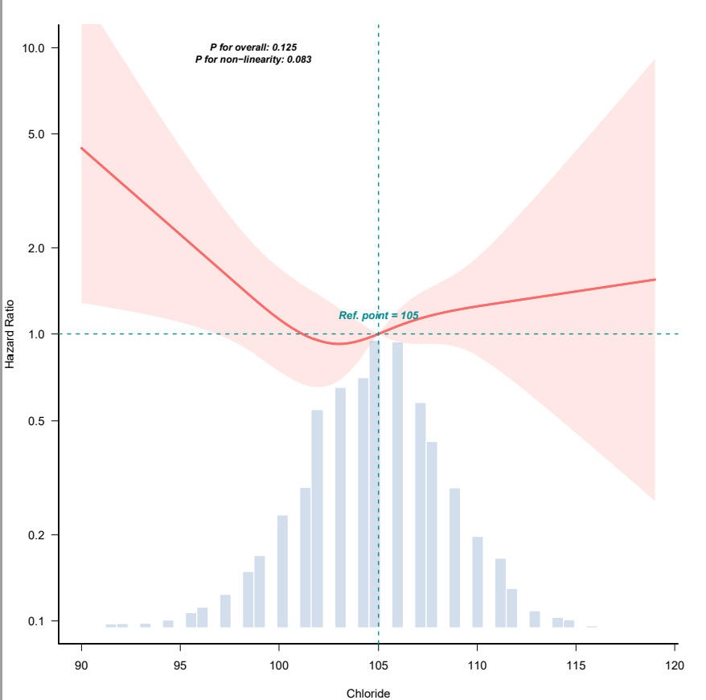

9. Supplementary Table S6. The meaning of ICD-9 and ICD-10 codes for chronic pulmonary disease and renal disease
Variables | ICD | ICD codes | Meaning of diagnostic code
chronic pulmonary disease | ICD-9 | 490 | bronchitis, not specified as acute or chronic
chronic pulmonary disease | ICD-9 | 49121,49122,49120,4919,4918,4911 | chronic bronchitis
chronic pulmonary disease | ICD-9 | 4928,4920 | emphysema
chronic pulmonary disease | ICD-9 | 49390,49391,49320,49392,49322,49300,49381,49302,49382,49321,49301,49312,49310 | asthma
chronic pulmonary disease | ICD-9 | 4940,4941 | allergic alveolitis and pneumonitis
chronic pulmonary disease | ICD-9 | 4959,4958 | allergic alveolitis and pneumonitis
chronic pulmonary disease | ICD-9 | 496 | chronic airway obstruction, not elsewhere classified
chronic pulmonary disease | ICD-9 | 500 | coal workers' pneumoconiosis
chronic pulmonary disease | ICD-9 | 501 | asbestosis
chronic pulmonary disease | ICD-9 | 502 | pneumoconiosis due to other silica or silicates
chronic pulmonary disease | ICD-9 | 5060 | Bronchitis and pneumonitis due to fumes and vapors
chronic pulmonary disease | ICD-9 | 5081 | Chronic and other pulmonary manifestations due to radiation
chronic pulmonary disease | ICD-9 | 5088 | Respiratory conditions due to other specified external agents
chronic pulmonary disease | ICD-10 | J40 | Bronchitis, not specified as acute or chronic
chronic pulmonary disease | ICD-10 | J410,J411 | chronic bronchitis
chronic pulmonary disease | ICD-10 | J42 | Unspecified chronic bronchitis
chronic pulmonary disease | ICD-10 | J430,J431,J432,J438,J439 | emphysema
chronic pulmonary disease | ICD-10 | J44,J440,J441,J449 | Chronic obstructive pulmonary disease
chronic pulmonary disease | ICD-10 | J45909,J45901,J45990,J45998,J45991,J45902 | asthma
chronic pulmonary disease | ICD-10 | J470,J471,J479 | bronchiectasis
chronic pulmonary disease | ICD-10 | J60 | coalworker's pneumoconiosis
chronic pulmonary disease | ICD-10 | J61 | pneumoconiosis due to asbestos and other mineral fibers
chronic pulmonary disease | ICD-10 | J62 | pneumoconiosis due to other dust containing silica
chronic pulmonary disease | ICD-10 | J632,J634,J636 | pneumoconiosis
chronic pulmonary disease | ICD-10 | J64 | unspecified pneumoconiosis
chronic pulmonary disease | ICD-10 | J668 | airway disease due to other specific organic dusts
chronic pulmonary disease | ICD-10 | J678,J679 | hypersensitivity pneumonitis
chronic pulmonary disease | ICD-10 | J684 | Chronic respiratory conditions due to chemicals, gases, fumes and vapors
chronic pulmonary disease | ICD-10 | J701 | Chronic and other pulmonary manifestations due to radiation
chronic pulmonary disease | ICD-10 | J703 | Chronic drug-induced interstitial lung disorders

Variables | ICD | ICD codes | Meaning of diagnostic code
Renal disease | ICD-9 | 5821,58281,5829,58289,5822 | Chronic glomerulonephritis
Renal disease | ICD-9 | 5859,5851,5852,5853,5854,5855,5856 | Chronic kidney disease
Renal disease | ICD-9 | 586 | Renal failure, unspecified
Renal disease | ICD-9 | V560,V561,V562,V568,V5631 | other dialysis
Renal disease | ICD-9 | 5880 | Renal osteodystrophy
Renal disease | ICD-9 | V420 | Kidney replaced by transplant
Renal disease | ICD-9 | V4511,V4512 | Renal dialysis status
Renal disease | ICD-9 | 5830 | Nephritis and nephropathy, not specified as acute or chronic, with lesion of proliferative glomerulonephritis
Renal disease | ICD-9 | 5831 | Nephritis and nephropathy, not specified as acute or chronic, with lesion of membranous glomerulonephritis
Renal disease | ICD-9 | 5832 | Nephritis and nephropathy, not specified as acute or chronic, with lesion of membranoproliferative glomerulonephritis
Renal disease | ICD-9 | 5834 | Nephritis and nephropathy, not specified as acute or chronic, with lesion of rapidly progressive glomerulonephritis
Renal disease | ICD-9 | 5836 | Nephritis and nephropathy, not specified as acute or chronic, with lesion of renal cortical necrosis
Renal disease | ICD-9 | 58381,5839,58389 | Nephritis and nephropathy
Renal disease | ICD-9 | 40391,40310,40311,40301,40300 | Hypertensive chronic kidney disease
Renal disease | ICD-9 | 40403 | Hypertensive heart and chronic kidney disease, malignant, with heart failure and with chronic kidney disease stage V or end stage renal disease
Renal disease | ICD-9 | 40413 | Hypertensive heart and chronic kidney disease, benign, with heart failure and chronic kidney disease stage V or end stage renal disease
Renal disease | ICD-9 | 40493,40492,40490 | Hypertensive heart and chronic kidney disease
Renal disease | ICD-10 | N189,N183,N186,N182,N184,N185,N1830,N1831,N1832,N181 | Chronic kidney disease
Renal disease | ICD-10 | N19 | Unspecified kidney failure
Renal disease | ICD-10 | I120 | Hypertensive chronic kidney disease with stage 5 chronic kidney disease or end stage renal disease
Renal disease | ICD-10 | I1310,I1311 | Hypertensive heart and chronic kidney disease
Renal disease | ICD-10 | N250 | Renal osteodystrophy
Renal disease | ICD-10 | Z4901,Z4902 | Dialysis
Renal disease | ICD-10 | Z940 | Kidney transplant status
Renal disease | ICD-10 | Z992 | Dependence on renal dialysis
Renal disease | ICD-10 | N032 | Chronic nephritic syndrome with diffuse membranous glomerulonephritis
Renal disease | ICD-10 | N039 | Chronic nephritic syndrome with unspecified morphologic changes
Renal disease | ICD-10 | N038 | Chronic nephritic syndrome with other morphologic changes
Renal disease | ICD-10 | N050 | Unspecified nephritic syndrome with minor glomerular abnormality
Renal disease | ICD-10 | N051 | Unspecified nephritic syndrome with focal and segmental glomerular lesions
Renal disease | ICD-10 | N052 | Unspecified nephritic syndrome with diffuse membranous glomerulonephritis
Renal disease | ICD-10 | N055 | Unspecified nephritic syndrome with diffuse mesangiocapillary glomerulonephritis
Renal disease | ICD-10 | N057 | Unspecified nephritic syndrome with diffuse crescentic glomerulonephritis
Renal disease | ICD-10 | N058 | Unspecified nephritic syndrome with other morphologic changes
Renal disease | ICD-10 | N059 | Unspecified nephritic syndrome with unspecified morphologic changes
Abbreviation: ICD: international classification of diseases.

10. Supplementary Table S7. Multivariable logistic regression to assess the association between the sodium-to-chloride ratio and 30-Day mortality
Exposure | Crude Model | P | Model Ⅰ | P | Model Ⅱ | P | Model Ⅲ | P
Exposure | OR (95%CI) | P | OR (95%CI) | P | OR (95%CI) | P | OR  (95%CI) | P
sodium-to-chloride ratioª | 1.11 (1.06~1.16) | <0.001 | 1.12 (1.07~1.18) | <0.001 | 1.08 (1.03~1.13) | 0.001 | 1.07 (1.02~1.13) | 0.005
sodium-to-chloride ratio tertiles
Tertile 1 | Reference |  | Reference |  | Reference |  | Reference
Tertile 2 | 1.15 (0.65~2.02) | 0.633 | 1.3 (0.73~2.29) | 0.372 | 1.43 (0.8~2.57) | 0.229 | 1.33 (0.74~2.4) | 0.345
Tertile 3 | 1.82 (1.08~3.05) | 0.023 | 2.14 (1.27~3.6) | 0.004 | 2.02 (1.18~3.45) | 0.011 | 1.81(1.04~3.15) | 0.037
P for trend |  | 0.017 |  | 0.003 |  | 0.01 |  | 0.034
Note: sodium-to-chloride ratioª was entered as continuous variable per 0.01 increase; Crude Model: didn’t adjusted for covariates; Model Ⅰ: adjusted for age, gender; Model Ⅱ: Model Ⅰ+myocardial infarction, congestive heart failure, cerebrovascular disease, chronic pulmonary disease, diabetes, renal disease, CCI, and APSⅢ; Model Ⅲ: Model Ⅱ+heart rate, MBP, RR, SPO₂, WBC, platelet count, hemoglobin, potassium, urea nitrogen, and glucose.

11. Supplementary Table S8. Multivariable cox regression to assess the association between the sodium-to-chloride ratio and 30-Day mortality, with additional adjustment for surgical type (on-pump vs off-pump).
Exposure | Crude Model | P | Model Ⅰ | P | Model Ⅱ | P | Model Ⅲ | P
Exposure | HR (95%CI) | P | HR (95%CI) | P | HR (95%CI) | P | HR(95%CI) | P
sodium-to-chloride ratioª | 1.11 (1.06~1.16) | <0.001 | 1.12 (1.07~1.17) | <0.001 | 1.07 (1.03~1.12) | 0.001 | 1.08 (1.03~1.13) | 0.002
sodium-to-chloride ratio tertiles
Tertile 1 | Reference |  | Reference |  | Reference |  | Reference
Tertile 2 | 1.15 (0.65~2.02) | 0.632 | 1.29 (0.74~2.27) | 0.373 | 1.44 (0.82~2.53) | 0.208 | 1.35 (0.76~2.39) | 0.301
Tertile 3 | 1.81 (1.08~3.03) | 0.023 | 2.13 (1.27~3.56) | 0.004 | 1.99 (1.18~3.34) | 0.009 | 2.01 (1.15~3.49) | 0.014
P for trend |  | 0.017 |  | 0.003 |  | 0.009 |  | 0.012
Note: sodium-to-chloride ratioª was entered as continuous variable per 0.01 increase; Crude Model: didn’t adjusted for covariates; Model Ⅰ: adjusted for age, gender; Model Ⅱ: Model Ⅰ+myocardial infarction, congestive heart failure, cerebrovascular disease, chronic pulmonary disease, diabetes, renal disease, CCI, and APSⅢ; Model Ⅲ: Model Ⅱ+heart rate, MBP, RR, SPO₂, WBC, platelet count, hemoglobin, potassium, urea nitrogen, and glucose, surgical type (on-pump vs off-pump).

