Table S1. Comparison of baseline characteristics between the primary analysis cohort and patients excluded due to missing HbA1c.
Characteristics | Excluded (n=3030) | Included (n=2763) | p
Age (yrs) | 74.13 [64.07, 83.45] | 68.99 [60.50, 77.15] | <0.001
Male (n, %) | 1767 (58.3) | 1958 (70.9) | <0.001
Body Mass Index (kg/m²) | 27.27 [23.92, 31.64] | 28.21 [24.94, 32.19] | <0.001
Hypertension (n, %) | 1104 (36.4) | 1212 (43.9) | <0.001
Diabetes (n, %) | 703 (23.2) | 679 (24.6) | 0.232
Congestive heart failure (n, %) | 1693 (55.9) | 1257 (45.5) | <0.001
Renal disease (n, %) | 1018 (33.6) | 695 (25.2) | <0.001
Systolic Blood Pressure, mmHg | 113.21 [104.55, 124.56] | 112.68 [105.74, 121.15] | 0.257
Heart rate (bpm) | 81.32 [71.88, 92.55] | 80.76 [73.00, 89.24] | 0.033
Creatinine (mg/dL) | 1.40 [1.00, 2.30] | 1.10 [0.90, 1.50] | <0.001
STEMI (n, %) | 723 (23.9) | 723 (26.2) | 0.046
Killip class (n, %) |  |  | <0.001
Class I | 1546 (51.0) | 1709 (61.9)
Class II | 489 (16.1) | 413 (14.9)
Class III | 500 (16.5) | 246 (8.9)
Class IV | 495 (16.3) | 395 (14.3)
Cardiac arrest (n, %) | 321 (10.6) | 213 (7.7) | <0.001
ST-segment deviation (n, %) | 2382 (78.6) | 2520 (91.2) | <0.001
Glucose (mg/dL) | 139.00 [113.00, 189.75] | 127.00 [109.00, 165.00] | <0.001
HbA1c (%) | 5.90 [5.50, 7.00] | 6.00 [5.50, 7.10] | 0.092
GRACE score | 190.00 [163.00, 219.00] | 176.00 [156.00, 202.00] | <0.001
MCS | 248 ( 8.2) | 351 (12.7) | <0.001
Revascularization | 1039 (34.3) | 2082 (75.4) | <0.001
28-day mortality | 688 (22.7) | 229 (8.3) | <0.001
The "Excluded" group comprises patients who met the inclusion criteria but were excluded solely due to missing HbA1c data. Patients excluded due to aged <18 years, ICU stay <12 hours, missing glucose or diagnosis of malignancy were not included in this comparison. Abbreviations: HbA1c: Glycated Hemoglobin; GRACE: Global Registry of Acute Coronary Events; ICU: Intensive Care Unit; STEMI: ST-segment Elevation Myocardial Infarction; MCS: Mechanical Circulatory Support.
Table S2. Complete baseline characteristics of the primary analysis cohort (N = 2,763) stratified by SHR quartiles.
 | Overall | SHR<0.84 | 0.84≤SHR<1.02 | 1.02≤SHR<1.26 | SHR≥1.26 | p
Characteristics | 2763 | 668 | 682 | 718 | 695
Demographics
Age (yrs) | 68.99  [60.50, 77.15] | 69.37  [61.29, 76.48] | 68.34  [60.35, 76.40] | 68.93  [59.76, 78.01] | 69.70  [61.08, 78.74] | 0.223
Male (n, %) | 1958 (70.9) | 481 (72.0) | 489 (71.7) | 517 (72.0) | 471 (67.8) | 0.228
Race
White (n, %) | 1631 (59.0) | 384 (57.5) | 419 (61.4) | 432 (60.2) | 396 (57.0) | 0.055
Black (n, %) | 151 (5.5) | 42 (6.3) | 36 (5.3) | 29 (4.0) | 44 (6.3)
Asian (n, %) | 55 (2.0) | 13 (1.9) | 12 (1.8) | 19 (2.6) | 11 (1.6)
Hispanic/Latino (n, %) | 97 (3.5) | 35 (5.2) | 26 (3.8) | 16 (2.2) | 20 (2.9)
Other (n, %) | 125 (4.5) | 32 (4.8) | 34 (5.0) | 26 (3.6) | 33 (4.7)
Unknown (n, %) | 704 (25.5) | 162 (24.3) | 155 (22.7) | 196 (27.3) | 191 (27.5)
BMI (kg/m²) | 28.10  [24.82, 32.00] | 28.59  [24.81, 32.22] | 28.22  [25.09, 32.10] | 27.88  [24.97, 31.55] | 28.03  [24.34, 32.04] | 0.374
Comorbidities
CHF (n, %) | 1257 (45.5) | 274 (41.0) | 252 (37.0) | 311 (43.3) | 420 (60.4) | <0.001
Hypertension (n, %) | 1212 (43.9) | 318 (47.6) | 311 (45.6) | 329 (45.8) | 254 (36.5) | <0.001
Diabetes (n, %) | 679 (24.6) | 247 (37.0) | 147 (21.6) | 103 (14.3) | 182 (26.2) | <0.001
CVD (n, %) | 441 (16.0) | 119 (17.8) | 107 (15.7) | 96 (13.4) | 119 (17.1) | 0.110
Atrial fibrillation (n, %) | 961 (34.8) | 234 (35.0) | 218 (32.0) | 258 (35.9) | 251 (36.1) | 0.338
PVD (n, %) | 345 (12.5) | 72 (10.8) | 86 (12.6) | 93 (13.0) | 94 (13.5) | 0.454
CPD (n, %) | 560 (20.3) | 132 (19.8) | 133 (19.5) | 139 (19.4) | 156 (22.4) | 0.430
Renal disease (n, %) | 695 (25.2) | 182 (27.2) | 150 (22.0) | 167 (23.3) | 196 (28.2) | 0.019
Severe liver disease (n, %) | 23 (0.8) | 3 (0.4) | 9 (1.3) | 3 (0.4) | 8 (1.2) | 0.139
Clinical Presentation and Severity
MI Type (n, %) |  |  |  |  |  | <0.001
NSTEMI | 1750 (63.4) | 528 (79.0) | 436 (64.0) | 442 (61.8) | 344 (49.5)
STEMI | 723 (26.2) | 94 (14.1) | 188 (27.6) | 201 (28.1) | 240 (34.5)
OTHER | 286 (10.4) | 46 (6.9) | 57 (8.4) | 72 (10.1) | 111 (16.0)
Killip class (n, %) |  |  |  |  |  | <0.001
Class I | 1709 (61.9) | 457 (68.4) | 484 (71.0) | 453 (63.1) | 315 (45.3)
Class II | 413 (14.9) | 106 (15.9) | 83 (12.2) | 118 (16.4) | 106 (15.3)
Class III | 246 (8.9) | 44 (6.6) | 49 (7.2) | 64 (8.9) | 89 (12.8)
Class IV | 395 (14.3) | 61 (9.1) | 66 (9.7) | 83 (11.6) | 185 (26.6)
Cardiac Arrest (n, %) | 213 (7.7) | 25 (3.7) | 39 (5.7) | 42 (5.8) | 107 (15.4) | <0.001
APSIII | 36.00  [27.00, 49.00] | 36.00  [29.00, 46.25] | 33.00  [25.00, 43.00] | 34.00  [26.00, 46.00] | 42.00  [30.00, 55.00] | <0.001
GRACE Score | 176.00  [156.00, 202.00] | 176.00  [157.75, 195.00] | 170.00  [150.00, 194.00] | 174.00  [156.00, 198.00] | 191.00  [165.50, 227.00] | <0.001
Vital Signs and Laboratory Values
HR (bpm) | 80.77  [73.00, 89.24] | 81.83  [75.11, 88.63] | 79.70  [72.21, 87.50] | 79.40  [71.38, 87.81] | 82.90  [73.21, 92.53] | <0.001
SBP (mmHg) | 112.71  [105.74, 121.17] | 112.97  [106.76, 118.94] | 113.88  [106.73, 122.36] | 112.42  [106.06, 121.28] | 111.82  [103.92, 122.30] | 0.067
RR (/min) | 18.50  [16.78, 20.65] | 18.02  [16.40, 19.77] | 18.00  [16.52, 19.88] | 18.52  [16.81, 20.92] | 19.45  [17.48, 22.17] | <0.001
SpO2 (%) | 97.17  [96.00, 98.39] | 97.55  [96.38, 98.67] | 97.22  [96.00, 98.32] | 96.95  [95.91, 98.14] | 97.07  [95.66, 98.39] | <0.001
WBC (10^9/L) | 14.10  [10.90, 18.40] | 14.60  [11.07, 19.20] | 13.20  [10.10, 17.20] | 13.60  [10.70, 17.80] | 15.20  [11.55, 19.45] | <0.001
Hemoglobin (g/L) | 10.10  [8.50, 12.00] | 9.30  [8.10, 10.80] | 10.30  [8.60, 12.20] | 10.50  [8.70, 12.10] | 10.50  [8.60, 12.60] | <0.001
Platelets (10^9/L) | 168.00  [127.00, 219.00] | 153.50  [121.00, 200.00] | 168.00  [127.25, 217.75] | 168.50  [128.25, 215.75] | 180.00  [135.00, 239.00] | <0.001
AST (U/L) | 45.00  [32.00, 98.00] | 36.00  [31.00, 53.00] | 45.00  [32.00, 95.00] | 48.00  [35.00, 97.00] | 61.00  [36.00, 187.50] | <0.001
ALT (U/L) | 31.00  [21.00, 46.00] | 29.00  [22.00, 37.00] | 31.00  [21.00, 44.00] | 31.00  [21.00, 45.00] | 36.00  [22.00, 72.00] | <0.001
BUN (mg/dL) | 20.00  [15.00, 30.00] | 19.00  [15.00, 28.00] | 18.00  [14.00, 25.00] | 19.00  [15.00, 28.00] | 23.00  [17.00, 38.00] | <0.001
Creatinine (mg/dL) | 1.10  [0.90, 1.50] | 1.10  [0.80, 1.40] | 1.00  [0.80, 1.30] | 1.10  [0.90, 1.50] | 1.20  [0.90, 1.90] | <0.001
Calcium (mg/dL) | 8.30  [8.00, 8.70] | 8.30  [8.00, 8.60] | 8.40  [8.00, 8.80] | 8.30  [8.00, 8.70] | 8.30  [7.90, 8.70] | <0.001
Chloride (mEq/L) | 103.00  [99.00, 105.00] | 104.00  [101.00, 106.00] | 103.00  [100.00, 106.00] | 103.00  [100.00, 105.00] | 101.00  [97.00, 104.00] | <0.001
Sodium (mEq/L) | 137.00  [134.00, 139.00] | 137.00  [135.00, 139.00] | 137.00  [135.00, 139.00] | 136.00  [134.00, 138.00] | 136.00  [133.00, 138.00] | <0.001
Potassium (mEq/L) | 4.00  [3.70, 4.30] | 4.10  [3.80, 4.43] | 4.00  [3.70, 4.30] | 4.00  [3.70, 4.30] | 3.90  [3.60, 4.30] | <0.001
Glucose (mg/dL) | 127.00  [109.00, 165.00] | 104.00  [91.00, 124.00] | 113.00  [105.00, 126.00] | 131.00  [120.00, 146.00] | 189.00  [156.00, 266.50] | <0.001
HbA1c (%) | 6.00  [5.50, 7.10] | 7.30  [6.20, 8.80] | 5.80  [5.60, 6.40] | 5.70  [5.40, 6.10] | 5.80  [5.40, 6.90] | <0.001
Interventions and Medications
Revascularization | 2082 (75.4) | 579 (86.7) | 539 (79.0) | 548 (76.3) | 416 (59.9) | <0.001
PCI (n, %) | 644 (23.3) | 82 (12.3) | 171 (25.1) | 184 (25.6) | 207 (29.8) | <0.001
CABG (n, %) | 1483 (53.7) | 507 (75.9) | 380 (55.7) | 373 (51.9) | 223 (32.1) | <0.001
Aspirin (n, %) | 2662 (96.3) | 661 (99.0) | 666 (97.7) | 687 (95.7) | 648 (93.2) | <0.001
P2Y12 RA (n, %) | 1160 (42.0) | 223 (33.4) | 274 (40.2) | 305 (42.5) | 358 (51.5) | <0.001
ACEI/ARB/ARNI(n, %) | 1554 (56.2) | 402 (60.2) | 382 (56.0) | 421 (58.6) | 349 (50.2) | 0.001
Beta blocker (n, %) | 2605 (94.3) | 651 (97.5) | 659 (96.6) | 682 (95.0) | 613 (88.2) | <0.001
CCB (n, %) | 907 (32.8) | 278 (41.6) | 219 (32.1) | 225 (31.3) | 185 (26.6) | <0.001
SGLT2(n, %) | 27 (1.0) | 12 (1.8) | 4 (0.6) | 4 (0.6) | 7 (1.0) | 0.071
Statin (n, %) | 2606 (94.3) | 645 (96.6) | 657 (96.3) | 670 (93.3) | 634 (91.2) | <0.001
Insulin (n, %) | 2217 (80.2) | 620 (92.8) | 516 (75.7) | 527 (73.4) | 554 (79.7) | <0.001
Oral hypoglycemic (n, %) | 474 (17.2) | 261 (39.1) | 86 (12.6) | 58 (8.1) | 69 (9.9) | <0.001
Diuretic (n, %) | 2182 (79.0) | 603 (90.3) | 504 (73.9) | 546 (76.0) | 529 (76.1) | <0.001
MCS (n, %) | 351 (12.7) | 61 (9.1) | 74 (10.9) | 80 (11.1) | 136 (19.6) | <0.001
IABP (n, %) | 293 (10.6) | 54 (8.1) | 66 (9.7) | 70 (9.7) | 103 (14.8) | <0.001
ECMO (n, %) | 27 (1.0) | 6 (0.9) | 3 (0.4) | 3 (0.4) | 15 (2.2) | 0.002
Impella (n, %) | 65 (2.4) | 7 (1.0) | 10 (1.5) | 14 (1.9) | 34 (4.9) | <0.001
Mechanical ventilation (n, %) | 1427 (51.6) | 426 (63.8) | 323 (47.4) | 328 (45.7) | 350 (50.4) | <0.001
MV duration (hrs) | 3.00  [0.00, 14.10] | 5.80  [0.00, 12.48] | 0.00  [0.00, 10.48] | 0.00  [0.00, 11.18] | 3.00  [0.00, 34.00] | <0.001
ICU MV (n, %) | 1291 (46.7) | 403 (60.3) | 283 (41.5) | 297 (41.4) | 308 (44.3) | <0.001
Vasoactive drugs (n, %) | 1260 (45.6) | 370 (55.4) | 292 (42.8) | 280 (39.0) | 318 (45.8) | <0.001
Norepinephrine (n, %) | 526 (19.0) | 107 (16.0) | 101 (14.8) | 113 (15.7) | 205 (29.5) | <0.001
Vasopressin (n, %) | 198 (7.2) | 36 (5.4) | 35 (5.1) | 38 (5.3) | 89 (12.8) | <0.001
Epinephrine (n, %) | 337 (12.2) | 104 (15.6) | 70 (10.3) | 78 (10.9) | 85 (12.2) | 0.014
Phenylephrine (n, %) | 754 (27.3) | 264 (39.5) | 195 (28.6) | 165 (23.0) | 130 (18.7) | <0.001
Dopamine (n, %) | 120 (4.3) | 7 (1.0) | 15 (2.2) | 30 (4.2) | 68 (9.8) | <0.001
Dobutamine (n, %) | 89 (3.2) | 13 (1.9) | 19 (2.8) | 16 (2.2) | 41 (5.9) | <0.001
Milrinone (n, %) | 121 (4.4) | 30 (4.5) | 28 (4.1) | 23 (3.2) | 40 (5.8) | 0.130
Clinical Outcomes
28-day mortality (n, %) | 229 (8.3) | 31 (4.6) | 36 (5.3) | 45 (6.3) | 117 (16.8) | <0.001
ICU mortality (n, %) | 143 (5.2) | 18 (2.7) | 18 (2.6) | 24 (3.3) | 83 (11.9) | <0.001
ICU stay (d) | 2.12 [1.26, 3.94] | 2.13 [1.25, 3.54] | 1.96 [1.19, 3.34] | 2.00 [1.25, 3.43] | 2.73 [1.46, 5.19] | <0.001
Hospital mortality (n, %) | 206 (7.5) | 28 (4.2) | 29 (4.3) | 36 (5.0) | 113 (16.3) | <0.001
Hospital stay (d) | 8.70  [5.75, 12.87] | 9.78  [7.13, 13.63] | 7.95  [4.94, 12.01] | 7.91  [5.20, 12.13] | 8.66  [4.93, 13.98] | <0.001
Abbreviations: SHR, stress hyperglycemia ratio; BMI, body mass index; CHF, congestive heart failure; CVD, cerebrovascular disease; PVD, peripheral vascular disease; CPD, chronic pulmonary disease; APSIII, Acute Physiology Score III; GRACE, Global Registry of Acute Coronary Events; HR, heart rate; SBP, systolic blood pressure; RR, respiratory rate; SpO2, pulse oxygen saturation; WBC, white blood cell; AST, aspartate aminotransferase; ALT, alanine aminotransferase; BUN, blood urea nitrogen; HbA1c, glycated hemoglobin; MI, myocardial infarction; NSTEMI, non-ST-segment elevation myocardial infarction; STEMI, ST-segment elevation myocardial infarction; PCI, percutaneous coronary intervention; CABG, coronary artery bypass grafting; MCS, mechanical circulatory support; IABP, intra-aortic balloon pump; ECMO, extracorporeal membrane oxygenation; P2Y12 RA, P2Y12 receptor antagonist; ACEI, angiotensin-converting enzyme inhibitor; ARB, angiotensin receptor blocker; ARNI, angiotensin receptor-neprilysin inhibitor; CCB, calcium channel blocker; SGLT2, sodium-glucose cotransporter-2 inhibitor; MV, mechanical ventilation; ICU, intensive care unit.
Table S3. Performance of Machine Learning Models in the Primary Analysis and Full Cohorts.
Cohort / Model | AUC (95% CI) | Sensitivity | Specificity | F1 Score | p
Primary Analysis Cohort (N = 2,763)
Logistic Regression | 0.858 (0.813–0.902) | 0.227 | 0.981 | 0.357 | Reference
Random Forest | 0.879 (0.840–0.919) | 0.306 | 0.981 | 0.446 | 0.172
XGBoost | 0.880 (0.841–0.919) | 0.281 | 0.985 | 0.424 | 0.103
Full Cohort (Imputed Dataset, N = 5,793)
Logistic Regression | 0.842 (0.817–0.867) | 0.335 | 0.964 | 0.483 | Reference
Random Forest | 0.861 (0.839–0.883) | 0.384 | 0.953 | 0.519 | 0.023
XGBoost | 0.860 (0.838–0.883) | 0.38 | 0.958 | 0.521 | 0.028
Input features included SHR, GRACE score, age, sex, BMI, congestive heart failure, hypertension, diabetes mellitus, atrial fibrillation, cerebrovascular disease, renal disease, heart rate, systolic blood pressure, white blood cell count, hemoglobin, creatinine, Killip class, and cardiac arrest. Abbreviations: AUC, area under the receiver operating characteristic curve; CI, confidence interval; SHR, stress hyperglycemia ratio; GRACE, Global Registry of Acute Coronary Events; BMI, body mass index; XGBoost, extreme gradient boosting.

Table S4. Multivariable Cox regression analysis of the association between SHR and clinical outcomes in the full cohort (N = 5,793).
Outcomes Exposure | Model 1 |  | Model 2 |  | Model 3 |  | Model 4
Outcomes Exposure | HR (95%CI) | p | HR (95%CI) | p | HR (95%CI) | p | HR (95%CI) | p
28−day mortality
SHR index | 2.59 (2.36, 2.86) | <0.001 | 2.57 (2.33, 2.83) | <0.001 | 2.46 (2.23, 2.72) | <0.001 | 1.52 (1.35, 1.70) | <0.001
Quartile 1 | Reference |  | Reference |  | Reference |  | Reference
Quartile 2 | 1.30 (1.03, 1.64) | 0.026 | 1.30 (1.03, 1.64) | 0.027 | 1.32 (1.05, 1.66) | 0.020 | 1.36 (1.08, 1.73) | 0.010
Quartile 3 | 1.76 (1.41, 2.19) | <0.001 | 1.72 (1.38, 2.14) | <0.001 | 1.73 (1.39, 2.16) | <0.001 | 1.51 (1.20, 1.89) | <0.001
Quartile 4 | 3.68 (3.02, 4.50) | <0.001 | 3.50 (2.87, 4.27) | <0.001 | 3.36 (2.75, 4.10) | <0.001 | 2.04 (1.65, 2.51) | <0.001
ICU mortality
SHR index | 1.97 (1.75, 2.21) | <0.001 | 2.01 (1.79, 2.27) | <0.001 | 2.06 (1.83, 2.33) | <0.001 | 1.50 (1.31, 1.71) | <0.001
Quartile 1 | Reference |  | Reference |  | Reference |  | Reference
Quartile 2 | 1.30 (0.95, 1.78) | 0.099 | 1.22 (0.89, 1.66) | 0.222 | 1.24 (0.90, 1.70) | 0.185 | 1.12 (0.80, 1.56) | 0.512
Quartile 3 | 1.49 (1.11, 2.00) | 0.007 | 1.45 (1.08, 1.94) | 0.014 | 1.47 (1.10, 1.98) | 0.010 | 1.25 (0.92, 1.70) | 0.161
Quartile 4 | 2.63 (2.02, 3.42) | <0.001 | 2.46 (1.89, 3.20) | <0.001 | 2.50 (1.92, 3.25) | <0.001 | 1.70 (1.28, 2.25) | <0.001
Hospital mortality
SHR index | 2.31 (2.09, 2.56) | <0.001 | 2.34 (2.11, 2.59) | <0.001 | 2.36 (2.13, 2.62) | <0.001 | 1.58 (1.40, 1.77) | <0.001
Quartile 1 | Reference |  | Reference |  | Reference |  | Reference
Quartile 2 | 1.41 (1.10, 1.81) | 0.006 | 1.38 (1.08, 1.77) | 0.011 | 1.36 (1.06, 1.75) | 0.015 | 1.24 (0.95, 1.60) | 0.110
Quartile 3 | 1.63 (1.29, 2.07) | <0.001 | 1.58 (1.24, 2.00) | <0.001 | 1.57 (1.23, 1.99) | <0.001 | 1.36 (1.06, 1.75) | 0.014
Quartile 4 | 3.38 (2.73, 4.17) | <0.001 | 3.21 (2.60, 3.96) | <0.001 | 3.17 (2.56, 3.92) | <0.001 | 2.00 (1.60, 2.51) | <0.001
Model 1 was unadjusted. Model 2 was adjusted for age and gender. Model 3 was further adjusted for hypertension, renal disease, congestive heart failure, and cerebrovascular disease. Model 4 was additionally adjusted for myocardial infarction type, revascularization status, mechanical circulatory support, vasoactive drugs, beta-blockers, and mechanical ventilation. Abbreviations: SHR, stress hyperglycemia ratio; HR, hazard ratio; CI, confidence interval; ICU, intensive care unit.
Table S5. Incremental Predictive Value of Adding SHR to GRACE Score for Clinical Outcomes the full cohort (N = 5,793).
Outcome | Model | AUC (95% CI) | Brier Score | H-L χ² (p) | ΔAUC p* | IDI (95% CI)* | NRI*
28-day Mortality | GRACE | 0.769 (0.751-0.786) | 0.1116 | 20.86 (0.008) | - | - | -
 | SHR | 0.661 (0.641-0.681) | 0.126 | 7.18 (0.518) | - | - | -
 | GRACE + SHR | 0.788 (0.771-0.804) | 0.1098 | 11.27 (0.187) | <0.001 | 0.019 (0.013-0.025) | 0.008
Hospital Mortality | GRACE | 0.772 (0.753-0.791) | 0.1005 | 21.68 (0.006) | - | - | -
 | SHR | 0.663 (0.642-0.685) | 0.1135 | 12.49 (0.131) | - | - | -
 | GRACE + SHR | 0.79 (0.773-0.808) | 0.0988 | 10.6 (0.225) | <0.001 | 0.020 (0.013-0.026) | 0.019
ICU Mortality | GRACE | 0.779 (0.758-0.801) | 0.0764 | 22.91 (0.003) | - | - | -
 | SHR | 0.685 (0.661-0.709) | 0.0841 | 12.73 (0.122) | - | - | -
 | GRACE + SHR | 0.801 (0.782-0.821) | 0.0747 | 5.52 (0.701) | <0.001 | 0.025 (0.017-0.033) | 0.059
* Compared with GRACE model alone. Abbreviations: SHR, stress hyperglycemia ratio; GRACE, Global Registry of Acute Coronary Events; AUC, area under the receiver operating characteristic curve; CI, confidence interval; H-L, Hosmer-Lemeshow goodness-of-fit test; IDI, integrated discrimination improvement; NRI, net reclassification improvement; ICU, intensive care unit.
Table S6. Detailed Definitions and Extraction Strategies for GRACE Score Variables Based on ICD Codes.
GRACE Score Variables | Definition and Extraction Strategy (Based on ICD Codes)
Killip Class | A hierarchical classification strategy was applied to proxy clinical Killip classes:  • Class IV (Cardiogenic Shock): Defined by the presence of diagnosis codes for cardiogenic shock.  • Class III (Pulmonary Edema): Defined by diagnosis codes for acute pulmonary edema or respiratory failure concurrent with heart failure, in the absence of shock.  • Class II (Heart Failure): Defined by diagnosis codes for heart failure without evidence of pulmonary edema or shock.  • Class I: Patients with ACS but no codes indicating heart failure, pulmonary edema, or shock.
Cardiac Arrest | Defined as the presence of either:  1. Diagnosis codes for cardiac arrest or ventricular fibrillation;  2. Procedure codes indicating cardiopulmonary resuscitation (CPR) or defibrillation.
ST-segment Deviation and Cardiac Enzymes | Categorized consistent with the Universal Definition of Myocardial Infarction and administrative data limitations:  • Positive (+): Patients with a confirmed diagnosis of Acute Myocardial Infarction (STEMI or NSTEMI).  • Negative (-): Patients with a diagnosis of Unstable Angina.
Abbreviations: GRACE, Global Registry of Acute Coronary Events; ICD, International Classification of Diseases; ACS, acute coronary syndrome; STEMI, ST-segment elevation myocardial infarction; NSTEMI, non-ST-segment elevation myocardial infarction; CPR, cardiopulmonary resuscitation.

Table S7. List of 18 clinical features included in the machine learning models.
Category | Variable Name | Type | Unit / Definition
Demographics | Age | Continuous | Years
 | Sex | Categorical | Male (1) / Female (0)
 | Body Mass Index | Continuous | kg/m²
Vital Signs | Heart Rate | Continuous | Beats per minute (bpm)
 | Systolic Blood Pressure | Continuous | mmHg
Comorbidities | Hypertension | Categorical | Yes / No
 | Diabetes Mellitus | Categorical | Yes / No
 | Congestive Heart Failure | Categorical | Yes / No
 | Atrial Fibrillation | Categorical | Yes / No
 | Cerebrovascular Disease | Categorical | Yes / No
 | Renal Disease | Categorical | Yes / No
Laboratory | White Blood Cell Count | Continuous | ×10⁹/L
 | Hemoglobin | Continuous | g/dL
 | Creatinine | Continuous | mg/dL
Clinical Assessment | Killip Class | Categorical | Class I / II / III / IV
Clinical Assessment | Cardiac Arrest | Categorical | Yes / No
Prognostic Scores | GRACE Score | Continuous | Range: 0–372
Prognostic Scores | Stress Hyperglycemia Ratio | Continuous | Ratio
Abbreviations: BMI, body mass index; HR, heart rate; bpm, beats per minute; SBP, systolic blood pressure; WBC, white blood cell count; GRACE, Global Registry of Acute Coronary Events; SHR, stress hyperglycemia ratio.

Table S8. Hyperparameter search space and optimal values selected for machine learning models.
Model | Hyperparameter | Tested Values (Grid Search) | Selected Optimal Value
Random Forest | mtry | 2, 4, 6, 8 | 2
 | ntree | Fixed: 500 | 500
XGBoost | nrounds | 50, 100, 150, 200, 300 | 300
 | max_depth | 3, 6 | 6
 | eta | 0.01, 0.1 | 0.01
 | gamma | 0, 1, 5 | 1
 | subsample | Fixed: 0.8 | 0.8
 | colsample_bytree | Fixed: 0.8 | 0.8
 | min_child_weight | Fixed: 1 | 1
Abbreviations: XGBoost, extreme gradient boosting. Note: mtry, number of variables randomly sampled as candidates at each split; ntree, number of trees to grow; nrounds, max number of boosting iterations; eta, step size shrinkage used in update to prevent overfitting; gamma, minimum loss reduction required to make a further partition on a leaf node.
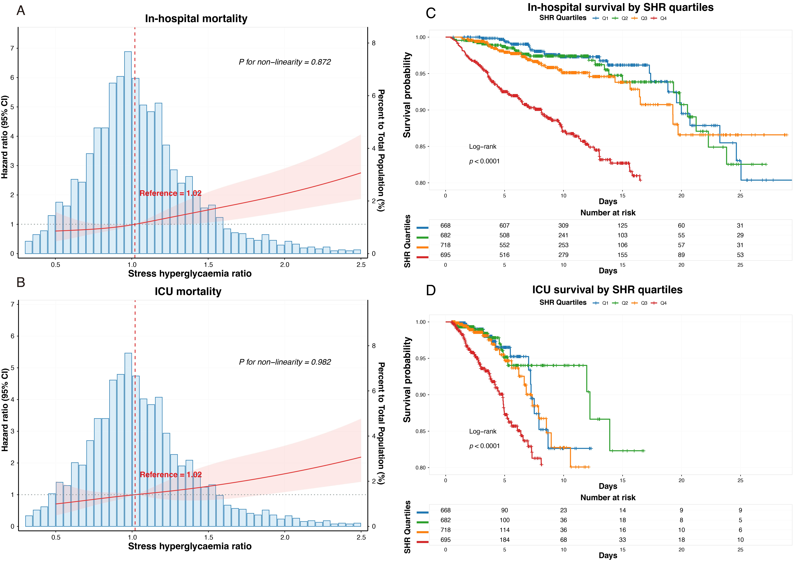
Figure S1. Prognostic analysis of SHR for in-hospital and ICU mortality. (A) Restricted cubic splines for in-hospital mortality. (B) Restricted cubic splines for ICU mortality. (C) Kaplan-Meier curves for in-hospital mortality. (D) Kaplan-Meier curves for ICU mortality. Abbreviations: SHR, stress hyperglycemia ratio; ICU, intensive care unit; CI, confidence interval; HR, hazard ratio.
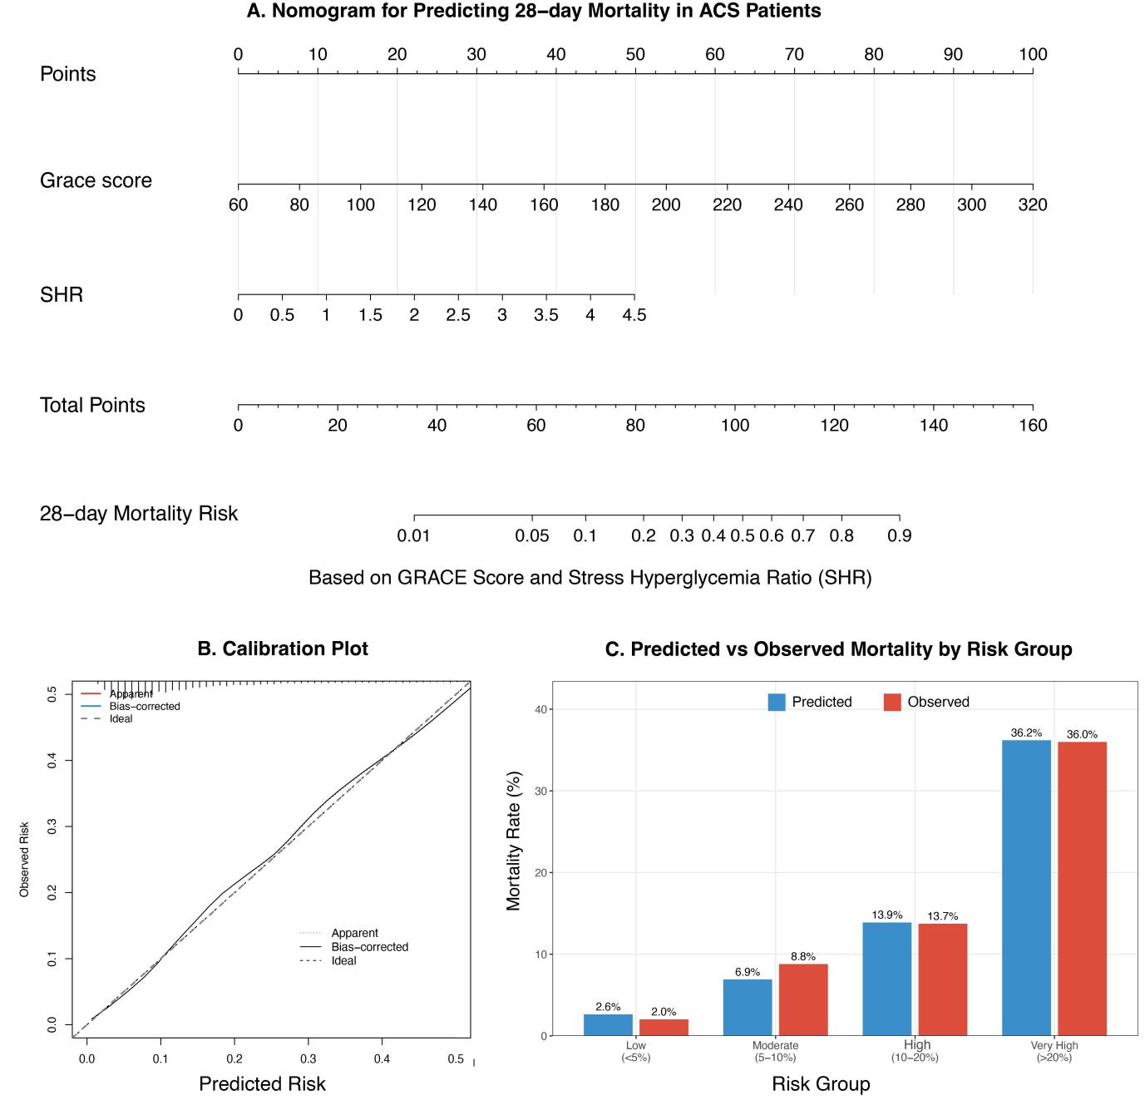
Figure S2. Nomogram and model performance. (A) Nomogram based on GRACE score and SHR. (B) Model calibration curve. (C) Predicted vs. observed mortality by risk group. Abbreviations: ACS, acute coronary syndrome; GRACE, Global Registry of Acute Coronary Events; SHR, stress hyperglycemia ratio.
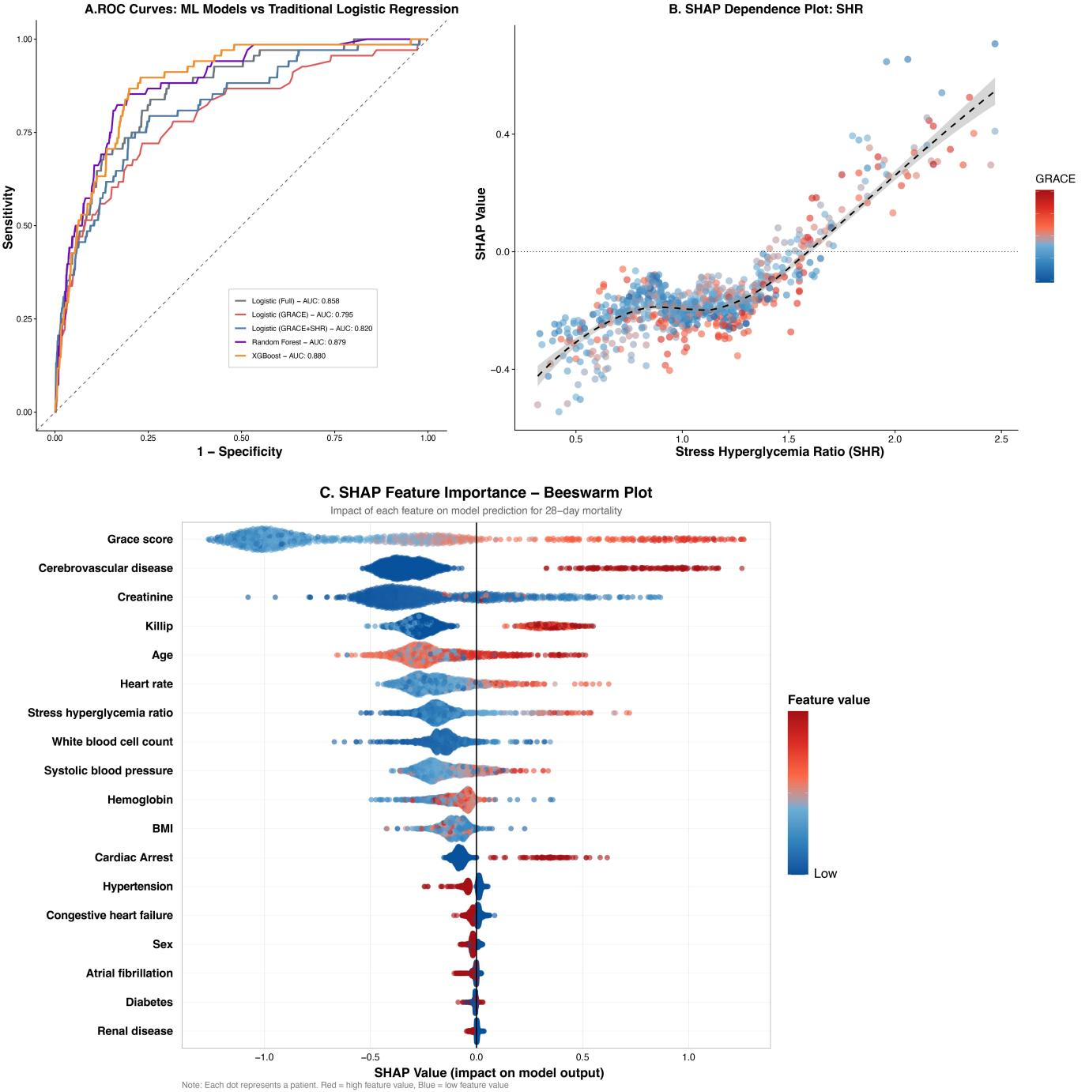
Figure S3. Machine learning validation. (A) ROC curves for XGBoost, Random Forest, and Logistic Regression models. (B) SHAP dependence plot for SHR. (C) SHAP summary beeswarm plot of feature importance. Abbreviations: ROC, receiver operating characteristic; XGBoost, extreme gradient boosting; SHAP, SHapley Additive exPlanations; SHR, stress hyperglycemia ratio; AUC, area under the curve; GRACE, Global Registry of Acute Coronary Events; WBC, white blood cell; SBP, systolic blood pressure; BMI, body mass index; CHF, congestive heart failure.

