Table S1: SBP criteria for reducing or discontinuing doses of study treatment
Blood Pressure Assessment | Dose Modification
SBP <90 mmHg, asymptomatic | • If currently on 5 or 10 mg - decrease dose
 | • If currently on 2.5 mg - interrupt dose
SBP <90 mmHg, symptomatic | Interrupt Dose
SBP, systolic blood pressure

Table S2: Secondary outcomes: Intergroup differences in SBP, DBP and eGFR
Variable | Vericiguat(n=61) | Control(n=36) | P-values
Blood pressure, mmHg
SBP | 100.00 (95.00, 105.00) | 99.00 (95.00, 104.25) | 0.914
DBP | 62.00 (57.00, 65.00) | 62.00 (58.00, 68.00) | 0.503
Laboratory findings
eGFR, ml/min | 88.89 ± 20.91 | 90.40 ± 20.26 | 0.729
SBP, systolic blood pressure; DBP, diastolic blood pressure; GFR, estimated glomerular filtration rate.

Table S3: Safety outcomes: the incidence of severe hypotension and syncope between the two groups
Variable | Total(n=97) | Vericiguat(n=61) | Control(n=36) | P-values
Severe hypotension / syncope n (%) |  |  |  | 0.540
No | 92 (94.85) | 59 (96.72) | 33 (91.67)
Yes | 5 (5.15) | 2 (3.28) | 3 (8.33)

Table S4: Univariate Cox regression analysis for primary outcome in participants with LVEF ≤ 40%
Variables | HR | 95%CI | P-values
Age, years | 0.990 | 0.97 ~ 1.02 | 0.505
Sex, No. (%)
Male | 1.00 (Reference)
Female | 0.830 | 0.43 ~ 1.59 | 0.575
BMI, kg/m^² | 1.010 | 0.99 ~ 1.02 | 0.242
SBP, mmHg | 1.000 | 0.95 ~ 1.06 | 0.885
DBP, mmHg | 1.010 | 0.98 ~ 1.04 | 0.587
Cause of heart failure
DCM | 1.00 (Reference)
ICM | 0.740 | 0.40 ~ 1.34 | 0.320
Others | 1.030 | 0.44 ~ 2.38 | 0.952
Medical history, No. (%)
Hypertension
No | 1.00 (Reference)
Yes | 0.960 | 0.51 ~ 1.81 | 0.896
Coronary heart disease
No | 1.00 (Reference)
Yes | 0.720 | 0.41 ~ 1.25 | 0.243
AF/Af
No | 1.00 (Reference)
Yes | 1.130 | 0.57 ~ 2.20 | 0.730
Diabetes mellitus
No | 1.00 (Reference)
Yes | 1.070 | 0.48 ~ 2.38 | 0.871
Use of vericiguat
No | 1.00 (Reference)
Yes | 2.180 | 1.17 ~ 4.06 | 0.014
Time from GDMT, months | 0.770 | 0.29 ~ 2.00 | 0.585
Laboratory findings
NT-proBNP, pg/ml | 1.010 | 1.01 ~ 1.01 | 0.017
eGFR, ml/min | 1.010 | 0.99 ~ 1.02 | 0.252
Echocardiographic parameters
LAD, mm | 1.010 | 0.98 ~ 1.04 | 0.366
LVEDD, mm | 1.020 | 0.99 ~ 1.05 | 0.286
RVD, mm | 1.070 | 1.01 ~ 1.15 | 0.037
LVEF, % | 0.950 | 0.92 ~ 0.99 | 0.024
LVMI, g/m^² | 1.000 | 1.00 ~ 1.01 | 0.222
LVEDV, ml | 1.000 | 1.00 ~ 1.01 | 0.351
LVESV, ml | 1.000 | 1.00 ~ 1.01 | 0.382
LVEDVI, ml/m^² | 1.000 | 1.00 ~ 1.01 | 0.405
LVESVI, ml/m^² | 1.010 | 0.99 ~ 1.02 | 0.303
BMI, body mass index; SBP, systolic blood pressure; DBP, diastolic blood pressure; DCM, dilated cardiomyopathy; ICM, ischemic cardiomyopathy; AF, atrial flutter; Af, atrial fibrillation; GDMT, guideline-directed medical therapy; NT-proBNP, N-terminal B-type natriuretic peptide; eGFR, estimated glomerular filtration rate; LAD, left atrial diameter; LVEDD, left ventricular end-diastolic diameter; RVD, right ventricular diameter; LVEF, left ventricular ejection fraction; LVMI, left ventricular mass index; LVEDV, left ventricular end-diastolic volume; LVESV, left ventricular end-systolic volume; LVEDVI, left ventricular end-diastolic volume index; LVESVI, left ventricular end-systolic volume index.

Table S5: Multivariate Cox regression analysis for primary outcomes in participants with LVEF ≤ 40%
 | Model 1 |  |  | Model 2 |  |  | Model 3
 | HR | 95%CI | P-value | HR | 95%CI | P-value | HR | 95%CI | P-value
Reduction in NT-proBNP
Control group | Reference |  |  | Reference |  |  | Reference
Vericiguat group | 2.18 | 1.17-4.06 | 0.014 | 2.15 | 1.16-4.01 | 0.015 | 2.29 | 1.22-4.28 | 0.010
Model 1: unadjusted
Model 2: adjusted for age and gender
Model 3: further adjusted for baseline NT-proBNP, LVEF.
NT-proBNP, N-terminal B-type natriuretic peptide; LVEF, left ventricular ejection fraction.

Table S6：Standardized mean differences after propensity score matching
 |  | Before Matching |  |  | After Matching
 |  | Control(n=40) | Vericiguat(n=124) | SMD | Control(n=36) | Vericiguat(n=61) | SMD
age |  | 54.23 ± 12.25 | 50.55 ± 12.15 | 0.301 | 55.00 (47.00, 60.25) | 56.00 (49.00, 61.00) | 0.042
NT-proBNP |  | 507.50（198.00，1109.00） | 590.85（224.75，1097.00） | 0.002 | 386.50 (175.25, 1091.75) | 567.00 (228.00, 1097.00) | 0.009
eGFR |  | 91.43 ± 18.65 | 90.71 ± 21.34 | 0.036 | 91.55 ± 19.18 | 90.02 ± 19.92 | 0.112
LVEF |  | 31.50 ± 12.06 | 30.46 ± 9.82 | 0.095 | 33.00 (29.25, 40.00) | 33.00 (27.00, 40.00) | 0.036
sex, n(%) |  |  |  | 0.109 |  |  | 0.101
male |  | 30 (75.00) | 87 (70.16) |  | 27 (75.00) | 44 (72.13)
female |  | 10 (25.00) | 37 (29.84) |  | 9 (25.00) | 17 (27.87)
NYHA, n(%) |  |  |  | 0.239 |  |  | 0.239
I |  | 1 (2.50) | 0 (0.00) |  | 1 (2.78) | 0 (0.00)
II |  | 32 (80.00) | 98 (79.03) |  | 29 (80.56) | 52 (85.25)
III |  | 7 (17.50) | 26 (20.97) |  | 6 (16.67) | 9 (14.75)
NT-proBNP, N-terminal B-type natriuretic peptide; eGFR, estimated glomerular filtration rate; LVEF, left ventricular ejection fraction; NYHA, New York Heart Association.

Figure S1: Association between vericiguat and primary outcome plotted by Kaplan–Meier curves in participants with LVEF ≤ 40%
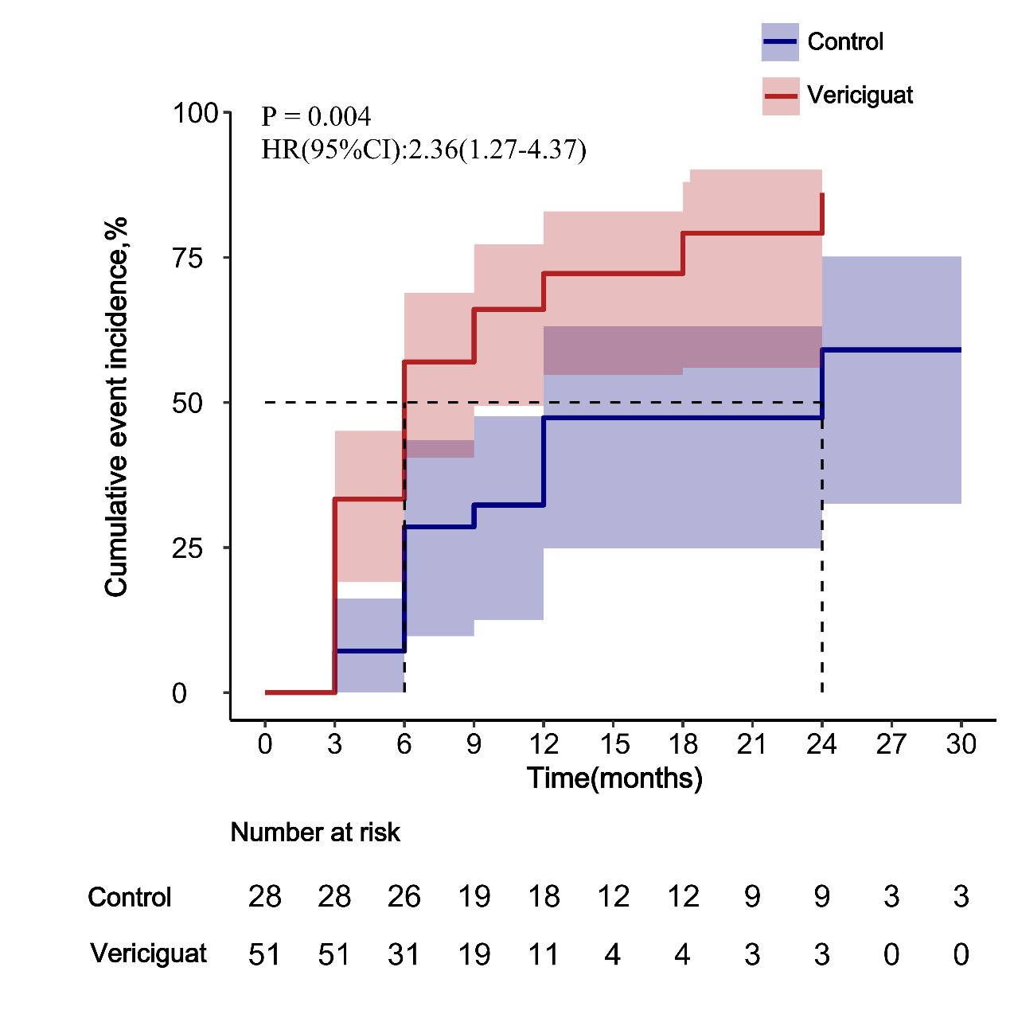
LVEF: LV ejection fraction, HR: hazard ratio; CI: confidence interval.

Figure S2: Love plot after propensity score matching
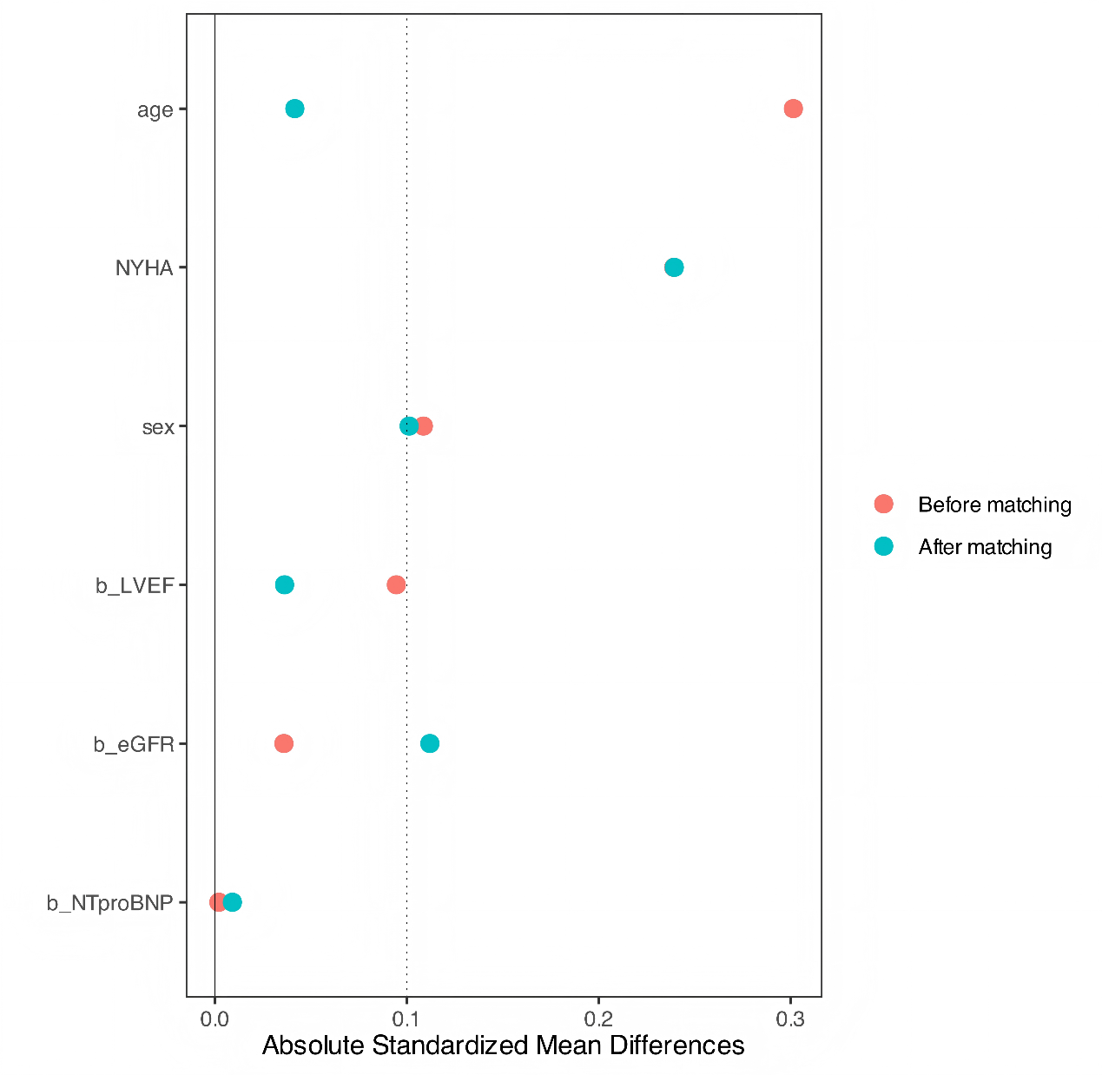
NYHA, New York Heart Association; LVEF, left ventricular ejection fraction; eGFR, estimated glomerular filtration rate; NT-proBNP, N-terminal B-type natriuretic peptide.

Figure S3: Propensity score matching flowchart
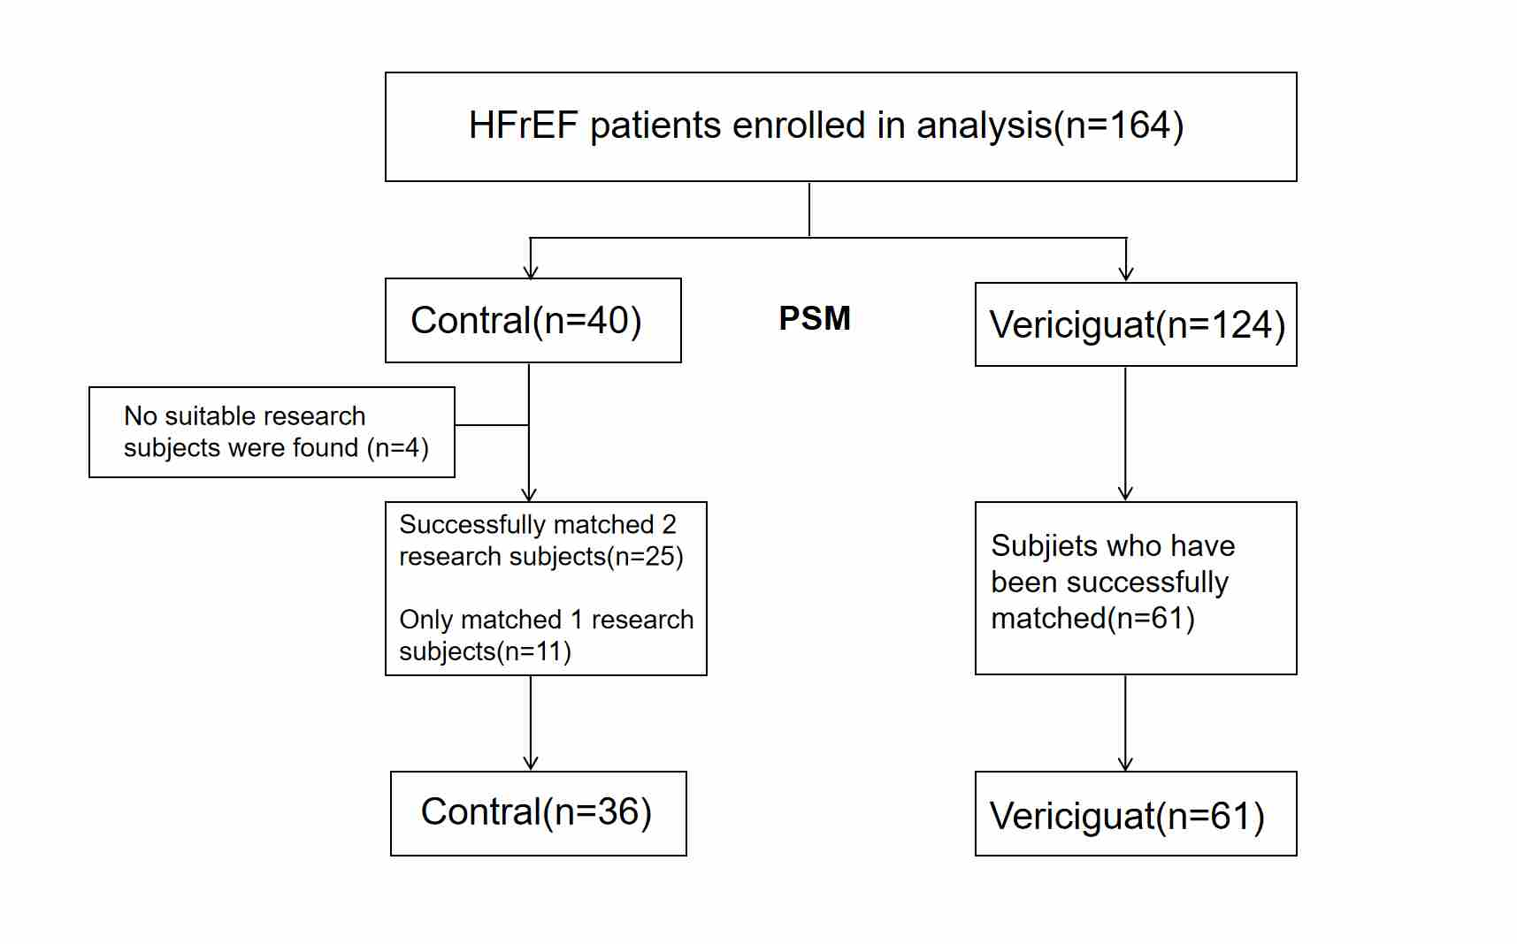
HFrEF, heart failure with reduced ejection fraction; PSM, Propensity score matching.

