Supplementary Material

Contents
Supplementary Methods 2
Table S1. The missing number and rates of covariates. 3
Table S2. Baseline characteristics of 9120 participants according to quartiles of baseline CMI 4
Figure S1. Changes of CMI and its components from 2011 to 2015. 5
Table S3. Associations of baseline CMI with clinical outcomes 6
Figure S2. Confirmation of threshold by utilizing Maximally Selected Rank Statisitcs. 7
Table S4. Associations of changes in CMI with heart diseases and stroke 7
Table S5. Associations of cumulative CMI with heart diseases 7
Table S6. Associations of cumulative CMI with stroke 8
Table S7. Associations of ΔCMI with CVD 9
Table S8. Associations of ΔCMI with heart diseases 9
Table S9. Associations of ΔCMI with stroke 10
Table S10. Associations of baseline CMI with CVD in complete dataset 10
Table S11. Associations of changes in CMI with CVD in complete dataset 10
Table S12. Associations of cumulative CMI with CVD in complete dataset 11
Table S13. Associations of ΔCMI with CVD in complete dataset 11
Table S14. Comparison of baseline characteristics of the excluded and included participants before and after inverse probability weighting 12
Figure S3. Love plots show differences based on the original unweighted and inverse probability weighted participants. 13
Table S15. Associations of changes in CMI with CVD with the use of inverse probability weighting (HR (95%CI)) 13
Table S16. Associations of cumulative CMI and ΔCMI with CVD with the use of inverse probability weighting (HR (95%CI)) 14
Table S17. Subgroup analysis of baseline CMI with clinical outcomes in participants with or without hypertension 15
Table S18. Subgroup analysis of changes in CMI with clinical outcomes in participants with or without hypertension 15
Table S19. Subgroup analysis of cumulative CMI with CVD in participants with or without hypertension 16
Table S20. Subgroup analysis of ΔCMI with CVD in participants with or without hypertension 16
Table S21. Subgroup analysis of baseline CMI with clinical outcomes in male and female 17
Table S22. Subgroup analysis of changes in CMI with clinical outcomes in male and female 18
Table S23. Subgroup analysis of cumulative CMI with CVD in male and female 18
Table S24. Subgroup analysis of ΔCMI with CVD in male and female 19
Table S25. Subgroup analysis of baseline CMI with clinical outcomes in different levels of CRP 19
Table S26. Subgroup analysis of changes in CMI with clinical outcomes in different levels of CRP 20
Table S27. Subgroup analysis of cumulative CMI with CVD in different levels of CRP 21
Table S28. Subgroup analysis of ΔCMI with CVD in different levels of CRP 21
Table S29. Changes of factors associated with CVD during follow-up in the participants with high baseline CMI level* 22
Table S30. Incremental value of adding changes in CMI to baseline model 23
Figure S4. Decile-based calibration plots at 3-year. 23

Supplementary Methods
Covariates
Education level was categorized into three levels: low (less than lower secondary), middle (upper secondary and vocational training), and high (tertiary). Smoking habits was classified into three categories: never, former and current smokers. The venous blood samples were collected from each participant by medically-trained staff from the China Center for Disease Control and Prevention (China CDC) in baseline and the third survey¹. The samples of blood were kept under 4℃ until the samples were centrifuged at local hospitals or health center. Then, the samples were immediately stored frozen at -20℃ and were transferred to China CDC in Beijing within two weeks by a cold-chain shipping company. The levels of TC, TG and HDL-C were determined through enzymatic colormetric test. The high-sensitivity CRP levels were quantified using immunoturbidimetric assay, while serum creatinine was measured using rate-blanked and compensated Jaffe creatinine method. All measurements were conducted at Youanmen Center for Clinical Laboratory of Capital Medical University.
The physical examination collect at Wave 1 and Wave 3, and includes resting blood pressure (sitting) and anthropometric measures (weight, height and waist)². Blood pressure was measured three times at 45-second intervals using an electronic sphygmomanometer (Omron HEM-7200), and the mean value of the last two readings was used in the analysis. Body weight and height in light clothing and without shoes were measured.
Definitions of clinical outcomes
Cardiovascular disease (CVD) was defined based on the self-reported physician-diagnosed heart diseases or stroke. In each wave of the CHARLS, participants were asked "Have you have been diagnosed with heart attack, coronary heart disease, angina, congestive heart failure, or other heart problems by a doctor?" and "Have you been diagnosed with stroke by a doctor?" Those who reported being diagnosed with heart diseases or stroke were considered to have CVD. In the next wave, the respondents were required to confirm the existence of heart disease and stroke if they reported those in the last wave. If the respondent disputed self-reported heart disease or stroke from previous waves, they were corrected retrospectively. Our CVD ascertainment was consistent with previous studies using the CHARLS³.
Multiple imputation
The missing data of covariates were imputed using the multiple imputation with chained equation⁴. The missing number and rates of covariates were showed in Table S1. We performed 5 imputations and generated 5 imputed datasets. Effect estimates were computed separately for each of the 5 datasets, and then combined according to Rubin’s rules. The multiple imputation was conducted using the R package “mice”.

Table S1. The missing number and rates of covariates.
Variables | Smoking | Drinking | Lipid-lowering | Glucose | LDL-C | SBP | DBP | hsCRP
No. (%) | 7 (0.1) | 12 (0.1) | 198 (2.2) | 9 (0.1) | 18 (0.2) | 88 (1.0) | 89 (1.0) | 1(0.01)
There were no missing data of age, sex, education level, TG, HDL, waist and height.

Competing-risks analyses
Competing-risks regression was used to evaluate the association between baseline CMI and CVD. CVD was defined as the event of interest, while non-cardiovascular death was defined as a competing event. Sub-distribution hazard ratios (SHRs) and 95%CI were estimated using the Fine-Gray proportional sub-distribution hazards model. Cumulative incidence function using the Fine-Gray method. Cumulative incidence curves were plotted according to the quartiles of CMI.

Table S2. Baseline characteristics of 9120 participants according to quartiles of baseline CMI
 | Overall  (n=9120) | Baseline CMI |  |  |  | p-value¹
 | Overall  (n=9120) | Quartiles 1  (n=2301) | Quartiles 2  (n=2239) | Quartiles 3  (n=2296) | Quartiles4  (n=2284) | p-value¹
Age, years | 59.3 (9.3) | 59.7 (9.6) | 59.4 (9.4) | 59.1 (9.2) | 58.8 (8.9) | 0.007
Sex
male | 4257 (46.7) | 1275 (55.4) | 1072 (47.9) | 956 (41.6) | 954 (41.8) | <0.001
female | 4863 (53.3) | 1026 (44.6) | 1167 (52.1) | 1340 (58.4) | 1330 (58.2)
BMI, kg/m² | 23.5 (3.9) | 21.4 (3.1) | 22.7 (3.5) | 24.2 (3.7) | 25.7 (3.9) | <0.001
Waist, cm | 85.4 (10.1) | 79.2 (8.0) | 83.3 (8.8) | 87.2 (9.4) | 91.7 (9.5) | <0.001
Height, cm | 157.9 (8.6) | 158.2 (8.5) | 157.7 (8.6) | 157.5 (8.7) | 158.1 (8.5) | 0.023
SBP, mmHg | 129.7 (21.5) | 126.2 (21.2) | 127.6 (20.6) | 131.1 (21.8) | 133.8 (21.4) | <0.001
DBP, mmHg | 75.4 (12.2) | 72.8 (12.0) | 74.3 (11.6) | 76.4 (12.4) | 78.0 (12.1) | <0.001
TC, mmol/L | 5.0 (1.0) | 4.9 (0.9) | 4.9 (1.0) | 5.1 (1.0) | 5.3 (1.1) | <0.001
TG, mmol/L | 1.5 (1.2) | 0.7 (0.2) | 1.0 (0.2) | 1.4 (0.3) | 2.8 (1.8) | <0.001
HDL-C, mmol/L | 1.3 (0.4) | 1.7 (0.4) | 1.4 (0.3) | 1.2 (0.2) | 1.0 (0.2) | <0.001
LDL-C, mmol/L | 3.0 (0.9) | 2.9 (0.8) | 3.1 (0.9) | 3.2 (0.9) | 2.9 (1.1) | <0.001
Glucose, mmol/L | 6.1 (2.1) | 5.7 (1.4) | 5.8 (1.6) | 6.1 (2.0) | 6.9 (2.8) | <0.001
WBC in thousands | 6.3 (2.2) | 6.0 (1.8) | 6.2 (1.9) | 6.4 (2.9) | 6.6 (1.9) | <0.001
hsCRP, mg/L | 2.8 (7.6) | 2.7 (8.7) | 2.7 (6.9) | 2.7 (7.5) | 3.0 (7.2) | 0.395
Smoking habit, n (%) |  |  |  |  |  | <0.001
never | 5521 (60.5) | 1247 (54.2) | 1331 (59.4) | 1492 (65.0) | 1451 (63.5)
former | 836 (9.2) | 213 (9.3) | 193 (8.6) | 201 (8.8) | 229 (10.0)
current | 2756 (30.2) | 839 (36.5) | 713 (31.8) | 603 (26.3) | 601 (26.3)
Drinking, n (%) |  |  |  |  |  | <0.001
No | 5559 (61.0) | 1222 (53.1) | 1368 (61.1) | 1495 (65.1) | 1474 (64.5)
Yes | 3549 (38.9) | 1076 (46.8) | 869 (38.8) | 798 (34.8) | 806 (35.3)
Education level, n (%) |  |  |  |  |  | 0.367
Low | 8281 (90.8) | 2110 (91.7) | 2037 (91.0) | 2077 (90.5) | 2057 (90.1)
Middle | 743 (8.1) | 170 (7.4) | 182 (8.1) | 196 (8.5) | 195 (8.5)
High | 96 (1.1) | 21 (0.9) | 20 (0.9) | 23 (1.0) | 32 (1.4)
Medication use, n(%)
Antidiabetic | 359 (3.9) | 53 (2.3) | 54 (2.4) | 86 (3.7) | 166 (7.3) | <0.001
Antihypertension | 1804 (19.8) | 263 (11.4) | 333 (14.9) | 510 (22.2) | 698 (30.6) | <0.001
Lipid-lowering | 465 (5.1) | 46 (2.0) | 80 (3.6) | 113 (4.9) | 226 (9.9) | <0.001
Hypertension, n(%)
No | 5277 (57.9) | 1558 (67.7) | 1439 (64.3) | 1244 (54.2) | 1036 (45.4) | <0.001
Yes | 3805 (41.7) | 733 (31.9) | 787 (35.1) | 1044 (45.5) | 1241 (54.3)
Diabetes, n(%)
No | 7541 (82.7) | 2081 (90.4) | 1962 (87.6) | 1911 (83.2) | 1587 (69.5) | <0.001
Yes | 1579 (17.3) | 220 (9.6) | 277 (12.4) | 385 (16.8) | 697 (30.5)
BMI, body mass index; BP, blood pressure; WBC, white blood cell; TC, total cholesterol; TG, triglyceride; HDL-C, high-density lipoprotein-cholesterol.
Data was expressed as mean (SD) for continuous variables and frequency (percentage) for categorical variables.
¹ p values were obtained by ANOVA for continuous variables or the chi-square test for categorical variables.

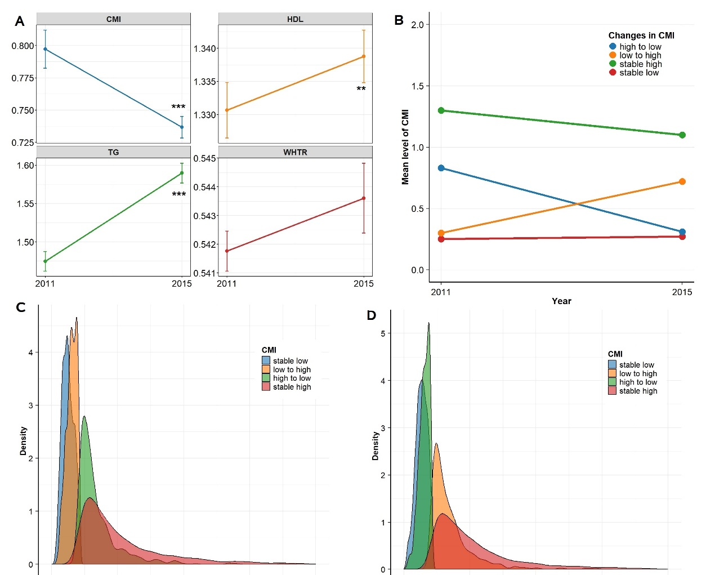

Figure S1. Changes of CMI and its components from 2011 to 2015.
(A) the levels of CMI and its components in 2011 and 2015; (B) Mean CMI levels in 2011 and 2015 across four CMI change patterns; (C and D) Distribution of CMI in 2011 and 2015. TG, triglyceride; HDL-C, high-density lipoprotein-cholesterol; WHTR, waist to height ratio. ***, p<0.0001; **, p<0.01.

Table S3. Associations of baseline CMI with clinical outcomes
 | Quartile 1 | Quartile 2 | Quartile 3 | Quartile 4 | P for trend
CVD
Event proportion | 559/2301 (24.3) | 636/2239 (28.4) | 755/2296 (32.9) | 846/2284 (37.0)
Model 1 | Ref. | 1.22 (1.09, 1.37) | 1.42 (1.28, 1.59) | 1.64 (1.47, 1.82) | <0.001
Model 2 | Ref. | 1.22 (1.09, 1.37) | 1.41 (1.26, 1.57) | 1.63 (1.46, 1.81) | <0.001
Model 3 | Ref. | 1.15 (1.03, 1.29) | 1.26 (1.12, 1.41) | 1.33 (1.18, 1.48) | <0.001
Heart diseases
Event proportion | 469/2301 (20.4) | 516/2239 (23.0) | 618/2296 (26.9) | 688/2284 (30.1)
Model 1 | Ref. | 1.17 (1.03, 1.33) | 1.37 (1.21, 1.54) | 1.55 (1.38, 1.74) | <0.001
Model 2 | Ref. | 1.16 (1.02, 1.31) | 1.33 (1.18, 1.5) | 1.51 (1.34, 1.7) | <0.001
Model 3 | Ref. | 1.09 (0.96, 1.24) | 1.19 (1.05, 1.34) | 1.24 (1.09, 1.4) | <0.001
Stroke
Event proportion | 141/2301 (6.1) | 196/2239 (8.8) | 231/2296 (10.1) | 291/2284 (12.7)
Model 1 | Ref. | 1.46 (1.18, 1.82) | 1.68 (1.36, 2.07) | 2.17 (1.78, 2.66) | <0.001
Model 2 | Ref. | 1.51 (1.22, 1.87) | 1.77 (1.44, 2.19) | 2.31 (1.88, 2.83) | <0.001
Model 3 | Ref. | 1.41 (1.14, 1.76) | 1.52 (1.23, 1.89) | 1.78 (1.44, 2.19) | <0.001
Model 1: crude model;
Model 2: adjusted for age and sex;
Model 3: additionally adjusted for smoking habit, drinking, education level, LDL-C, glucose, SBP, DBP, hsCRP and medication use of lipid-lowering.

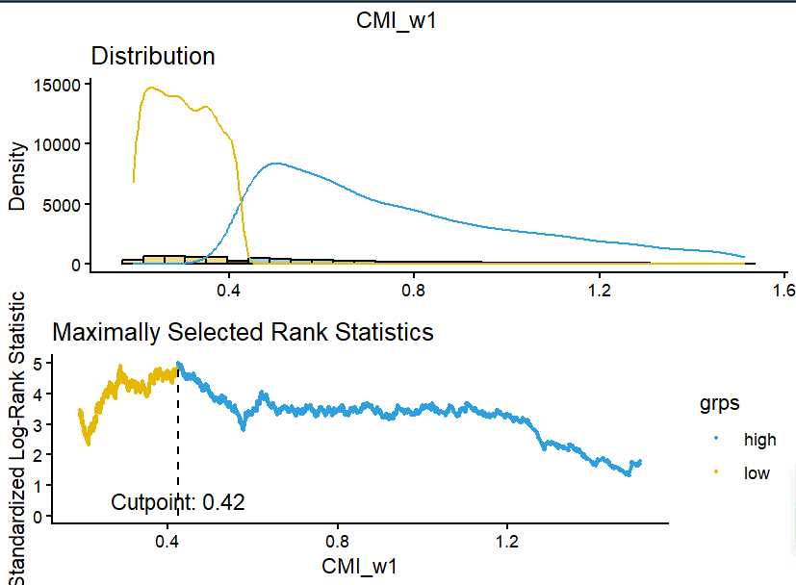

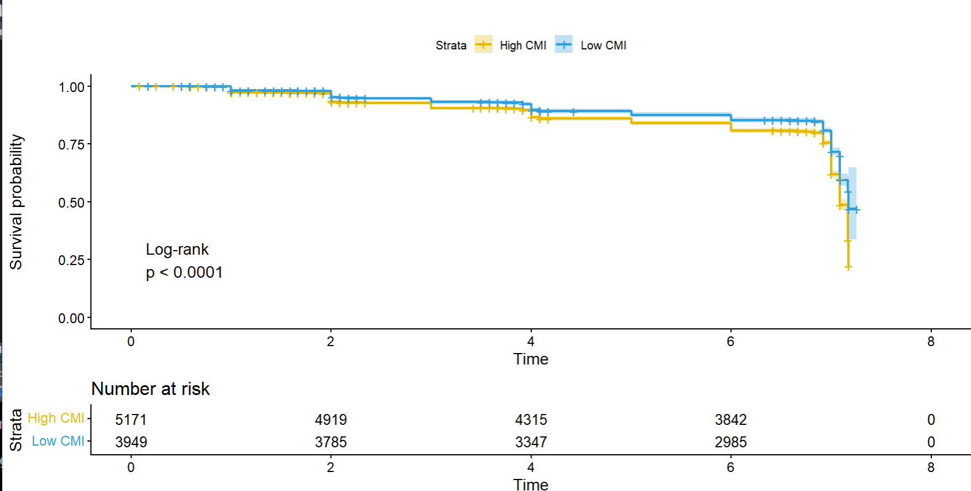

Figure S2. Confirmation of threshold by utilizing Maximally Selected Rank Statisitcs.
(Upper figure) Determination of cut point at 0.42. (Lower figure) Kaplan-Meier survival curves when cohort stratified as high (>0.42) or low (<0.42).

Table S4. Associations of changes in CMI with heart diseases and stroke
 | Event proportion | Model 1 |  | Model 2
 | Event proportion | HR (95%CI) | P value | HR (95%CI) | P value
Heart diseases
Stable low | 271/1632 (16.6) | Ref. |  | Ref.
Low to high | 205/990 (20.7) | 1.22 (1.02, 1.47) | 0.03 | 1.23 (1.02, 1.47) | 0.029
High to low | 124/629 (19.7) | 1.17 (0.95, 1.45) | 0.142 | 1.18 (0.95, 1.46) | 0.134
Stable high | 706/2913 (24.2) | 1.29 (1.11, 1.49 | 0.001 | 1.3 (1.12, 1.52) | 0.001
Stroke
Stable low | 85/1632 (5.2) | Ref. |  | Ref.
Low to high | 65/990 (6.6) | 1.29 (0.93, 1.79) | 0126 | 1.23 (0.93, 1.79) | 0.123
High to low | 34/629 (5.4) | 1.01 (0.67, 1.50) | 0.978 | 1.01 (0.68, 1.51) | 0.953
Stable high | 287/2913 (9.9) | 1.68 (1.31, 2.17) | <0.001 | 1.71 (1.31, 2.22) | <0.001
Model 1 adjusted for age, sex, smoking habit, drinking, education level, LDL-C, glucose, SBP, DBP, hsCRP and medication use of lipid-lowering.
Model 2 additionally adjusted for baseline CMI.

Table S5. Associations of cumulative CMI with heart diseases
 | Event proportion | Model 1 |  | Model 2
 | Event proportion | HR (95%CI) | P value | HR (95%CI) | P value
Total population (n=6164)
T1 | 464/2076 (22.4%) | Ref. |  | Ref.
T2 | 409/2040 (20%) | 0.95 (0.83, 1.09) | 0.477 | 0.96 (0.83, 1.1) | 0.564
T3 | 433/2048 (21.1%) | 0.97 (0.85, 1.11) | 0.669 | 0.98 (0.85, 1.12) | 0.746
P for trend |  | 0.664 |  | 0.757
Participants with low baseline CMI (<0.42) (n=2622)
T1 | 39/251 (15.5%) | Ref. |  | Ref.
T2 | 232/1330 (17.4%) | 1.05 (0.74, 1.47) | 0.797 | 1.02 (0.72, 1.44) | 0.930
T3 | 205/1041 (19.7%) | 1.26 (0.89, 1.78) | 0.197 | 1.23 (0.86, 1.74) | 0.251
P for trend |  | 0.056 |  | 0.062
Participants with high baseline CMI (>0.42) (n=3542)
T1 | 425/1825 (23.3%) | Ref. |  | Ref.
T2 | 177/710 (24.9%) | 1.11 (0.93, 1.33) | 0.239 | 1.11 (0.93, 1.33) | 0.251
T3 | 228/1007 (22.6%) | 0.93 (0.79, 1.10) | 0.384 | 0.93 (0.79, 1.10) | 0.383
P for trend |  | 0.496 |  | 0.477
Model 1 adjusted for age, sex, smoking habit, drinking, education level, LDL-C, glucose, SBP, DBP, hsCRP and medication use of lipid-lowering.
Model 2 additionally adjusted for baseline CMI.

Table S6. Associations of cumulative CMI with stroke
 | Event proportion | Model 1 |  | Model 2
 | Event proportion | HR (95%CI) | P value | HR (95%CI) | P value
Total population (n=6164)
T1 | 173/2076 (8.3%) | Ref. |  | Ref.
T2 | 130/2040 (6.4%) | 0.84 (0.67, 1.06) | 0.138 | 0.86 (0.67, 1.09) | 0.198
T3 | 168/2048 (8.2%) | 1.05 (0.85, 1.31) | 0.649 | 1.07 (0.86, 1.33) | 0.558
P for trend |  | 0.660 |  | 0.529
Participants with low baseline CMI (<0.42) (n=2622)
T1 | 18/251 (7.2%) | Ref. |  | Ref.
T2 | 68/1330 (5.1%) | 0.68 (0.40, 1.15) | 0.154 | 0.78 (0.45, 1.33) | 0.360
T3 | 64/1041 (6.1%) | 0.85 (0.50, 1.45) | 0.547 | 0.94 (0.55, 1.61) | 0.820
P for trend |  | 0.864 |  | 0.727
Participants with high baseline CMI (>0.42) (n=3542)
T1 | 155/1825 (8.5%) | Ref. |  | Ref.
T2 | 62/710 (8.7%) | 1.11 (0.82, 1.50) | 0.482 | 1.11 (0.82, 1.50) | 0.509
T3 | 104/1007 (10.3%) | 1.27 (0.99, 1.64) | 0.065 | 1.27 (0.98, 1.64) | 0.074
P for trend |  | 0.066 |  | 0.075
Model 1 adjusted for age, sex, smoking habit, drinking, education level, LDL-C, glucose, SBP, DBP, hsCRP and medication use of lipid-lowering.
Model 2 additionally adjusted for baseline CMI.

Table S7. Associations of ΔCMI with CVD
 | Event proportion | Model 1 |  | Model 2
 | Event proportion | HR (95%CI) | P value | HR (95%CI) | P value
Total population (n=6164)
ΔT1 | 554/2076 (26.7%) | 1.02 (0.90, 1.15) | 0.797 | 1.00 (0.88, 1.14) | 0.966
ΔT2 | 468/2040 (22.9%) | 0.92 (0.81, 1.04) | 0.195 | 0.92 (0.81, 1.05) | 0.210
ΔT3 | 520/2048 (25.4%) | Ref. |  | Ref.
P for trend |  | 0.200 |  | 0.217
Participants with low baseline CMI (<0.42) (n=2622)
ΔT1 | 48/251 (19.1%) | 0.82 (0.60, 1.12) | 0.212 | 0.82 (0.60, 1.13) | 0.225
ΔT2 | 271/1330 (20.4%) | 0.82 (0.69, 0.98) | 0.026 | 0.82 (0.69, 0.98) | 0.025
ΔT3 | 245/1041 (23.5%) | Ref. |  | Ref.
P for trend |  | 0.027 |  | 0.026
Participants with high baseline CMI (>0.42) (n=3542)
ΔT1 | 506/1825 (27.7%) | 1.04 (0.89, 1.21) | 0.631 | 1.03 (0.89, 1.20) | 0.663
ΔT2 | 197/710 (27.7%) | 1.07 (0.89, 1.29) | 0.454 | 1.07 (0.89, 1.29 | 0.450
ΔT3 | 275/1007 (27.3%) | Ref. |  | Ref.
P for trend |  | 0.449 |  | 0.449
Model 1 adjusted for age, sex, smoking habit, drinking, education level, LDL-C, glucose, SBP, DBP, hsCRP at baseline and medication use of lipid-lowering.
Model 2 additionally adjusted for baseline CMI.

Table S8. Associations of ΔCMI with heart diseases
 | Event proportion | Model 1 |  | Model 2
 | Event proportion | HR (95%CI) | P value | HR (95%CI) | P value
Total population (n=6164)
ΔT1 | 464/2076 (22.4%) | 1.03 (0.90, 1.18) | 0.669 | 1.02 (0.89, 1.17) | 0.746
ΔT2 | 409/2040 (20%) | 0.98 (0.86, 1.12) | 0.776 | 0.98 (0.86, 1.13) | 0.790
ΔT3 | 433/2048 (21.1%) | Ref. |  | Ref.
P for trend |  | 0.781 |  | 0.799
Participants with low baseline CMI (<0.42) (n=2622)
ΔT1 | 39/251 (15.5%) | 0.80 (0.56, 1.13) | 0.197 | 0.81 (0.57, 1.16) | 0.251
ΔT2 | 232/1330 (17.4%) | 0.83 (0.69, 1.01) | 0.060 | 0.83 (0.68, 1.00) | 0.052
ΔT3 | 205/1041 (19.7%) | Ref. |  | Ref.
P for trend |  | 0.065 |  | 0.054
Participants with high baseline CMI (>0.42) (n=3542)
ΔT1 | 425/1825 (23.3%) | 1.08 (0.91, 1.27) | 0.384 | 1.08 (0.91, 1.27) | 0.383
ΔT2 | 177/710 (24.9%) | 1.20 (0.98, 1.46) | 0.074 | 1.20 (0.98, 1.46 | 0.075
ΔT3 | 228/1007 (22.6%) | Ref. |  | Ref.
P for trend |  | 0.078 |  | 0.078
Model 1 adjusted for age, sex, smoking habit, drinking, education level, LDL-C, glucose, SBP, DBP, hsCRP and medication use of lipid-lowering.
Model 2 additionally adjusted for baseline CMI.

Table S9. Associations of ΔCMI with stroke
 | Event proportion | Model 1 |  | Model 2
 | Event proportion | HR (95%CI) | P value | HR (95%CI) | P value
Total population (n=6164)
ΔT1 | 173/2076 (8.3%) | 0.95 (0.77, 1.18) | 0.649 | 0.94 (0.75, 1.17) | 0.558
ΔT2 | 130/2040 (6.4%) | 0.80 (0.63, 1.01) | 0.057 | 0.80 (0.63, 1.01) | 0.060
ΔT3 | 168/2048 (8.2%) | Ref. |  | Ref.
P for trend |  | 0.059 |  | 0.062
Participants with low baseline CMI (<0.42) (n=2622)
ΔT1 | 18/251 (7.2%) | 1.18 (0.69, 2.01) | 0.547 | 1.06 (0.62, 1.83) | 0.820
ΔT2 | 68/1330 (5.1%) | 0.80 (0.57, 1.14) | 0.218 | 0.83 (0.58, 1.17) | 0.286
ΔT3 | 64/1041 (6.1%) | Ref. |  | Ref.
P for trend |  | 0.204 |  | 0.282
Participants with high baseline CMI (>0.42) (n=3542)
ΔT1 | 155/1825 (8.5%) | 0.79 (0.61, 1.02) | 0.065 | 0.79 (0.61, 1.02) | 0.074
ΔT2 | 62/710 (8.7%) | 0.88 (0.64, 1.20) | 0.411 | 0.87 (0.64, 1.20) | 0.409
ΔT3 | 104/1007 (10.3%) | Ref. |  | Ref.
P for trend |  | 0.285 |  | 0.287
Model 1 adjusted for age, sex, smoking habit, drinking, education level, LDL-C, glucose, SBP, DBP, hsCRP and medication use of lipid-lowering.
Model 2 additionally adjusted for baseline CMI.

Table S10. Associations of baseline CMI with CVD in complete dataset
 | Quartile 1 | Quartile 2 | Quartile 3 | Quartile 4 | P for trend
Model 1 | Ref. | 1.22 (1.09, 1.37) | 1.42 (1.28, 1.59) | 1.64 (1.47, 1.82) | <0.001
Model 2 | Ref. | 1.22 (1.09, 1.37) | 1.41 (1.26, 1.57) | 1.63 (1.46, 1.81) | <0.001
Model 3 | Ref. | 1.15 (1.02, 1.29) | 1.25 (1.12, 1.41) | 1.32 (1.18, 1.48) | <0.001
Model 1: crude model;
Model 2: adjusted for age and sex;
Model 3: additionally adjusted for smoking habit, drinking, education level, LDL-C, glucose, SBP, DBP, hsCRP and medication use of lipid-lowering.

Table S11. Associations of changes in CMI with CVD in complete dataset
 | Model 1 |  | Model 2
 | HR (95%CI) | P value | HR (95%CI) | P value
Stable low | Ref. |  | Ref.
Low to high | 1.24 (1.05, 1.47) | 0.012 | 1.24 (1.05, 1.47) | 0.013
High to low | 1.13 (0.93, 1.39) | 0.217 | 1.13 (0.92, 1.38) | 0.133
Stable high | 1.31 (1.14, 1.50) | <0.001 | 1.28 (1.11, 1.49) | <0.001
Model 1 adjusted for age, sex, smoking habit, drinking, education level, LDL-C, glucose, SBP, DBP, hsCRP and medication use of lipid-lowering.
Model 2 additionally adjusted for baseline CMI.

Table S12. Associations of cumulative CMI with CVD in complete dataset
 | Model 1 |  | Model 2
 | HR (95%CI) | P value | HR (95%CI) | P value
Total population (n=6164)
T1 | Ref. |  | Ref.
T2 | 0.89 (0.78, 1.01) | 0.069 | 0.92 (0.80, 1.05) | 0.217
T3 | 0.97 (0.86, 1.10) | 0.635 | 1.00 (0.88, 1.13) | 0.967
P for trend | 0.620 |  | 0.977
Participants with low baseline CMI (<0.42)
T1 | Ref. |  | Ref.
T2 | 0.97 (0.71, 1.33) | 0.833 | 0.97 (0.70, 1.33) | 0.832
T3 | 1.18 (0.86, 1.62) | 0.315 | 1.18 (0.85, 1.63) | 0.323
P for trend | 0.061 |  | 0.060
Participants with high baseline CMI (>0.42)
T1 | Ref. |  | Ref.
T2 | 1.01 (0.85, 1.19) | 0.942 | 1.02 (0.86, 1.22) | 0.806
T3 | 0.95 (0.82, 1.11) | 0.513 | 0.96 (0.82, 1.12) | 0.628
P for trend | 0.540 |  | 0.659
Model 1 adjusted for age, sex, smoking habit, drinking, education level, LDL-C, glucose, SBP, DBP, hsCRP and medication use of lipid-lowering.
Model 2 additionally adjusted for baseline CMI.

Table S13. Associations of ΔCMI with CVD in complete dataset
 | Model 1 |  | Model 2
 | HR (95%CI) | P value | HR (95%CI) | P value
Total population (n=6164)
ΔT1 | 1.03 (0.91, 1.17) | 0.635 | 1.00 (0.88, 1.14) | 0.967
ΔT2 | 0.92 (0.81, 1.04) | 0.181 | 0.92 (0.81, 1.05) | 0.213
ΔT3 | Ref. |  | Ref.
P for trend | 0.188 |  | 0.223
Participants with low baseline CMI (<0.42)
ΔT1 | 0.85 (0.62, 1.17) | 0.315 | 0.85 (0.61, 1.17) | 0.323
ΔT2 | 0.82 (0.69, 0.98) | 0.03 | 0.82 (0.69, 0.98) | 0.03
ΔT3 | Ref. |  | Ref.
P for trend | 0.031 |  | 0.031
Participants with high baseline CMI (>0.42)
ΔT1 | 1.05 (0.90, 1.23) | 0.513 | 1.04 (0.89, 1.21) | 0.628
ΔT2 | 1.06 (0.88, 1.28) | 0.552 | 1.06 (0.88, 1.28) | 0.531
ΔT3 | Ref. |  | Ref.
P for trend | 0.521 |  | 0.517
Model 1 adjusted for age, sex, smoking habit, drinking, education level, LDL-C, glucose, SBP, DBP, hsCRP and medication use of lipid-lowering.
Model 2 additionally adjusted for baseline CMI.

Table S14. Comparison of baseline characteristics of the excluded and included participants before and after inverse probability weighting
 | Participants |  |  | Before IPW |  | After IPW
 | Overall  (n=17708) | Excluded  (n=11544) | Included  (n=6164) | P value | SMD | P value | SMD
Age, years | 58.50 (10.17) | 58.33 (10.90) | 58.80 (8.67) | 0.003 | 0.048 | 0.657 | 0.007
Sex |  |  |  | 0.001 | 0.060 | 0.637 | 0.008
male | 8478 (47.9) | 5641 (48.9) | 2837 (46.0)
female | 9228 (52.1) | 5901 (51.1) | 3327 (54.0)
Smoking habits |  |  |  | <0.001 | 0.215 | 0.733 | 0.013
never | 10619 (60.0) | 6842 (59.3) | 3777 (61.3)
former | 2069 (11.7) | 1534 (13.3) | 535 (8.7)
current | 4871 (27.5) | 3024 (26.2) | 1847 (30.0)
Drinking, n (%) |  |  |  | <0.001 | 0.145 | 0.849 | 0.003
No | 10718 (60.5) | 6946 (60.2) | 3772 (61.2)
Yes | 6823 (38.5) | 4439 (38.5) | 2384 (38.7)
Educational level |  |  |  | <0.001 | 0.200 | 0.001 | 0.065
Low | 15545 (87.8) | 9904 (85.8) | 5641 (91.5)
Middle | 1793 (10.1) | 1323 (11.5) | 470 (7.6)
High | 354 (2.0) | 301 (2.6) | 53 (0.9)
Antidiabetic |  |  |  | <0.001 | 0.084 | 0.913 | 0.002
No | 16692 (94.3) | 10827 (93.8) | 5865 (95.1)
Yes | 712 (4.0) | 478 (4.1) | 234 (3.8)
Antihypertension |  |  |  | <0.001 | 0.106 | 0.933 | 0.001
No | 14046 (79.3) | 9140 (79.2) | 4906 (79.6)
Yes | 3414 (19.3) | 2196 (19.0) | 1218 (19.8)
Lipid-lowering |  |  |  | <0.001 | 0.073 | 0.982 | <0.001
No | 16336 (92.3) | 10651 (92.3) | 5685 (92.2)
Yes | 865 (4.9) | 524 (4.5) | 341 (5.5)
hsCRP, mg/L | 2.80 (7.63) | 3.14 (8.44) | 2.50 (6.82) | <0.001 | 0.084 | 0.447 | 0.015
IPW: inverse probability weighting; SMD: standardized mean differences.

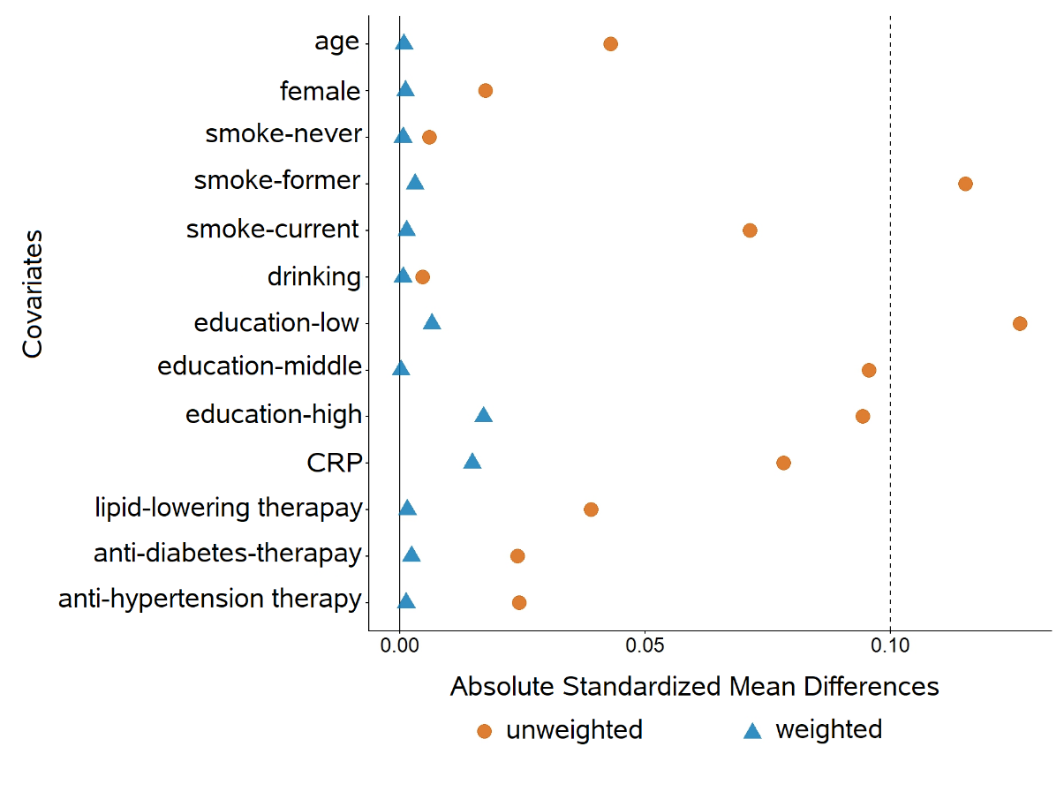

Figure S3. Love plots show differences based on the original unweighted and inverse probability weighted participants.

Table S15. Associations of changes in CMI with CVD with the use of inverse probability weighting (HR (95%CI))
 | Model 1 |  | Model 2
 | HR (95%CI) | P value | HR (95%CI) | P value
Changes in CMI
Stable low | Ref. |  | Ref.
Low to high | 1.25 (1.06, 1.48) | 0.009 | 1.23 (1.04, 1.45) | 0.014
High to low | 1.10 (0.90, 1.34) | 0.357 | 1.09 (0.90, 1.34) | 0.376
Stable high | 1.30 (1.14, 1.49) | 0.0001 | 1.28 (1.12, 1.47) | 0.0004
Model 1 adjusted for age, sex, smoking habit, drinking, education level, LDL-C, glucose, SBP, DBP, hsCRP and medication use of lipid-lowering.
Model 2 additionally adjusted for baseline CMI.

Table S16. Associations of cumulative CMI and ΔCMI with CVD with the use of inverse probability weighting (HR (95%CI))
 | Model 1 |  | Model 2
 | HR (95%CI) | P value | HR (95%CI) | P value
Cumulative CMI
Overall
T1 | Ref. |  | Ref.
T2 | 0.96 (0.86, 1.08) | 0.511 | 0.98 (0.88, 1.10) | 0.735
T3 | 1.02 (0.92, 1.14) | 0.655 | 1.04 (0.93, 1.16) | 0.480
Participants with low baseline CMI
T1 | Ref. |  | Ref.
T2 | 1.14 (0.86, 1.50) | 0.361 | 1.17 (0.88, 1.55) | 0.276
T3 | 1.33 (1.01, 1.76) | 0.044 | 1.37 (1.03, 1.82) | 0.031
Participants with high baseline CMI
T1 | Ref. |  | Ref.
T2 | 1.15 (0.99, 1.32) | 0.064 | 1.15 (0.99, 1.33) | 0.065
T3 | 1.03 (0.91, 1.18) | 0.610 | 1.04 (0.91, 1.18) | 0603
ΔCMI
Overall
ΔT3 | Ref. |  | Ref.
ΔT2 | 0.94 (0.84, 1.05) | 0.279 | 0.94 (0.86, 1.07) | 0.297
ΔT1 | 0.98 (0.88, 1.09) | 0.655 | 0.96 (0.84, 1.05) | 0.480
Participants with low baseline CMI
ΔT3 | Ref. |  | Ref.
ΔT2 | 0.85 (0.73, 1.00) | 0.044 | 0.85 (0.73, 1.00) | 0.046
ΔT1 | 0.75 (0.57, 0.99) | 0.044 | 0.73 (0.55, 0.97) | 0.031
Participants with high baseline CMI
ΔT3 | Ref. |  | Ref.
ΔT2 | 1.11 (0.94, 1.30) | 0.209 | 1.11 (0.94, 1.30) | 0.209
ΔT1 | 0.97 (0.85, 1.10) | 0.610 | 0.97 (0.85, 1.10) | 0.603
Model 1 adjusted for age, sex, smoking habit, drinking, education level, LDL-C, glucose, SBP, DBP, hsCRP and medication use of lipid-lowering.
Model 2 additionally adjusted for baseline CMI.

Table S17. Subgroup analysis of baseline CMI with clinical outcomes in participants with or without hypertension
 | Quartile 1 | Quartile 2 | Quartile 3 | Quartile 4 | P for trend
CVD
Normotension
Event proportion | 305/1558 (19.6) | 332/1439 (23.1) | 319/1244 (25.6) | 283/1036 (27.3)
HR (95%CI) | Ref. | 1.16 (1.00, 1.36) | 1.29 (1.10, 1.51) | 1.36 (1.15, 1.61) | <0.001
Hypertension
Event proportion | 249/733 (34.0) | 303/787 (38.5) | 434/1044 (41.6) | 563/1241 (45.4)
HR (95%CI) | Ref. | 1.12 (0.95, 1.33) | 1.15 (0.98, 1.34) | 1.18 (1.01, 1.37) | 0.045
Heart diseases
Normotension
Event proportion | 309/1566 (19.7) | 333/1446 (23.0) | 321/1250 (25.7) | 283/1042 (27.2)
HR (95%CI) | Ref. | 1.13 (0.96, 1.35) | 1.31 (1.1, 1.56) | 1.29 (1.07, 1.55) | 0.001
Hypertension
Event proportion | 250/735 (34.0) | 303/793 (38.2) | 434/1046 (41.5) | 563/1242 (45.3)
HR (95%CI) | Ref. | 1.03 (0.86, 1.24) | 1.01 (0.85, 1.2) | 1.06 (0.89, 1.26) | 0.522
Stroke
Normotension
Event proportion | 64/1566 (4.1) | 85/1446 (5.9) | 76/1250 (6.1) | 68/1042 (6.5)
HR (95%CI) | Ref. | 1.46 (1.05, 2.02) | 1.50 (1.07, 2.11) | 1.63 (1.15, 2.32) | 0.007
Hypertension
Event proportion | 77/735 (10.5) | 111/793 (14.0) | 155/1046 (14.8) | 223/1242 (18.0)
HR (95%CI) | Ref. | 1.37 (1.02, 1.84) | 1.42 (1.07, 1.88) | 1.65 (1.26, 2.17) | <0.001
Model adjusted for age, sex, smoking habit, drinking, education level, LDL-C, glucose, SBP, DBP, hsCRP and medication use of lipid-lowering.

Table S18. Subgroup analysis of changes in CMI with clinical outcomes in participants with or without hypertension
 | Stable low | Low to high | High to low | Stable high
CVD
Normotension
Event proportion | 191/1146 (16.7) | 128/651 (19.7) | 63/383 (16.4) | 314/1433 (21.9)
HR (95%CI) | Ref. | 1.19 (0.95, 1.49) | 1.06 (0.79, 1.41) | 1.33 (1.10, 1.60)
Hypertension
Event proportion | 132/486 (36.5) | 113/339 (33.3) | 79/246 (32.1) | 522/1480 (35.3)
HR (95%CI) | Ref. | 1.26 (0.98, 1.62) | 1.11 (0.84, 1.47) | 1.16 (0.95, 1.41)
Heart diseases
Normotension
Event proportion | 159/1146 (13.9) | 102/651 (15.7) | 55/383 (14.4) | 270/1433 (18.8)
HR (95%CI) | Ref. | 1.10 (0.86, 1.42) | 1.11 (0.81, 1.50) | 1.34 (1.09, 1.64)
Hypertension
Event proportion | 112/486 (23.0) | 103/339 (30.4) | 69/246 (28.0) | 436/1480 (29.5)
HR (95%CI) | Ref. | 1.33 (1.01, 1.74) | 1.14 (0.84, 1.54) | 1.12 (0.91, 1.39)
Stroke
Normotension
Event proportion | 42/1146 (3.7) | 36/651 (5.5) | 15/383 (3.9) | 75/1433 (5.2)
HR (95%CI) | Ref. | 1.61 (1.02, 2.53) | 1.17 (0.64, 2.11) | 1.50 (1.01, 2.21)
Hypertension
Event proportion | 43/486 (8.8) | 29/339 (8.6) | 19/246 (7.7) | 212/1480 (14.3)
HR (95%CI) | Ref. | 1.02 (0.64, 1.65) | 0.87 (0.51, 1.50) | 1.57 (1.12, 2.21)
Model adjusted for age, sex, smoking habit, drinking, education level, LDL-C, glucose, SBP, DBP, hsCRP and medication use of lipid-lowering.

Table S19. Subgroup analysis of cumulative CMI with CVD in participants with or without hypertension
 | T1 | T2 | T3 | P for trend
Participants with low baseline CMI
Normotension
Event proportion | 26/189 (13.8%) | 161/911 (17.7%) | 132/697 (18.9%)
HR (95%CI) | Ref. | 1.18 (0.78, 1.79) | 1.35 (0.88, 2.07) | 0.115
Hypertension
Event proportion | 22/62 (35.5%) | 110/419 (26.3%) | 113/344 (32.8%)
HR (95%CI) | Ref. | 0.70 (0.44, 1.12) | 0.92 (0.58, 1.48) | 0.346
Participants with high baseline CMI
Normotension
Event proportion | 193/939 (20.6%) | 82/358 (22.9%) | 102/519 (19.7%)
HR (95%CI) | Ref. | 1.05 (0.81, 1.37) | 0.88 (0.68, 1.12) | 0.337
Hypertension
Event proportion | 313/886 (35.3%) | 115/352 (32.7%) | 173/488 (35.5%)
HR (95%CI) | Ref. | 1.02 (0.82, 1.27) | 1.01 (0.83, 1.22) | 0.920
Model adjusted for age, sex, smoking habit, drinking, education level, LDL-C, glucose, SBP, DBP, hsCRP and medication use of lipid-lowering.

Table S20. Subgroup analysis of ΔCMI with CVD in participants with or without hypertension
 | ΔT1 | ΔT2 | ΔT3 | P for trend
Participants with low baseline CMI
Normotension
Event proportion | 26/189 (13.8%) | 161/911 (17.7%) | 132/697 (18.9%)
HR (95%CI) | 0.74 (0.48, 1.13) | 0.87 (0.69, 1.1) | Ref. | 0.280
Hypertension
Event proportion | 22/62 (35.5%) | 110/419 (26.3%) | 113/344 (32.8%)
HR (95%CI) | 1.08 (0.68, 1.73) | 0.76 (0.58, 1.00) | Ref. | 0.045
Participants with high baseline CMI
Normotension
Event proportion | 193/939 (20.6%) | 82/358 (22.9%) | 102/519 (19.7%)
HR (95%CI) | 1.14 (0.89, 1.46) | 1.2 (0.9, 1.61) | Ref. | 0.205
Hypertension
Event proportion | 313/886 (35.3%) | 115/352 (32.7%) | 173/488 (35.5%)
HR (95%CI) | 1.02 (0.8, 1.29 | 1.02 (0.8, 1.29 | Ref. | 0.921
Model adjusted for age, sex, smoking habit, drinking, education level, LDL-C, glucose, SBP, DBP, hsCRP and medication use of lipid-lowering.

Table S21. Subgroup analysis of baseline CMI with clinical outcomes in male and female
 | Quartile 1 | Quartile 2 | Quartile 3 | Quartile 4 | P for trend
CVD
Male
Event proportion | 291/1275 (22.8) | 266/1072 (24.8) | 284/956 (29.7) | 324/954 (34.0)
HR (95%CI) | Ref. | 1.05 (0.89, 1.24) | 1.28 (1.08, 1.51) | 1.41 (1.19, 1.66) | <0.001
Female
Event proportion | 268/1026 (26.1) | 370/1167 (31.7) | 471/1340 (35.1) | 522/1330 (39.2)
HR (95%CI) | Ref. | 1.23 (1.05, 1.44) | 1.26 (1.08, 1.47) | 1.30 (1.12, 1.52) | 0.002
Heart diseases
Male
Event proportion | 233/1275 (18.3) | 206/1072 (19.2) | 224/956 (23.4) | 239/954 (25.1)
HR (95%CI) | Ref. | 1.01 (0.83, 1.21) | 1.24 (1.03, 1.5) | 1.27 (1.05, 1.54) | 0.003
Female
Event proportion | 236/1026 (23.0) | 310/1167 (26.6) | 394/1340 (29.4) | 449/1330 (33.8)
HR (95%CI) | Ref. | 1.15 (0.97, 1.36) | 1.18 (1.00, 1.38) | 1.25 (1.06, 1.47) | 0.012
Stroke
Male
Event proportion | 89/1275 (7.0) | 99/1072 (9.2) | 101/956 (10.6) | 135/954 (14.2)
HR (95%CI) | Ref. | 1.25 (0.93, 1.66) | 1.40 (1.04, 1.87) | 1.77 (1.33, 2.34) | <0.001
Female
Event proportion | 52/1026 (5.1) | 97/1167 (8.3) | 130/1340 (9.7) | 156/1330 (11.7)
HR (95%CI) | Ref. | 1.67 (1.19, 2.34) | 1.75 (1.26, 2.43) | 1.92 (1.39, 2.65) | <0.001
Model adjusted for age, smoking habit, drinking, education level, LDL-C, glucose, SBP, DBP, hsCRP and medication use of lipid-lowering.

Table S22. Subgroup analysis of changes in CMI with clinical outcomes in male and female
 | Stable low | Low to high | High to low | Stable high
CVD
Male
Event proportion | 162/908 (17.8) | 93/433 (21.5) | 63/320 (19.7) | 317/1176 (27.0)
HR (95%CI) | Ref. | 1.31 (1.01, 1.69) | 1.14 (0.85, 1.52) | 1.50 (1.23, 1.83)
Female
Event proportion | 161/724 (22.2) | 148/557 (26.6) | 79/309 (25.6) | 519/1737 (29.9)
HR (95%CI) | Ref. | 1.14 (0.91, 1.43) | 1.09 (0.83, 1.43) | 1.16 (0.96, 1.39)
Heart diseases
Male
Event proportion | 131/908 (14.4) | 77/433 (17.8) | 51/320 (15.9) | 258/1176 (21.9)
HR (95%CI) | Ref. | 1.34 (1.01, 1.79) | 1.13 (0.81, 1.56) | 1.51 (1.22, 1.88)
Female
Event proportion | 140/724 (19.3) | 128/557 (23.0) | 73/309 (23.6) | 448/1737 (25.8)
HR (95%CI) | Ref. | 1.13 (0.89, 1.43) | 1.18 (0.89, 1.57) | 1.14 (0.93, 1.38)
Stroke
Male
Event proportion | 49/908 (5.4) | 30/433 (6.9) | 21/320 (6.6) | 119/1176 (10.1)
HR (95%CI) | Ref. | 1.31 (0.83, 2.07) | 1.24 (0.74, 2.07) | 1.69 (1.20, 2.38)
Female
Event proportion | 36/724 (5.0) | 35/557 (6.3) | 13/309 (4.2) | 168/1737 (9.7)
HR (95%CI) | Ref. | 1.22 (0.76, 1.96) | 0.78 (0.41, 1.49) | 1.66 (1.14, 2.42)
Model adjusted for age, smoking habit, drinking, education level, LDL-C, glucose, SBP, DBP, hsCRP and medication use of lipid-lowering.

Table S23. Subgroup analysis of cumulative CMI with CVD in male and female
 | T1 | T2 | T3 | P for trend
Participants with low baseline CMI
Male
Event proportion | 24/153 (15.7%) | 127/711 (17.9%) | 104/477 (21.8%)
HR (95%CI) | Ref. | 1.07 (0.69, 1.66) | 1.48 (0.95, 2.32) | 0.015
Female
Event proportion | 24/98 (24.5%) | 144/619 (23.3%) | 141/564 (25%)
HR (95%CI) | Ref. | 0.86 (0.56, 1.34) | 0.95 (0.62, 1.48) | 0.723
Participants with high baseline CMI
Male
Event proportion | 198/812 (24.4%) | 83/295 (28.1%) | 99/389 (25.4%)
HR (95%CI) | Ref. | 1.28 (0.99, 1.67) | 1.09 (0.85, 1.4) | 0.339
Female
Event proportion | 176/618 (28.5%) | 176/618 (28.5%) | 176/618 (28.5%)
HR (95%CI) | Ref. | 0.90 (0.72, 1.11) | 0.90 (0.74, 1.09) | 0.244
Model adjusted for age, smoking habit, drinking, education level, LDL-C, glucose, SBP, DBP, hsCRP and medication use of lipid-lowering.

Table S24. Subgroup analysis of ΔCMI with CVD in male and female
 | ΔT1 | ΔT2 | ΔT3 | P for trend
Participants with low baseline CMI
Male
Event proportion | 24/153 (15.7%) | 127/711 (17.9%) | 104/477 (21.8%)
HR (95%CI) | 0.67 (0.43, 1.05) | 0.72 (0.55, 0.94) | Ref. | 0.018
Female
Event proportion | 24/98 (24.5%) | 144/619 (23.3%) | 141/564 (25%)
HR (95%CI) | 1.05 (0.68, 1.63) | 0.91 (0.72, 1.15) | Ref. | 0.412
Participants with high baseline CMI
Male
Event proportion | 198/812 (24.4%) | 83/295 (28.1%) | 99/389 (25.4%)
HR (95%CI) | 0.92 (0.72, 1.17) | 1.18 (0.87, 1.58) | Ref. | 0.361
Female
Event proportion | 308/1013 (30.4%) | 114/415 (27.5%) | 176/618 (28.5%)
HR (95%CI) | 1.11 (0.92, 1.35) | 1.00 (0.79, 1.27) | Ref. | 0.873
Model adjusted for age, smoking habit, drinking, education level, LDL-C, glucose, SBP, DBP, hsCRP and medication use of lipid-lowering.

Table S25. Subgroup analysis of baseline CMI with clinical outcomes in different levels of CRP
 | Quartile 1 | Quartile 2 | Quartile 3 | Quartile 4 | P for trend
CVD
CRP < 1 mg/L
Event proportion | 323/1371 (23.6%) | 320/1215 (26.3%) | 318/1051 (30.3%) | 259/811 (31.9%)
HR (95%CI) | Ref. | 1.10 (0.94, 1.29) | 1.22 (1.04, 1.43) | 1.21 (1.01, 1.43) | 0.012
CRP 1-3 mg/L
Event proportion | 152/599 (25.4%) | 217/670 (32.4%) | 296/844 (35.1%) | 356/943 (37.8%)
HR (95%CI) | Ref. | 1.24 (1.01, 1.54) | 1.22 (0.99, 1.49) | 1.27 (1.04, 1.56) | 0.053
CRP > 3 mg/L
Event proportion | 84/331 (25.4%) | 99/354 (28%) | 141/400 (35.2%) | 231/530 (43.6%)
HR (95%CI) | Ref. | 1.11 (0.83, 1.5) | 1.40 (1.05, 1.86) | 1.53 (1.17, 2.00) | <0.001
Heart diseases
CRP < 1 mg/L
Event proportion | 274/1371 (20%) | 265/1215 (21.8%) | 262/1051 (24.9%) | 216/811 (26.6%)
HR (95%CI) | Ref. | 1.05 (0.88, 1.24) | 1.16 (0.97, 1.38) | 1.14 (0.94, 1.38) | 0.085
CRP 1-3 mg/L
Event proportion | 129/599 (21.5%) | 172/670 (25.7%) | 245/844 (29.0%) | 282/943 (29.9%)
HR (95%CI) | Ref. | 1.15 (0.91, 1.45) | 1.17 (0.93, 1.46) | 1.16 (0.93, 1.45) | 0.250
CRP > 3 mg/L
Event proportion | 66/331 (19.9%) | 79/354 (22.3%) | 111/400 (27.8%) | 190/530 (35.8%)
HR (95%CI) | Ref. | 1.12 (0.80, 1.56) | 1.32 (0.96, 1.82) | 1.51 (1.12, 2.05) | 0.003
Stroke
CRP < 1 mg/L
Event proportion | 69/1371 (5%) | 89/1215 (7.3%) | 90/1051 (8.6%) | 76/811 (9.4%)
HR (95%CI) | Ref. | 1.47 (1.07, 2.02) | 1.61 (1.16, 2.22) | 1.62 (1.15, 2.29) | 0.004
CRP 1-3 mg/L
Event proportion | 41/599 (6.8%) | 67/670 (10%) | 92/844 (10.9%) | 135/943 (14.3%)
HR (95%CI) | Ref. | 1.41 (0.95, 2.11) | 1.37 (0.93, 2.03) | 1.70 (1.17, 2.47) | 0.009
CRP > 3 mg/L
Event proportion | 31/331 (9.4%) | 40/354 (11.3%) | 49/400 (12.2%) | 80/530 (15.1%)
HR (95%CI) | Ref. | 1.25 (0.77, 2.01) | 1.34 (0.84, 2.16) | 1.49 (0.95, 2.34) | 0.082
Model adjusted for age, sex, smoking habit, drinking, education level, LDL-C, glucose, SBP, DBP and medication use of lipid-lowering.

Table S26. Subgroup analysis of changes in CMI with clinical outcomes in different levels of CRP
 | Stable low | Low to high | High to low | Stable high
CVD
CRP < 1 mg/L
Event proportion | 192/993 (19.3%) | 126/563 (22.4%) | 73/334 (21.9%) | 311/1191 (26.1%)
HR (95%CI) | Ref. | 1.16 (0.92, 1.45) | 1.11 (0.84, 1.45) | 1.26 (1.05, 1.52)
CRP 1-3 mg/L
Event proportion | 89/436 (20.4%) | 79/279 (28.3%) | 47/205 (22.9%) | 342/1160 (29.5%)
HR (95%CI) | Ref. | 1.46 (1.08, 1.99) | 1.17 (0.82, 1.67) | 1.35 (1.06, 1.73)
CRP > 3 mg/L
Event proportion | 42/203 (20.7%) | 36/148 (24.3%) | 22/90 (24.4%) | 183/562 (32.6%)
HR (95%CI) | Ref. | 1.14 (0.73, 1.80) | 1.11 (0.66, 1.87) | 1.32 (0.93, 1.89)
Heart diseases
CRP < 1 mg/L
Event proportion | 165/993 (16.6%) | 104/563 (18.5%) | 62/334 (18.6%) | 264/1191 (22.2%)
HR (95%CI) | Ref. | 1.08 (0.84, 1.38) | 1.1 (0.82, 1.47) | 1.23 (1.01, 1.50)
CRP 1-3 mg/L
Event proportion | 75/436 (17.2%) | 68/279 (24.4%) | 41/205 (20%) | 287/1160 (24.7%)
HR (95%CI) |  | 1.47 (1.05, 2.05) | 1.20 (0.82, 1.77) | 1.31 (1.00, 1.71)
CRP > 3 mg/L
Event proportion | 31/203 (15.3%) | 33/148 (22.3%) | 21/90 (23.3%) | 155/562 (27.6%)
HR (95%CI) | Ref. | 1.46 (0.89, 2.40) | 1.50 (0.86, 2.63) | 1.54 (1.02, 2.31)
Stroke
CRP < 1 mg/L
Event proportion | 47/993 (4.7%) | 32/563 (5.7%) | 16/334 (4.8%) | 100/1191 (8.4%)
HR (95%CI) | Ref. | 1.22 (0.78, 1.92) | 0.97 (0.55, 1.71) | 1.62 (1.13, 2.31)
CRP 1-3 mg/L
Event proportion | 20/436 (4.6%) | 22/279 (7.9%) | 10/205 (4.9%) | 125/1160 (10.8%)
HR (95%CI) | Ref. | 1.82 (0.98, 3.38) | 1.13 (0.52, 2.44) | 2.22 (1.35, 3.66)
CRP > 3 mg/L
Event proportion | 18/203 (8.9%) | 11/148 (7.4%) | 8/90 (8.9%) | 62/562 (11.0%)
HR (95%CI) | Ref. | 0.88 (0.41, 1.88) | 0.97 (0.42, 2.26) | 1.11 (0.63, 1.94)
Model adjusted for age, sex, smoking habit, drinking, education level, LDL-C, glucose, SBP, DBP and medication use of lipid-lowering.

Table S27. Subgroup analysis of cumulative CMI with CVD in different levels of CRP
 | T1 | T2 | T3 | P for trend
Participants with low baseline CMI
CRP < 1 mg/L
Event proportion | 32/154 (20.8%) | 154/804 (19.2%) | 132/598 (22.1%)
HR (95%CI) | Ref. | 0.84 (0.57, 1.23) | 1.01 (0.68, 1.50) | 0.402
CRP 1-3 mg/L
Event proportion | 9/56 (16.1%) | 84/375 (22.4%) | 75/284 (26.4%)
HR (95%CI) | Ref. | 1.68 (0.83, 3.37) | 2.01 (0.99, 4.07) | 0.048
CRP > 3 mg/L
Event proportion | 7/41 (17.1%) | 33/151 (21.9%) | 38/159 (23.9%)
HR (95%CI) | Ref. | 0.94 (0.41, 2.15) | 1.12 (0.49, 2.55) | 0.575
Participants with high baseline CMI
CRP < 1 mg/L
Event proportion | 193/799 (24.2%) | 76/306 (24.8%) | 115/420 (27.4%)
HR (95%CI) | Ref. | 1.08 (0.82, 1.41) | 1.12 (0.88, 1.42) | 0.334
CRP 1-3 mg/L
Event proportion | 206/686 (30.0%) | 85/273 (31.1%) | 98/406 (24.1%)
HR (95%CI) | Ref. | 1.03 (0.80, 1.34) | 0.77 (0.61, 0.99) | 0.056
CRP > 3 mg/L
Event proportion | 107/340 (31.5%) | 36/131 (27.5%) | 62/181 (34.3%)
HR (95%CI) | Ref. | 0.91 (0.62, 1.34) | 1.08 (0.78, 1.50) | 0.704
Model adjusted for age, sex, smoking habit, drinking, education level, LDL-C, glucose, SBP, DBP and medication use of lipid-lowering.

Table S28. Subgroup analysis of ΔCMI with CVD in different levels of CRP
 | ΔT1 | ΔT2 | ΔT3 | P for trend
Participants with low baseline CMI
CRP < 1 mg/L
Event proportion | 132/598 (22.1%) | 32/154 (20.8%) | 154/804 (19.2%)
HR (95%CI) | 0.99 (0.67, 1.46) | 0.83 (0.66, 1.05) | Ref. | 0.117
CRP 1-3 mg/L
Event proportion | 75/284 (26.4%) | 9/56 (16.1%) | 84/375 (22.4%)
HR (95%CI) | 0.50 (0.25, 1.01) | 0.83 (0.61, 1.15) | Ref. | 0.301
CRP > 3 mg/L
Event proportion | 38/159 (23.9%) | 7/41 (17.1%) | 33/151 (21.9%)
HR (95%CI) | 0.89 (0.39, 2.04) | 0.84 (0.51, 1.37) | Ref. | 0.479
Participants with high baseline CMI
CRP < 1 mg/L
Event proportion | 115/420 (27.4%) | 193/799 (24.2%) | 76/306 (24.8%)
HR (95%CI) | 0.89 (0.70, 1.13) | 0.96 (0.72, 1.29) | Ref. | 0.711
CRP 1-3 mg/L
Event proportion | 98/406 (24.1%) | 206/686 (30%) | 85/273 (31.1%)
HR (95%CI) | 1.29 (1.01, 1.65) | 1.34 (1.00, 1.79) | Ref. | 0.040
CRP > 3 mg/L
Event proportion | 62/181 (34.3%) | 107/340 (31.5%) | 36/131 (27.5%)
HR (95%CI) | 0.93 (0.67, 1.29) | 0.84 (0.56, 1.27) | Ref. | 0.410
Model adjusted for age, sex, smoking habit, drinking, education level, LDL-C, glucose, SBP, DBP and medication use of lipid-lowering.

Table S29. Changes of factors associated with CVD during follow-up in the participants with high baseline CMI level*
Factors | High to low  (n = 629) | Stable high  (n = 2913) | P value
Quit smoking, n (%) | 34.0 (5.4%) | 147.0 (5.0%) | 0.8
Quit drinking, n (%) | 36.0 (5.7%) | 151.0 (5.2%) | 0.7
Return to normal BMI, n (%) | 65.0 (10.4%) | 191.0 (6.6%) | 0.001
Increase in physical activity, n (%) | 86.0 (40.8%) | 308.0 (29.0%) | 0.001
Return to normal sleep, n (%) | 97.0 (15.8%) | 353.0 (12.4%) | 0.027
Start Nap, n (% | 89.0 (14.4%) | 469.0 (16.4%) | 0.3
Increase in hsCRP, n (%) | 98.0 (15.6%) | 792.0 (27.2%) | <0.001
Start lipid-lowering drugs, n (%) | 26.0 (4.1%) | 220.0 (7.6%) | 0.003
New diabetic diagnostic, n (%) | 55.0 (8.7%) | 415.0 (14.2%) | <0.001
New hypertension diagnostic, n (%) | 69.0 (11.0%) | 317.0 (10.9%) | >0.9
* Only the participants with measurements at both baseline and follow-up (Wave 3) were included.
Definitions: Quit smoking - current smoker at baseline who quit at Wave 3. Quit drinking -current drinker at baseline who quit at Wave 3. Return to normal BMI – baseline BMI<18.5 or >24, and BMI 18.5~24 at Wave 3. Increase in physical activity – mild or walking at baseline and moderate-to-vigorous at Wave 3. Return to normal sleep - sleep <6 hours/night at baseline, and >6 hours/night at Wave 3. Start Nap - no nap at baseline, and nap taken at Wave 3. Increase in hsCRP - hsCRP <2 mg/L at baseline, and hsCRP >2 mg/L at Wave 3. New diabetes/hypertension diagnosis – newly diagnosed between baseline and Wave 3.

Table S30. Incremental value of adding changes in CMI to baseline model
 | Value/slope | 95%CI
Δ C-statistic | 0.007 | (0.003, 0.012)
IDI | 0.002 | (0.0007, 0.0035)
Continuous NRI | 0.274 | (0.135, 0.364)
Category-free NRI | 0.018 | (-0.018, 0.051)
Calibration slope-base model | 0.841 | (0.630, 1.050)
Calibration slope-extended model | 0.906 | (0.700, 1.110)
IDI: integrated discrimination improvement;
Continuous NRI: category-free net reclassification improvement;
Category-based NRI: calculated using predefined risk categories (<5%, 5-10% and >10%).
Base model including baseline CMI, age, sex, smoking habit, drinking, education level, LDL-C, glucose, SBP, DBP and medication use of lipid-lowering.
Extended model including baseline CMI, age, sex, smoking habit, drinking, education level, LDL-C, glucose, SBP, DBP, medication use of lipid-lowering and changes in CMI.

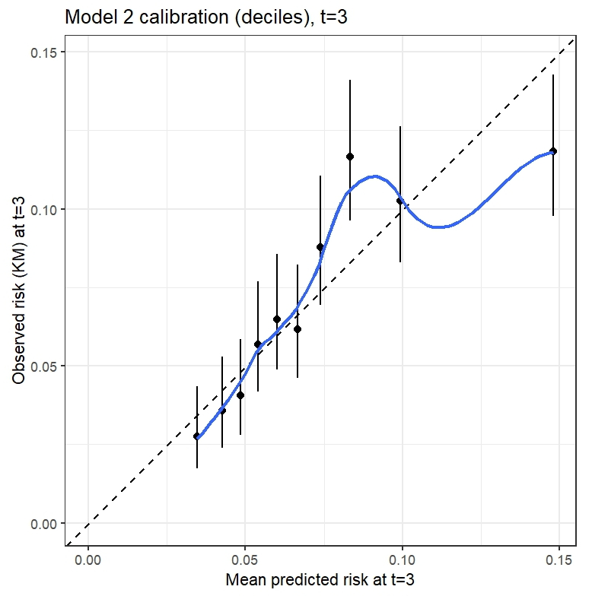

Figure S4. Decile-based calibration plots at 3-year.

Table S31. Fine-Gray competing-risks regression for cardiovascular mortality
Variable | SHR | 95%CI | P value
Quartiles of baseline CMI
Q2 vs Q1 | 1.15 | 1.03–1.29 | 0.012
Q3 vs Q1 | 1.27 | 1.14–1.42 | <0.001
Q4 vs Q1 | 1.34 | 1.20–1.49 | <0.001
Age (per year) | 1.03 | 1.02–1.03 | <0.001
Male sex | 1.13 | 1.02–1.25 | 0.015
Smoking* | 0.92 | 0.83–1.02 | 0.104
Drinking | 0.98 | 0.90–1.07 | 0.646
Higher education* | 1.43 | 1.06–1.92 | 0.018
Lipid-lowering medication | 1.92 | 1.73–2.14 | <0.001
LDL-C | 1.04 | 1.00–1.08 | 0.066
SBP | 1.00 | 1.00–1.01 | 0.003
DBP | 1.01 | 1.00–1.01 | <0.001
Glucose | 1.01 | 1.00–1.03 | 0.131
CRP | 1.00 | 1.00–1.01 | 0.574
*the “never” and “former” categories of the smoking habits variable was combined into one; the “low” and “Middle” of education level variable was combined into one.
SHR: sub-distribution hazard ration. Cardiovascular disease was treated as the event of interest, and non-cardiovascular death was treated as a competing event.

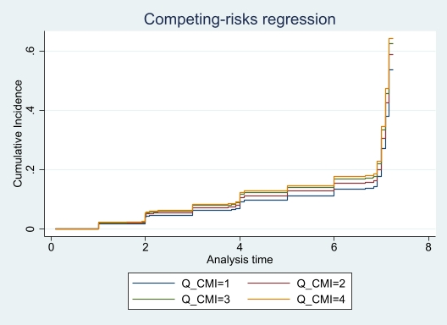

Figure S5. The cumulative incidence of CVD according to quartiles of baseline CMI, accounting for non-cardiovascular death as a competing event.

Reference
1. Chen X, Crimmins E, Hu P, et al. Venous Blood-based Biomarkers in the China Health and Retirement Longitudinal Study: Rationale, Design, and Results of the 2015 Wave. American Journal of Epidemiology. 2019;188(11):1871–1877.
2. Zhao Y, Hu Y, Smith JP, Strauss J, Yang G. Cohort Profile: The China Health and Retirement Longitudinal Study (CHARLS). International Journal of Epidemiology. 2012;43(1):61-68.
3. He D, Wang Z, Li J, et al. Changes in frailty and incident cardiovascular disease in three prospective cohorts. European Heart Journal. 2024;45(12):1058-1068.
4. White IR, Royston P, Wood AM. Multiple imputation using chained equations: Issues and guidance for practice. Statistics in medicine. 2011;30(4):377-399.

