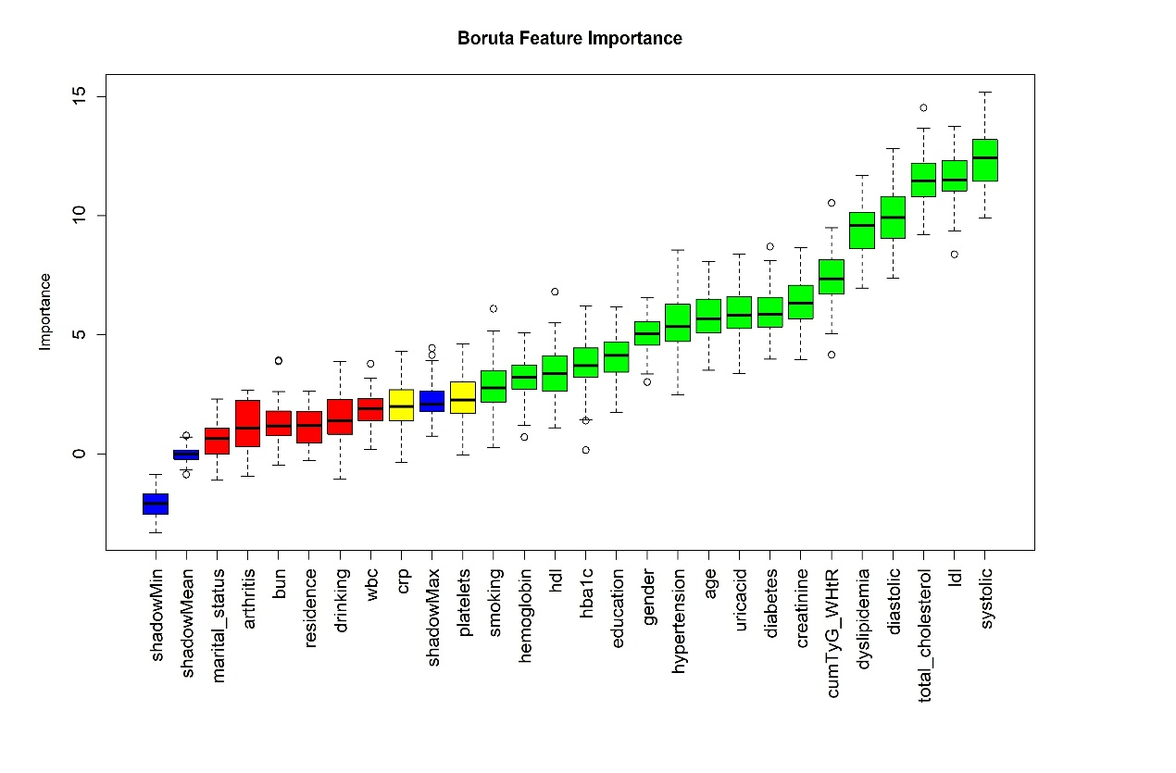
Fig.S1 Feature selection for predicting CVD incidence risk via the Boruta algorithm. The horizontal axis represents the name of each variable, and the vertical axis represents the Z value of each variable. The box plot shows the Z value of each variable during model calculation. The green boxes represent important variables, and the red boxes represent unimportant variables.

