Supplementary Tables
Supplementary Table 1. Literature Search Strategy.
Database | Search Strategy
PubMed | ("Left Atrial Appendage Closure"[MeSH] OR "LAAC"[tiab] OR "Left Atrial Appendage Occlusion"[tiab] OR "LAAO"[tiab])AND (("Direct Oral Anticoagulants"[MeSH] OR "DOAC"[tiab] OR "NOAC"[tiab] OR "non-vitamin K antagonist oral anticoagulant"[tiab] OR "novel oral anticoagulant"[tiab] OR "rivaroxaban"[tiab] OR "apixaban"[tiab] OR "edoxaban"[tiab] OR "dabigatran"[tiab])OR ("Warfarin"[MeSH] OR "VKA"[tiab] OR "Vitamin K Antagonists"[MeSH] OR "vitamin K antagonist"[tiab]))
Embase | ('Left Atrial Appendage Closure'/exp OR 'Left Atrial Appendage Occlusion'/exp OR ('LAAC'/ti,ab OR 'Left Atrial Appendage Closure'/ti,ab OR 'LAAO'/ti,ab OR 'Left Atrial Appendage Occlusion'/ti,ab))  AND  ('Non-vitamin K Antagonist Oral Anticoagulants'/exp OR 'Direct Oral Anticoagulant'/exp OR ('DOAC'/ti,ab OR 'NOAC'/ti,ab OR 'Direct Oral Anticoagulant'/ti,ab OR 'Non-vitamin K Antagonist Oral Anticoagulant'/ti,ab OR 'Novel Oral Anticoagulants'/ti,ab OR 'Rivaroxaban'/ti,ab OR 'Apixaban'/ti,ab OR 'Edoxaban'/ti,ab OR 'Dabigatran'/ti,ab))  OR ('Warfarin'/exp OR 'Warfarin'/ti,ab OR 'VKA'/ti,ab OR 'Vitamin K Antagonists'/exp OR 'Vitamin K Antagonist'/ti,ab)
Cochrane Library | ("Left Atrial Appendage Closure" OR "LAAC" OR "Left Atrial Appendage Occlusion" OR "LAAO")  AND  ("Direct Oral Anticoagulants" OR "DOAC" OR "Non-vitamin K Antagonist Oral Anticoagulant" OR "Novel Oral Anticoagulants" OR "Rivaroxaban" OR "Apixaban" OR "Edoxaban" OR "Dabigatran")  OR ("Warfarin" OR "VKA" OR "Vitamin K Antagonists")  AND  ("Postoperative" OR "Post-surgery" OR "Post-procedure")
Web of Science | TS=("Left Atrial Appendage Closure" OR "LAAC" OR "Left Atrial Appendage Occlusion" OR "LAAO")  AND  TS=("Direct Oral Anticoagulants" OR "DOAC" OR "Non-vitamin K Antagonist Oral Anticoagulant" OR "Novel Oral Anticoagulants" OR "Rivaroxaban" OR "Apixaban" OR "Edoxaban" OR "Dabigatran")  OR TS=("Warfarin" OR "VKA" OR "Vitamin K Antagonists")  AND  TS=("Postoperative" OR "Post-surgery" OR "Post-procedure")

Supplementary Table 2. Definitions of Major Bleeding Used Across Studies
Definition of Major Bleeding | Source
ISTH Major Bleeding | International Society on Thrombosis and Haemostasis (ISTH)
BARC Major Bleeding | Bleeding Academic Research Consortium (BARC)
Site-defined (Details in study) | Site-specific criteria (Details provided in the original study)
ISTH Major Bleeding | International Society on Thrombosis and Haemostasis (ISTH)
Site-defined (Details in study) | Site-specific criteria (Details provided in the original study)
BARC Major Bleeding | Bleeding Academic Research Consortium (BARC)
ISTH Major Bleeding | International Society on Thrombosis and Haemostasis (ISTH)
Site-defined (Details in study) | Site-specific criteria (Details provided in the original study)
BARC Major Bleeding | Bleeding Academic Research Consortium (BARC)
ISTH Major Bleeding | International Society on Thrombosis and Haemostasis (ISTH)

Supplementary Table 3
Components contributing to the exploratory “any major adverse event” composite outcome by study
Study | Major bleeding | Stroke/SE/TIA | Device-related thrombosis | All-cause mortality | Included in exploratory composite
Ajmal M et al. (2022) [18] | Reported | Reported | NR | NR | Yes
Apte N.M. et al. (2019) [19] | Reported | NR | Reported | NR | Yes
Bergmann M.W. et al. (2017) [20] | Reported | Reported | Reported | Reported | Yes
Chen Y et al. (2021) [21] | Reported | Reported | Reported | NR | Yes
Cohen J.A. et al. (2019) [22] | Reported | Reported | Reported | NR | Yes
Enomoto Y et al. (2017) [23] | Reported | Reported | Reported | NR | Yes
Freeman J.V. et al. (2022) [24] | Reported | Reported | Reported | Reported | Yes
Fry E et al. (2021) [25] | Reported | Reported | Reported | NR | Yes
Fu G et al. (2022) [26] | Reported | Reported | Reported | NR | Yes
Fu G. et al. (2019) [27] | NR | NR | Reported | NR | No
Ge H et al. (2022) [28] | Reported | Reported | Reported | NR | Yes
Preda A et al. (2025) [29] | Reported | Reported | Reported | Reported | Yes
Qiao Z. et al. (2018) [30] | NR | NR | Reported | NR | No
Reinhardt S.W. et al. (2024) [31] | Reported | Reported | Reported | Reported | Yes
Su F et al. (2022) [32] | Reported | Reported | Reported | Reported | Yes
Tan B.E.-X. et al. (2020) [33] | NR | NR | NR | NR | No
Tan B.E. et al. (2022) [34] | Reported | Reported | Reported | NR | Yes
Tjoe B. et al. (2021) [35] | Reported | Reported | Reported | NR | Yes
Yao Y et al. (2025) [36] | Reported | Reported | Reported | Reported | Yes
Zhou X.D. et al. (2023) [37] | Reported | Reported | Reported | NR | Yes
Zhu J et al. (2021) [38] | Reported | Reported | Reported | NR | Yes
Abbreviations: SE, systemic embolism; TIA, transient ischemic attack; NR, not reported.
Note: The composite outcome was analyzed as exploratory because not all studies reported all component endpoints consistently.

Supplementary Table 4. GRADE Certainty of Evidence for Key Outcomes

Outcome | Certainty of Evidence | Rationale
Major Bleeding | Moderate | Serious risk of bias (confounding/selection bias), moderate inconsistency (I² = 28-29%)
Stroke/SE/TIA | Moderate | Risk of bias, low imprecision, but some inconsistency (I² = 4.1%)
Any Major Adverse Event | Low | High risk of bias (selection/confounding), publication bias

Supplementary Table 5. Assessment of quality of studies.
Study | Q1 | Q2 | Q3 | Q4 | Q5 | Q6 | Q7 | Q8 | Total Score | Overall Rating
Ajmal M et al.(2022) | 0 | 1 | 1 | 1 | 1 | 1 | 1 | 0 | 6 | Moderate quality
Apte N.M. et al.(2019) | 1 | 0 | 1 | 1 | 1 | 1 | 1 | 0 | 6 | Moderate quality
Bergmann MW et al.(2017) | 1 | 1 | 1 | 1 | 2 | 1 | 1 | 1 | 9 | High quality
Chen Y et al.(2021) | 1 | 1 | 1 | 1 | 2 | 1 | 1 | 1 | 9 | High quality
Cohen JA et al.(2019) | 1 | 1 | 1 | 1 | 1 | 1 | 1 | 1 | 8 | High quality
Enomoto Y et al.(2017) | 1 | 1 | 1 | 1 | 2 | 1 | 1 | 1 | 9 | High quality
Freeman JV et al.(2022) | 1 | 1 | 1 | 1 | 2 | 1 | 1 | 1 | 9 | High quality
Fry E et al.(2021) | 1 | 1 | 1 | 1 | 1 | 1 | 1 | 1 | 8 | High quality
Fu G et al.(2022) | 1 | 1 | 1 | 1 | 1 | 1 | 1 | 1 | 8 | High quality
Fu G. et al.(2019) | 1 | 1 | 1 | 1 | 1 | 1 | 1 | 1 | 8 | High quality
Ge H et al.(2022) | 1 | 1 | 1 | 1 | 1 | 1 | 1 | 0 | 7 | High quality
Preda A et al.(2025) | 1 | 1 | 1 | 1 | 1 | 1 | 1 | 0 | 7 | High quality
Qiao Z. et al.(2018) | 1 | 0 | 1 | 1 | 1 | 1 | 0 | 1 | 6 | Moderate quality
Reinhardt SW et al.(2024) | 1 | 1 | 1 | 1 | 1 | 1 | 1 | 0 | 7 | High quality
Su F et al.(2022) | 1 | 0 | 1 | 1 | 1 | 1 | 1 | 1 | 7 | High quality
Tan B.E.-X. et al.(2020) | 1 | 1 | 1 | 1 | 2 | 1 | 1 | 1 | 9 | High quality
Tan BE et al.(2022) | 1 | 1 | 1 | 1 | 2 | 1 | 1 | 1 | 9 | High quality
Tjoe B. et al.(2021) | 1 | 1 | 1 | 1 | 2 | 1 | 1 | 1 | 9 | High quality
Yao Y et al.(2025) | 1 | 1 | 1 | 1 | 2 | 1 | 1 | 1 | 9 | High quality
Zhou XD et al.(2023) | 1 | 1 | 1 | 1 | 1 | 1 | 1 | 0 | 7 | High quality
Zhu J et al.(2021) | 1 | 1 | 1 | 1 | 1 | 1 | 1 | 1 | 8 | High quality
Notes: Quality assessment was performed using the Newcastle–Ottawa Scale (NOS). Q1: Was the exposed cohort truly representative of the general population? Q2: Was the selection of the non-exposed cohort appropriate? Q3: Was the ascertainment of exposure reliable? Q4: Was it demonstrated that the outcome of interest was not present at the start of the study? Q5: Were appropriate controls for comparability implemented in the study design or analysis? Q6: Was the assessment of outcomes adequate? Q7: Was the follow-up period sufficiently long for outcomes to occur? Q8: Was the follow-up of cohorts adequate? Scoring: Each question was answered with a score.Total scores range from 0 to 9, with higher scores indicating better quality. Studies scoring 7-9 were considered high quality, 4-6 moderate quality, and 0-3 low quality. Of the included studies, three were rated as moderate quality and eighteen as high quality.

Supplementary Table 6
Components Contributing to the Exploratory Composite Outcome of Any Major Adverse Event
Study | Major bleeding | Stroke/SE/TIA | Device-related thrombosis | All-cause mortality | Included in composite
Ajmal et al., 2022 | Reported | Reported | Not reported | Not reported | Yes
Apte et al., 2019 | Reported | Not reported | Reported | Not reported | Yes
Bergmann et al., 2017 | Reported | Reported | Reported | Reported | Yes
Chen et al., 2021 | Reported | Reported | Reported | Not reported | Yes
Cohen et al., 2019 | Reported | Reported | Reported | Not reported | Yes
Enomoto et al., 2017 | Reported | Reported | Reported | Not reported | Yes
Freeman et al., 2022 | Reported | Reported | Reported | Reported | Yes
Fry et al., 2021 | Reported | Reported | Reported | Not reported | Yes
Fu et al., 2022 | Reported | Reported | Reported | Not reported | Yes
Ge et al., 2022 | Reported | Reported | Reported | Not reported | Yes
Preda et al., 2025 | Reported | Reported | Reported | Reported | Yes
Reinhardt et al., 2024 | Reported | Reported | Reported | Reported | Yes
Su et al., 2022 | Reported | Reported | Reported | Reported | Yes
Tan et al., 2022 | Reported | Reported | Reported | Not reported | Yes
Tjoe et al., 2021 | Reported | Reported | Reported | Not reported | Yes
Yao et al., 2025 | Reported | Reported | Reported | Reported | Yes
Zhou et al., 2023 | Reported | Reported | Reported | Not reported | Yes
Zhu et al., 2021 | Reported | Reported | Reported | Not reported | Yes
Abbreviations: SE, systemic embolism; TIA, transient ischemic attack.
Note: The composite outcome was considered exploratory because component endpoints were not reported uniformly across all studies. The certainty of evidence for this composite was therefore lower than that for major bleeding and stroke/SE/TIA.

Supplementary figure
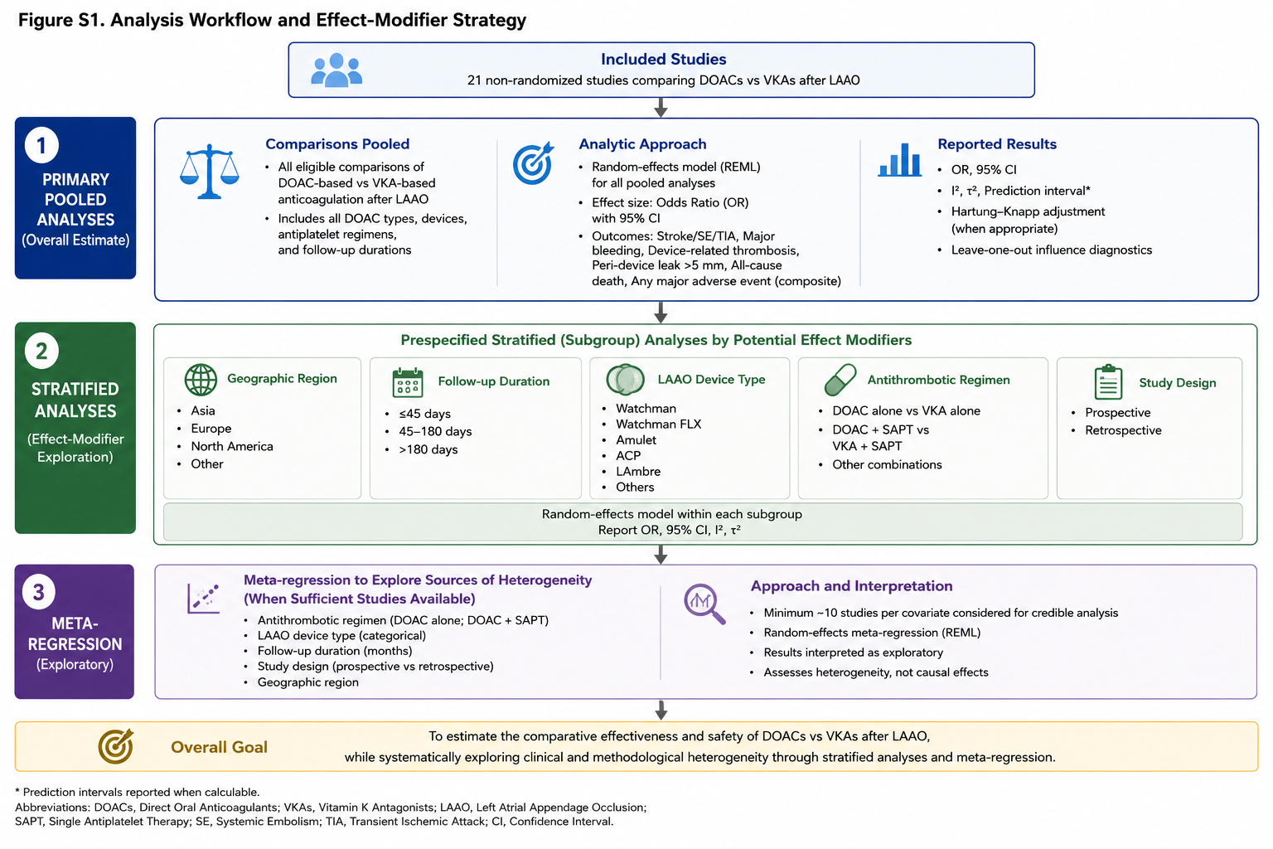
Figure S1 Analysis Workflow and Effect-Modifier Strategy.

