Supplementary File 1.

Association of left ventricular end-systolic volume with peri-echocardiographic acute kidney injury proxy beyond ejection fraction

Supplementary Methods
All supplementary tables used the locked analytical cohort of 1,022 studies with complete biplane LVEF and LVESV measurements. Temporal analyses were limited to the 80 AKI-positive studies in this cohort. Sensitivity analyses retained the same core clinical covariates as the main model unless otherwise specified. BMI sensitivity analysis used complete cases with plausible BMI values and observed SOFA.
Table S1. Comorbidity profile by AKI proxy status.
Variable | No AKI proxy (n = 942) | AKI proxy (n = 80) | P value
Chronic kidney disease | 210 (22.3%) | 67 (83.8%) | <0.001
Diabetes mellitus | 289 (30.7%) | 49 (61.3%) | <0.001
Heart failure | 331 (35.1%) | 52 (65.0%) | <0.001
Hypertension | 654 (69.4%) | 70 (87.5%) | <0.001
Coronary artery disease | 329 (34.9%) | 45 (56.2%) | <0.001
Atrial fibrillation | 289 (30.7%) | 38 (47.5%) | 0.003
COPD or asthma | 179 (19.0%) | 21 (26.2%) | 0.141
Table S2. Peri-echocardiographic nephrotoxic drug exposure.
Variable | No AKI proxy (n = 942) | AKI proxy (n = 80) | P value
Any nephrotoxic exposure | 60 (6.4%) | 20 (25.0%) | <0.001
Aminoglycoside | 2 (0.2%) | 1 (1.2%) | 0.217
Vancomycin | 53 (5.6%) | 20 (25.0%) | <0.001
NSAID | 11 (1.2%) | 0 (0.0%) | 1.000
ACE inhibitor or ARB | 106 (11.3%) | 14 (17.5%) | 0.103
Loop diuretic | 157 (16.7%) | 44 (55.0%) | <0.001
Intravenous contrast | 0 (0.0%) | 0 (0.0%) | 1.000
Amphotericin | 0 (0.0%) | 0 (0.0%) | 1.000
Table S3. Temporal relationship between echocardiography and the AKI proxy threshold.
Category | Studies | Percent | Summary
Threshold before echocardiography | 73 | 91.3% | Median -30 h (range -445 to -1)
Threshold after echocardiography | 7 | 8.8% | Median +13 h (range 5 to 20)
Admission baseline creatinine, pre-echo subgroup | 73 |  | Median 3.0 mg/dL
Admission baseline creatinine, post-echo subgroup | 7 |  | Median 1.8 mg/dL

Table S4. Model discrimination and fit.
Model | C-statistic | AIC | BIC | HL χ² | HL P value | NRI vs previous | IDI vs previous
Model 1 (clinical baseline) | 0.720 | 518.0 | 542.7 | 14.66 | 0.066
Model 2 (+ LVEF) | 0.717 | 519.7 | 549.2 | 6.35 | 0.608 | +0.096 | +0.002
Model 3 (+ LVEF + LVESV) | 0.727 | 517.0 | 551.5 | 16.99 | 0.030 | +0.155* | +0.008*
* NRI and IDI compare Model 3 with Model 2; reclassification gains were modest and were driven mainly by non-event movement.
Table S5. Variance inflation factors for Model 3.
Variable | VIF
Age | 1.04
Male sex | 1.17
First-day SOFA score | 1.08
Vasopressor exposure | 1.07
LVEF | 2.27
LVESV | 2.57
Pearson correlation between LVEF and LVESV: r = -0.73 (r² = 0.54).
Table S6. Cohort composition by care setting and admission characteristics.
Characteristic | No AKI proxy (n = 942) | AKI proxy (n = 80) | P value
ICU studies | 443 (47.0%) | 69 (86.2%) | <0.001
Non-ICU studies | 499 (53.0%) | 11 (13.8%)
Medical service | 760 (80.7%) | 76 (95.0%) | 0.005
Surgical service | 132 (14.0%) | 4 (5.0%)
Other service | 50 (5.3%) | 0 (0.0%)
Emergency admission | 271 (28.8%) | 40 (50.0%) | <0.001
Elective admission | 20 (2.1%) | 3 (3.8%)
Observation admission | 469 (49.8%) | 36 (45.0%)
Other admission category | 182 (19.3%) | 1 (1.2%)
Table S7. ICU subgroup analysis and care-setting interaction.
Analysis | N | Events | AKI rate | LVESV OR | 95% CI | P value | C-statistic
ICU subgroup | 512 | 69 | 13.5% | 1.47 | 1.09-1.97 | 0.011 | 0.735
Non-ICU subgroup | 510 | 11 | 2.2% | Not estimated | Low EPV | Exploratory
LVESV × ICU interaction | 1022 | 80 | 7.8% | 0.64 | 0.36-1.17 | 0.145
Non-ICU multivariable modeling was treated as exploratory because only 11 events remained in that stratum.

Table S8. Sensitivity analyses for LVESV-AKI proxy association.
Analysis | N | Events | LVESV OR | 95% CI | P value | C-statistic
Primary model | 1022 | 80 | 1.40 | 1.10-1.78 | 0.006 | 0.727
Nephrotoxic + loop-diuretic adjusted | 1022 | 80 | 1.32 | 1.05-1.66 | 0.017 | 0.800
CKD adjusted | 1022 | 80 | 1.29 | 0.94-1.78 | 0.112 | 0.891
CKD + diabetes + nephrotoxic + loop-diuretic adjusted | 1022 | 80 | 1.19 | 0.88-1.62 | 0.260 | 0.908
RRT-proxy adjusted | 1022 | 80 | 1.20 | 0.87-1.66 | 0.266 | 0.784
Post-echo AKI analyses were not emphasized because only 7 AKI-positive studies remained after temporal restriction.
Table S9. BMI-adjusted complete-case sensitivity analysis.
Analysis | N | Events | LVESV OR | 95% CI | P value | BMI OR per 5 kg/m² | 95% CI | P value | C-statistic
BMI-adjusted complete-case model | 484 | 65 | 1.40 | 1.04-1.90 | 0.029 | 1.04 | 0.80-1.34 | 0.791 | 0.716
BMI was available for 963 of 1,022 studies; one implausible BMI value outside 10-80 kg/m² was excluded. Complete-case restriction for observed SOFA and BMI yielded 484 studies and 65 AKI-proxy events.

Supplementary Figures

Figure S1: Temporal relationship between echocardiography and AKI proxy threshold. Description: Panel A shows the distribution of hours from echocardiography to the first serum creatinine value ≥2.0 mg/dL among 80 AKI-proxy positive studies (negative values indicate threshold crossing before echocardiography). Panel B shows the count of studies in each category.

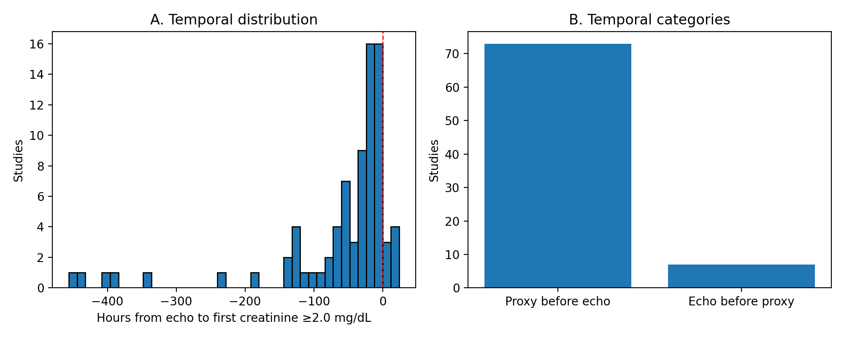

Figure S2: Decision-curve analysis. Description: Net benefit curves for Model 1 (clinical baseline), Model 2 (+ LVEF), and Model 3 (+ LVEF + LVESV) across threshold probabilities, showing the incremental gain of adding LVESV to the clinical model.
