Supplementary Figure S1
Receiver operating characteristic (ROC) curve of puncture-to-wire time for prediction of the clinical composite endpoint. The area under the curve (AUC) was 0.564.
Supplementary Figure S2
Receiver operating characteristic (ROC) curve of puncture-to-wire time for prediction of the procedural composite endpoint. The area under the curve (AUC) was 0.567.
Supplementary Figure 1
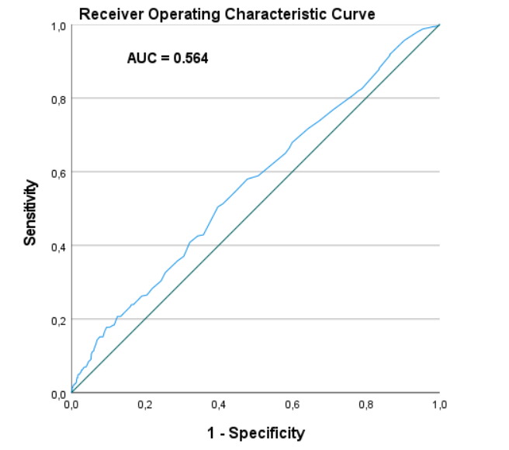
Supplementary Figure 2
