SUPPLEMENTARY TABLES

Supplementary Table 1: Absolute numbers of Chronic Kidney Disease and Valvular Heart Diseases-Related Deaths Stratified by Sex and Race/Ethnicity in the United States, 1999-2023

Year | Overall | Female | Male | NH Black or African American | NH White | NH American Indian or Alaska Native | NH Asian or Pacific Islander | Hispanic or Latino
1999 | 1424 | 727 | 697 | 219 | 1109 | Suppressed | 29 | 62
2000 | 1483 | 757 | 726 | 184 | 1176 | 10 | 36 | 77
2001 | 1598 | 799 | 799 | 205 | 1271 | Suppressed | 41 | 73
2002 | 1694 | 819 | 875 | 228 | 1344 | 12 | 43 | 67
2003 | 1732 | 842 | 890 | 234 | 1368 | 10 | 36 | 84
2004 | 1747 | 844 | 903 | 222 | 1379 | Suppressed | 46 | 92
2005 | 1955 | 964 | 991 | 244 | 1560 | Suppressed | 37 | 106
2006 | 1841 | 885 | 956 | 204 | 1489 | 13 | 42 | 93
2007 | 1825 | 884 | 941 | 245 | 1450 | Suppressed | 35 | 90
2008 | 1882 | 943 | 939 | 215 | 1511 | 12 | 52 | 92
2009 | 1945 | 966 | 979 | 238 | 1517 | 13 | 52 | 125
2010 | 2023 | 1008 | 1015 | 244 | 1569 | 20 | 61 | 129
2011 | 4083 | 2049 | 2034 | 382 | 3345 | 19 | 118 | 219
2012 | 4223 | 2061 | 2162 | 415 | 3425 | 20 | 107 | 256
2013 | 2942 | 1385 | 1557 | 280 | 2420 | 14 | 90 | 138
2014 | 2908 | 1360 | 1548 | 260 | 2425 | 12 | 81 | 130
2015 | 3284 | 1553 | 1731 | 310 | 2683 | 10 | 88 | 193
2016 | 3464 | 1622 | 1842 | 312 | 2831 | 25 | 103 | 193
2017 | 3678 | 1795 | 1883 | 359 | 2987 | 21 | 95 | 216
2018 | 3868 | 1961 | 1907 | 402 | 3129 | 20 | 100 | 217
2019 | 4149 | 2016 | 2133 | 423 | 3328 | 31 | 124 | 243
2020 | 4329 | 2150 | 2179 | 451 | 3458 | 34 | 142 | 244
2021 | 4518 | 2131 | 2387 | 435 | 3645 | 23 | 130 | 285
2022 | 4443 | 2149 | 2294 | 491 | 3500 | 27 | 139 | 286
2023 | 4374 | 2124 | 2250 | 488 | 3430 | 22 | 144 | 290

Supplementary Table 2: Trends in Chronic Kidney Disease and Valvular Heart Diseases-Related Stratified by Location of Death in the United States, 1999-2023
Place of Death | Death | Percentage
Medical Facility - Inpatient | 35,872 | 50.48%
Medical Facility - Outpatient or ER | 2,641 | 3.92%
Medical Facility - Dead on Arrival | 149 | 0.24%
Medical Facility - Status unknown | 39 | 0.07%
Decedent's home | 15,851 | 21.36%
Hospice facility | 3,407 | 4.27%
Nursing home/long term care | 10,990 | 16.21%
Other | 96 | 3.29%

Supplementary Table 3: Annual Percentage Change (APC) and Average Annual Percentage Change Difference (AAPCD) with 95% Confidence Intervals (CI) and P-values for the overall population, sex, race/ ethnicity, census region, and urbanization status.
Annual Percentage Change; 95% CI; P-value
Overall and Sex
Overall | 1999-2023 (AAPC: 3.22*; 95 % CI: 2.20 to 4.26; p= 0.000001
Male | 1999-2023 (AAPC: 2.94*; 95% CI: 1.89 to 4.01; p= 0.000006
Female | 1999-2023 (AAPC: 3.31*; 95% CI: 2.25 to 4.38; p= 0.000001
Race
NH Asian or Pacific Islander | 1999-2023 (AAPC: 0.32; 95% CI: -4.91 to 5.83; p=0.907509
NH Black or African American | 1999-2023 (AAPC: 1.48*; 95% CI: 0.63 to 2.35; p=0.001528
NH White | 1999-2023 (AAPC: 3.91*; 95% CI: 2.82 to 5.01; p<0.000001
Hispanic or Latino | 1999-2023 (AAPC: 1.59*; 95% CI: 0.25 to 2.94; p=0.022049
Age
25-44 years | 1999-2023 (AAPC: 1.65*; 95% CI: 0.32 to 2.99; p= 0.016821
45 to 64 years | 1999-2023 (AAPC: 2.12*; 95% CI: 0.15 to 4.13; p= 0.035074
65 years and older | 1999-2023 (AAPC: 2.90*; 95% CI: 1.71 to 4.10; p= 0.000037
Census region
Northeast | 1999-2023 (AAPC: 2.85*; 95% CI: 1.94 to 3.77; p= 0.000001
Midwest | 1999-2023 (AAPC: 4.06*; 95% CI: 2.94 to 5.20; p< 0.000001
South | 1999-2023 (AAPC: 2.76*; 95% CI: 1.82 to 3.70; p= 0.000003
West | 1999-2023 (AAPC: 3.53*; 95% CI: 2.25 to 4.82; p= 0.000007
Urban-Rural Classification
Urban | 1999-2023 (AAPC: 3.36*; 95% CI: 2.02 to 4.71; p= 0.000034
Rural | 1999-2020 (AAPC: 4.04*; 95% CI: 2.61 to 5.50; p= 0.000008
Individual disease
Valvular Heart Diseases | 1999-2023 (AAPC: -0.24; 95% CI: -0.59 to 0.10; p= 0.163920
Chronic Kidney disease | 1999-2023 (AAPC: 1.42*; 95% CI: 0.52 to 2.34; p= 0.003449
Comparison between Combined Disease versus Individual Disease related mortality
Combined versus Valvular Heart Diseases | 1999-2023 (AAPCD: 3.47; 95% CI: 2.43 to 4.50; p<0.000001
Combined versus Chronic Kidney Disease | 1999-2023 (AAPCD: 1.80; 95% CI: 0.50 to 3.10; p= 0.006832
Supplementary Table 4: Overall and Sex-Stratified Chronic Kidney Disease and Valvular Heart Diseases-Related Age-Adjusted Mortality Rates per 100,000 in the United States, 1999 to 2023
Year | Overall | Female | Male
1999 | 0.8198 | 0.679 | 1.0371
2000 | 0.8262 | 0.6984 | 1.0889
2001 | 0.8801 | 0.7148 | 1.1482
2002 | 0.9141 | 0.7355 | 1.2471
2003 | 0.9374 | 0.7338 | 1.2583
2004 | 0.9152 | 0.7314 | 1.2165
2005 | 1.015 | 0.8231 | 1.3338
2006 | 0.9421 | 0.7317 | 1.2556
2007 | 0.8927 | 0.7124 | 1.2291
2008 | 0.9164 | 0.7605 | 1.1825
2009 | 0.9393 | 0.7488 | 1.1715
2010 | 0.9609 | 0.8115 | 1.2027
2011 | 1.8505 | 1.5471 | 2.3797
2012 | 1.8578 | 1.4942 | 2.4477
2013 | 1.2639 | 0.9741 | 1.7082
2014 | 1.2179 | 0.9348 | 1.6221
2015 | 1.3282 | 1.0687 | 1.802
2016 | 1.4047 | 1.0839 | 1.8667
2017 | 1.4467 | 1.1973 | 1.861
2018 | 1.4965 | 1.2895 | 1.8309
2019 | 1.5743 | 1.2907 | 1.9888
2020 | 1.6215 | 1.3705 | 1.9946
2021 | 1.7881 | 1.4249 | 2.2789
2022 | 1.648 | 1.3425 | 2.0859
2023 | 1.6235 | 1.3541 | 2.0111

Supplementary Table 5: Chronic Kidney Disease and Valvular Heart Diseases-Related Age-Adjusted Mortality Rates per 100,000 Stratified by Race/Ethnicity in the United States, 1999 to 2023
Year | NH Black or African American | NH White | NH American Indian or Alaska Native | NH Asian or Pacific Islander | Hispanic or Latino
1999 | 1.3779 | 0.7212 | Suppressed | 0.7163 | 0.6882
2000 | 1.1905 | 0.7524 | Unreliable | 0.9011 | 0.8091
2001 | 1.2745 | 0.8029 | Suppressed | 0.9566 | 0.7326
2002 | 1.3919 | 0.8659 | Unreliable | 0.912 | 0.6182
2003 | 1.427 | 0.8568 | Unreliable | 0.7187 | 0.7989
2004 | 1.3063 | 0.8704 | Suppressed | 0.9662 | 0.7846
2005 | 1.446 | 0.953 | Suppressed | 0.6607 | 0.9048
2006 | 1.1556 | 0.9189 | Unreliable | 0.7467 | 0.7504
2007 | 1.3922 | 0.866 | Suppressed | 0.605 | 0.6736
2008 | 1.1509 | 0.8698 | Unreliable | 0.7708 | 0.6142
2009 | 1.2762 | 0.8878 | Unreliable | 0.7409 | 0.8306
2010 | 1.2528 | 0.9094 | 1.833 | 0.8367 | 0.8282
2011 | 1.9725 | 1.8559 | Unreliable | 1.5709 | 1.4572
2012 | 2.0926 | 1.8658 | 1.792 | 1.3162 | 1.5719
2013 | 1.339 | 1.2677 | Unreliable | 1.0069 | 0.8145
2014 | 1.182 | 1.2632 | Unreliable | 0.8401 | 0.7037
2015 | 1.3748 | 1.3852 | Unreliable | 0.8695 | 0.9738
2016 | 1.3708 | 1.4496 | 1.8015 | 0.96 | 0.9048
2017 | 1.4571 | 1.5071 | 1.4019 | 0.8182 | 0.9664
2018 | 1.6428 | 1.5652 | 1.3816 | 0.8295 | 0.9527
2019 | 1.6872 | 1.6232 | 2.006 | 0.9413 | 1.0179
2020 | 1.7677 | 1.6891 | 2.1123 | 1.047 | 0.9813
2021 | 1.7488 | 1.8957 | 1.6434 | 0.9778 | 1.1402
2022 | 1.8941 | 1.7046 | 1.7116 | 0.999 | 1.089
2023 | 1.8142 | 1.707 | 1.2944 | 0.9732 | 1.0832

Supplementary Table 6: State-Level Chronic Kidney Disease and Valvular Heart Diseases-Related Age-Adjusted Mortality Rates per 100,000 in the United States
State | Age Adjusted Rate per 100,000 (1999-2020) | Age Adjusted Rate per 100,000 (2021-2023)
Alabama | 0.8527 | 0.8536
Alaska | 1.7225 | Unreliable
Arizona | 0.7163 | 1.2961
Arkansas | 0.7283 | 1.2079
California | 1.4986 | 1.6694
Colorado | 1.2027 | 2.5886
Connecticut | 0.9527 | 1.1124
Delaware | 1.3529 | 1.7464
District of Columbia | 0.9448 | 2.0726
Florida | 0.7915 | 1.1904
Georgia | 0.7012 | 0.7174
Hawaii | 1.4016 | 1.4385
Idaho | 1.3329 | 2.2546
Illinois | 0.9244 | 1.1234
Indiana | 1.4814 | 2.0189
Iowa | 1.6054 | 2.5751
Kansas | 1.0252 | 1.7875
Kentucky | 1.0639 | 2.03
Louisiana | 0.6997 | 1.0434
Maine | 1.5821 | 2.1598
Maryland | 1.3036 | 1.9998
Massachusetts | 1.1655 | 1.8604
Michigan | 1.0353 | 1.5382
Minnesota | 2.1592 | 3.7415
Mississippi | 0.9132 | 0.9876
Missouri | 1.2599 | 1.6169
Montana | 1.1923 | 1.8189
Nebraska | 1.6226 | 2.2399
Nevada | 0.6357 | 1.4342
New Hampshire | 1.6419 | 1.9968
New Jersey | 1.2676 | 1.5259
New Mexico | 0.7422 | 0.7975
New York | 0.7347 | 1.0786
North Carolina | 1.2494 | 1.7071
North Dakota | 1.6731 | 1.5501
Ohio | 1.3379 | 1.612
Oklahoma | 0.9923 | 1.2719
Oregon | 2.3082 | 4.6829
Pennsylvania | 1.7068 | 2.3678
Rhode Island | 1.4076 | 1.7124
South Carolina | 1.3949 | 1.469
South Dakota | 1.4825 | 3.0628
Tennessee | 1.2965 | 1.7002
Texas | 1.1042 | 1.3824
Utah | 0.6467 | 1.4761
Vermont | 2.1655 | 2.9794
Virginia | 1.0848 | 1.5699
Washington | 2.2227 | 3.4308
West Virginia | 1.1873 | 1.6149
Wisconsin | 1.7414 | 3.4462
Wyoming | 1.0584 | 1.7525

Supplementary Table 7: Chronic Kidney Disease Valvular Heart Diseases-Related Age-Adjusted Mortality Rates per 100,000 Stratified by Urban-Rural Classification in the United States, 1999 to 2023
Year | Urban | Rural
1999 | 0.8078 | 0.7743
2000 | 0.8181 | 0.8498
2001 | 0.8666 | 0.9549
2002 | 0.909 | 0.9841
2003 | 0.9371 | 0.8791
2004 | 0.9414 | 0.8921
2005 | 1.0171 | 1.0064
2006 | 0.9467 | 0.9041
2007 | 0.8959 | 0.944
2008 | 0.9287 | 0.8946
2009 | 0.9084 | 1.0152
2010 | 0.9441 | 1.0204
2011 | 1.817 | 2.0418
2012 | 1.8388 | 1.9671
2013 | 1.2303 | 1.3681
2014 | 1.202 | 1.3439
2015 | 1.3409 | 1.4648
2016 | 1.374 | 1.5768
2017 | 1.4343 | 1.4898
2018 | 1.465 | 1.6462
2019 | 1.538 | 1.7358
2020 | 1.5857 | 1.8172

Supplementary Table 8: Chronic Kidney Disease and Valvular Heart Diseases-Related Age-Adjusted Mortality Rates per 100,000 Stratified by Census Regions in the United States, 1999 to 2023
Year | Northeast | Midwest | South | West
1999 | 0.8629 | 0.8151 | 0.7281 | 0.8555
2000 | 0.9045 | 0.7896 | 0.7553 | 0.8757
2001 | 1.0703 | 0.8624 | 0.8331 | 0.807
2002 | 0.9945 | 0.9646 | 0.7664 | 1.0411
2003 | 0.9019 | 1.0277 | 0.801 | 0.9823
2004 | 0.9292 | 0.8671 | 0.7755 | 1.1658
2005 | 0.9781 | 1.0816 | 0.8917 | 1.1146
2006 | 0.9327 | 0.9883 | 0.7957 | 1.0734
2007 | 0.8962 | 0.9768 | 0.7632 | 1.0466
2008 | 0.9444 | 0.9879 | 0.7511 | 1.0371
2009 | 0.8402 | 1.0059 | 0.8308 | 1.0782
2010 | 0.9743 | 0.9626 | 0.8365 | 1.0374
2011 | 1.6888 | 2.14 | 1.4364 | 2.3294
2012 | 1.7749 | 1.9861 | 1.5326 | 2.3197
2013 | 1.1904 | 1.4252 | 1.0046 | 1.5597
2014 | 1.2082 | 1.3647 | 0.9548 | 1.4893
2015 | 1.2857 | 1.533 | 1.0972 | 1.6228
2016 | 1.4121 | 1.6338 | 1.1041 | 1.6538
2017 | 1.4304 | 1.6897 | 1.164 | 1.7048
2018 | 1.4829 | 1.8007 | 1.1392 | 1.7863
2019 | 1.4614 | 1.9197 | 1.2185 | 1.8628
2020 | 1.5524 | 1.9099 | 1.3149 | 1.8206
2021 | 1.6296 | 2.1461 | 1.4318 | 2.1109
2022 | 1.6724 | 1.891 | 1.3701 | 2.0044
2023 | 1.6172 | 1.9215 | 1.3113 | 1.9044

Supplementary Table 9: Chronic Kidney Disease and Valvular Heart Diseases-Related Crude Mortality Rates per 100,000 Stratified by Age Groups in the United States, 1999 to 2023
Year | 25-44 years | 45 to 64 years | ≥ 65 years
1999 | 0.0469 | 0.3032 | 3.4514
2000 | 0.0482 | 0.3164 | 3.5608
2001 | 0.0343 | 0.3365 | 3.8311
2002 | 0.0571 | 0.3314 | 4.0116
2003 | 0.0456 | 0.324 | 4.1017
2004 | 0.053 | 0.3186 | 4.0797
2005 | 0.0411 | 0.3186 | 4.6058
2006 | 0.0545 | 0.2991 | 4.2272
2007 | 0.0291 | 0.2829 | 4.185
2008 | 0.0352 | 0.2913 | 4.188
2009 | 0.0462 | 0.3139 | 4.1768
2010 | 0.0414 | 0.3142 | 4.3037
2011 | 0.0534 | 0.4458 | 8.866
2012 | 0.0483 | 0.4538 | 8.8237
2013 | 0.0264 | 0.2973 | 5.9793
2014 | 0.0298 | 0.3065 | 5.6808
2015 | 0.0354 | 0.3795 | 6.1452
2016 | 0.0705 | 0.3798 | 6.2627
2017 | 0.0452 | 0.3876 | 6.5122
2018 | 0.0552 | 0.41 | 6.6296
2019 | 0.0651 | 0.4453 | 6.8833
2020 | 0.0487 | 0.4724 | 6.9979
2021 | 0.0647 | 0.4974 | 7.3309
2022 | 0.0773 | 0.5319 | 6.8967
2023 | 0.0653 | 0.5332 | 6.6283

Supplementary Table 10: Absolute numbers of Chronic Kidney Disease-alone and Valvular Heart Diseases-alone Related Deaths in the United States, 1999-2023
Year | Chronic Kidney Disease | Valvular Heart Diseases
1999 | 59481 | 37459
2000 | 62262 | 37320
2001 | 65330 | 37224
2002 | 68089 | 37447
2003 | 71542 | 37827
2004 | 72829 | 37292
2005 | 74940 | 38228
2006 | 74050 | 37784
2007 | 73159 | 38200
2008 | 72055 | 39194
2009 | 71394 | 39697
2010 | 71224 | 40424
2011 | 127988 | 41601
2012 | 135082 | 42096
2013 | 83065 | 44041
2014 | 86026 | 44814
2015 | 93788 | 45730
2016 | 100050 | 46033
2017 | 105853 | 47092
2018 | 110701 | 47264
2019 | 115537 | 48294
2020 | 135864 | 50424
2021 | 138500 | 51574
2022 | 129952 | 53271
2023 | 123348 | 52101

Supplementary Table 11: Chronic Kidney Disease Alone and Valvular Heart Diseases Alone-Related Age-Adjusted Mortality Rates per 100,000 in the United States, 1999 to 2023.
Year | Valvular Heart Diseases | Chronic Kidney Disease
1999 | 21.3186 | 33.6496
2000 | 20.9394 | 34.8167
2001 | 20.5525 | 35.9175
2002 | 20.3828 | 36.8915
2003 | 20.2582 | 38.1273
2004 | 19.6996 | 38.2192
2005 | 19.7735 | 38.6115
2006 | 19.1034 | 37.421
2007 | 18.8984 | 36.2362
2008 | 18.9431 | 34.9717
2009 | 18.8264 | 33.9945
2010 | 18.8395 | 33.3391
2011 | 18.7748 | 58.2336
2012 | 18.5479 | 59.927
2013 | 18.931 | 35.9638
2014 | 18.8215 | 36.4067
2015 | 18.8255 | 38.8697
2016 | 18.566 | 40.5999
2017 | 18.5936 | 41.9212
2018 | 18.267 | 42.8876
2019 | 18.3417 | 43.8984
2020 | 18.812 | 50.6922
2021 | 20.445 | 54.0996
2022 | 19.8814 | 48.3074
2023 | 19.539 | 45.7253

SUPPLEMENTARY FIGURES
Supp Fig 1: Sensitivity analysis of mortality trends after excluding 2011–2012.
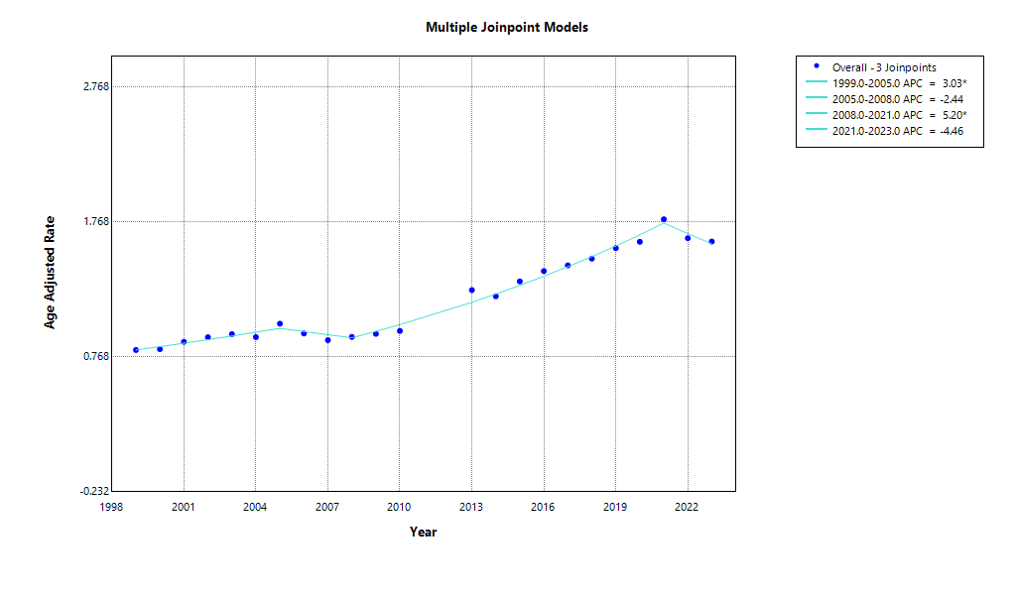
Supp Fig 2: Sensitivity analysis of mortality trends after excluding 2020–2021.
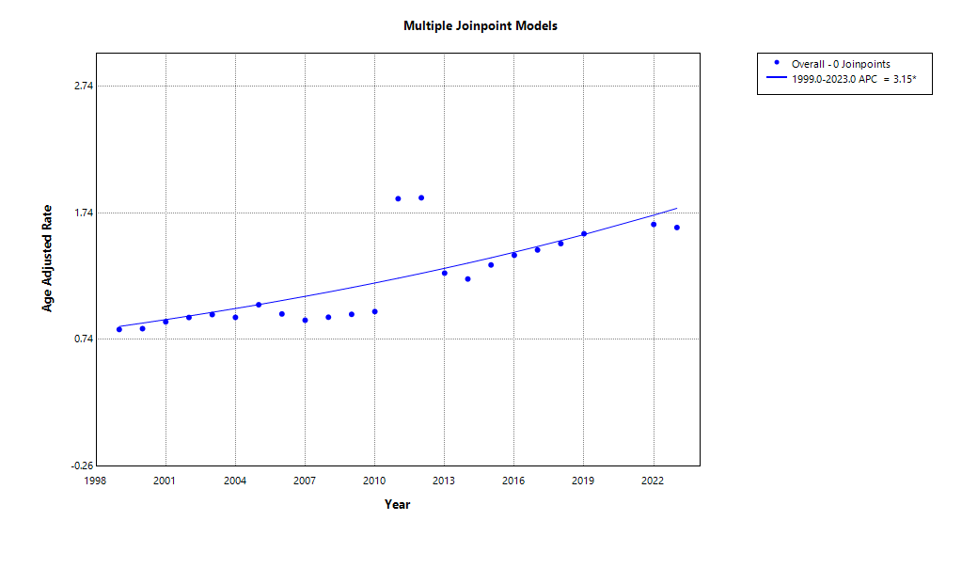
Supp Fig 3: Mortality trends with valvular heart disease as the underlying cause of death and chronic kidney disease as a contributing cause.
