Table S1. Clinical endpoint at 12 months in the PSM cohort
 | Vericiguat | Control | P
Composite clinical endpoint | 8 (5.56%) | 13 (9.03%) | 0.365
Cardiovascular death | 3 (2.08%) | 3 (2.08%) | 1.000
First hospitalization for HF | 6 (4.17%) | 11 (7.64%) | 0.317
All-cause mortality | 7 (4.86%) | 6 (4.17%) | 1.000
Table S2. NYHA functional classification at 12 months before PSM
 | Vericiguat | Control | P
NYHA functional class, n% |  |  | 0.036
Ⅰ | 145 (75.13%) | 159 (65.70%)
Ⅱ | 43 (22.28%) | 76 (31.41%)
Ⅲ | 5 (2.59%) | 6 (2.48%)
Ⅳ | 0 | 1 (0.41%)
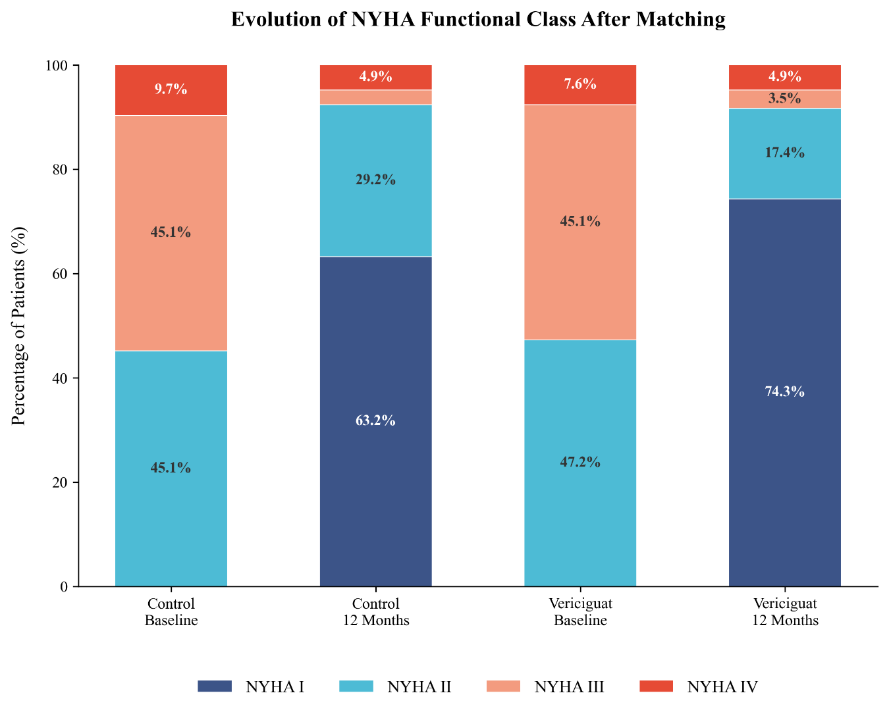 Figure S1. Evolution of NYHA functional classification at 12 months in the PSM cohort

Table S3. KCCQ-12 scores at 12 months in the PSM cohort

 | Vericiguat |  | Control | P
KCCQ-12 Physical Limitation |  | 91.97 ± 10.90 | 89.01 ± 13.62 | 0.048
KCCQ-12 Symptom Frequency |  | 94.48 ± 11.45 | 94.25 ± 9.71 | 0.857
KCCQ-12 Quality of Life |  | 86.25 ± 14.97 | 77.72 ± 19.52 | <0.001
KCCQ-12 Social Limitation |  | 93.92 ± 11.68 | 90.70 ± 14.42 | 0.043
KCCQ-12 Total Score |  | 91.66 ± 9.80 | 87.92 ± 11.49 | 0.004
Change in KCCQ-12 Physical Limitation |  | 21.28 ± 17.28 | 21.10 ± 21.40 | 0.938
Change in KCCQ-12 Symptom Frequency |  | 15.19 ± 18.65 | 12.09 ± 15.58 | 0.136
Change in KCCQ-12 Quality of Life |  | 29.68 ± 23.38 | 23.94 ± 29.45 | 0.075
Change in KCCQ-12 Social Limitation |  | 29.30 ± 25.47 | 27.38 ± 28.42 | 0.556
Change in KCCQ-12 Total Score |  | 23.86 ± 14.94 | 21.13 ± 18.80 | 0.183
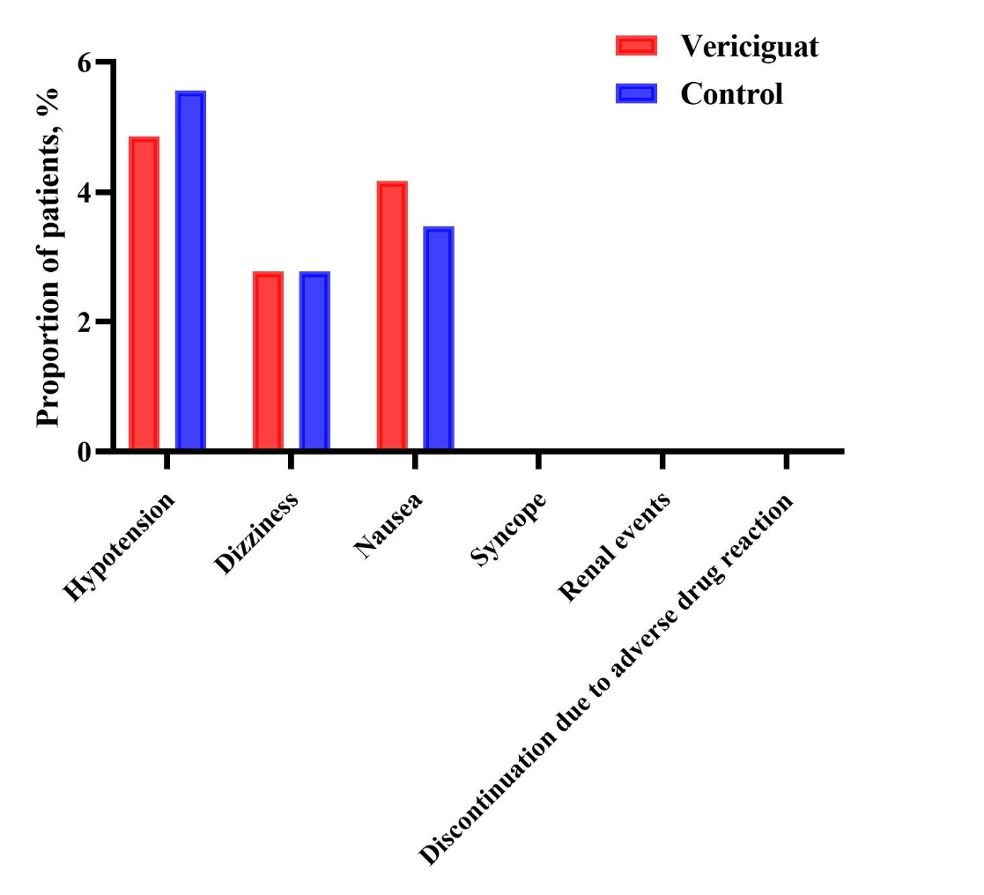
Figure S2. Drug-related adverse events in the PSM cohort
(Using the McNemar test)

