Table S1. Sensitivity analyses for the associations between RCII and clinical outcomes
Cohort and outcome | Sensitivity scenario | N | Events | Effect estimate (95% CI) | P value
Panel A. CHARLS incident hypertension
CHARLS incident hypertension | Main analysis | 4,972 | 1,622 | OR 1.346 (1.192–1.519) | <0.001
CHARLS incident hypertension | Excluding participants with CVD history | 4,533 | 1,457 | OR 1.322 (1.165–1.502) | <0.001
CHARLS incident hypertension | Excluding participants with diabetes | 4,794 | 1,548 | OR 1.349 (1.192–1.527) | <0.001
CHARLS incident hypertension | Excluding participants with obesity | 4,622 | 1,460 | OR 1.179 (1.036–1.342) | 0.013
Panel B. UK Biobank prognostic outcomes
UK Biobank MACE | Main analysis | 270,861 | 34,875 | HR 1.273 (1.232–1.315) | <0.001
UK Biobank MACE | Excluding events within the first 2 years | 267,447 | 31,461 | HR 1.268 (1.225–1.312) | <0.001
UK Biobank all-cause mortality | Main analysis | 270,861 | 26,247 | HR 1.214 (1.169–1.261) | <0.001
UK Biobank all-cause mortality | Excluding events within the first 2 years | 269,589 | 24,975 | HR 1.183 (1.138–1.229) | <0.001
UK Biobank cardiovascular death | Main analysis | 270,861 | 9,430 | HR 1.284 (1.205–1.368) | <0.001
UK Biobank cardiovascular death | Excluding events within the first 2 years | 270,456 | 9,025 | HR 1.264 (1.185–1.348) | <0.001
in the CHARLS and UK Biobank cohorts
Note: Effect estimates are odds ratios (ORs) for CHARLS and hazard ratios (HRs) for UK Biobank. CHARLS models were fully adjusted logistic regressions comparing high versus low RCII based on the median cutoff; UK Biobank models were fully adjusted Cox regressions comparing the highest versus lowest RCII quartile. CVD history was defined as baseline heart disease or stroke, and obesity as BMI ≥28 kg/m². Early-event sensitivity analyses excluded outcome events within the first 2 years of follow-up for the corresponding UK Biobank endpoint. Abbreviations: BMI, body mass index; CI, confidence interval; CVD, cardiovascular disease; MACE, major adverse cardiovascular events; RCII, Remnant Cholesterol-Inflammation Index.

Table S2. Joint Association of Remnant Cholesterol and C-Reactive Protein with Prevalent Hypertension in the CHARLS Cohort

Joint Categories (RC / CRP) | Model 1 (Crude) | P-value | Model 2 (Age & Sex) | P-value | Model 3 (Fully Adjusted) | P-value
 | OR (95% CI) |  | OR (95% CI) |  | OR (95% CI)
Low RC / Low CRP | 1.00 (Reference) | — | 1.00 (Reference) | — | 1.00 (Reference) | —
High RC / Low CRP | 1.46 (1.27–1.67) | < 0.001 | 1.47 (1.28–1.68) | < 0.001 | 1.32 (1.14–1.52) | < 0.001
Low RC / High CRP | 1.50 (1.25–1.80) | < 0.001 | 1.38 (1.15–1.66) | 0.001 | 1.29 (1.06–1.56) | 0.010
High RC / High CRP | 2.29 (1.95–2.69) | < 0.001 | 2.18 (1.85–2.56) | < 0.001 | 1.69 (1.42–2.02) | < 0.001

Note: Data are presented as odds ratios (ORs) and 95% confidence intervals (CIs).
Model Definitions: Model 1: Crude model, unadjusted.
Model 2: Adjusted for demographic factors (age and sex).
Model 3: Fully adjusted for age, sex, education, hukou, residence, history of diabetes, heart disease and stroke, smoking status, drinking status, body mass index (BMI), and baseline biochemical markers (blood urea nitrogen, fasting plasma glucose, creatinine, HbA1c, serum uric acid, and cystatin C).
Operational Definitions: High RC and High CRP were defined by values ≥ the population-specific medians, respectively. Participants were categorized into four mutually exclusive groups based on these cut-offs.
Abbreviations: RC, remnant cholesterol; CRP, C-reactive protein; OR, odds ratio; CI, confidence interval.

Table S3. Incremental discrimination of RCII beyond traditional, Framingham-like, and ASCVD-like risk-factor models for MACE in the UK Biobank cohort

Model | C-index | C-index + RCII | ΔC-index
Traditional model | 0.6745 | 0.6767 | 0.0022
Framingham-like risk-factor model | 0.6768 | 0.6792 | 0.0024
ASCVD-like risk-factor model | 0.6775 | 0.6799 | 0.0024

Note: The baseline model included established traditional cardiovascular risk factors: age, sex, body mass index (BMI), smoking status, systolic blood pressure, fasting glucose, and lipid-lowering medication use. The incremental predictive value of adding RCII (as a continuous variable) was evaluated by comparing Harrell’s C-index before and after RCII addition.

Table S4. Incremental discrimination of RCII beyond traditional, Framingham-like, and ASCVD-like risk-factor models for all-cause mortality in the UK Biobank cohort

Model | C-index | C-index + RCII | ΔC-index
Traditional model | 0.7017 | 0.7030 | 0.0014
Framingham-like risk-factor model | 0.7004 | 0.7039 | 0.0034
ASCVD-like risk-factor model | 0.7005 | 0.7039 | 0.0034

Note: Model discrimination was assessed using Harrell’s C-index, and incremental discrimination was quantified as the change in C-index after adding RCII to each model.

Table S5. Stratified associations of RCII with UK Biobank outcomes according to baseline lipid-lowering medication use
Outcome | Baseline lipid-lowering medication use | N | Events | HR (95 % CI)  for RCII Q4 vs Q1 | P value | P for interaction
MACE | No | 249,679 | 31,325 | 1.29 (1.25–1.34) | <0.001 | 0.011
MACE | Yes | 21,182 | 3,550 | 1.18 (1.07–1.30) | 0.001
All-cause mortality | No | 249,679 | 24,207 | 1.22 (1.18–1.27) | <0.001 | 0.303
All-cause mortality | Yes | 21,182 | 2,040 | 1.18 (1.03–1.34) | 0.014
Cardiovascular death | No | 249,679 | 8,693 | 1.31 (1.22–1.40) | <0.001 | 0.240
Cardiovascular death | Yes | 21,182 | 737 | 1.14 (0.92–1.42) | 0.219

Note: Values are hazard ratios and 95% confidence intervals for the highest versus lowest RCII quartile in fully adjusted complete-case Cox models stratified by baseline lipid-lowering medication use. P for interaction was calculated using RCII-by-medication interaction terms. Baseline lipid-lowering medication use was analyzed as a binary variable.

Figure S1. Joint Association of Remnant Cholesterol and Systemic Inflammation with the Risk of MACE in the UK Biobank Cohort
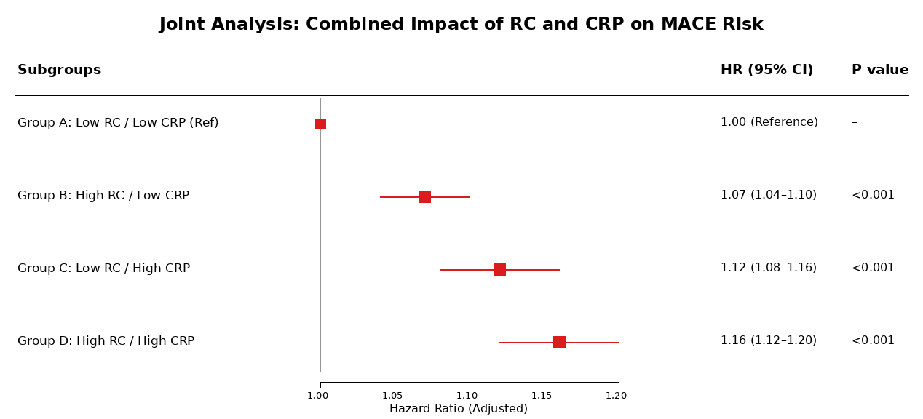

Figure S2. Subgroup Analysis of the Association Between RCII and Incident Hypertension in the CHARLS Cohort

Figure S3. Subgroup Analysis of the Association Between RCII and the Prevalence of Hypertension in the CHARLS Cohort

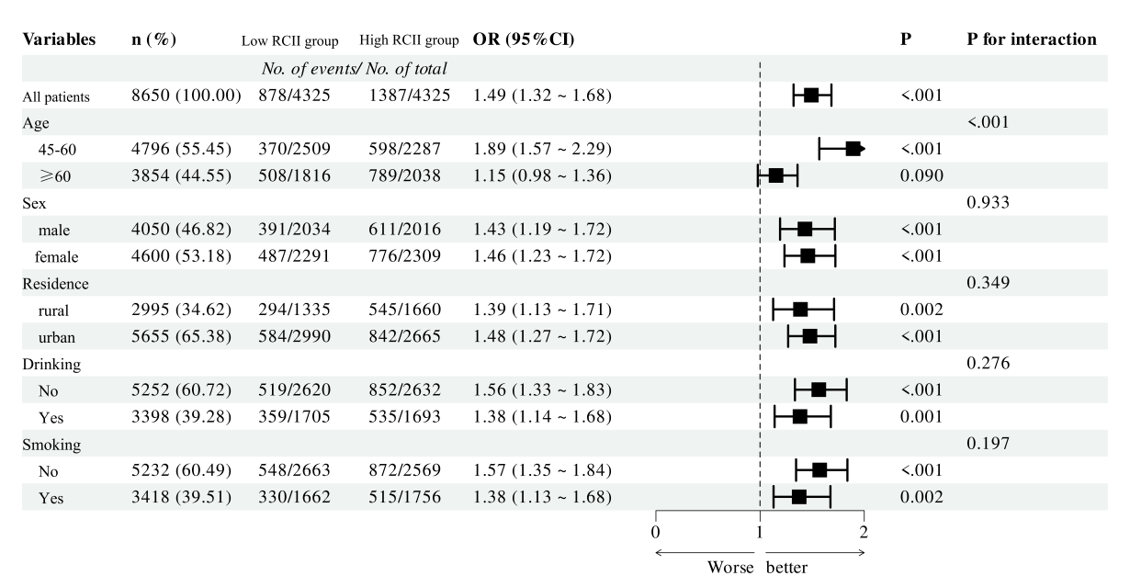

Figure S4. Restricted Cubic Spline Analysis of the Cross-Sectional Association Between RCII and Prevalent Hypertension in the CHARLS Cohort
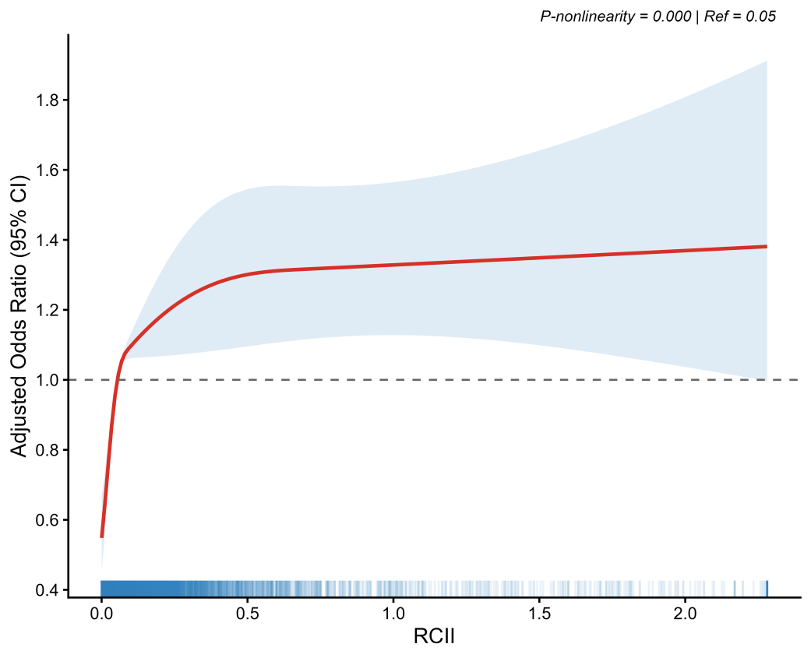
Figure legend
Figure S1. Joint Association of Remnant Cholesterol and Systemic Inflammation with the Risk of MACE in the UK Biobank Cohort. The forest plot illustrates the joint association of combined exposure to remnant cholesterol (RC) and C-reactive protein (CRP) on the risk of major adverse cardiovascular events (MACE). Hazard ratios (HRs) and 95% confidence intervals (CIs) were derived from multivariable Cox proportional hazards regression models. Participants were stratified into four mutually exclusive groups based on baseline levels: Low RC / Low CRP (Reference), High RC / Low CRP, Low RC / High CRP, and High RC / High CRP. High RC was defined by values ≥the population-specific median, and High CRP was defined as high-sensitivity CRP ≥2 mg/L. The model was fully adjusted for age, sex, body mass index, Townsend deprivation index, education level, smoking status, drinking status, lipid-lowering medication use, history of diabetes, serum urate, estimated glomerular filtration rate, and glycated hemoglobin. The size of the data markers corresponds to the statistical weight of each joint category, and the horizontal lines represent the 95% CIs. The vertical dashed line indicates an HR of 1.00. Abbreviations: RC, remnant cholesterol; CRP, C-reactive protein; MACE, major adverse cardiovascular events; HR, hazard ratio; CI, confidence interval.
Figure S2. Subgroup Analysis of the Association Between RCII and Incident Hypertension in the CHARLS Cohort. The forest plot illustrates the consistency of the longitudinal association between the Remnant Cholesterol-Inflammation Index (RCII) and the risk of incident hypertension across various prespecified subgroups. Effect estimates are presented as fully adjusted odds ratios (ORs) with 95% confidence intervals (CIs), comparing high RCII levels (≥ the median) to low RCII levels (< the median). The overall model and subgroup-specific models were fully adjusted for age, sex, education, hukou, residence, body mass index (BMI), smoking status, drinking status, and baseline biochemical markers, except for the stratifying variable itself. The size of the data squares corresponds to the point estimate and the statistical weight of each subgroup, while the horizontal lines represent the 95% CIs. The vertical dashed line indicates an OR of 1.00 (no effect). P for interaction was calculated to assess the heterogeneity of the effect across different strata. Abbreviations: RCII, Remnant Cholesterol-Inflammation Index; OR, odds ratio; CI, confidence interval; BMI, body mass index. The primary incident-hypertension cohort included 5,022 participants; model-specific complete-case samples varied according to covariate availability.
Figure S3. Subgroup Analysis of the Association Between RCII and the Prevalence of Hypertension in the CHARLS Cohort. The forest plot illustrates the cross-sectional association between the Remnant Cholesterol-Inflammation Index (RCII) and the prevalence of baseline hypertension across various prespecified subgroups. Effect estimates are presented as fully adjusted odds ratios (ORs) with 95% confidence intervals (CIs), comparing high RCII levels (≥ the median) to low RCII levels (< the median). The overall model and subgroup-specific models were fully adjusted for age, sex, education, hukou, residence, body mass index (BMI), smoking status, drinking status, and baseline comorbidities (including diabetes, heart disease, and stroke), except for the stratifying variable itself. The size of the data squares corresponds to the point estimate and the statistical weight of each subgroup, while the horizontal lines represent the 95% CIs. The vertical dashed line indicates an OR of 1.00 (no effect). P for interaction was calculated to assess the heterogeneity of the associations across different strata. Abbreviations: RCII, Remnant Cholesterol-Inflammation Index; OR, odds ratio; CI, confidence interval; BMI, body mass index.
Figure S4. Restricted Cubic Spline Analysis of the Cross-Sectional Association Between RCII and Prevalent Hypertension in the CHARLS Cohort. The restricted cubic spline (RCS) curve illustrates the dose-response relationship between the continuous Remnant Cholesterol-Inflammation Index (RCII) and the prevalence of hypertension at baseline. The solid red line represents the fully adjusted estimated odds ratios (ORs), and the shaded area corresponds to the 95% confidence intervals (CIs). The reference point (OR = 1.00) was set at the median value of RCII. The multivariable logistic regression model was fully adjusted for age, sex, education, hukou, residence, body mass index (BMI), smoking status, drinking status, and baseline comorbidities (including diabetes, heart disease, and stroke).P for overall association and P for non-linearity are reported to assess the significance and the shape of the dose-response relationship, respectively. Abbreviations: RCII, Remnant Cholesterol-Inflammation Index; RCS, restricted cubic spline; OR, odds ratio; CI, confidence interval; BMI, body mass index.

