Supplementary Table 1. Schoenfeld residual tests of the proportional hazards (PH) assumption for Cox models by outcome.
Outcome | Model | NWCO | Global | Age | Sex | Smoking status | Drinking status
CMD | Model 1 | 0.82 | 0.82
CMD | Model 2 | 0.48 | 0.05 | 0.15 | 0.01
CMD | Model 3 | 0.53 | 0.10 | 0.15 | 0.01 | 0.96 | 0.27
DB | Model 1 | 0.61 | 0.61
DB | Model 2 | 0.67 | 0.88 | 0.46 | 0.94
DB | Model 3 | 0.68 | 0.71 | 0.45 | 0.94 | 0.74 | 0.13
HTN | Model 1 | 0.28 | 0.28
HTN | Model 2 | 0.65 | 0.26 | 0.72 | 0.05
HTN | Model 3 | 0.66 | 0.52 | 0.72 | 0.05 | 0.37 | 0.74
HLP | Model 1 | 0.57 | 0.57
HLP | Model 2 | 0.46 | 0.32 | 0.77 | 0.09
HLP | Model 3 | 0.53 | 0.46 | 0.78 | 0.10 | 0.68 | 0.40
Values are P-values from Schoenfeld residual tests (cox.zph in R) for each covariate and for the global test of each model. PH violation was defined as P < 0.05 (bolding values).
Model 1: unadjusted; Model 2: adjusted for age and sex; Model 3: adjusted for age, sex, cigarette smoking, and alcohol consumption.
Abbreviations: CMD, cardiometabolic disorder; HTN, hypertension; DM, type 2 diabetes; HLP, hyperlipidemia; NWCO, normal-weight central obesity; NWNO, normal-weight non-central obesity.

Supplementary Table 2. Spearman’s correlation coefficients with 95% confidence intervals between waist circumference and cardiometabolic risk factors.
Variables | WC | SBP | DBP | FBG | TG | TC | HDL-C | LDL-C
WC | 1
SBP | 0.25, 0.3 | 1
DBP | 0.18, 0.23 | 0.68, 0.71 | 1
FBG | 0.16, 0.21 | 0.18, 0.23 | 0.12, 0.17 | 1
TG | 0.35, 0.4 | 0.18, 0.23 | 0.18, 0.23 | 0.15, 0.2 | 1
TC | 0.04, 0.09 | 0.05, 0.1 | 0.06, 0.11 | 0.06, 0.11 | 0.3, 0.35 | 1
HDL-C | -0.48, -0.43 | -0.17, -0.11 | -0.16, -0.11 | -0.12, -0.07 | -0.4, -0.35 | 0.2, 0.25 | 1
LDL-C | 0.19, 0.24 | 0.09, 0.14 | 0.11, 0.16 | 0.06, 0.12 | 0.33, 0.37 | 0.87, 0.89 | -0.17, -0.12 | 1
Abbreviations: WC, waist circumference; SBP, systolic blood pressure; DBP, diastolic blood pressure; FBG, fasting blood glucose; TG, triglycerides; TC, total cholesterol; HDL-C, high-density lipoprotein cholesterol; LDL-C, low-density lipoprotein cholesterol.

Supplementary Table 3. Sensitivity Analysis: Hazard ratios for the association between normal-weight central obesity (NWCO) and cardiometabolic disorder stratified by sex.
Model | Analysis Type | HR (95% CI) | P-value
Model 1 | Unstratified (sex) | 1.39 (1.13–1.70) | 0.0019
 | Stratified (sex) | 1.40 (1.14–1.72) | 0.0016
Model 2 | Unstratified (sex) | 1.39 (1.13–1.71) | 0.0019
 | Stratified (sex) | 1.39 (1.13–1.71) | 0.0016
Models labeled 'Stratified' were fitted using a Cox model stratified by sex (strata(sex)), which does not assume a constant hazard ratio for sex itself but allows for estimation of the NWCO effect.

Supplementary Figure 1. ﻿Flowchart. We extracted the data of 16,002 normal-weight individuals defined as body mass index of 18.0-24.0 kg/m² who were enrolled in our study between January and December 2022 and whose baseline health check-up data (including data on waist circumference) were available. Exclusion criteria were as follows: (i) prior history of hypertension, type 2 diabetes or hyperlipidemia (n = 7,326); (ii) without physical examination in 2024 (n=2,931);
and (iii) missing follow-up data on waist circumference (n = 139). Ultimately, we analyzed 5,606 participants in this study.
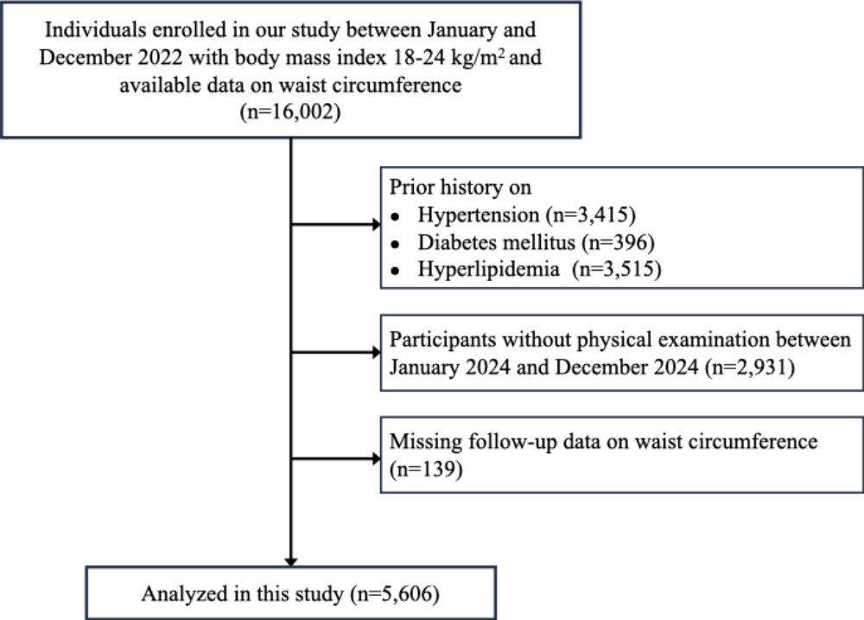

Supplementary Figure 2. Body fat percentage calculated by CUN-BAE formula and development of cardiometabolic disorder.
