Supplementary Material

Supplementary Table 1. Sources of diabetes mellitus diagnosis among study participants.
Supplementary Table 2. Sensitivity analysis of the association between the TyG index and cfPWV after additional adjustment for continuous fasting glucose.
Supplementary Table 3. Sensitivity analysis of the association between the TyG index and cfPWV using MAP instead of SBP and DBP.
Supplementary Table 4. Sensitivity analysis of the association between the TyG index and elevated cfPWV after additional adjustment for continuous fasting glucose.
Supplementary Table 5. Sensitivity analysis of the association between the TyG index and elevated cfPWV using MAP instead of SBP and DBP.
Supplementary Table 6. Subgroup-specific event of elevated cfPWV according to obesity status.
Supplementary Figure 1. Flow Chart of the Study Participants.
Supplementary Figure 2. The smooth curve of correlation between TyG index and cfPWV.
Supplementary Figure 3. Correlation between TyG index and cfPWV.

Supplementary Table 1. Sources of diabetes mellitus diagnosis among study participants.

Diabetes | N | Percentage (%)
self-reported physician diagnosis | 545 | 4.3
fasting glucose ≥7.0 mmol/L | 1258 | 9.9
self-reported physician diagnosis and fasting glucose ≥7.0 mmol/L | 331 | 2.6

Supplementary Table 2. Sensitivity analysis of the association between the TyG index and cfPWV after additional adjustment for continuous fasting glucose.

TyG index | N | Mean ± SD |  | cfPWV (m/s), β (95%CI), P value
TyG index | N | Mean ± SD | Crude model | Model I | Model II | Model III
Per 1 unit increase | 12751 | 8.9 ± 0.7 | 0.26 (0.20, 0.31) <0.001 | 0.36 (0.31, 0.42) <0.001 | 0.15 (0.10, 0.21) <0.001 | 0.07 (0.03, 0.11) <0.001
Quartiles
Q1 (<8.4) | 3187 | 8.1 ± 0.4 | Ref. | Ref. | Ref. | Ref.
Q2 (8.4-8.8) | 3188 | 8.6 ± 0.1 | 0.03 (-0.08, 0.14) 0.584 | 0.11 (0.01, 0.21) 0.039 | 0.05 (-0.04, 0.15) 0.277 | 0.04 (-0.06, 0.13) 0.459
Q3 (8.8-9.2) | 3188 | 9.0 ± 0.1 | 0.18 (0.07, 0.29) 0.002 | 0.26 (0.16, 0.36) <0.001 | 0.12 (0.03, 0.22) 0.012 | 0.09 (-0.00, 0.19) 0.059
Q4 (≥9.2) | 3188 | 9.7 ± 0.5 | 0.42 (0.31, 0.53) <0.001 | 0.62 (0.52, 0.72) <0.001 | 0.28 (0.17, 0.38) <0.001 | 0.21 (0.10, 0.32) <0.001
P for trend |  |  | ＜0.001 | ＜0.001 | ＜0.001 | ＜0.001
Model I: adjusted for age, sex and BMI;
Model II: adjusted for age, sex, BMI, SBP, DBP, smoking status, alcohol drinking status, total cholesterol, total homocysteine, antihypertensive drugs, diabetes mellitus.
Model III: adjusted for age, sex, BMI, SBP, DBP, smoking status, alcohol drinking status, total cholesterol, total homocysteine, antihypertensive drugs, diabetes mellitus, and fasting glucose.

Supplementary Table 3. Sensitivity analysis of the association between the TyG index and cfPWV using MAP instead of SBP and DBP.

TyG index | N | Mean ± SD | cfPWV (m/s), β (95%CI), P value
TyG index | N | Mean ± SD | Crude model | Model I | Model II | Model III
Per 1 unit increase | 12751 | 8.9 ± 0.7 | 0.26 (0.20, 0.31) <0.001 | 0.36 (0.31, 0.42) <0.001 | 0.15 (0.10, 0.21) <0.001 | 0.11(0.07, 0.14) <0.001
Quartiles
Q1 (<8.4) | 3187 | 8.1 ± 0.4 | Ref. | Ref. | Ref. | Ref.
Q2 (8.4-8.8) | 3188 | 8.6 ± 0.1 | 0.03 (-0.08, 0.14) 0.584 | 0.11 (0.01, 0.21) 0.039 | 0.05 (-0.04, 0.15) 0.277 | 0.05 (-0.04, 0.15) 0.277
Q3 (8.8-9.2) | 3188 | 9.0 ± 0.1 | 0.18 (0.07, 0.29) 0.002 | 0.26 (0.16, 0.36) <0.001 | 0.12 (0.03, 0.22) 0.012 | 0.12 (0.03, 0.22) 0.012
Q4 (≥9.2) | 3188 | 9.7 ± 0.5 | 0.42 (0.31, 0.53) <0.001 | 0.62 (0.52, 0.72) <0.001 | 0.28 (0.17, 0.38) <0.001 | 0.28 (0.17, 0.38) <0.001
P for trend |  |  | ＜0.001 | ＜0.001 | ＜0.001 | ＜0.001
Model I: adjusted for age, sex and BMI;
Model II: adjusted for age, sex, BMI, SBP, DBP, smoking status, alcohol drinking status, total cholesterol, total homocysteine, antihypertensive drugs, diabetes mellitus.
Model III: adjusted for age, sex, BMI, MAP, smoking status, alcohol drinking status, total cholesterol, total homocysteine, antihypertensive drugs, diabetes mellitus.

Supplementary Table 4. Sensitivity analysis of the association between the TyG index and elevated cfPWV after additional adjustment for continuous fasting glucose.

TyG index | N | Events, n (%) | Arterial Stiffness, RR (95%CI), P value
TyG index | N | Events, n (%) | Crude model | Model I | Model II | Model III
Per 1 unit increase | 12751 | 3780 (29.6%) | 1.19 (1.15,1.24) <0.001 | 1.25 (1.19,1.31) <0.001 | 1.12 (1.07,1.18) <0.001 | 1.07 (1.04,1.11) <0.001
Quartiles
Q1 (<8.4) | 3187 | 838 (26.3%) | Ref. | Ref. | Ref. | Ref.
Q2 (8.4-8.8) | 3188 | 858 (26.9%) | 1.02 (0.94,1.11) 0.576 | 1.05 (0.98,1.13) 0.163 | 1.04 (0.94,1.14) 0.217 | 1.05 (0.98,1.14) 0.176
Q3 (8.8-9.2) | 3188 | 962 (30.2%) | 1.15 (1.06,1.24) <0.001 | 1.19 (1.10,1.28) <0.001 | 1.13 (1.03,1.25) <0.001 | 1.13 (1.05,1.22) 0.013
Q4 (≥9.2) | 3188 | 1122 (35.2%) | 1.34 (1.24,1.44) <0.001 | 1.43 (1.33,1.53) <0.001 | 1.26 (1.14,1.39) <0.001 | 1.25 (1.16,1.35) <0.001
P for trend |  |  | ＜0.001 | ＜0.001 | ＜0.001 | ＜0.001
Model I: adjusted for age, sex and BMI;
Model II: adjusted for age, sex, BMI, SBP, DBP, smoking status, alcohol drinking status, total cholesterol, total homocysteine, antihypertensive drugs, diabetes mellitus.
Model III: adjusted for age, sex, BMI, SBP, DBP, smoking status, alcohol drinking status, total cholesterol, total homocysteine, antihypertensive drugs, diabetes mellitus, and fasting glucose.

Supplementary Table 5. Sensitivity analysis of the association between the TyG index and elevated cfPWV using MAP instead of SBP and DBP.

TyG index | N | Events, n (%) | Arterial Stiffness, RR (95%CI), P value
TyG index | N | Events, n (%) | Crude model | Model I | Model II | Model III
Per 1 unit increase | 12751 | 3780 (29.6%) | 1.19 (1.15,1.24) <0.001 | 1.25 (1.19,1.31) <0.001 | 1.12 (1.07,1.18) <0.001 | 1.09 (1.07,1.18) <0.001
Quartiles
Q1 (<8.4) | 3187 | 838 (26.3%) | Ref. | Ref. | Ref. | Ref.
Q2 (8.4-8.8) | 3188 | 858 (26.9%) | 1.02 (0.94,1.11) 0.576 | 1.05 (0.98,1.13) 0.163 | 1.04 (0.94,1.14) 0.217 | 1.06 (0.99,1.15) 0.120
Q3 (8.8-9.2) | 3188 | 962 (30.2%) | 1.15 (1.06,1.24) <0.001 | 1.19 (1.10,1.28) <0.001 | 1.13 (1.03,1.25) <0.001 | 1.15 (1.06,1.23) <0.001
Q4 (≥9.2) | 3188 | 1122 (35.2%) | 1.34 (1.24,1.44) <0.001 | 1.43 (1.33,1.53) <0.001 | 1.26 (1.14,1.39) <0.001 | 1.30 (1.20,1.40) <0.001
P for trend |  |  | ＜0.001 | ＜0.001 | ＜0.001 | ＜0.001
Model I: adjusted for age, sex and BMI;
Model II: adjusted for age, sex, BMI, SBP, DBP, smoking status, alcohol drinking status, total cholesterol, total homocysteine, antihypertensive drugs, diabetes mellitus.
Model III: adjusted for age, sex, BMI, MAP, smoking status, alcohol drinking status, total cholesterol, total homocysteine, antihypertensive drugs, diabetes mellitus.

Supplementary Table 6. Subgroup-specific event of elevated cfPWV according to obesity status.

Obesity status | elevated cfPWV  (N, percentage (%))
Without obesity (BMI＜28 kg/m²) | 2798 (30.25)
Obesity (BMI ≥28 kg/m²) | 982 (28.06)

13965 individuals measured cfPWV assessed in the study

535 Excluded
465 with using lipid-lowering medications
70 with using glucose-lowering medications
13430 participants
679 Excluded
191 with missing fasting triglycerides data
163 with missing fasting glucose data
1 with missing age data
221 with missing BMI data
102 with extreme Hcy data

12751 participants
Supplementary Figure 1. Flow Chart of the Study Participants.
cfPWV indicates carotid-femoral pulse wave velocity; BMI body mass index; Hcy homocysteine; extreme Hcy levels refer to Hcy<2μmol/L or >400μmol/L.

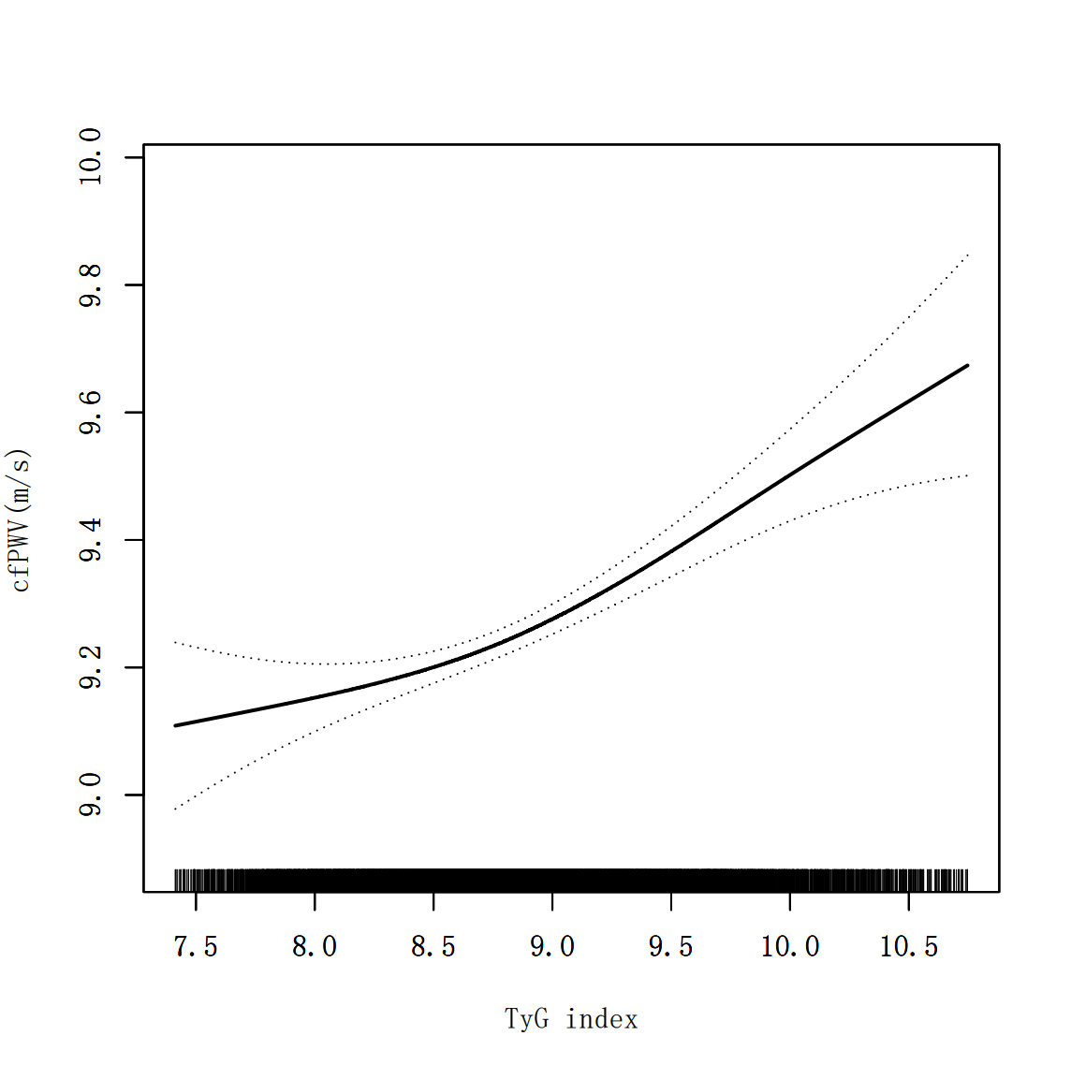
Supplementary Figure 2. The smooth curve of correlation between TyG index and cfPWV.
Adjusted for age, sex, BMI, SBP, DBP, smoking status, alcohol drinking status, total cholesterol, total homocysteine, antihypertensive drugs, diabetes mellitus.

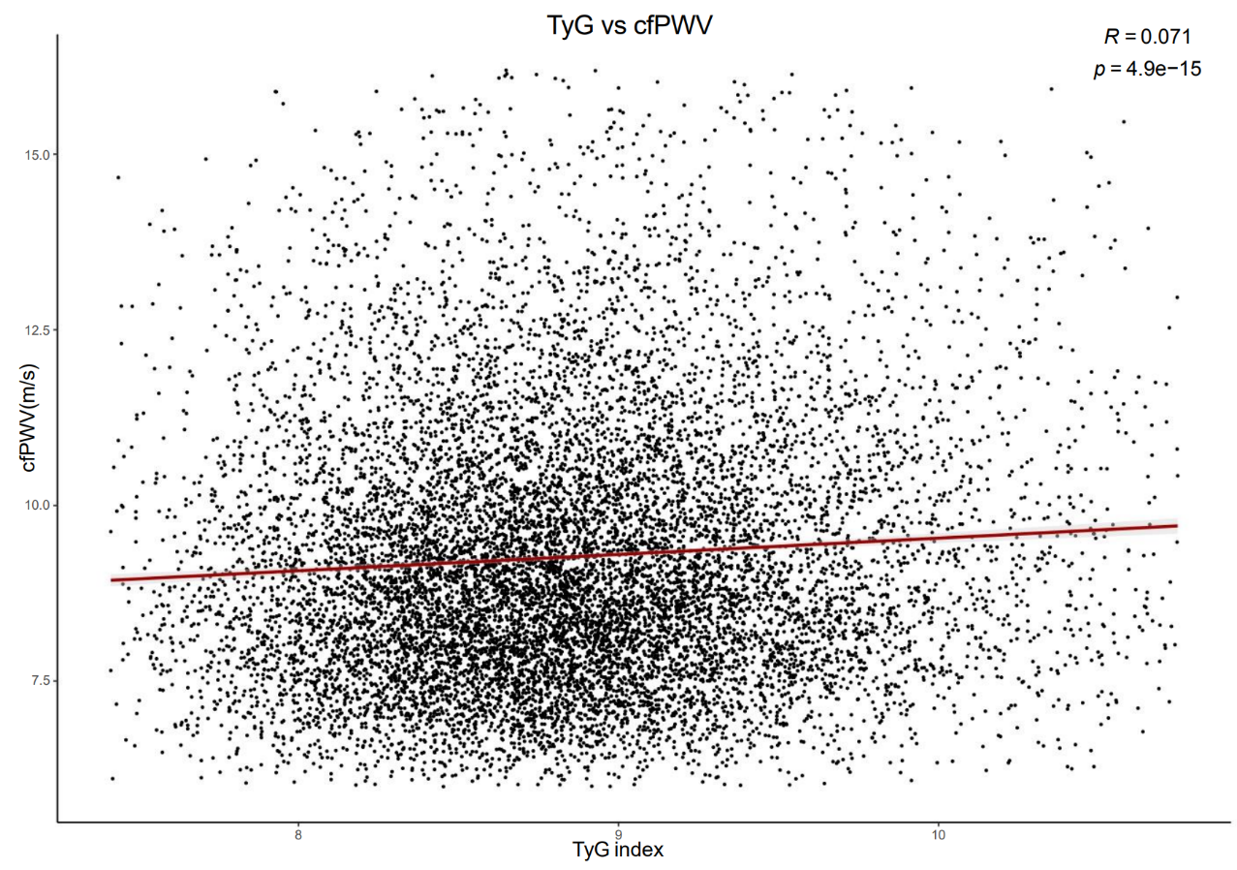
Supplementary Figure 3. Correlation between TyG index and cfPWV.

