Risk of Bias Assessment:

Lv et. all (2026) Using ROB 2.0:
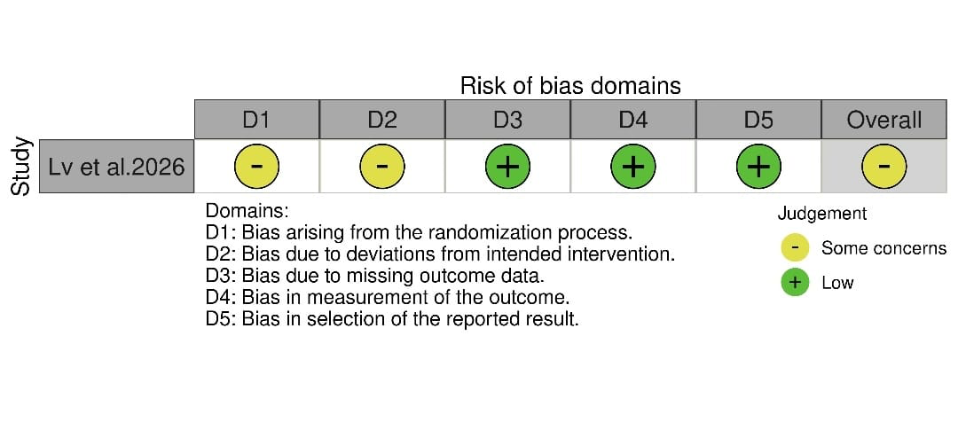
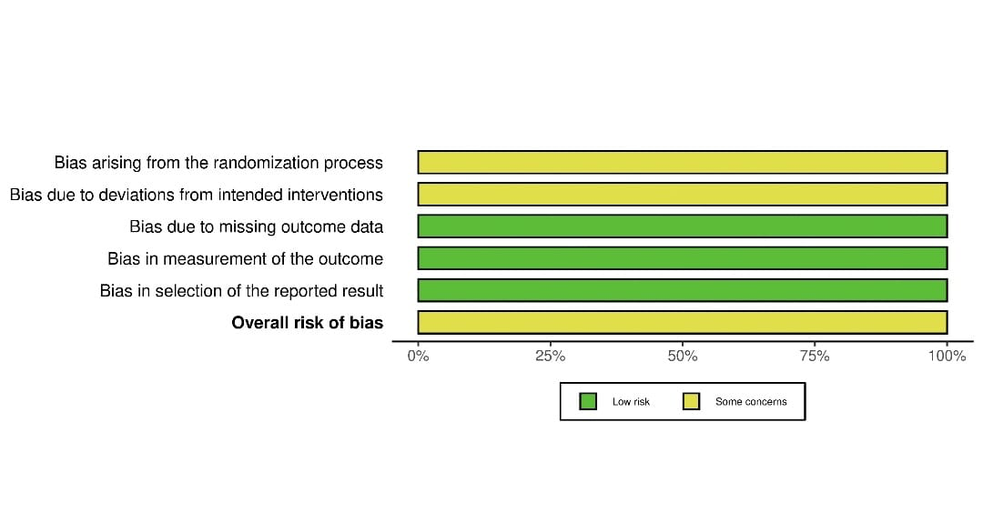

Risk of Bias Assessment for Storey (2024) and Johnson (2024) using Newcastle-Ottawa Scale (NOS):

Study ID | SELECTION |  |  |  | COMPARIBILITY |  | OUTCOMES |  |  | TOTAL
Study ID | S1 | S2 | S3 | S4 | C1 | C2 | O1 | O2 | O3 | TOTAL
Storey et al.2024 | * | * | * | _ | * | * | * | * | * | 8
Johnson et al. 2024 | * | * | * | _ | * | * | * | * | * | 8

Newcastle–Ottawa Scale (NOS) Quality Assessment
Storey et al.2024
Selection | Item | Stars | Rationale
Selection |  | 1 | Cohort reflects typical patients presenting with hypertensive crisis in a real-world hospital setting.
  Representativeness of exposed cohort
Selection | Selection of non-exposed cohort | 1 | Historical comparison group from the same hospital, treated with the alternative drug.
Selection | Ascertainment of exposure | 1 | Exposure (nicardipine or clevidipine) determined from electronic health records and infusion logs.
Selection | Outcome not present at start | 0 | outcomes occur after treatment, not present at baseline.
Comparability | Controlled for primary confounder | 1 | Baseline characteristics were compared using various test.
Comparability | Controlled for additional factors | 1 | Present
Outcome | Assessment of outcome | 1 | Outcomes like MAP reduction and SBP control clearly defined and assessed from patient records.
Outcome | Follow-up long enough | 1 | Acute BP outcomes measured at 1–6 hours; sufficient for hypertensive crisis evaluation.
Outcome | Adequacy of follow-up | 1 | No patients were lost from the retrospective database used for analysis
Total Stars =8/9

Johnson et al. 2024
Selection | Item | Stars | Rationale
Selection |  | 1 | ICU patients from multiple hospital types, typical for hypertensive crisis.
  Representativeness of exposed cohort
Selection | Selection of non-exposed cohort | 1 | Comparison group from same hospitals and period, fair and comparable.
Selection | Ascertainment of exposure | 1 | Drug assignment obtained from reliable EMR data
Selection | Outcome not present at start | 0 | outcomes occur after treatment, not present at baseline.
Comparability | Controlled for primary confounder | 1 | Baseline characteristics were compared using various tests.
Comparability | Controlled for additional factors | 1 | Present
Outcome | Assessment of outcome | 1 | BP measurements obtained from EMR , outcome clearly defined.
Outcome | Follow-up long enough | 1 | Time to goal BP occurs within minutes to hours ,ICU stay recorded.
Outcome | Adequacy of follow-up | 1 | Complete outcome data available from EMR , no significant loss to follow-up.
Total Stars =8/9

