Supplemental Material

Supplemental Tables
Table S1 Construction of the Frailty Index (FI).
Table S2 Standard frailty index and our frailty index correlation analysis.
Table S3 Summary of missing value proportions for covariates.
Table S4 Baseline characteristics according to the quartiles of the RCII.
Table S5 Baseline characteristics according to the FI.
Table S6 Association of RCII with the risk of CMM.
Table S7 Interaction of RCII and frailty on CMM events.
Table S8 Interaction of cumulative RCII and frailty on CMM events.
Table S9 Sensitivity analyses for the association between cumulative RCII (optimal threshold) and risk of CMM.
Table S10 Sensitivity analyses for the combined effect of cumulative RCII (median cutoff) and frailty status on risk of CMM.
Table S11 Incremental discriminative performance of RCII, CumRCII, and frailty beyond conventional covariates for predicting incident CMM during the 2015–2020 follow-up period.
Table S12. Discrete-time survival sensitivity analysis for the joint-category associations of RCII, CumRCII, and frailty with incident CMM.
Table S13 Proportional hazards assumption testing using Schoenfeld residuals.
Table S14 Multiplicative interaction tests and FDR correction for subgroup analyses.
Table S15 Baseline characteristics of included and excluded eligible participants.
Supplemental Figures
Figure S1 Distribution of cumulative RCII and identification of optimal cut point using maximally selected rank statistics.
Figure S2 Cumulative hazard curves of incident CMM according to RCII, cumulative RCII, and their combined effect with frailty status.
Figure S3 DAG-informed conceptual causal framework for covariate selection.
Figure S4 Restricted cubic spline analysis of the association between CumRCII and incident CMM.

Table S1 Construction of the Frailty Index (FI).
NO. | Description of the items | Cut-off value
1 | Self-reported diagnosis of hypertension by a doctor | Yes = 1, No = 0
2 | Self-reported diagnosis of cancer by a doctor | Yes = 1, No = 0
3 | Self-reported diagnosis of arthritis by a doctor | Yes = 1, No = 0
4 | Self-reported diagnosis of chronic lung diseases by a doctor | Yes = 1, No = 0
5 | Self-reported diagnosis of asthma by a doctor | Yes = 1, No = 0
6 | Self-reported diagnosis of emotional, nervous, or psychiatric problems by a doctor | Yes = 1, No = 0
7 | Self-reported diagnosis of memory-related disease by a doctor | Yes = 1, No = 0
8 | Self-reported vision problems | Yes = 1, No = 0
9 | Self-reported hearing problems | Yes = 1, No = 0
10 | Difficulty with dressing | Did not have any problems with the activity=0; some difficulty with the activity or could not do the activity=1.
11 | Difficulty with bathing or showering
12 | Difficulty with eating
13 | Difficulty with getting in and out of bed
14 | Difficulty with using the toilet
15 | Difficulty with managing money
16 | Difficulty with taking medications
17 | Difficulty with shopping for groceries
18 | Difficulty with preparing meals
19 | Difficulty with doing housework
20 | Difficulty with walking 100 yards
21 | Difficulty with getting up from a chair after sitting for long periods
22 | Difficulty with climbing several flights of stairs without resting
23 | Difficulty with lifting or carrying weights over 10 pounds/ jins
24 | Difficulty with picking up a coin from the table
25 | Difficulty with stooping, kneeling, or crouching
26 | Difficulty with reaching arms above shoulder level
27 | Self-reported health | Poor/ fair = 1, excellent/ very good/ or good = 0
28 | Depressive symptoms: CESD-10 questionnaire | CESD-10 >10 =1, ≤10 =0
29 | Cognition: (memory test score + orientation test score) / 14 | Continuous, ranging from 0 to 1

Table S2 Standard frailty index and our frailty index correlation analysis
 |  | Our Frailty Index | Standard Frailty Index
Our Frailty Index | r | 1 | 0.961
 | P | - | ＜0.001
Standard Frailty Index | r | 0.961 | 1
 | P | < 0.001 | -

Table S3 Summary of missing value proportions for covariates.
Age | Gender | Location
0.0% | 0.0% | 0.05%
Marital | Education | BMI
0.0% | 0.0% | 11.5%
Smoking | Drinking | Sleep duration
1.25% | 5.43% | 3.17%
Hypertension | Kidney disease | TG
0.07% | 0.62% | 0.00%
UA | Creatinine
0.00% | 0.05%
Abbreviations: BMI, body mass index; TG, triglyceride; UA, uric acid.

Table S4 Baseline characteristics according to the quartiles of the RCII.
Characteristics | RCII = Q1  (n = 1445) | RCII = Q2  (n = 1445) | RCII = Q3  (n = 1445) | RCII = Q4  (n = 1445) | p value
Age (years) | 57.60 ± 8.58 | 57.86 ± 8.16 | 58.50 ± 8.48 | 58.24 ± 8.14 | 0.020
Gender, N (%) |  |  |  |  | 0.141
Male | 637 (44.1) | 644 (44.6) | 677 (46.9) | 616 (42.6)
Female
Location, n (%) |  |  |  |  | 0.003
Urban | 262 (12.9) | 291 (14.3) | 347 (17.1) | 385 (18.9)
Rural
Marital, n (%) |  |  |  |  | 0.255
Non-married | 123 (8.5) | 146 (10.1) | 133 (9.2) | 152 (10.5)
Married
Education, n(%) |  |  |  |  | 0.283
College or above | 30 (2.1) | 38 (2.6) | 46 (3.2) | 49 (3.4)
High school | 411 (28.4) | 389 (26.9) | 374 (25.9) | 391 (27.1)
Primary school or below | 1004 (69.5) | 1018 (70.4) | 1024 (70.9) | 1005 (69.6)
BMI (kg/m2) |  |  |  |  | <0.001
<18.5 | 128 (8.9) | 84 (5.8) | 52 (3.6) | 49 (3.4)
≥24 | 381 (26.4) | 543 (37.6) | 684 (47.4) | 806 (55.8)
18.5-24 | 936 (64.8) | 818 (56.6) | 708 (49.0) | 590 (40.8)
Smoking, n(%) |  |  |  |  | 0.007
Non-smoker | 951 (65.8) | 913 (63.2) | 868 (60.1) | 926 (64.1)
Current smoker | 408 (28.2) | 427 (29.6) | 448 (31.0) | 396 (27.4)
Ex-smoker | 86 (6.0) | 105 (7.3) | 128 (8.9) | 123 (8.5)
Drinking, n(%) |  |  |  |  | 0.456
Drink but less than once a month | 131 (9.1) | 138 (9.6) | 125 (8.7) | 109 (7.5)
Drink more than once a month | 301 (20.8) | 317 (21.9) | 301 (20.8) | 296 (20.5)
None of these | 1013 (70.1) | 990 (68.5) | 1018 (70.5) | 1040 (72.0)
Sleep duration (h | 6.41 ± 1.87 | 6.32 ± 1.89 | 6.39 ± 1.85 | 6.33 ± 1.87 | 0.495
Hypertension, n(%) | 402 ± 27.8 | 480 ± 33.2 | 642 ± 44.5 | 718 ± 49.7 | <0.001
Kidney disease, n(%) | 81 ± 5.6 | 82 ± 5.7 | 72 ± 5.0 | 81 ± 5.6 | 0.832
LDL (mmol/L) | 3.01 ± 0.79 | 3.07 ± 0.86 | 3.09 ± 0.88 | 2.90 ± 1.03 | <0.001
HDL (mmol/L) | 1.56 ± 0.40 | 1.38 ± 0.35 | 1.25 ± 0.34 | 1.11 ± 0.33 | <0.001
TC (mmol/L) | 2.10 ± 0.40 | 2.16 ± 0.40 | 2.21 ± 0.42 | 2.25 ± 0.47 | <0.001
TG (mmol/L) | 1.99 ± 0.74 | 2.78 ± 1.18 | 3.55 ± 1.75 | 5.20 ± 3.62 | <0.001
CRP(mg/L) | 0.60 ± 1.12 | 0.85 ± 0.58 | 1.62 ± 2.20 | 6.75 ±12.05 | <0.001
UA (µmol/L) | 238.55 ± 64.84 | 251.88 ± 68.89 | 268.63 ± 72.69 | 278.61 ± 74.60 | <0.001
Creatinine (µmol/L) | 65.57 ± 15.03 | 66.95 ± 15.25 | 69.75 ± 16.14 | 68.95 ± 16.33 | <0.001
FI | 0.37 ± 0.38 | 1.29 ± 0.33 | 3.21 ± 0.91 | 20.75 ± 56.22 | <0.001
Abbreviations: BMI, body mass index; CMM, cardiometabolic multimorbidity; CRP, C-reactive protein; FI, frailty index; HDL, high-density lipoprotein cholesterol; LDL, low-density lipoprotein cholesterol; RCII, remnant cholesterol inflammatory index; TC, total cholesterol; TG, triglyceride; UA, uric acid.
Table S5 Baseline characteristics according to the FI.
Characteristics | Robust (n = 4554) | Frailty (n = 1225) | P value
Age (years) | 57.27 ± 8.19 | 60.93 ± 8.28 | <0.001
Gender, N (%) |  |  | <0.001
Male | 2175 (47.8) | 399 (32.6)
Female | 2379 (52.2) | 826 (67.4)
Location, n (%) |  |  | <0.001
Urban | 759 (16.7) | 89 (7.3)
Rural | 3795 (83.3) | 1136 (92.7)
Marital, n (%) |  |  | <0.001
Non-married | 384 (8.4) | 170 (13.9)
Married | 4170 (91.6) | 1055 (86.1)
Education, n(%) |  |  | <0.001
College or above | 156 (3.4) | 7 (0.6)
High school | 1419 (31.2) | 146 (11.9)
Primary school or below | 2979 (65.4) | 1072 (87.5)
BMI (kg/m2) |  |  | 0.028
<18.5 | 230 (5.1) | 83 (6.8)
≥24 | 1891 (41.5) | 523 (42.7)
18.5-24 | 2433 (53.4) | 619 (50.5)
Smoking, n(%) |  |  | <0.001
Non-smoker | 2820 (61.9) | 838 (68.4)
Current smoker | 1399 (30.7) | 280 (22.9)
Ex-smoker | 335 (7.4) | 107 (8.7)
Drinking, n(%) |  |  | <0.001
Drink but less than once a month | 404 (8.9) | 99 (8.1)
Drink more than once a month | 1024 (22.5) | 191 (15.6)
None of these | 3126 (68.6) | 935 (76.3)
Sleep duration (h) | 6.55 ± 1.75 | 5.67 ± 2.13 | <0.001
Hypertension, n(%) | 1621 ± 35.6 | 621 ± 50.7 | <0.001
Kidney disease, n(%) | 210 ± 4.6 | 106 ± 8.7 | <0.001
LDL (mmol/L) | 3.01 ± 0.89 | 3.05 ± 0.91 | 0.110
HDL (mmol/L) | 1.32 ± 0.39 | 1.34 ± 0.40 | 0.166
TC (mmol/L) | 2.17 ± 0.42 | 2.21 ± 0.43 | 0.011
TG (mmol/L) | 3.37 ± 2.46 | 3.42 ± 2.32 | 0.548
CRP(mg/L) | 2.38 ± 6.77 | 2.73 ± 6.18 | 0.103
UA (µmol/L) | 261.42 ± 72.58 | 251.96 ± 69.32 | <0.001
Creatinine (µmol/L) | 68.33 ± 15.75 | 65.86 ± 15.76 | <0.001
RCII | 6.21 ± 31.65 | 7.13 ± 18.22 | 0.328
CumRCII | 30.34 ± 81.85 | 40.83 ± 165.33 | 0.002
Abbreviations: BMI, body mass index; CMM, cardiometabolic multimorbidity; CRP, C-reactive protein; CumRCII, cumulative remnant cholesterol inflammatory index; HDL, high-density lipoprotein cholesterol; LDL, low-density lipoprotein cholesterol; RCII, remnant cholesterol inflammatory index; TC, total cholesterol; TG, triglyceride; UA, uric acid.

Table S6 Association of RCII with the risk of CMM.
Characteristics | Quartiles of RCII |  |  |  | p for trend*
Characteristics | Q1 | Q2 | Q3 | Q4 | p for trend*
Cases/N | 69/1445 | 97/1445 | 151/1445 | 193/1445
Model 1, HR (95% CI) | 1.00 (ref) | 1.424 (1.046, 1.939) | 2.256 (1.697, 2.999) | 2.937 (2.231, 3.867) | <0.001
Model 2, HR (95% CI) | 1.00 (ref) | 1.288 (0.945, 1.755) | 1.846 (1.384, 2.464) | 2.253 (1.701, 2.985) | <0.001
Model 3, HR (95% CI) | 1.00 (ref) | 1.223 (0.896, 1.670) | 1.587 (1.180, 2.134) | 1.812 (1.330, 2.468) | <0.001
Model 1: Unadjusted; Model 2: Adjusted for age, gender, education, location, marital status, BMI, smoking and drinking; Model 3: Further adjusted for sleep duration, hypertension, kidney disease, TG, UA and creatinine . *p value for linear trend calculated from category median values.
Abbreviations: BMI, body mass index; CI, confidence interval; CMM, cardiometabolic multimorbidity; HR, hazard ratio; Q, quartile; RCII, remnant cholesterol inflammatory index; ref, reference; TG, triglyceride; UA, uric acid.
Table S7 the joint-category association of RCII and frailty on CMM events.
Interactive items | Interactive effects (95% CI)
Interactive items | Model 1 | Model 2 | Model 3
Additive effects
RERI | 0.82 (-0.22, 1.86) | 0.30 (-0.58, 1.18) | 0.07 (-0.67, 0.81)
AP | 0.18 (-0.04, 0.41) | 0.09 (-0.19, 0.37) | 0.03 (-0.31, 0.36)
Multiplicative effect
SI | 1.22 (0.90, 1.54) | 1.10 (0.80, 1.40) | 1.03 (0.73, 1.32)
Model 1: Unadjusted; Model 2: Adjusted for age, gender, education, location, marital status, BMI, smoking and drinking; Model 3: Further adjusted for sleep duration, hypertension, kidney disease, TG, UA and creatinine . *p value for linear trend calculated from category median values.
Abbreviations: AP, proportion attributable to interaction; BMI, body mass index; CMM, cardiometabolic multimorbidity; CumRCII, cumulative remnant cholesterol inflammatory index; RERI, relative excess risk due to interaction; SI, synergy index; TG, triglyceride; UA, uric acid.

Table S8 the joint-category association of cumulative RCII and frailty on CMM events.
Interactive items | Interactive effects (95% CI)
Interactive items | Model 1 | Model 2 | Model 3
Additive effects
RERI | 1.33 (0.31, 2.36) | 0.89 (0.03, 1.74) | 0.04 (-0.77,0.84)
AP | 0.30 (0.13, 0.47) | 0.25 (0.06, 0.44) | 0.01 (-0.29,0.32)
Multiplicative effect
SI | 1.43 (1.05, 1.80) | 1.33 (0.97, 1.70) | 1.01 (0.73,1.29)
Model 1: Unadjusted; Model 2: Adjusted for age, gender, education, location, marital status, BMI, smoking and drinking; Model 3: Further adjusted for sleep duration, hypertension, kidney disease, TG, UA and creatinine . *p value for linear trend calculated from category median values.
Abbreviations: AP, proportion attributable to interaction; BMI, body mass index; CMM, cardiometabolic multimorbidity; RCII, remnant cholesterol inflammatory index; RERI, relative excess risk due to interaction; SI, synergy index; TG, triglyceride; UA, uric acid.

Table S9 Sensitivity analyses for the joint-category association between cumulative RCII (optimal threshold) and risk of CMM.
Categories | Model 1 |  | Model 2 |  | Model 3
Categories | HR (95% CI) | P value | HR (95% CI) | P value | HR (95% CI) | P value
CumRCII < Optimal threshold | 1.000 (ref) |  | 1.000 (ref) |  | 1.000 (ref)
CumRCII ≥ Optimal threshold | 2.171 (1.824, 2.583) | <0.001 | 1.864 (1.562, 2.225) | <0.001 | 1.620 (1.340, 1.959) | <0.001
Model 1: Unadjusted; Model 2: Adjusted for age, gender, education, location, marital status, BMI, smoking and drinking; Model 3: Further adjusted for sleep duration, hypertension, kidney disease, TG, UA and creatinine . *p value for linear trend calculated from category median values.
Abbreviations: BMI, body mass index; CI, confidence interval; CMM, cardiometabolic multimorbidity; CumRCII, cumulative remnant cholesterol inflammatory index; HR, hazard ratio; ref, reference; TG, triglyceride; UA, uric acid.

Table S10 Sensitivity analyses for the joint-category association of cumulative RCII (median cutoff) and frailty status on risk of CMM.
Categories | Model 1 |  | Model 2 |  | Model 3
Categories | HR (95% CI) | P value | HR (95% CI) | P value | HR (95% CI) | P value
CumRCII < median with non-frailty | 1.000 (ref) |  | 1.000 (ref) |  | 1.000 (ref)
CumRCII ≥ median with non-frailty | 2.312 (1.832, 2.917) | <0.001 | 1.980 (1.565, 2.506) | <0.001 | 1.678 (1.313, 2.145) | <0.001
CumRCII < median with frailty | 2.357 (1.710, 3.250) | <0.001 | 2.162 (1.557, 3.000) | <0.001 | 1.941 (1.395, 2.701) | <0.001
CumRCII ≥ median with frailty | 4.588 (3.535, 5.954) | <0.001 | 3.631 (2.766, 4.767) | <0.001 | 2.844 (2.144, 3.773) | <0.001
Model 1: Unadjusted; Model 2: Adjusted for age, gender, education, location, marital status, BMI, smoking and drinking; Model 3: Further adjusted for sleep duration, hypertension, kidney disease, TG, UA and creatinine . *p value for linear trend calculated from category median values.
Abbreviations: BMI, body mass index; CI, confidence interval; CMM, cardiometabolic multimorbidity; CumRCII, cumulative remnant cholesterol inflammatory index; HR, hazard ratio; ref, reference; TG, triglyceride; UA, uric acid.

Table S11 Incremental discriminative performance of RCII, CumRCII, and frailty beyond conventional covariates for predicting incident CMM during the 2015–2020 follow-up period.
Model | AUC (95% CI) | ΔAUC | DeLong comparison | DeLong P value
Base model | 0.721 (0.699-0.743) | Reference | — | —
Base + RCII | 0.727 (0.705-0.749) | 0.006 | vs Base | 0.077
Base + Frailty | 0.737 (0.716-0.758) | 0.016 | vs Base | 0.303
Base + RCII + Frailty | 0.742 (0.721-0.764) | 0.021 | vs Base | 0.164
Base + RCII + Frailty | 0.742 (0.721-0.764) | 0.015 | vs Base + RCII | 0.323
Base + RCII + Frailty | 0.742 (0.721-0.764) | 0.005 | vs Base + Frailty | 0.091
Base + CumRCII | 0.740 (0.722-0.759) | 0.019 | vs Base | 0.186
Base + CumRCII + Frailty | 0.757 (0.739-0.775) | 0.036 | vs Base | 0.530
Base + CumRCII + Frailty | 0.757 (0.739-0.775) | 0.017 | vs Base + CumRCII | <0.001
Base + CumRCII + Frailty | 0.757 (0.739-0.775) | 0.020 | vs Base + Frailty | 0.163
Base + CumRCII + Frailty | 0.757 (0.739-0.775) | 0.015 | vs Base + RCII+ Frailty | 0.314

Abbreviations: AUC, area under the receiver operating characteristic curve; CI, confidence interval; ΔAUC, absolute increase in the AUC compared with the reference model indicated in the DeLong comparison column. The base model included age, gender, education, location, marital status, body mass index, smoking status, drinking status, sleep duration, hypertension, kidney disease, triglycerides, uric acid, and creatinine. P values were obtained using DeLong's test for correlated ROC curves.

Table S12 Discrete-time survival sensitivity analysis for the joint-category associations of RCII, CumRCII, and frailty with incident CMM.
Exposure category | OR (95% CI) | P value
Low RCII + non-fraily | Reference | —
High RCII + non-fraily | 1.76 (1.26–2.48) | <0.001
Low RCII + fraily | 2.01 (1.29–3.10) | 0.002
High RCII + fraily | 2.47 (1.66–3.68) | <0.001
Low CumRCII + non-fraily | Reference | —
High CumRCII + non-fraily | 1.38 (1.01–1.89) | 0.040
Low CumRCII + fraily | 1.68 (1.16–2.41) | 0.005
High CumRCII + fraily | 2.04 (1.38–2.98) | <0.001

Table S13 Proportional hazards assumption testing using Schoenfeld residuals.
Exposure model | Variable | χ² | df | P value
RCII + frailty | exposure_group | 1.638 | 3 | 0.651
RCII + frailty | Age | 5.273 | 1 | 0.022
RCII + frailty | Location | 4.521 | 1 | 0.033
RCII + frailty | Sleep duration | 4.823 | 1 | 0.028
RCII + frailty | GLOBAL | 25.485 | 21 | 0.227
CumRCII + frailty | exposure_group4 | 6.413 | 3 | 0.093
CumRCII + frailty | Age | 5.239 | 1 | 0.022
CumRCII + frailty | Location | 4.597 | 1 | 0.032
CumRCII + frailty | Sleep duration | 4.923 | 1 | 0.027
CumRCII + frailty | GLOBAL | 30.876 | 21 | 0.076
Abbreviations: RCII, residual cholesterol inflammation index; CumRCII, cumulative residual cholesterol inflammation index. The proportional hazards assumption was assessed using Schoenfeld residuals. Both variable-specific and global tests were performed for the primary fully adjusted Cox models.The base model included age, gender, education, location, marital status, body mass index, smoking status, drinking status, sleep duration, hypertension, kidney disease, triglycerides, uric acid, and creatinine.
Table S14 Multiplicative interaction tests and FDR correction for subgroup analyses.
Exposure model | Subgroup variable | P for interaction | FDR-adjusted P | Nominal significance | FDR significance
RCII + frailty | Gender | 0.356 | 0.473 | No | No
RCII + frailty | Age | 0.111 | 0.222 | No | No
RCII + frailty | Location | 0.021 | 0.126 | Yes | No
RCII + frailty | Marital status | 0.083 | 0.187 | No | No
RCII + frailty | BMI | 0.028 | 0.126 | Yes | No
RCII + frailty | Smoking status | 0.996 | 0.996 | No | No
RCII + frailty | Drinking status | 0.217 | 0.326 | No | No
RCII + frailty | Hypertension | 0.593 | 0.628 | No | No
RCII + frailty | Kidney disease | 0.214 | 0.326 | No | No
CumRCII + frailty | Gender | 0.047 | 0.141 | Yes | No
CumRCII + frailty | Age | 0.079 | 0.187 | No | No
CumRCII + frailty | Location | 0.010 | 0.090 | Yes | No
CumRCII + frailty | Marital status | 0.586 | 0.628 | No | No
CumRCII + frailty | BMI | 0.002 | 0.036 | Yes | Yes
CumRCII + frailty | Smoking status | 0.368 | 0.473 | No | No
CumRCII + frailty | Drinking status | 0.037 | 0.133 | Yes | No
CumRCII + frailty | Hypertension | 0.469 | 0.563 | No | No
CumRCII + frailty | Kidney disease | 0.124 | 0.223 | No | No
Abbreviations: RCII, residual cholesterol inflammation index; CumRCII, cumulative residual cholesterol inflammation index; BMI, body mass index; FDR, false discovery rate. Multiplicative interactions were tested by adding cross-product terms between the exposure variable and each subgroup variable to the fully adjusted Cox models. A total of 18 interaction tests were performed across nine subgroup variables for the RCII-based and CumRCII-based joint exposure models. FDR-adjusted P values were calculated using the Benjamini–Hochberg method.

Table S15 Baseline characteristics of included and excluded eligible participants.
Characteristics | Level | Included (n = 5,779) | Excluded (n = 4,527) | P value | SMD
Age (years) | Mean (SD) | 58.05 (8.35) | 57.54 (8.85) | 0.003 | 0.059
Gender | Female | 3,205 (55.5) | 2,274 (50.2) | <0.001 | 0.105
 | Male | 2,574 (44.5) | 2,253 (49.8)
Location | Rural | 4,928 (85.3) | 3,668 (81.0) | <0.001 | 0.114
 | Urban | 848 (14.7) | 857 (18.9)
 | Missing | 3 (0.1) | 2 (0.0)
Marital status | Married | 5,225 (90.4) | 4,042 (89.3) | 0.064 | 0.037
 | Non-married | 554 (9.6) | 485 (10.7)
Education | College or above | 163 (2.8) | 173 (3.8) | <0.001 | 0.102
 | High school | 1,565 (27.1) | 1,387 (30.6)
 | Primary school or below | 4,051 (70.1) | 2,967 (65.5)
BMI | <18.5 | 286 (4.9) | 247 (5.5) | <0.001 | 0.328
 | ≥24 | 2,125 (36.8) | 1,327 (29.3)
 | 18.5–24 | 2,705 (46.8) | 1,892 (41.8)
 | Missing | 663 (11.5) | 1,061 (23.4)
Smoking status | Current smoker | 1,648 (28.5) | 1,297 (28.7) | <0.001 | 0.206
 | Ex-smoker | 441 (7.6) | 312 (6.9)
 | Non-smoker | 3,618 (62.6) | 2,706 (59.8)
 | Missing | 72 (1.2) | 212 (4.7)
Drinking status | Drink but less than once a month | 466 (8.1) | 351 (7.8) | <0.001 | 0.107
 | Drink more than once a month | 1,118 (19.3) | 849 (18.8)
 | None of these | 3,881 (67.2) | 2,960 (65.4)
 | Missing | 314 (5.4) | 367 (8.1)
Sleep duration (h) | Mean (SD) | 6.36 (1.87) | 6.38 (1.88) | 0.620 | 0.010
Hypertension | No | 3,533 (61.1) | 2,958 (65.3) | <0.001 | 0.100
 | Yes | 2,242 (38.8) | 1,558 (34.4)
 | Missing | 4 (0.1) | 11 (0.2)
Kidney disease | No | 5,430 (94.0) | 4,272 (94.4) | 0.358 | 0.028
 | Yes | 313 (5.4) | 221 (4.9)
 | Missing | 36 (0.6) | 34 (0.8)
TG (mmol/L) | Mean (SD) | 3.38 (2.43) | 3.64 (3.76) | 0.001 | 0.081
UA (µmol/L) | Mean (SD) | 259.42 (72.00) | 268.00 (71.46) | <0.001 | 0.120
Creatinine (µmol/L) | Mean (SD) | 67.80 (15.78) | 69.74 (17.99) | <0.001 | 0.115
Abbreviations: BMI, body mass index; TG, triglycerides; UA, uric acid; SMD, standardized mean difference. Included participants were those retained in the final longitudinal analytic sample. Excluded eligible participants were those who met the initial eligibility criteria but were excluded because of missing RCII data at wave 1 or wave 3 or missing baseline frailty information. Comparisons were based on observed baseline data before imputation. P values were calculated using t tests for continuous variables and chi-square tests for categorical variables. Standardized mean differences were reported to assess the magnitude of baseline imbalance. Missing values were retained as separate categories for categorical variables to describe the completeness of baseline information.

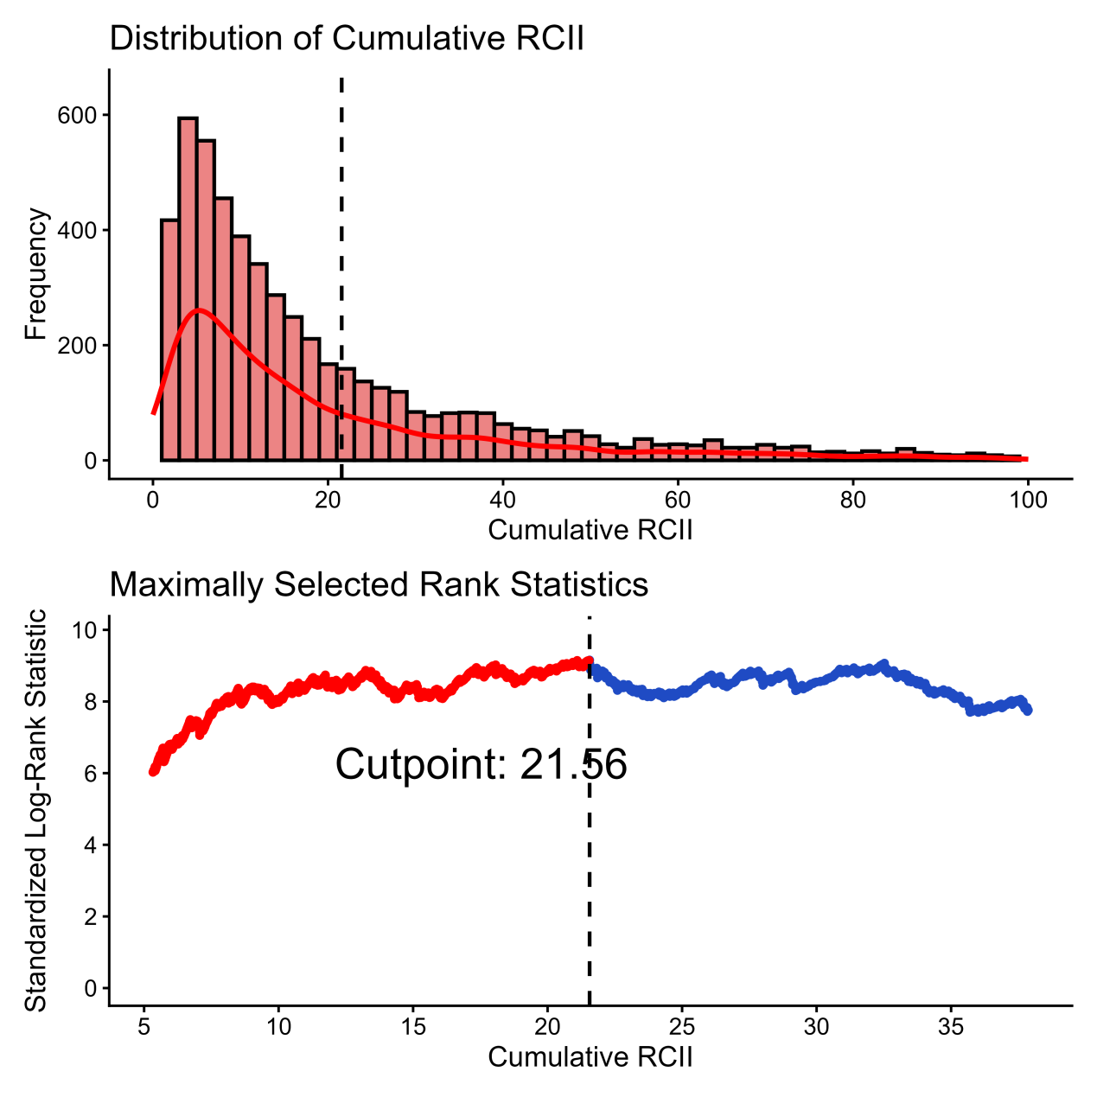
Figure S1 Distribution of cumulative RCII and identification of optimal cut point using maximally selected rank statistics.

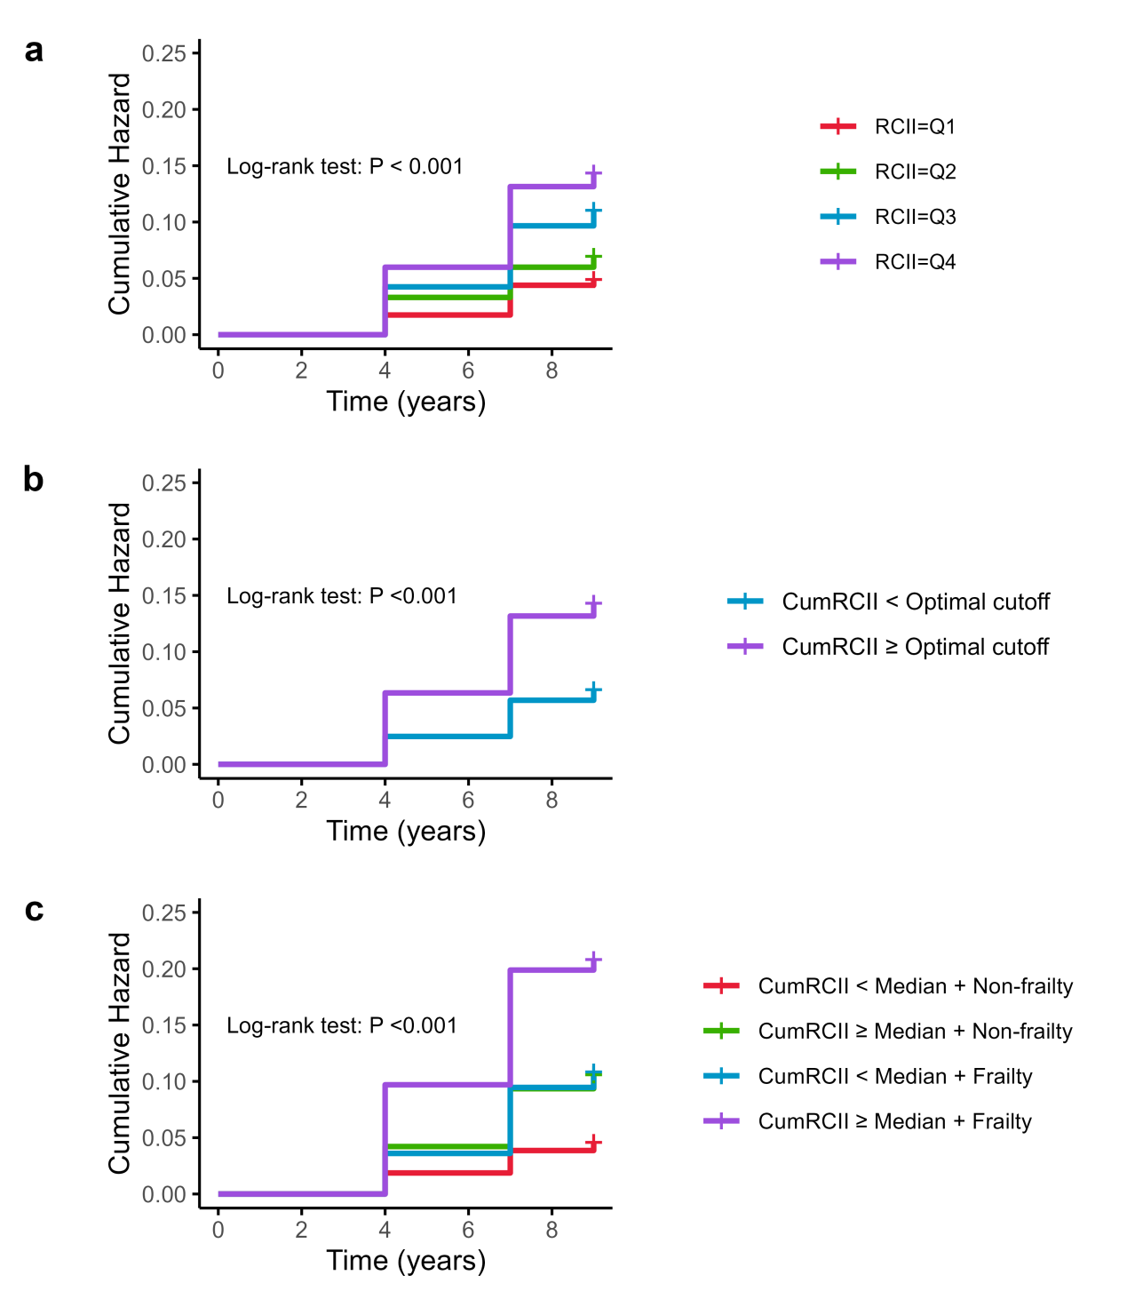
Figure S2 (a) Cumulative hazard curves of incident CMM stratified by quartiles of RCII (Q1–Q4). (b) Cumulative hazard curves of incident CMM stratified by cumulative RCII status (optimal cutoff). (c) Cumulative hazard curves of incident CMM stratified by combined categories of cumulative RCII (median cutoff) and frailty status.

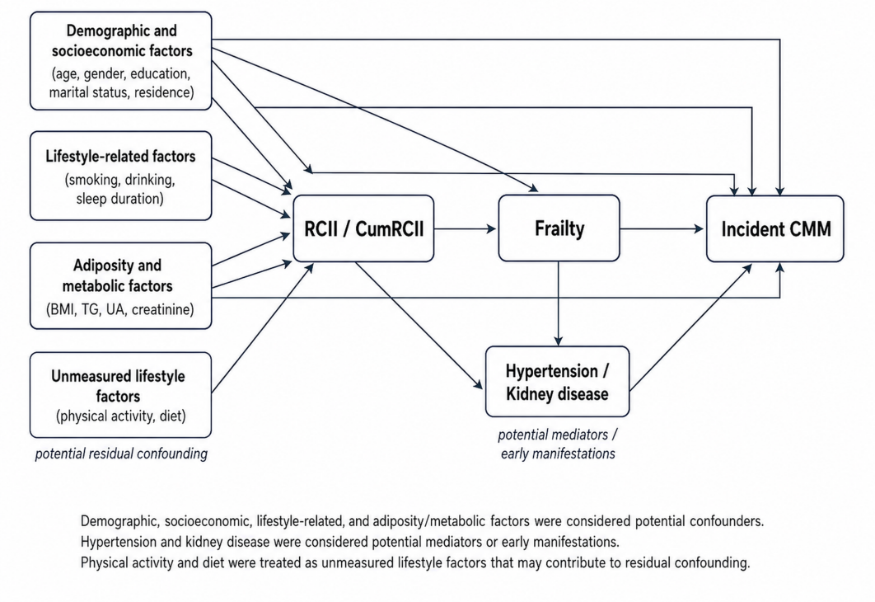
Figure S3 DAG-informed conceptual causal framework for covariate selection.

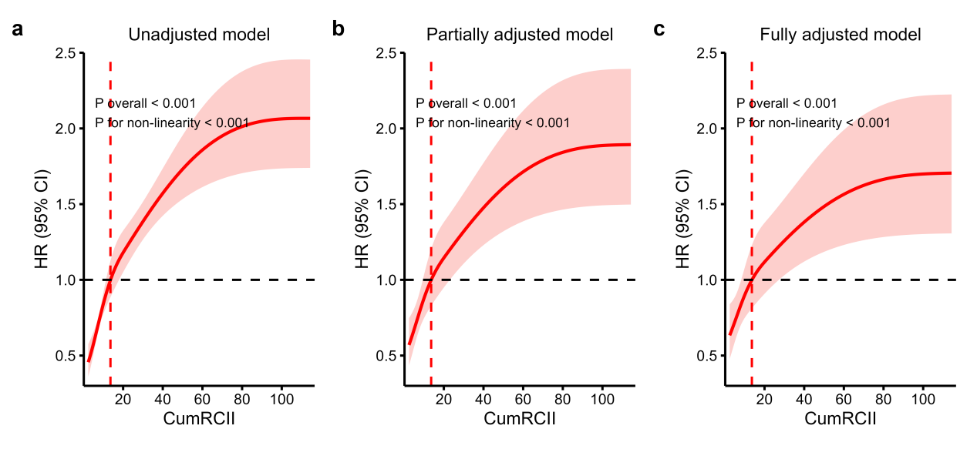
Figure S4 Restricted cubic spline analysis of the association between CumRCII and incident CMM.
a: Unadjusted model; b: Partially adjusted model; c: Fully adjusted model.
Figure legend: Partially adjusted model: Adjusted for age, gender, education, location, marital status, BMI, smoking and drinking; Fully adjusted model: Further adjusted for sleep duration, hypertension, kidney disease. The red solid line represents the estimated hazard ratio, and the shaded area indicates the corresponding 95% confidence interval. The horizontal dashed black line indicates HR = 1. The vertical dashed red line indicates the median CumRCII value used as the reference. Hazard ratios were estimated relative to the median CumRCII value.
Abbreviations: BMI, body mass index; CI, confidence interval; CMM, cardiometabolic multimorbidity; CumRCII, cumulative residual cholesterol inflammation index; HR, hazard ratio; TG, triglycerides; UA, uric acid.

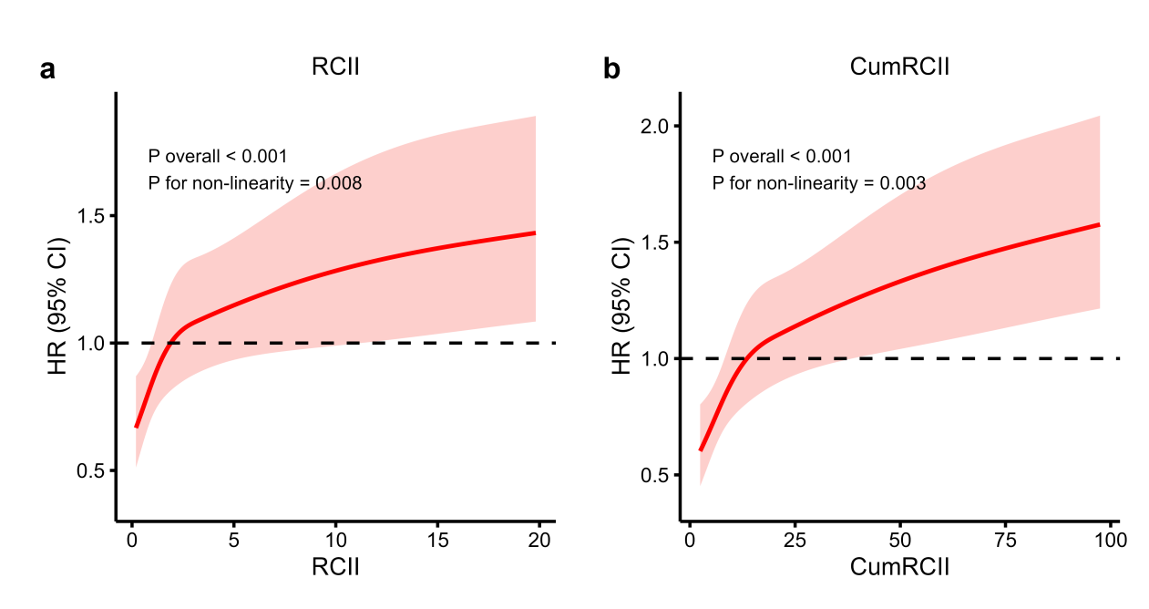

Figure S5 Sensitivity restricted cubic spline analysis after excluding participants with exposure values above the 99th percentile.
a: Fully adjusted RCS analysis of RCII after excluding participants with RCII values above the 99th percentile.
b: Fully adjusted RCS analysis of CumRCII after excluding participants with CumRCII values above the 99th percentile.
The red solid line represents the estimated hazard ratio, and the shaded area indicates the corresponding 95% confidence interval. The horizontal dashed black line indicates HR = 1. Models were adjusted for age, gender, education, residence, marital status, BMI, smoking status, drinking status, sleep duration, hypertension, kidney disease, triglycerides, uric acid, and creatinine.
Abbreviations: BMI, body mass index; CI, confidence interval; CMM, cardiometabolic multimorbidity; CumRCII, cumulative residual cholesterol inflammation index; HR, hazard ratio; RCII, residual cholesterol inflammation index; TG, triglycerides; UA, uric acid.

