Table S1. Baseline characteristics of overweight and obese individuals stratified by all-cause mortality after propensity score matching (PSM)
Characteristics | Survivors (n = 1688) | Deaths (n = 994) | P
Age(Years), M (Q₁, Q₃) | 69.00 (60.00, 76.00) | 72.00 (62.00, 80.00) | 0.062
Male(%) | 944 (55.92) | 586 (58.95) | 0.126
Smoking, n (%) | 961 (56.93) | 593 (59.66) | 0.167
Drinking, n (%) | 1450 (85.90) | 850 (85.51) | 0.782
Education, n (%) |  |  | 0.797
Less than 9th grade | 242 (14.34) | 154 (15.49)
9-11th grade | 311 (18.42) | 189 (19.01)
High school graduate | 456 (27.01) | 272 (27.36)
Some college or AA degree | 430 (25.47) | 246 (24.75)
College graduate or above | 249 (14.75) | 133 (13.38)
Race, n (%) |  |  | 0.143
Mexican American | 161 (9.54) | 86 (8.65)
Non-Hispanic Black | 187 (11.08) | 89 (8.95)
Non-Hispanic White | 985 (58.35) | 621 (62.47)
Others | 355 (21.03) | 198 (19.92)
PIR, M (Q₁, Q₃) | 1.73 (1.05, 3.04) | 1.67 (1.05, 3.00) | 0.838
WBC count(×10^⁹/L), M (Q₁, Q₃) | 6.90 (5.70, 8.20) | 6.90 (5.60, 8.40) | 0.643
Dyslipidemia, n (%) | 1195 (70.79) | 698 (70.22) | 0.753
Hypertension, n (%) | 380 (22.51) | 216 (21.73) | 0.638
Diabetes, n (%) | 586 (34.72) | 347 (34.91) | 0.919
Abbreviation: TyG, Triglyceride and glucose.BMI, Body Mass Index.WC, Waist Circumference. WBC, White blood cell. PIR, Family income-poverty ratio. AA, the associate in arts degree.

Table S2. Baseline characteristics of overweight/obese individuals based on all-cause mortality before and after PSM without ≤2 years of follow-up.
 | Before PSM |  |  | AfterPSM
 | Survivors (n = 9660) | Deaths (n = 920) | P | Survivors (n = 1411) | Deaths (n = 838) | P
AgeYear, M (Q₁, Q₃) | 48.00 (35.00, 61.00) | 72.00 (62.75, 80.00) | <0.001 | 69.00 (61.00, 76.00) | 72.00 (62.00, 80.00) | 0.051
Male(%) | 4673 (48.37) | 533 (57.93) | <0.001 | 772 (54.71) | 490 (58.47) | 0.082
Smoking, n (%) | 4203 (43.51) | 547 (59.46) | <0.001 | 807 (57.19) | 500 (59.67) | 0.251
Drinking, n (%) | 8361 (86.55) | 788 (85.65) | 0.445 | 1220 (86.46) | 720 (85.92) | 0.717
Education, n (%) |  |  | <0.001 |  |  | 0.398
Less than 9th grade | 1112 (11.51) | 145 (15.76) |  | 202 (14.32) | 126 (15.04)
9-11th grade | 1375 (14.23) | 191 (20.76) |  | 254 (18.00) | 165 (19.69)
High school graduate | 2184 (22.61) | 251 (27.28) |  | 361 (25.58) | 230 (27.45)
Some college or AA degree | 2925 (30.28) | 213 (23.15) |  | 380 (26.93) | 204 (24.34)
College graduate or above | 2064 (21.37) | 120 (13.04) |  | 214 (15.17) | 113 (13.48)
Race, n (%) |  |  | <0.001 |  |  | 0.690
Mexican American | 1911 (19.78) | 75 (8.15) |  | 116 (8.22) | 63 (7.52)
Non-Hispanic Black | 1866 (19.32) | 79 (8.59) |  | 118 (8.36) | 67 (8.00)
Non-Hispanic White | 3848 (39.83) | 583 (63.37) |  | 872 (61.80) | 539 (64.32)
Others | 2035 (21.07) | 183 (19.89) |  | 305 (21.62) | 169 (20.17)
PIR, M (Q₁, Q₃) | 2.13 (1.10, 4.08) | 1.69 (1.10, 3.03) | <0.001 | 1.81 (1.06, 3.09) | 1.72 (1.10, 3.03) | 0.538
WBC count(×10^9/L), M (Q₁, Q₃) | 6.60 (5.60, 8.00) | 6.90 (5.70, 8.47) | <0.001 | 6.80 (5.60, 8.10) | 6.90 (5.70, 8.40) | 0.097
Dyslipidemia, n (%) | 6834 (70.75) | 637 (69.24) | 0.338 | 993 (70.38) | 588 (70.17) | 0.917
Hypertension, n (%) | 2025 (20.96) | 195 (21.20) | 0.868 | 308 (21.83) | 179 (21.36) | 0.794
Diabetes, n (%) | 2006 (20.77) | 334 (36.30) | <0.001 | 482 (34.16) | 294 (35.08) | 0.656
Abbreviation: TyG, Triglyceride and glucose.BMI, Body Mass Index.WC, Waist Circumference. WBC, White blood cell. PIR, Family income-poverty ratio. AA, the associate in arts degree.

Figure S1. Restricted cubic spline curve for the association of all-cause and cardiovascular mortality for TyG-WC after excluding participants with less than 2 years of follow-up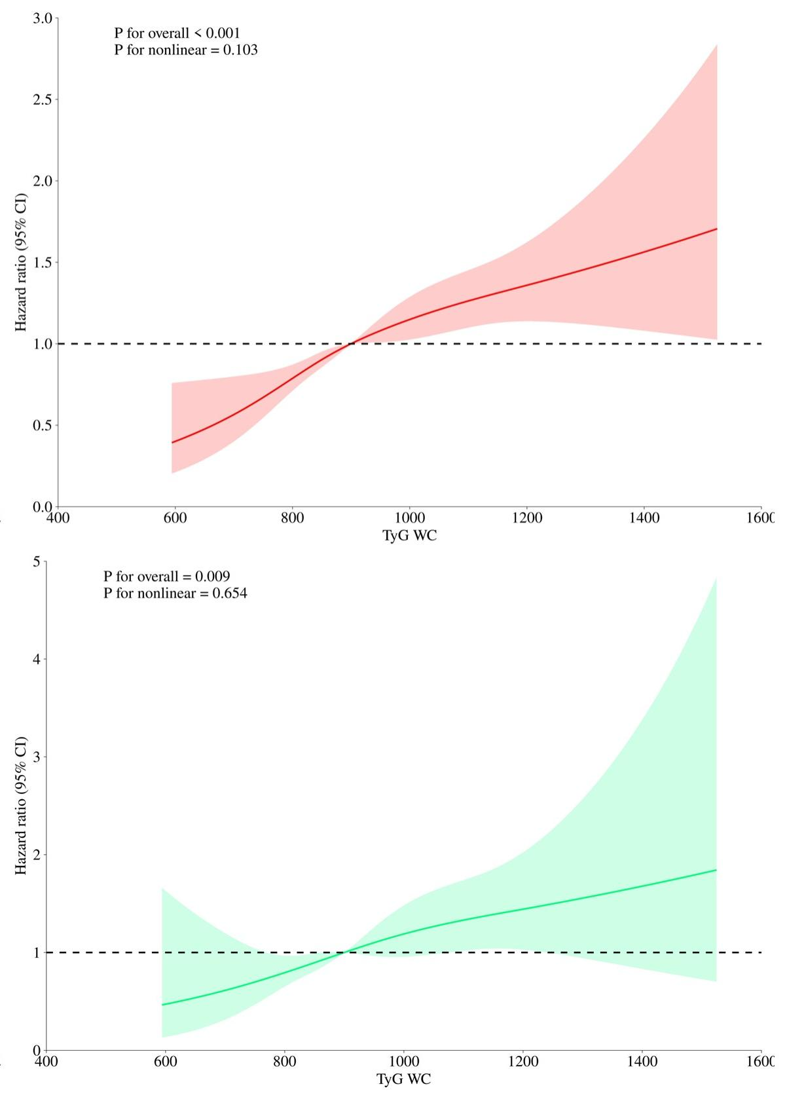
Abbreviation: Red and green solid lines represent hazard ratios, and red and green region represent 95% confidence intervals. The red curves represent the association between the TyG-WC index and all-cause mortality, and the green curves represent the association with cardiovascular mortality among adults with overweight or obesity.
Figure S2. Restricted cubic spline curve for the association of all-cause and cardiovascular mortality for TyG-WC in overweight/obese individuals after propensity score matching.
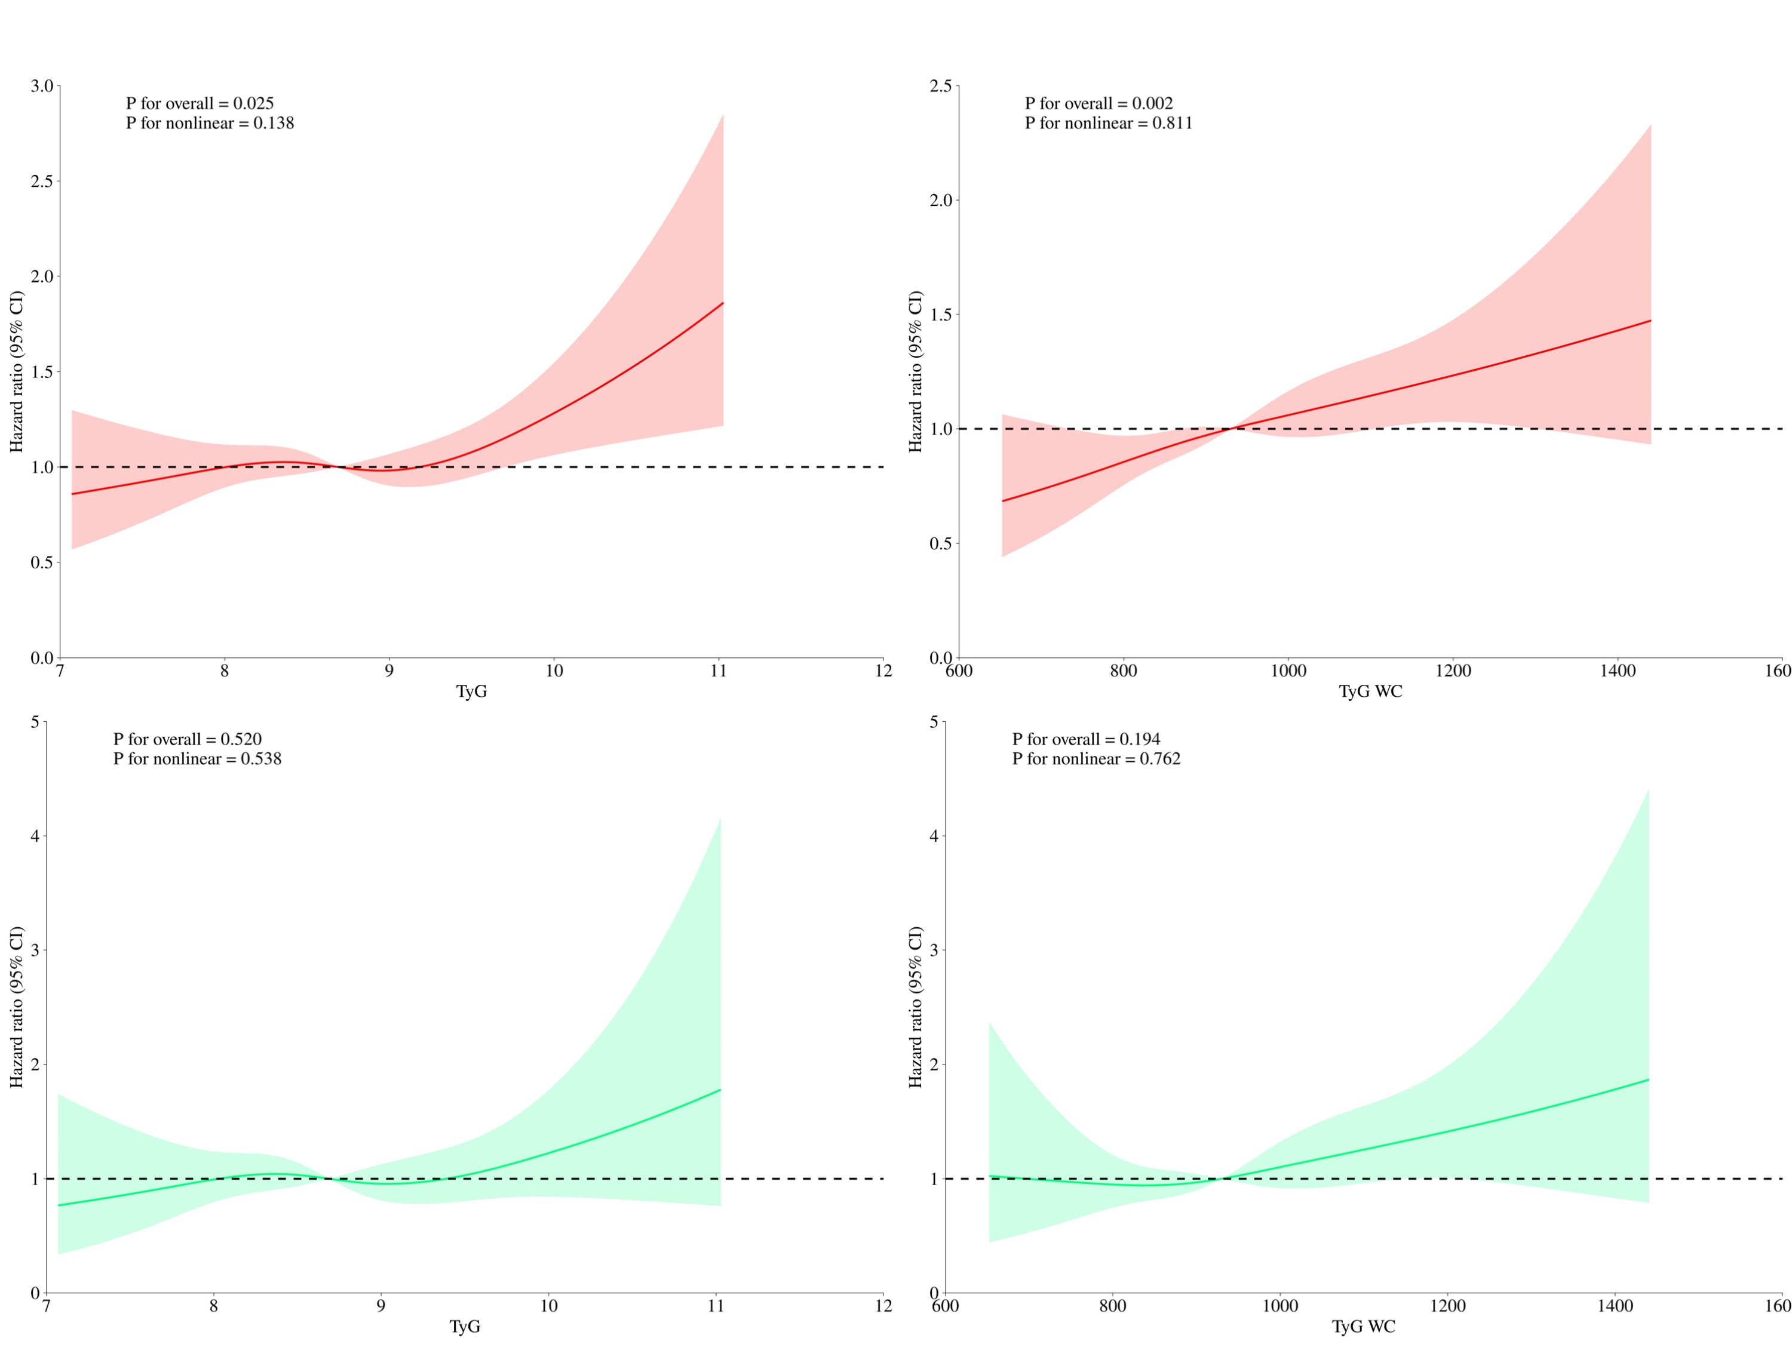
Abbreviation: Red and green solid lines represent hazard ratios, and red and green region represent 95% confidence intervals. The red curves represent the association between the TyG-WC index and all-cause mortality, and the green curves represent the association with cardiovascular mortality among adults with overweight or obesity.
Figure S3. Restricted cubic spline curves for TyG-WC and mortality after PSM, additionally excluding early deaths (<2 years)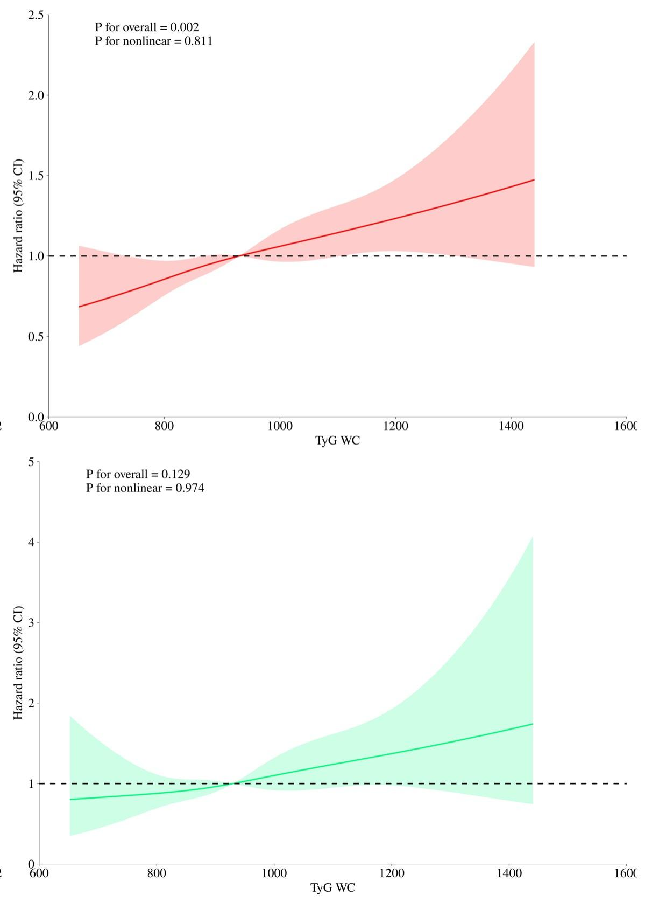
Abbreviation: Red and green solid lines represent hazard ratios, and red and green region represent 95% confidence intervals. The red curves represent the association between the TyG-WC index and all-cause mortality, and the green curves represent the association with cardiovascular mortality among adults with overweight or obesity.
Figure S4. Restricted cubic spline curve for the association of all-cause and cardiovascular mortality for TyG-WC in overweight/obese individuals with 25≤BMI≤30.
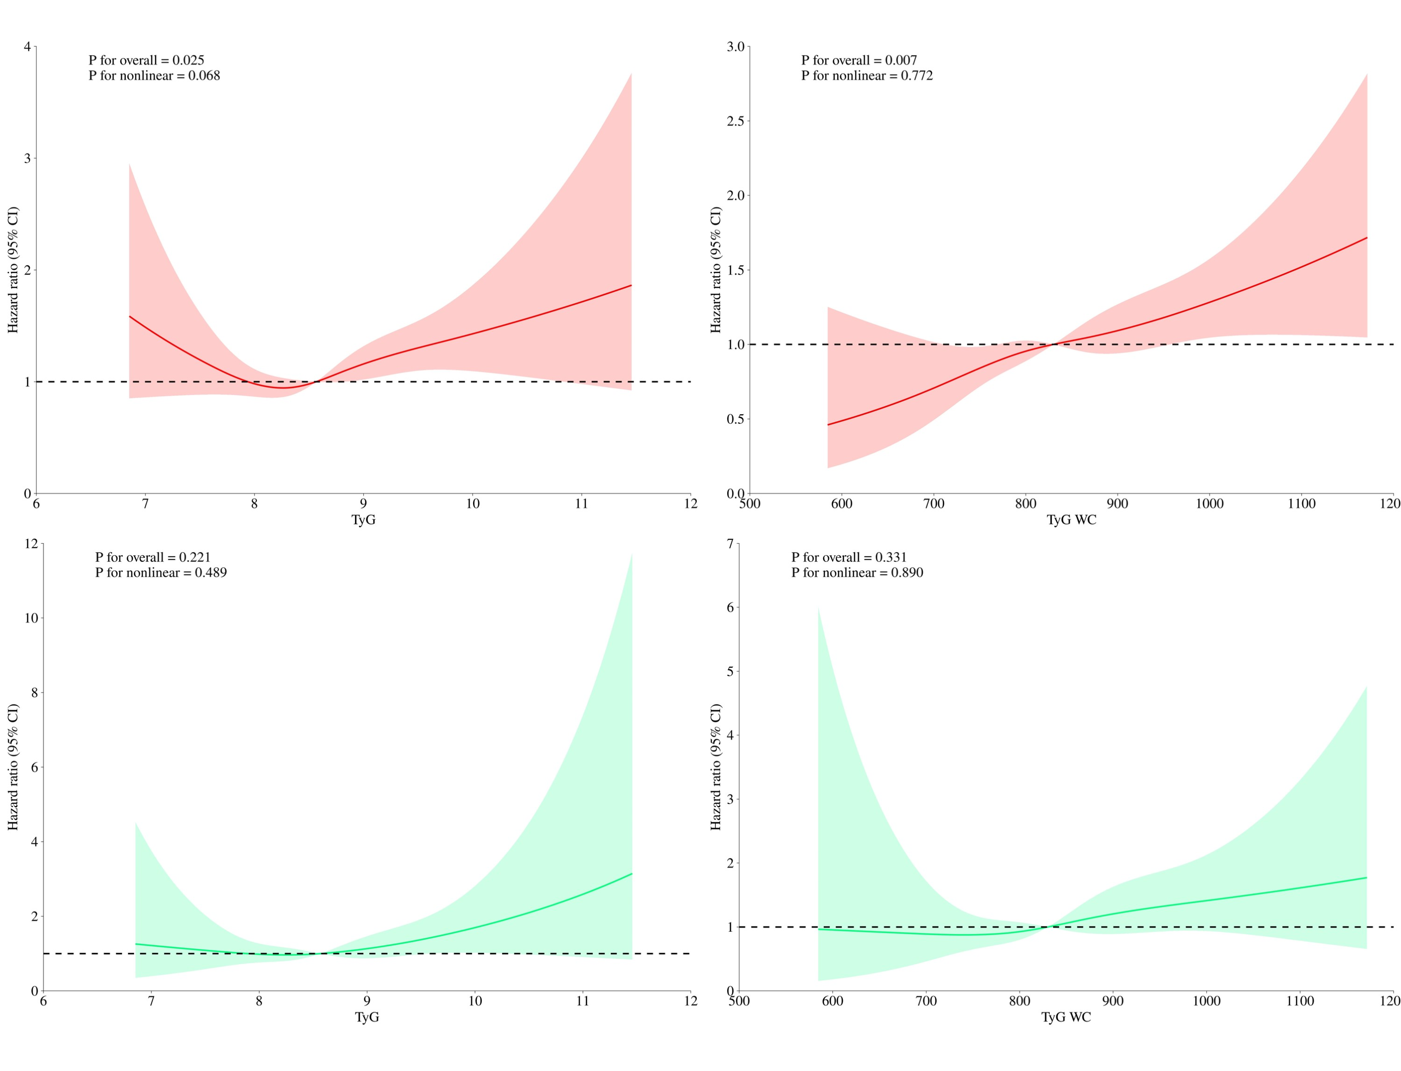
Abbreviation: Red and green solid lines represent hazard ratios, and red and green region represent 95% confidence intervals. The red curves represent the association between the TyG-WC index and all-cause mortality, and the green curves represent the association with cardiovascular mortality among adults with overweight or obesity.
Figure S5. Restricted cubic spline curve for the association of all-cause and cardiovascular mortality for TyG-WC in overweight/obese individuals with BMI>30.
Abbreviation: Red and green solid lines represent hazard ratios, and red and green region represent 95% confidence intervals. The red curves represent the association between the TyG-WC index and all-cause mortality, and the green curves represent the association with cardiovascular mortality among adults with overweight or obesity.
Figure S6. Restricted cubic spline curve for the association of all-cause and cardiovascular mortality for TyG-WC in overweight/obese individuals ≥60 years of age.
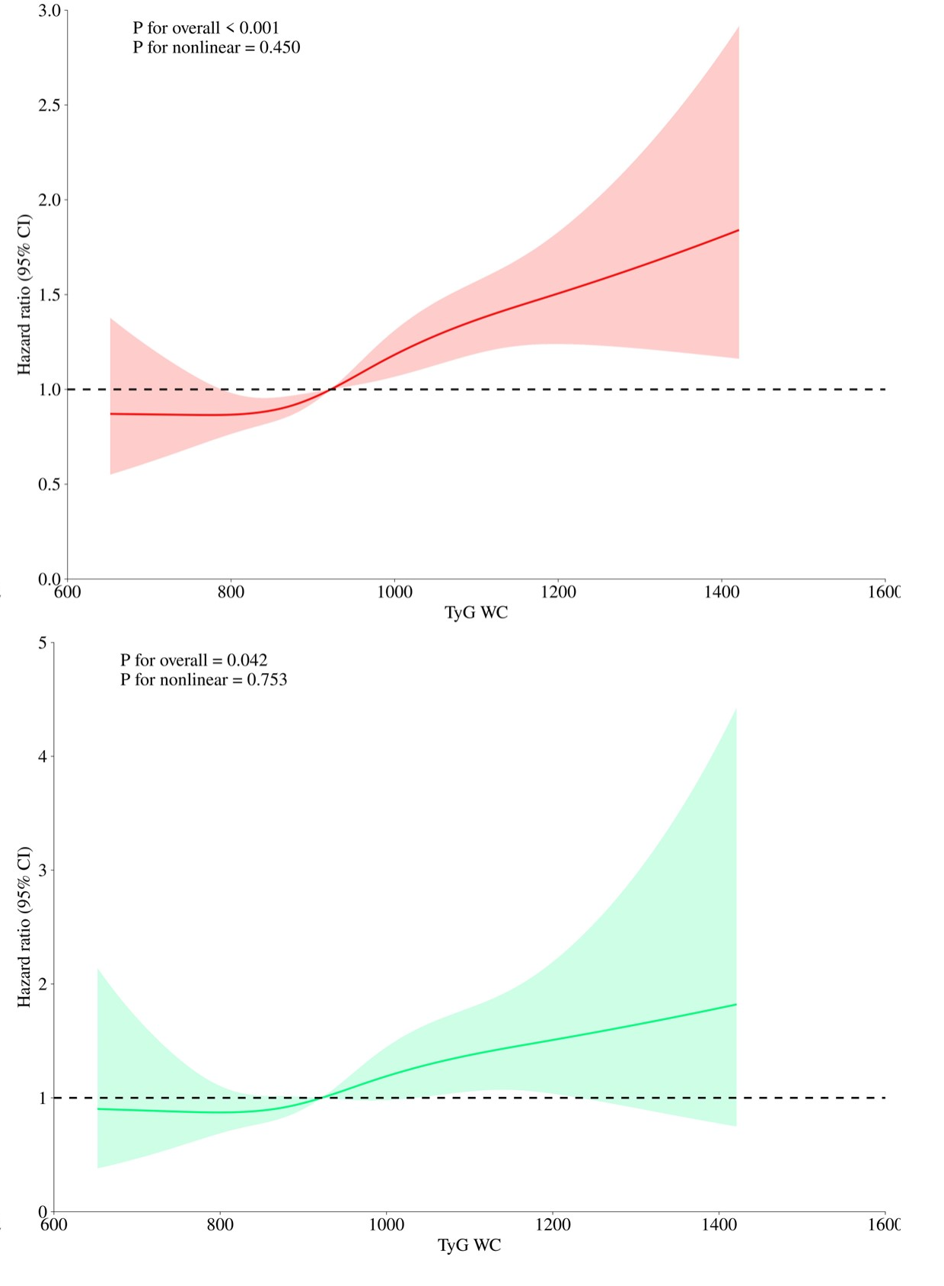
Abbreviation: Red and green solid lines represent hazard ratios, and red and green region represent 95% confidence intervals. The red curves represent the association between the TyG-WC index and all-cause mortality, and the green curves represent the association with cardiovascular mortality among adults with overweight or obesity.
Figure S7. Restricted cubic spline curve for the association of all-cause and cardiovascular mortality for TyG-WC in overweight/obese individuals <60 years of age.
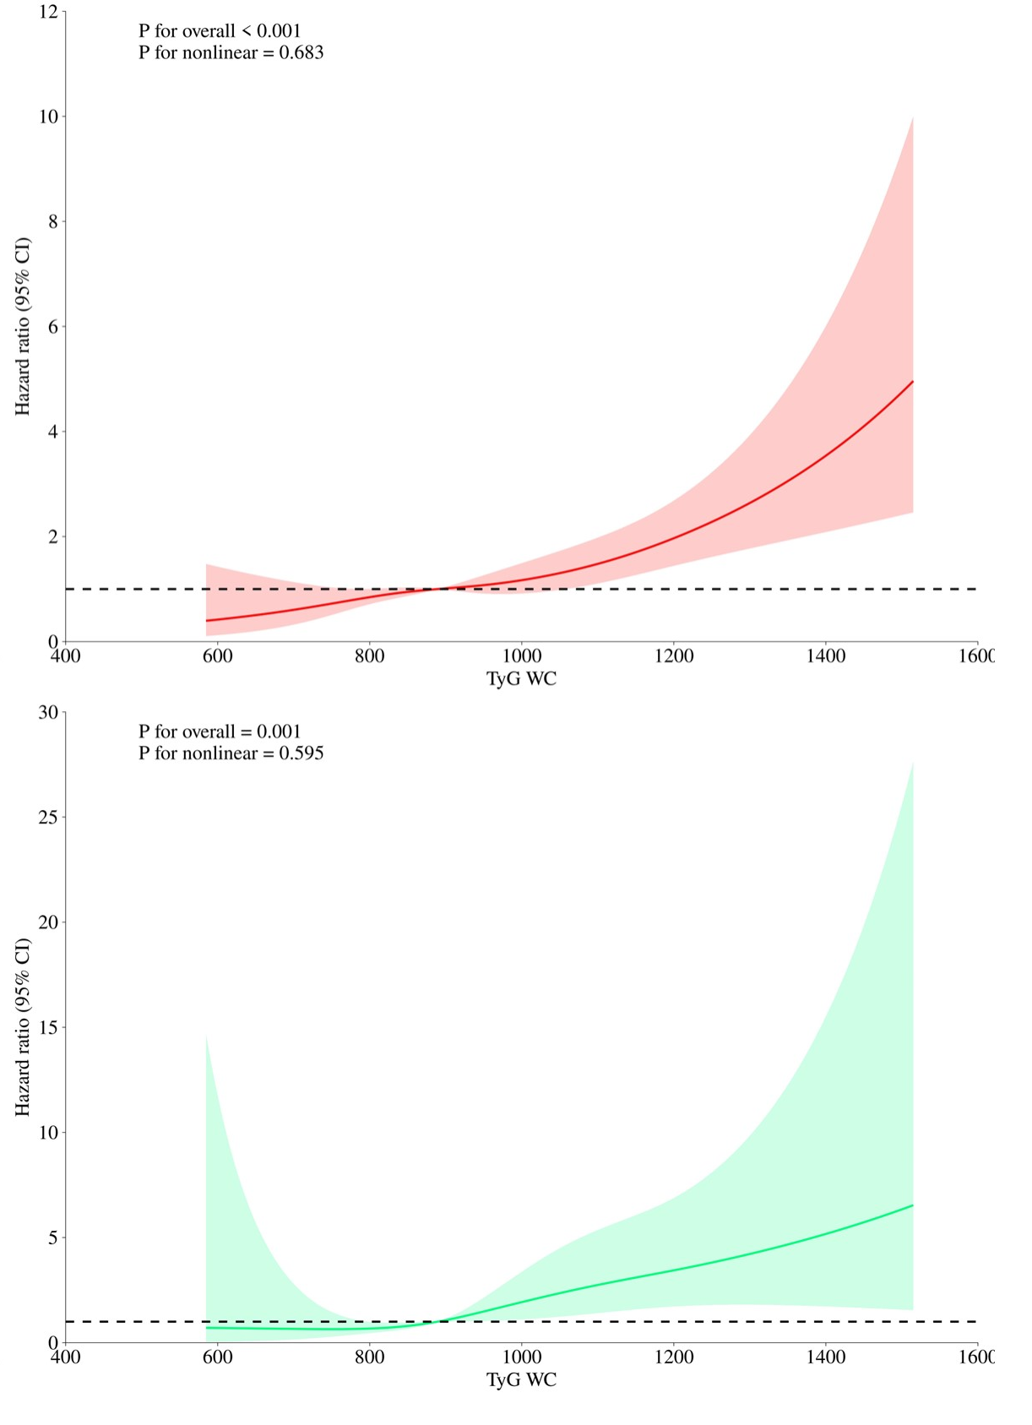
Abbreviation: Red and green solid lines represent hazard ratios, and red and green region represent 95% confidence intervals. The red curves represent the association between the TyG-WC index and all-cause mortality, and the green curves represent the association with cardiovascular mortality among adults with overweight or obesity.
Figure S8. Restricted cubic spline curve for the association of all-cause and cardiovascular mortality for TyG-WC in overweight/obese in men.
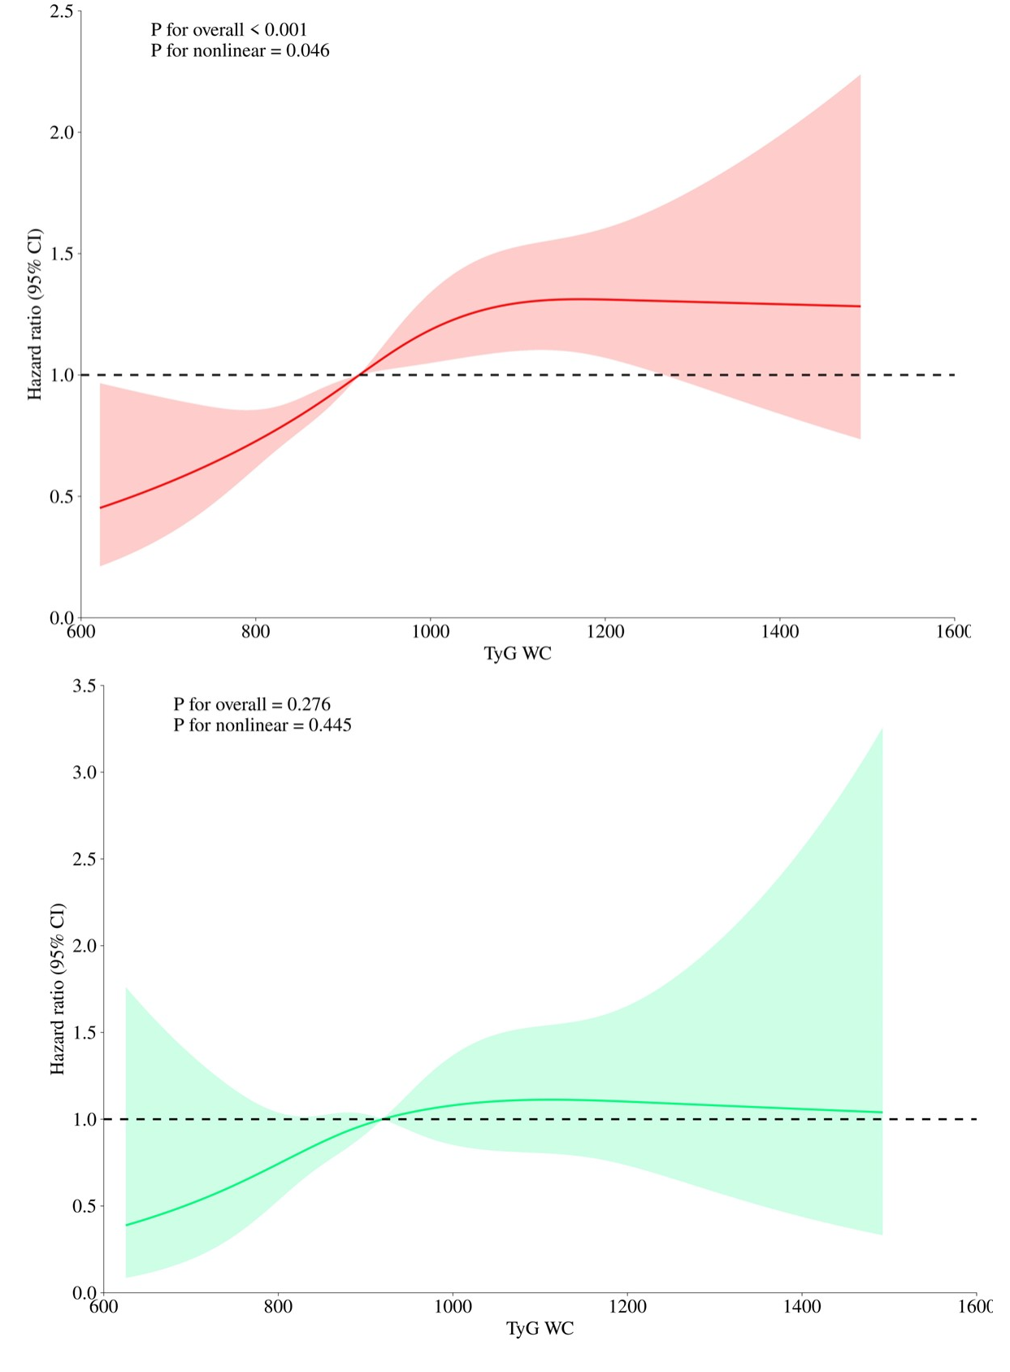
Abbreviation: Red and green solid lines represent hazard ratios, and red and green region represent 95% confidence intervals. The red curves represent the association between the TyG-WC index and all-cause mortality, and the green curves represent the association with cardiovascular mortality among adults with overweight or obesity.
Figure S9. Restricted cubic spline curve for the association of all-cause and cardiovascular mortality for TyG-WC among overweight/obese individuals of women.
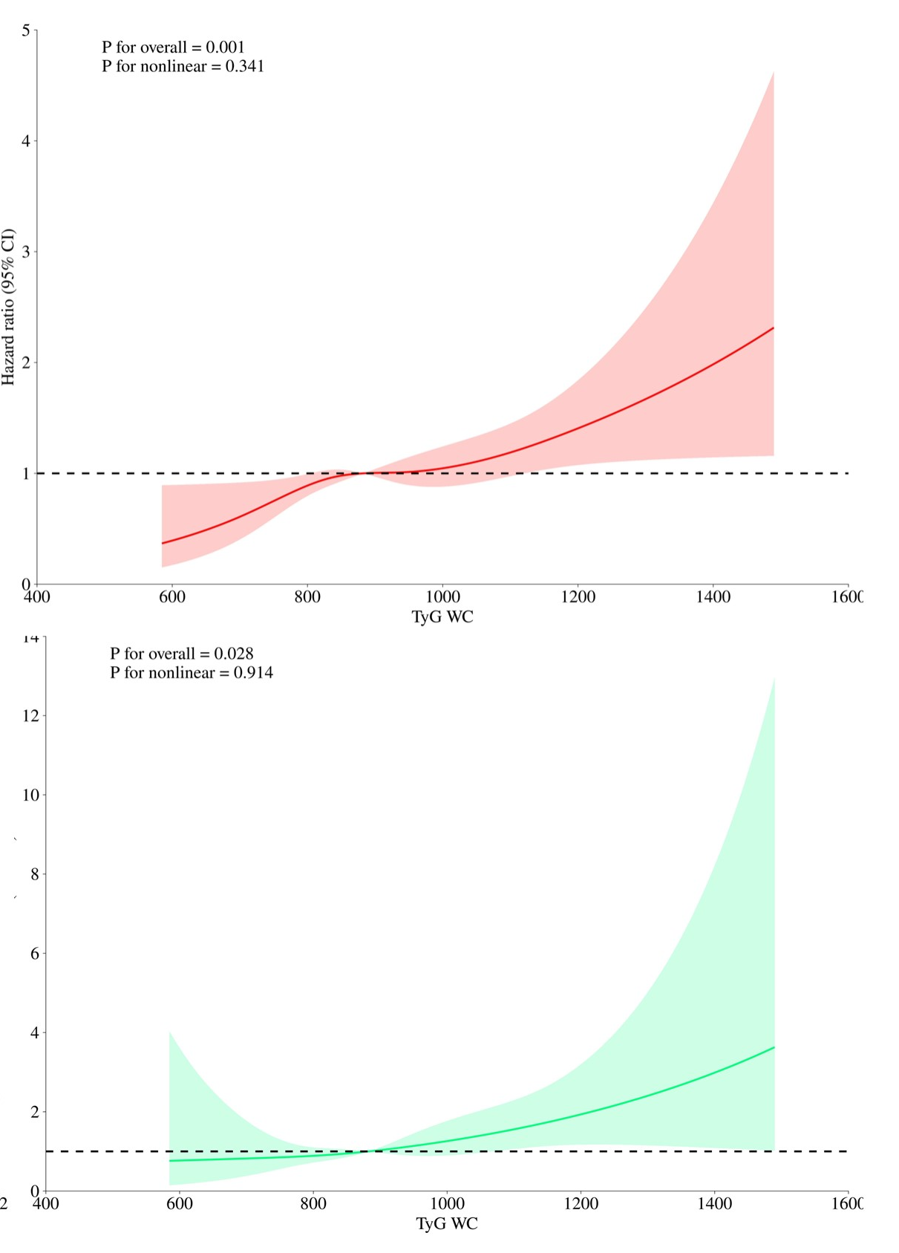
Abbreviation: Red and green solid lines represent hazard ratios, and red and green region represent 95% confidence intervals. The red curves represent the association between the TyG-WC index and all-cause mortality, and the green curves represent the association with cardiovascular mortality among adults with overweight or obesity.
Supplementary Figure S10. Descriptive ROC analysis of the TyG-WC index for all-cause and cardiovascular mortality.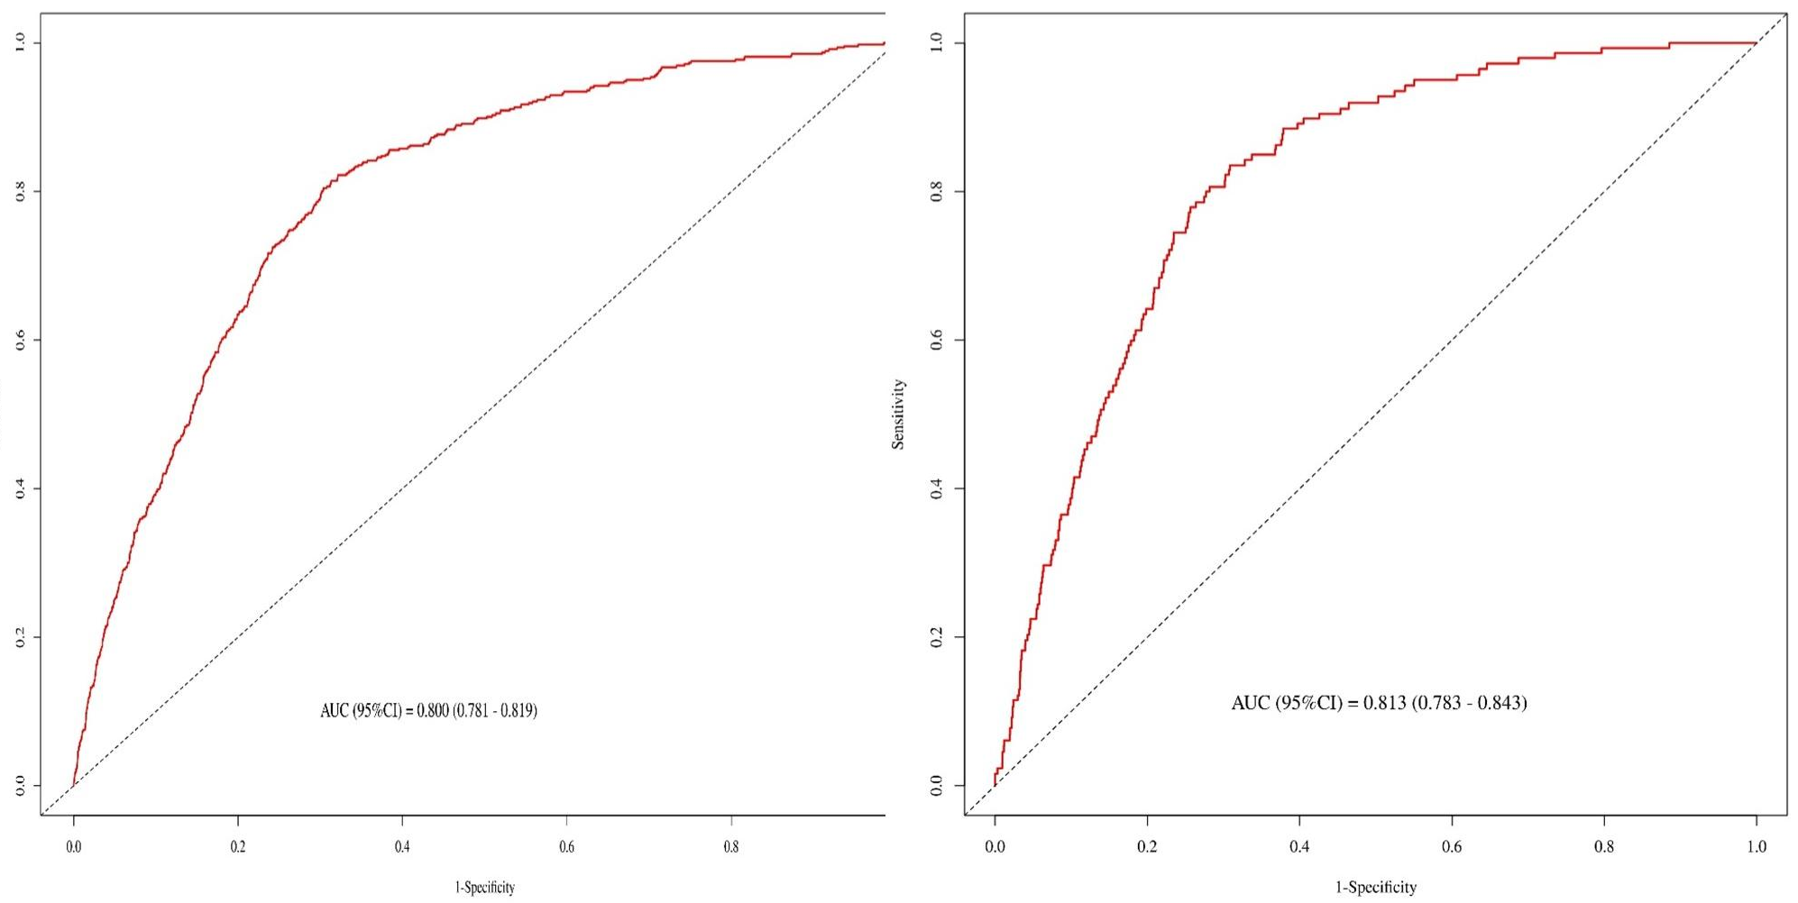
A. TyG-WC predicted all-cause mortality. B. TyG-WC predicted cardiovascular mortality. Models were adjusted for age, sex, race/ethnicity, poverty–income ratio (PIR), education level, smoking status, alcohol consumption, hypertension, dyslipidemia, and diabetes.

