Supplementary Materials
Contents
Supplementary Table 1. UK Biobank variable and outcome definitions 2
Supplementary Table 2. CHARLS variable and outcome definitions 4
Supplementary Table 3. UKB baseline characteristics by ePWV quartile 6
Supplementary Table 4. UKB biomarker distributions and correlations with ePWV 6
Supplementary Table 5. UKB cumulative incidence of first-ever stroke by ePWV quartile 7
Supplementary Table 6. UKB global and pairwise log-rank tests across ePWV quartiles 7
Supplementary Table 7. Associations of ePWV with mortality outcomes in the revised UKB risk set 8
Supplementary Table 8. Fine-Gray models for first-ever stroke under alternative competing events 8
Supplementary Table 9. Biomarker-stratified associations of ePWV with first-ever stroke in UKB 9
Supplementary Table 10. UKB continuous-ePWV sensitivity analyses for age adjustment and outcome definition 10
Supplementary Table 11. UKB ePWV-quartile sensitivity analyses for age adjustment and outcome definition 10
Supplementary Table 12. UKB landmark sensitivity analyses excluding early incident strokes 10
Supplementary Table 13. UKB collinearity diagnostics when ePWV is entered with age, SBP, DBP, and hypertension 10
Supplementary Table 14. UKB proportional-hazards diagnostics for continuous ePWV association models 10
Supplementary Table 15. UKB paired discrimination comparison of the comprehensive conventional and ePWV substitution models 11
Supplementary Table 16. UKB model complexity, fit, and cross-validated calibration for the comprehensive comparison 11
Supplementary Table 17. UKB alternative prediction comparator sensitivity analyses 11
Supplementary Table 18. Incremental discrimination from ePWV and biomarkers for first-ever stroke in UKB 11
Supplementary Table 19. Nested-model likelihood-ratio tests and information criteria for ePWV and biomarker additions 13
Supplementary Table 20. CHARLS baseline characteristics by physician-diagnosed incident stroke status 14
Supplementary Table 21. CHARLS baseline characteristics by ePWV quartile 15
Supplementary Table 22. CHARLS cumulative incidence and log-rank comparisons across ePWV quartiles 15
Supplementary Table 23. CHARLS association of continuous ePWV with primary and sensitivity outcomes 16
Supplementary Table 24. CHARLS association of ePWV quartiles with primary and sensitivity outcomes 16
Supplementary Table 25. CHARLS landmark sensitivity analysis excluding early incident strokes 16
Supplementary Table 26. CHARLS collinearity diagnostics when ePWV is entered with age, SBP, DBP, and hypertension 16
Supplementary Table 27. CHARLS proportional-hazards diagnostics for continuous ePWV association models 17
Supplementary Table 28. CHARLS paired discrimination comparison of the comprehensive conventional and ePWV substitution models 17
Supplementary Table 29. CHARLS model complexity, fit, and cross-validated calibration for the comprehensive comparison 17
Supplementary Table 30. CHARLS alternative prediction comparator sensitivity analyses 17
Supplementary Figure S1. Cumulative incidence functions under heart-disease and all-cause death competing events 18
Supplementary Figure S2. Fine-Gray restricted cubic splines with heart-disease death as the competing event 18
Supplementary Figure S3. Fine-Gray restricted cubic splines with all-cause death as the competing event 19
Supplementary Figure S4. Scaled Schoenfeld residual diagnostics for ePWV 19
Supplementary Figure S5. Calibration of comprehensive conventional and ePWV substitution models 20
Supplementary Figure S6. Cumulative incidence of first-ever stroke by ePWV quartile in CHARLS 21

Variable and outcome definitions
Supplementary Table 1. UK Biobank variable and outcome definitions
Variable / outcome | Definition
Age | Age was defined as the participant’s age in years at the time of the baseline assessment, taken from UK Biobank Field 21003 at instance 0. This variable was treated as a continuous covariate.
SBP, DBP, MAP, and ePWV | UKB SBP and DBP were the means of the available values from two automated readings taken a few moments apart at the baseline assessment. MAP was DBP + 0.4 x (SBP - DBP). ePWV was calculated using the same age-MAP equation as in CHARLS.
Sex | Sex was defined using UK Biobank Field 31 at instance 0, coded as 1 for males and 0 for females.
Ethnicity | Ethnicity was defined using UK Biobank Field 21000 at instance 0. Participants were classified as White if their recorded code was 1, 1001, 1002, or 1003 (White / White British / White Irish / other White background); all other categories were treated as non-White for analysis.
Townsend deprivation index | Socioeconomic deprivation was assessed using the Townsend Deprivation Index at baseline (UK Biobank Field 22189).
Body mass index | Body mass index (BMI) was taken from UK Biobank Field 21001 at instance 0, calculated as weight (kg) divided by height squared (m²). For analysis, BMI was categorised into four groups using standard clinical cut-points: (i) <18.5 kg/m² (underweight); (ii) ≥18.5 and <25 kg/m² (normal weight); (iii) ≥25 and <30 kg/m² (overweight); and (iv) ≥30 kg/m² (obesity). These categories were encoded as 1, 2, 3, and 4 respectively.
Alcohol drinking status | Alcohol drinking status at baseline was derived from UK Biobank Field 20117 at instance 0. Participants were classified into three mutually exclusive categories: 0 = never drinker, 1 = previous drinker, and 2 = current drinker.
Smoking status | Smoking status at baseline was derived from UK Biobank Field 20116 at instance 0. Participants were categorised as 0 = never smoker, 1 = previous smoker, or 2 = current smoker.
Physical activity | Physical activity at baseline was defined using self-reported moderate and vigorous activity from UK Biobank fields 884, 894, 904, and 914 (instance 0). Participants were classified as physically active if they met any of the following criteria: (i) more than 150 minutes of moderate physical activity per week; (ii) more than 75 minutes of vigorous physical activity per week; (iii) moderate physical activity on at least 5 days per week; or (iv) participation in vigorous physical activity on at least 1 day per week. Participants who did not meet any of these criteria were classified as inactive, according to American Heart Association criteria (Lloyd-Jones et al., Circulation 2010).
Household income | Household income was taken from UK Biobank Field 738 at instance 0, which records self-reported total gross household income before tax in predefined UK Biobank income bands.
Education | Educational attainment at baseline was taken from UK Biobank Field 6138 at instance 0 and categorised into three groups: 0 = unknown / not reported, 1 = college or university degree, and 2 = other qualifications (e.g. A-levels, vocational, or other non-degree education).
Residential environment category | Participants’ residential environment at baseline was derived from the UK Biobank “urban/rural classification” field (UK Biobank Field 20118 at instance 0). We used this field to categorise each participant’s home area into broader urban vs rural groups. Specifically, we collapsed the original UK Biobank area codes such that (i) codes 1, 2, 3, 4, or 5 were grouped as “Urban”, reflecting residence in urban, suburban, or densely populated settings; (ii) codes 6, 7, 8, or 9 were grouped as “Rural”, reflecting residence in less densely populated or rural settings; and (iii) all other or missing codes were set to missing.
Any malignant cancer | ICD-10 C00–C97 (all malignant neoplasms: head & neck, lung, liver, colorectal, breast, hematologic, etc.)
Asthma | ICD-10 J45 (asthma), J46 (status asthmaticus / acute severe asthma)
Chronic Obstructive Pulmonary Disease (COPD), including chronic bronchitis / emphysema | ICD-10 J41 (chronic simple bronchitis), J42 (unspecified chronic bronchitis), J43 (emphysema), J44 (other COPD)
Bronchiectasis | ICD-10 J47 (bronchiectasis)
Chronic kidney disease (CKD) | ICD-10 N18 (chronic kidney disease)
Chronic ischaemic heart disease / coronary heart disease | ICD-10: I25 (chronic ischaemic heart disease); ICD-9: 4140, 4148, 4149 (coronary atherosclerosis / ischaemic heart disease codes)
Myocardial infarction (MI), including recurrent MI / prior MI | ICD-10: I21 (acute MI), I22 (subsequent MI); ICD-9: 410, 411, 412 (acute/subacute ischaemic syndromes and old MI)
Heart failure | ICD-10: I110, I130, I132 (hypertensive heart/reno-cardiac disease with heart failure), I50 (heart failure); ICD-9: 40201, 40211, 40291, 40401, 40411, 40491, 40403, 40413, 40493, 428 (hypertensive heart/renal disease with HF and congestive heart failure codes)
Stroke | Primary incident stroke was defined using ICD-10 I60, I61, I63, and I64 and ICD-9 430, 431, 434, and 436. TIA codes (ICD-10 G45; ICD-9 435) were excluded from the primary outcome and included only in the stroke/TIA sensitivity outcome.
Hypertension | Participants were classified as having prevalent hypertension at baseline if there was evidence of hypertension from any source at or before the baseline assessment. Evidence was defined as: (i) doctor-diagnosed hypertension reported at the baseline assessment (UK Biobank Field 6150 at instance 0, where the participant selected code “4”, indicating high blood pressure); (ii) self-reported hypertension in the longstanding illness questionnaire at baseline (UK Biobank Field 20002 at instance 0); or (iii) reported use of antihypertensive medication at baseline, defined as selecting antihypertensive treatment in the sex-specific medication question (for males, Field 6177 includes code “2”; for females, Field 6153 includes code “2”). These sources were combined using an OR rule: meeting any of the above criteria resulted in classification as “yes”. If at least one source was available but none met the “yes” criteria, the participant was classified as “no”. If no information was available from any source, status was set to missing.
Diabetes | Participants were classified as having baseline diabetes if diabetes was identified by self-report, physician diagnosis, antidiabetic medication use, or relevant medical records at or before baseline. Evidence was defined as: (i) a positive response to “Has a doctor ever told you that you have diabetes?” at baseline (UK Biobank Field 2443 at instance 0,; values -1 or -3 were treated as missing); (ii) self-reported diabetes in the longstanding illness questionnaire at baseline (UK Biobank Field 20002 at instance 0, where any of `20002` matched the UK Biobank diabetes codes 1220, 1221, 1222, or 1223); or (iii) reported use of glucose-lowering / insulin therapy at baseline, defined using the sex-specific medication questions (for males, Field 6177 includes code “3”; for females, Field 6153 includes code “3”). These sources were combined using an OR rule: meeting any of the above criteria resulted in classification as “yes”. If at least one source was available but none met the “yes” criteria, the participant was classified as “no”. If no information was available from any source, status was set to missing.
Dyslipidaemia | Participants were classified as having prevalent dyslipidaemia at baseline if there was evidence of dyslipidaemia or hypercholesterolaemia from any source at or before the baseline assessment. Evidence was taken from three sources: (i) self-reported longstanding illness at baseline, where any of the non-cancer illness codes in UK Biobank Field 20002 (instance 0) indicated “high cholesterol” (code 1473); (ii) use of lipid-lowering medication at baseline, defined as reporting cholesterol-lowering medication in the sex-specific medication questions (males: Field p6177_i0 contains code “1”; females: Field p6153_i0 contains code “3”); and (iii) linked hospital episode statistics indicating a prior clinical diagnosis of a lipid disorder, defined as ICD-10 code E78 (“disorders of lipoprotein metabolism and other lipidaemias, including hypercholesterolaemia”) (i.e. before or at baseline). These information sources were combined using an OR rule, such that meeting any of the above criteria resulted in classification as “yes”. If at least one source was present but none fulfilled the “yes” criteria, the participant was classified as “no”. If no information was available from any source, status was set to missing.
Haemoglobin (UKB Field 30020) | Baseline instance 0; g/dL.
Total cholesterol (UKB Field 30690) | Baseline instance 0; mmol/L.
HDL cholesterol (UKB Field 30760) | Baseline instance 0; mmol/L.
LDL cholesterol (UKB Field 30780) | Directly measured at baseline instance 0; mmol/L.
Triglycerides (UKB Field 30870) | Baseline instance 0; mmol/L.
Glucose (UKB Field 30740) | Baseline instance 0; mmol/L.
HbA1c (UKB Field 30750) | Baseline instance 0; mmol/mol. Percentage units were derived as 0.0915 x HbA1c (mmol/mol) + 2.15.
Creatinine (UKB Field 30700) | Baseline instance 0; micromol/L.
Cystatin C (UKB Field 30720) | Baseline instance 0; mg/L.
Non-HDL cholesterol | Derived as total cholesterol minus HDL cholesterol; mmol/L.
Total cholesterol/HDL ratio | Derived as total cholesterol divided by HDL cholesterol.
eGFR | Derived from creatinine, age, and sex using the 2021 race-free CKD-EPI creatinine equation; mL/min/1.73 m2.
Triglyceride-glucose (TyG) index | Derived as ln[(triglycerides in mg/dL x glucose in mg/dL)/2], using conversion factors of 88.57 and 18.0, respectively.
Mortality outcomes(heart disease mortality, stroke death, all-cause death) | Deaths were ascertained through national death-registry linkage. Heart-disease death used ICD-10 I20-I25 and I50; stroke death under the first-ever stroke definition used I60, I61, I63, and I64 and excluded G45; all-cause death included any registered death. Non-index deaths were handled as censoring events in cause-specific Cox models and as competing events where specified.
Note. The revised first-ever stroke and stroke-death definitions exclude TIA. Abbreviations: UKB, UK Biobank; CHARLS, China Health and Retirement Longitudinal Study; ePWV, estimated pulse wave velocity; TIA, transient ischaemic attack; ICD-9, International Classification of Diseases, Ninth Revision; ICD-10, International Classification of Diseases, Tenth Revision; SBP, systolic blood pressure; DBP, diastolic blood pressure; MAP, mean arterial pressure; BMI, body mass index; HbA1c, glycated haemoglobin; HDL, high-density lipoprotein cholesterol; LDL, low-density lipoprotein cholesterol; TyG, triglyceride-glucose index; eGFR, estimated glomerular filtration rate; CKD, chronic kidney disease; CKD-EPI, Chronic Kidney Disease Epidemiology Collaboration; COPD, chronic obstructive pulmonary disease; MI, myocardial infarction; HF, heart failure.
Supplementary Table 2. CHARLS variable and outcome definitions
Variable | Coding | Definition / questionnaire description
ePWV | Continuous (m/s) | Estimated pulse wave velocity. Derived from age and brachial BP using a validated formula to approximate aortic/carotid–femoral PWV; higher = stiffer arteries (greater arterial stiffness / vascular aging). Measured at baseline (Wave 1, 2011).
SBP | Continuous (mmHg) | Systolic blood pressure. CHARLS staff measured BP three times using an automated oscillometric sphygmomanometer with the participant seated at rest; dataset stores the mean of the 2nd and 3rd measurements as r1systo_w1_r_average_blood_pressure_measure__2_&_3.
DBP | Continuous (mmHg) | Diastolic blood pressure. Same protocol as SBP; stored as r1diasto_w1_r_average_blood_pressure_measure__2_&_3.
MAP | Continuous (mmHg) | Calculated as DBP + 0.4 x (SBP - DBP), identical to UKB.
Event | Binary: 1 = incident stroke; 0 = censored | Primary outcome: first physician-diagnosed stroke at a follow-up wave. Current stroke medication was not used to define the primary incident event; the original diagnosis-or-medication rule was retained as a sensitivity outcome.
Follow-up time | Continuous (months) | Follow-up time from baseline interview date (Wave 1 year/month) to: (i) first wave where stroke is newly reported (if event = 1), or (ii) last observed interview wave (if event = 0). We convert interview year+month to elapsed months, then to years.
Stroke | Yes / No / missing (before recode) | Baseline stroke-free status required no physician-diagnosed stroke and no current stroke medication at Wave 1. Follow-up physician diagnosis defined the primary event.
Follow-up interview dates (2011–2018) | Interview year and month at each CHARLS wave | Used to construct survival time and censoring time (baseline = 2011 wave; follow-up from interview date to first report of stroke or last available wave).
Heart disease | Yes / No / missing | “Has a doctor ever told you that you had heart disease (heart attack, coronary heart disease, angina, congestive heart failure, or other heart problems)?”
Sex | Male / Female | From “ragender_r_gender” (“1.man”, “2.woman”).
Age | Continuous (years) | r1agey_w1_r_age_in_years, participant’s age at baseline (Wave 1, 2011).
Marital | Marital status at baseline was obtained from CHARLS (r1mstath_w1_r_marital_status) and analysed as a categorical variable (married, widowed, divorced, separated, never married, cohabiting/other). For sensitivity analyses, we additionally used a binary derivation (married/cohabiting vs not married). Responses of “don’t know/refused” were coded as missing. | r1mstath_w1_r_marital_status.  Self-reported current marital status at baseline.
Education | Illiterate / Literate (no formal school) / Elementary / Middle school / High school or above | From ‘raeduc_c_r_education_’. We collapsed CHARLS’ detailed schooling ladder: “No formal education, illiterate”; “Can read/write but no formal primary completion”; “Elementary school”; “Middle school”; and “High school or above (incl. vocational, college, postgraduate).”
Live place | Rural / Urban | h1rural_w1_lives_in_rural_or_urban, which records whether the household is in a rural village vs. urban community at baseline. Often used in CHARLS to stratify rural vs. urban health risk.
Socioeconomic status (SES) | low; low–middle; middle; middle–high; high. | Treated as an ordinal categorical variable (lowest → highest). If needed, categories may be collapsed for sample-size balance (e.g., low/low–middle vs middle/high groups).
Smoke status | Never / Current / Ever(former) | Built from two items: (1) “Have you ever smoked?” (r1smokev_w1_r_smoke_ever); (2) “Do you smoke now?” (r1smoken_w1_r_smoke_now). We code: Never = never smoked; Current = currently smokes; Ever = smoked before but not now.
Drink status | Never / Current / Ever(former) | Based on (1) “Have you ever drunk any alcoholic beverages?” (r1drinkev_w1_r_ever_drinks_any_alcohol_before), and (2) “How often did you drink alcohol in the last year?” (r1drinkn_c_w1_r_frequency_of_drinking_last_year, with options from “Less than once a month” to “More than twice a day”). We code: Never = never and none in last year; Current = any nonzero drinking frequency in past year; Ever = drank before but not in last year.
BMI | Continuous kg/m² (and optionally categorized) | r1mbmi_w1_r_measured_body_mass_index_. Height and weight were measured by trained staff; BMI is weight(kg) / height(m)². Commonly modeled as continuous or grouped (Normal / Overweight / Obese) in CHARLS cardiometabolic studies.
HbA1c | Continuous (%) | Baseline glycated hemoglobin (HbA1c) from venous blood. Reflects ~2–3 month average glycemia; higher = poorer glucose control.
Glucose | Continuous (mg/dL) | Blood glucose (mg/dL) from baseline blood draw (glucose_). Used as a metabolic risk marker. Fasting conditions are recorded in CHARLS biomarker protocol.
Total cholesterol | Continuous (mg/dL equivalent) | Total cholesterol from serum.
HDL | Continuous (mg/dL) | High-density lipoprotein cholesterol.
LDL | Continuous (mg/dL) | Low-density lipoprotein cholesterol.
Triglycerides | Continuous (mg/dL) | Serum triglycerides.
Hemoglobin | Continuous (g/dL) | Hemoglobin concentration from baseline lab (hemoglobin_). Used to assess anemia / oxygen-carrying capacity in older adults.
eGFR | Continuous (mL/min/1.73m²) | Estimated glomerular filtration rate. Calculated from serum creatinine an cystatin C using CKD-EPI-style equations; higher = better kidney function.
Hypertension | Yes / No / missing | “Has a doctor ever told you that you have hypertension (high blood pressure)?” (r1hibpe_w1_r_ever_had_high_blood_pressure) OR “Are you currently taking medication for high blood pressure?” (r1rxhibp_c_w1_r_takes_any_meds_for_high_blood_pressure).
Diabetes | Yes / No / missing | “Has a doctor ever told you that you have diabetes or high blood sugar?” (r1diabe_w1_r_ever_had_diabetes) OR “Are you currently taking modern meds for diabetes?” (r1rxdiab_c_w1_r_takes_any_meds_for_diabetes).
Dyslipidaemia | Yes / No / missing | “Has a doctor ever told you that you have dyslipidemia / abnormal blood lipids?” (r1dyslipe_w1_r_ever_had_dyslipidemia) OR “Are you currently taking medication for dyslipidemia / high cholesterol?” (r1rxdyslip_w1_r_takes_modern_meds_for_dyslipidemia).
Kidney disease | Yes / No / missing | “Has a doctor ever told you that you have kidney disease?” (r1kidneye_w1_r_ever_had_kidney_disease) OR “Are you now taking modern medication for kidney disease?” (r1rxkidney_w1_r_takes_modern_meds_for_kidney_disease).
Cancer | Yes / No / missing | “Have you been diagnosed with cancer or a malignant tumor (excluding minor skin cancers)?” (r1cancre_w1_r_ever_had_cancer) OR “Are you currently taking any medicines for cancer?” (r1cncrmeds_c_w1_r_takes_any_meds_for_cancer).
Lung disease | Yes / No / missing | “Have you been diagnosed with chronic lung disease (e.g. chronic bronchitis or emphysema)?” (r1lunge_w1_r_ever_had_lung_disease) OR “Are you currently taking modern medication for lung disease?” (r1rxlung_w1_r_takes_modern_meds_for_lung_condition). Often interpreted as COPD-type chronic respiratory disease in CHARLS work.
Asthma | Yes / No / missing | “Has a doctor ever told you that you have asthma?” (r1asthmae_w1_r_ever_had_asthma).
Note. This table summarizes the coding and questionnaire definitions used in CHARLS. Abbreviations: UKB, UK Biobank; CHARLS, China Health and Retirement Longitudinal Study; ePWV, estimated pulse wave velocity; PWV, pulse wave velocity; SBP, systolic blood pressure; DBP, diastolic blood pressure; BP, blood pressure; MAP, mean arterial pressure; BMI, body mass index; HbA1c, glycated haemoglobin; eGFR, estimated glomerular filtration rate; CKD, chronic kidney disease; CKD-EPI, Chronic Kidney Disease Epidemiology Collaboration; COPD, chronic obstructive pulmonary disease; SES, socioeconomic status.

UKB characteristics and incidence analyses
Supplementary Table 3. UKB baseline characteristics by ePWV quartile
Variable | Level | Overall | Q1 | Q2 | Q3 | Q4 | P
Age, years | Mean (SD) | 61.97 (5.82) | 56.02 (6.15) | 61.68 (4.41) | 64.16 (3.53) | 65.99 (3.04) | <0.001
ePWV, m/s | Mean (SD) | 10.19 (1.32) | 8.49 (0.68) | 9.81 (0.27) | 10.64 (0.24) | 11.83 (0.64) | <0.001
SBP, mmHg | Mean (SD) | 137.34 (18.87) | 120.11 (12.06) | 131.07 (11.85) | 140.39 (11.67) | 157.82 (15.39) | <0.001
DBP, mmHg | Mean (SD) | 78.48 (10.23) | 71.62 (8.54) | 75.89 (8.64) | 79.36 (7.97) | 87.04 (8.94) | <0.001
Sex | Female | 2017 (21.3%) | 554 (23.4%) | 534 (22.5%) | 491 (20.7%) | 438 (18.5%) | <0.001
 | Male | 7469 (78.7%) | 1818 (76.6%) | 1838 (77.5%) | 1880 (79.3%) | 1933 (81.5%)
BMI category | Normal | 1616 (17.0%) | 485 (20.4%) | 416 (17.5%) | 386 (16.3%) | 329 (13.9%) | <0.001
 | Overweight | 4267 (45.0%) | 980 (41.3%) | 1022 (43.1%) | 1093 (46.1%) | 1172 (49.4%)
 | Obese | 3603 (38.0%) | 907 (38.2%) | 934 (39.4%) | 892 (37.6%) | 870 (36.7%)
Smoking | Never | 3350 (35.3%) | 906 (38.2%) | 790 (33.3%) | 822 (34.7%) | 832 (35.1%) | 0.004
 | Ever/Current | 6136 (64.7%) | 1466 (61.8%) | 1582 (66.7%) | 1549 (65.3%) | 1539 (64.9%)
Alcohol use | Never | 456 (4.8%) | 126 (5.3%) | 115 (4.8%) | 114 (4.8%) | 101 (4.3%) | 0.410
 | Ever/Current | 9030 (95.2%) | 2246 (94.7%) | 2257 (95.2%) | 2257 (95.2%) | 2270 (95.7%)
Physical activity | Yes | 5482 (57.8%) | 1311 (55.3%) | 1343 (56.6%) | 1401 (59.1%) | 1427 (60.2%) | 0.002
 | No | 4004 (42.2%) | 1061 (44.7%) | 1029 (43.4%) | 970 (40.9%) | 944 (39.8%)
Hypertension | no | 2197 (23.2%) | 640 (27.0%) | 597 (25.2%) | 521 (22.0%) | 439 (18.5%) | <0.001
 | yes | 7289 (76.8%) | 1732 (73.0%) | 1775 (74.8%) | 1850 (78.0%) | 1932 (81.5%)
Diabetes | no | 7673 (80.9%) | 1929 (81.3%) | 1901 (80.1%) | 1883 (79.4%) | 1960 (82.7%) | 0.026
 | yes | 1813 (19.1%) | 443 (18.7%) | 471 (19.9%) | 488 (20.6%) | 411 (17.3%)
Dyslipidaemia | no | 1257 (13.3%) | 353 (14.9%) | 319 (13.4%) | 265 (11.2%) | 320 (13.5%) | 0.002
 | yes | 8229 (86.7%) | 2019 (85.1%) | 2053 (86.6%) | 2106 (88.8%) | 2051 (86.5%)
Chronic kidney disease | 0 | 9380 (98.9%) | 2329 (98.2%) | 2350 (99.1%) | 2351 (99.2%) | 2350 (99.1%) | 0.003
 | 1 | 106 (1.1%) | 43 (1.8%) | 22 (0.9%) | 20 (0.8%) | 21 (0.9%)
Note. Continuous variables are mean (SD); categorical variables are n (%). P values are unadjusted descriptive comparisons. Abbreviations: UKB, UK Biobank; ePWV, estimated pulse wave velocity; SBP, systolic blood pressure; DBP, diastolic blood pressure; BMI, body mass index; SD, standard deviation; Q1-Q4, first through fourth quartiles.
Supplementary Table 4. UKB biomarker distributions and correlations with ePWV
Biomarker | N | Mean (SD) | Median (IQR) | Spearman rho | Raw P | Adjusted partial r | Adjusted P
Haemoglobin, g/dL | 9,486 | 14.45 (1.27) | 14.54 (13.69-15.30) | 0.086 | <0.001 | 0.128 | <0.001
Total cholesterol, mmol/L | 9,486 | 4.47 (1.00) | 4.35 (3.79-4.99) | 0.091 | <0.001 | 0.168 | <0.001
HDL cholesterol, mmol/L | 9,486 | 1.20 (0.31) | 1.15 (0.98-1.36) | 0.104 | <0.001 | 0.114 | <0.001
LDL cholesterol, mmol/L | 9,486 | 2.69 (0.73) | 2.60 (2.19-3.06) | 0.075 | <0.001 | 0.152 | <0.001
Triglycerides, mmol/L | 9,486 | 1.92 (1.10) | 1.66 (1.16-2.36) | 0.020 | 0.050 | 0.045 | <0.001
Glucose, mmol/L | 9,486 | 5.59 (1.91) | 5.11 (4.70-5.69) | 0.053 | <0.001 | 0.045 | <0.001
HbA1c, mmol/mol | 9,486 | 40.40 (9.75) | 38.00 (35.10-42.00) | 0.029 | 0.004 | -0.022 | 0.031
Creatinine, umol/L | 9,486 | 84.07 (31.98) | 80.40 (70.50-92.00) | 0.037 | <0.001 | -0.090 | <0.001
Cystatin C, mg/L | 9,486 | 1.03 (0.31) | 0.98 (0.88-1.10) | 0.124 | <0.001 | -0.056 | <0.001
Non-HDL cholesterol, mmol/L | 9,486 | 3.27 (0.93) | 3.13 (2.64-3.73) | 0.066 | <0.001 | 0.144 | <0.001
Total cholesterol/HDL ratio | 9,486 | 3.88 (1.03) | 3.73 (3.16-4.44) | -0.026 | 0.012 | 0.035 | <0.001
eGFR, mL/min/1.73 m2 | 9,486 | 86.94 (15.85) | 90.88 (77.74-98.37) | -0.191 | <0.001 | 0.081 | <0.001
Triglyceride-glucose index | 9,486 | 8.88 (0.61) | 8.84 (8.45-9.25) | 0.032 | 0.002 | 0.056 | <0.001
Note. Partial correlations adjust for age, sex, BMI category, lifestyle, socioeconomic factors, diabetes, dyslipidaemia, CKD, cancer, COPD, asthma, and bronchiectasis. Abbreviations: UKB, UK Biobank; ePWV, estimated pulse wave velocity; BMI, body mass index; HbA1c, glycated haemoglobin; HDL, high-density lipoprotein cholesterol; LDL, low-density lipoprotein cholesterol; TyG, triglyceride-glucose index; eGFR, estimated glomerular filtration rate; CKD, chronic kidney disease; COPD, chronic obstructive pulmonary disease; SD, standard deviation; IQR, interquartile range.
Supplementary Table 5. UKB cumulative incidence of first-ever stroke by ePWV quartile
Horizon, y | ePWV quartile | N | Events | Cumulative incidence (95% CI)
5 | Q1 | 2,372 | 111 | 1.73% (1.20-2.26%)
5 | Q2 | 2,372 | 134 | 1.48% (0.98-1.97%)
5 | Q3 | 2,371 | 164 | 2.17% (1.57-2.76%)
5 | Q4 | 2,371 | 203 | 2.66% (2.00-3.31%)
10 | Q1 | 2,372 | 111 | 3.69% (2.91-4.47%)
10 | Q2 | 2,372 | 134 | 3.90% (3.08-4.70%)
10 | Q3 | 2,371 | 164 | 5.14% (4.22-6.06%)
10 | Q4 | 2,371 | 203 | 6.07% (5.07-7.06%)
15 | Q1 | 2,372 | 111 | 5.67% (4.51-6.81%)
15 | Q2 | 2,372 | 134 | 7.00% (5.68-8.31%)
15 | Q3 | 2,371 | 164 | 9.52% (6.69-12.26%)
15 | Q4 | 2,371 | 203 | 11.21% (9.48-12.91%)
Note. Cumulative incidence is 1 minus the Kaplan-Meier survival estimate. Abbreviations: UKB, UK Biobank; ePWV, estimated pulse wave velocity; CI, confidence interval; Q1-Q4, first through fourth quartiles.
Supplementary Table 6. UKB global and pairwise log-rank tests across ePWV quartiles
Comparison | Chi-square | df | Raw P | BH P
Global (Q1-Q4) | 37.46 | 3 | <0.001 | <0.001
Q1 vs Q2 | 2.83 | 1 | 0.092 | 0.092
Q1 vs Q3 | 12.51 | 1 | <0.001 | <0.001
Q1 vs Q4 | 32.70 | 1 | <0.001 | <0.001
Q2 vs Q3 | 3.56 | 1 | 0.059 | 0.069
Q2 vs Q4 | 16.67 | 1 | <0.001 | <0.001
Q3 vs Q4 | 4.84 | 1 | 0.028 | 0.039
Note. Benjamini-Hochberg (BH) values account for the comparisons shown in this table. Abbreviations: UKB, UK Biobank; ePWV, estimated pulse wave velocity; BH, Benjamini-Hochberg; df, degrees of freedom; Q1-Q4, first through fourth quartiles.

Secondary outcomes and effect-modification analyses
Supplementary Table 7. Associations of ePWV with mortality outcomes in the revised UKB risk set
Outcome | Model | Exposure | N | Events | HR (95% CI) | P
Heart-disease death | Model 1 | Continuous ePWV | 9,486 | 727 | 1.149 (1.087-1.215) | <0.001
Heart-disease death | Model 2 | Continuous ePWV | 9,486 | 727 | 1.004 (0.930-1.084) | 0.926
Heart-disease death | Model 3 | Continuous ePWV | 9,486 | 727 | 0.994 (0.920-1.074) | 0.883
Heart-disease death | Model 4 | Continuous ePWV | 9,486 | 727 | 1.036 (0.958-1.120) | 0.379
Heart-disease death | Model 4 | Q4 vs Q1 | 9,486 | 727 | 1.075 (0.818-1.412) | 0.604
First-ever stroke death | Model 1 | Continuous ePWV | 9,486 | 106 | 1.290 (1.114-1.493) | <0.001
First-ever stroke death | Model 2 | Continuous ePWV | 9,486 | 106 | 0.981 (0.803-1.200) | 0.855
First-ever stroke death | Model 3 | Continuous ePWV | 9,486 | 106 | 0.997 (0.814-1.221) | 0.977
First-ever stroke death | Model 4 | Continuous ePWV | 9,486 | 106 | 1.011 (0.824-1.240) | 0.918
First-ever stroke death | Model 4 | Q4 vs Q1 | 9,486 | 106 | 0.877 (0.430-1.790) | 0.718
All-cause death | Model 1 | Continuous ePWV | 9,486 | 2,820 | 1.194 (1.161-1.228) | <0.001
All-cause death | Model 2 | Continuous ePWV | 9,486 | 2,820 | 0.978 (0.941-1.017) | 0.273
All-cause death | Model 3 | Continuous ePWV | 9,486 | 2,820 | 0.984 (0.946-1.024) | 0.427
All-cause death | Model 4 | Continuous ePWV | 9,486 | 2,820 | 1.002 (0.963-1.043) | 0.907
All-cause death | Model 4 | Q4 vs Q1 | 9,486 | 2,820 | 0.987 (0.858-1.136) | 0.858
Note. Continuous ePWV is shown for Models 1-4 and Q4 versus Q1 for primary Model 4. Stroke death under the first-ever stroke definition excludes TIA; cause-specific Cox models censor non-index deaths. Abbreviations: UKB, UK Biobank; ePWV, estimated pulse wave velocity; TIA, transient ischaemic attack; HR, hazard ratio; CI, confidence interval; Q1-Q4, first through fourth quartiles.
Supplementary Table 8. Fine-Gray models for first-ever stroke under alternative competing events
Competing event | Model | Exposure | Contrast | N | Stroke | Competing | sHR (95% CI) | P
Heart-disease death | Model 1 | Continuous | ePWV | 9,486 | 612 | 671 | 1.256 (1.180-1.336) | <0.001
Heart-disease death | Model 2 | Continuous | ePWV | 9,486 | 612 | 671 | 1.180 (1.084-1.285) | <0.001
Heart-disease death | Model 3 | Continuous | ePWV | 9,486 | 612 | 671 | 1.193 (1.096-1.299) | <0.001
Heart-disease death | Model 4 | Continuous | ePWV | 9,486 | 612 | 671 | 1.208 (1.110-1.315) | <0.001
Heart-disease death | Model 4 | Quartile | Q2 | 9,486 | 612 | 671 | 1.050 (0.803-1.373) | 0.720
Heart-disease death | Model 4 | Quartile | Q3 | 9,486 | 612 | 671 | 1.231 (0.924-1.641) | 0.160
Heart-disease death | Model 4 | Quartile | Q4 | 9,486 | 612 | 671 | 1.461 (1.084-1.970) | 0.013
Heart-disease death | Model 4 | Quartile | ePWV_q_num | 9,486 | 612 | 671 | 1.149 (1.046-1.263) | 0.004
All-cause death | Model 1 | Continuous | ePWV | 9,486 | 608 | 2,482 | 1.242 (1.167-1.322) | <0.001
All-cause death | Model 2 | Continuous | ePWV | 9,486 | 608 | 2,482 | 1.186 (1.090-1.290) | <0.001
All-cause death | Model 3 | Continuous | ePWV | 9,486 | 608 | 2,482 | 1.197 (1.101-1.302) | <0.001
All-cause death | Model 4 | Continuous | ePWV | 9,486 | 608 | 2,482 | 1.213 (1.115-1.319) | <0.001
All-cause death | Model 4 | Quartile | Q2 | 9,486 | 608 | 2,482 | 1.067 (0.816-1.396) | 0.630
All-cause death | Model 4 | Quartile | Q3 | 9,486 | 608 | 2,482 | 1.265 (0.950-1.685) | 0.110
All-cause death | Model 4 | Quartile | Q4 | 9,486 | 608 | 2,482 | 1.491 (1.108-2.006) | 0.008
All-cause death | Model 4 | Quartile | ePWV_q_num | 9,486 | 608 | 2,482 | 1.155 (1.052-1.269) | 0.002
Note. Continuous ePWV is shown for Models 1-4; quartile and ordinal-trend estimates are shown for primary Model 4. Q1 is the quartile reference. Abbreviations: ePWV, estimated pulse wave velocity; sHR, subdistribution hazard ratio; CI, confidence interval; Q1-Q4, first through fourth quartiles.

Supplementary Table 9. Biomarker-stratified associations of ePWV with first-ever stroke in UKB
Biomarker | Stratum | N | Events | HR per 1 m/s (95% CI) | P | Interaction P
Haemoglobin, g/dL | Lower half | 4,744 | 331 | 1.154 (1.030-1.292) | 0.014 | 0.629
Haemoglobin, g/dL | Upper half | 4,742 | 281 | 1.254 (1.111-1.417) | <0.001 | 0.629
Total cholesterol, mmol/L | Lower half | 4,744 | 287 | 1.170 (1.031-1.326) | 0.015 | 0.999
Total cholesterol, mmol/L | Upper half | 4,742 | 325 | 1.179 (1.054-1.318) | 0.004 | 0.999
HDL cholesterol, mmol/L | Lower half | 4,744 | 303 | 1.171 (1.038-1.320) | 0.010 | 0.050
HDL cholesterol, mmol/L | Upper half | 4,742 | 309 | 1.196 (1.067-1.340) | 0.002 | 0.050
LDL cholesterol, mmol/L | Lower half | 4,744 | 296 | 1.140 (1.006-1.291) | 0.039 | 0.872
LDL cholesterol, mmol/L | Upper half | 4,742 | 316 | 1.222 (1.093-1.368) | <0.001 | 0.872
Triglycerides, mmol/L | Lower half | 4,744 | 278 | 1.118 (0.989-1.263) | 0.074 | 0.865
Triglycerides, mmol/L | Upper half | 4,742 | 334 | 1.247 (1.114-1.395) | <0.001 | 0.865
Glucose, mmol/L | Lower half | 4,744 | 279 | 1.120 (0.989-1.268) | 0.075 | 0.082
Glucose, mmol/L | Upper half | 4,742 | 333 | 1.243 (1.113-1.387) | <0.001 | 0.082
HbA1c, mmol/mol | Lower half | 4,744 | 249 | 1.149 (1.011-1.304) | 0.033 | 0.474
HbA1c, mmol/mol | Upper half | 4,742 | 363 | 1.237 (1.109-1.379) | <0.001 | 0.474
Creatinine, umol/L | Lower half | 4,744 | 296 | 1.261 (1.123-1.417) | <0.001 | 0.181
Creatinine, umol/L | Upper half | 4,742 | 316 | 1.124 (0.999-1.264) | 0.051 | 0.181
Cystatin C, mg/L | Lower half | 4,744 | 259 | 1.178 (1.037-1.337) | 0.012 | 0.617
Cystatin C, mg/L | Upper half | 4,742 | 353 | 1.206 (1.083-1.344) | <0.001 | 0.617
Non-HDL cholesterol, mmol/L | Lower half | 4,744 | 295 | 1.182 (1.044-1.337) | 0.008 | 0.644
Non-HDL cholesterol, mmol/L | Upper half | 4,742 | 317 | 1.186 (1.060-1.328) | 0.003 | 0.644
Total cholesterol/HDL ratio | Lower half | 4,744 | 289 | 1.148 (1.017-1.296) | 0.026 | 0.586
Total cholesterol/HDL ratio | Upper half | 4,742 | 323 | 1.207 (1.080-1.350) | <0.001 | 0.586
eGFR, mL/min/1.73 m2 | Lower half | 4,744 | 339 | 1.096 (0.979-1.228) | 0.112 | 0.479
eGFR, mL/min/1.73 m2 | Upper half | 4,742 | 273 | 1.311 (1.163-1.478) | <0.001 | 0.479
Triglyceride-glucose index | Lower half | 4,744 | 274 | 1.120 (0.989-1.267) | 0.073 | 0.816
Triglyceride-glucose index | Upper half | 4,742 | 338 | 1.242 (1.111-1.388) | <0.001 | 0.816
Note. Biomarker strata are the lower versus upper halves of biomarker-specific quartiles. Interaction P values are likelihood-ratio tests. Abbreviations: UKB, UK Biobank; ePWV, estimated pulse wave velocity; HbA1c, glycated haemoglobin; HDL, high-density lipoprotein cholesterol; LDL, low-density lipoprotein cholesterol; TyG, triglyceride-glucose index; eGFR, estimated glomerular filtration rate; HR, hazard ratio; CI, confidence interval.

Sensitivity analyses and model diagnostics
Supplementary Table 10. UKB continuous-ePWV sensitivity analyses for age adjustment and outcome definition
Outcome | Model | N (events) | HR per 1 m/s (95% CI) | P
Primary: first-ever stroke | Age-excluded Model 4 sensitivity | 9,486 (612) | 1.235 (1.159-1.317) | <0.001
Sensitivity: stroke/TIA composite | Model 4 | 9,377 (778) | 1.178 (1.095-1.268) | <0.001
Sensitivity: stroke/TIA composite | Age-excluded Model 4 sensitivity | 9,377 (778) | 1.219 (1.152-1.291) | <0.001
Note. Model 1 is unadjusted. Model 2 adjusts for age and sex. Model 3 additionally adjusts for lifestyle and socioeconomic factors. Model 4 additionally adjusts for comorbidities and kidney function and is the primary adjusted model. The age-excluded Model 4 sensitivity removes only age while retaining all other Model 4 covariates. Abbreviations: UKB, UK Biobank; ePWV, estimated pulse wave velocity; TIA, transient ischaemic attack; HR, hazard ratio; CI, confidence interval.
Supplementary Table 11. UKB ePWV-quartile sensitivity analyses for age adjustment and outcome definition
Outcome | Model | N (events) | Q2 vs Q1 HR (95% CI); P | Q3 vs Q1 HR (95% CI); P | Q4 vs Q1 HR (95% CI); P | P trend
Primary: first-ever stroke | Age-excluded Model 4 sensitivity | 9,486 (612) | 1.177 (0.913-1.518); 0.208 | 1.430 (1.118-1.829); 0.004 | 1.777 (1.398-2.259); <0.001 | <0.001
Sensitivity: stroke/TIA composite | Model 4 | 9,377 (778) | 1.142 (0.897-1.454); 0.280 | 1.261 (0.978-1.626); 0.074 | 1.432 (1.095-1.871); 0.009 | 0.005
Sensitivity: stroke/TIA composite | Age-excluded Model 4 sensitivity | 9,377 (778) | 1.292 (1.032-1.618); 0.025 | 1.504 (1.207-1.875); <0.001 | 1.785 (1.438-2.215); <0.001 | <0.001
Note. Q1 is the reference. Model and sensitivity definitions are identical to those in the preceding table. Abbreviations: UKB, UK Biobank; ePWV, estimated pulse wave velocity; TIA, transient ischaemic attack; HR, hazard ratio; CI, confidence interval; Q1-Q4, first through fourth quartiles.
Supplementary Table 12. UKB landmark sensitivity analyses excluding early incident strokes
Landmark, y | N | Events | Continuous ePWV HR (95% CI) | P | Q4 vs Q1 HR (95% CI) | P | Trend HR (95% CI) | Trend P
1 | 9,413 | 596 | 1.215 (1.118-1.321) | <0.001 | 1.476 (1.090-2.000) | 0.012 | 1.146 (1.043-1.259) | 0.005
2 | 9,299 | 570 | 1.201 (1.103-1.309) | <0.001 | 1.393 (1.022-1.897) | 0.036 | 1.125 (1.022-1.239) | 0.016
Note. Participants had to remain under observation beyond the landmark; follow-up time was reset at 1 or 2 years. Estimates use Model 4. Abbreviations: UKB, UK Biobank; ePWV, estimated pulse wave velocity; HR, hazard ratio; CI, confidence interval; Q1-Q4, first through fourth quartiles.
Supplementary Table 13. UKB collinearity diagnostics when ePWV is entered with age, SBP, DBP, and hypertension
ePWV HR (95% CI); P | ePWV GVIF* | Age GVIF* | SBP GVIF* | DBP GVIF* | Hypertension GVIF* | Condition number
2.810 (1.068-7.390); 0.036 | 15.81 | 9.57 | 7.52 | 6.01 | 1.04 | 31.52
Note. The unnumbered diagnostic model simultaneously includes ePWV, age, SBP, DBP, hypertension history, and the remaining Model 4 covariates. GVIF* is GVIF^(1/[2 x df]). The estimates are presented only to diagnose overadjustment and multicollinearity and are not interpreted as blood-pressure-independent effects. Abbreviations: UKB, UK Biobank; ePWV, estimated pulse wave velocity; SBP, systolic blood pressure; DBP, diastolic blood pressure; HR, hazard ratio; CI, confidence interval; GVIF, generalised variance inflation factor; df, degrees of freedom.
Supplementary Table 14. UKB proportional-hazards diagnostics for continuous ePWV association models
Outcome | Model | Term | P
Primary: first-ever stroke | Model 1 | ePWV | 0.383
Primary: first-ever stroke | Model 1 | GLOBAL | 0.383
Primary: first-ever stroke | Model 2 | ePWV | 0.397
Primary: first-ever stroke | Model 2 | GLOBAL | 0.208
Primary: first-ever stroke | Model 3 | ePWV | 0.385
Primary: first-ever stroke | Model 3 | GLOBAL | 0.109
Primary: first-ever stroke | Model 4 | ePWV | 0.387
Primary: first-ever stroke | Model 4 | GLOBAL | 0.164
Primary: first-ever stroke | Age-excluded Model 4 sensitivity | ePWV | 0.380
Primary: first-ever stroke | Age-excluded Model 4 sensitivity | GLOBAL | 0.174
Note. P values are from scaled Schoenfeld residual tests using the Kaplan-Meier time transformation. GLOBAL denotes the whole-model proportional-hazards test. Abbreviations: UKB, UK Biobank; ePWV, estimated pulse wave velocity.

Prediction and exploratory model analyses
Supplementary Table 15. UKB paired discrimination comparison of the comprehensive conventional and ePWV substitution models
Metric | Conventional model | ePWV substitution model | Difference (95% CI) | Raw P | BH P | Inference
Harrell C | 0.6279 | 0.6331 | +0.0053 (+0.0008 to +0.0097) | 0.015 | 0.037 | Candidate higher
AUC at 5 y | 0.6492 | 0.6578 | +0.0086 (+0.0017 to +0.0156) | 0.015 | 0.037 | Candidate higher
AUC at 15 y | 0.6348 | 0.6390 | +0.0042 (-0.0056 to +0.0140) | 0.397 | 0.537 | No clear difference
Note. Conventional model: age + SBP + DBP + hypertension history + cohort-specific covariates. ePWV substitution model: ePWV + hypertension history + identical remaining covariates. Differences are the ePWV substitution model minus the conventional model. Abbreviations: UKB, UK Biobank; ePWV, estimated pulse wave velocity; SBP, systolic blood pressure; DBP, diastolic blood pressure; CI, confidence interval; AUC, area under the curve; BH, Benjamini-Hochberg.
Supplementary Table 16. UKB model complexity, fit, and cross-validated calibration for the comprehensive comparison
Model | Parameters | Events/parameter | AIC | BIC | Calibration slope (95% CI)
Conventional model | 28 | 21.86 | 10814.8 | 10938.5 | 0.755 (0.621-0.889)
ePWV substitution model | 26 | 23.54 | 10812.5 | 10927.4 | 0.802 (0.665-0.939)
Note. A calibration slope of 1 is ideal. Abbreviations: UKB, UK Biobank; ePWV, estimated pulse wave velocity; CI, confidence interval; AIC, Akaike information criterion; BIC, Bayesian information criterion.
Supplementary Table 17. UKB alternative prediction comparator sensitivity analyses
Comparator model | Metric | Comparator | ePWV substitution model | Difference (95% CI) | Raw P | BH P
Age + hypertension | Harrell C | 0.6310 | 0.6360 | +0.0050 (-0.0053 to +0.0151) | 0.378 | 0.628
Age + hypertension | AUC at 5 y | 0.6546 | 0.6622 | +0.0076 (-0.0097 to +0.0250) | 0.388 | 0.628
Age + hypertension | AUC at 15 y | 0.6467 | 0.6494 | +0.0027 (-0.0166 to +0.0220) | 0.786 | 0.942
Age + SBP + DBP | Harrell C | 0.6376 | 0.6378 | +0.0002 (-0.0029 to +0.0032) | 0.912 | 0.942
Age + SBP + DBP | AUC at 5 y | 0.6616 | 0.6637 | +0.0020 (-0.0026 to +0.0067) | 0.394 | 0.628
Age + SBP + DBP | AUC at 15 y | 0.6608 | 0.6566 | -0.0042 (-0.0099 to +0.0015) | 0.145 | 0.628
Note. All model pairs use identical cohort-specific covariates. The two comparator structures are shown in a single flat table. Abbreviations: UKB, UK Biobank; ePWV, estimated pulse wave velocity; SBP, systolic blood pressure; DBP, diastolic blood pressure; CI, confidence interval; AUC, area under the curve; BH, Benjamini-Hochberg.
Supplementary Table 18. Incremental discrimination from ePWV and biomarkers for first-ever stroke in UKB
Reference model | Added predictor | Comparison | Reference C | Candidate C | Delta C (95% CI) | Raw P | BH P
Base | ePWV | Base vs Base + ePWV | 0.6222 | 0.6262 | +0.0040 (-0.0040 to +0.0120) | 0.324 | 0.673
Base | Haemoglobin, g/dL | Base vs Base + biomarker | 0.6222 | 0.6244 | +0.0022 (-0.0031 to +0.0076) | 0.413 | 0.694
Base + ePWV | Haemoglobin, g/dL | Base + ePWV vs Base + ePWV + biomarker | 0.6262 | 0.6304 | +0.0042 (-0.0019 to +0.0103) | 0.177 | 0.531
Base | Total cholesterol, mmol/L | Base vs Base + biomarker | 0.6222 | 0.6239 | +0.0018 (-0.0023 to +0.0058) | 0.391 | 0.694
Base + ePWV | Total cholesterol, mmol/L | Base + ePWV vs Base + ePWV + biomarker | 0.6262 | 0.6270 | +0.0008 (-0.0017 to +0.0033) | 0.535 | 0.694
Base | HDL cholesterol, mmol/L | Base vs Base + biomarker | 0.6222 | 0.6219 | -0.0003 (-0.0008 to +0.0002) | 0.283 | 0.672
Base + ePWV | HDL cholesterol, mmol/L | Base + ePWV vs Base + ePWV + biomarker | 0.6262 | 0.6257 | -0.0005 (-0.0013 to +0.0003) | 0.220 | 0.593
Base | LDL cholesterol, mmol/L | Base vs Base + biomarker | 0.6222 | 0.6239 | +0.0017 (-0.0027 to +0.0061) | 0.447 | 0.694
Base + ePWV | LDL cholesterol, mmol/L | Base + ePWV vs Base + ePWV + biomarker | 0.6262 | 0.6271 | +0.0010 (-0.0020 to +0.0039) | 0.516 | 0.694
Base | Triglycerides, mmol/L | Base vs Base + biomarker | 0.6222 | 0.6227 | +0.0006 (-0.0027 to +0.0038) | 0.740 | 0.780
Base + ePWV | Triglycerides, mmol/L | Base + ePWV vs Base + ePWV + biomarker | 0.6262 | 0.6264 | +0.0003 (-0.0026 to +0.0031) | 0.856 | 0.856
Base | Glucose, mmol/L | Base vs Base + biomarker | 0.6222 | 0.6243 | +0.0021 (-0.0019 to +0.0061) | 0.299 | 0.672
Base + ePWV | Glucose, mmol/L | Base + ePWV vs Base + ePWV + biomarker | 0.6262 | 0.6273 | +0.0012 (-0.0025 to +0.0048) | 0.538 | 0.694
Base | HbA1c, mmol/mol | Base vs Base + biomarker | 0.6222 | 0.6289 | +0.0068 (+0.0005 to +0.0130) | 0.034 | 0.232
Base + ePWV | HbA1c, mmol/mol | Base + ePWV vs Base + ePWV + biomarker | 0.6262 | 0.6314 | +0.0053 (-0.0005 to +0.0111) | 0.075 | 0.337
Base | Creatinine, umol/L | Base vs Base + biomarker | 0.6222 | 0.6241 | +0.0020 (-0.0005 to +0.0044) | 0.115 | 0.387
Base + ePWV | Creatinine, umol/L | Base + ePWV vs Base + ePWV + biomarker | 0.6262 | 0.6285 | +0.0023 (-0.0003 to +0.0050) | 0.087 | 0.337
Base | Cystatin C, mg/L | Base vs Base + biomarker | 0.6222 | 0.6304 | +0.0082 (+0.0025 to +0.0139) | 0.005 | 0.068
Base + ePWV | Cystatin C, mg/L | Base + ePWV vs Base + ePWV + biomarker | 0.6262 | 0.6352 | +0.0090 (+0.0030 to +0.0150) | 0.003 | 0.068
Base | Non-HDL cholesterol, mmol/L | Base vs Base + biomarker | 0.6222 | 0.6237 | +0.0015 (-0.0028 to +0.0057) | 0.496 | 0.694
Base + ePWV | Non-HDL cholesterol, mmol/L | Base + ePWV vs Base + ePWV + biomarker | 0.6262 | 0.6270 | +0.0009 (-0.0020 to +0.0037) | 0.556 | 0.694
Base | Total cholesterol/HDL ratio | Base vs Base + biomarker | 0.6222 | 0.6233 | +0.0011 (-0.0034 to +0.0056) | 0.617 | 0.694
Base + ePWV | Total cholesterol/HDL ratio | Base + ePWV vs Base + ePWV + biomarker | 0.6262 | 0.6272 | +0.0010 (-0.0029 to +0.0049) | 0.609 | 0.694
Base | eGFR, mL/min/1.73 m2 | Base vs Base + biomarker | 0.6222 | 0.6281 | +0.0059 (+0.0002 to +0.0117) | 0.043 | 0.233
Base + ePWV | eGFR, mL/min/1.73 m2 | Base + ePWV vs Base + ePWV + biomarker | 0.6262 | 0.6336 | +0.0074 (+0.0012 to +0.0136) | 0.020 | 0.178
Base | Triglyceride-glucose index | Base vs Base + biomarker | 0.6222 | 0.6235 | +0.0013 (-0.0033 to +0.0059) | 0.577 | 0.694
Base + ePWV | Triglyceride-glucose index | Base + ePWV vs Base + ePWV + biomarker | 0.6262 | 0.6268 | +0.0006 (-0.0032 to +0.0045) | 0.751 | 0.780
Note. The Base model included age, sex, BMI category, smoking, alcohol use, physical activity, education, household income, residential area, Townsend deprivation index, diabetes, dyslipidaemia, chronic kidney disease, cancer, chronic obstructive pulmonary disease, asthma, and bronchiectasis; Base + ePWV additionally included ePWV. Each biomarker was entered as a standardised z score. Harrell C values use averaged out-of-fold predictions from five repeats of five-fold cross-validation. Paired differences use the covariance of C estimates; BH values address the comparisons shown. Abbreviations: UKB, UK Biobank; ePWV, estimated pulse wave velocity; BMI, body mass index; HbA1c, glycated haemoglobin; HDL, high-density lipoprotein cholesterol; LDL, low-density lipoprotein cholesterol; TyG, triglyceride-glucose index; eGFR, estimated glomerular filtration rate; CI, confidence interval; BH, Benjamini-Hochberg.

Supplementary Table 19. Nested-model likelihood-ratio tests and information criteria for ePWV and biomarker additions
Reference model | Added predictor | Comparison | Reference AIC | Candidate AIC | Delta AIC | Reference BIC | Candidate BIC | Delta BIC | LRT P | BH P
Base | ePWV | Base vs Base + ePWV | 10845.7 | 10830.9 | -14.7 | 10942.8 | 10932.5 | -10.3 | <0.001 | <0.001
Base | Haemoglobin, g/dL | Base vs Base + biomarker | 10845.7 | 10840.1 | -5.5 | 10942.8 | 10941.7 | -1.1 | 0.006 | 0.018
Base + ePWV | Haemoglobin, g/dL | Base + ePWV vs Base + ePWV + biomarker | 10830.9 | 10821.9 | -9.0 | 10932.5 | 10927.9 | -4.6 | <0.001 | 0.004
Base | Total cholesterol, mmol/L | Base vs Base + biomarker | 10845.7 | 10843.3 | -2.3 | 10942.8 | 10944.9 | +2.1 | 0.037 | 0.056
Base + ePWV | Total cholesterol, mmol/L | Base + ePWV vs Base + ePWV + biomarker | 10830.9 | 10831.0 | +0.1 | 10932.5 | 10937.0 | +4.5 | 0.168 | 0.181
Base | HDL cholesterol, mmol/L | Base vs Base + biomarker | 10845.7 | 10847.6 | +2.0 | 10942.8 | 10949.2 | +6.4 | 0.880 | 0.880
Base + ePWV | HDL cholesterol, mmol/L | Base + ePWV vs Base + ePWV + biomarker | 10830.9 | 10832.8 | +1.9 | 10932.5 | 10938.8 | +6.3 | 0.758 | 0.788
Base | LDL cholesterol, mmol/L | Base vs Base + biomarker | 10845.7 | 10842.8 | -2.9 | 10942.8 | 10944.4 | +1.5 | 0.027 | 0.049
Base + ePWV | LDL cholesterol, mmol/L | Base + ePWV vs Base + ePWV + biomarker | 10830.9 | 10830.5 | -0.4 | 10932.5 | 10936.5 | +4.0 | 0.118 | 0.135
Base | Triglycerides, mmol/L | Base vs Base + biomarker | 10845.7 | 10844.7 | -0.9 | 10942.8 | 10946.3 | +3.5 | 0.086 | 0.111
Base + ePWV | Triglycerides, mmol/L | Base + ePWV vs Base + ePWV + biomarker | 10830.9 | 10830.5 | -0.5 | 10932.5 | 10936.5 | +3.9 | 0.115 | 0.135
Base | Glucose, mmol/L | Base vs Base + biomarker | 10845.7 | 10841.0 | -4.7 | 10942.8 | 10942.6 | -0.3 | 0.010 | 0.026
Base + ePWV | Glucose, mmol/L | Base + ePWV vs Base + ePWV + biomarker | 10830.9 | 10826.8 | -4.1 | 10932.5 | 10932.8 | +0.3 | 0.014 | 0.033
Base | HbA1c, mmol/mol | Base vs Base + biomarker | 10845.7 | 10833.1 | -12.6 | 10942.8 | 10934.7 | -8.2 | <0.001 | <0.001
Base + ePWV | HbA1c, mmol/mol | Base + ePWV vs Base + ePWV + biomarker | 10830.9 | 10819.1 | -11.8 | 10932.5 | 10925.1 | -7.4 | <0.001 | 0.001
Base | Creatinine, umol/L | Base vs Base + biomarker | 10845.7 | 10843.7 | -1.9 | 10942.8 | 10945.3 | +2.5 | 0.047 | 0.064
Base + ePWV | Creatinine, umol/L | Base + ePWV vs Base + ePWV + biomarker | 10830.9 | 10828.0 | -2.9 | 10932.5 | 10934.0 | +1.5 | 0.027 | 0.049
Base | Cystatin C, mg/L | Base vs Base + biomarker | 10845.7 | 10832.5 | -13.2 | 10942.8 | 10934.0 | -8.8 | <0.001 | <0.001
Base + ePWV | Cystatin C, mg/L | Base + ePWV vs Base + ePWV + biomarker | 10830.9 | 10815.7 | -15.3 | 10932.5 | 10921.7 | -10.9 | <0.001 | <0.001
Base | Non-HDL cholesterol, mmol/L | Base vs Base + biomarker | 10845.7 | 10843.0 | -2.7 | 10942.8 | 10944.6 | +1.7 | 0.031 | 0.049
Base + ePWV | Non-HDL cholesterol, mmol/L | Base + ePWV vs Base + ePWV + biomarker | 10830.9 | 10830.5 | -0.4 | 10932.5 | 10936.5 | +4.0 | 0.120 | 0.135
Base | Total cholesterol/HDL ratio | Base vs Base + biomarker | 10845.7 | 10842.2 | -3.5 | 10942.8 | 10943.8 | +0.9 | 0.019 | 0.043
Base + ePWV | Total cholesterol/HDL ratio | Base + ePWV vs Base + ePWV + biomarker | 10830.9 | 10828.2 | -2.7 | 10932.5 | 10934.2 | +1.7 | 0.029 | 0.049
Base | eGFR, mL/min/1.73 m2 | Base vs Base + biomarker | 10845.7 | 10839.2 | -6.5 | 10942.8 | 10940.7 | -2.1 | 0.004 | 0.012
Base + ePWV | eGFR, mL/min/1.73 m2 | Base + ePWV vs Base + ePWV + biomarker | 10830.9 | 10822.1 | -8.9 | 10932.5 | 10928.1 | -4.5 | <0.001 | 0.004
Base | Triglyceride-glucose index | Base vs Base + biomarker | 10845.7 | 10842.6 | -3.0 | 10942.8 | 10944.2 | +1.4 | 0.025 | 0.049
Base + ePWV | Triglyceride-glucose index | Base + ePWV vs Base + ePWV + biomarker | 10830.9 | 10828.9 | -2.1 | 10932.5 | 10934.9 | +2.3 | 0.044 | 0.062
Note. The Base model included age, sex, BMI category, smoking, alcohol use, physical activity, education, household income, residential area, Townsend deprivation index, diabetes, dyslipidaemia, chronic kidney disease, cancer, chronic obstructive pulmonary disease, asthma, and bronchiectasis; Base + ePWV additionally included ePWV. Each biomarker was entered as a standardised z score. Negative delta AIC/BIC favours the candidate model. Likelihood-ratio tests compare nested apparent-fit models; BH values address all comparisons in this table. Abbreviations: ePWV, estimated pulse wave velocity; BMI, body mass index; HbA1c, glycated haemoglobin; HDL, high-density lipoprotein cholesterol; LDL, low-density lipoprotein cholesterol; TyG, triglyceride-glucose index; eGFR, estimated glomerular filtration rate; AIC, Akaike information criterion; BIC, Bayesian information criterion; LRT, likelihood-ratio test; BH, Benjamini-Hochberg.

CHARLS cohort analyses
Supplementary Table 20. CHARLS baseline characteristics by physician-diagnosed incident stroke status
Variable | Level | Overall | No stroke | Stroke | P
Age, years | Mean (SD) | 60.15 (8.14) | 60.13 (8.26) | 60.27 (7.30) | 0.786
ePWV, m/s | Mean (SD) | 9.75 (1.72) | 9.69 (1.72) | 10.09 (1.66) | 0.040
SBP, mmHg | Mean (SD) | 132.28 (22.66) | 131.54 (21.99) | 137.27 (26.39) | 0.137
DBP, mmHg | Mean (SD) | 76.80 (12.43) | 76.16 (12.22) | 81.13 (13.05) | 0.003
BMI, kg/m2 | Mean (SD) | 24.51 (4.57) | 24.18 (4.32) | 26.72 (5.57) | <0.001
Sex | Female | 323 (62.0%) | 286 (63.0%) | 37 (55.2%) | 0.276
 | Male | 198 (38.0%) | 168 (37.0%) | 30 (44.8%)
Smoking | Never | 335 (64.3%) | 289 (63.7%) | 46 (68.7%) | 0.509
 | Ever/Current | 186 (35.7%) | 165 (36.3%) | 21 (31.3%)
Alcohol use | Never | 347 (66.6%) | 305 (67.2%) | 42 (62.7%) | 0.556
 | Ever/Current | 174 (33.4%) | 149 (32.8%) | 25 (37.3%)
Hypertension | no | 272 (52.2%) | 253 (55.7%) | 19 (28.4%) | <0.001
 | yes | 249 (47.8%) | 201 (44.3%) | 48 (71.6%)
Diabetes | no | 460 (88.3%) | 405 (89.2%) | 55 (82.1%) | 0.137
 | yes | 61 (11.7%) | 49 (10.8%) | 12 (17.9%)
Dyslipidaemia | no | 401 (77.0%) | 360 (79.3%) | 41 (61.2%) | 0.002
 | yes | 120 (23.0%) | 94 (20.7%) | 26 (38.8%)
Kidney disease | no | 455 (87.3%) | 398 (87.7%) | 57 (85.1%) | 0.690
 | yes | 66 (12.7%) | 56 (12.3%) | 10 (14.9%)
Residence | Urban | 196 (37.6%) | 167 (36.8%) | 29 (43.3%) | 0.373
 | Rural | 325 (62.4%) | 287 (63.2%) | 38 (56.7%)
Education | Elementary school | 118 (22.6%) | 103 (22.7%) | 15 (22.4%) | 0.810
 | High school or above | 56 (10.7%) | 51 (11.2%) | 5 (7.5%)
 | Illiterate | 144 (27.6%) | 126 (27.8%) | 18 (26.9%)
 | Literate | 102 (19.6%) | 89 (19.6%) | 13 (19.4%)
 | Middle school | 101 (19.4%) | 85 (18.7%) | 16 (23.9%)
Note. Continuous variables are mean (SD); categorical variables are n (%). P values are unadjusted descriptive comparisons. Abbreviations: CHARLS, China Health and Retirement Longitudinal Study; ePWV, estimated pulse wave velocity; SBP, systolic blood pressure; DBP, diastolic blood pressure; BMI, body mass index; SD, standard deviation.

Supplementary Table 21. CHARLS baseline characteristics by ePWV quartile
Variable | Level | Overall | Q1 | Q2 | Q3 | Q4 | P
Age, years | Mean (SD) | 60.15 (8.14) | 52.84 (4.91) | 58.09 (5.95) | 61.92 (6.14) | 67.80 (6.98) | <0.001
ePWV, m/s | Mean (SD) | 9.75 (1.72) | 7.69 (0.59) | 9.02 (0.32) | 10.24 (0.38) | 12.05 (0.93) | <0.001
SBP, mmHg | Mean (SD) | 132.28 (22.66) | 113.58 (10.08) | 122.91 (12.98) | 136.98 (16.51) | 155.78 (22.45) | <0.001
DBP, mmHg | Mean (SD) | 76.80 (12.43) | 67.56 (8.49) | 75.33 (9.97) | 79.67 (11.23) | 84.70 (12.84) | <0.001
BMI, kg/m2 | Mean (SD) | 24.51 (4.57) | 23.96 (4.06) | 25.09 (4.75) | 24.31 (4.24) | 24.69 (5.15) | 0.189
Sex | Female | 323 (62.0%) | 96 (73.3%) | 73 (56.2%) | 70 (53.8%) | 84 (64.6%) | 0.005
 | Male | 198 (38.0%) | 35 (26.7%) | 57 (43.8%) | 60 (46.2%) | 46 (35.4%)
Smoking | Never | 335 (64.3%) | 95 (72.5%) | 79 (60.8%) | 77 (59.2%) | 84 (64.6%) | 0.111
 | Ever/Current | 186 (35.7%) | 36 (27.5%) | 51 (39.2%) | 53 (40.8%) | 46 (35.4%)
Alcohol use | Never | 347 (66.6%) | 89 (67.9%) | 84 (64.6%) | 85 (65.4%) | 89 (68.5%) | 0.891
 | Ever/Current | 174 (33.4%) | 42 (32.1%) | 46 (35.4%) | 45 (34.6%) | 41 (31.5%)
Hypertension | no | 272 (52.2%) | 102 (77.9%) | 72 (55.4%) | 55 (42.3%) | 43 (33.1%) | <0.001
 | yes | 249 (47.8%) | 29 (22.1%) | 58 (44.6%) | 75 (57.7%) | 87 (66.9%)
Diabetes | no | 460 (88.3%) | 120 (91.6%) | 114 (87.7%) | 113 (86.9%) | 113 (86.9%) | 0.592
 | yes | 61 (11.7%) | 11 (8.4%) | 16 (12.3%) | 17 (13.1%) | 17 (13.1%)
Dyslipidaemia | no | 401 (77.0%) | 101 (77.1%) | 100 (76.9%) | 96 (73.8%) | 104 (80.0%) | 0.708
 | yes | 120 (23.0%) | 30 (22.9%) | 30 (23.1%) | 34 (26.2%) | 26 (20.0%)
Kidney disease | no | 455 (87.3%) | 113 (86.3%) | 110 (84.6%) | 112 (86.2%) | 120 (92.3%) | 0.253
 | yes | 66 (12.7%) | 18 (13.7%) | 20 (15.4%) | 18 (13.8%) | 10 (7.7%)
Note. Continuous variables are mean (SD); categorical variables are n (%). P values are unadjusted descriptive comparisons. Abbreviations: CHARLS, China Health and Retirement Longitudinal Study; ePWV, estimated pulse wave velocity; SBP, systolic blood pressure; DBP, diastolic blood pressure; BMI, body mass index; SD, standard deviation; Q1-Q4, first through fourth quartiles.
Supplementary Table 22. CHARLS cumulative incidence and log-rank comparisons across ePWV quartiles
Analysis | Quartile / comparison | N | Events | Estimate | Raw P | BH P
5-year cumulative incidence | Q1 | 131 | 12 | 0.76% (0.00-2.24%)
5-year cumulative incidence | Q2 | 130 | 16 | 3.08% (0.06-6.00%)
5-year cumulative incidence | Q3 | 130 | 14 | 3.08% (0.06-6.00%)
5-year cumulative incidence | Q4 | 130 | 25 | 3.85% (0.48-7.10%)
Log-rank test | Global (Q1-Q4) |  |  | Chi-square 7.17 | 0.067 | 0.137
Log-rank test | Q1 vs Q2 |  |  | Chi-square 0.49 | 0.485 | 0.679
Log-rank test | Q1 vs Q3 |  |  | Chi-square 0.20 | 0.654 | 0.763
Log-rank test | Q1 vs Q4 |  |  | Chi-square 4.96 | 0.026 | 0.137
Log-rank test | Q2 vs Q3 |  |  | Chi-square 0.06 | 0.814 | 0.814
Log-rank test | Q2 vs Q4 |  |  | Chi-square 3.09 | 0.079 | 0.137
Log-rank test | Q3 vs Q4 |  |  | Chi-square 3.21 | 0.073 | 0.137
Note. Cumulative incidence is 1 minus the Kaplan-Meier survival estimate. Log-rank P values compare the ePWV quartiles; BH values account for the comparisons shown. Abbreviations: CHARLS, China Health and Retirement Longitudinal Study; ePWV, estimated pulse wave velocity; BH, Benjamini-Hochberg; Q1-Q4, first through fourth quartiles.

Supplementary Table 23. CHARLS association of continuous ePWV with primary and sensitivity outcomes
Outcome | Model | N (events) | HR per 1 m/s (95% CI) | P
Primary: first-ever physician-diagnosed stroke | Model 1 | 521 (67) | 1.134 (0.989-1.300) | 0.072
Primary: first-ever physician-diagnosed stroke | Model 2 | 521 (67) | 1.348 (1.111-1.634) | 0.002
Primary: first-ever physician-diagnosed stroke | Model 3 | 521 (67) | 1.266 (1.027-1.562) | 0.027
Primary: first-ever physician-diagnosed stroke | Model 4 | 521 (67) | 1.296 (1.048-1.604) | 0.017
Primary: first-ever physician-diagnosed stroke | Age-excluded Model 4 sensitivity | 521 (67) | 1.204 (1.020-1.422) | 0.028
Sensitivity: diagnosis or stroke medication | Model 4 | 521 (67) | 1.298 (1.049-1.606) | 0.017
Sensitivity: diagnosis or stroke medication | Age-excluded Model 4 sensitivity | 521 (67) | 1.204 (1.019-1.422) | 0.029
Note. Model 1 is unadjusted. Model 2 adjusts for age and sex. Model 3 additionally adjusts for lifestyle and socioeconomic factors. Model 4 additionally adjusts for comorbidities and kidney function and is the primary adjusted model. The age-excluded Model 4 sensitivity removes only age while retaining all other Model 4 covariates. Abbreviations: CHARLS, China Health and Retirement Longitudinal Study; ePWV, estimated pulse wave velocity; HR, hazard ratio; CI, confidence interval.
Supplementary Table 24. CHARLS association of ePWV quartiles with primary and sensitivity outcomes
Outcome | Model | N (events) | Q2 vs Q1 HR (95% CI); P | Q3 vs Q1 HR (95% CI); P | Q4 vs Q1 HR (95% CI); P | P trend
Primary: first-ever physician-diagnosed stroke | Model 1 | 521 (67) | 1.276 (0.602-2.705); 0.525 | 1.199 (0.554-2.591); 0.645 | 2.204 (1.106-4.391); 0.025 | 0.025
Primary: first-ever physician-diagnosed stroke | Model 2 | 521 (67) | 1.522 (0.698-3.319); 0.291 | 1.764 (0.764-4.072); 0.184 | 4.616 (1.929-11.047); <0.001 | <0.001
Primary: first-ever physician-diagnosed stroke | Model 3 | 521 (67) | 1.173 (0.520-2.642); 0.701 | 1.336 (0.566-3.156); 0.508 | 3.159 (1.254-7.956); 0.015 | 0.013
Primary: first-ever physician-diagnosed stroke | Model 4 | 521 (67) | 1.175 (0.520-2.654); 0.698 | 1.395 (0.583-3.340); 0.455 | 3.277 (1.305-8.229); 0.011 | 0.009
Primary: first-ever physician-diagnosed stroke | Age-excluded Model 4 sensitivity | 521 (67) | 1.058 (0.477-2.345); 0.890 | 1.178 (0.518-2.678); 0.696 | 2.461 (1.142-5.303); 0.022 | 0.013
Sensitivity: diagnosis or stroke medication | Model 4 | 521 (67) | 1.177 (0.522-2.657); 0.694 | 1.403 (0.587-3.357); 0.446 | 3.299 (1.314-8.287); 0.011 | 0.008
Sensitivity: diagnosis or stroke medication | Age-excluded Model 4 sensitivity | 521 (67) | 1.059 (0.478-2.347); 0.887 | 1.182 (0.520-2.684); 0.690 | 2.464 (1.143-5.312); 0.021 | 0.013
Note. Q1 is the reference. Model and sensitivity definitions are identical to those in the preceding table. Abbreviations: CHARLS, China Health and Retirement Longitudinal Study; ePWV, estimated pulse wave velocity; HR, hazard ratio; CI, confidence interval; Q1-Q4, first through fourth quartiles.
Supplementary Table 25. CHARLS landmark sensitivity analysis excluding early incident strokes
Landmark, y | N | Events | Continuous ePWV HR (95% CI) | P | Q4 vs Q1 HR (95% CI) | P | Trend HR (95% CI) | Trend P
4 | 510 | 56 | 1.192 (0.942-1.509) | 0.144 | 2.458 (0.904-6.683) | 0.078 | 1.359 (0.977-1.891) | 0.069
Note. Participants had to remain under observation beyond the landmark; follow-up time was reset at 4 years. Estimates use Model 4. Abbreviations: CHARLS, China Health and Retirement Longitudinal Study; ePWV, estimated pulse wave velocity; HR, hazard ratio; CI, confidence interval; Q1-Q4, first through fourth quartiles.
Supplementary Table 26. CHARLS collinearity diagnostics when ePWV is entered with age, SBP, DBP, and hypertension
ePWV HR (95% CI); P | ePWV GVIF* | Age GVIF* | SBP GVIF* | DBP GVIF* | Hypertension GVIF* | Condition number
0.965 (0.131-7.122); 0.972 | 13.28 | 9.41 | 5.88 | 5.17 | 1.26 | 26.03
Note. The unnumbered diagnostic model simultaneously includes ePWV, age, SBP, DBP, hypertension history, and the remaining Model 4 covariates. GVIF* is GVIF^(1/[2 x df]). The estimates are presented only to diagnose overadjustment and multicollinearity and are not interpreted as blood-pressure-independent effects. Abbreviations: CHARLS, China Health and Retirement Longitudinal Study; ePWV, estimated pulse wave velocity; SBP, systolic blood pressure; DBP, diastolic blood pressure; HR, hazard ratio; CI, confidence interval; GVIF, generalised variance inflation factor; df, degrees of freedom.

Supplementary Table 27. CHARLS proportional-hazards diagnostics for continuous ePWV association models
Outcome | Model | Term | P
Primary: first-ever physician-diagnosed stroke | Model 1 | ePWV | 0.963
Primary: first-ever physician-diagnosed stroke | Model 1 | GLOBAL | 0.963
Primary: first-ever physician-diagnosed stroke | Model 2 | ePWV | 0.835
Primary: first-ever physician-diagnosed stroke | Model 2 | GLOBAL | 0.136
Primary: first-ever physician-diagnosed stroke | Model 3 | ePWV | 0.989
Primary: first-ever physician-diagnosed stroke | Model 3 | GLOBAL | 0.329
Primary: first-ever physician-diagnosed stroke | Model 4 | ePWV | 0.888
Primary: first-ever physician-diagnosed stroke | Model 4 | GLOBAL | 0.469
Primary: first-ever physician-diagnosed stroke | Age-excluded Model 4 sensitivity | ePWV | 0.903
Primary: first-ever physician-diagnosed stroke | Age-excluded Model 4 sensitivity | GLOBAL | 0.430
Note. P values are from scaled Schoenfeld residual tests using the Kaplan-Meier time transformation. GLOBAL denotes the whole-model proportional-hazards test. Abbreviations: CHARLS, China Health and Retirement Longitudinal Study; ePWV, estimated pulse wave velocity.
Supplementary Table 28. CHARLS paired discrimination comparison of the comprehensive conventional and ePWV substitution models
Metric | Conventional model | ePWV substitution model | Difference (95% CI) | Raw P | BH P | Inference
Harrell C | 0.5246 | 0.5289 | +0.0043 (-0.0063 to +0.0171) | 0.430 | 0.537 | No clear difference
AUC at 5 y | 0.5516 | 0.5533 | +0.0017 (-0.0218 to +0.0252) | 0.888 | 0.888 | No clear difference
Note. Conventional model: age + SBP + DBP + hypertension history + cohort-specific covariates. ePWV substitution model: ePWV + hypertension history + identical remaining covariates. Differences are the ePWV substitution model minus the conventional model. Abbreviations: CHARLS, China Health and Retirement Longitudinal Study; ePWV, estimated pulse wave velocity; SBP, systolic blood pressure; DBP, diastolic blood pressure; CI, confidence interval; AUC, area under the curve; BH, Benjamini-Hochberg.
Supplementary Table 29. CHARLS model complexity, fit, and cross-validated calibration for the comprehensive comparison
Model | Parameters | Events/parameter | AIC | BIC | Calibration slope (95% CI)
Conventional model | 26 | 2.58 | 764.7 | 822.0 | -0.025 (-0.116-0.067)
ePWV substitution model | 24 | 2.79 | 762.2 | 815.1 | -0.022 (-0.115-0.071)
Note. A calibration slope of 1 is ideal. Abbreviations: CHARLS, China Health and Retirement Longitudinal Study; ePWV, estimated pulse wave velocity; CI, confidence interval; AIC, Akaike information criterion; BIC, Bayesian information criterion.
Supplementary Table 30. CHARLS alternative prediction comparator sensitivity analyses
Comparator model | Metric | Comparator | ePWV substitution model | Difference (95% CI) | Raw P | BH P
Age + hypertension | Harrell C | 0.5569 | 0.5429 | -0.0140 (-0.0293 to +0.0009) | 0.067 | 0.628
Age + hypertension | AUC at 5 y | 0.5790 | 0.5633 | -0.0158 (-0.0428 to +0.0112) | 0.252 | 0.628
Age + SBP + DBP | Harrell C | 0.4908 | 0.4912 | +0.0003 (-0.0087 to +0.0094) | 0.942 | 0.942
Age + SBP + DBP | AUC at 5 y | 0.4872 | 0.4817 | -0.0055 (-0.0194 to +0.0084) | 0.440 | 0.628
Note. All model pairs use identical cohort-specific covariates. The two comparator structures are shown in a single flat table. Abbreviations: CHARLS, China Health and Retirement Longitudinal Study; ePWV, estimated pulse wave velocity; SBP, systolic blood pressure; DBP, diastolic blood pressure; CI, confidence interval; AUC, area under the curve; BH, Benjamini-Hochberg.

Supplementary figures
Supplementary Figure 1. Cumulative incidence functions under heart-disease and all-cause death competing events
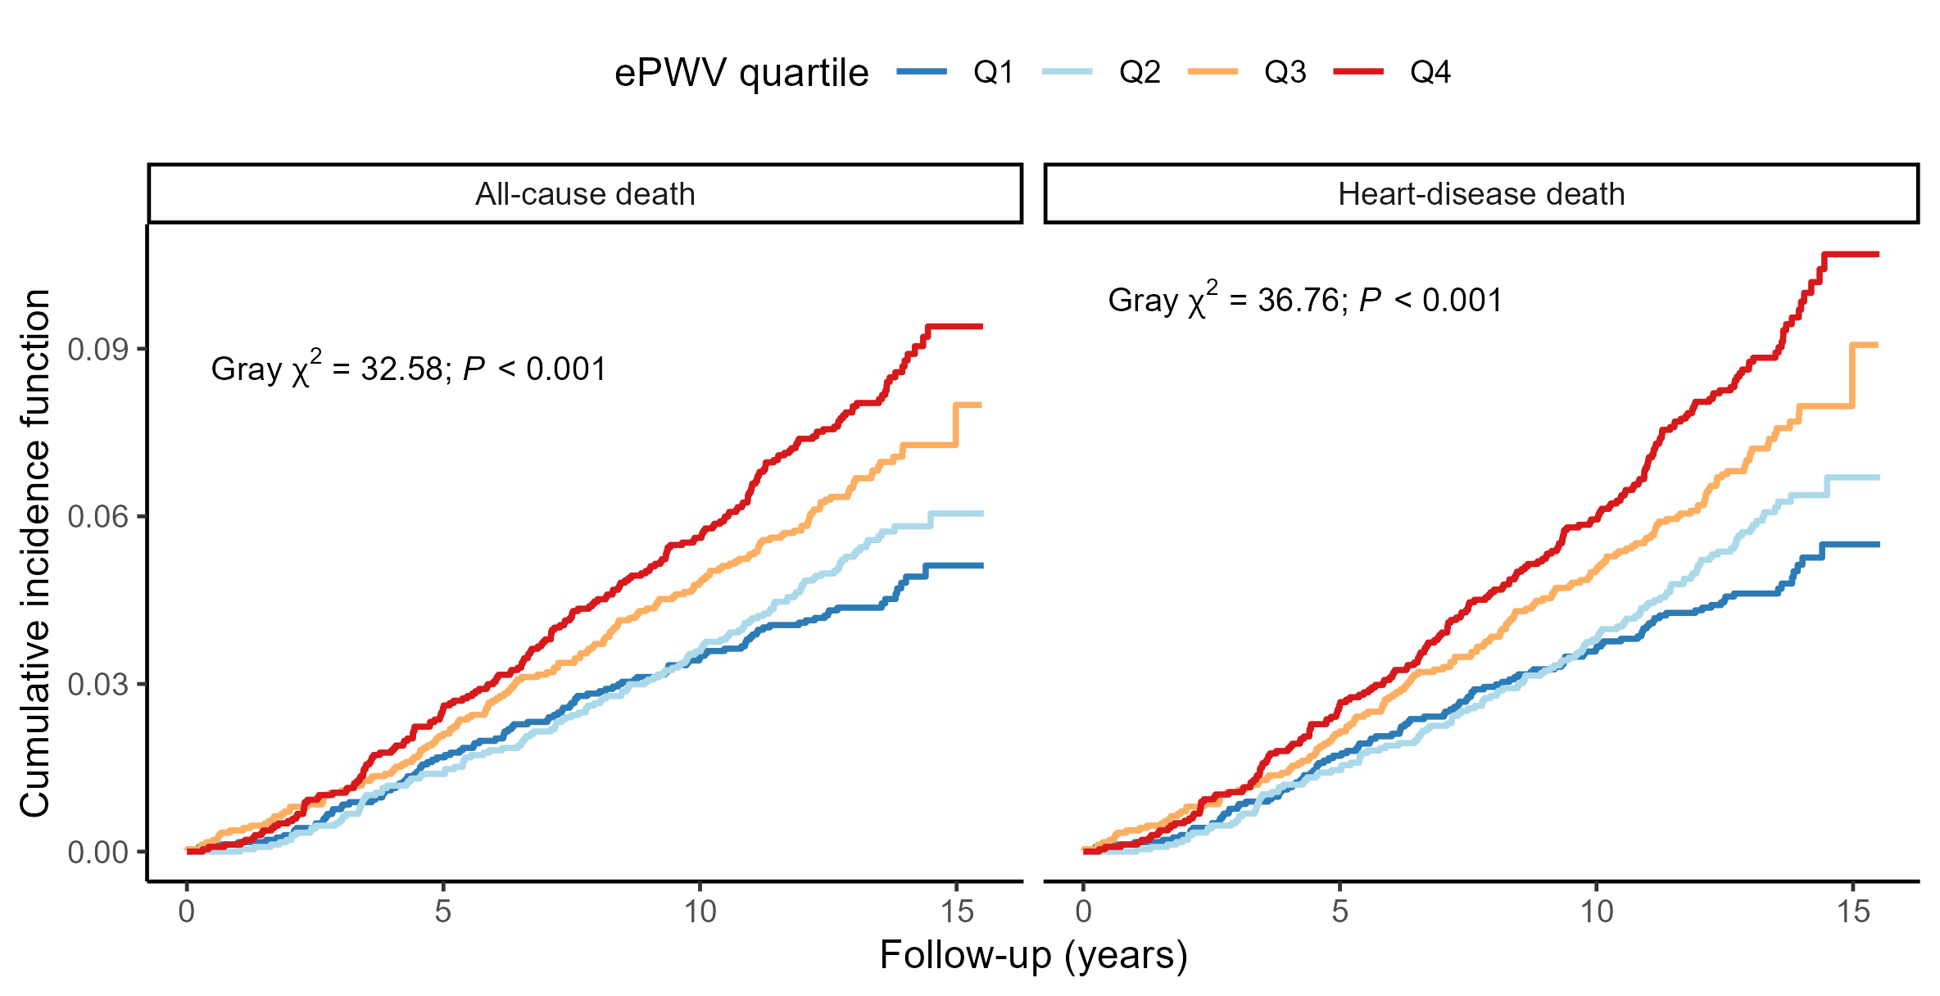
Note. Cumulative incidence functions for first-ever stroke are shown across ePWV quartiles in UKB, treating all-cause death or heart-disease death as the competing event. Global differences across quartiles were evaluated using Gray's test (all-cause death: chi-square = 32.58, df = 3, P < 0.001; heart-disease death: chi-square = 36.76, df = 3, P < 0.001). Curves are distinguished by colour and line type. Abbreviations: UKB, UK Biobank; ePWV, estimated pulse wave velocity; df, degrees of freedom.
Supplementary Figure 2. Fine-Gray restricted cubic splines with heart-disease death as the competing event
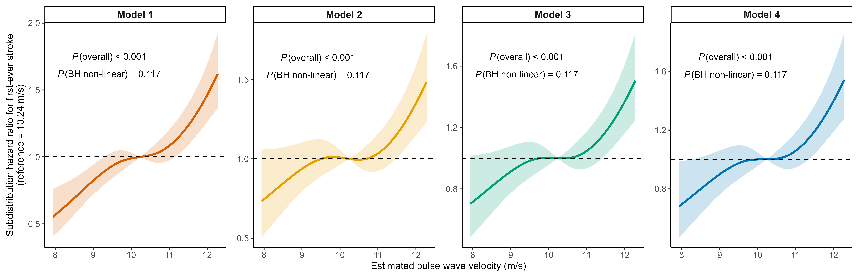
Note. Fine-Gray restricted cubic spline curves show the association between ePWV and first-ever stroke when heart-disease death is treated as the competing event. Model 1 is unadjusted; Model 2 adjusts for age and sex; Model 3 additionally adjusts for lifestyle and socioeconomic factors; and Model 4 additionally adjusts for comorbidities and kidney function. Solid lines denote subdistribution hazard ratios and shaded areas denote 95% confidence intervals. Knots are placed at the 5th, 35th, 65th, and 95th percentiles of ePWV, with the cohort median as the reference. Each panel reports the raw overall P value and BH-adjusted nonlinear P value. Abbreviations: ePWV, estimated pulse wave velocity; BH, Benjamini-Hochberg.
Supplementary Figure 3. Fine-Gray restricted cubic splines with all-cause death as the competing event
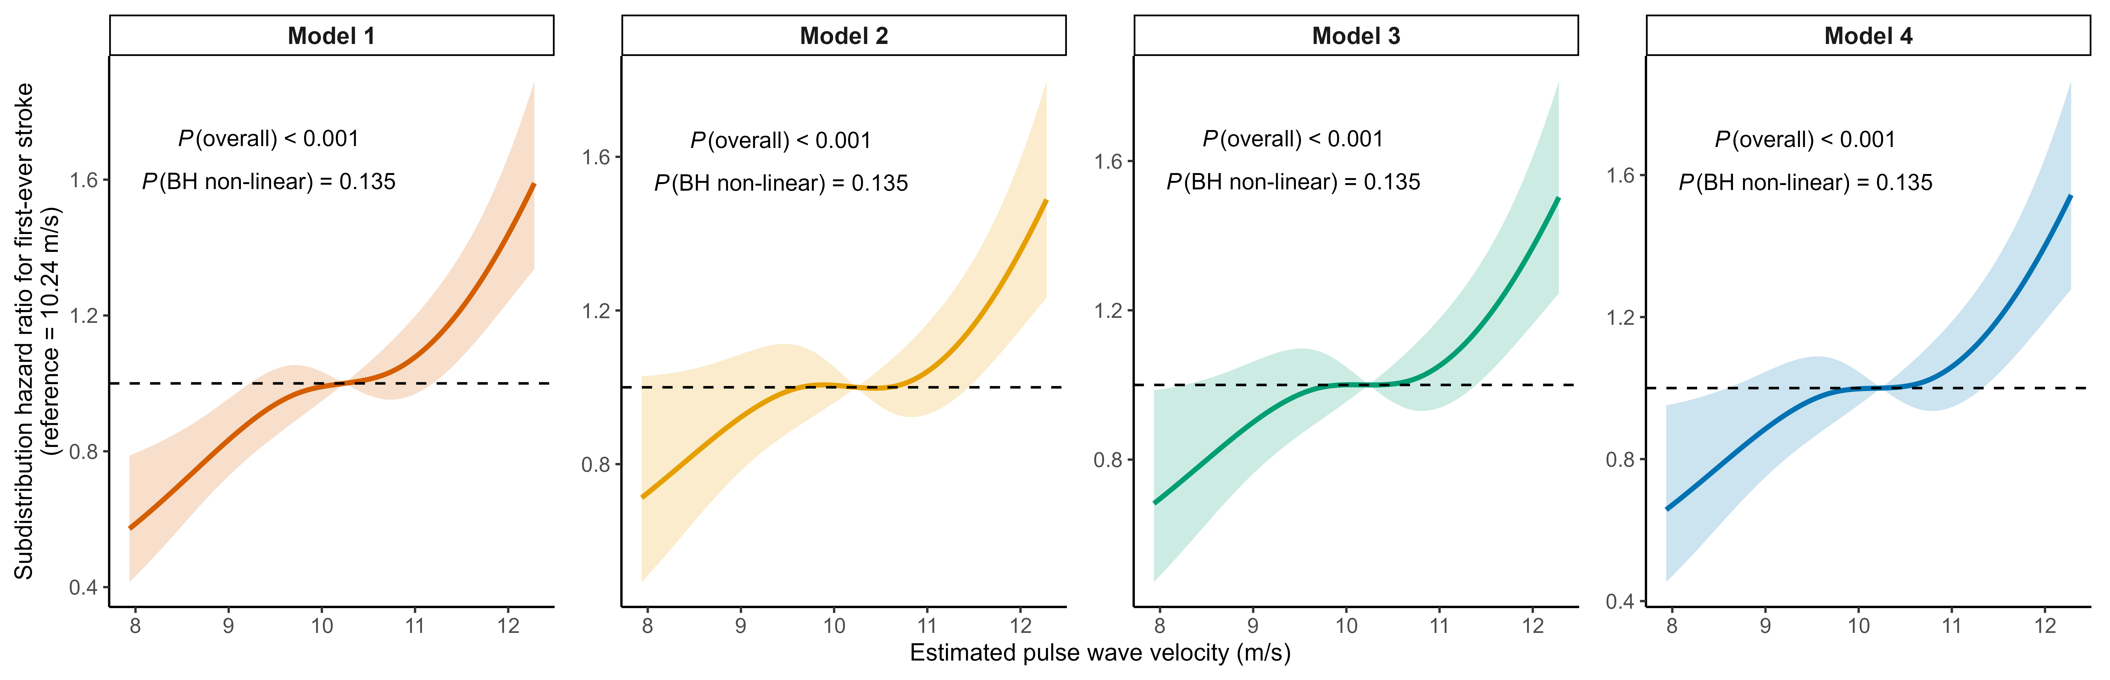
Note. Fine-Gray restricted cubic spline curves show the association between ePWV and first-ever stroke when all-cause death is treated as the competing event. Model 1 is unadjusted; Model 2 adjusts for age and sex; Model 3 additionally adjusts for lifestyle and socioeconomic factors; and Model 4 additionally adjusts for comorbidities and kidney function. Solid lines denote subdistribution hazard ratios and shaded areas denote 95% confidence intervals. Knots are placed at the 5th, 35th, 65th, and 95th percentiles of ePWV, with the cohort median as the reference. Each panel reports the raw overall P value and BH-adjusted nonlinear P value. Abbreviations: ePWV, estimated pulse wave velocity; BH, Benjamini-Hochberg.
Supplementary Figure 4. Scaled Schoenfeld residual diagnostics for ePWV
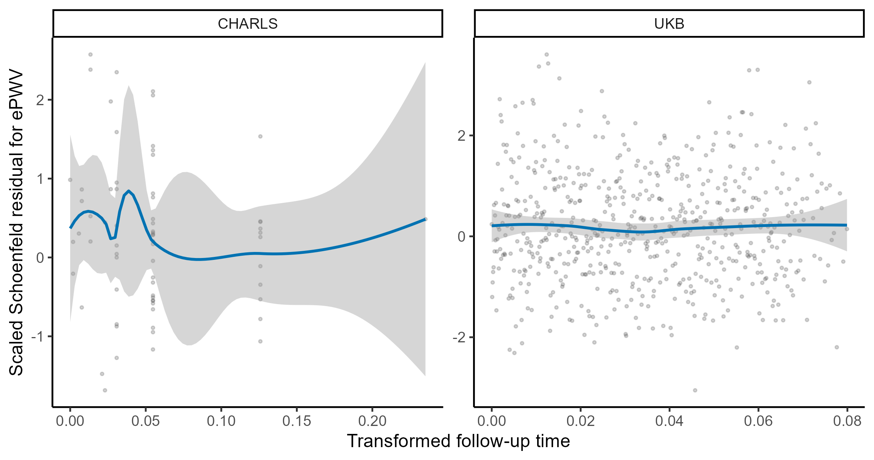
Note. Scaled Schoenfeld residuals and their smoothed trends are shown against transformed follow-up time for primary Model 4 in UKB and CHARLS. Abbreviations: UKB, UK Biobank; CHARLS, China Health and Retirement Longitudinal Study; ePWV, estimated pulse wave velocity.
Supplementary Figure 5. Calibration of comprehensive conventional and ePWV substitution models
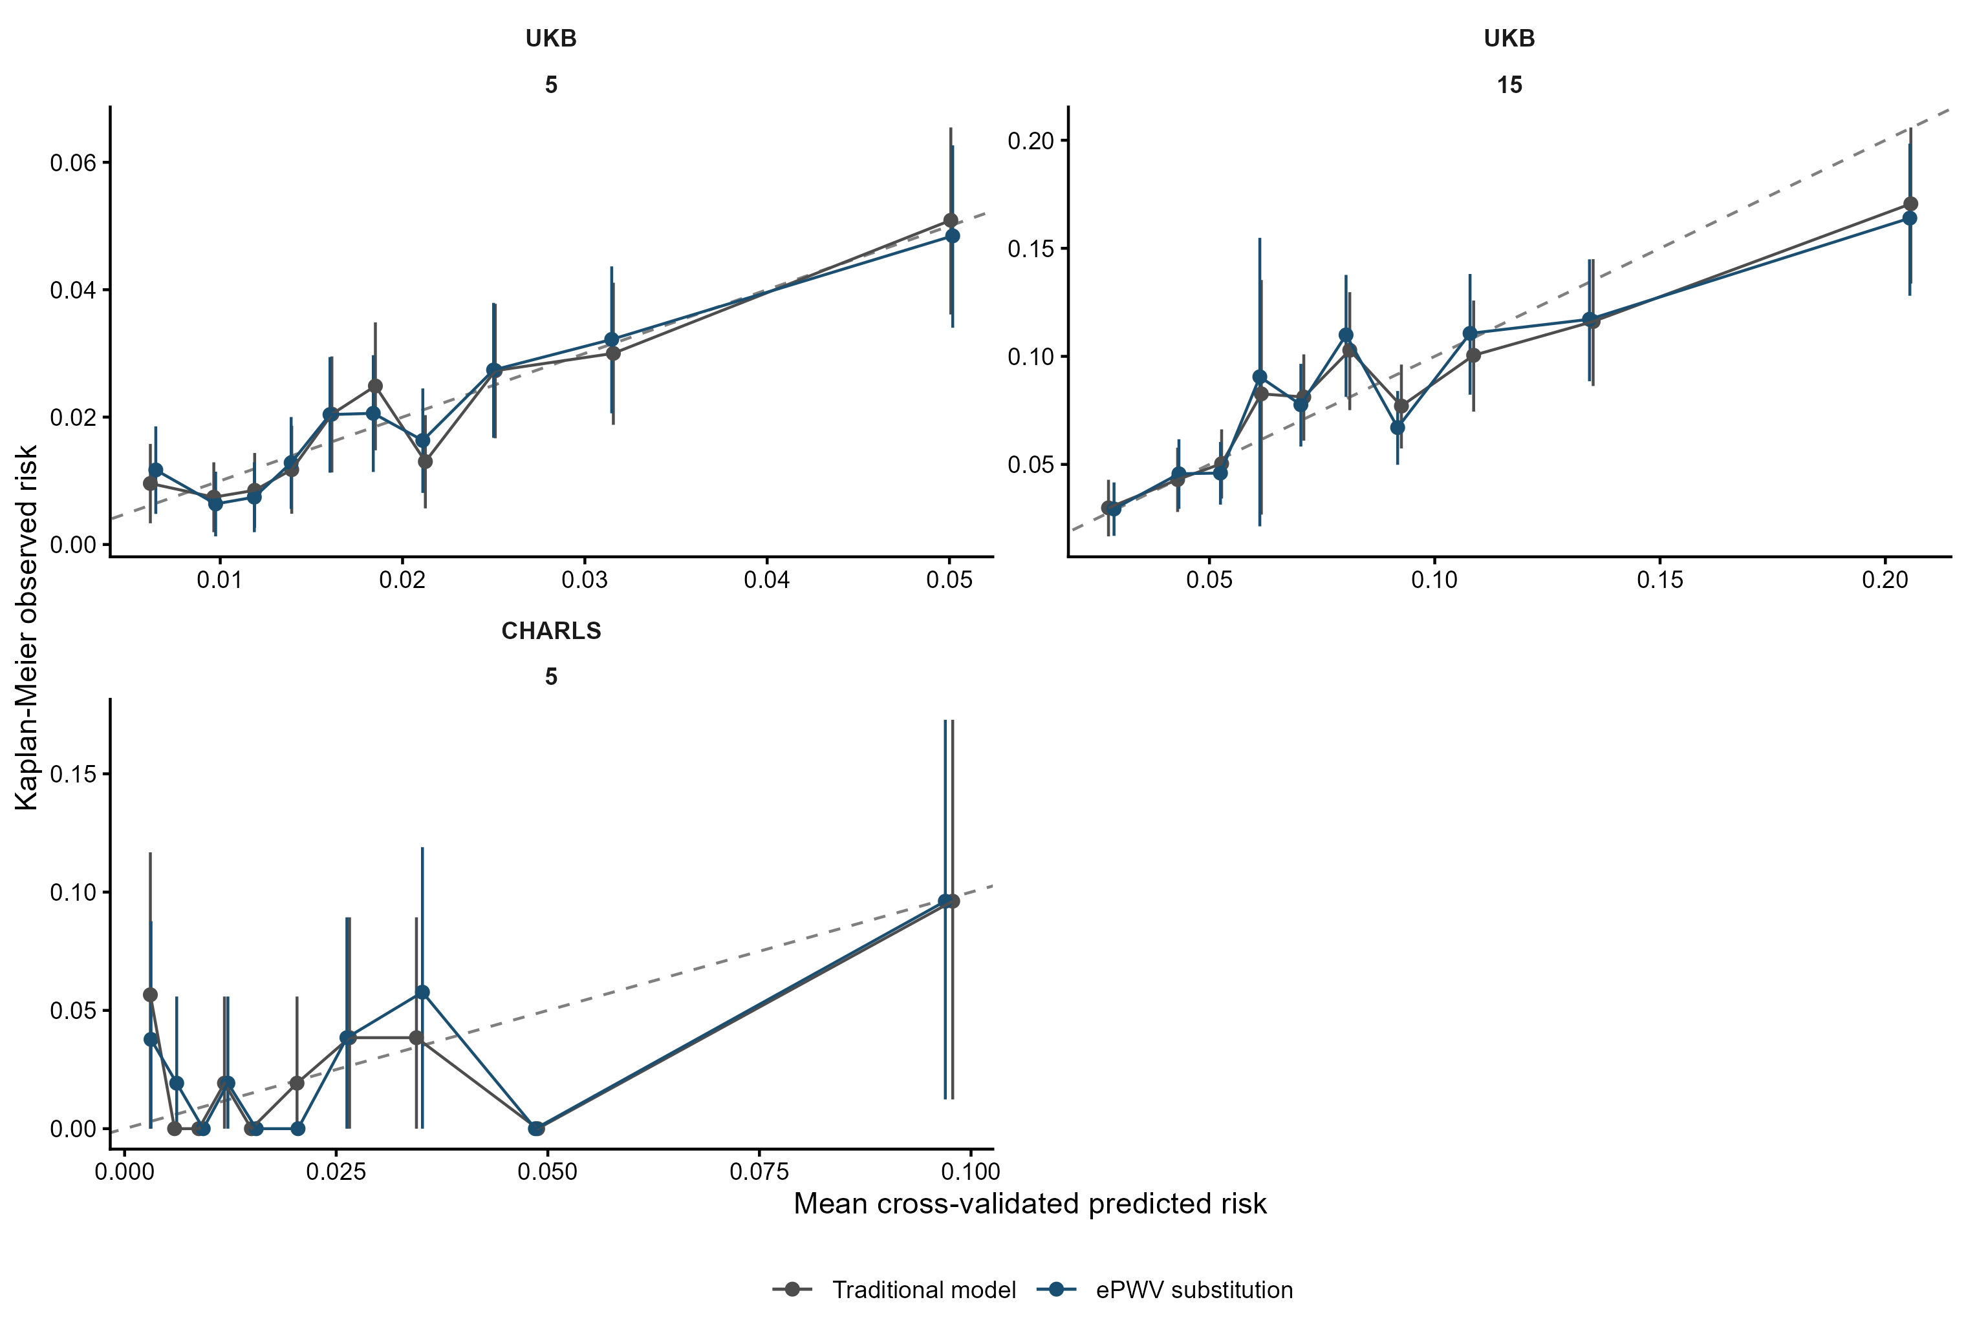
Note. UKB and CHARLS panels show observed versus predicted risk across deciles of averaged out-of-fold predictions, with 95% CIs for observed risk. The dashed diagonal denotes ideal calibration. Abbreviations: UKB, UK Biobank; CHARLS, China Health and Retirement Longitudinal Study; ePWV, estimated pulse wave velocity.
Supplementary Figure 6. Cumulative incidence of first-ever stroke by ePWV quartile in CHARLS
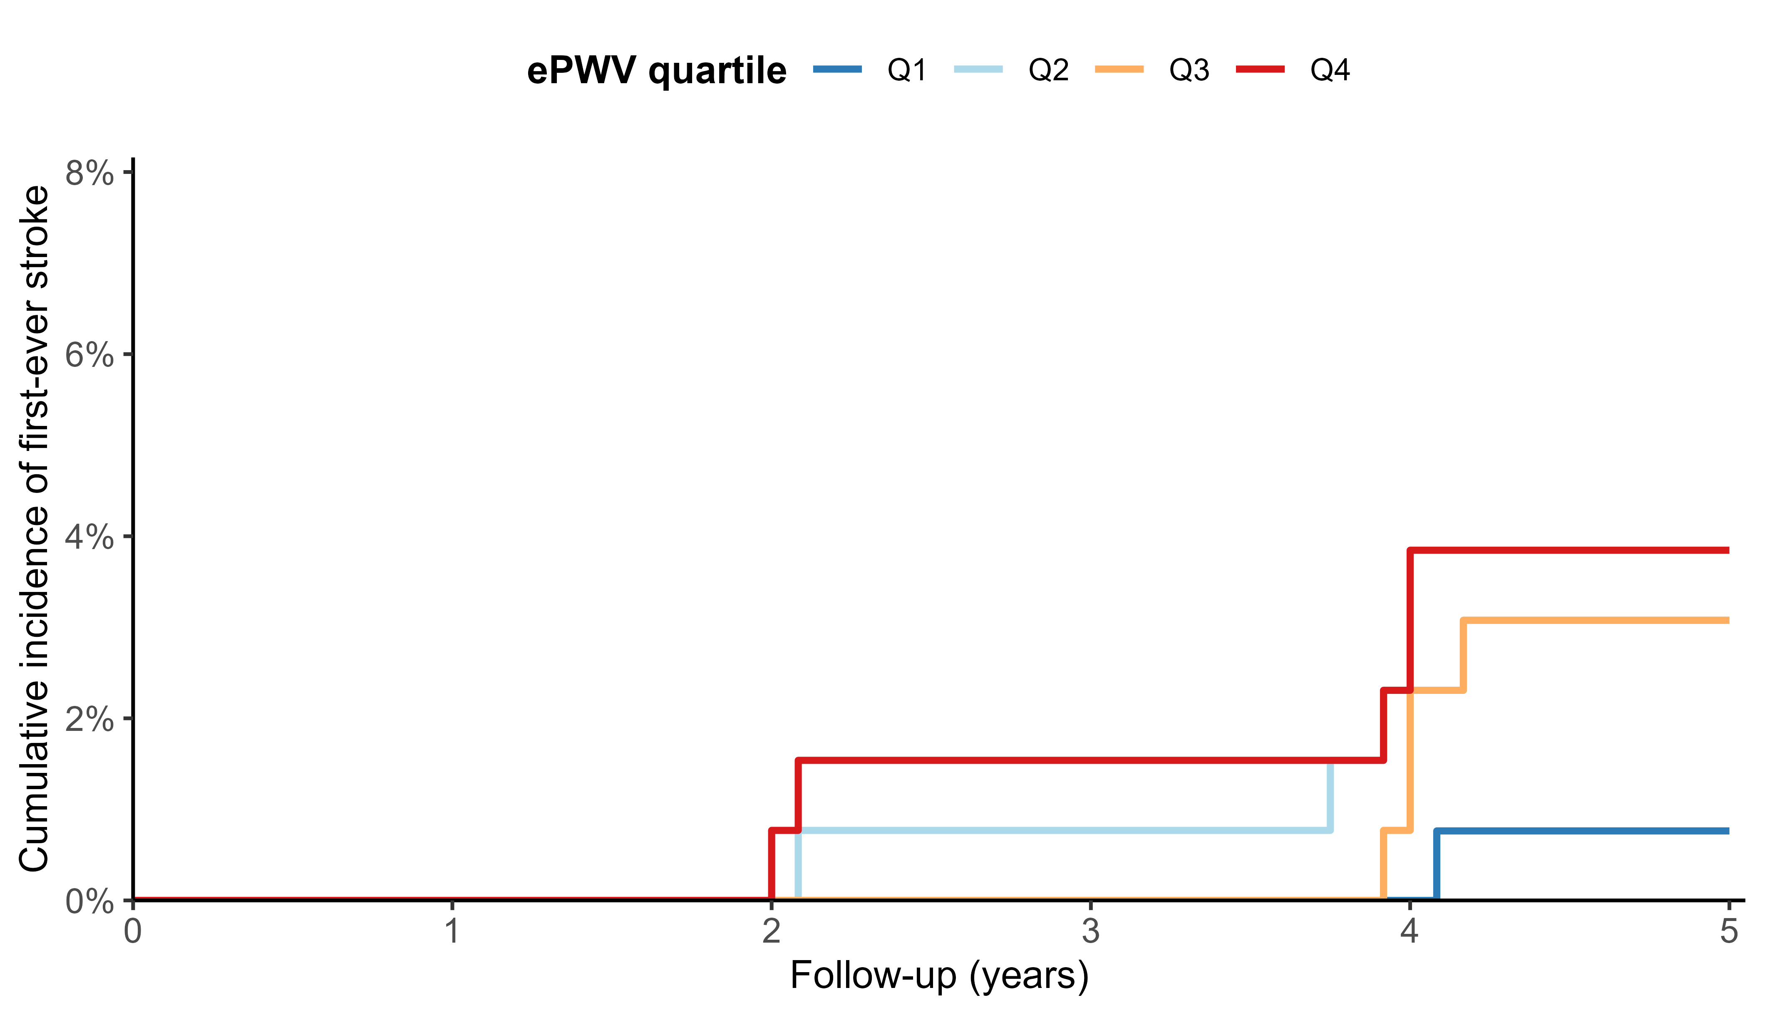
Note. Kaplan-Meier cumulative-incidence curves are shown across cohort-specific ePWV quartiles in CHARLS through 5 years. The global log-rank test compared the four quartiles (P = 0.067). Abbreviations: CHARLS, China Health and Retirement Longitudinal Study; ePWV, estimated pulse wave velocity.

