Table S1. Search strategy and results

Database | Query | Results (No.)
PubMed | (arterial stiffness [tiab] OR "Vascular endothelium"[tiab] OR “Endothelium Dependent Relaxing Factors"[tiab] OR “endothelium”[tiab] OR “vasodilatation”[tiab] OR “vasorelaxation”[tiab] OR “Vascular Stiffness”[tiab] OR “Aortic Stiffnesses”[tiab]) AND (magnesium[tiab]) | 316
Web of Science | Query #1: ‘arterial stiffness’(Topic) or ‘Vascular endothelium’(Topic) or ‘Endothelium Dependent Relaxing Factors’(Topic) or ‘endothelium’(Topic) or ‘vasodilatation’(Topic) or ‘vasorelaxation’(Topic) or ‘Vascular Stiffness’(Topic) or ‘Aortic Stiffnesses’(Topic)  Query #2: magnesium(Topic)  Query#3: #1 AND #2 | 471
SCOPUS | ( ( TITLE-ABS-KEY ( arterial stiffness ) OR TITLE-ABS-KEY ( Vascular endothelium ) OR TITLE-ABS-KEY ( Endothelium Dependent Relaxing Factors ) OR TITLE-ABS-KEY ( endothelium ) OR TITLE-ABS-KEY ( vasodilatation ) OR TITLE-ABS-KEY ( vasorelaxation ) OR TITLE-ABS-KEY ( Vascular Stiffness ) OR TITLE-ABS-KEY ( Aortic Stiffnesses ) ) ) AND ( TITLE-ABS-KEY ( magnesium ) ) | 1843
CENTRAL | Query#1: (Vasodilation):ti,ab,kw OR (Vascular endothelium):ti,ab,kw OR (arterial stiffness):ti,ab,kw OR (Vasorelaxation):ti,ab,kw OR (endothelium):ti,ab,kw  Query#2: (Magnesium):ti,ab,kw  Query#3: #1 AND #2 | 163
Clinicaltrial.gov | (arterial stiffness OR Vascular endothelium OR Endothelium Dependent Relaxing Factors OR endothelium OR vasodilatation OR vasorelaxation OR Vascular Stiffness OR Aortic Stiffnesses) AND (magnesium) | 74

Quality Assessment
_____________________________________________________________________________________
Table S2. Risk of bias assessment of included randomized controlled trials according to the Cochrane RoB2 tool
Colors indicate the risk level for each domain and study (green = low risk, yellow = some concerns, red = high risk).
Study ID | Randomization  Process | Deviations from the intended interventions | Missing Outcome Data | Outcome Measurement | Selection of reported results | Overall
Shechter, 2000 | Some Concerns | Some Concerns | Low risk | Some Concerns | Low risk | Some Concerns
Mortazavi, 2013 | Low risk | Low risk | Low risk | Low risk | Low risk | Low risk
Rahnama, 2022 | Low risk | Some Concerns | Low risk | Low risk | Some Concerns | Some Concerns
Cunha, 2017 | Low risk | Low risk | Low risk | Some Concerns | Low risk | Some Concerns
Talari, 2019 | Low risk | Low risk | Some Concerns | Some Concerns | Low risk | Some Concerns
Joris, 2017 | Low risk | Low risk | Low risk | Low risk | Low risk | Low risk
Cosaro, 2014 | Low risk | Some Concerns | Low risk | Some Concerns | Low risk | Some Concerns
Ferrara, 1992 | Low risk | Low risk | Some Concerns | Some Concerns | Low risk | Some Concerns
Meer, 2026 | Some Concerns | Some Concerns | Low risk | Low risk | Low risk | Some Concerns
Rashvand, 2019 | Low risk | Low risk | Some Concerns | Some Concerns | Low risk | Some Concerns
Schutten, 2022 | Low risk | Low risk | Low risk | Low risk | Low risk | Low risk
Barbagallo, 2010 | Some Concerns | Low risk | Some Concerns | Some Concerns | Some Concerns | Some Concerns

Table S3. Meta-regression analysis
Variable | moderator | Β Coefficient | Std. Error | 95% CI | p-value
Primary Outcomes
FMD | Age | 0.37 | 0.35 | -0.31, 1.06 | 0.28
FMD | BMI | -2.39 | 0.35 | -3.08, -1.70 | p<0.001
FMD | Duration of follow-up | 0.14 | 0.27 | -0.38, 0.67 | 0.58
FMD | Dose | 0.02 | 0.008 | 0.006, 0.038 | 0.006
FMD | Baseline serum Mg level | -9.12 | 10.84 | -0.76, -0.09 | 0.40
FMD | Baseline SBP | 0.36 | 0.11 | 0.14, 0.58 | 0.001
FMD | Baseline DBP | 0.06 | 0.37 | -0.67, 0.81 | 0.85
FMD | Baseline FMD | -9.64 | 2.25 | -1.66, 3.16 | 0.54
FMD | Baseline PWV | -0.20 | 0.36 | -4.06, -5.22 | p<0.001
FMD | Baseline CIMT | -138.80 | 26.27 | -190.30, -87.29 | p<0.001
PWV | Age | 0.05 | 0.04 | -0.03, 0.15 | 0.21
PWV | BMI | -0.18 | 0.10 | -0.38, 0.02 | 0.83
PWV | Dose | 0.0007 | 0.002 | -0.004, 0.006 | 0.78
PWV | Baseline serum Mg level | -5.43 | 3.71 | -12.71, 1.84 | 0.14
PWV | Baseline SBP | 0.02 | 0.02 | -0.02. 0.08 | 0.29
PWV | Baseline DBP | 0.02 | 0.005 | -0.08,0.13 | 0.64
PWV | Baseline PWV | 0.11 | 0.07 | -0.03,0.26 | 0.13
CIMT | Age | 0.06 | 0.08 | -0.10,0.24 | 0.42
CIMT | BMI | 0.17 | 0.09 | -0.01, 0.36 | 0.07
CIMT | Dose | 0.0001 | 0.006 | -0.001, 0.001 | 0.81
CIMT | Baseline serum Mg level | 0.31 | 6.82 | -13.06,13.96 | 0.96
CIMT | Baseline SBP | 0.017 | 0.013 | -0.009,0.043 | 0.20
CIMT | Baseline DBP | 0.02 | 0.02 | -0.016, 0.073 | 0.20
CIMT | Baseline FMD | 0.05 | 0.04 | -0.02,0.13 | 0.20
CIMT | Baseline CIMT | -0.65 | 0.63 | -1.89,0.58 | 0.30
Secondary Outcomes
SBP | Age | -0.01 | 0.12 | -0.25, 0.22 | 0.90
SBP | BMI | 0.22 | 0.09 | 0.04, 0.4 | 0.01
SBP | Duration of follow-up | 0.04 | 0.07 | -0.10, 0.19 | 0.53
SBP | Dose | 0.0009 | 0.005 | -0.009, 0.011 | 0.85
SBP | Baseline serum Mg level | -1.37 | 3.47 | -8.18, 5.42 | 0.69
SBP | Baseline SBP | 0.01 | 0.06 | -0.10, 0.14 | 0.76
SBP | Baseline DBP | -0.003 | 0.14 | -0.28, 0.27 | 0.98
SBP | Baseline PWV | 4.17 | 5.60 | -6.81, 15.17 | 0.45
SBP | Baseline FMD | -1.02 | 0.71 | -2.41, 0.36 | 0.15
SBP | Baseline CIMT | 100.40 | 98.11 | -91.90, 292.70 | 0.30
DBP | Age | 0.11 | 0.11 | -0.11, 0.33 | 0.33
DBP | BMI | -0.05 | 0.05 | -0.16, 0.5 | 0.29
DBP | Duration of follow-up | -0.08 | 0.09 | -0.26, 0.09 | 0.37
DBP | Dose | -0.005 | 0.005 | -0.016, 0.006 | 0.38
DBP | Baseline serum Mg level | 0.22 | 2.34 | -4.37, 4.82 | 0.92
DBP | Baseline SBP | -0.13 | 0.05 | -0.23, -0.03 | 0.008
DBP | Baseline DBP | -0.23 | 0.08 | -0.39, -0.07 | 0.004
DBP | Baseline PWV | 5.29 | 3.68 | -1.93, 12.51 | 0.15
DBP | Baseline FMD | -1.01 | 0.64 | -2.28, 0.25 | 0.11
DBP | Baseline CIMT | 110.80 | 50.21 | 12.37, 209.22 | 0.027
Serum magnesium level | Age | -0.002 | 0.002 | -0.007,0.002 | 0.36
Serum magnesium level | BMI | 0.002 | 0.002 | -0.002,0.008 | 0.27
Serum magnesium level | Duration of follow-up | -0.002 | 0.002 | -0.006,0.001 | 0.31
Serum magnesium level | Dose | 0.0002 | 0.0001 | 0.0002, 0.004 | 0.03
Serum magnesium level | Baseline serum Mg level | 0.08 | 0.03 | 0.01,0.14 | 0.01
Serum magnesium level | Baseline SBP | 0.004 | 0.001 | 0.001, 0.007 | 0.005
Serum magnesium level | Baseline DBP | 0.006 | 0.001 | 0.003, 0.009 | p<0.001
Serum magnesium level | Baseline PWV | 0.005 | 0.003 | -0.0005, 0.011 | 0.07
Serum magnesium level | Baseline FMD | 0.01 | 0.004 | 0.002, 0.020 | 0.009
Serum magnesium level | Baseline CIMT | 0.11 | 0.38 | -0.63, 0.86 | 0.75

Table S4. GRADE Summary of Findings for the Effects of Oral Magnesium Supplementation on Primary Vascular Outcomes

Outcome | No. of studies / effect sizes | Effect (MD, 95% CI, p-value) | Risk of bias | Inconsistency | Indirectness | Imprecision | Publication bias | Overall certainty
Flow-mediated dilation (FMD) | 6 effect sizes | MD = 2.86; 95% CI: -1.31 to 7.03; p = 0.18 | Serious – most trials had “some concerns” in RoB 2, only three at low risk. | Very serious – I² = 97.5%; heterogeneity largely unexplained despite subgroup and meta-regression analyses. | Not serious – populations, interventions, comparators, and outcome were consistent with the review question. | Serious – wide CI crossing no effect and limited number of studies. | Serious – funnel plot asymmetry; Egger’s test significant (p = 0.009); trim-and-fill did not impute studies and did not change the pooled effect. | Very low
Pulse wave velocity (PWV) | 6 effect sizes | MD = -0.17; 95% CI: -0.60 to 0.25; p = 0.43 | Serious – most included RCTs were rated as having “some concerns” in RoB 2. | Not serious to serious – heterogeneity and subgroup trends do not clearly justify very severe downgrade, but some inconsistency cannot be excluded. | Not serious – direct comparison of oral magnesium supplementation versus placebo on arterial stiffness. | Serious – CI compatible with both a small benefit and no effect; six effect sizes only. | Serious – Egger’s test significant (p = 0.01); trim-and-fill did not impute studies and did not change the pooled effect. | Low
Carotid intima-media thickness (CIMT) | 3 effect sizes | MD = -0.08 mm; 95% CI: -0.15 to -0.01; p = 0.03 | Serious – most trials were not unequivocally low risk; study limitations present. | Not serious – no substantial unresolved heterogeneity reported, although the evidence base is small. | Not serious – studies directly evaluated oral magnesium supplementation and CIMT. | Serious – only three studies; pooled estimate was fragile in leave-one-out sensitivity analyses. | Serious – Egger’s test significant (p = 0.04); trim-and-fill did not impute studies and did not change the pooled effect. | Very low

Figure S1. Subgroup analysis of serum magnesium level changes based on intervention follow-up duration

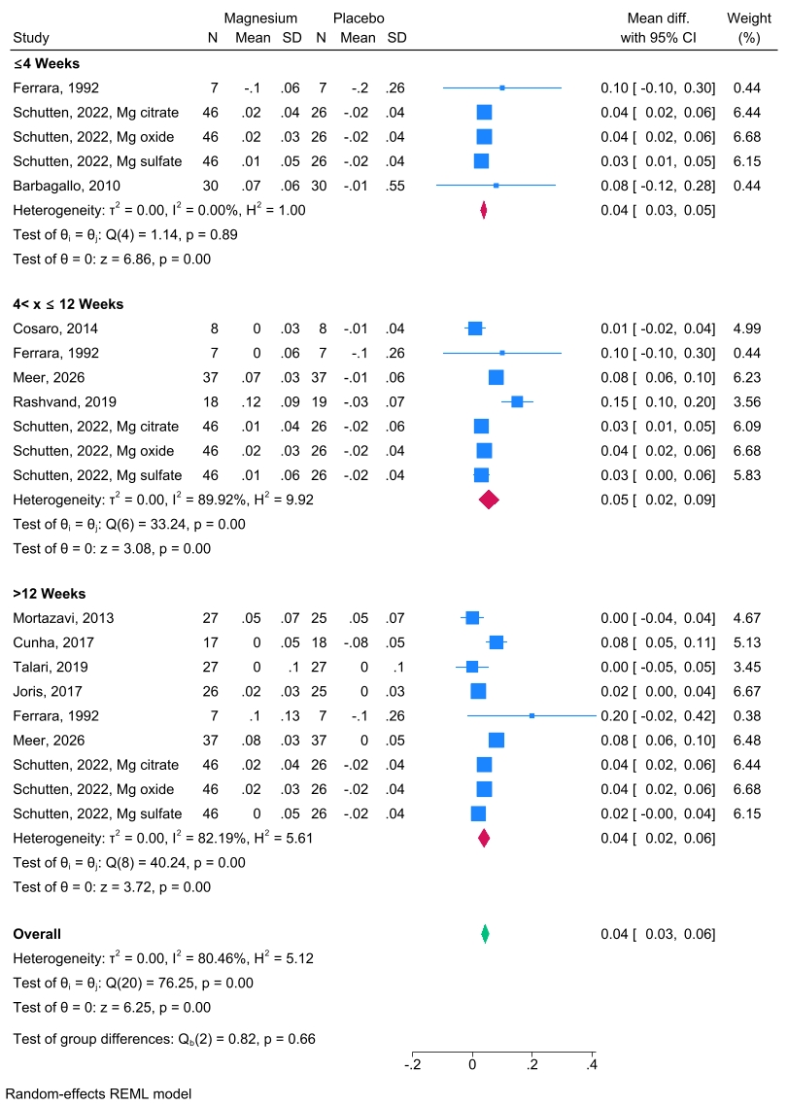

Figure S2. Subgroup analysis of serum magnesium level changes based on magnesium dosage
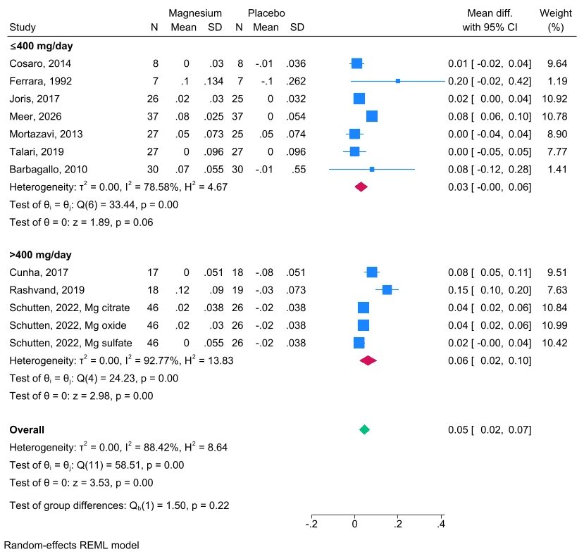

Figure S3. Subgroup analysis of serum magnesium level changes based on type of magnesium formula
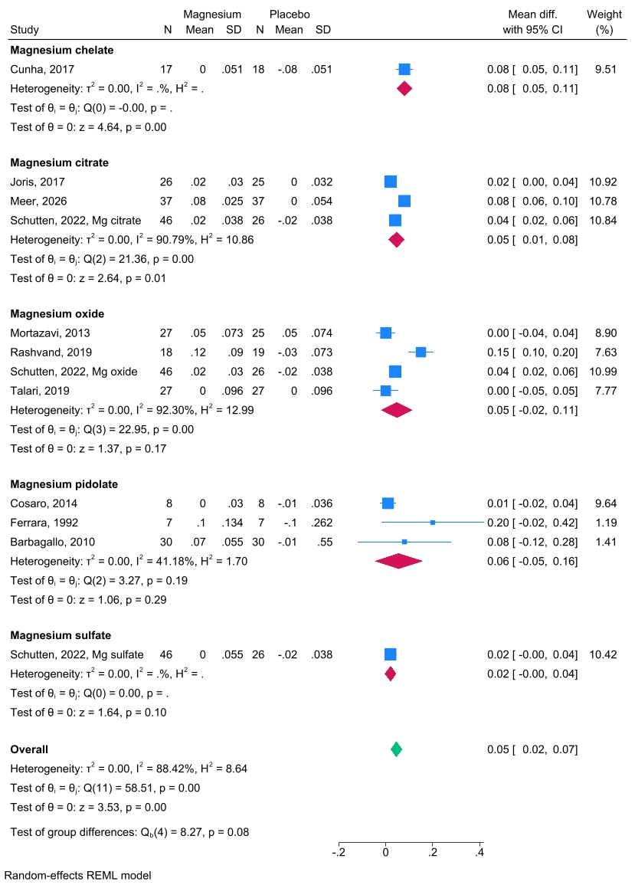

Figure S4. Subgroup analysis of systolic blood pressure based on intervention follow-up duration
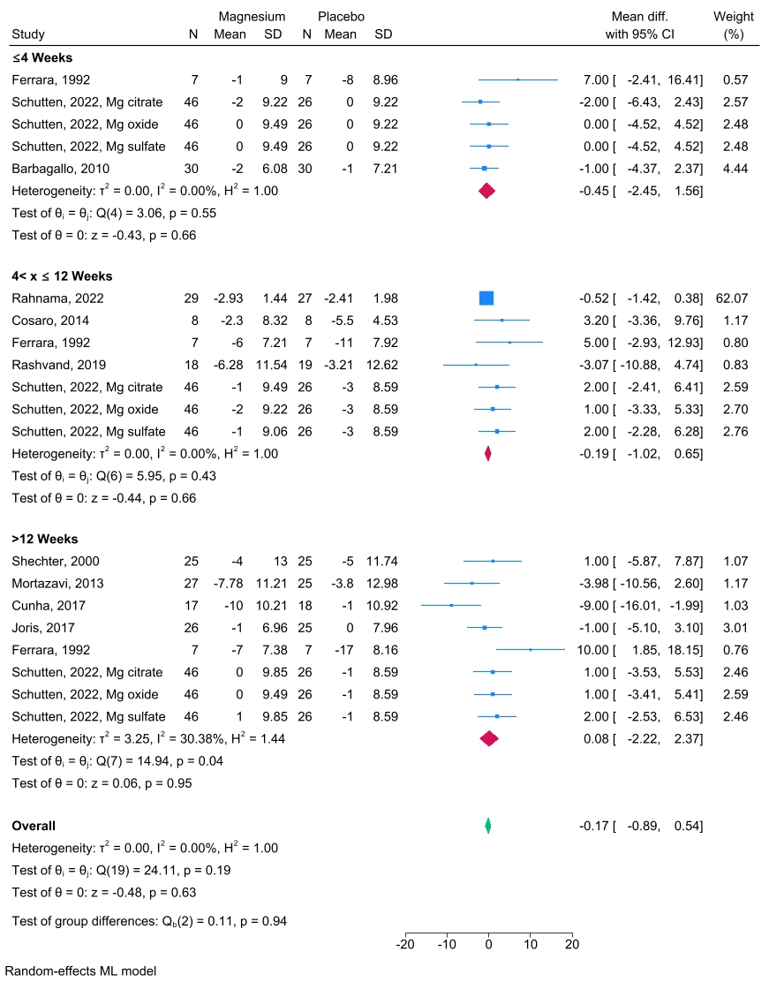
Figure S5. Subgroup analysis of systolic blood pressure changes based on magnesium dosages
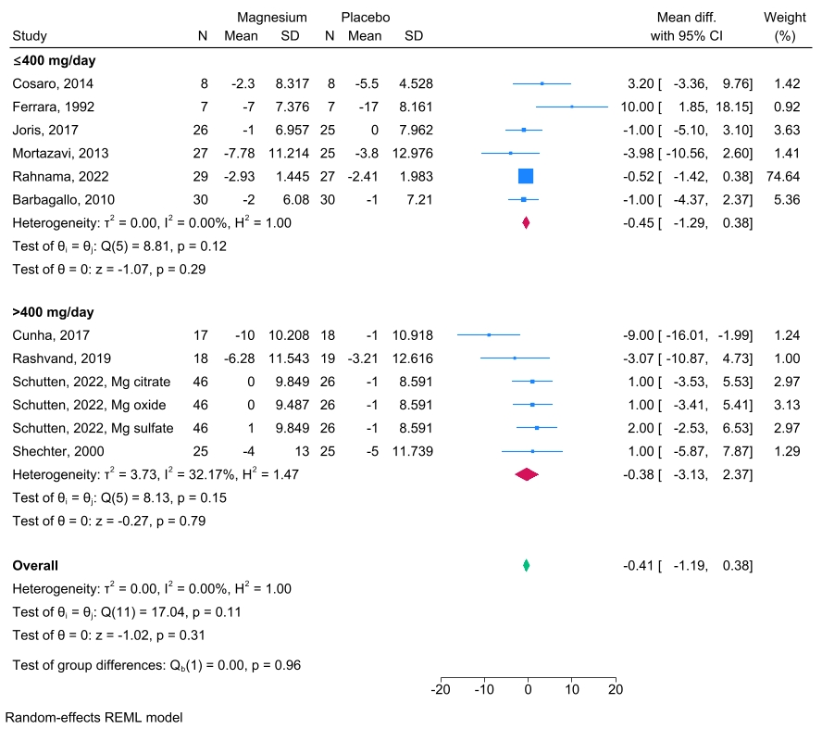

Figure S6. Subgroup analysis of systolic blood pressure changes based on type of magnesium formula
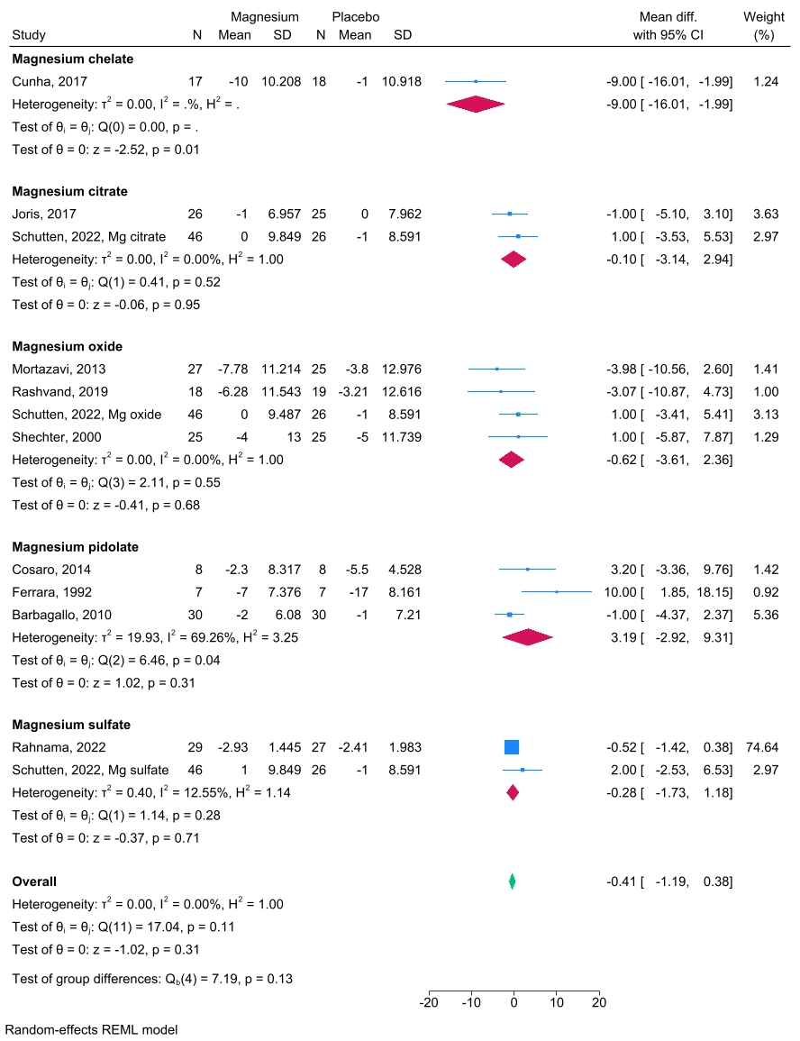

Figure S7. Subgroup analysis of diastolic blood pressure changes based on intervention follow-up duration
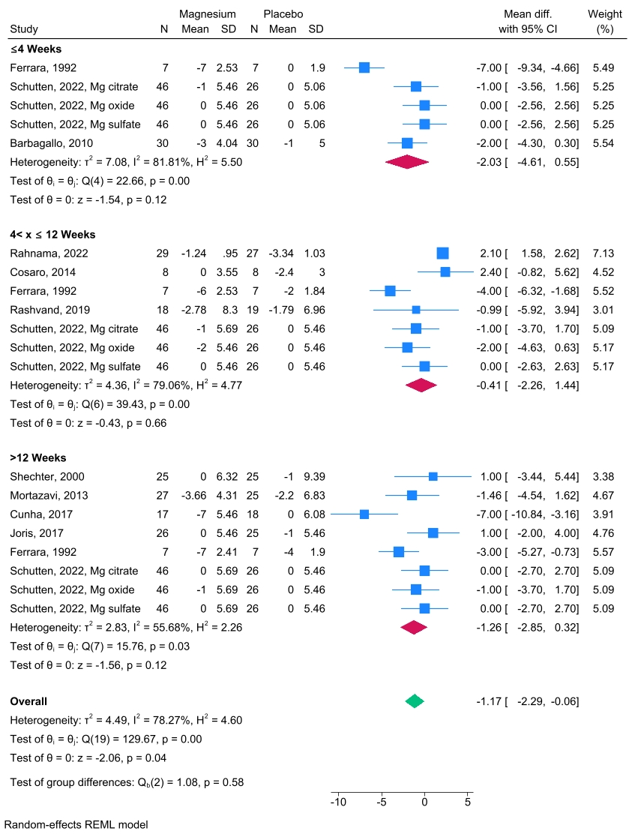

Figure S8. Subgroup analysis of diastolic blood pressure changes based on magnesium dosages
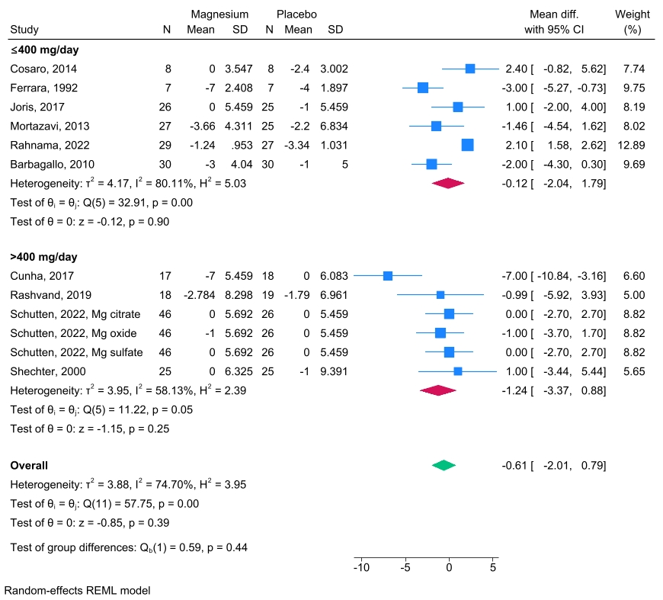

Figure S9. Subgroup analysis of serum magnesium level changes based on type of magnesium formula
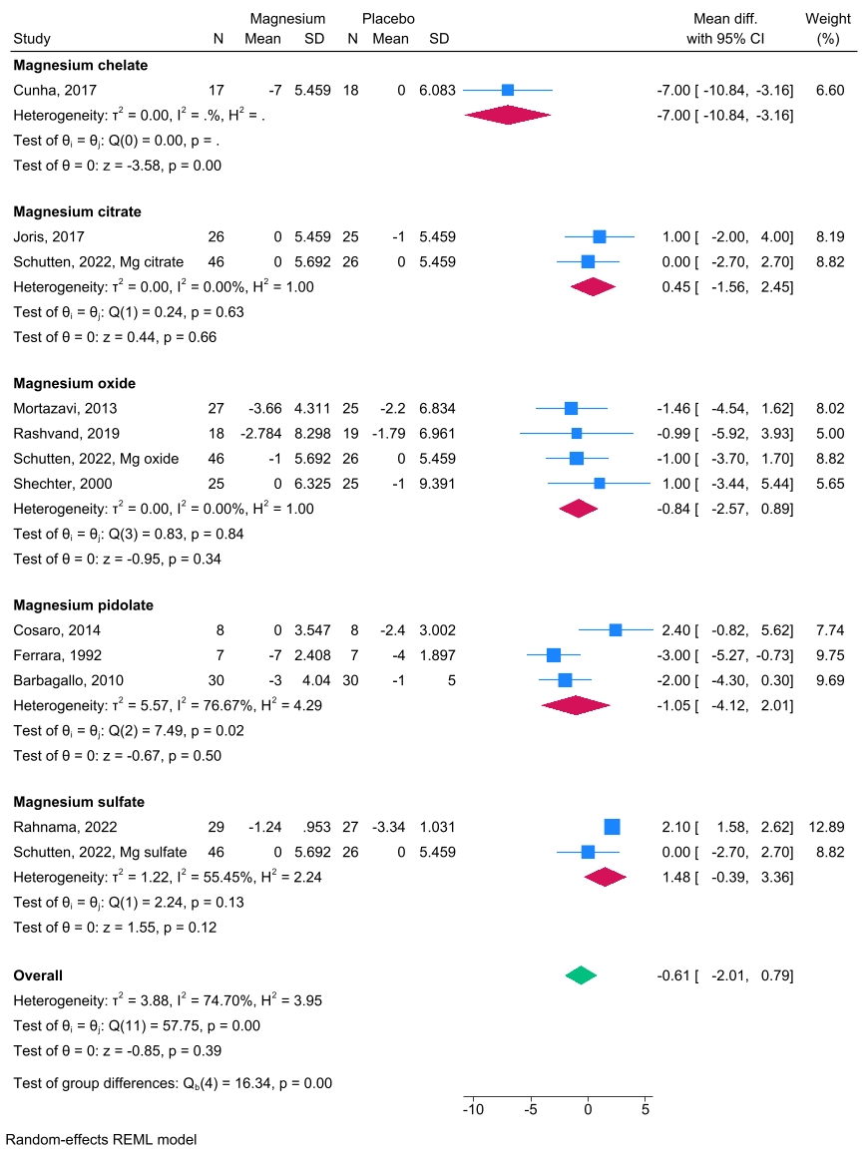
Figure S10. Leave-one-out sensitivity analysis of pulse wave velocity
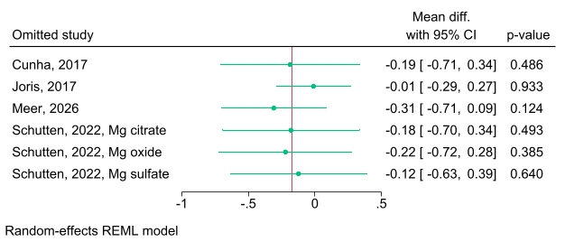

Figure S11. Leave-one-out sensitivity analysis of systolic blood pressure
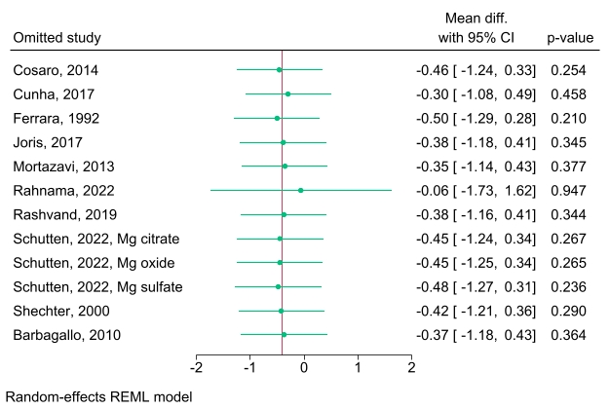

Figure S12. Leave-one-out sensitivity analysis of diastolic blood pressure
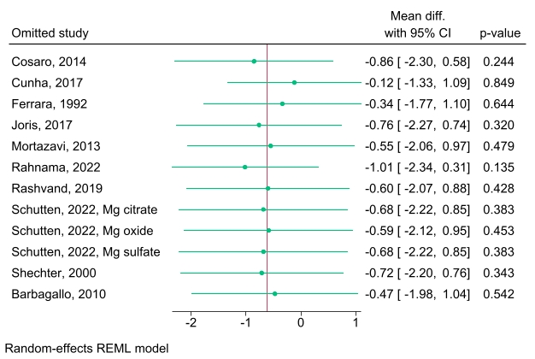

Figure S13. Leave-one-out sensitivity analysis of serum magnesium level
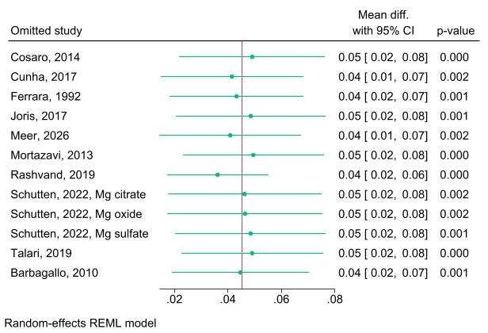

Figure S14. Leave-one-out sensitivity analysis of flow-mediated dilation
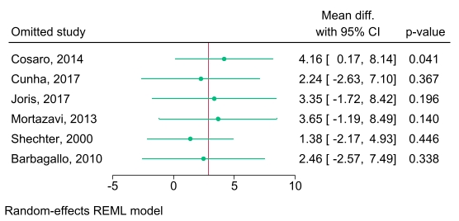

Figure S15. Leave-one-out sensitivity analysis of carotid intima-media thickness
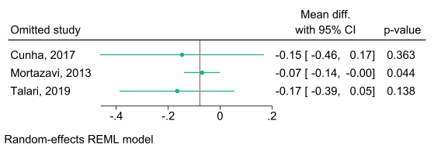

Figure S16. Funnel plot of publication bias for seum magnesium level (Egger’s test p-value=0.18)
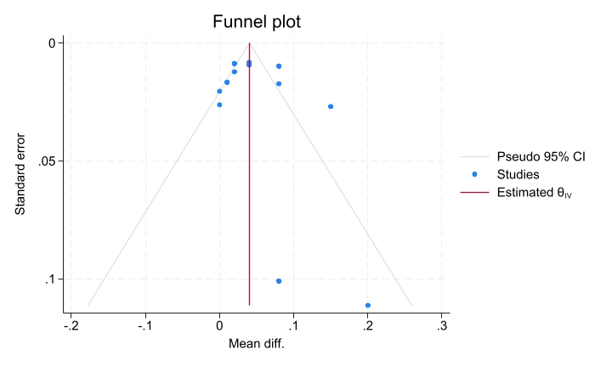

Figure S17. Funnel plot of publication bias for systolic blood pressure (Egger’s test p-value=0.60)
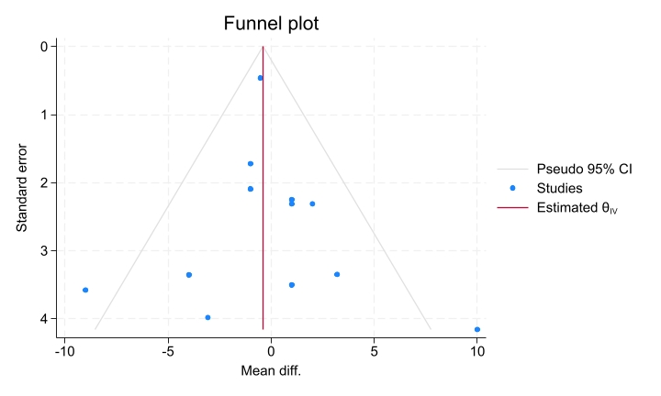

Figure S18. Funnel plot of publication bias for diastolic blood pressure (Egger’s test p-value=0.24)
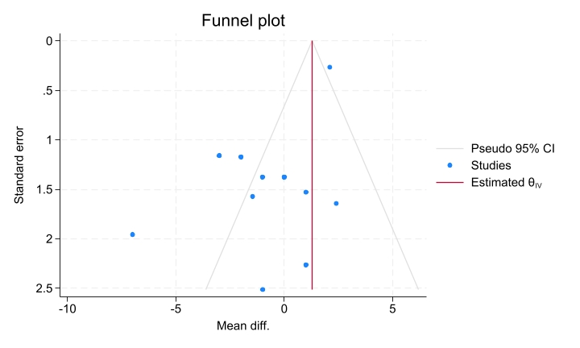

Figure S19. Funnel plot of publication bias for flow-mediated dialation (Egger’s test p-value=0.009)
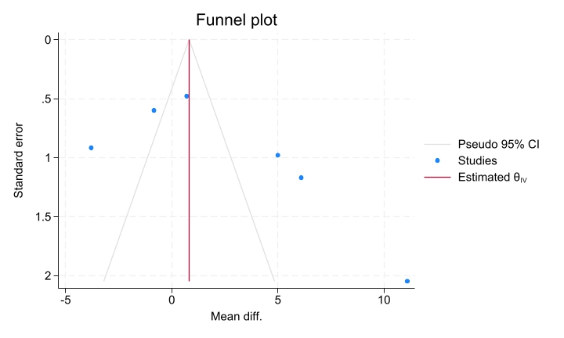

Figure S20. Funnel plot of publication bias for carotid intima-media thickness (Egger’s test p-value=0.046)
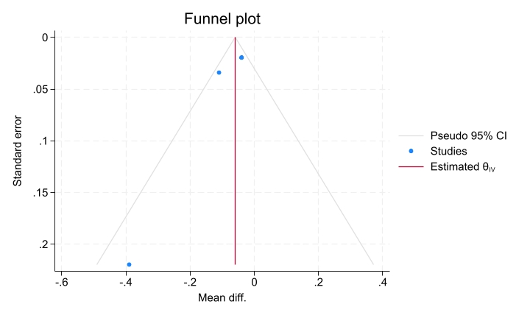

Figure S21. Funnel plot of publication bias for pulse wave velocity (Egger’s test p-value=0.010)
