Supplementary Appendix

Comparative Efficacy and Safety of PCSK9 Inhibitors for
Lipoprotein(a) Reduction: A Systematic Review and Network Meta-Analysis
Contents
Appendix 1: Search strategy 3
Table S1.1. Search strategy of PubMed 3
Table S1.2. Search strategy of Web of Science: Science Citation Index Expanded 4
Table S1.3. Search strategy of Embase 4
Table S1.4. Search strategy of Cochrane Central Register of Controlled Trials 5
(CENTRAL) 5
Appendix 2: Characteristics of included studies 6
Table S2.1: Baseline of characteristics of included studies 6
References 13
Table S2.2: PCSK9 inhibitors list 24
Appendix 3: List of data extracted from the included randomized clinical trials 26
Appendix 4: Risk of bias of randomized clinical trials 27
Figure S4.1: Overall risk of bias presented as percentage of each risk of bias item across all included studies. 27
Table S4.2: Study level risk of bias assessment using Cochrane risk of bias tool 2.0 for assessing risk of bias of randomized clinical trials. 28
Appendix 5: Evaluation of heterogeneity 32
Table S5.1: Network heterogeneity 32
Appendix 6: Network plots and forest plots of secondary outcomes 33
Figure S6.1: Network plot of the effect on non-HDL-C, and forest plot of network effect sizes for compared with placebo. 33
Appendix 7: SUCRA and cumulative probability plots 35
Figure S7.1: Cumulative ranking curve plots of PCSK9 inhibitors for Lp(a) in range network. 35
Figure S7.2: Cumulative ranking curve plots of PCSK9 inhibitors for LDL-C in range network. 36
Figure S7.3: Cumulative ranking curve plots of PCSK9 inhibitors for non-HDL-C in range network. 37
Figure S7.4: Cumulative ranking curve plots of PCSK9 inhibitors for TG in range network. 38
Figure S7.5: Cumulative ranking curve plots of PCSK9 inhibitors for TC in range network. 39
Figure S7.6: Cumulative ranking curve plots of PCSK9 inhibitors for HDL-C in range network. 40
Figure S7.7: Cumulative ranking curve plots of PCSK9 inhibitors for ApoB in range network. 41
Figure S7.8: Cumulative ranking curve plots of PCSK9 inhibitors for AE in range network. 42
Figure S7.9: Cumulative ranking curve plots of PCSK9 inhibitors for SAE in range network. 43
Appendix 8: League table of Summary Estimates for PCSK9 inhibitors 44
Table S8.1: Lp(a) 44
Table S8.2: LDL-C 45
Table S8.3: non-HDL-C 46
Table S8.4: TG 47
Table S8.5: TC 48
Table S8.6: HDL-C 49
Table S8.7: ApoB 50
Table S8.8: AEs 51
Table S8.9: SAEs 52
Appendix 9: CINeMA Assessment 53
Figure S9.1: Risk of bias contribution by intervention group in Lp(a). 53
Figure S9.2: Overall risk of bias by treatment comparison in Lp(a). 54
Figure S9.3: Risk of bias contribution by intervention group in LDL-C. 55
Figure S9.4: Overall risk of bias by treatment comparison in LDL-C. 56
Table S9.1: Transitivity assessment. 57
Table S9.2: CINeMA Results of Lp(a). 58
Table S9.3: CINeMA Results of LDL-C. 60
Appendix 10: Funnel plots 61
Figure S10.1: Funnel plot of Lpa. 61
Figure S10.2: Funnel plot of LDL-C. 61
Figure S10.3: Funnel plot of non-HDL-C. 62
Figure S10.4: Funnel plot of TG. 63
Figure S10.5: Funnel plot of TC. 63
Figure S10.6: Funnel plot of HDL-C. 64
Figure S10.7: Funnel plot of ApoB. 65
Figure S10.8: Funnel plot of AE. 65
Figure S10.9: Funnel plot of SAE. 66
Appendix 11: Comprehensive comparisons of different PCSK9 inhibitors at various doses and dosing regimens 67
Figure S11.1: Lp(a) 67
Appendix 12: Subgroup analysis of PCSK9 inhibitors stratified by Lp(a) efficacy analysis time points 68
Figure S12.1: Early response (≤12 weeks) 68
Figure S12.2: Mid-term maintenance (13–26 weeks) 69
Figure S12.3: Long-term durability (>26 weeks) 70
Appendix 13: Subgroup analysis of PCSK9 inhibitors stratified by background statin therapy 71
Figure S13.1: With background statins 71
Figure S13.2: Without background statins 72
Appendix 14: Comparison of the effects of PCSK9 inhibitors on Lp(a) levels between East Asian and Global populations 73
Figure S14.1: East Asian 73
Figure S14.2: Global 74
Appendix 15: Sensitivity analysis 75
Table S15.1 Sensitivity analysis of treatment effects on Lp(a) according to the reported measurement unit (mg/dL vs. nmol/L) 75
Figure S15.1 Sensitivity analysis of treatment effects on Lp(a) restricted to standard approved doses 76
Appendix 16: Specific AEs 77

Appendix 1: Search strategy

Table S1.1. Search strategy of PubMed
# Searches
1 ((Hypercholesterolemia[MeSH Terms]) OR (Hyperlipidemias[MeSH Terms])) OR (Dyslipidemias[MeSH Terms])
2 ((((hypercholesterolemia[Title/Abstract]) OR (hypercholesterolaemia[Title/Abstract])) OR (hyperlipidemia[Title/Abstract])) OR (hyperlipidaemia[Title/Abstract])) OR (dyslipidemia[Title/Abstract]) OR (dyslipidemia[Title/Abstract])
3 1 OR 2
4 ((("PCSK9 Inhibitors"[MeSH Terms]) OR ("Proprotein Convertase 9"[MeSH Terms])) OR ("PCSK9 inhibitor*"[Title/Abstract])) OR ("proprotein convertase subtilisin/kexin type 9"[Title/Abstract])
5 (((alirocumab[Title/Abstract]) OR (praluent[Title/Abstract])) OR (REGN727[Title/Abstract])) OR (SAR236553[Title/Abstract])
6 ((evolocumab[Title/Abstract]) OR (repatha[Title/Abstract])) OR (AMG145[Title/Abstract])
7 ((((Inclisiran[Title/Abstract]) OR (leqvio[Title/Abstract])) OR (ALN60212[Title/Abstract])) OR (ALN-PCS[Title/Abstract])) OR (ALN-PCSsc[Title/Abstract])
8 (tafolecimab[Title/Abstract]) OR (sintbilo[Title/Abstract])
9 (recaticimab[Title/Abstract]) OR (SHR-1209[Title/Abstract])
10 (ongericimab[Title/Abstract]) OR (JS002[Title/Abstract])
11 4 OR 5 OR 6 OR 7 OR 8 OR 9 OR 10
12 ((((((("randomized controlled trial"[Publication Type]) OR ("controlled clinical trial"[Publication Type])) OR (randomized[Title/Abstract])) OR (randomised[Title/Abstract])) OR (randomization[Title/Abstract])) OR (randomly[Title/Abstract])) OR (rct[Title/Abstract])) OR (trial[Title/Abstract])
13 animals[MeSH Terms] NOT humans[MeSH Terms]
14 12 NOT 13
15 3 AND 11 AND 14

Table S1.2. Search strategy of Web of Science: Science Citation Index Expanded
# Searches
1 TS=(hypercholesterolemia OR hypercholesterolaemia OR hyperlipidemia OR hyperlipidaemia OR dyslipidemia OR dyslipidemia)
2 TS=("PCSK9 Inhibitor*" OR "Proprotein Convertase 9" OR "proprotein convertase subtilisin/kexin type 9")
3 TS=(alirocumab OR praluent OR REGN727 OR SAR236553)
4 TS=(evolocumab OR repatha OR AMG145)
5 TS=(Inclisiran OR leqvio OR ALN60212 OR ALN-PCS OR ALN-PCSsc)
6 TS=(tafolecimab OR sintbilo)
7 TS=(recaticimab OR SHR-1209)
8 TS=(ongericimab OR JS002)
9 #2 OR #3 OR #4 OR #5 OR #6 OR #7 OR #8
10 TS=("randomized controlled trial" OR "controlled clinical trial" OR randomized OR randomised OR randomization OR randomly OR rct OR trial)
11 TS=(animal* NOT human*)
12 #10 NOT #11
13 #1 AND #9 AND #12

Table S1.3. Search strategy of Embase
# Searches
1 'hypercholesterolemia'/exp OR 'hyperlipidemia'/exp OR 'dyslipidemia'/exp OR 'hypercholesterolemia':ti,ab,kw OR 'hypercholesterolaemia':ti,ab,kw OR 'hyperlipidemia':ti,ab,kw OR 'hyperlipidaemia':ti,ab,kw OR 'dyslipidemia':ti,ab,kw OR 'dyslipidemia':ti,ab,kw
2 'pcsk9 inhibitor'/exp OR 'proprotein convertase 9'/exp OR 'pcsk9 inhibitor*':ti,ab,kw OR 'proprotein convertase subtilisin/kexin type 9':ti,ab,kw
3 'alirocumab'/exp OR 'praluent':ti,ab,kw OR 'regn727':ti,ab,kw OR 'sar236553':ti,ab,kw
4 'evolocumab'/exp OR 'repatha':ti,ab,kw OR 'amg145':ti,ab,kw
5 'inclisiran'/exp OR 'leqvio':ti,ab,kw OR 'aln60212':ti,ab,kw OR 'aln-pcs':ti,ab,kw OR 'aln-pcssc':ti,ab,kw
6 'tafolecimab'/exp OR 'sintbilo':ti,ab,kw
7 'recaticimab'/exp OR 'shr-1209':ti,ab,kw
8 'ongericimab'/exp OR 'js002':ti,ab,kw
9 #2 OR #3 OR #4 OR #5 OR #6 OR #7 OR #8
10 'randomized controlled trial'/exp OR 'controlled clinical trial'/exp OR 'randomized':ti,ab,kw OR 'randomised':ti,ab,kw OR 'randomization':ti,ab,kw OR 'randomly':ti,ab,kw OR 'rct':ti,ab,kw OR 'trial':ti,ab,kw
11 'animal'/exp NOT 'human'/exp
12 #10 NOT #11
13 #1 AND #9 AND #12

Table S1.4. Search strategy of Cochrane Central Register of Controlled Trials

(CENTRAL)
# Searches
1 MeSH descriptor: [Hypercholesterolemia] explode all trees
2 MeSH descriptor: [Hyperlipidemias] explode all trees
3 MeSH descriptor: [Dyslipidemias] explode all trees
4 (hypercholesterolemia OR hypercholesterolaemia OR hyperlipidemia OR hyperlipidaemia OR dyslipidemia OR dyslipidemia):ti,ab,kw
5 #1 OR #2 OR #3 OR #4
6 MeSH descriptor: [PCSK9 Inhibitors] explode all trees
7 ("Proprotein Convertase 9"):ti,ab,kw
8 ("proprotein convertase subtilisin kexin type 9"):ti,ab,kw
9 (alirocumab OR praluent OR REGN727 OR SAR236553):ti,ab,kw
10 (evolocumab OR repatha OR AMG145):ti,ab,kw
11 (Inclisiran OR leqvio OR ALN60212 OR ALN-PCS OR ALN-PCSsc):ti,ab,kw
12 (tafolecimab OR sintbilo):ti,ab,kw
13 (recaticimab OR SHR-1209):ti,ab,kw
14 (ongericimab OR JS002):ti,ab,kw
15 #6 OR #7 OR #8 OR #9 OR #10 OR #11 OR #12 OR #13 OR #14
16 MeSH descriptor: [Randomized Controlled Trial] explode all trees
17 MeSH descriptor: [Controlled Clinical Trial] explode all trees
18 (randomized OR randomised OR randomization OR randomly OR rct OR trial):ti,ab,kw
19 #16 OR #17 OR #18
20 (Animal*):ti,ab,kw
21 (Human*):ti,ab,kw
22 #20 NOT #21
23 #19 NOT #22
24 #5 AND #15 AND #23

Appendix 2: Characteristics of included studies

Table S2.1: Baseline of characteristics of included studies
Study | Registration | Country/Region | Duration | Population | Treatments (N) | Age (I/C), yr | Male% (I/C) | On statin % (I/C) | Ezetimibe% (I/C) | Background lipid-lowering treatment
Stiekema et al, 2019  ANITSCHKOW | NCT02729025 | Multinational (3) | 16w | Elevated Lp(a)/LDL-C | Evo: 65; PBO: 64 | 59.0 / 60.5 | 40.0 / 53.1 | 55.4 / 53.1 | 15.4 / 26.6 | Stable statin ± EZE
Rosenson et al, 2019  BANTING | NCT02739984 | Multinational (6) | 12w | Hypercholesterolaemia/dyslipidemia & T2DM | Evo: 280; PBO: 141 | 62.5 / 62.2 | 57.1 / 53.9 | 99.6 / 98.6 | NR | Max-tolerated statin
Boccara et al, 2020  BEIJERINCK | NCT02833844 | Multinational (4) | 48w | Hypercholesterolaemia/dyslipidemia & HIV | Evo: 307; PBO: 157 | 56.4 / 56.2 | 85.7 / 76.4 | 75.5 / 72.6 | 17.3 / 23.6 | Max-tolerated statin
Lorenzatti et al, 2019  BERSON | NCT02662569 | Multinational (10) | 14w | Hyperlipidaemia/Mixed dyslipidemia & T2DM | Evo: 657; PBO: 484 | 62.0 / 62.0 | 44.1 / 39.8 | 56.9 / 57.4 | NR | Atorvastatin 20 mg
Huo et al, 2023  CREDIT-1 | NCT04289285 | China | 52w | Non-familial hypercholesterolemia | Taf: 411; PBO: 203 | 57.8 / 57.0 | 66.4 / 65.1 | 99.25 / 99.05 | 9.4 / 8.9 | Mod/High statin ± EZE
Chai et al, 2023  CREDIT-2 | NCT04179669 | China | 32w | Hypercholesterolaemia (HeFH) | Taf: 100; PBO: 48 | 50.3 / 47.7 | 49.8 / 55.9 | 98.95 / 100 | 30.1 / 24.9 | Mod/High statin ± EZE
Qi et al, 2023  CREDIT-4 | NCT04709536 | China | 28w | Hypercholesterolaemia (High risk/HeFH) | Taf: 205; PBO: 98 | 56.9 / 56.8 | 71.7 / 63.3 | 100 / 100 | 11.2 /8.2 | Mod/High statin ± EZE
Blom et al, 2014  DESCARTES | NCT01516879 | Multinational (5) | 52w | Hyperlipidaemia & various CV risk | Evo: 599; PBO: 302 | 55.9 / 56.7 | 48.4 / 46.4 | 87.6 / 87.8 | 21.0 / 20.9 | Diet, Statin ± EZE
Koskinas et al, 2019  EVOPACS | NCT03287609 | Switzerland | 8w | dyslipidemia & ACS | Evo: 155; PBO: 153 | 60.5 / 61.0 | 83.0 / 80.0 | 20.0 / 23.0 | 4.0 / 6.0 | High-intensity statin
Sabatine et al, 2017  FOURIER | NCT01764633 | Multinational (48) | Median 2.2 years | dyslipidemia & ASCVD | Evo: 13784; PBO: 13780 | 62.5 / 62.5 | 75.4 / 75.5 | 99.7 / 99.8 | 5.3 / 5.2 | Mod/High statin ± EZE
Gao et al. 2021/2022 | NCT04851769 | China | 15 m | Hypercholesterolaemia & CAD | Ali: 30;  SC: 31 | 61.3 / 61.3 | 66.7 / 74.2 | 26.7 / 32.3 | NR | Mod-intensity statin
Nicholls et al, 2016  GLAGOV | NCT01813422 | Multinational (32) | 78w | dyslipidemia & angiographic CAD | Evo: 484; PBO: 484 | 59.8 / 59.8 | 72.1 / 72.3 | 98.8 / 98.3 | 2.1 / 2.1 | Stable statin therapy
Hao et al, 2022 | NR | China | 3m | dyslipidemia & high-risk ACS | Evo: 68;  SC: 68 | 62.2 / 62.2 | 66.2 / 70.6 | NR | NR | High-intensity statin
Tan et al, 2023  HUATUO | NCT03433755 | China | 12w | Hypercholesterolaemia/Mixed dyslipidemia | Evo: 159; PBO: 82 | 61.0 / 58.6 | 64.2 / 74.4 | 100 / 100 | 17.7 / 20.7 | Stable statin ± LLT
Nicholls et al, 2022  HUYGENS | NCT03570697 | Multinational (7) | 52w | dyslipidemia & NSTEMI | Evo: 80; PBO: 81 | 60.9 / 60.2 | 75.0 / 67.9 | 93.8 / 96.3 | 1.3 / 2.5 | Maximally tolerated statin
Janik et al, 2021 | NR | Multinational (9) | 106w | Hypercholesterolaemia (HeFH or high risk) | Ali: 1087; PBO: 1084 | 63.0 / 63.0 | 58.8 / 57.7 | 90.1 / 90.8 | NR | Max-tolerated statin
Ji et al, 2023 | NR | China | 6m | Dyslipidemia & NSTE-ACS | Evo: 55;  SC: 55 | 60.5 / 61.2 | 69.1 / 65.4 | NR | NR | Atorvastatin 20 mg
Robinson et al, 2014  LAPLACE-2 | NCT01763866 | Multinational (17) | 12w | Hypercholesterolaemia/Mixed dyslipidemia | Evo: 1117;  PBO: 558 | 59.6 / 60.8 | 56.0 / 50.7 | 100 / 100 | 0 | Mod/High statin
Giugliano et al, 2012  LAPLACE-TIMI 57 | NCT01380730 | Multinational (5) | 12w | Hypercholesterolemic | Evo: 474; PBO: 157 | 62.2 / 62.0 | 49.2 / 46.5 | 99.7 / 98.5 | 9.0 / 9.5 | Stable statin ± EZE
Lin et al, 2025 | NCT05325203 | China | 32w | Heterozygous familial hypercholesterolemia (HeFH) | Ong: 88; PBO: 45 | 48.1 / 47.0 | 38.7 / 51.0 | 100/ 100 | 69.3 / 48.7 | Mod-intensity statin
McKenney et al, 2012 | NCT01288443 | USA | 20w | Hypercholesterolaemia | Ali: 152; PBO: 31 | 57.4 / 53.3 | 46.8 / 51.6 | 100 / 100 | 0 | Stable Atorvastatin
Koren et al, 2014  MENDEL-2 | NCT01763827 | Multinational (9) | 12w | Hypercholesterolaemia | Evo: 306; PBO: 154 | 53.0 / 53.5 | 33.0 / 38.5 | 0 | 0 | None
Schwartz et al, 2018  ODYSSEY OUTCOME | NCT01666457 | Multinational (56) | Median 2.8 years | dyslipidemia & recent ACS | Ali: 9462; PBO: 9462 | 58.5 / 58.6 | 74.7 / 74.9 | 97.6 / 97.6 | 2.8 / 3.0 | High-intensity statins
Stroes et al, 2016  ODYSSEY CHOICE II | NCT01730053 | Multinational (10) | 32w | Hypercholesterolaemia (No statin) | Ali: 175; PBO: 58 | 63.3 / 63.1 | 55.2 / 53.4 | 0 | 59.8 / 60.3 | None
Roth et al, 2016  ODYSSEY CHOICE I | NCT01926782 | Multinational (8) | 56w | Hypercholesterolemic | Ali: 573; PBO: 230 | 61.2 / 60.5 | 52.3 / 59.6 | 50.2 / 50.0 | 11.3 / 14.6 | Max statin or No statin
Kereiakes et al, 2015  ODYSSEY COMBO I | NCT01644175 | USA | 60w | Hypercholesterolaemia & high CV risk | Ali: 209; PBO: 107 | 63.0 / 63.0 | 62.7 / 72.0 | 99.5 / 100 | 7.2 / 10.3 | Max-tolerated statin
Leiter et al, 2017  ODYSSEY DM-INSULIN | NCT02585778 | Multinational (10) | 32w | dyslipidemia & high CV risk | Ali: 345; PBO: 172 | 62.6 / 63.2 | 55.9 / 60.6 | 73.05 / 70.45 | 9.6 / 9.4 | maximally tolerated statin
Moriarty et al, 2016  ODYSSEY ESCAPE | NCT02326220 | Germany, USA | 18w | HeFH | Ali: 41; PBO: 21 | 59.5 / 57.0 | 63.4 / 47.6 | 46.3 / 61.9 | NR | Max statin ± LLT
Kastelein et al, 2015  ODYSSEY FH I | NCT01623115 | Multinational (14) | 78w | HeFH | Ali: 323; PBO: 163 | 52.1 / 51.7 | 55.7/ 57.7 | 100 / 100 | 56.0 / 59.5 | Stable maximally tolerated statin
Kastelein et al, 2015  ODYSSEY FH II | NCT01709500 | Multinational (10) | 78w | HeFH | Ali: 167; PBO: 82 | 53.2 / 53.2 | 51.5 / 54.9 | 100 / 100 | 67.1 / 64.6 | Stable maximally tolerated statin
Ginsberg et al, 2016  ODYSSEY HIGH FH | NCT01617655 | Multinational (5) | 86w | HeFH | Ali: 72; PBO: 35 | 49.8 / 52.1 | 48.6 / 62.9 | 100 / 100 | 19.4 / 34.3 | Stable maximally tolerated statin
Blom et al, 2020  ODYSSEY HoFH | NCT01617486 | Multinational (13) | 32w | HoFH | Ali: 45; PBO: 24 | 42.3 / 45.4 | 46.7 / 54.2 | 97.8 / 95.8 | 68.9 / 79.2 | Stable LLT
Teramoto et al, 2016  ODYSSEY JAPAN | NCT02107898 | Japan | 60w | HeFH | Ali: 144; PBO: 72 | 60.3 / 61.8 | 58.3 / 65.3 | 100 / 100 | NR | Stable maximally tolerated statin
Koh et al, 2018  ODYSSEY KT | NCT02289963 | South Korea, Taiwan | 32w | Hypercholesterolaemia & high CV risk | Ali: 97; PBO: 102 | 61.2 / 60.1 | 85.6 / 79.4 | 100 / 100 | 14.4 / 11.8 | Stable maximally tolerated statin
Robinson et al, 2015  ODYSSEY LONG TERM | NCT01507831 | Multinational (29) | 86w | Hypercholesterolaemia (HeFH/High risk) | Ali: 1553; PBO: 788 | 60.4 / 60.6 | 63.3 / 60.2 | 100 / 100 | 13.9 / 15.0 | Stable maximally tolerated statin
Teramoto et al, 2019  ODYSSEY NIPPON | NCT02584504 | Japan | 64w | Japanese hypercholesterolemia | Ali: 107; PBO: 56 | 63.1 / 64.6 | 61.7 / 66.1 | 34.6 / 33.9 | 19.6 / 19.6 | Low-dose statin/diet
Bays et al, 2015  ODYSSEY OPTIONS I | NCT01730040 | Multinational (9) | 32w | Hypercholesterolaemia & high CVD risk | Ali: 104; SC: 149 | 63.2 / 64.8 / 61.2 | 62.0 / 63.3 / 69.7 | 100 / 100 / 100 | 0 | Stable statin
Farnier et al, 2016  ODYSSEY OPTIONS II | NCT01730053 | Multinational (8) | 32w | Hypercholesterolaemia & high CV risk | Ali: 103; SC: 101 | 60.0 / 61.8 / 61.05 | 57.6 / 56.4 / 70.25 | 100 / 100 / 100 | 0 | Stable statin
Ako et al, 2019  ODYSSEY J-IVUS | NCT02984982 | Japan | 36w | Hypercholesterolaemia & recent ACS | Ali: 104; SC: 102 | 61.8 / 60.5 | 79.6 / 80.9 | 100 / 100 | 7.5 / 7.9 | Stable statin
Ray et al, 2017  ORION-1 | NCT02597127 | Multinational (5) | 32w | Hypercholesterolaemia & high CV risk | Inc: 370; PBO: 127 | 63.6 / 62.4 | 67.0 / 59.1 | 72.4 / 73.5 | 30.0 / 30.5 | Max-tolerated statin
Raal et al, 2024  ORION-5 | NCT03851705 | Multinational (7) | 103w | HoFH | Inc: 37; PBO: 19 | 43.8 / 40.7 | 37.8 / 42.1 | 100 / 100 | 63.2 / 67.6 | Stable maximally tolerated statin
Raal et al, 2020  ORION-9 | NCT03397121 | Multinational (8) | 540d | HeFH | Inc: 242; PBO: 240 | 56.0 / 56.0 | 46.3 / 47.9 | 90.5 / 90.4 | 55.8 / 50.0 | Stable maximally tolerated statin
Ray et al, 2020  ORION-10 | NCT03399370 | USA | 540d | Hypercholesterolaemia & ASCVD | Inc: 781; PBO: 780 | 66.4 / 65.7 | 68.5 / 70.3 | 89.8 / 88.7 | 10.2 / 9.5 | Maximum tolerated dose of statin
Ray et al, 2020  ORION-11 | NCT03400800 | Multinational (7) | 540d | Hypercholesterolaemia & ASCVD | Inc: 810; PBO: 807 | 64.8 / 64.8 | 71.5 / 72.0 | 94.6 / 94.9 | 6.3 / 7.7 | Maximum tolerated dose of statin
Yamashita et al, 2024  ORION-15 | NCT04666298 | Japan | 360d | Japanese Hypercholesterolaemia (High risk) | Inc: 255; PBO: 57 | 63.5 / 63.8 | 74.2 / 68.4 | 90.0 / 87.7 | 41.3 / 36.8 | Maximally tolerated dose of statins
Huo et al, 2024  ORION-18 | NCT04765657 | China, South Korea, Singapore | 360d | Hypercholesterolaemia & ASCVD | Inc: 170; PBO: 174 | 58.8 / 60.1 | 76.5 / 73.0 | 98.8 / 96.6 | NR | Maximally tolerated dose of statins
Räber et al, 2022  PACMAN-AMI | NCT03067844 | Multinational (4) | 52w | dyslipidemia & recent ACS | Ali: 148; PBO: 152 | 58.4 / 58.6 | 83.8 / 78.3 | 11.5 / 13.2 | 0 / 0.7 | Rosuvastatin 20 mg
Xu et al, 2024  REMAIN-1 | NCT04849000 | China | 28w | Hypercholesterolaemia/Hyperlipidaemia | Rec: 468; PBO: 235 | 44.3 / 44.7 | 54.1 / 52.3 | 0 | 0 | None
Sun et al, 2024  REMAIN-2 | NCT04885218 | China | 52w | Non-familial Hypercholesterolaemia | Rec: 456; PBO: 233 | 56.0 / 55.6 | 63.6 / 66.1 | 100 / 100 | 10.7 / 12.0 | Mod/High statin ± EZE
Li et al, 2025  REMAIN-3 | NCT04844125 | China | 16w | HeFH | Rec: 95; PBO: 48 | 45.0 / 41.5 | 52.6 / 64.6 | 100 / 100 | 37.9 / 37.5 | Mod/High statin ± EZE
Roth et al, 2012 | NCT01288469 | USA | 16w | Primary Hypercholesterolemia | Ali: 61; PBO: 31 | 57.8 / 55.3 | 33.0 / 42.0 | 100 / 100 | 0 | Stable Atorvastatin
Raal et al, 2012  RUTHERFORD | NCT01375751 | Multinational (6) | 12w | HeFH | Evo: 111; PBO: 56 | 49.7 / 49.3 | 58.5 / 42.9 | 91.0 / 87.5 | 64.9 / 64.3 | Max-tolerated LLT
Raal et al, 2015  RUTHERFORD-2 | NCT01763918 | Multinational (12) | 14w | HeFH | Evo: 220; PBO: 109 | 52.3 / 49.0 | 59.0 / 55.0 | 100 / 100 | NR | Stable statin ± LLT
Shao et al, 2025 | NCT05621070 | China | 60w | Hypercholesterolaemia & statin intolerance | Ong: 92; PBO: 47 | 56.9 / 57.8 | 53.3 / 55.3 | 0 | 18.5 / 21.2 | None
Stein et al, 2012 | NCT01266876 | USA, Canada | 20w | HeFH | Ali: 62; PBO: 15 | 53.7 / 51.9 | 61.0 / 60.0 | 100 / 100 | 71.3 / 73.0 | Stable statin ± EZE
Uehara et al, 2024  Adage-Joto | UMIN000030588 | Japan | 9m | dyslipidemia & STEMI-ACS | ACSEvo: 29; SC: 23 | 59.6 / 60.0 | 75.8 / 69.5 | 100 / 100 | 7.0 / 26.0 | Intensive statin
Wang et al, 2024 | CTR20220027 | China | 20w | Hypercholesterolaemia/Mixed dyslipidemia | Ong: 169; PBO: 86 | 58.4 / 60.8 | 51.5 / 51.7 | 100 / 100 | 8.9 / 5.8 | Stable optimized LLT
Wang et al, 2024 | NCT04781114 | China | 60w | Hypercholesterolaemia/Mixed dyslipidemia | Ong: 537; PBO: 265 | 59.1 / 60.3 | 60.4 / 61.9 | 100 / 100 | 17.7 / 18.2 | Stable optimized LLT
Hirayama et al, 2014  YUKAWA | NCT01586520 | Japan | 12w | Japanese Hypercholesterolaemia (High risk) | Evo: 205; PBO: 102 | 61.9 / 60.6 | 61.3 / 70.6 | 100 / 100 | NR | Stable statin ± EZE
Kiyosue et al, 2016  YUKAWA-2 | NCT01953328 | Japan | 12w | Hyperlipidaemia/dyslipidemia | Evo: 202; PBO: 202 | 62.0 / 61.0 | 60.0 / 61.0 | 100 / 100 | NR | Atorvastatin 5/20 mg
Koren et al, 2012  MENDEL | NCT01375777 | Multinational (4) | 12w | Hypercholesterolaemia | Evo: 271; PBO: 90 | 50.1 / 51.25 | 31.0 / 37.5 | 0 | NR | None
Teramoto et al, 2016 | NCT01812707 | Japan | 20w | Japanese Hypercholesterolaemia | Ali: 75; PBO: 25 | 57.4 / 58.6 | 41.3 / 56.0 | 100 / 100 | NR | Atorvastatin 5/20 mg
ACS: Acute Coronary Syndrome; Ali: Alirocumab; ASCVD: Atherosclerotic Cardiovascular Disease; ATV: Atorvastatin; CAD: Coronary Artery Disease; Dur. : Duration; Dyslip.: dyslipidemia; Evo: Evolocumab; EZE: Ezetimibe; HeFH: Heterozygous Familial Hypercholesterolaemia; HIV: Human Immunodeficiency Virus; HoFH: Homozygous Familial Hypercholesterolaemia; I/C: Intervention group / Control group; Inc: Inclisiran; LLT: Lipid-Lowering Therapy; Lp(a): Lipoprotein(a); m: Months; Mod/High: Moderate or high intensity; NR: Not reported; NSTE-ACS: Non-ST-elevation Acute Coronary Syndrome; NSTEMI: Non-ST-elevation Myocardial Infarction; Ong: Ongericimab; PBO: Placebo; PCI: Percutaneous Coronary Intervention; Rec: Recaticimab; SAMS: Statin-associated muscle symptoms; SC: Standard Care; STEMI-ACS: ST-elevation Myocardial Infarction Acute Coronary Syndrome; T2DM: Type 2 Diabetes Mellitus; Taf: Tafolecimab; w: Weeks; yr: Years

References
- Stiekema LCA, Stroes ESG, Verweij SL, et al. Persistent arterial wall inflammation in patients with elevated lipoprotein(a) despite strong low-density lipoprotein cholesterol reduction by proprotein convertase subtilisin/kexin type 9 antibody treatment. Eur Heart J. 2018;40(33):2775–81. doi:10.1093/eurheartj/ehy862.

- Rosenson RS, Daviglus ML, Handelsman Y, et al. Efficacy and safety of evolocumab in individuals with type 2 diabetes mellitus: primary results of the randomised controlled BANTING study. Diabetologia. 2019;62(6):948–58. doi:10.1007/s00125-019-4856-7.

- Boccara F, Kumar PN, Caramelli B, et al. Evolocumab in HIV-infected patients with dyslipidemia: primary results of the randomized, double-blind BEIJERINCK study. J Am Coll Cardiol. 2020;75(20):2570–84. doi:10.1016/j.jacc.2020.03.025.

- Lorenzatti AJ, Eliaschewitz FG, Chen Y, et al. Randomised study of evolocumab in patients with type 2 diabetes and dyslipidemia on background statin: primary results of the BERSON clinical trial. Diabetes Obes Metab. 2019;21(6):1455–63. doi:10.1111/dom.13680.

- Huo Y, Chen B, Lian Q, et al. Tafolecimab in Chinese patients with non-familial hypercholesterolemia (CREDIT-1): a 48-week randomized, double-blind, placebo-controlled phase 3 trial. Lancet Reg Health West Pac. 2023;41:100907. doi:10.1016/j.lanwpc.2023.100907.

- Chai M, He Y, Zhao W, et al. Efficacy and safety of tafolecimab in Chinese patients with heterozygous familial hypercholesterolemia: a randomized, double-blind, placebo-controlled phase 3 trial (CREDIT-2). BMC Med. 2023;21(1):50. doi:10.1186/s12916-023-02797-8.

- Qi L, Liu D, Qu Y, et al. Tafolecimab in Chinese patients with hypercholesterolemia (CREDIT-4) a randomized, double-blind, placebo-controlled phase 3 trial. JACC Asia. 2023;3(4):636–45. doi:10.1016/j.jacasi.2023.04.011.

- Blom DJ, Hala T, Bolognese M, et al. A 52-week placebo-controlled trial of evolocumab in hyperlipidemia. N Engl J Med. 2014;370(19):1809–19. doi:10.1056/NEJMoa1316222.

- Koskinas KC, Windecker S, Pedrazzini G, et al. Evolocumab for early reduction of LDL cholesterol levels in patients with acute coronary syndromes (EVOPACS). J Am Coll Cardiol. 2019;74(20):2452–62. doi:10.1016/j.jacc.2019.08.010.

- Sabatine MS, Giugliano RP, Keech AC, et al. Evolocumab and clinical outcomes in patients with cardiovascular disease. N Engl J Med. 2017;376(18):1713–22. doi:10.1056/NEJMoa1615664.

- Gao F, Wang ZJ, Ma XT, Shen H, Yang LX, Zhou YJ. Effect of alirocumab on coronary plaque in patients with coronary artery disease assessed by optical coherence tomography. Lipids Health Dis. 2021;20(1):106. doi:10.1186/s12944-021-01528-3.

- Gao F, Li YP, Ma XT, Wang ZJ, Shi DM, Zhou YJ. Effect of alirocumab on coronary calcification in patients with coronary artery disease. Front Cardiovasc Med. 2022;9:907662. doi:10.3389/fcvm.2022.907662.

- Nicholls SJ, Puri R, Anderson T, et al. Effect of evolocumab on progression of coronary disease in statin-treated patients: the GLAGOV randomized clinical trial. JAMA. 2016;316(22):2373–84. doi:10.1001/jama.2016.16951.

- Hao Y, Yang YL, Wang YC, Li J. Effect of the early application of evolocumab on blood lipid profile and cardiovascular prognosis in patients with extremely high-risk acute coronary syndrome. Int Heart J. 2022;63(4):669–77. doi:10.1536/ihj.22-052.

- Tan H, Li W, Huang Z, et al. Efficacy and safety of evolocumab in Chinese patients with primary hypercholesterolemia and mixed dyslipidemia: 12-week primary results of the HUA TUO randomized clinical trial. Cardiol Ther. 2023;12:341–59. doi:10.1007/s40119-023-00304-x.

- Nicholls SJ, Kataoka Y, Nissen SE, et al. Effect of evolocumab on coronary plaque phenotype and burden in statin-treated patients following myocardial infarction. JACC Cardiovasc Imaging. 2022;15(7):1308–21. doi:10.1016/j.jcmg.2022.03.002.

- Janik MJ, Urbach DV, van Nieuwenhuizen E, et al. Alirocumab treatment and neurocognitive function according to the CANTAB scale in patients at increased cardiovascular risk: a prospective, randomized, placebo-controlled study. Atherosclerosis. 2021;331:20–7. doi:10.1016/j.atherosclerosis.2021.06.913.

- Ji J, Wei X, Chen W, Wan D, Han W, Liu H. Effects of early PCSK9 inhibitor application on inflammation levels and microcirculatory function after PCI in patients with NSTE-ACS. Am J Transl Res. 2023;15(5):3586–94.

- Robinson JG, Nedergaard BS, Rogers WJ, et al. Effect of evolocumab or ezetimibe added to moderate- or high-intensity statin therapy on LDL-C lowering in patients with hypercholesterolemia: the LAPLACE-2 randomized clinical trial. JAMA. 2014;311(18):1870–82. doi:10.1001/jama.2014.4030.

- Giugliano RP, Desai NR, Kohli P, et al. Efficacy, safety, and tolerability of a monoclonal antibody to proprotein convertase subtilisin/kexin type 9 in combination with a statin in patients with hypercholesterolaemia (LAPLACE-TIMI 57): a randomised, placebo-controlled, dose-ranging, phase 2 study. Lancet. 2012;380(9858):2007–17. doi:10.1016/S0140-6736(12)61770-X.

- Lin J, Ji Y, Wang G, et al. Efficacy and safety of ongericimab in Chinese patients with heterozygous familial hypercholesterolemia: a randomized, double-blind, placebo-controlled phase 3 trial. Atherosclerosis. 2025;403:119120. doi:10.1016/j.atherosclerosis.2025.119120.

- McKenney JM, Koren MJ, Kereiakes DJ, Hanotin C, Ferrand AC, Stein EA. Safety and efficacy of a monoclonal antibody to proprotein convertase subtilisin/kexin type 9 serine protease, SAR236553/REGN727, in patients with primary hypercholesterolemia receiving ongoing stable atorvastatin therapy. J Am Coll Cardiol. 2012;59(25):2344–53. doi:10.1016/j.jacc.2012.03.007.

- Koren MJ, Lundqvist P, Bolognese M, et al. Anti-PCSK9 monotherapy for hypercholesterolemia: the MENDEL-2 randomized, controlled phase III clinical trial of evolocumab. J Am Coll Cardiol. 2014;63(23):2531–40. doi:10.1016/j.jacc.2014.03.018.

- Schwartz GG, Steg PG, Szarek M, et al. Alirocumab and cardiovascular outcomes after acute coronary syndrome. N Engl J Med. 2018;379(22):2097–107. doi:10.1056/NEJMoa1801174.

- Stroes E, Guyton JR, Lepor N, et al. Efficacy and safety of alirocumab 150 mg every 4 weeks in patients with hypercholesterolemia not on statin therapy: the ODYSSEY CHOICE II study. J Am Heart Assoc. 2016;5(9):e003421. doi:10.1161/JAHA.116.003421.

- Roth EM, Moriarty PM, Bergeron J, et al. A phase III randomized trial evaluating alirocumab 300 mg every 4 weeks as monotherapy or add-on to statin: ODYSSEY CHOICE I. Atherosclerosis. 2016;254:254–62. doi:10.1016/j.atherosclerosis.2016.08.043.

- Kereiakes DJ, Robinson JG, Cannon CP, et al. Efficacy and safety of the proprotein convertase subtilisin/kexin type 9 inhibitor alirocumab among high cardiovascular risk patients on maximally tolerated statin therapy: the ODYSSEY COMBO I study. Am Heart J. 2015;169(6):906–15. doi:10.1016/j.ahj.2015.03.004.

- Leiter LA, Cariou B, Müller‐Wieland D, et al. Efficacy and safety of alirocumab in insulin‐treated individuals with type 1 or type 2 diabetes and high cardiovascular risk: the ODYSSEY DM‐INSULIN randomized trial. Diabetes Obes Metab. 2017;19(12):1781–92. doi:10.1111/dom.13114.

- Moriarty PM, Parhofer KG, Babirak SP, et al. Alirocumab in patients with heterozygous familial hypercholesterolaemia undergoing lipoprotein apheresis: the ODYSSEY ESCAPE trial. Eur Heart J. 2016;37(48):3588–95. doi:10.1093/eurheartj/ehw388.

- Kastelein JJP, Ginsberg HN, Langslet G, et al. ODYSSEY FH I and FH II: 78 week results with alirocumab treatment in 735 patients with heterozygous familial hypercholesterolaemia. Eur Heart J. 2015;36(43):2996–3003. doi:10.1093/eurheartj/ehv370.

- Ginsberg HN, Rader DJ, Raal FJ, et al. Efficacy and safety of alirocumab in patients with heterozygous familial hypercholesterolemia and LDL-C of 160 mg/dl or higher. Cardiovasc Drugs Ther. 2016;30(5):473–83. doi:10.1007/s10557-016-6685-y.

- Blom DJ, Harada-Shiba M, Rubba P, et al. Efficacy and safety of alirocumab in adults with homozygous familial hypercholesterolemia: the ODYSSEY HoFH trial. J Am Coll Cardiol. 2020;76(2):131–42. doi:10.1016/j.jacc.2020.05.027.

- Teramoto T, Kobayashi M, Tasaki H, et al. Efficacy and safety of alirocumab in Japanese patients with heterozygous familial hypercholesterolemia or at high cardiovascular risk with hypercholesterolemia not adequately controlled with statins: ODYSSEY JAPAN randomized controlled trial. Circ J. 2016;80(9):1980–7. doi:10.1253/circj.CJ-16-0387.

- Koh KK, Nam CW, Chao TH, et al. A randomized trial evaluating the efficacy and safety of alirocumab in South Korea and Taiwan (ODYSSEY KT). J Clin Lipidol. 2018;12(1):162–72. doi:10.1016/j.jacl.2017.09.007.

- Robinson JG, Farnier M, Krempf M, et al. Efficacy and safety of alirocumab in reducing lipids and cardiovascular events. N Engl J Med. 2015;372(16):1489–99. doi:10.1056/NEJMoa1501031.

- Teramoto T, Kiyosue A, Ishigaki Y, et al. Efficacy and safety of alirocumab 150 mg every 4 weeks in hypercholesterolemic patients on non-statin lipid-lowering therapy or lowest strength dose of statin: ODYSSEY NIPPON. J Cardiol. 2019;73(3):218–27. doi:10.1016/j.jjcc.2018.10.004.

- Bays H, Gaudet D, Weiss R, et al. Alirocumab as add-on to atorvastatin versus other lipid treatment strategies: ODYSSEY OPTIONS I randomized trial. J Clin Endocrinol Metab. 2015;100(8):3140–8. doi:10.1210/jc.2015-1520.

- Farnier M, Jones P, Severance R, et al. Efficacy and safety of adding alirocumab to rosuvastatin versus adding ezetimibe or doubling the rosuvastatin dose in high cardiovascular-risk patients: the ODYSSEY OPTIONS II randomized trial. Atherosclerosis. 2016;244:138–46. doi:10.1016/j.atherosclerosis.2015.11.010.

- Ako J, Hibi K, Tsujita K, et al. Effect of alirocumab on coronary atheroma volume in Japanese patients with acute coronary syndrome: the ODYSSEY J-IVUS trial. Circ J. 2019;83(10):2025–33. doi:10.1253/circj.CJ-19-0412.

- Ray KK, Landmesser U, Leiter LA, et al. Inclisiran in patients at high cardiovascular risk with elevated LDL cholesterol. N Engl J Med. 2017;376(15):1430–40. doi:10.1056/NEJMoa1615758.

- Raal F, Durst R, Bi R, et al. Efficacy, safety, and tolerability of inclisiran in patients with homozygous familial hypercholesterolemia: results from the ORION-5 randomized clinical trial. Circulation. 2023;149(5):354–62. doi:10.1161/CIRCULATIONAHA.122.063460.

- Raal FJ, Kallend D, Ray KK, et al. Inclisiran for the treatment of heterozygous familial hypercholesterolemia. N Engl J Med. 2020;382(16):1520–30. doi:10.1056/NEJMoa1913805.

- Ray KK, Wright RS, Kallend D, et al. Two phase 3 trials of inclisiran in patients with elevated LDL cholesterol. N Engl J Med. 2020;382(16):1507–19. doi:10.1056/NEJMoa1912387.

- Yamashita S, Kiyosue A, Maheux P, et al. Efficacy, safety, and pharmacokinetics of inclisiran in Japanese patients: results from ORION-15. J Atheroscler Thromb. 2024;31(6):780–94. doi:10.5551/jat.64454.

- Huo Y, Lesogor A, Lee CW, et al. Efficacy and safety of inclisiran in Asian patients: results from ORION-18. JACC Asia. 2024;4(2):123–34. doi:10.1016/j.jacasi.2023.09.006.

- Räber L, Ueki Y, Otsuka T, et al. Effect of alirocumab added to high-intensity statin therapy on coronary atherosclerosis in patients with acute myocardial infarction: the PACMAN-AMI randomized clinical trial. JAMA. 2022;327(18):1771–81. doi:10.1001/jama.2022.5218.

- Xu M, Wang Z, Zhang Y, et al. Recaticimab monotherapy for nonfamilial hypercholesterolemia and mixed hyperlipemia: the phase 3 REMAIN-1 randomized trial. J Am Coll Cardiol. 2024;84(20):2026–36. doi:10.1016/j.jacc.2024.07.035.

- Sun Y, Lv Q, Guo Y, et al. Recaticimab as add-on therapy to statins for nonfamilial hypercholesterolemia. J Am Coll Cardiol. 2024;84(20):2037–47. doi:10.1016/j.jacc.2024.09.012.

- Li L, Zhou Y, Deng C, et al. Recaticimab in adult heterozygous familial hypercholesterolaemia (REMAIN-3): a multicentre, randomized, double-blind, placebo-controlled phase 3 study. Cardiovasc Res. 2025;121(12):1856–64. doi:10.1093/cvr/cvaf155.

- Roth EM, McKenney JM, Hanotin C, Asset G, Stein EA. Atorvastatin with or without an antibody to PCSK9 in primary hypercholesterolemia. N Engl J Med. 2012;367(20):1891–900. doi:10.1056/NEJMoa1201832.

- Raal F, Scott R, Somaratne R, et al. Low-density lipoprotein cholesterol-lowering effects of AMG 145, a monoclonal antibody to proprotein convertase subtilisin/kexin type 9 serine protease in patients with heterozygous familial hypercholesterolemia. Circulation. 2012;126(20):2408–17. doi:10.1161/CIRCULATIONAHA.112.144055.

- Raal FJ, Stein EA, Dufour R, et al. PCSK9 inhibition with evolocumab (AMG 145) in heterozygous familial hypercholesterolemia (RUTHERFORD-2): a randomised, double-blind, placebo-controlled trial. Lancet. 2015;385(9965):331–40. doi:10.1016/S0140-6736(14)61399-4.

- Shao C, Zhang S, Cheng Z, et al. Efficacy and safety of ongericimab in Chinese statin-intolerant patients with primary hypercholesterolemia or mixed dyslipidemia: a randomized, placebo-controlled phase 3 trial. Atherosclerosis. 2025;407:120408. doi:10.1016/j.atherosclerosis.2025.120408.

- Stein EA, Gipe D, Bergeron J, et al. Effect of a monoclonal antibody to PCSK9, REGN727/SAR236553, to reduce low-density lipoprotein cholesterol in patients with heterozygous familial hypercholesterolaemia on stable statin dose with or without ezetimibe therapy: a phase 2 randomised controlled trial. Lancet. 2012;380(9836):29–36. doi:10.1016/S0140-6736(12)60771-5.

- Uehara H, Kajiya T, Abe M, et al. Early and short-term use of PCSK9-inhibitors on coronary plaque stability in acute coronary syndrome. Eur Heart J Open. 2024;4(4):oeae055. doi:10.1093/ehjopen/oeae055.

- Zhao W, Cheng Z, Ji X, et al. Efficacy and safety of ongericimab given by prefilled syringe or autoinjector in primary hypercholesterolemia and mixed hyperlipidemia. Nutr Metab Cardiovasc Dis. 2024;34(9):2217–25. doi:10.1016/j.numecd.2024.04.011.

- Wang X, Qiu M, Cheng Z, et al. Efficacy and safety of ongericimab in Chinese patients with primary hypercholesterolemia and mixed dyslipidemia. J Am Heart Assoc. 2024;13(11):e033669. doi:10.1161/JAHA.123.033669.

- Hirayama A, Honarpour N, Yoshida M, et al. Effects of evolocumab (AMG 145), a monoclonal antibody to PCSK9, in hypercholesterolemic, statin-treated Japanese patients at high cardiovascular risk. Circ J. 2014;78(5):1073–82. doi:10.1253/circj.CJ-14-0130.

- Kiyosue A, Honarpour N, Kurtz C, et al. A phase 3 study of evolocumab (AMG 145) in statin-treated Japanese patients at high cardiovascular risk. Am J Cardiol. 2016;117(1):40–7. doi:10.1016/j.amjcard.2015.10.021.

- Koren MJ, Scott R, Kim JB, et al. Efficacy, safety, and tolerability of a monoclonal antibody to proprotein convertase subtilisin/kexin type 9 as monotherapy in patients with hypercholesterolaemia (MENDEL): a randomised, double-blind, placebo-controlled, phase 2 study. Lancet. 2012;380(9858):1995–2006. doi:10.1016/S0140-6736(12)61771-1.

- Teramoto T, Kobayashi M, Uno K, et al. Efficacy and safety of alirocumab in Japanese subjects (phase 1 and 2 studies). Am J Cardiol. 2016;118(1):56–63. doi:10.1016/j.amjcard.2016.04.011.

Table S2.2: PCSK9 inhibitors list

Drug | Synonyms | Drug type | Company | Highest phase | Drug approved country/region | ATC | Note
Alirocumab | Praluent; REGN727;SAR236553 | Monoclonal antibody | Sanofi / Regeneron | Approved | USA, EU, China, Japan, Canada | C10AX14 | Fully human monoclonal antibody against PCSK9
Evolocumab | Repatha; AMG 145 | Monoclonal antibody | Amgen | Approved | USA, EU, China, Japan, Canada | C10AX13 | Fully human monoclonal antibody against PCSK9
Inclisiran | Leqvio; ALN60212; ALN-PCS;ALN-PCSsc | siRNA | Novartis | Approved | USA, EU, China | C10AX16 | Small interfering RNA (siRNA) targeting PCSK9 mRNA
Ongericimab | JS002 | Monoclonal antibody | Junshi Biosciences | Approved | China | N/A | Fully human monoclonal antibody against PCSK9
Recaticimab | SHR-1209 | Monoclonal antibody | Hengrui Medicine | Approved | China | N/A | Fully human monoclonal antibody against PCSK9
Tafolecimab | SINTBILO | Monoclonal antibody | Innovent Biologics | Approved | China | N/A | Fully human monoclonal antibody against PCSK9

Appendix 3: List of data extracted from the included randomized clinical trials
Variable category | Data extracted
Study characteristics | First author, year of publication, trial name, trial registration (NCT number), country/region, and total duration.
Patient characteristics | Clinical population (diagnosis or inclusion criteria), sample size (N), mean/median age, and gender (male %).
Baseline comorbidities | Proportion of participants with hypertension (HTN) and diabetes mellitus (DM).
Treatment details | Intervention and comparator names, specific dosage, frequency of administration.
Background therapy | Stable background lipid-lowering treatments, including the use of statins and ezetimibe (%).
Efficacy outcomes | Percentage changes from baseline in lipid profiles: Lp(a), LDL-C, non-HDL-C, TG, TC, HDL-C, and ApoB.
Safety outcomes | Incidence of adverse events (AEs) and serious adverse events (SAEs).

Appendix 4: Risk of bias of randomized clinical trials

Figure S4.1: Overall risk of bias presented as percentage of each risk of bias item across all included studies.

Green = Low risk, Red = High risk, Yellow = Some concerns

Table S4.2: Study level risk of bias assessment using Cochrane risk of bias tool 2.0 for assessing risk of bias of randomized clinical trials.

Unique ID | Study ID | Randomization process | Deviations from intended interventions | Missing outcome data | Measurement of the outcome | Selection of the reported result | Overall
Stiekema et al, 2019  ANITSCHKOW | NCT02729025 | Low | Low | Low | Low | Low | Low
Rosenson et al, 2019  BANTING | NCT02739984 | Low | Low | Low | Low | Low | Low
Boccara et al, 2020  BEIJERINCK | NCT02833844 | Low | Low | Low | Low | Low | Low
Lorenzatti et al, 2019  BERSON | NCT02662569 | Low | Low | Low | Low | Low | Low
Huo et al, 2023  CREDIT-1 | NCT04289285 | Low | Low | Low | Low | Low | Low
Chai et al, 2023  CREDIT-2 | NCT04179669 | Low | Low | Low | Low | Low | Low
Qi et al, 2023  CREDIT-4 | NCT04709536 | Low | Low | Low | Low | Low | Low
Blom et al, 2014  DESCARTES | NCT01516879 | Low | Low | Low | Low | Low | Low
Koskinas et al, 2019  EVOPACS | NCT03287609 | Low | Low | Low | Low | Low | Low
Sabatine et al, 2017  FOURIER | NCT01764633 | Low | Low | Low | Low | Low | Low
Gao et al. 2021/2022 | NCT04851769 | Low | Some concerns | Low | Low | Low | Some concerns
Nicholls et al, 2016  GLAGOV | NCT01813422 | Low | Low | Low | Low | Low | Low
Hao et al, 2022 | NR | Low | Some concerns | Low | Low | Low | Some concerns
Tan et al, 2023  HUATUO | NCT03433755 | Low | Low | Low | Low | Low | Low
Nicholls et al, 2022  HUYGENS | NCT03570697 | Low | Low | Low | Low | Low | Low
Janik et al, 2021 | NR | Low | Low | Low | Low | Low | Low
Ji et al, 2023 | NR | Some concerns | Some concerns | Low | Low | Low | Some concerns
Robinson et al, 2014  LAPLACE-2 | NCT01763866 | Low | Low | Low | Low | Low | Low
Giugliano et al, 2012  LAPLACE-TIMI 57 | NCT01380730 | Low | Low | Low | Low | Low | Low
Lin et al, 2025 | NCT05325203 | Low | Low | Low | Low | Low | Low
McKenney et al, 2012 | NCT01288443 | Low | Low | Low | Low | Low | Low
Koren et al, 2014  MENDEL-2 | NCT01763827 | Low | Low | Low | Low | Low | Low
Schwartz et al, 2018  ODYSSEY OUTCOME | NCT01666457 | Low | Low | Low | Low | Low | Low
Stroes et al, 2016  ODYSSEY CHOICE II | NCT01730053 | Low | Low | Low | Low | Low | Low
Roth et al, 2016  ODYSSEY CHOICE I | NCT01926782 | Low | Low | Low | Low | Low | Low
Kereiakes et al, 2015  ODYSSEY COMBO I | NCT01644175 | Low | Low | Low | Low | Low | Low
Leiter et al, 2017  ODYSSEY DM-INSULIN | NCT02585778 | Low | Low | Low | Low | Low | Low
Moriarty et al, 2016  ODYSSEY ESCAPE | NCT02326220 | Low | Low | Low | Low | Low | Low
Kastelein et al, 2015  ODYSSEY FH I | NCT01623115 | Low | Low | Low | Low | Low | Low
Kastelein et al, 2015  ODYSSEY FH II | NCT01709500 | Low | Low | Low | Low | Low | Low
Ginsberg et al, 2016  ODYSSEY HIGH FH | NCT01617655 | Low | Low | Low | Low | Low | Low
Blom et al, 2020  ODYSSEY HoFH | NCT01617486 | Low | Low | Low | Low | Low | Low
Teramoto et al, 2016  ODYSSEY JAPAN | NCT02107898 | Low | Low | Low | Low | Low | Low
Koh et al, 2018  ODYSSEY KT | NCT02289963 | Low | Low | Low | Low | Low | Low
Robinson et al, 2015  ODYSSEY LONG TERM | NCT01507831 | Low | Low | Low | Low | Low | Low
Teramoto et al, 2019  ODYSSEY NIPPON | NCT02584504 | Low | Low | Low | Low | Low | Low
Bays et al, 2015  ODYSSEY OPTIONS I | NCT01730040 | Low | Low | Low | Low | Low | Low
Farnier et al, 2016  ODYSSEY OPTIONS II | NCT01730053 | Low | Low | Low | Low | Low | Low
Ako et al, 2019  ODYSSEY J-IVUS | NCT02984982 | Low | Low | Low | Low | Low | Low
Ray et al, 2017  ORION-1 | NCT02597127 | Low | Low | Low | Low | Low | Low
Raal et al, 2024  ORION-5 | NCT03851705 | Low | Low | Low | Low | Low | Low
Raal et al, 2020  ORION-9 | NCT03397121 | Low | Low | Low | Low | Low | Low
Ray et al, 2020  ORION-10 | NCT03399370 | Low | Low | Low | Low | Low | Low
Ray et al, 2020  ORION-11 | NCT03400800 | Low | Low | Low | Low | Low | Low
Yamashita et al, 2024  ORION-15 | NCT04666298 | Low | Low | Low | Low | Low | Low
Huo et al, 2024  ORION-18 | NCT04765657 | Low | Low | Low | Low | Low | Low
Räber et al, 2022  PACMAN-AMI | NCT03067844 | Low | Low | Low | Low | Low | Low
Xu et al, 2024  REMAIN-1 | NCT04849000 | Low | Low | Low | Low | Low | Low
Sun et al, 2024  REMAIN-2 | NCT04885218 | Low | Low | Low | Low | Low | Low
Li et al, 2025  REMAIN-3 | NCT04844125 | Low | Low | Low | Low | Low | Low
Roth et al, 2012 | NCT01288469 | Low | Low | Low | Low | Low | Low
Raal et al, 2012  RUTHERFORD | NCT01375751 | Low | Low | Low | Low | Low | Low
Raal et al, 2015  RUTHERFORD-2 | NCT01763918 | Low | Low | Low | Low | Low | Low
Shao et al, 2025 | NCT05621070 | Low | Low | Low | Low | Low | Low
Stein et al, 2012 | NCT01266876 | Low | Low | Low | Low | Low | Low
Uehara et al, 2024  Adage-Joto | UMIN000030588 | Low | Some concerns | Some concerns | Low | Low | Some concerns
Wang et al, 2024 | CTR20220027 | Low | Low | Low | Low | Low | Low
Wang et al, 2024 | NCT04781114 | Low | Low | Low | Low | Low | Low
Hirayama et al, 2014  YUKAWA | NCT01586520 | Low | Low | Low | Low | Low | Low
Kiyosue et al, 2016  YUKAWA-2 | NCT01953328 | Low | Low | Low | Low | Low | Low
Koren et al, 2012  MENDEL | NCT01375777 | Low | Low | Low | Low | Low | Low
Teramoto et al, 2016 | NCT01812707 | Low | Low | Low | Low | Low | Low

Appendix 5: Evaluation of heterogeneity

Table S5.1: Network heterogeneity
Clinical outcome | τ² network
Lp(a) | 0.67
LDL-C | 0.79
non-HDL-C | 0.54
TG | 0.19
TC | 0.35
HDL-C | 0.15
ApoB | 0.55
AE | 0.01
SAE | 0.05
Abbreviations: Lp(a), Lipoprotein(a); LDL-C, Low-Density Lipoprotein Cholesterol; non-HDL-C, Non-High-Density Lipoprotein Cholesterol; TG, Triglycerides; TC, Total Cholesterol; HDL-C, High-Density Lipoprotein Cholesterol; ApoB, Apolipoprotein B; AE, Adverse Event; SAE, Serious Adverse Event.

Appendix 6: Network plots and forest plots of secondary outcomes

Figure S6.1: Network plot of the effect on non-HDL-C, and forest plot of network effect sizes for compared with placebo.
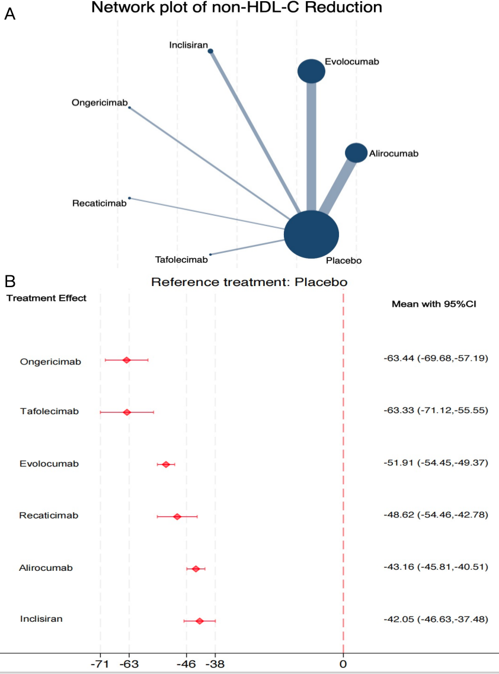

Figure S6.2: Network plot of the effect on HDL-C, and forest plot of network effect sizes for compared with placebo.

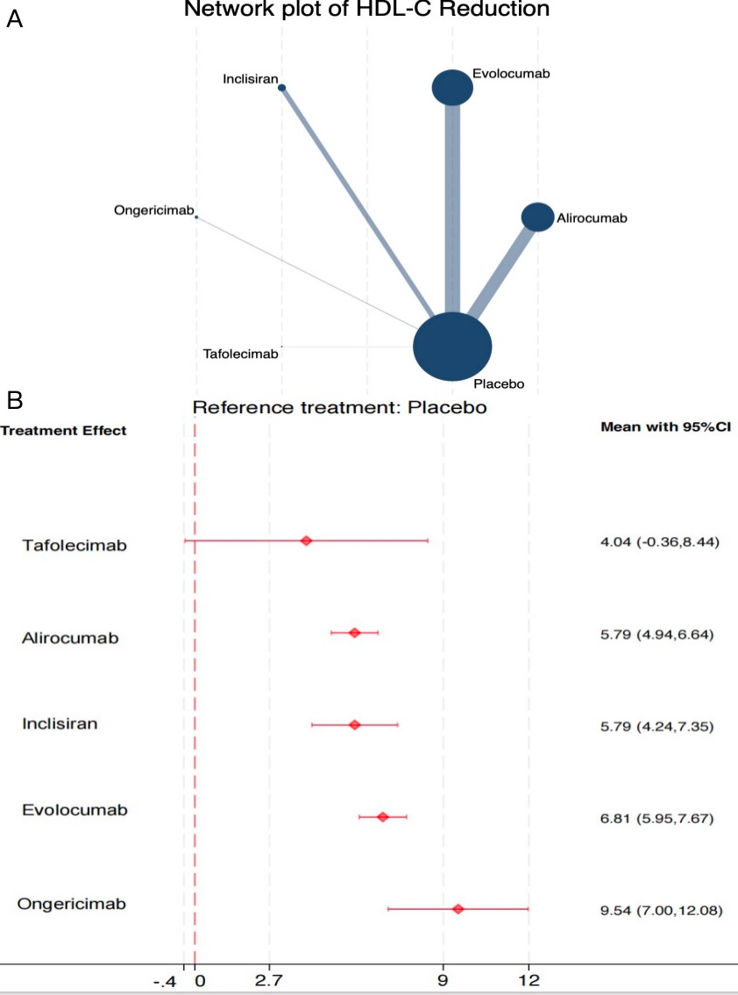

Appendix 7: SUCRA and cumulative probability plots

Figure S7.1: Cumulative ranking curve plots of PCSK9 inhibitors for Lp(a) in range network.
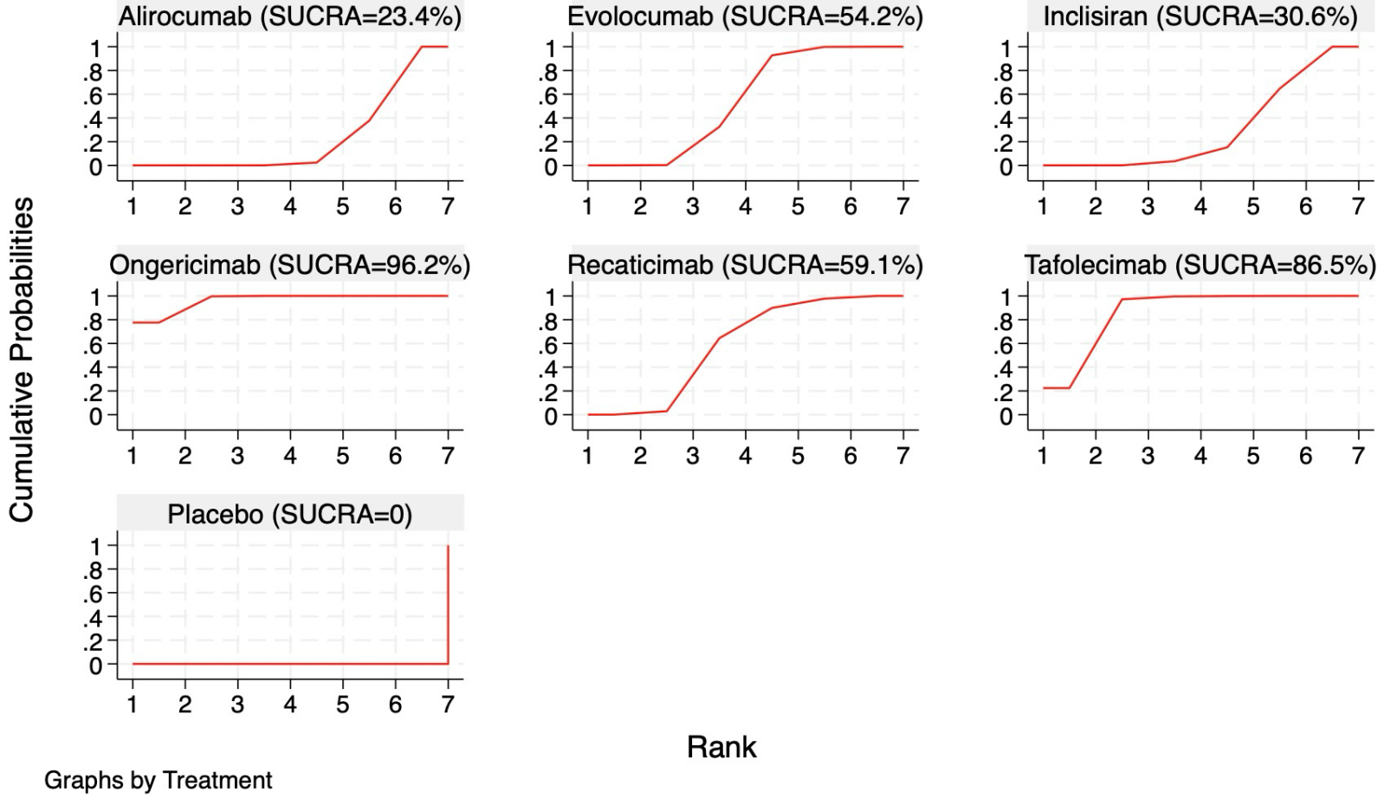

Treatment | SUCRA | PrBest | MeanRank
Ongericimab | 96.2 | 77.6 | 1.2
Tafolecimab | 86.5 | 22.4 | 1.8
Recaticimab | 59.1 | 0.0 | 3.5
Evolocumab | 54.2 | 0.0 | 3.7
Inclisiran | 30.6 | 0.0 | 5.2
Alirocumab | 23.4 | 0.0 | 5.6
Placebo | 0.0 | 0.0 | 7.0

Abbreviations: SUCRA, surface under the cumulative ranking curve.

Figure S7.2: Cumulative ranking curve plots of PCSK9 inhibitors for LDL-C in range network.

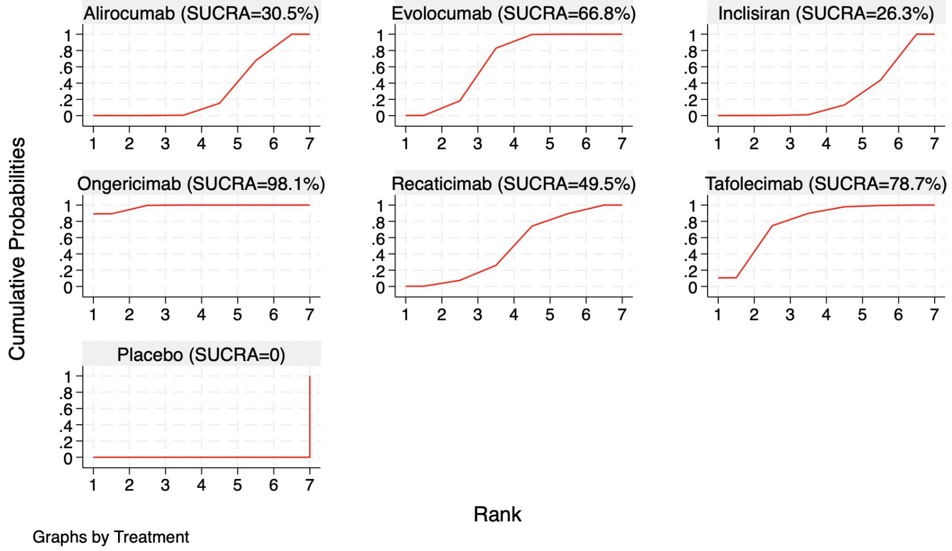
Treatment | SUCRA | PrBest | MeanRank
Ongericimab | 98.1 | 89.2 | 1.1
Tafolecimab | 78.7 | 10.5 | 2.3
Evolocumab | 66.8 | 0.1 | 3.0
Recaticimab | 49.5 | 0.2 | 4.0
Alirocumab | 30.5 | 0.0 | 5.2
Inclisiran | 26.3 | 0.0 | 5.4
Placebo | 0.0 | 0.0 | 7.0

Figure S7.3: Cumulative ranking curve plots of PCSK9 inhibitors for non-HDL-C in range network.

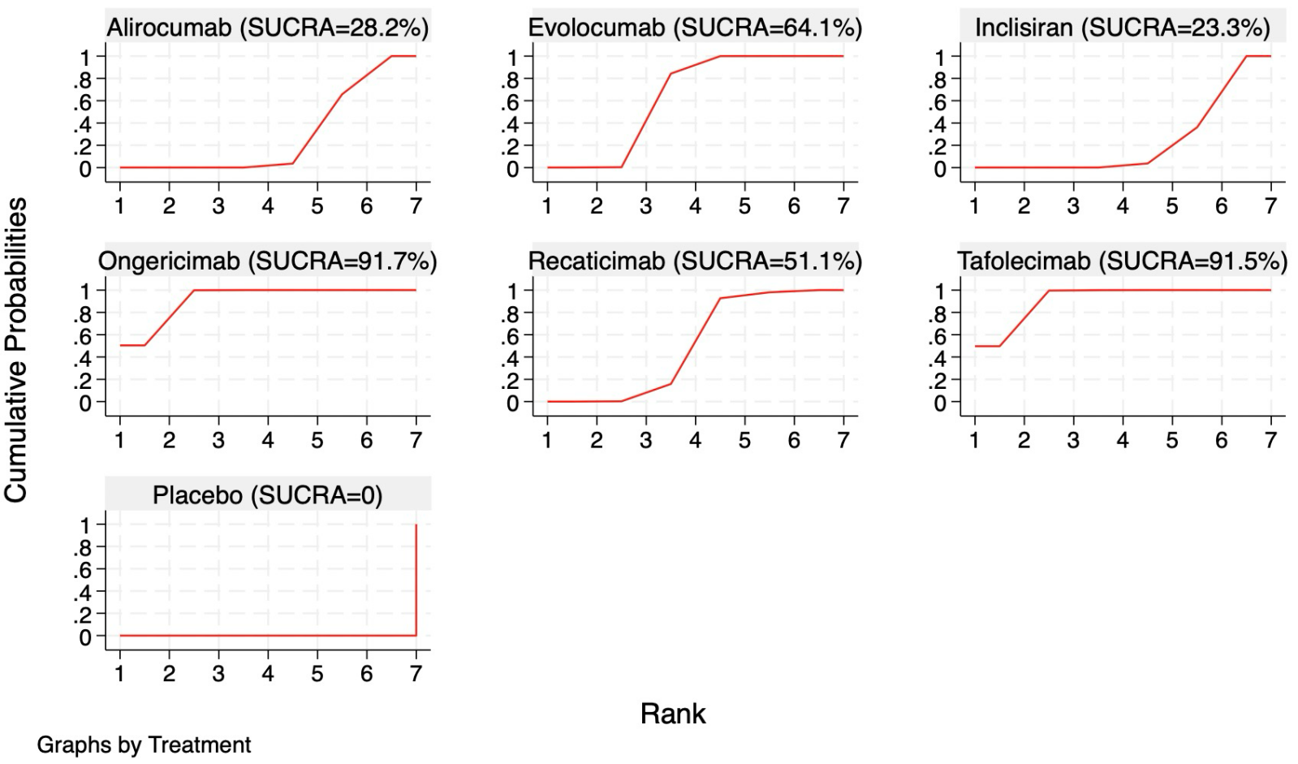

Treatment | SUCRA | PrBest | MeanRank
Ongericimab | 91.7 | 50.0 | 1.5
Tafolecimab | 91.5 | 50.0 | 1.5
Evolocumab | 64.1 | 0.0 | 3.2
Recaticimab | 51.1 | 0.0 | 3.9
Alirocumab | 28.2 | 0.0 | 5.3
Inclisiran | 23.3 | 0.0 | 5.6
Placebo | 0.0 | 0.0 | 7.0

Figure S7.4: Cumulative ranking curve plots of PCSK9 inhibitors for TG in range network.

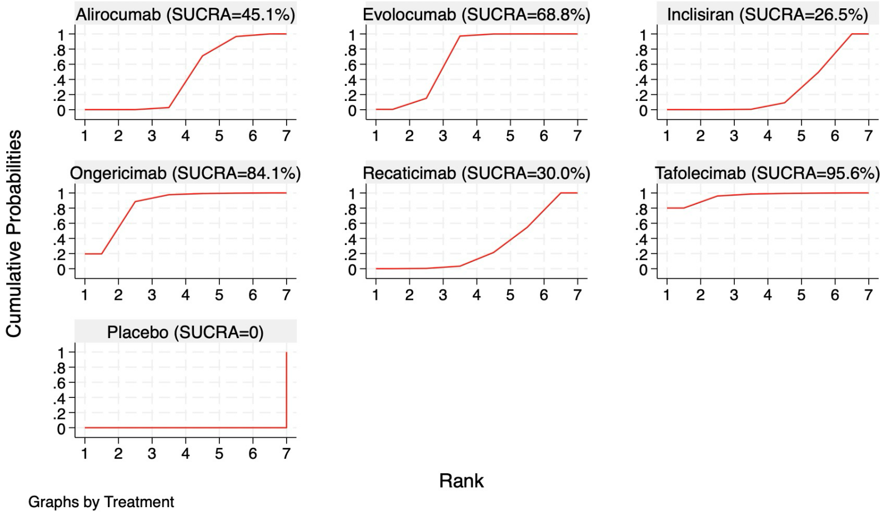

Treatment | SUCRA | PrBest | MeanRank
Tafolecimab | 95.6 | 81.5 | 1.2
Ongericimab | 84.1 | 17.7 | 2.0
Evolocumab | 68.8 | 0.7 | 2.9
Alirocumab | 45.1 | 0.0 | 4.3
Recaticimab | 30.0 | 0.0 | 5.2
Inclisiran | 26.5 | 0.0 | 5.4
Placebo | 0.0 | 0.0 | 7.0

Figure S7.5: Cumulative ranking curve plots of PCSK9 inhibitors for TC in range network.
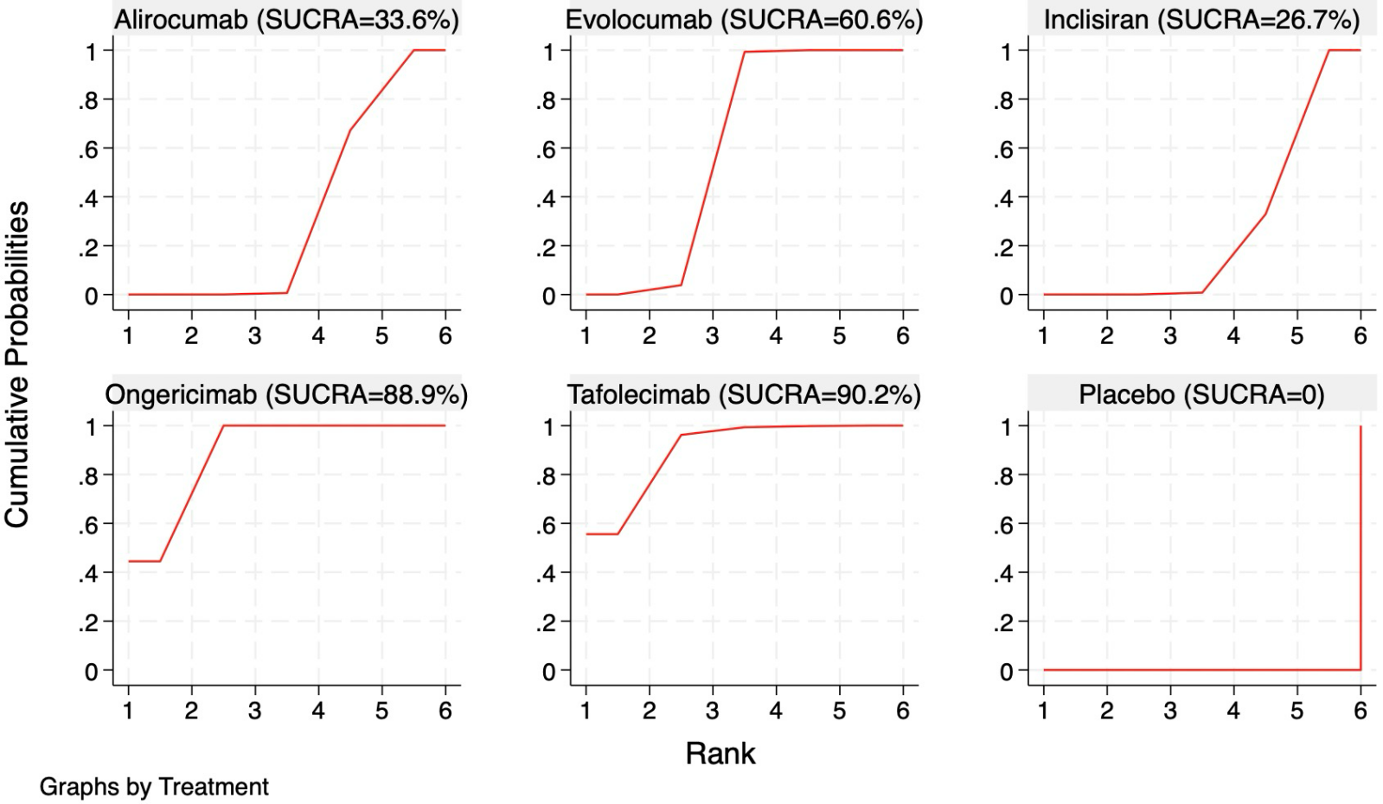

Treatment | SUCRA | PrBest | MeanRank
Tafolecimab | 90.2 | 54.0 | 1.5
Ongericimab | 88.9 | 46.0 | 1.5
Evolocumab | 60.6 | 0.0 | 3.0
Alirocumab | 33.6 | 0.0 | 4.3
Inclisiran | 26.7 | 0.0 | 4.7
Placebo | 0.0 | 0.0 | 6.0

Figure S7.6: Cumulative ranking curve plots of PCSK9 inhibitors for HDL-C in range network.

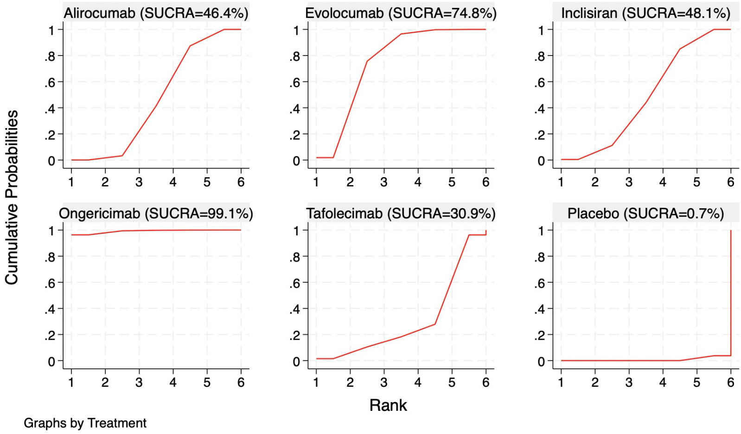

Treatment | SUCRA | PrBest | MeanRank
Ongericimab | 99.1 | 96.1 | 1.0
Evolocumab | 74.8 | 2.0 | 2.3
Inclisiran | 48.1 | 0.3 | 3.6
Alirocumab | 46.4 | 0.0 | 3.7
Tafolecimab | 30.9 | 1.6 | 4.5
Placebo | 0.7 | 0.0 | 6.0

Figure S7.7: Cumulative ranking curve plots of PCSK9 inhibitors for ApoB in range network.
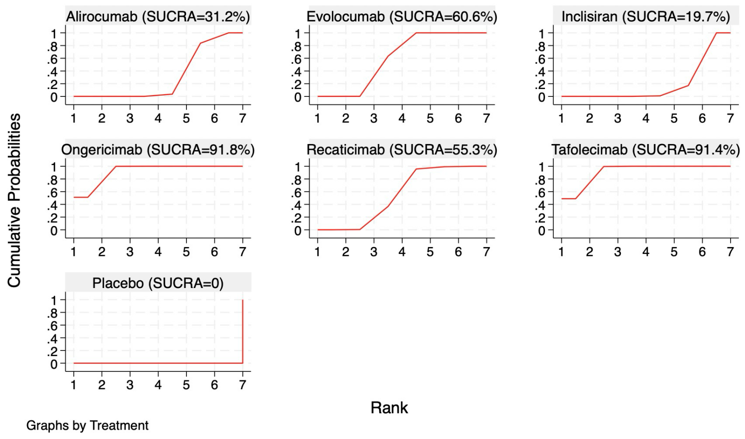

Treatment | SUCRA | PrBest | MeanRank
Ongericimab | 91.8 | 52.5 | 1.5
Tafolecimab | 91.4 | 47.5 | 1.5
Evolocumab | 60.6 | 0.0 | 3.4
Recaticimab | 55.3 | 0.0 | 3.7
Alirocumab | 31.2 | 0.0 | 5.1
Inclisiran | 19.7 | 0.0 | 5.8
Placebo | 0.0 | 0.0 | 7.0

Figure S7.8: Cumulative ranking curve plots of PCSK9 inhibitors for AE in range network.
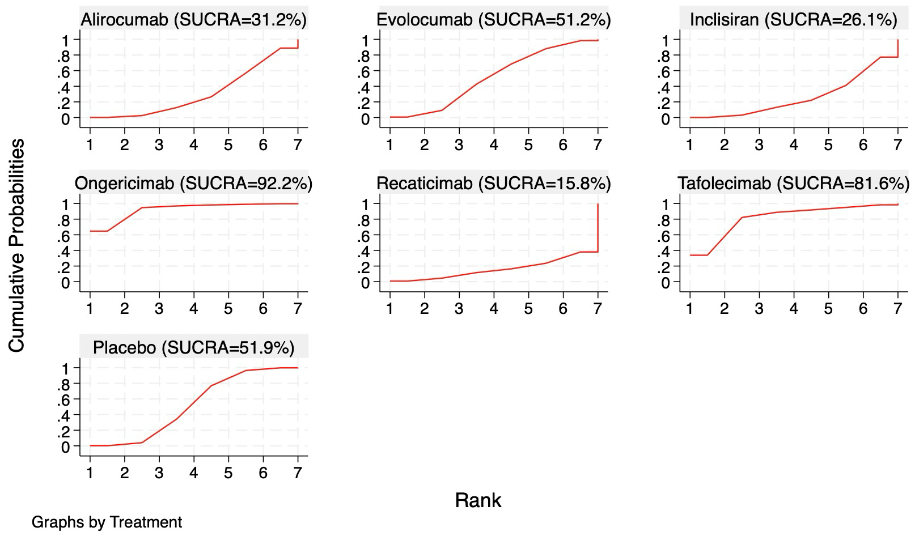

Treatment | SUCRA | PrBest | MeanRank
Ongericimab | 92.2 | 63.0 | 1.5
Tafolecimab | 81.6 | 35.5 | 2.0
Placebo | 51.9 | 0.5 | 3.9
Evolocumab | 51.2 | 0.1 | 3.9
Alirocumab | 31.2 | 0.1 | 5.2
Inclisiran | 26.1 | 0.1 | 5.4
Recaticimab | 15.8 | 0.7 | 6.0

Figure S7.9: Cumulative ranking curve plots of PCSK9 inhibitors for SAE in range network.
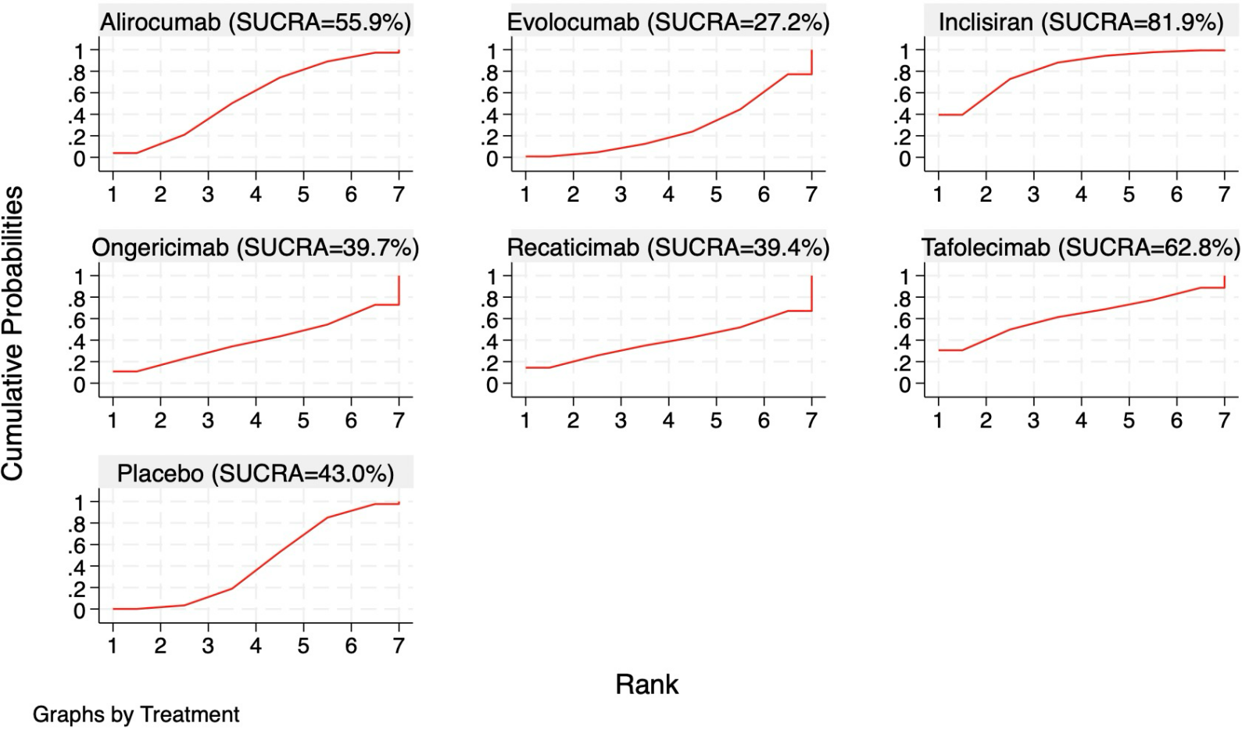

Treatment | SUCRA | PrBest | MeanRank
Inclisiran | 81.9 | 37.6 | 2.1
Tafolecimab | 62.8 | 31.0 | 3.3
Alirocumab | 55.9 | 4.4 | 3.7
Placebo | 43.0 | 0.2 | 4.5
Ongericimab | 39.7 | 11.2 | 4.5
Recaticimab | 39.4 | 14.5 | 4.6
Evolocumab | 27.2 | 1.0 | 5.3

Appendix 8: League table of Summary Estimates for PCSK9 inhibitors

Table S8.1: Lp(a)

Alirocumab
5.48 (1.21,9.74) | Evolocumab
1.20 (-5.25,7.65) | -4.27 (-10.64,2.09) | Inclisiran
23.74 (13.66,33.83) | 18.27 (8.24,28.30) | 22.54 (11.41,33.67) | Ongericimab
7.09 (-0.51,14.68) | 1.61 (-5.92,9.14) | 5.88 (-3.06,14.83) | -16.66 (-28.49,-4.82) | Recaticimab
18.50 (8.41,28.60) | 13.03 (2.98,23.08) | 17.30 (6.15,28.45) | -5.24 (-18.82,8.34) | 11.42 (-0.44,23.27) | Tafolecimab
-22.62 (-25.71,-19.53) | -28.09 (-31.03,-25.16) | -23.82 (-29.47,-18.16) | -46.36 (-55.96,-36.77) | -29.70 (-36.64,-22.77) | -41.12 (-50.73,-31.51) | Placebo

Table S8.2: LDL-C
Alirocumab
7.84 (3.02,12.65) | Evolocumab
-1.11 (-8.26,6.04) | -8.95 (-15.82,-2.08) | Inclisiran
20.60 (11.16,30.05) | 12.77 (3.54,22.00) | 21.71 (11.07,32.35) | Ongericimab
4.12 (-5.05,13.29) | -3.72 (-12.67,5.23) | 5.23 (-5.17,15.63) | -16.48 (-28.57,-4.40) | Recaticimab
12.05 (0.86,23.24) | 4.22 (-6.80,15.23) | 13.16 (0.94,25.38) | -8.55 (-22.24,5.14) | 7.93 (-5.57,21.43) | Tafolecimab
-49.05 (-52.73,-45.36) | -56.88 (-59.98,-53.79) | -47.94 (-54.07,-41.81) | -69.65 (-78.35,-60.96) | -53.17 (-61.57,-44.77) | -61.10 (-71.67,-50.53) | Placebo

Table S8.3: non-HDL-C
Alirocumab
8.75  (5.07,12.42) | Evolocumab
-1.10 (-6.40,4.19) | -9.85 (-15.09,-4.62) | Inclisiran
20.28 (13.49,27.06) | 11.53 (4.79,18.27) | 21.38 (13.64,29.12) | Ongericimab
5.46 (-0.95,11.88) | -3.28 (-9.65,3.08) | 6.57 (-0.85,13.99) | -14.81 (-23.36,-6.27) | Recaticimab
20.17 (11.95,28.39) | 11.43 (3.24,19.62) | 21.28 (12.24,30.31) | -0.10 (-10.08,9.88) | 14.71 (4.98,24.44) | Tafolecimab
-43.16 (-45.81,-40.51) | -51.91 (-54.45,-49.37) | -42.05 (-46.63,-37.48) | -63.44 (-69.68,-57.19) | -48.62 (-54.46,-42.78) | -63.33 (-71.12,-55.55) | Placebo

Table S8.4: TG
Alirocumab
3.32 (0.59,6.05) | Evolocumab
-2.30 (-5.97,1.37) | -5.62 (-9.32,-1.92) | Inclisiran
7.74 (0.39,15.10) | 4.42 (-2.94,11.79) | 10.04 (2.28,17.81) | Ongericimab
-2.08 (-7.39,3.24) | -5.40 (-10.73,-0.06) | 0.23 (-5.65,6.10) | -9.82 (-18.49,-1.15) | Recaticimab
13.93 (1.92,25.95) | 10.61 (-1.41,22.64) | 16.23 (3.96,28.51) | 6.19 (-7.63,20.01) | 16.01 (3.15,28.87) | Tafolecimab
-11.21 (-13.11,-9.31) | -14.53 (-16.49,-12.57) | -8.91 (-12.05,-5.76) | -18.95 (-26.05,-11.85) | -9.13 (-14.10,-4.17) | -25.14 (-37.00,-13.28) | Placebo

Table S8.5: TC

Alirocumab
4.59 (1.53,7.65) | Evolocumab
-0.97 (-5.32,3.38) | -5.56 (-9.79,-1.33) | Inclisiran
14.80 (9.32,20.27) | 10.21 (4.83,15.59) | 15.77 (9.57,21.97) | Ongericimab
15.61 (3.16,28.06) | 11.02 (-1.39,23.43) | 16.58 (3.79,29.37) | 0.81 (-12.40,14.02) | Tafolecimab
-30.59 (-32.86,-28.32) | -35.18 (-37.23,-33.13) | -29.62 (-33.32,-25.91) | -45.39 (-50.37,-40.41) | -46.20 (-58.44,-33.96) | Placebo

Table S8.6: HDL-C

Alirocumab
-1.02 (-2.24,0.19) | Evolocumab
-0.00 (-1.78,1.77) | 1.02 (-0.75,2.79) | Inclisiran
-3.75 (-6.42,-1.08) | -2.73 (-5.41,-0.04) | -3.75 (-6.72,-0.77) | Ongericimab
1.75 (-2.73,6.23) | 2.77 (-1.71,7.25) | 1.75 (-2.91,6.42) | 5.50 (0.42,10.58) | Tafolecimab
5.79 (4.94,6.64) | 6.81 (5.95,7.67) | 5.79 (4.24,7.35) | 9.54 (7.00,12.08) | 4.04 (-0.36,8.44) | Placebo

Table S8.7: ApoB
Alirocumab
6.95 (3.35,10.54) | Evolocumab
-2.55 (-7.78,2.68) | -9.49 (-14.64,-4.34) | Inclisiran
19.42 (12.76,26.07) | 12.47 (5.88,19.06) | 21.96 (14.36,29.57) | Ongericimab
5.87 (-0.49,12.23) | -1.08 (-7.37,5.22) | 8.42 (1.07,15.77) | -13.55 (-21.97,-5.12) | Recaticimab
19.23 (11.00,27.46) | 12.29 (4.11,20.47) | 21.78 (12.76,30.80) | -0.18 (-10.10,9.73) | 13.36 (3.65,23.08) | Tafolecimab
-40.09 (-42.72,-37.47) | -47.04 (-49.50,-44.58) | -37.55 (-42.07,-33.02) | -59.51 (-65.63,-53.39) | -45.96 (-51.76,-40.17) | -59.33 (-67.13,-51.53) | Placebo

Table S8.8: AEs

Alirocumab
1.06 (0.90,1.26) | Evolocumab
0.97 (0.78,1.22) | 0.92 (0.74,1.14) | Inclisiran
1.43 (1.02,2.00) | 1.35 (0.97,1.87) | 1.47 (1.02,2.10) | Ongericimab
0.89 (0.62,1.27) | 0.84 (0.59,1.19) | 0.91 (0.62,1.34) | 0.62 (0.39,0.98) | Recaticimab
1.31 (0.91,1.89) | 1.23 (0.86,1.77) | 1.34 (0.91,1.98) | 0.92 (0.58,1.45) | 1.47 (0.91,2.38) | Tafolecimab
1.06 (0.93,1.21) | 1.00 (0.89,1.12) | 1.09 (0.91,1.31) | 0.74 (0.55,1.01) | 1.20 (0.85,1.67) | 0.81 (0.58,1.14) | Placebo

Table S8.9: SAEs
Alirocumab
0.83 (0.56,1.24) | Evolocumab
1.24 (0.81,1.91) | 1.49 (0.92,2.42) | Inclisiran
0.89 (0.43,1.84) | 1.07 (0.50,2.28) | 0.72 (0.33,1.56) | Ongericimab
0.87 (0.37,2.09) | 1.05 (0.43,2.57) | 0.70 (0.28,1.75) | 0.98 (0.33,2.89) | Recaticimab
1.10 (0.51,2.41) | 1.32 (0.59,2.97) | 0.89 (0.39,2.03) | 1.24 (0.45,3.40) | 1.26 (0.41,3.87) | Tafolecimab
0.93 (0.74,1.19) | 1.12 (0.81,1.55) | 0.75 (0.52,1.08) | 1.05 (0.53,2.08) | 1.07 (0.46,2.47) | 0.85 (0.40,1.78) | Placebo

Appendix 9: CINeMA Assessment
We use the CINeMA framework to evidence certainty, assessing it for each network estimate based on the following criteria:
A: Within study bias: We classified the overall risk of bias for each study as low risk of bias, the risk of bias as moderate when none of the four assessed risk of bias items were rated as high risk, and the risk of bias as high when one or both items were rated as high risk. See Appendix 4 for the bias assessment. The
risk of bias for a pairwise comparison of each drug is shown in figure S9.1-9.6.

Figure S9.1: Risk of bias contribution by intervention group in Lp(a).
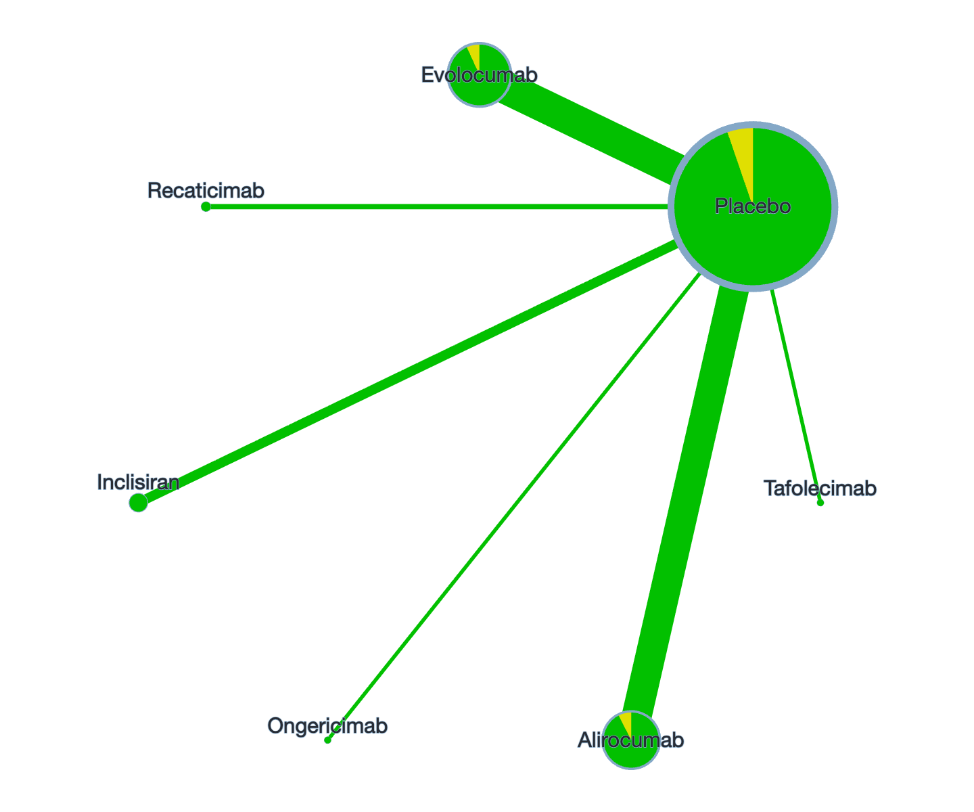

Figure S9.2: Overall risk of bias by treatment comparison in Lp(a).
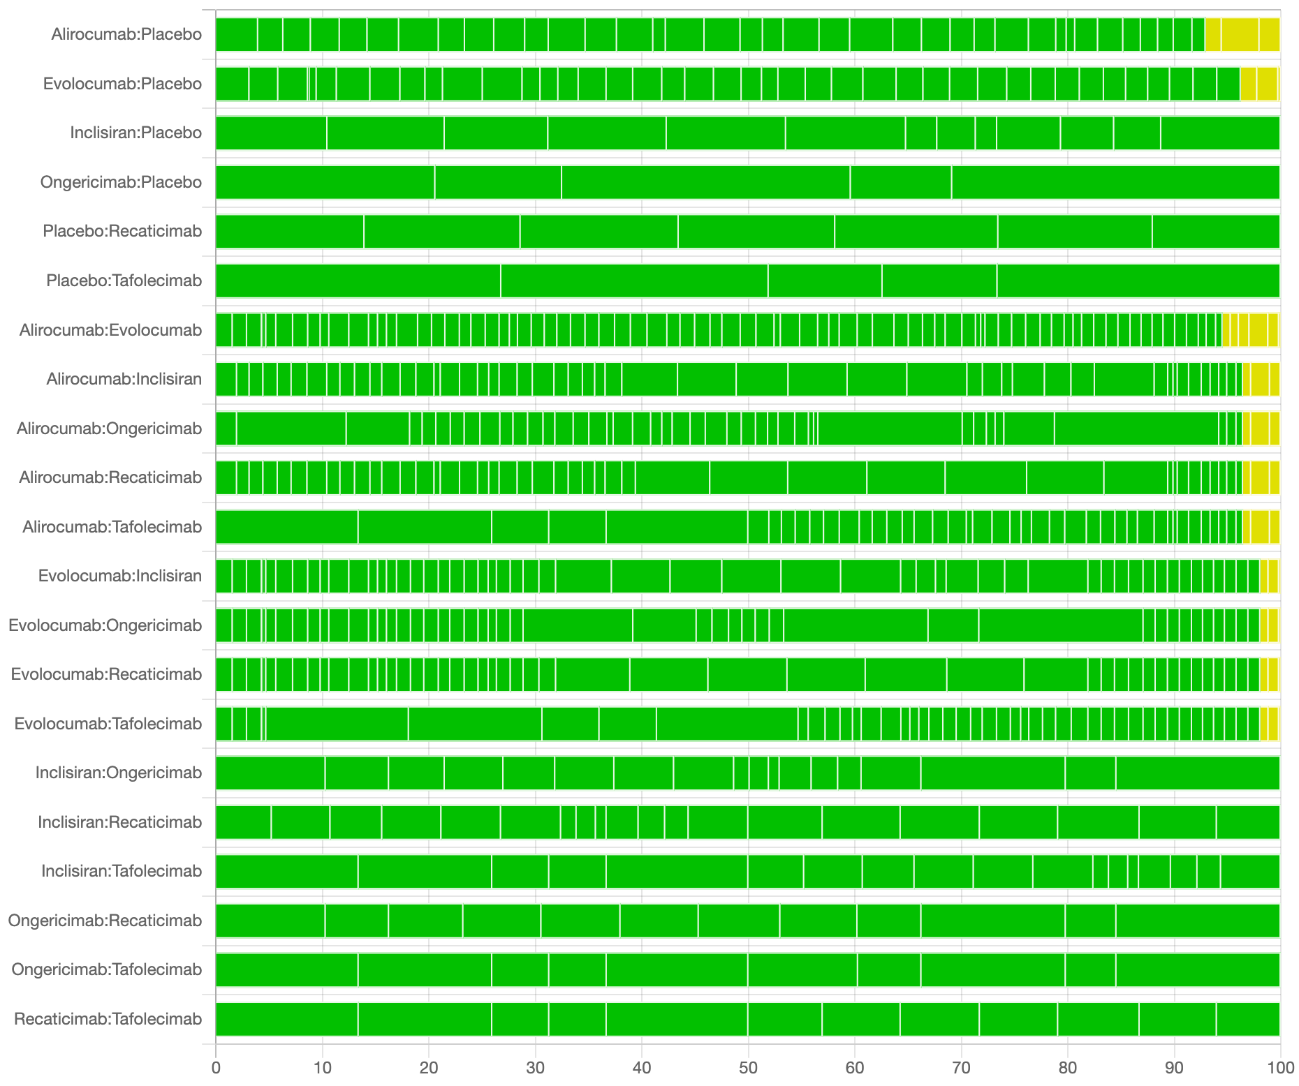

Figure S9.3: Risk of bias contribution by intervention group in LDL-C.
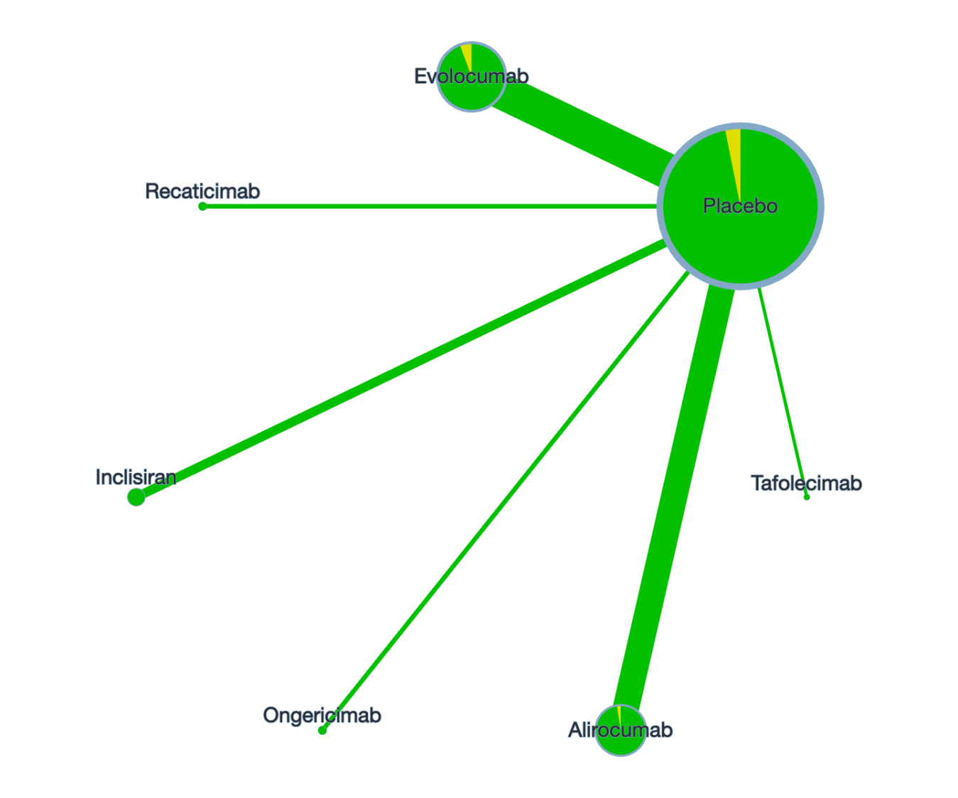

Figure S9.4: Overall risk of bias by treatment comparison in LDL-C.

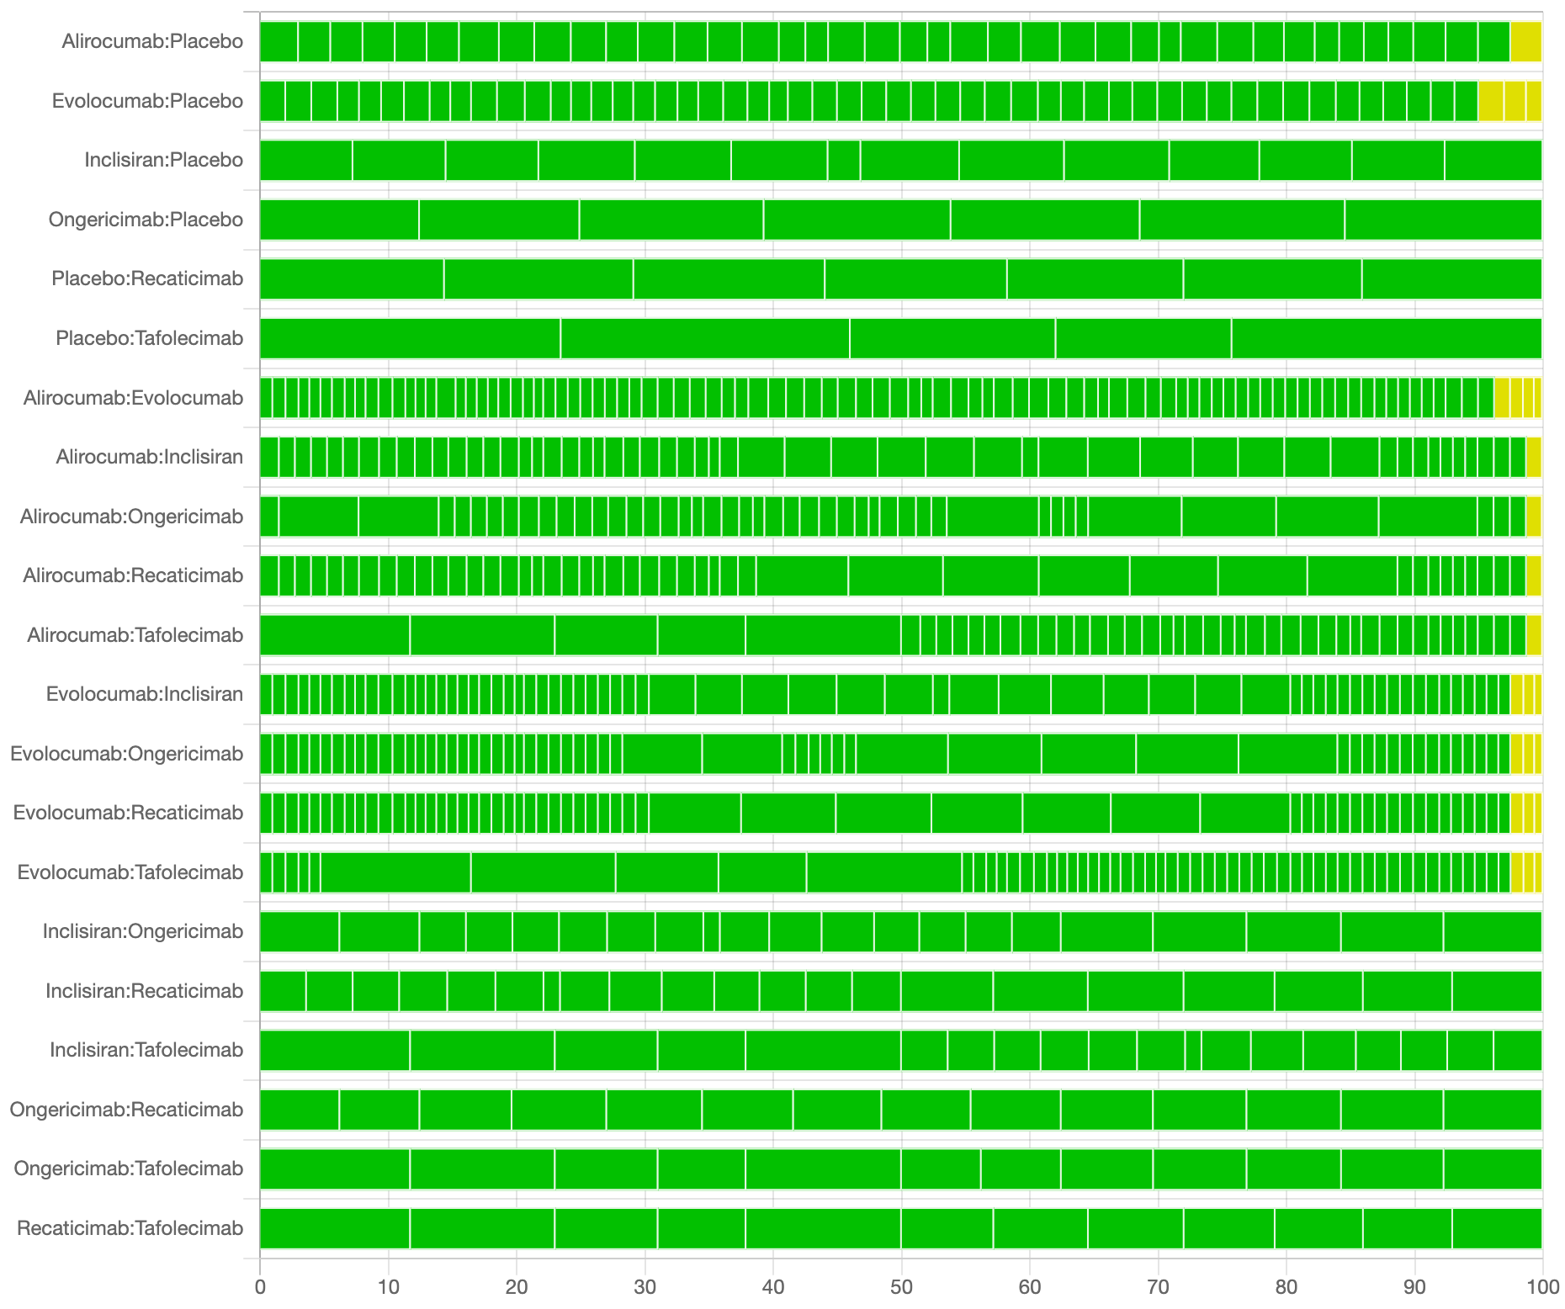

Table S9.1: Transitivity assessment.

 | Baseline variable (Mean ± SD)
Intervention | Age (Year) | Lp(a) (nmol/L / mg/dL) | LDL-C (mmol/L)
Alirocumab | 58.5 ± 9.8 | 57.93 ± 47.91 nmol/L | 2.92 ± 1.06
Alirocumab | 58.5 ± 9.8 | 27.93 ± 37.91 mg/dL | 2.92 ± 1.06
Evolocumab | 61.23 ± 9.9 | 74.00 ± 61.05 nmol/L | 3.05 ± 1.04
Evolocumab | 61.23 ± 9.9 | 24.70 ± 36.50 mg/dL | 3.05 ± 1.04
Inclisiran | 63.51 ± 10.45 | 79.69 ± 115.74 nmol/L | 3.02 ± 1.35
Ongericimab | 57.61 ± 10.79 | 59.98 ± 80.18 nmol/L | 2.98 ± 1.10
Recaticimab | 50.11 ± 11.05 | 113.18 ± 239.66 nmol/L | 3.29 ± 0.81
Tafolecimab | 56.49 ± 9.68 | 27.50 ± 30.50 mg/dL | 3.11 ± 0.99

Imprecision: We use the CINeMA website to grade the accuracy of each comparison.
Heterogeneity: We assessed the degree of worry by comparing clinical reasoning based on 95% confidence intervals (CIs) while applying the same clinical
reasoning framework as for inaccuracy. In particular, we judged the consistency of our findings based on the confidence and prediction intervals associated with
clinically important effect sizes. And we used the same thresholds of clinical significance as described above and followed the recommendations automatically
provided by CINeMA (https://cinema.ispm.unibe.ch/).
Inconsistency: For inconsistency, we looked at the results for node splitting (Appendix 5).

Table S9.2: CINeMA Results of Lp(a).
Comparison | Within-study bias | Reporting bias | Indirectness | Imprecision | Heterogeneity | Incoherence | Confidence rating
Alirocumab:Placebo | No concerns | Low risk | No concerns | No concerns | No concerns | Major concerns | Low
Evolocumab:Placebo | No concerns | Low risk | No concerns | No concerns | No concerns | Major concerns | Low
Inclisiran:Placebo | No concerns | Low risk | No concerns | No concerns | No concerns | Major concerns | Low
Ongericimab:Placebo | No concerns | Low risk | No concerns | No concerns | No concerns | Major concerns | Low
Placebo:Recaticimab | No concerns | Low risk | No concerns | No concerns | No concerns | Major concerns | Low
Placebo:Tafolecimab | No concerns | Low risk | No concerns | No concerns | No concerns | Major concerns | Low
Alirocumab:Evolocumab | No concerns | Low risk | No concerns | No concerns | Major concerns | Major concerns | Very low
Alirocumab:Inclisiran | No concerns | Low risk | No concerns | Major concerns | No concerns | Major concerns | Very low
Alirocumab:Ongericimab | No concerns | Low risk | No concerns | No concerns | No concerns | Major concerns | Low
Alirocumab:Recaticimab | No concerns | Low risk | No concerns | No concerns | Major concerns | Major concerns | Very low
Alirocumab:Tafolecimab | No concerns | Low risk | No concerns | No concerns | No concerns | Major concerns | Low
Evolocumab:Inclisiran | No concerns | Low risk | No concerns | Major concerns | No concerns | Major concerns | Very low
Evolocumab:Ongericimab | No concerns | Low risk | No concerns | No concerns | No concerns | Major concerns | Low
Evolocumab:Recaticimab | No concerns | Low risk | No concerns | Major concerns | No concerns | Major concerns | Very low
Evolocumab:Tafolecimab | No concerns | Low risk | No concerns | No concerns | Major concerns | Major concerns | Very low
Inclisiran:Ongericimab | No concerns | Low risk | No concerns | No concerns | No concerns | Major concerns | Low
Inclisiran:Recaticimab | No concerns | Low risk | No concerns | Major concerns | No concerns | Major concerns | Very low
Inclisiran:Tafolecimab | No concerns | Low risk | No concerns | No concerns | No concerns | Major concerns | Low
Ongericimab:Recaticimab | No concerns | Low risk | No concerns | No concerns | No concerns | Major concerns | Low
Ongericimab:Tafolecimab | No concerns | Low risk | No concerns | Major concerns | No concerns | Major concerns | Very low
Recaticimab:Tafolecimab | No concerns | Low risk | No concerns | No concerns | Major concerns | Major concerns | Very low

Table S9.3: CINeMA Results of LDL-C.
Comparison | Within-study bias | Reporting bias | Indirectness | Imprecision | Heterogeneity | Incoherence | Confidence rating
Alirocumab:Placebo | No concerns | Low risk | No concerns | No concerns | No concerns | Major concerns | Low
Evolocumab:Placebo | No concerns | Low risk | No concerns | No concerns | No concerns | Major concerns | Low
Inclisiran:Placebo | No concerns | Low risk | No concerns | No concerns | No concerns | Major concerns | Low
Ongericimab:Placebo | No concerns | Low risk | No concerns | No concerns | No concerns | Major concerns | Low
Placebo:Recaticimab | No concerns | Low risk | No concerns | No concerns | No concerns | Major concerns | Low
Placebo:Tafolecimab | No concerns | Low risk | No concerns | No concerns | No concerns | Major concerns | Low
Alirocumab:Evolocumab | No concerns | Low risk | No concerns | No concerns | Major concerns | Major concerns | Very low
Alirocumab:Inclisiran | No concerns | Low risk | No concerns | Major concerns | No concerns | Major concerns | Very low
Alirocumab:Ongericimab | No concerns | Low risk | No concerns | No concerns | No concerns | Major concerns | Low
Alirocumab:Recaticimab | No concerns | Low risk | No concerns | Major concerns | No concerns | Major concerns | Very low
Alirocumab:Tafolecimab | No concerns | Low risk | No concerns | No concerns | Major concerns | Major concerns | Very low
Evolocumab:Inclisiran | No concerns | Low risk | No concerns | No concerns | Major concerns | Major concerns | Very low
Evolocumab:Ongericimab | No concerns | Low risk | No concerns | No concerns | Major concerns | Major concerns | Very low
Evolocumab:Recaticimab | No concerns | Low risk | No concerns | Major concerns | No concerns | Major concerns | Very low
Evolocumab:Tafolecimab | No concerns | Low risk | No concerns | Major concerns | No concerns | Major concerns | Very low
Inclisiran:Ongericimab | No concerns | Low risk | No concerns | No concerns | No concerns | Major concerns | Low
Inclisiran:Recaticimab | No concerns | Low risk | No concerns | Major concerns | No concerns | Major concerns | Very low
Inclisiran:Tafolecimab | No concerns | Low risk | No concerns | No concerns | Major concerns | Major concerns | Very low
Ongericimab:Recaticimab | No concerns | Low risk | No concerns | No concerns | Major concerns | Major concerns | Very low
Ongericimab:Tafolecimab | No concerns | Low risk | No concerns | Major concerns | No concerns | Major concerns | Very low
Recaticimab:Tafolecimab | No concerns | Low risk | No concerns | Major concerns | No concerns | Major concerns | Very low

Appendix 10: Funnel plots

Figure S10.1: Funnel plot of Lpa.
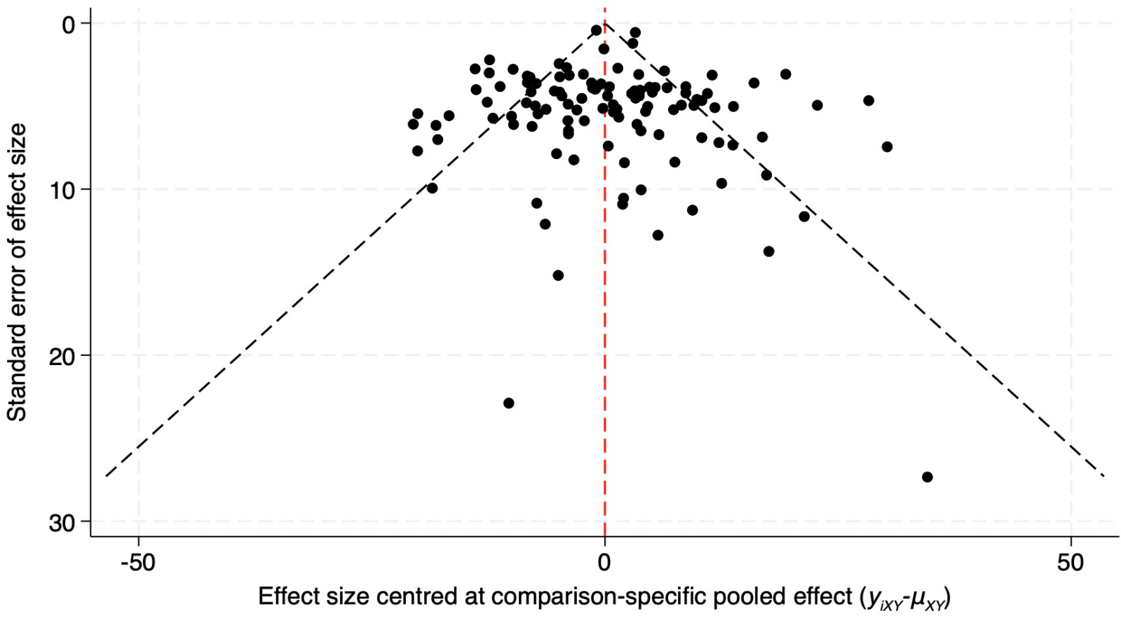
Figure S10.2: Funnel plot of LDL-C.
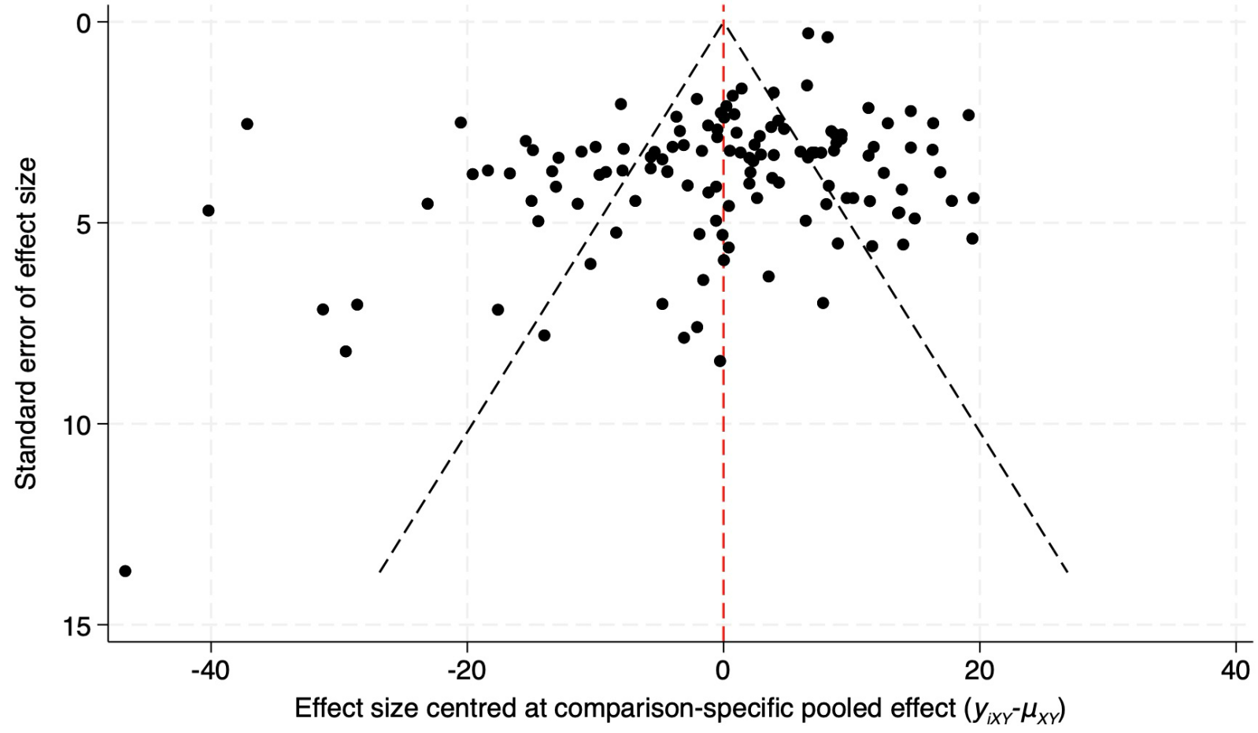

Figure S10.3: Funnel plot of non-HDL-C.

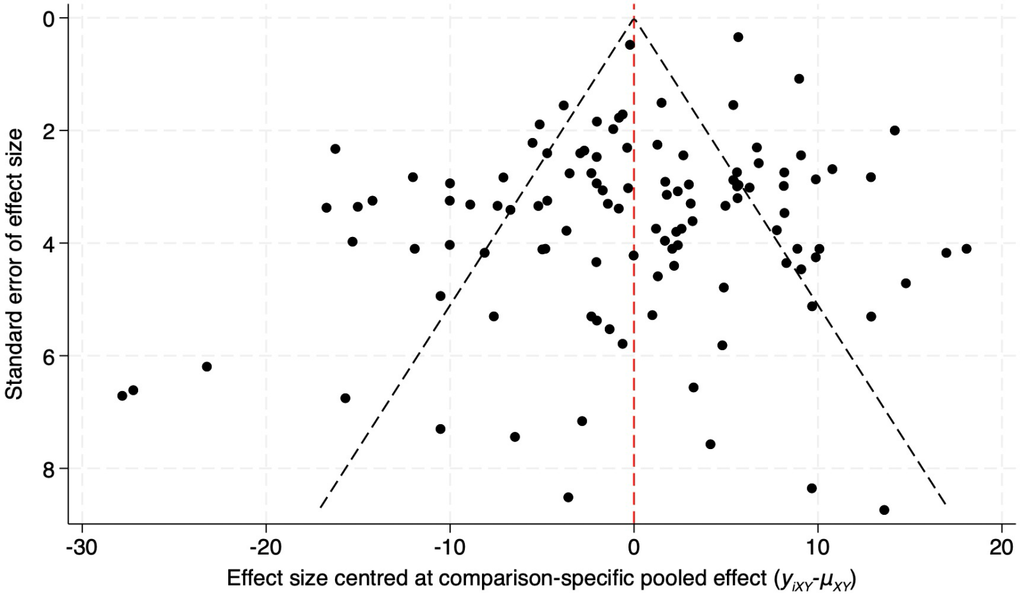

Figure S10.4: Funnel plot of TG.
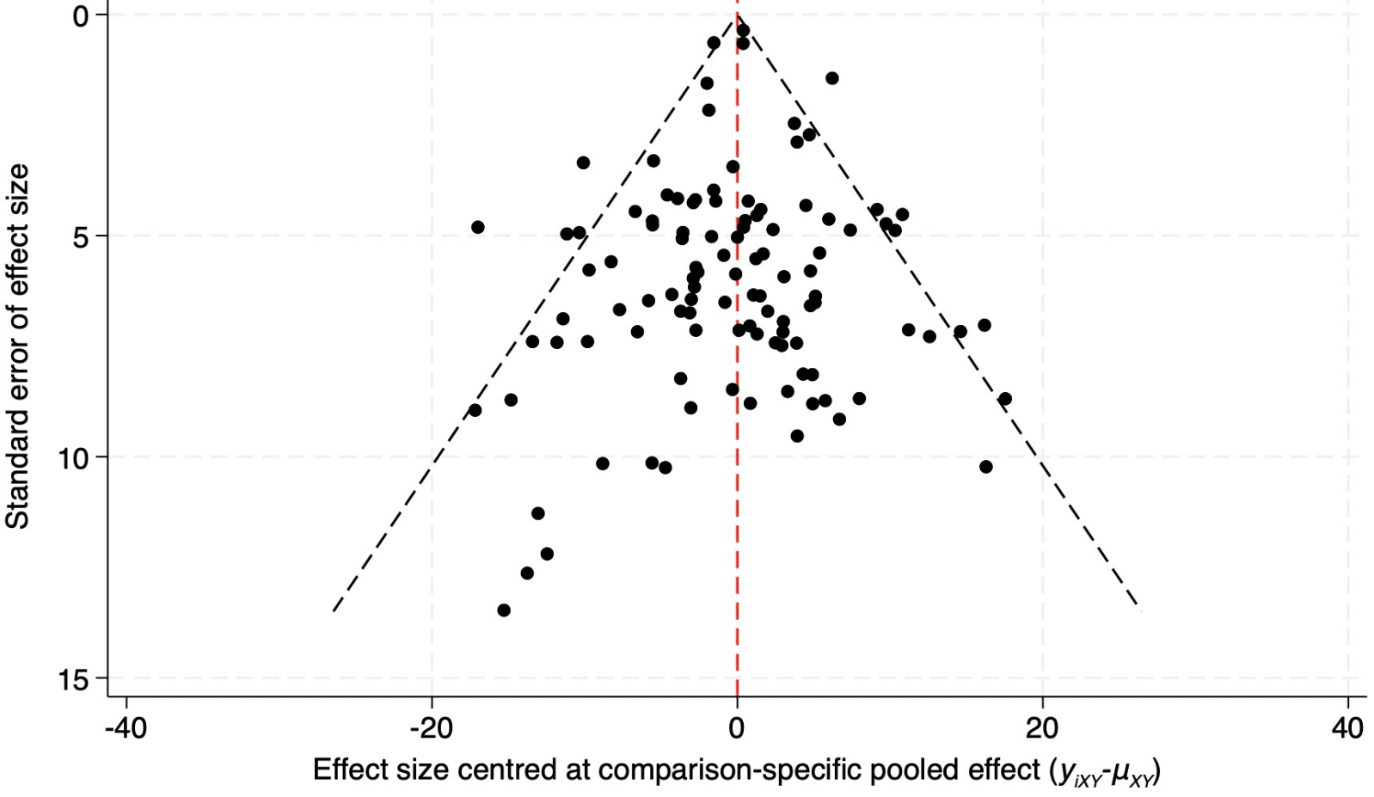

Figure S10.5: Funnel plot of TC.
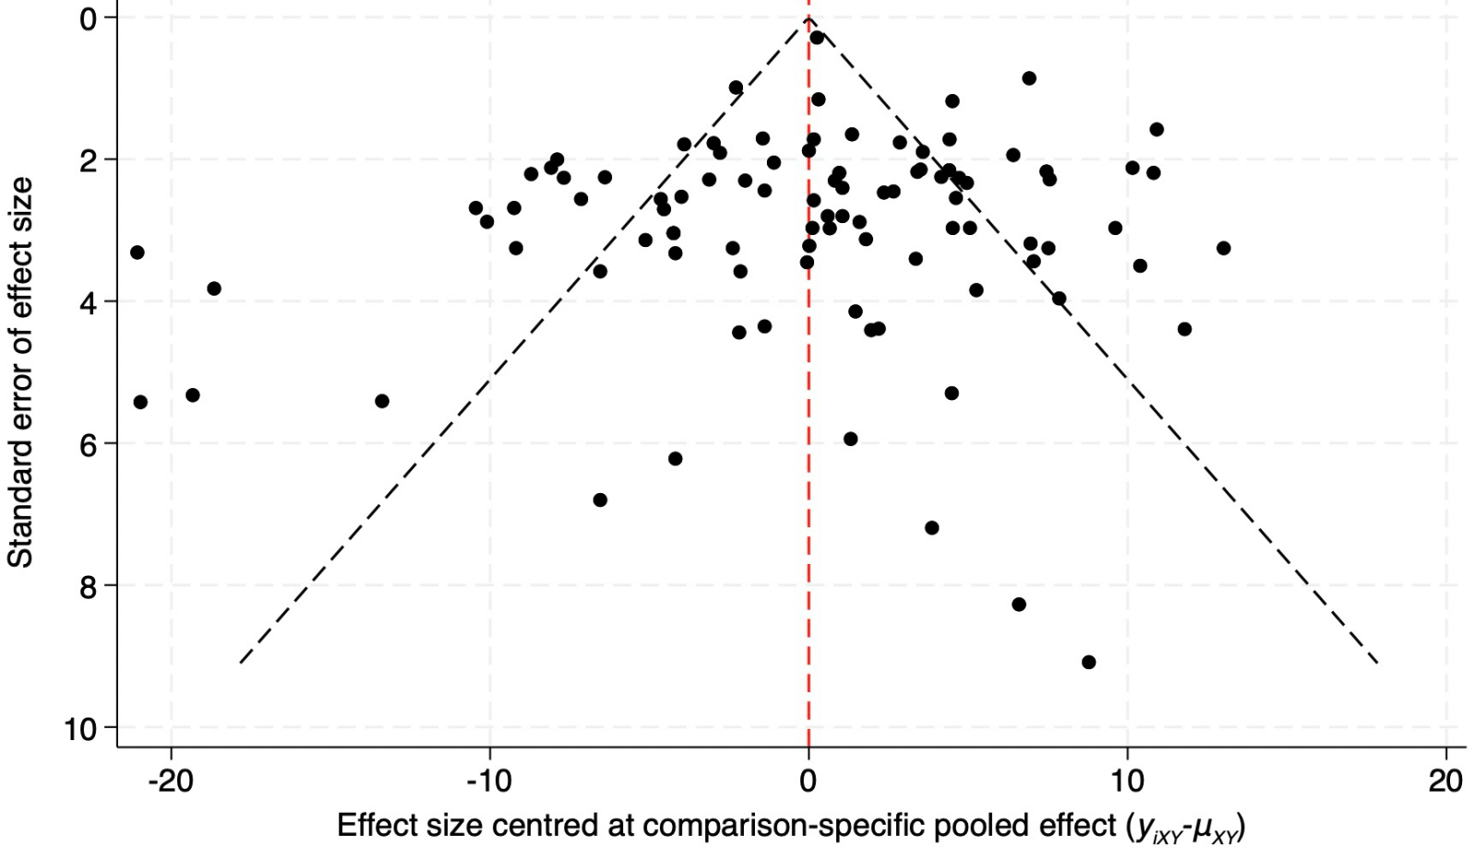

Figure S10.6: Funnel plot of HDL-C.
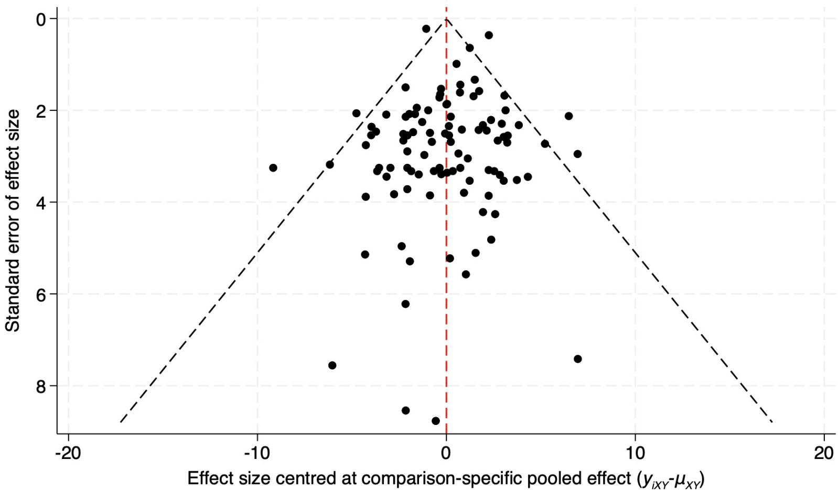

Figure S10.7: Funnel plot of ApoB.
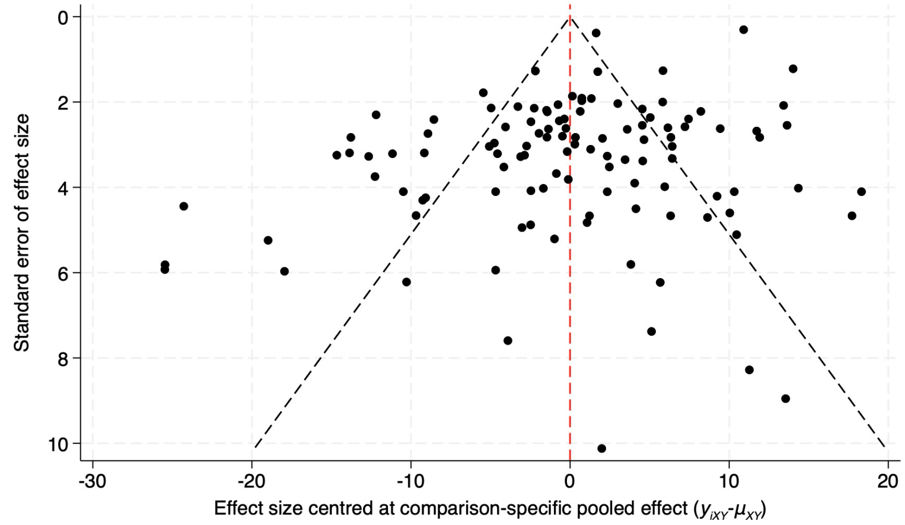

Figure S10.8: Funnel plot of AE.
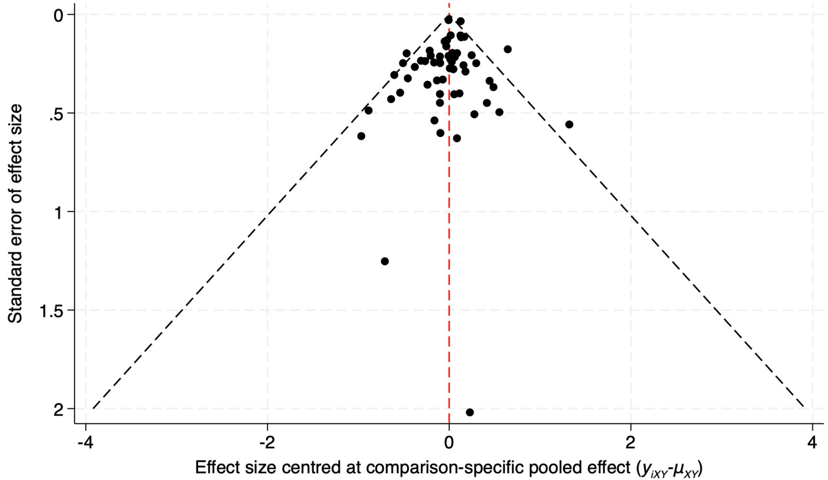

Figure S10.9: Funnel plot of SAE.
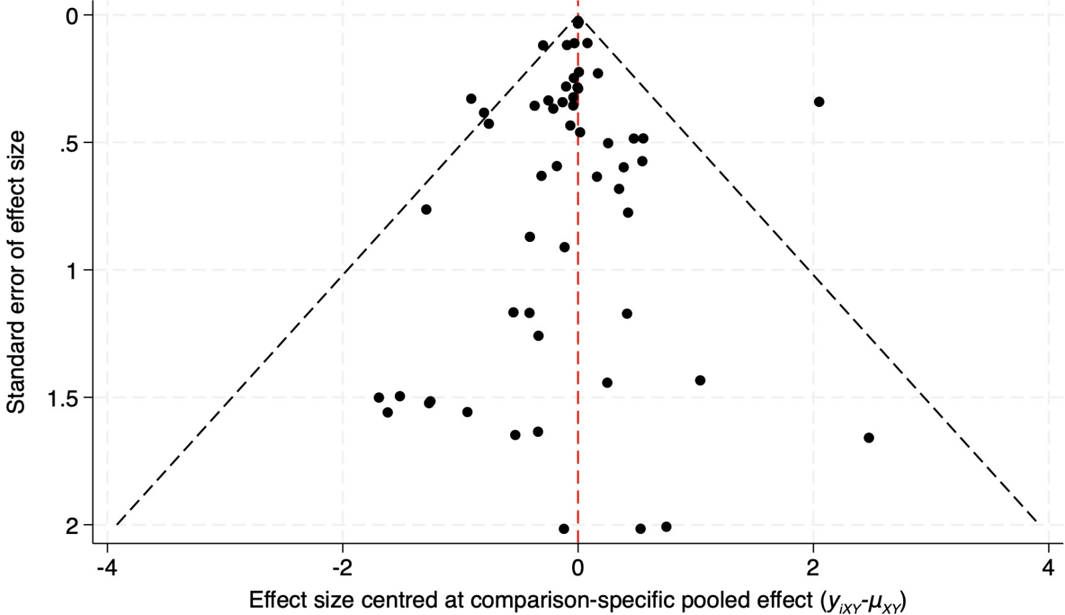

Appendix 11: Comprehensive comparisons of different PCSK9 inhibitors at various doses and dosing regimens

Figure S11.1: Lp(a)
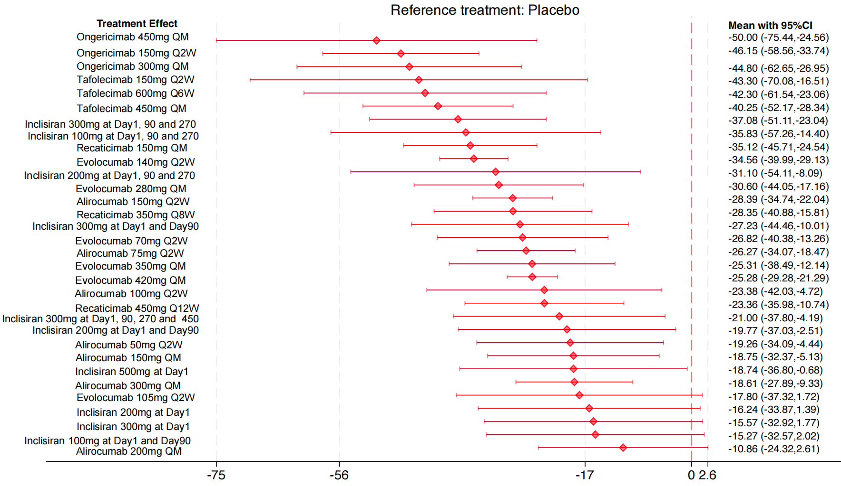

Appendix 12: Subgroup analysis of PCSK9 inhibitors stratified by Lp(a) efficacy analysis time points

Figure S12.1: Early response (≤12 weeks)
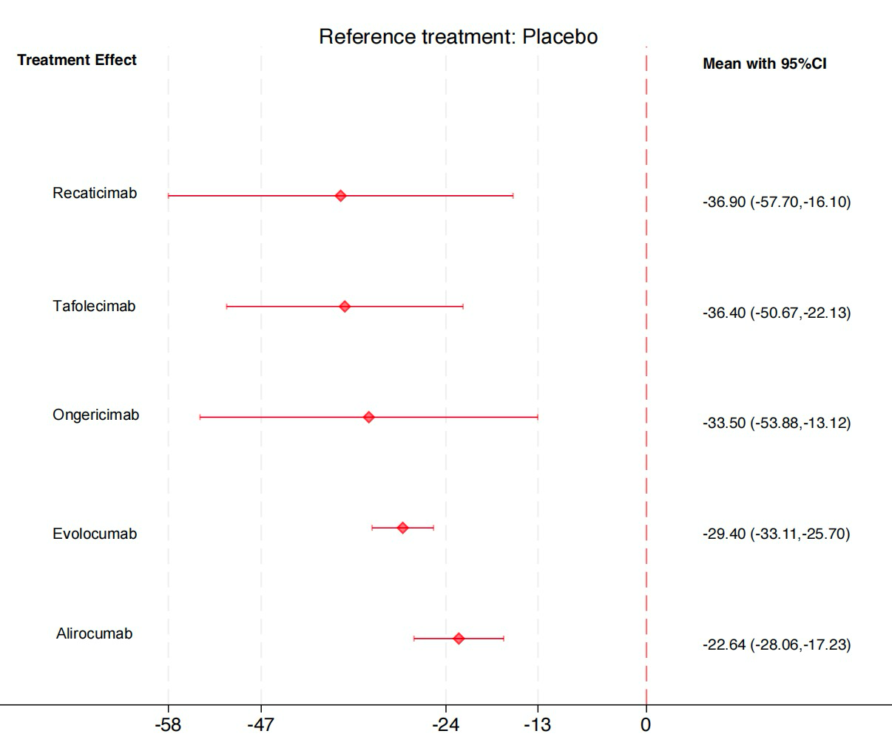

Figure S12.2: Mid-term maintenance (13–26 weeks)
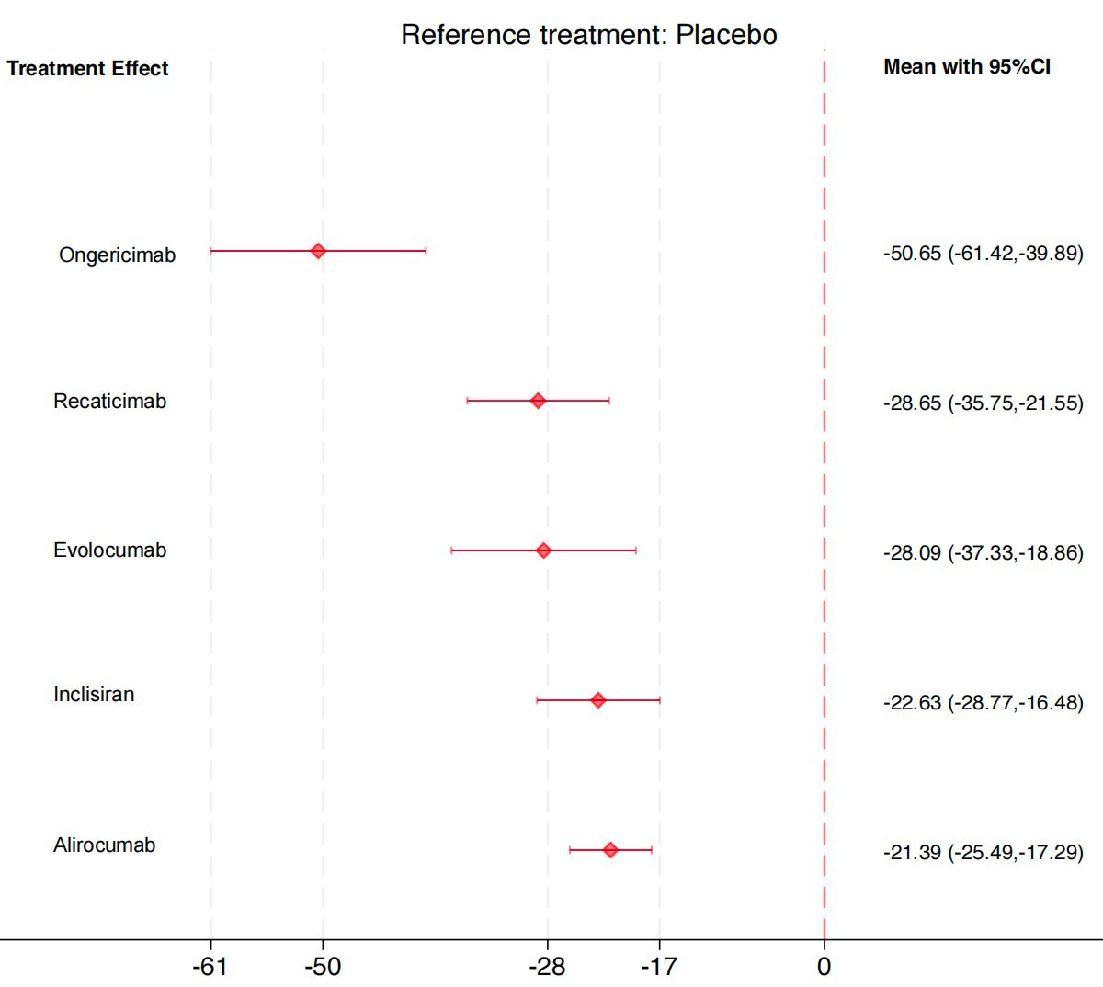

Figure S12.3: Long-term durability (>26 weeks)
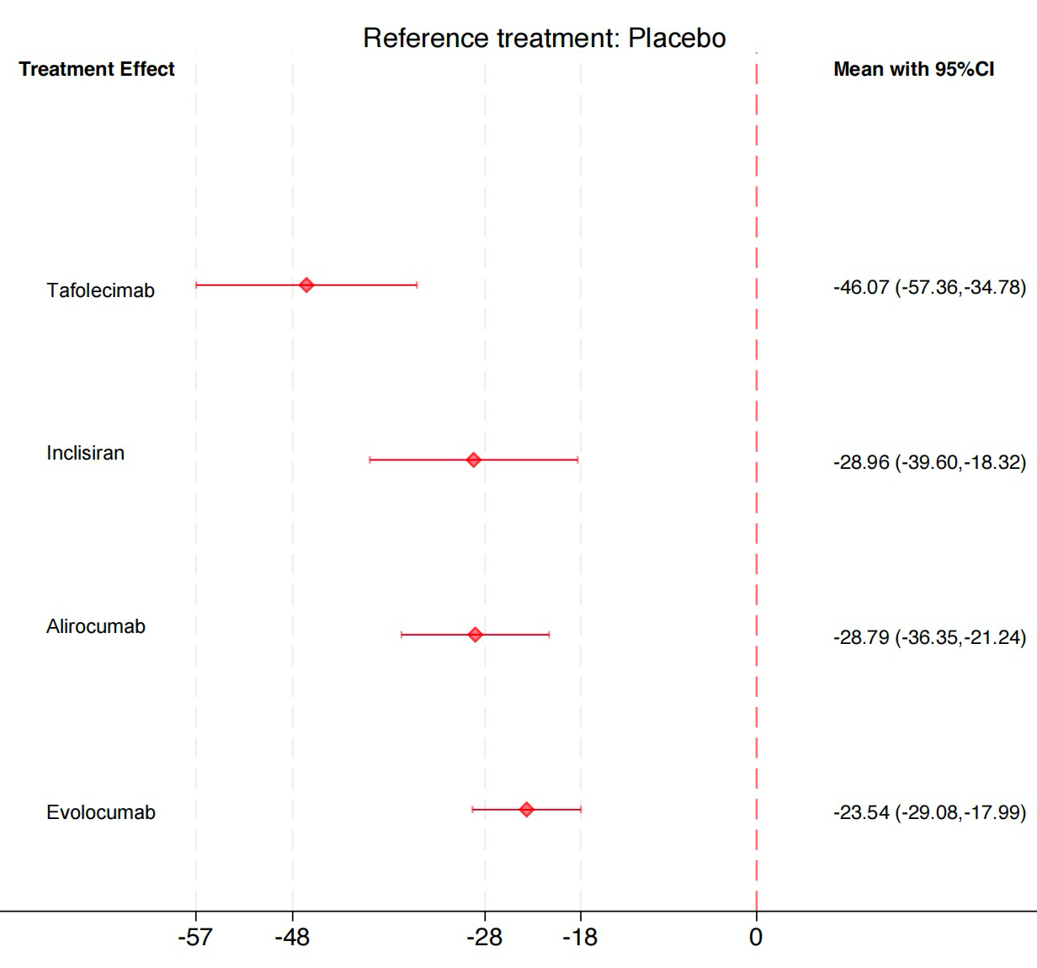

Appendix 13: Subgroup analysis of PCSK9 inhibitors stratified by background statin therapy

Figure S13.1: With background statins
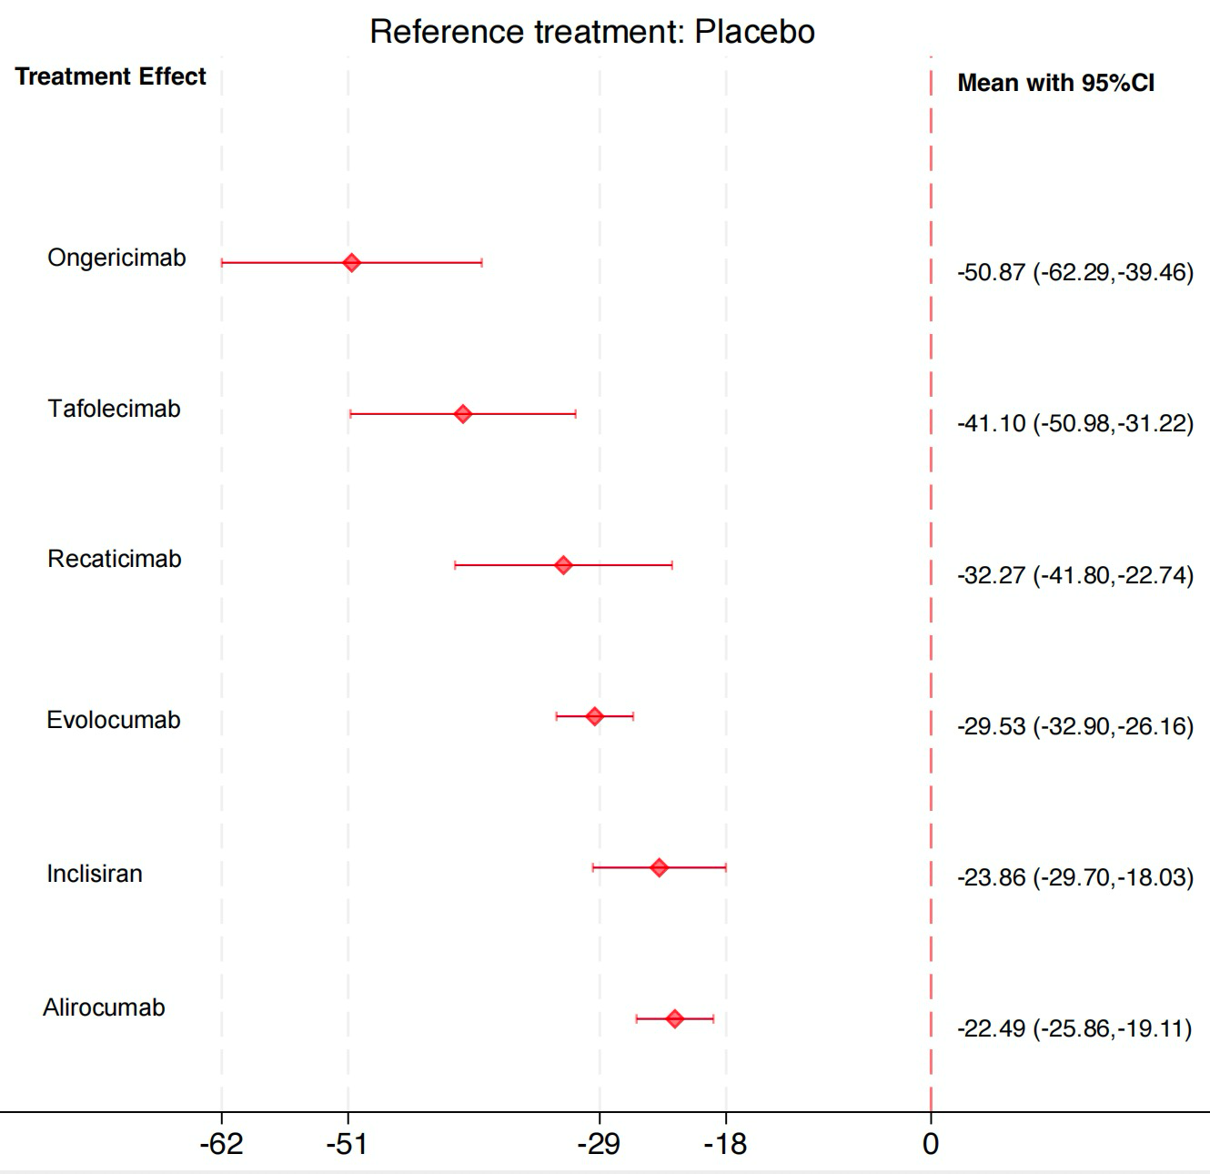

Figure S13.2: Without background statins
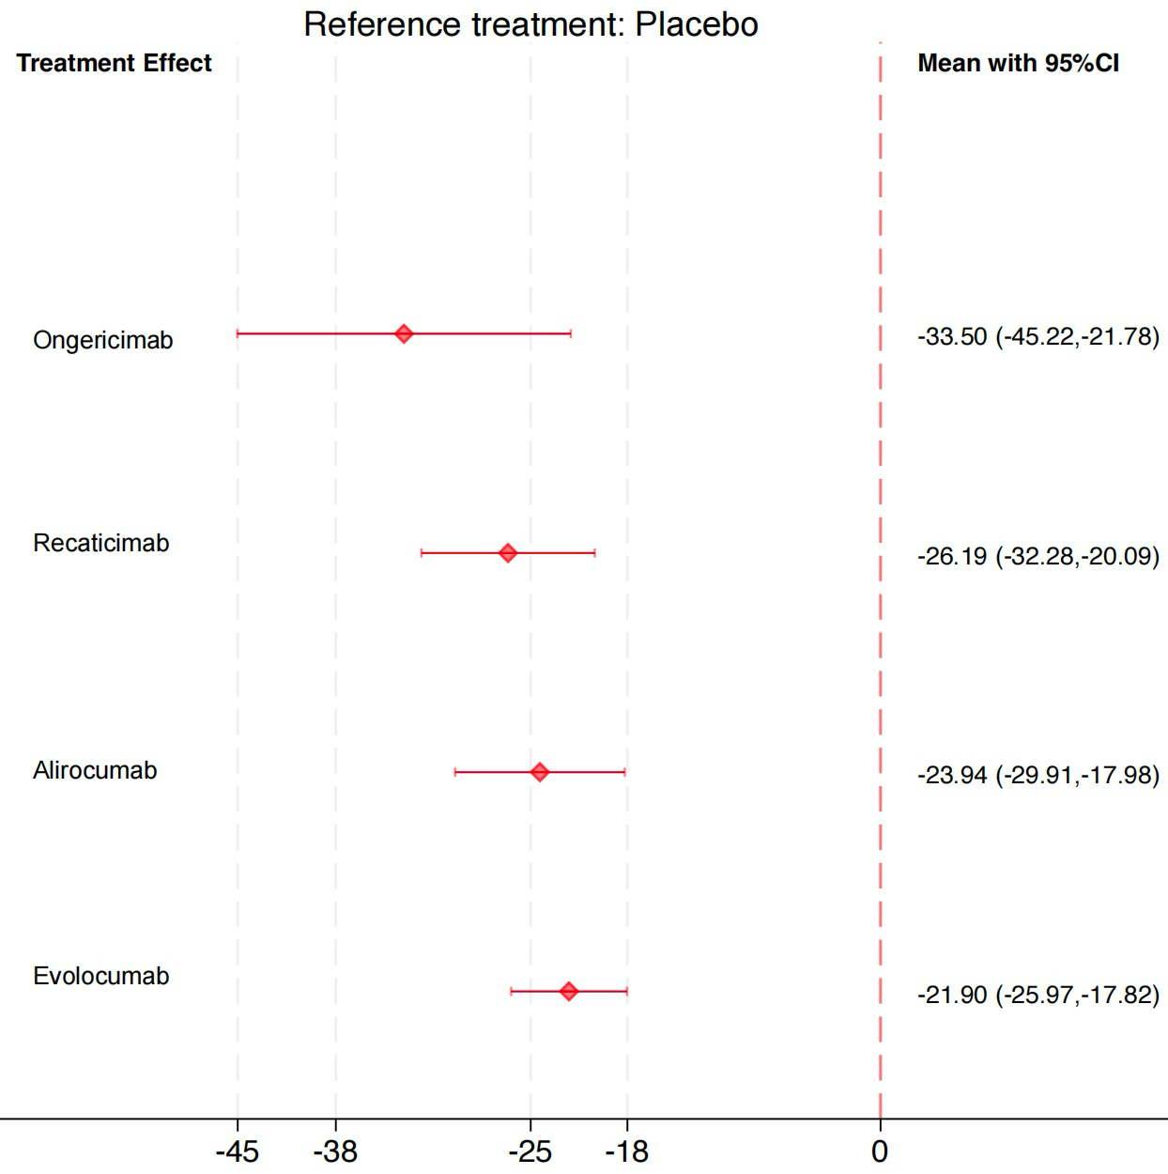

Appendix 14: Comparison of the effects of PCSK9 inhibitors on Lp(a) levels between East Asian and Global populations

Figure S14.1: East Asian
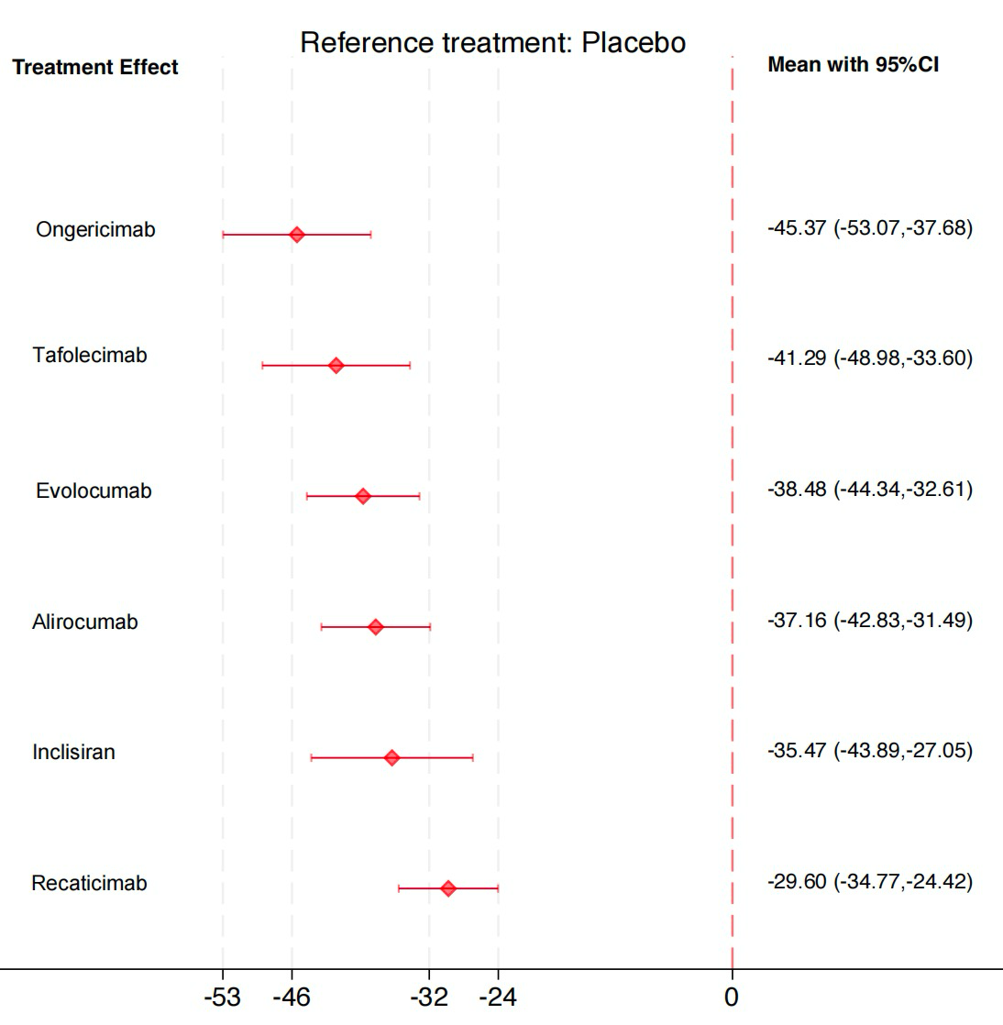
East Asian: China, Japan, South Korea, and Singapore.

Figure S14.2: Global
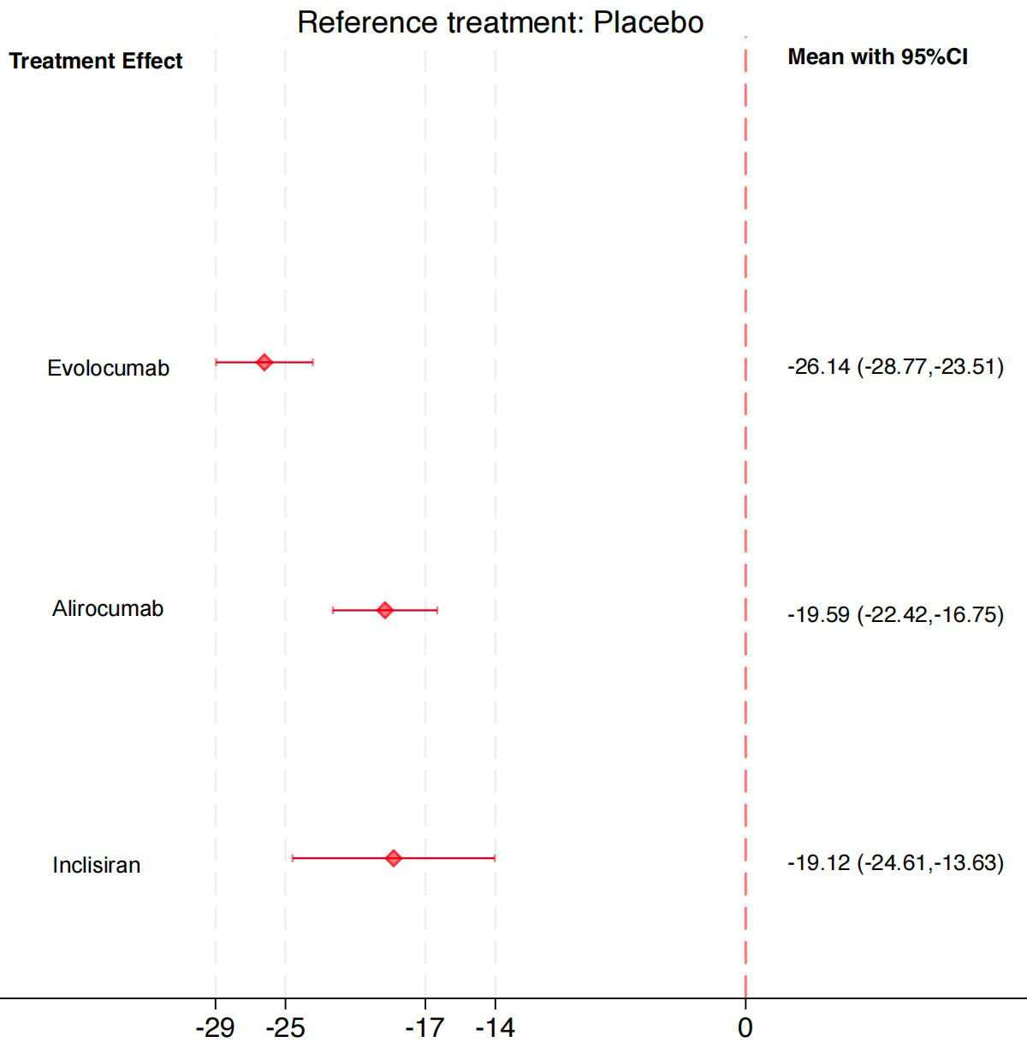

Appendix 15: Sensitivity analysis

Table S15.1 Sensitivity analysis of treatment effects on Lp(a) according to the reported measurement unit (mg/dL vs. nmol/L)
PCSK9 inhibitors | Lp(a)
PCSK9 inhibitors | Main estimate | Sensitivity analysis (mg/dL) | Sensitivity analysis (nmol/L)
Ongericimab | -46.36 (-55.96,-36.77) | NA | -45.93 (-54.59,-37.26)
Tafolecimab | -41.12 (-50.73,-31.51) | -41.05 (-51.76,-30.33) | NA
Recaticimab | -29.70 (-36.64,-22.77) | NA | -29.66 (-35.75,-23.58)
Evolocumab | -28.09 (-31.03,-25.16) | -34.93 (-47.12,-22.74) | -27.49 (-30.18,-24.79)
Inclisiran | -23.82 (-29.47,-18.16) | NA | -23.63 (-28.66,-18.61)
Alirocumab | -22.62 (-25.71,-19.53) | -22.95 (-26.53,-19.36) | -19.25 (-40.48,1.99)

Figure S15.1 Sensitivity analysis of treatment effects on Lp(a) restricted to standard approved doses
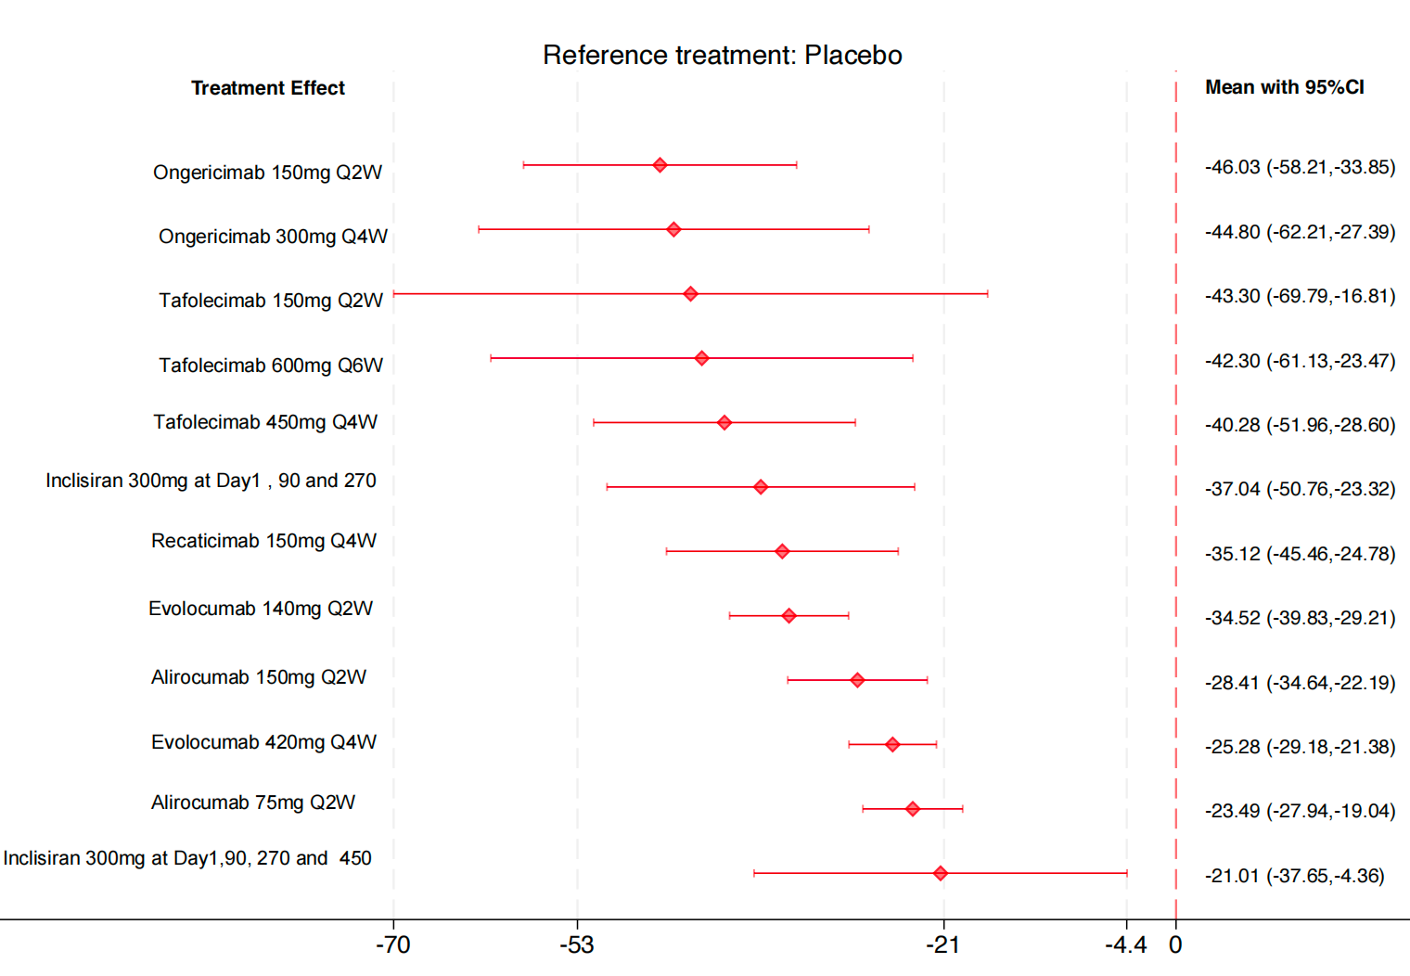

Appendix 16: Specific AEs
Study | Injectionsite reactions | Muscle-related events | Hepatic effects (ALT/AST) | Neurocognitive events | Diabetes/Glucose control | Nasopharyngitis | Upper respiratory tract infection | Urinary tract infection | Headache
Stiekema 2019  ANITSCHKOW | NA | NA | NA | NA | NA | NA | NA | NA | NA
Rosenson et al. 2019  BANTING | NA | NA | 1 (0.4%) / 1 (0.7%) | NA | 8 (2.9%) / 5 (3.5%) | NA | 5 (1.8%) / 4 (2.8%) | 6 (2.1%) / 2 (1.4%) | 6 (2.1%) / 3 (2.1%)
Boccara et al. 2020  BEIJERINCK | 7 (2.3%) / 8 (5.1%) | NA | 1 (0.4%) / 0 (0.0%) | NA | NA | 10 (3.3%) / 2 (1.3%) | 7 (2.3%) / 4 (2.5%) | NA | NA
Lorenzatti et al. 2019  BERSON | NA | NA | 1 (0.2%) / 2 (0.6%) | NA | 38 (5.8%) / 8 (2.4%) | 20 (3.0%) / 12 (3.7%) | 23 (3.5%) / 11 (3.4%) | NA | 8 (1.2%) / 3 (0.9%)
HUO et al. 2023  CREDIT-1 | 30 (7.3%) / 5 (2.5%) | 19 (4.6%) / 5 (2.5%) | 10 (2.4%) / 3 (1.5%) | NA | 26 (6.3%) / 13 (6.4%) | NA | 46 (11.2%) / 21 (10.3%) | 45 (10.9%) / 21 (10.3%) | NA
Chai et al. 2023 CREDIT-2 | 3 (3.0%) / 0 (0.0%) | 5 (5.0%) / 3 (6.3%) | 2 (3.8%) / 0 (0%) | NA | NA | NA | 13 (13.0%) / 4 (8.3%) | NA | NA
Qi et al. 2023  CREDIT-4 | 2 (1.0%) / 1 (1.0%) | 2 (1.0%) / 3 (3.1%) | 3 (1.5%) / 2 (2.0%) | NA | NA | NA | 6 (2.9%) / 3 (3.1%) | 12 (5.9%) / 4 (4.1%) | NA
Blom et al. 2014  DESCARTES | 34 (5.7%) / 15 (5.0%) | 24 (4.0%) / 9 (3.0%) | NA | NA | NA | 63 (10.5%) / 29 (9.6%) | 56 (9.3%) / 19 (6.3%) | 27 (4.5%) / 11 (3.6%) | 24 (4.0%) / 11 (3.6%)
Koskinas et al. 2019  EVOPACS | 5 (3.2%) / 3 (2.0%) | 9 (5.8%) / 5 (3.3%) | 2 (1.3%) / 2 (1.3%) | 1 (0.6%) / 0 (0.0%) | NA | 4 (2.6%) / 3 (2.0%) | NA | NA | NA
Sabatine et al. 2017  FOURIER | 296 (2.1%) / 219 (1.6%) | 682 (5.0%) / 656 (4.8%) | 240 (1.8%) / 242 (1.8%) | 217 (1.6%) / 202 (1.5%) | 677 (8.1%) / 644 (7.7%) | NA | NA | NA | NA
Gao et al. 2021  NCT04851769 | 2 (6.7%) / 0 (0%) | NA | NA | NA | NA | 2 (6.7%) / 1 (3.2%) | NA | NA | NA
Nicholls 2016 GLAGOV | 2 (0.4%) / 0 (0%) | 34 (7.0%) / 28 (5.8%) | 2 (0.5%) / 2 (0.5%) | 7 (1.4%) / 6 (1.2%) | 17 (3.6%) / 18 (3.7%) | NA | NA | NA | NA
Hao et al. 2022 | NA | 1 (1.47%) / 1 (1.64%) | 3 (4.41%) / 4 (6.56%) | NA | 1 (1.47%) / 1 (1.64%) | NA | NA | NA | NA
Tan et al. 2023 HUA TUO | NA | NA | 0 (0.0%) / 0 (0.0%) | NA | NA | NA | 13 (8.2%) / 7 (8.5%) | NA | NA
Nicholls et al. 2022  HUYGENS | 0 (0.0%) / 1 (1.2%) | 5 (6.3%) / 6 (7.4%) | NA | NA | NA | NA | NA | NA | NA
Janik et al. 2021 | 33 (3.0%) / 12 (1.1%) | NA | 35 (3.2%) / 35 (3.2%) | 14 (1.3%) / 18 (1.7%) | 49 (9.0%) / 50 (8.8%) | 82 (7.5%) / 89 (8.2%) | NA | 61 (5.6%) / 47 (4.3%) | 71 (6.5%) / 85 (7.8%)
Ji et al. 2023 | NA | 0 (0.0%) / 4 (7.3%) | 1 (1.8%) / 2 (3.6%) | NA | NA | NA | 1 (1.8%) / 1 (1.8%) | NA | NA
Robinson et al.  2014  LAPLACE-2 | 15 (1.3%) / 8 (1.4%) | 17 (1.5%) / 6 (1.1%) | 4 (0.4%) / 6 (1.1%) | 1 (0.1%) / 0 (0%) | NA | NA | NA | NA | 19 (1.7%) / 15 (2.7%)
Giugliano 2012  LAPLACE-TIMI 57 | 8 (1.7%) / 3 (1.9%) | NA | 0 (0.0%) / 1 (0.6%) | NA | NA | 48 (10%) / 11 (7%) | NA | NA | NA
Lin 2025 NCT05325203 | 6 (6.7%) / 1 (2.2%) | NA | 5 (5.6%) / 2 (4.4%) | NA | NA | NA | 14 (15.6%) / 9 (20.0%) | 9 (10.0%) / 5 (11.1%) | NA
McKenney 2012 NCT01288443 | 8 (5.3%) / 0 (0.0%) | 7 (4.6%) / 1 (3.2%) | 0 (0.0%) / 0 (0.0%) | NA | NA | 8 (5.3%) / 1 (3.2%) | 4 (2.6%) / 1 (3.2%) | NA | 6 (4.0%) / 1 (3.2%)
Koren 2014 MENDEL-2 | 16 (5.2%) / 8 (5.2%) | 8 (2.6%) / 6 (3.9%) | 3 (1.0%) / 5 (3.2%) | 0 (0.0%) / 0 (0.0%) | NA | 6 (2.0%) / 3 (1.9%) | NA | NA | 10 (3.3%) / 4 (2.6%)
Schwartz  2018 ODYSSEY OUTCOMES | 360 (3.8%) / 203 (2.1%) | NA | 500 (5.3%) / 534 (5.7%) | 143 (1.5%) / 167 (1.8%) | 1154 (12.2%) / 1259 (13.3%) | NA | NA | NA | NA
Stroes  2016  ODYSSEY CHOICE II | 12 (6.9%) / 0 (0.0%) | 10 (5.8%) / 3 (5.2%) | 1 (0.6%) / 0 (0.0%) | 2 (1.2%) / 0 (0.0%) | NA | 15 (8.7%) / 3 (5.2%) | 7 (4.0%) / 4 (6.9%) | 8 (4.6%) / 1 (1.7%) | 15 (8.7%) / 3 (5.2%)
Roth 2016  ODYSSEY CHOICE I | 87 (15.5%) / 18 (8.0%) | 19 (3.4%) / 8 (3.6%) | 6 (1.1%) / 2 (0.9%) | 7 (1.2%) / 2 (0.9%) | 12 (2.1%) / 2 (0.9%) | 49 (8.6%) / 18 (7.9%) | 49 (8.6%) / 18 (7.9%) | 35 (6.1%) / 10 (4.4%) | 35 (6.1%) / 13 (5.7%)
Kereiakes 2015  ODYSSEY COMBO I | 11 (5.3%) / 3 (2.8%) | 7 (3.4%)/4 (3.7%) | NA | 0 (0.0%) / 1 (0.9%) | NA | 15 (7.2%) / 5 (4.7%) | 16 (7.7%) / 11 (10.3%) | 13 (6.3%) / 4 (3.7%) | 7 (3.4%)/3 (2.8%)
Leiter 2017 ODYSSEY DM-INSULIN | 7 (2.0%)/8 (4.7%) | 15 (4.4%) / 3 (1.8%) | 2 (0.6%)/1 (0.6%) | 4 (1.2%)/0 (0.0%) | 3 (0.9%) / 4 (2.4%) | 17 (4.9%) / 9 (5.3%) | 3 (0.9%) / 4 (2.4%) | 15 (4.4%) / 7 (4.1%) | 10 (2.9%) / 4 (2.4%)
Moriarty 2016 ODYSSEY ESCAPE | 1 (2.4%) / 0 (0.0%) | 4 (9.8%) / 1 (4.8%) | 0 (0.0%) / 0 (0.0%) | NA | NA | 4 (9.8%) / 2 (9.5%) | 3 (7.3%) / 4 (19.0%) | NA | 3 (7.3%) / 1 (4.8%)
Kastelein 2015  ODYSSEY FH I | 40 (12.4%) / 18 (11.0%) | 6 (1.9%) / 11 (6.7%) | 5 (1.6%) / 2 (1.2%) | 2 (0.6%) / 2 (1.2%) | 6 (1.9%) / 4 (2.5%) | 36 (11.2%) / 12 (7.4%) | 22 (6.8%) / 14 (8.6%) | 13 (4.0%) / 5 (3.1%) | 15 (4.7%) / 9 (5.5%)
Kastelein 2015  ODYSSEY FH II | 19 (11.4%) / 6 (7.4%) | 10 (6.0%) / 5 (6.2%) | 6 (3.6%) / 1 (1.2%) | 0 (0.0%) / 1 (1.2%) | 4 (2.4%) / 2 (2.5%) | 21 (12.6%) / 18 (22.2%) | 5 (3.0%) / 1 (1.2%) | NA | 16 (9.6%) / 7 (8.6%)
Ginsberg 2016 ODYSSEY HIGH FH | 6 (8.3%) / 2 (5.7%) | NA | 3 (4.2%) / 1 (2.9%) | 1 (1.4%) / 1 (2.9%) | 1 (1.4%) / 1 (2.9%) | NA | NA | NA | NA
Blom 2020 ODYSSEY HoFH | 1 (2.2%) / 0 (0.0%) | NA | 0 (0.0%) / 0 (0.0%) | 0 (0.0%) / 0 (0.0%) | 0 (0.0%) / 0 (0.0%) | NA | 2 (4.4%) / 2 (8.3%) | NA | 2 (4.4%) / 2 (8.3%)
Teramoto 2016 ODYSSEY JAPAN | 18 (12.6%) / 3 (4.2%) | 2 (1.4%) / 3 (4.2%) | 5 (3.5%) / 1 (1.4%) | NA | NA | 65 (45.5%) / 26 (36.1%) | NA | NA | 5 (3.5%) / 2 (2.8%)
Koh 2018 ODYSSEY KT | 2 (2.1%) / 3 (2.9%) | NA | 3 (3.1%)/5 (4.9%) | 0 (0%)/1 (1.0%) | 4 (6.2%)/2 (3.1%) | 6 (6.2%) / 4 (3.9%) | 3 (3.1%) / 6 (5.9%) | NA | 5 (5.2%) / 3 (2.9%)
Robinson 2015 ODYSSEY LONG TERM | 91 (5.9%) / 33 (4.2%) | 84 (5.4%) / 23 (2.9%) | 28 (1.8%)/ 18 (2.3%) | 18 (1.2%) / 4 (0.5%) | NA | NA | NA | NA | NA
Teramoto 2019 ODYSSEY NIPPON | NA | NA | 0 (0.0%) / 0 (0.0%) | NA | NA | NA | 16 (15.0%) / 9 (16.1%) | NA | NA
Bays 2015  ODYSSEY OPTIONS I | 3 (2.9%) / 3 (2.0%) | NA | 0 (0%) / 1 (0.7%) | 0 (0%) / 0 (0%) | NA | 5 (4.8%) / 8 (5.4%) | 5 (4.8%) / (4.7%) | 3 (2.9%) / 8 (5.4%) | NA
Farnier 2016  ODYSSEY OPTIONS II | 4 (3.9%) / 2 (2.0%) | NA | 1 (1.0%) / 0 (0%) | 1 (1.0%) / 1 (1.0%) | NA | 4 (3.9%) / 7 (6.9%) | 6 (5.8%) / 9 (8.9%) | NA | NA
Ako J 2019  ODYSSEY J-IVUS | 7 (6.8%) / 0 (0%) | NA | NA | NA | 0 (0%) / 3 (2.9%) | 27 (26.2%) / 15 (14.7%) | NA | NA | 4 (3.9%) / 3 (2.9%)
Ray  2017  ORION-1 | 19 (5%) / 0 (0%) | 27 (7%) / 6 (5%) | 3 (1%) / 1 (1%) | NA | NA | NA | NA | NA | NA
Raal 2024 ORION-5 | 0 (0%) / 0 (0%) | NA | 0 (0%) / 1 (5.3%) | NA | NA | NA | 2 (5.4%) / 2 (10.5%) | NA | NA
Raal 2020 ORION-9 | 41 (17.0%) / 4 (1.7%) | NA | 3 (1.2%) / 1 (0.4%) | NA | NA | 28 (11.6%) / 20 (8.3%) | 16 (6.6%) / 16 (6.7%) | NA | NA
Ray 2020 ORION-10 | 20 (2.6%) / 7 (0.9%) | NA | 4 (0.5%) / 5 (0.6%) | NA | 120 (15.4%) / 108 (13.9%) | NA | 39 (5.0%) / 33 (4.2%) | NA | NA
Ray 2020 ORION-11 | 38 (4.7%) / 4 (0.5%) | NA | 4 (0.5%) / 4 (0.5%) | NA | 88 (10.9%) / 94 (11.7%) | 91 (11.2%) / 90 (11.2%) | 52 (6.4%) / 49 (6.1%) | NA | NA
Yamashita 2024 ORION-15 | 21 (8.2%) / 2 (3.5%) | 1 (0.4%) / 0 (0%) | 16 (6.3%) / 2 (3.5%) | NA | 77 (30.2%) / 15 (26.3%) | NA | NA | NA | 1 (0.4%) / 1 (1.8%)
Huo 2024 ORION-18 | 5 (2.9%) / 1 (0.6%) | 7 (4.1%) / 1 (0.6%) | 6 (3.5%) / 4 (2.3%) | NA | 15 (8.8%) / 16 (9.2%) | 4 (2.4%) / 2 (1.1%) | 11 (6.5%) / 9 (5.2%) | 10 (5.9%) / 4 (2.3%) | NA
Räber 2022 PACMAN-AMI | 9 (6.1%) / 5 (3.3%) | NA | 1 (0.7%) / 0 (0%) | 3 (2.0%) / 0 (0%) | NA | NA | NA | NA | NA
Xu 2024 REMAIN-1 | 14 (3.0%) / 4 (1.7%) | NA | 4 (0.9%) / 2 (0.4%) | NA | NA | NA | 8 (1.7%)/ 5 (2.1%) | 3 (0.6%) / 0 (0%) | NA
Sun 2024 REMAIN-2 | 18 (3.9%) / 3 (1.3%) | NA | 32 (7.0%) / 9 (3.9%) | NA | 6 (1.3%) / 0 (0%) | NA | 76 (16.7%) / 45 (19.3%) | 43 (9.4%) / 21 (9.0%) | NA
Li 2025 REMAIN-3 | 8 (8.4%) / 0 (0%) | 1 (1.1%) / 0 (0%) | 3 (3.2%) / 3 (6.3%) | NA | 1 (1.1%) / 0 (0%) | 0 (0%) / 1 (2.1%) | 1 (1.1%) / 0 (0%) | 1 (1.1%) / 0 (0%) | NA
Roth 2012 NCT01288469 | 1 (1.6%) / 2 (6.5%) | NA | 1 (1.6%) / 0 (0%) | NA | NA | NA | NA | NA | 3 (4.9%) / 2 (6.5%)
Raal 2012 RUTHERFORD | 7 (6.3%) / 1 (1.8%) | NA | 2 (1.8%) / 0 (0%) | NA | NA | 14 (12.6%) / 6 (10.7%) | 5 (4.5%) / 0 (0%) | NA | 6 (5.4%) / 5 (8.9%)
Raal 2014 RUTHERFORD-2 | 13 (5.9%) / 4 (3.7%) | 10 (4.5%) / 1 (0.9%) | 0 (0%) / 0 (0%) | 0 (0%) / 0 (0%) | NA | 19 (8.6%) / 5 (4.6%) | NA | NA | 9 (4.1%) / 4 (3.7%)
Shao 2025 NCT05621070 | 5 (5.4%) / 0 (0%) | NA | 2 (2.2%) / 8 (17.0%) | NA | NA | NA | 5 (5.4%) / 2 (4.3%) | 9 (9.8%) / 2 (4.3%) | NA
Stein 2012 NCT01266876 | 25 (40.3%) / 2 (13.3%) | NA | 0 (0%) / 0 (0%) | NA | NA | NA | NA | NA | NA
Uehara 2024  Adage-Joto | NA | NA | NA | NA | NA | NA | NA | NA | NA
Wang Zhao 2024 | 1 (0.6%) / 0 (0%) | NA | 8 (4.7%) / 2 (2.3%) | NA | 6 (3.6%) / 2 (2.3%) | NA | NA | 7 (4.1%) / 6 (7.0%) | NA
Wang 2024 NCT04781114 | 18 (3.4%) / 4 (1.5%) | NA | 40 (7.4%) / 20 (7.5%) | NA | 23 (4.3%) / 19 (7.2%) | NA | 58 (10.8%) / 35 (13.2%) | 53 (9.9%) / 31 (11.7%) | NA
Hirayama 2014 YUKAWA | 4 (2.0%) / 1 (1.0%) | 4 (2.0%) / 1 (1.0%) | 1 (0.5%) / 0 (0%) | NA | NA | NA | NA | NA | NA
Kiyosue  2016  YUKAWA-2 | 5 (2.5%) / 5 (2.5%) | 1 (0.5%) / 2 (1.0%) | 1 (0.5%) / 2 (1.0%) | 0 (0%) / 0 (0%) | 4 (2.0%) / 4 (2.0%) | 34 (16.8%) / 36 (17.8%) | NA | NA | NA
Koren 2012 MENDEL | 15 (6%) / 4 (4%) | 7 (2.6%) / 0 (0%) | 2 (0.7%) / 0 (0%) | NA | NA | 11 (4.1%) / 3 (3.3%) | 17 (6.3%) / 7 (7.8%) | NA | 8 (3.0%) / 4 (4.4%)
Teramoto 2016 NCT01812707 | 7 (9.3%) / 1 (4.0%) | NA | 1 (1.3%) / 0 (0%) | NA | NA | 16 (21.3%) / 2 (8.0%) | NA | NA | NA
Data are presented as the number and/or percentage of participants with each adverse event, as reported in the original studies. NA indicates that the corresponding adverse event was not reported in the original publication and should not be interpreted as indicating that no event occurred. For muscle-related events, the event category reported by the original study was extracted directly when available; when no overall muscle-related event category was provided, myalgia was extracted as the representative event in most studies. Hepatic effects included reported elevations or abnormalities in alanine aminotransferase (ALT) and/or aspartate aminotransferase (AST). Definitions and laboratory thresholds for ALT/AST abnormalities were retained as reported in the original studies and may therefore differ across trials.

