Additional file 1: Supplementary information
Cardiorespiratory fitness gap during stable recovery after percutaneous coronary intervention relative to a contemporaneous angiographic reference group: a propensity score overlap-weighted cross-sectional study
Supplementary methods
Participant screening
The initial database search identified 2443 potentially relevant records. Before eligibility assessment, 769 records were excluded: 231 duplicate patients or examinations, 385 examinations outside the prespecified study period, 118 records for which coronary angiography, CPET, and body-composition data could not be reliably linked, and 35 records with missing or implausible key dates. We then excluded 466 patients with previous myocardial infarction or coronary revascularization, 35 with LVEF <50%, 5 with moderate-to-severe valvular disease, 18 with severe anemia (hemoglobin <80 g/L), and 27 whose study group could not be established. CPET quality control excluded 379 patients with peak RER <1.0 and 30 with other CPET data-quality failures; body-composition quality control excluded 32 patients. The final cohort comprised 682 participants: 209 in the reference group and 473 in the PCI group.
Both groups completed the same study assessments 4–6 weeks after the corresponding coronary angiography or planned PCI; clinical data, laboratory tests, CPET, and body-composition measurements were obtained within the same assessment window. Principal analysis variables, NYHA class, and CCS class were complete in all 682 participants. No observations were excluded because of missing covariates from the core or expanded overlap-weighting models, principal outcome models, or full-cohort sensitivity analyses. Sample-size reductions in the cycle-ergometer-only and two propensity score-matched analyses arose from protocol restriction and matching, respectively, rather than from missing data.
Overlap weighting and outcome models
The core propensity score model included age, sex, exercise protocol, hypertension, diabetes, and current smoking. Weights were assigned as 1−e(x) in the PCI group and e(x) in the reference group. Targeted outcome models included age, sex, exercise protocol, LVEF, and outcome-aligned body-composition measures. The primary extended model additionally included hemoglobin, eGFRMDRD, fasting blood glucose, current smoking, hypertension, diabetes, and beta-blocker use.
Sensitivity analyses
Sensitivity analyses included overlap weighting with an expanded propensity score variable set, restriction to cycle-ergometer testing, alternative body-composition measures, unified SMM/BFM models, 1:1 propensity score matching based on prespecified age, sex, and exercise protocol, matching with the expanded propensity score variable set and exact matching on sex and exercise protocol, and recalculation of pVO₂ using the FRIEND equation in all 682 participants. Outcome models in matched cohorts used pair-clustered robust standard errors.
Supplementary Table S1 Propensity score and overlap-weight diagnostics
Propensity score model | Group | n | Sum of weights | Effective sample size | Weight range | Propensity score range
Core | Reference | 209 | 115.60 | 175.4 | 0.067–0.946 | 0.067–0.946
Core | PCI | 473 | 115.60 | 340.1 | 0.052–0.843 | 0.157–0.948
Core | Overall | 682 | 231.19 | 462.8 | 0.052–0.946 | 0.067–0.948
Expanded | Reference | 209 | 115.42 | 175.8 | 0.047–0.939 | 0.047–0.939
Expanded | PCI | 473 | 115.42 | 335.3 | 0.033–0.833 | 0.167–0.967
Expanded | Overall | 682 | 230.84 | 461.3 | 0.033–0.939 | 0.047–0.967
The core model was used for the primary analysis. The expanded model additionally included hemoglobin, eGFRMDRD, and fasting blood glucose in the propensity score.
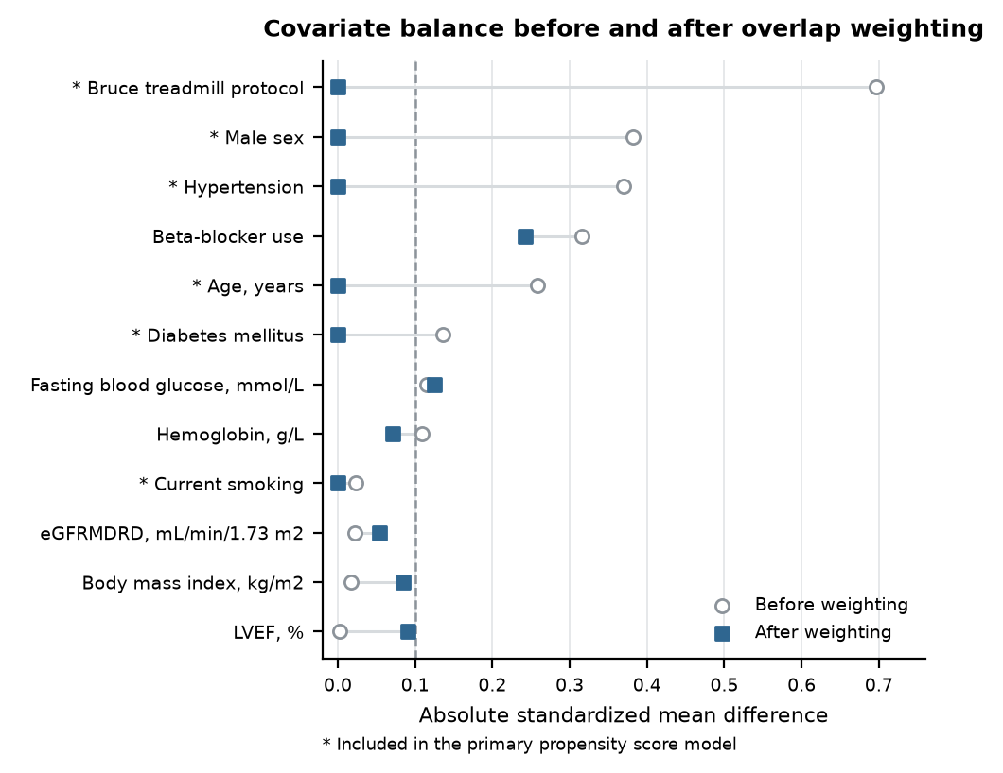
Supplementary Figure S1 Balance of selected covariates before and after overlap weighting
Circles and squares indicate absolute SMDs before and after weighting, respectively; the dashed line indicates 0.10. Asterisks identify variables included in the core propensity score model.
Supplementary Table S2A Associations of body-composition measures with CRF
Outcome | Body-composition measure | Coefficient per 1-SD increase | 95% CI | P value
Absolute VO₂peak | SMM | 171.35 | 125.33 to 217.37 | <0.001
Absolute VO₂peak | BFM | 42.02 | 7.36 to 76.68 | 0.017
VO₂peak/kg | SMMI | 0.49 | −0.07 to 1.04 | 0.086
VO₂peak/kg | FMI | −1.11 | −1.57 to −0.65 | <0.001
pVO₂ | SMMI | 2.53 | 0.66 to 4.39 | 0.008
pVO₂ | FMI | −0.76 | −2.45 to 0.93 | 0.379
Coefficients are from the primary extended overlap-weighted models and are expressed on the original scale of each outcome.
Supplementary Table S2B Joint body-composition interaction tests
Outcome | Joint interaction terms | Wald χ² | df | P value
Absolute VO₂peak | PCI×SMM, PCI×BFM | 3.99 | 2 | 0.136
VO₂peak/kg | PCI×SMMI, PCI×FMI | 6.49 | 2 | 0.039
pVO₂ | PCI×SMMI, PCI×FMI | 2.64 | 2 | 0.268
Each outcome model simultaneously included both corresponding PCI×body-composition interaction terms; a two-degree-of-freedom joint Wald test was used.
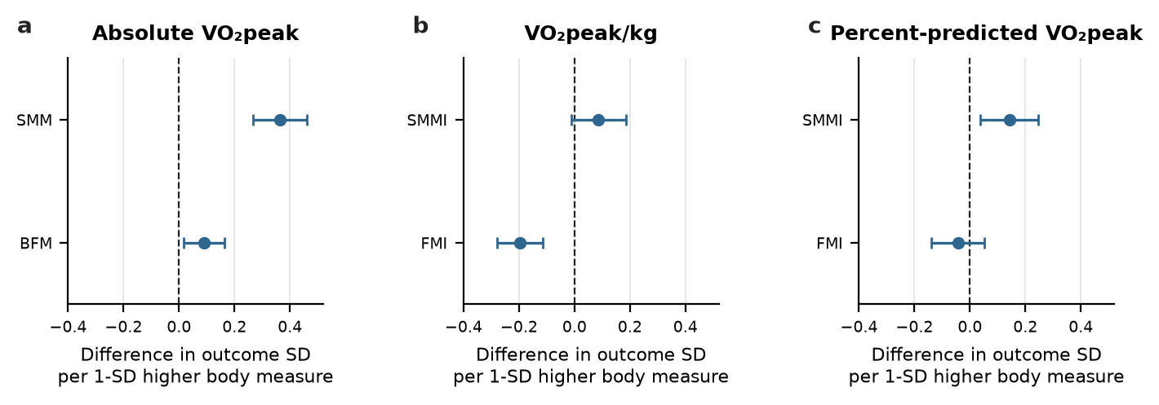
Supplementary Figure S2 Associations of body composition with cardiorespiratory fitness
Points and horizontal lines show standardized regression coefficients and 95% CIs. Each coefficient represents the change in outcome standard deviations per 1-SD higher body-composition measure. n=682.
Supplementary Table S3A Explained variance in nested weighted models
Outcome | Last block added | Weighted R² | ΔR² | Partial R²
Absolute VO₂peak | Core variables | 0.555 | — | —
Absolute VO₂peak | Body composition | 0.644 | 8.9% | 20.0%
Absolute VO₂peak | Clinical/metabolic factors | 0.661 | 1.7% | 4.7%
Absolute VO₂peak | PCI status | 0.665 | 0.4% | 1.1%
VO₂peak/kg | Core variables | 0.470 | — | —
VO₂peak/kg | Body composition | 0.501 | 3.1% | 5.8%
VO₂peak/kg | Clinical/metabolic factors | 0.531 | 3.0% | 6.0%
VO₂peak/kg | PCI status | 0.536 | 0.5% | 1.1%
pVO₂ | Core variables | 0.233 | — | —
pVO₂ | Body composition | 0.243 | 1.0% | 1.3%
pVO₂ | Clinical/metabolic factors | 0.274 | 3.1% | 4.1%
pVO₂ | PCI status | 0.287 | 1.4% | 1.9%
Variable blocks entered in the following order: core variables, body composition, clinical/metabolic factors, and PCI status. ΔR² depends on the prespecified order of entry and should not be interpreted as a causal mediation proportion.
Supplementary Table S3B Detailed cross-fitted reference-group mapping results
Outcome | Mean residual: reference group | Mean residual: PCI group | Between-group residual difference | Bootstrap 95% CI | P value
Absolute VO₂peak | −1.72 | −51.04 | −49.32 | −105.38 to 5.36 | 0.088
VO₂peak/kg | 0.00 | −0.72 | −0.72 | −1.55 to 0.08 | 0.096
pVO₂ | −0.02 | −4.19 | −4.16 | −7.45 to −1.00 | 0.012
Residuals are observed minus cross-fitted expected values. Models were fitted only in the reference group using repeated 10-fold cross-fitting, repeated 10 times; intervals and P values were obtained from 500 group-stratified bootstrap replicates.
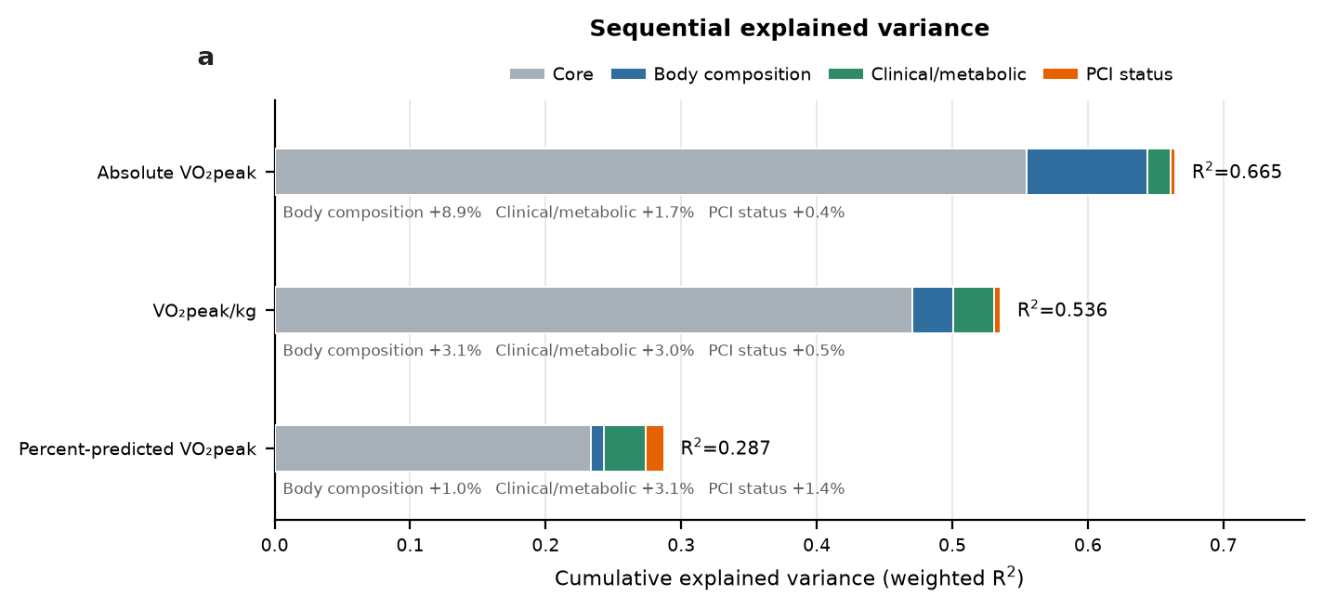
Supplementary Figure S3 Sequential explained variance in cardiorespiratory fitness
Horizontal stacked bars show cumulative weighted R² as the core, body-composition, clinical/metabolic, and PCI-status blocks entered sequentially. Labels after the core block show the corresponding ΔR². This analysis is descriptive and depends on the order of variable entry. n=682.
Supplementary Table S4 Overlap-weighted sensitivity analysis using the expanded propensity score variable set
Outcome | n | PCI–reference difference | 95% CI | P value
Absolute VO₂peak | 682 | −60.15 | −110.41 to −9.90 | 0.019
VO₂peak/kg | 682 | −0.83 | −1.55 to −0.11 | 0.023
pVO₂ | 682 | −4.28 | −7.14 to −1.43 | 0.003
The expanded propensity score model added hemoglobin, eGFRMDRD, and fasting blood glucose to the six core variables; effective sample size was 461.3.
Supplementary Table S5 Cycle-ergometer-only sensitivity analysis
Outcome | n | PCI–reference difference | 95% CI | P value
Absolute VO₂peak | 588 | −32.51 | −83.50 to 18.47 | 0.211
VO₂peak/kg | 588 | −0.45 | −1.20 to 0.30 | 0.240
pVO₂ | 588 | −3.44 | −6.53 to −0.36 | 0.029
This analysis included 588 participants who completed CPET using an individualized ramp cycle-ergometer protocol; effective sample size was 390.8.
Supplementary Table S6 Sensitivity analyses using alternative body-composition measures
Analysis | Outcome | n | PCI–reference difference | 95% CI | P value
ASMI/FMI for relative outcomes | Absolute VO₂peak | 682 | −59.69 | −109.65 to −9.74 | 0.019
ASMI/FMI for relative outcomes | VO₂peak/kg | 682 | −0.79 | −1.52 to −0.07 | 0.031
ASMI/FMI for relative outcomes | pVO₂ | 682 | −4.21 | −7.08 to −1.35 | 0.004
SMM/BFM for all outcomes | Absolute VO₂peak | 682 | −59.69 | −109.65 to −9.74 | 0.019
SMM/BFM for all outcomes | VO₂peak/kg | 682 | −0.83 | −1.54 to −0.11 | 0.023
SMM/BFM for all outcomes | pVO₂ | 682 | −4.17 | −7.04 to −1.30 | 0.004
The ASMI/FMI analysis retained SMM/BFM for absolute VO₂peak; ASMI was calculated as appendicular skeletal muscle mass/height².
Supplementary Table S7 1:1 propensity score-matched sensitivity analysis using three prespecified variables
Outcome | n | PCI–reference difference | 95% CI | P value
Absolute VO₂peak | 292 | −47.44 | −109.41 to 14.52 | 0.136
VO₂peak/kg | 292 | −0.79 | −1.71 to 0.13 | 0.095
pVO₂ | 292 | −3.82 | −7.31 to −0.32 | 0.034
The propensity score was based on age, sex, and exercise protocol and yielded 146 pairs. Outcome models used pair-clustered robust standard errors and included the same covariates as the primary extended model.
Supplementary Table S8 1:1 propensity score-matched sensitivity analysis using the expanded variable set
Outcome | n | PCI–reference difference | 95% CI | P value
Absolute VO₂peak | 334 | −69.87 | −132.05 to −7.70 | 0.029
VO₂peak/kg | 334 | −1.04 | −1.92 to −0.17 | 0.020
pVO₂ | 334 | −5.15 | −8.50 to −1.79 | 0.003
The expanded propensity score variable set with exact matching on sex and exercise protocol yielded 167 pairs. Outcome models used pair-clustered robust standard errors.
Supplementary Table S9A FRIEND-equation pVO₂ sensitivity analysis
Outcome | n | PCI–reference difference | 95% CI | P value
FRIEND-equation pVO₂ | 682 | −4.44 | −6.81 to −2.07 | <0.001
pVO₂ was recalculated using the FRIEND equation in all 682 participants. FRIEND was derived from a United States registry population; this analysis was used only to assess stability to the choice of prediction equation.
Supplementary Table S9B Precision and post hoc power
Outcome | Estimate | Robust standard error | Minimum detectable difference at 80% power | Post hoc power
Absolute VO₂peak | −59.69 | 25.49 | 71.41 | 64.9%
VO₂peak/kg | −0.83 | 0.36 | 1.02 | 62.1%
pVO₂ | −4.28 | 1.45 | 4.07 | 83.7%
Post hoc power is a transformation of the effect estimate and standard error. Primary inference should remain based on effect estimates and 95% CIs.
Supplementary conclusion
The expanded overlap-weighted analysis, both propensity score-matched analyses, alternative body-composition measures, and FRIEND prediction-equation analysis supported the overall direction of the primary findings. In the cycle-ergometer-only analysis, confidence intervals for absolute VO₂peak and VO₂peak/kg widened and crossed zero, whereas the pVO₂ difference remained statistically significant. The nominal interaction for body weight-normalized VO₂peak was not consistently reproduced across sensitivity analyses and was therefore not considered a principal finding.

