Figure S1. Receiver operating characteristic (ROC) curves comparing discrimination performance of baseline lipid composite indices versus corresponding cumulative lipid indices for incident cardiometabolic multimorbidity.

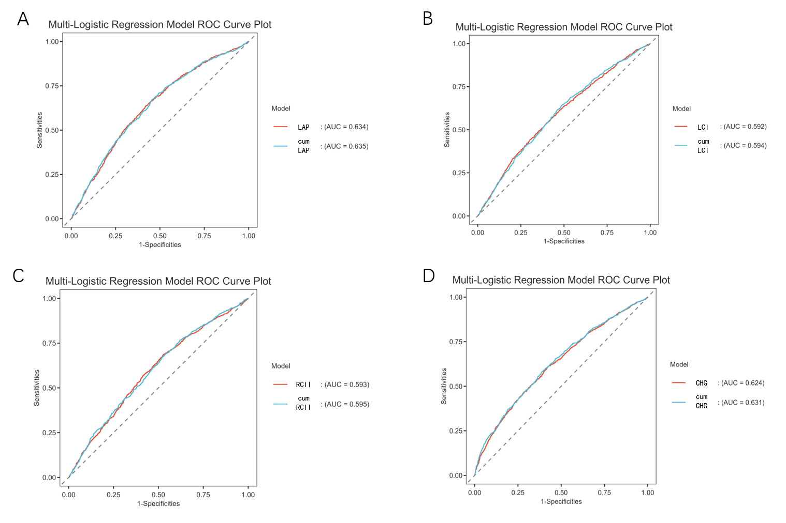
(A) LAP versus cumLAP; (B) LCI versus cumLCI; (C) RCII versus cumRCII; (D) CHG versus cumCHG.

Supplementary Table 1. Standardized odds ratios per 1-SD increment of four cumulative lipid indices for incident CMM in CHARLS and ELSA cohorts
Variable OR (95% CI) per 1-SD increment P -value
CHARLS(N=4782)
cumLCI 2.06 (0.98, 4.08) 0.053
cumRCII 4.26 (0.91, 16.39) 0.054
cumCHG 1.51 (1.23, 1.80) <0.01
cumLAP 1.55 (1.16, 2.10) <0.01
ELSA(N=2074)
cumLCI 1.17 (1.01, 1.34) 0.03
cumRCII 1.18 (1.05, 1.32) 0.04
cumCHG 1.50 (1.29, 1.75) <0.01
cumLAP 1.53 (1.35, 1.73) <0.01

Supplementary Table 2. Odds ratios for cardiometabolic multimorbidity comparing the 75th versus 25th percentile of each cumulative lipid index
Cumulative Lipid Index | Cohort | OR (75th vs 25th percentile) | P value
cumLCI | CHARLS | 1.84 | <0.0001
cumLAP | CHARLS | 2.45 | <0.0001
cumCHG | CHARLS | 1.87 | <0.0001
cumRCII | CHARLS | 1.86 | <0.0001
cumLCI | ELSA | 1.2995 | 0.2778
cumLAP | ELSA | 2.2606 | 0.0027
cumCHG | ELSA | 1.7498 | 0.0237
cumRCII | ELSA | 1.7165 | 0.0352

Supplementary Table 3. RCS Analysis Results of Cumulative Lipid Indices in Two Independent Cohorts
Index | Cohort | Overall χ² | df | P-overall | Nonlinear χ² | df | P-nonlinear
cumLCI | CHARLS | 74.2914 | 3 | <0.001 | 42.1797 | 2 | <0.001
 | ELSA | 7.3916 | 3 | 0.0604 | 3.3616 | 2 | 0.1862
cumLAP | CHARLS | 150.4589 | 3 | <0.001 | 41.0997 | 2 | <0.001
 | ELSA | 18.1919 | 3 | <0.001 | 1.7683 | 2 | 0.4131
cumRCII | CHARLS | 78.7376 | 3 | <0.001 | 67.3608 | 2 | <0.001
 | ELSA | 10.585 | 3 | 0.0144 | 6.6731 | 2 | 0.0356
cumCHG | CHARLS | 175.6718 | 3 | <0.001 | 2.0703 | 2 | 0.3555
 | ELSA | 16.9367 | 3 | <0.001 | 7.2888 | 2 | 0.0266

Supplementary Table 4. Area under the receiver operating characteristic curve (AUC) of four cumulative lipid indices for predicting incident CMM in the fully adjusted model among the CHARLS and ELSA cohorts
Metric | CHARLS Cohort AUC | ELSA Cohort AUC
cumLAP | 0.712 | 0.729
cumLCI | 0.699 | 0.712
cumCHG | 0.708 | 0.722
cumRCII | 0.696 | 0.726

Supplementary Table 5. P values from pairwise DeLong tests comparing AUC of cumLAP with three other cumulative lipid indices in the CHARLS and ELSA cohorts
Comparison | CHARLS Cohort DeLong P-value | ELSA Cohort DeLong P-value
cumLAP vs cumLCI | 0.013 | 0.013
cumLAP vs cumCHG | 0.084 | 0.055
cumLAP vs cumRCII | 0.016 | 0.015

Supplementary Table 6. NRI and IDI evaluating incremental predictive performance of cumulative lipid indices beyond the base clinical model
Comparison | Cohort | NRI | Pvalue | IDI | Pvalue
cumLCI vs cumLAP | CHARLS | 0.3693 | <0.001 | 0.0183 | <0.001
cumRCII vs cumLAP | CHARLS | 0.3788 | <0.001 | 0.0245 | <0.001
cumCHG vs cumLAP | CHARLS | 0.156 | <0.001 | 0.0156 | <0.001
cumLCI vs cumLAP | ELSA | 0.3774 | <0.001 | 0.024 | <0.001
cumRCII vs cumLAP | ELSA | 0.3194 | <0.001 | 0.0233 | <0.001
cumCHG vs cumLAP | ELSA | 0.0499 | 0.522 | 0.0114 | 0.030

