Supplementary

Table S1. Gelman-Rubin Diagnostic Statistics for Multivariate GLMM Parameters
Parameter | Outcome | Gelman-Rubin Statistic (PSRF) | 95% Upper CI | Effective Sample Size (ESS) | Convergence Status
Age | HTN | 1.00 | 1.01 | 5552 | Converged
Age | CVD | 1.02 | 1.04 | 3029 | Converged
Sex (Female vs. Male) | HTN | 1.05 | 1.07 | 5478 | Converged
Sex (Female vs. Male) | CVD | 1.02 | 1.03 | 6587 | Converged
Diabetes | HTN | 1.00 | 1.02 | 5825 | Converged
Diabetes | CVD | 1.04 | 1.06 | 4319 | Converged
Chronic Renal Failure | HTN | 1.03 | 1.04 | 5595 | Converged
Chronic Renal Failure | CVD | 1.02 | 1.04 | 5028 | Converged
Thyroid Dysfunction | HTN | 1.02 | 1.03 | 5517 | Converged
Thyroid Dysfunction | CVD | 1.02 | 1.03 | 4201 | Converged
Serum Creatinine | HTN | 1.01 | 1.02 | 3694 | Converged
Serum Creatinine | CVD | 1.00 | 1.01 | 3156 | Converged
Year (2014 vs. 2013) | HTN | 1.02 | 1.03 | 3578 | Converged
Year (2014 vs. 2013) | CVD | 1.03 | 1.05 | 3683 | Converged
Year (2015 vs. 2013) | HTN | 1.02 | 1.05 | 3303 | Converged
Year (2015 vs. 2013) | CVD | 1.01 | 1.04 | 2865 | Converged
Year (2017 vs. 2013) | HTN | 1.01 | 1.03 | 3122 | Converged
Year (2017 vs. 2013) | CVD | 1.02 | 1.04 | 2690 | Converged
Year (2018 vs. 2013) | HTN | 1.01 | 1.03 | 3330 | Converged
Year (2018 vs. 2013) | CVD | 1.03 | 1.06 | 3608 | Converged
Year (2019 vs. 2013) | HTN | 1.01 | 1.03 | 3959 | Converged
Year (2019 vs. 2013) | CVD | 1.03 | 1.05 | 4669 | Converged
Year (2022 vs. 2013) | HTN | 1.02 | 1.03 | 3497 | Converged
Year (2022 vs. 2013) | CVD | 1.04 | 1.07 | 3859 | Converged
Province (Random Effect) | HTN | 1.03 | 1.05 | 2559 | Converged
Province (Random Effect) | CVD | 1.02 | 1.04 | 12963 | Converged
Individual (Random Effect) | HTN | 1.01 | 1.03 | 1760 | Converged
Individual (Random Effect) | CVD | 1.02 | 1.04 | 4496 | Converged
Individual (Covariance of Random Effect) | - | 1.01 | 1.02 | 5545 | Converged
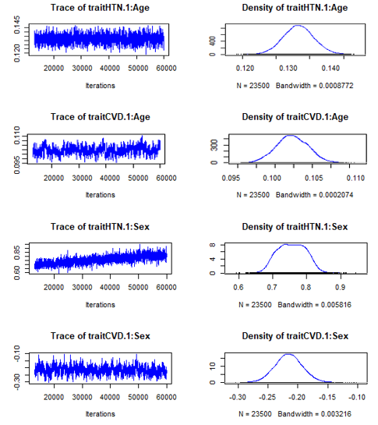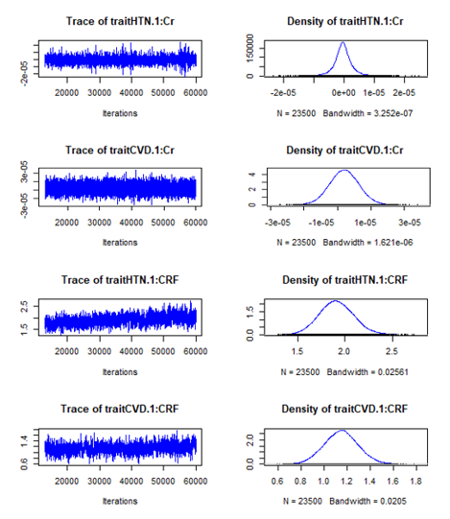
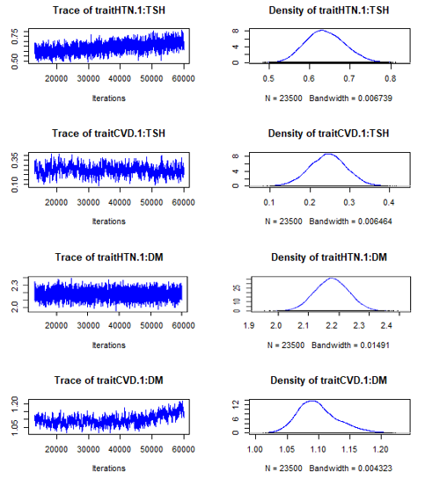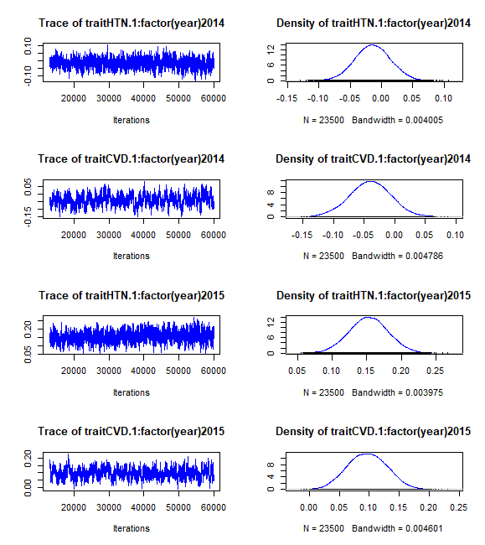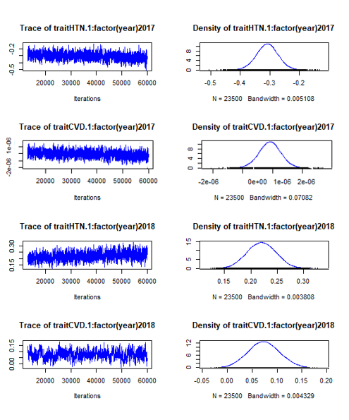
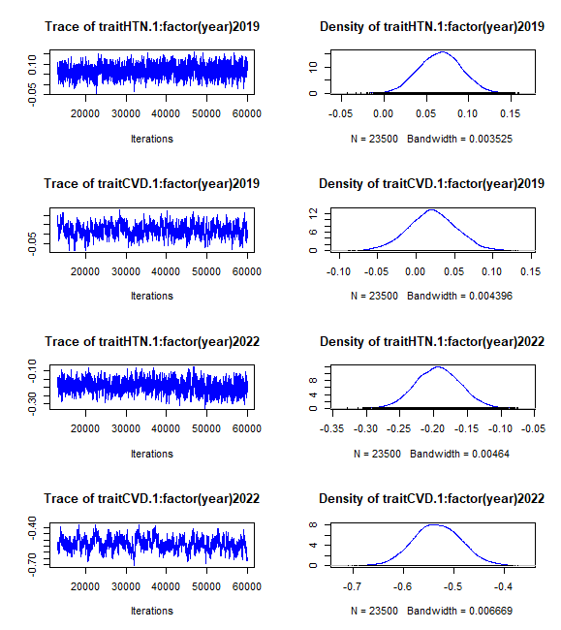
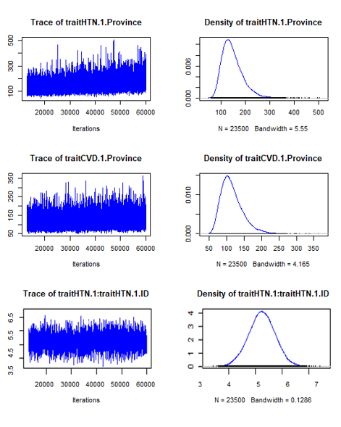
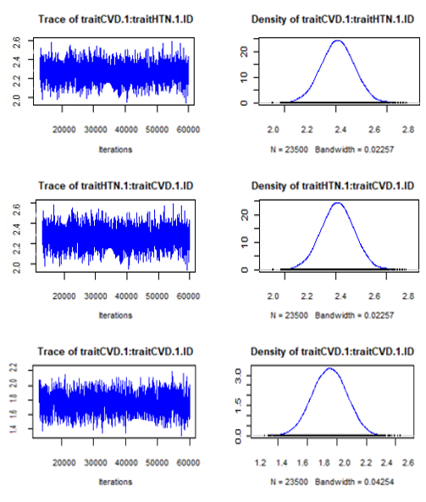
Figure S1. Trace Plots for Selected Model Parameters

