Supplementary Materials for Early Albumin Administration and Mortality in ICU Patients with Heart Failure and Hypoalbuminemia: A Target Trial Emulation
Supplementary Contents
Supplementary Methods S1. Key Covariate Operationalizations
Supplementary Tables
Table S1. Key R Packages and Their Functions
Table S2. Target trial protocol and observational emulation
Table S3. ICD Codes and Corresponding Diagnosis Names for Heart Failure
Table S4. Literature Citations for 33 Directed Edges in the Albumin-Mortality DAG
Table S5. Baseline Covariates Included in the Censoring Model
Table S6. Albumin concentration distribution
Table S7. Covariate balance before and after weighting
Table S8. Missing data summary
Table S9. Positivity diagnostics by baseline strata
Table S10. Artificial censoring by strategy group
Table S11. Stabilized inverse probability weight diagnostics
Table S12. Proportional hazards assumption tests
Table S13. Rubin's rules and fixed-imputation patient bootstrap confidence intervals
Table S14. E-value sensitivity analysis for hazard ratio estimates
Table S15. Prespecified sensitivity analyses
Table S16. Exploratory subgroup analyses
Supplementary Figures
Figure S1. Directed acyclic graph
Figure S2. Albumin concentration patterns
Figure S3. Covariate balance before and after weighting
Figure S4. Imputation density plots
Figure S5. Propensity score distribution
Figure S6. Artificial censoring times
Figure S7. Stabilized weight distribution
Figure S8. Stabilized weight boxplot
Figure S9. Schoenfeld residual plots at 28 days across five imputed datasets
Figure S10. 90-day weighted Kaplan-Meier estimates
Figure S11. 365-day weighted Kaplan-Meier estimates
Figure S12. Sensitivity-analysis forest plot
Supplementary Methods S1. Key Covariate Operationalizations
Key covariate operationalizations were as follows: serum albumin was defined as the measurement closest to ICU admission within the baseline window (labevents, itemid 50862); norepinephrine-equivalent vasopressor dose was calculated using the conversion formula of Goradia et al. [1]; furosemide-equivalent diuretic dose was converted from bumetanide [2]; and the Charlson Comorbidity Index was computed from ICD codes using the algorithm of Quan et al. [3].
In the 6-hour landmark analysis, patients who received albumin before the landmark were excluded. Physiologic variables, vasoactive therapy, diuretics, ventilation, renal replacement therapy, and urine output were measured before or at the landmark and treated as baseline covariates.
Table S1 Key R Packages and Their Functions
R Package | Primary Function | Version
mice | Multiple imputation by chained equations | 3.19.0
survival | Survival analysis and Cox proportional hazards modeling | 3.8-6
boot | Non-parametric bootstrap inference | 1.3-32
sandwich | Robust (sandwich) variance estimation | 3.1-1
lmtest | Robust inference tests for model coefficients | 0.9-40
dagitty | DAG construction and minimal sufficient adjustment set identification | 0.3-4
ggdag | DAG visualization | 0.2.13
splines | Natural spline basis function construction | 4.6.0
tableone | Baseline characteristics summary table generation | 0.13.2
ggplot2 | Statistical graphics binding and visualization | 4.0.3
dplyr | Data manipulation and piped transformations | 1.2.1
tidyr | Data tidying and wide/long format reshaping | 1.3.2
naniar | Missing data pattern visualization and diagnostics | 1.1.0
forcats | Factor level management | 1.0.0

Table S2 Target trial protocol and observational emulation
Component | Target Trial Specification | Emulation
Eligibility criteria | Adults with ICD-coded heart failure and hypoalbuminemia who were alive, remained in the ICU, had no albumin before the 6-hour landmark, and met all exclusion criteria. | Based on MIMIC-IV records. Patients with albumin before 6 hours were excluded, and follow-up started at the 6-hour landmark.
Treatment strategies | Strategy A: initiate intravenous human albumin during 6–<48 hours after ICU admission. Strategy B: avoid intravenous albumin during the same window. | Albumin was identified from time-stamped MIMIC-IV inputevents records. The 6–<48-hour exposure window yielded 80 treated patients in the landmark cohort.
Assignment procedures | Eligible individuals would be randomly assigned at the 6-hour landmark to Strategy A or Strategy B. | Each patient was cloned into both strategies, censored at deviation from the assigned strategy, and reweighted using inverse probability of censoring weights.
Follow-up | Follow-up began at the 6-hour landmark and continued until death, the relevant horizon (28, 90, or 365 days), or administrative censoring. | Mortality was ascertained from in-hospital records and death registry data, with the same follow-up horizons as the target trial.
Outcomes | Primary outcome: 28-day all-cause mortality from the landmark. Extended outcomes: 90-day and 365-day all-cause mortality. | Cumulative mortality risks were estimated from weighted survival curves; Cox models estimated hazard ratios.
Causal contrasts | Per-protocol contrast comparing Strategy A versus Strategy B under sustained adherence to the assigned strategy. | Reported measures were the risk difference (Strategy A minus Strategy B) and hazard ratio, pooled across five imputed datasets.
Identifying assumptions | Conditional exchangeability, positivity, consistency, correct model specification for censoring weights, and non-informative administrative censoring. | Exchangeability was addressed using baseline covariates measured before or at the 6-hour landmark; positivity and weight diagnostics are reported in supplementary tables.
Data analysis plan | Use clone-censor-reweight methods, multiple imputation, stabilized IPCW, and robust survival models for 28-, 90-, and 365-day outcomes. | The primary analysis used a natural cubic time spline with 3 df and 1st/99th percentile weight truncation, with sensitivity analyses varying covariates, eligibility, dose thresholds, spline df, and trimming.

Table S3 ICD Codes and Corresponding Diagnosis Names for Heart Failure
ICD code | ICD version | Diagnosis name
39891 | 9 | Rheumatic heart failure (congestive)
40201 | 9 | Malignant hypertensive heart disease with heart failure
40211 | 9 | Benign hypertensive heart disease with heart failure
40291 | 9 | Unspecified hypertensive heart disease with heart failure
40401 | 9 | Hypertensive heart and chronic kidney disease, malignant, with heart failure and with chronic kidney disease stage I through stage IV, or unspecified
40403 | 9 | Hypertensive heart and chronic kidney disease, malignant, with heart failure and with chronic kidney disease stage V or end stage renal disease
40411 | 9 | Hypertensive heart and chronic kidney disease, benign, with heart failure and with chronic kidney disease stage I through stage IV, or unspecified
40413 | 9 | Hypertensive heart and chronic kidney disease, benign, with heart failure and chronic kidney disease stage V or end stage renal disease
40491 | 9 | Hypertensive heart and chronic kidney disease, unspecified, with heart failure and with chronic kidney disease stage I through stage IV, or unspecified
40493 | 9 | Hypertensive heart and chronic kidney disease, unspecified, with heart failure and chronic kidney disease stage V or end stage renal disease
4280 | 9 | Congestive heart failure, unspecified
4281 | 9 | Left heart failure
42820 | 9 | Systolic heart failure, unspecified
42821 | 9 | Acute systolic heart failure
42822 | 9 | Chronic systolic heart failure
42823 | 9 | Acute on chronic systolic heart failure
42830 | 9 | Diastolic heart failure, unspecified
42831 | 9 | Acute diastolic heart failure
42832 | 9 | Chronic diastolic heart failure
42833 | 9 | Acute on chronic diastolic heart failure
42840 | 9 | Combined systolic and diastolic heart failure, unspecified
42841 | 9 | Acute combined systolic and diastolic heart failure
42842 | 9 | Chronic combined systolic and diastolic heart failure
42843 | 9 | Acute on chronic combined systolic and diastolic heart failure
4289 | 9 | Heart failure, unspecified
I0981 | 10 | Rheumatic heart failure
I110 | 10 | Hypertensive heart disease with heart failure
I130 | 10 | Hypertensive heart and chronic kidney disease with heart failure and stage 1 through stage 4 chronic kidney disease, or unspecified chronic kidney disease
I132 | 10 | Hypertensive heart and chronic kidney disease with heart failure and with stage 5 chronic kidney disease, or end stage renal disease
I50 | 10 | Heart failure
I502 | 10 | Systolic (congestive) heart failure
I5020 | 10 | Unspecified systolic (congestive) heart failure
I5021 | 10 | Acute systolic (congestive) heart failure
I5022 | 10 | Chronic systolic (congestive) heart failure
I5023 | 10 | Acute on chronic systolic (congestive) heart failure
I503 | 10 | Diastolic (congestive) heart failure
I5030 | 10 | Unspecified diastolic (congestive) heart failure
I5031 | 10 | Acute diastolic (congestive) heart failure
I5032 | 10 | Chronic diastolic (congestive) heart failure
I5033 | 10 | Acute on chronic diastolic (congestive) heart failure
I504 | 10 | Combined systolic (congestive) and diastolic (congestive) heart failure
I5040 | 10 | Unspecified combined systolic (congestive) and diastolic (congestive) heart failure
I5041 | 10 | Acute combined systolic (congestive) and diastolic (congestive) heart failure
I5042 | 10 | Chronic combined systolic (congestive) and diastolic (congestive) heart failure
I5043 | 10 | Acute on chronic combined systolic (congestive) and diastolic (congestive) heart failure
I508 | 10 | Other heart failure
I5081 | 10 | Right heart failure
I50810 | 10 | Right heart failure, unspecified
I50811 | 10 | Acute right heart failure
I50812 | 10 | Chronic right heart failure
I50813 | 10 | Acute on chronic right heart failure
I50814 | 10 | Right heart failure due to left heart failure
I5082 | 10 | Biventricular heart failure
I5083 | 10 | High output heart failure
I5084 | 10 | End stage heart failure
I5089 | 10 | Other heart failure
I509 | 10 | Heart failure, unspecified
I9713 | 10 | Postprocedural heart failure
I97130 | 10 | Postprocedural heart failure following cardiac surgery
I97131 | 10 | Postprocedural heart failure following other surgery
T8622 | 10 | Heart transplant failure
T8632 | 10 | Heart-lung transplant failure

Table S4 Literature Citations for 33 Directed Edges in the Albumin–Mortality DAG for a MIMIC-IV Target Trial Emulation in ICU Heart Failure Patients with Hypoalbuminemia
No. | Causal Pathway | Reference(s) | Key Finding
1 | Age → CCI | Barnett K, Mercer SW, Norbury M, et al. Epidemiology of multimorbidity and implications for health care, research, and medical education: a cross-sectional study. Lancet. 2012;380(9836):37-43. | In 1,751,841 people, multimorbidity prevalence rose steeply with age and was present in the majority of those aged ≥65.
2 | Age → Baseline Albumin | Salive ME, Cornoni-Huntley J, Phillips CL, et al. Serum albumin in older persons: relationship with age and health status. J Clin Epidemiol. 1992;45(3):213-221.  Gom I, Fukushima H, Shiraki M, et al. Relationship between serum albumin level and aging in community-dwelling self-supported elderly population. J Nutr Sci Vitaminol. 2007;53(1):37-42. | 10-year age increment associated with 0.8 g/L lower albumin (OR 1.56). Longitudinal decline of 0.015 g/dL per year in 62,854 elderly.
3 | Age → Renal/Metabolic Dysfunction | Rule AD, Amer H, Cornell LD, et al. The association between age and nephrosclerosis on renal biopsy among healthy adults. Ann Intern Med. 2010;152(9):561-567. | GFR declined ~6.3 mL/min/1.73 m² per decade after age 30–40, with increasing nephrosclerosis.
4 | Age → Mortality | Fuchs L, Chronaki CE, Park S, et al. ICU admission characteristics and mortality rates among elderly and very elderly patients. Intensive Care Med. 2012;38(10):1654-1661.  Knaus WA, Draper EA, Wagner DP, et al. APACHE II: a severity of disease classification system. Crit Care Med. 1985;13(10):818-829. | Age ≥85: adjusted OR 1.53 for 28-day mortality vs. 65–74. APACHE II assigns 0–6 age points reflecting age's contribution to ICU mortality.
5 | Weight → Baseline Albumin | Don BR, Kaysen GA. Serum albumin: relationship to inflammation and nutrition. Semin Dial. 2004;17(6):432-437. | Malnutrition and inflammation reduce albumin synthesis; nutritional variables primarily affect synthesis rate while inflammation affects catabolism.
6 | Weight → Mortality | Horwich TB, Fonarow GC, Hamilton MA, et al. The relationship between obesity and mortality in patients with heart failure. J Am Coll Cardiol. 2001;38(3):789-795.  Akinnusi ME, Pineda LA, El Solh AA. Effect of obesity on intensive care morbidity and mortality: a meta-analysis. Crit Care Med. 2008;36(1):151-158. | Obesity paradox in HF (1,203 patients). Meta-analysis (62,045 ICU patients): obesity RR 1.00 (95% CI 0.86–1.16) for ICU mortality.
7 | CCI → Baseline Albumin | Don BR, Kaysen GA. Serum albumin: relationship to inflammation and nutrition. Semin Dial. 2004;17(6):432-437.  Touma E, Bisharat N, Engell R, et al. Trends in admission serum albumin and mortality in patients with hospital readmission. Int J Clin Pract. 2019;73(6):e13314. | Chronic diseases suppress hepatic albumin synthesis via pro-inflammatory cytokines. Low albumin patients had significantly higher CCI and 24.2% vs. 5.2% 6-month mortality.
8 | CCI → Albumin Prescribing | Vincent JL, Sakr Y, Reinhart K, et al. Is albumin administration in the acutely ill associated with increased mortality? Results of the SOAP study. Crit Care. 2005;9(6):R745-R754.  Finfer S, Liu B, Taylor C, et al. Resuscitation fluid use in critically ill adults: an international cross-sectional study in 391 intensive care units. Crit Care. 2010;14(5):R185. | SOAP study (3,147 patients, 198 ICUs): albumin recipients had higher SAPS II/SOFA. Albumin prescribing driven by impaired perfusion (44.6%) and abnormal vitals (34.8%).
9 | CCI → Mortality | Charlson ME, Pompei P, Ales KL, et al. A new method of classifying prognostic comorbidity in longitudinal studies: development and validation. J Chronic Dis. 1987;40(5):373-383.  Christensen S, Johansen MB, Christiansen CF, et al. Comparison of Charlson comorbidity index with SAPS and APACHE scores for prediction of mortality following intensive care. Clin Epidemiol. 2011;3:203-211. | CCI dose-response: 12% (score 0) to 85% (≥5) 1-year mortality. CCI c-statistic 0.75 in ICU, comparable to APACHE II/SAPS II.
10 | CCI → Renal Dysfunction | Thomas MC, Cooper ME, Zimmet P. Diabetic kidney disease. Nat Rev Dis Primers. 2015;1:15018.  United States Renal Data System. 2023 USRDS Annual Data Report: Epidemiology of Kidney Disease in the United States. National Institutes of Health, National Institute of Diabetes and Digestive and Kidney Diseases; 2023. Accessed February 21, 2026. https://usrds-adr.niddk.nih.gov/2023 | Diabetes (CCI 1–2 pts) is the leading cause of CKD. Diabetes (38%) and hypertension (27%) account for 65% of all ESKD cases.
11 | CCI → Hepatic Dysfunction | Charlson ME, Pompei P, Ales KL, et al. A new method of classifying prognostic comorbidity in longitudinal studies: development and validation. J Chronic Dis. 1987;40(5):373-383.  Quan H, Li B, Couris CM, et al. Updating and validating the Charlson comorbidity index and score for risk adjustment in hospital discharge abstracts using data from 6 countries. Am J Epidemiol. 2011;173(6):676-682. | CCI assigns weight 1 (mild) to 3 (moderate/severe) for liver disease. Updated CCI c-statistics 0.83–0.92 across 6 countries.
12 | GCS → Albumin Prescribing | Vincent JL, Sakr Y, Reinhart K, et al. Is albumin administration in the acutely ill associated with increased mortality? Results of the SOAP study. Crit Care. 2005;9(6):R745-R754.  Dubois MJ, Orellana-Jimenez C, Melot C, et al. Albumin administration improves organ function in critically ill hypoalbuminemic patients: a prospective, randomized, controlled, pilot study. Crit Care Med. 2006;34(10):2536-2540. | Albumin recipients had higher SOFA scores (incorporating GCS). Higher illness severity including neurological dysfunction triggered albumin replacement.
13 | GCS → Treatments 0–6 h | Hatchimonji JS, Sayed ZA, Engstrom CC, et al. Questioning dogma: does a GCS of 8 require intubation? Eur J Trauma Emerg Surg. 2020;46:1471-1480.  Elkbuli A, Dowd B, Hai S, et al. Glasgow Coma Scale intubation thresholds and outcomes of patients with traumatic brain injury. Am Surg. 2023;89(3):474-480. | 61% of patients with GCS 6–8 intubated within 1 hour. Intubation rates increased sharply with decreasing GCS.
14 | GCS → Mortality | Bastos PG, Sun X, Wagner DP, et al. Glasgow Coma Scale score in the evaluation of outcome in the intensive care unit: findings from the APACHE III study. Crit Care Med. 1993;21(10):1459-1465.  Teasdale G, Maas A, Lecky F, et al. The Glasgow Coma Scale at 40 years: standing the test of time. Lancet Neurol. 2014;13(8):844-854. | In 15,973 non-traumatic ICU admissions, GCS–mortality r² = 0.922. GCS integral to APACHE, SOFA, SAPS across >80 countries.
15 | ICU Type → Albumin Prescribing | Vincent JL, Sakr Y, Reinhart K, et al. Is albumin administration in the acutely ill associated with increased mortality? Results of the SOAP study. Crit Care. 2005;9(6):R745-R754.  Vincent JL, Russell JA, Jacob M, et al. Albumin administration in the acutely ill: what is new and where next? Crit Care. 2014;18(4):231. | Prescribing varied significantly by admission type. Surgical ICUs use albumin for volume expansion; medical ICUs for sepsis/hypoalbuminemia.
16 | ICU Type → Treatments 0–6 h | Sakr Y, Moreira CL, Rhodes A, et al. The impact of hospital and ICU organizational factors on outcome in critically ill patients: results from the EPIC II study. Crit Care Med. 2015;43(3):519-526. | EPIC II (13,796 patients, 1,265 ICUs, 75 countries): ICU type significantly influenced treatment practices and protocols.
17 | ICU Type → Mortality | Knaus WA, Wagner DP, Zimmerman JE, et al. Variations in mortality and length of stay in intensive care units. Ann Intern Med. 1993;118(10):753-761.  Zimmerman JE, Kramer AA, McNair DS, et al. Acute Physiology and Chronic Health Evaluation (APACHE) IV: hospital mortality assessment for today's critically ill patients. Crit Care Med. 2006;34(5):1297-1310. | Mortality ranged 6.4–40% across ICU types (17,440 admissions); 90% of variation attributable to case-mix. ICU type included in APACHE IV.
18 | Baseline Albumin → Albumin Prescribing | Lyu PF, Murphy DJ, Engel HJ, et al. Impact of a sequential intervention on albumin utilization in critical care. Crit Care Med. 2016;44(7):1307-1313.  Buckley MS, Knutson KA, Agarwal SK, et al. Clinical pharmacist–led impact on inappropriate albumin use and costs in the critically ill. Ann Pharmacother. 2020;54(2):132-139. | Low albumin (<2.5–3.0 g/dL) was the most common prescribing trigger. 44.3% of albumin use deemed inappropriate per national guidelines.
19 | Baseline Albumin → Mortality | Vincent JL, Dubois MJ, Navickis RJ, et al. Hypoalbuminemia in acute illness: is there a rationale for intervention? A meta-analysis of cohort studies and controlled trials. Ann Surg. 2003;237(3):319-334.  Goldwasser P, Feldman J. Association of serum albumin and mortality risk. J Clin Epidemiol. 1997;50(6):693-703. | Meta-analysis (291,433 patients): each 10 g/L albumin decline raised mortality odds by 137%. 24–56% increased death odds per 2.5 g/L decrement.
20 | Renal/Metabolic → Albumin Prescribing | Sort P, Navasa M, Arroyo V, et al. Effect of intravenous albumin on renal impairment and mortality in patients with cirrhosis and spontaneous bacterial peritonitis. N Engl J Med. 1999;341(6):403-409.  European Association for the Study of the Liver (EASL). EASL Clinical Practice Guidelines for the management of patients with decompensated cirrhosis. J Hepatol. 2018;69(2):406-460. | Albumin + cefotaxime reduced renal impairment from 33% to 10% and mortality from 29% to 10% in SBP (RCT, n=126). EASL guidelines formalize renal dysfunction as prescribing trigger.
21 | Renal/Metabolic → Mortality | Hoste EAJ, Bagshaw SM, Bellomo R, et al. Epidemiology of acute kidney injury in critically ill patients: the multinational AKI-EPI study. Intensive Care Med. 2015;41(8):1411-1423.  Uchino S, Kellum JA, Bellomo R, et al. Acute renal failure in critically ill patients: a multinational, multicenter study. JAMA. 2005;294(7):813-818. | AKI in 57.3% of ICU patients; KDIGO stage 3 adjusted OR 6.88. BEST Kidney study: 60.3% hospital mortality with severe AKI requiring RRT.
22 | Renal/Metabolic → Treatments 0–6 h | Gaudry S, Hajage D, Schortgen F, et al. Initiation strategies for renal-replacement therapy in the intensive care unit. N Engl J Med. 2016;375(2):122-133.  Bagshaw SM, Uchino S, Bellomo R, et al. Timing of renal replacement therapy and clinical outcomes in critically ill patients with severe acute kidney injury. J Crit Care. 2009;24(1):129-140. | AKIKI trial (n=620): severe AKI triggered early RRT. 64% of patients with severe AKI received RRT within first 2 days.
23 | Heme/Coag → Albumin Prescribing | European Association for the Study of the Liver (EASL). EASL Clinical Practice Guidelines on prevention and management of bleeding and thrombosis in patients with cirrhosis. J Hepatol. 2022;76(5):1151-1184.  Caraceni P, Angeli P, Prati D, et al. Use of albumin infusion for cirrhosis-related complications: an international position statement. JHEP Reports. 2023;5(7):100785. | Liver failure–associated coagulopathy linked to albumin indications. 33 investigators/19 countries established 12 position statements connecting coagulopathy to albumin use.
24 | Heme/Coag → Mortality | Vanderschueren S, De Weerdt A, Malbrain M, et al. Thrombocytopenia and prognosis in intensive care. Crit Care Med. 2000;28(6):1871-1876.  Levi M, ten Cate H. Disseminated intravascular coagulation. N Engl J Med. 1999;341(8):586-592. | Thrombocytopenia: crude OR 5.0 for ICU mortality; ≤50% platelet drop OR 6.0. DIC carries 28-day mortality of 20–50%.
25 | Hepatic → Albumin Prescribing | Angeli P, Bernardi M, Berzigotti A, et al. EASL Clinical Practice Guidelines for the management of patients with decompensated cirrhosis. J Hepatol. 2018;69(2):406-460.  Bernardi M, Angeli P, Trevisani F, et al. Albumin in decompensated cirrhosis: new concepts and perspectives. Gut. 2020;69(6):1127-1138. | Strongest guideline-supported indication for albumin in liver disease. ANSWER trial: long-term albumin reduced mortality hazard by 38%.
26 | Hepatic → Baseline Albumin | Rothschild MA, Oratz M, Schreiber SS. Serum albumin. Hepatology. 1988;8(2):385-401.  Quinlan GJ, Martin GS, Evans TW. Albumin: biochemical properties and therapeutic potential. Hepatology. 2005;41(6):1211-1219. | Liver synthesizes 12–25 g/day of albumin (50% of hepatic protein output). Hepatic dysfunction directly reduces synthesis; half-life ~20 days.
27 | Hepatic → Mortality | Levesque E, Hoti E, Azoulay D, et al. Prospective evaluation of the prognostic scores for cirrhotic patients admitted to an intensive care unit. J Hepatol. 2012;56(1):95-102.  Cholongitas E, Senzolo M, Patch D, et al. Risk factors, SOFA and MELD scores for predicting short term mortality in cirrhotic patients admitted to intensive care unit. Aliment Pharmacol Ther. 2006;23(7):883-893. | MELD, Child-Pugh, SOFA predict ICU mortality in cirrhosis. In-ICU mortality 42.7%; MELD >26: OR 3.97.
28 | Hepatic → Heme/Coag | Tripodi A, Mannucci PM. The coagulopathy of chronic liver disease. N Engl J Med. 2011;365(2):147-156.  Caldwell SH, Hoffman M, Lisman T, et al. Coagulation disorders and hemostasis in liver disease: pathophysiology and critical assessment of current management. Hepatology. 2006;44(4):1039-1046. | Liver synthesizes virtually all procoagulant and anticoagulant factors. Chronic liver disease produces a "rebalanced" but fragile hemostatic state with thrombocytopenia.
29 | Treatments 0–6 h → Albumin Prescribing | Martin GS, Moss M, Wheeler AP, et al. A randomized, controlled trial of furosemide with or without albumin in hypoproteinemic patients with acute lung injury. Crit Care Med. 2005;33(8):1681-1687.  Lee EH, Kim EY, Yoo S, et al. Diuretic effect of co-administration of furosemide and albumin in comparison to furosemide therapy alone: an updated systematic review and meta-analysis. PLoS ONE. 2021;16(12):e0260312. | Albumin + furosemide improved oxygenation (PaO₂/FiO₂ +43 vs −24 mmHg) in RCT. Meta-analysis confirmed advantages when albumin <2.5 g/dL.
30 | Treatments 0–6 h → Mortality | Roberts RJ, Miano TA, Gaieski DF, et al. Evaluation of vasopressor exposure and mortality in patients with septic shock. Crit Care Med. 2020;48(10):1445-1453.  Brand DA, Patrick PA, Berger JT, et al. Intensity of vasopressor therapy for septic shock and the risk of in-hospital death. J Pain Symptom Manage. 2017;53(5):938-943. | Each 10 μg/min norepinephrine increase: adjusted OR 1.33 for 30-day mortality. Only 20% on ≥2 vasopressors survived to discharge.
31 | Sex → Mortality | Valentin A, Jordan B, Lang T, et al. Gender-related differences in intensive care: a multiple-center cohort study of therapeutic interventions and outcome in critically ill patients. Crit Care Med. 2003;31(7):1901-1907.  Modra LJ, Higgins AM, Vithanage RM, et al. Sex differences in mortality of ICU patients according to diagnosis-related sex balance. Am J Respir Crit Care Med. 2022;206(10):1268-1276. | Sex-based disparities in ICU access/treatment (25,998 patients). In 1,450,782 admissions, women had higher mortality in conditions where women were underrepresented.
32 | Race → Mortality | Danziger J, Ángel Armengol de la Hoz M, Li W, et al. Temporal trends in critical care outcomes in U.S. minority-serving hospitals. Am J Respir Crit Care Med. 2020;201(6):681-687. | Among ~1.1 million ICU admissions, minority-serving hospitals showed no annual mortality decline (HR 0.99), demonstrating persistent racial disparities.
33 | Albumin Use → Mortality (causal effect of interest) | Finfer S, Bellomo R, Boyce N, et al. A comparison of albumin and saline for fluid resuscitation in the intensive care unit. N Engl J Med. 2004;350(22):2247-2256.  Caironi P, Tognoni G, Masson S, et al. Albumin replacement in patients with severe sepsis or septic shock. N Engl J Med. 2014;370(15):1412-1421.  Delaney AP, Dan A, Finfer S, et al. The role of albumin as a resuscitation fluid for patients with sepsis: a systematic review and meta-analysis. Crit Care Med. 2011;39(2):386-391. | SAFE (n=6,997): 28-day mortality RR 0.99. ALBIOS (n=1,818): septic shock subgroup 90-day mortality RR 0.87 (95% CI 0.77–0.99). Meta-analysis (17 RCTs): OR 0.82 in sepsis.

Table S5. Baseline Covariates Included in the Censoring Model
Covariate Group | Corresponding Operational Variables
Baseline albumin | Albumin closest
Charlson Index | Charlson comorbidity index
GCS | Glasgow Coma Scale score
ICU type | ICU type
Renal/Metabolic | Creatinine, BUN, sodium, potassium, chloride, bicarbonate, anion gap, calcium
Heme/Coag | WBC, hemoglobin, platelet, INR, APTT
Hepatic | ALT, AST, ALP, total bilirubin
Treatments (0–6 h) | Furosemide Equivalent Dose (0–6 h), Diuretic Use (0–6 h), Vasopressor Use (0–6 h), Norepinephrine Equivalent Dose (0–6 h), Mechanical Ventilation, CRRT activated, Urine Output Rate (0–6 h)
Additional baseline variables | Age, sex, race, weight, glucose, PT

Table S6. Albumin concentration distribution among patients initiating albumin during 6–<48 hours
Domain | Category | Patients/events | Dose or volume
First concentration | 5% | 51 patients (63.7%)
First concentration | 25% | 29 patients (36.2%)
Patient-level pattern | Hyperoncotic only | 25 patients (31.2%)
Patient-level pattern | Iso-/low-oncotic only | 48 patients (60.0%)
Patient-level pattern | Mixed | 7 patients (8.8%)
Event-level exposure | 5% albumin | 107 events; 55 patients | 1,870.6 g; 37,412.5 mL
Event-level exposure | 25% albumin | 79 events; 32 patients | 1,249.6 g; 4,998.3 mL
This descriptive summary included 80 treated patients and 186 albumin events in the treatment window. No concentration-specific causal effect was estimated.
Table S7. Covariate balance between treatment groups before and after weighting in the 6-hour landmark cohort
Characteristic | SMD before weighting | SMD after weighting | Balanced after weighting
Sex | 0.194 | 0.008 | Yes
Age, years | 0.065 | 0.005 | Yes
Race/Ethnicity | 0.197 | 0.012 | Yes
Weight, kg | 0.080 | −0.006 | Yes
Charlson Comorbidity Index | 0.056 | −0.010 | Yes
ICU Type | 0.679 | 0.014 | Yes
GCS Score | 0.094 | 0.012 | Yes
Baseline Albumin, g/dL | −0.500 | −0.008 | Yes
Creatinine, mg/dL | −0.013 | −0.008 | Yes
BUN, mg/dL | −0.112 | −0.014 | Yes
Glucose, mg/dL | −0.059 | −0.006 | Yes
Sodium, mEq/L | −0.088 | −0.000 | Yes
Potassium, mEq/L | −0.012 | −0.016 | Yes
Chloride, mEq/L | 0.158 | 0.002 | Yes
Bicarbonate, mEq/L | −0.337 | 0.001 | Yes
Anion Gap, mEq/L | 0.108 | −0.001 | Yes
Calcium, mg/dL | −0.158 | −0.008 | Yes
WBC, ×10³/µL | 0.134 | 0.029 | Yes
Hemoglobin, g/dL | 0.101 | 0.002 | Yes
Platelets, ×10³/µL | −0.138 | 0.006 | Yes
INR | −0.085 | −0.006 | Yes
PT, s | −0.080 | −0.006 | Yes
aPTT, s | 0.060 | 0.001 | Yes
ALT, U/L | −0.019 | −0.005 | Yes
AST, U/L | 0.004 | −0.005 | Yes
ALP, U/L | 0.131 | 0.017 | Yes
Total Bilirubin, mg/dL | 0.238 | 0.019 | Yes
Furosemide Equivalent Dose 0-6 h, mg | −0.101 | −0.008 | Yes
Diuretic Use 0-6 h | −0.378 | −0.009 | Yes
Vasopressor Use 0-6 h | 0.238 | −0.006 | Yes
Norepinephrine Equivalent Dose 0-6 h, µg/kg/min | 0.048 | −0.000 | Yes
Mechanical Ventilation 0-6 h | 0.390 | 0.006 | Yes
RRT 0-6 h | −0.042 | −0.003 | Yes
Urine Output 0-6 h, mL/h | −0.207 | −0.006 | Yes

Table S8. Missing data summary of candidate baseline covariates in the 6-hour landmark cohort
Variable | Label | Missing, n | Missing, % | Handling
alt_baseline | ALT, U/L | 105 | 8.0% | included in imputation model
aptt_baseline | aPTT, s | 98 | 7.5% | included in imputation model
bilirubin_total_enz_baseline | Total Bilirubin, mg/dL | 95 | 7.3% | included in imputation model
pt_baseline | PT, s | 87 | 6.7% | included in imputation model
alp_baseline | ALP, U/L | 87 | 6.7% | included in imputation model
inr_baseline | INR | 86 | 6.6% | included in imputation model
ast_baseline | AST, U/L | 82 | 6.3% | included in imputation model
calcium_baseline | Calcium, mg/dL | 61 | 4.7% | included in imputation model
weight | Weight, kg | 41 | 3.1% | included in imputation model
glucose_baseline | Glucose, mg/dL | 12 | 0.9% | included in imputation model
sodium_baseline | Sodium, mEq/L | 8 | 0.6% | included in imputation model
potassium_baseline | Potassium, mEq/L | 8 | 0.6% | included in imputation model
chloride_baseline | Chloride, mEq/L | 7 | 0.5% | included in imputation model
bicarbonate_baseline | Bicarbonate, mEq/L | 7 | 0.5% | included in imputation model
aniongap_baseline | Anion Gap, mEq/L | 7 | 0.5% | included in imputation model
creatinine_max | Creatinine, mg/dL | 4 | 0.3% | included in imputation model
bun_baseline | BUN, mg/dL | 4 | 0.3% | included in imputation model
gcs | GCS Score | 3 | 0.2% | included in imputation model
wbc_baseline | WBC, ×10³/µL | 2 | 0.2% | included in imputation model
hemoglobin_baseline | Hemoglobin, g/dL | 2 | 0.2% | included in imputation model
platelet_baseline | Platelets, ×10³/µL | 2 | 0.2% | included in imputation model
gender | Sex | 0 | 0.0% | complete in landmark cohort
admission_age | Age, years | 0 | 0.0% | complete in landmark cohort
race | Race/Ethnicity | 0 | 0.0% | complete in landmark cohort
charlson | Charlson Comorbidity Index | 0 | 0.0% | complete in landmark cohort
icu_type | ICU Type | 0 | 0.0% | complete in landmark cohort
albumin_closest | Baseline Albumin, g/dL | 0 | 0.0% | complete in landmark cohort
furosemide_eq_dose_6h | Furosemide Equiv. Dose 0–6 h, mg | 0 | 0.0% | complete in landmark cohort
diuretics_use_baseline | Diuretic Use 0–6 h | 0 | 0.0% | complete in landmark cohort
vaso_use_at_admission | Vasopressor Use 0–6 h | 0 | 0.0% | complete in landmark cohort
vaso_ne_dose_max_6h | NE Equiv. Dose 0–6 h, µg/kg/min | 0 | 0.0% | complete in landmark cohort
mech_vent_baseline | Mechanical Ventilation 0–6 h | 0 | 0.0% | complete in landmark cohort
rrt_baseline | RRT 0–6 h | 0 | 0.0% | complete in landmark cohort
urineoutput_6h_rate | Urine Output 0–6 h, mL/h | 0 | 0.0% | complete in landmark cohort

Table S9. Positivity diagnostics by baseline strata
Stratification variable | Stratum | Total n | Exposed n | Unexposed n | Exposed, %
alb_strata | <2.0 | 67 | 12 | 55 | 17.9%
alb_strata | 2.0–2.5 | 328 | 28 | 300 | 8.5%
alb_strata | ≥2.5 | 913 | 40 | 873 | 4.4%
charlson_strata | 0–3 | 98 | 4 | 94 | 4.1%
charlson_strata | 4–6 | 365 | 26 | 339 | 7.1%
charlson_strata | ≥7 | 845 | 50 | 795 | 5.9%
gcs_strata | 3–8 | 104 | 7 | 97 | 6.7%
gcs_strata | 9–12 | 109 | 0 | 109 | 0.0%
gcs_strata | 13–15 | 1,095 | 73 | 1,022 | 6.7%
icu_type | Cardiac Vascular Intensive Care Unit (CVICU) | 111 | 26 | 85 | 23.4%
icu_type | Coronary Care Unit (CCU) | 253 | 4 | 249 | 1.6%
icu_type | Medical Intensive Care Unit (MICU) | 418 | 15 | 403 | 3.6%
icu_type | Medical/Surgical Intensive Care Unit (MICU/SICU) | 313 | 16 | 297 | 5.1%
icu_type | Other | 46 | 0 | 46 | 0.0%
icu_type | Surgical Intensive Care Unit (SICU) | 104 | 8 | 96 | 7.7%
icu_type | Trauma SICU (TSICU) | 63 | 11 | 52 | 17.5%
vaso_strata | ≤0.1 | 117 | 13 | 104 | 11.1%
vaso_strata | >0.3 | 103 | 17 | 86 | 16.5%
vaso_strata | 0.1–0.3 | 93 | 13 | 80 | 14.0%
vaso_strata | No vasopressor | 995 | 37 | 958 | 3.7%
mech_vent_baseline | 0 | 885 | 40 | 845 | 4.5%
mech_vent_baseline | 1 | 423 | 40 | 383 | 9.5%
rrt_baseline | 0 | 1,231 | 76 | 1,155 | 6.2%
rrt_baseline | 1 | 77 | 4 | 73 | 5.2%
The table summarizes treatment initiation during 6–<48 hours after ICU admission across selected baseline strata.
Table S10. Artificial censoring by strategy group within the clone-censor-reweight framework
Strategy | Total clones | Compliers (n) | Deviators (n) | Deviation % | Censoring time
A (initiate albumin 6–<48h) | 1,308 | 80 | 1,228 | 93.9% | 42h after landmark (fixed)
B (avoid albumin 6–<48h) | 1,308 | 1,228 | 80 | 6.1% | Median 9.2 (IQR 5.2–20.7) h after landmark

Table S11. Stabilized inverse probability weight diagnostics
Imputation | Weight p1 | Weight median | Weight p99 | Truncation bounds | Truncated, % | ESS A | ESS B
1 | 0.883 | 1.000 | 1.192 | 0.883–1.192 | 2.1% | 1302.1 | 1308.0
2 | 0.885 | 1.000 | 1.182 | 0.885–1.182 | 2.1% | 1302.3 | 1308.0
3 | 0.881 | 1.000 | 1.190 | 0.881–1.190 | 2.1% | 1302.2 | 1308.0
4 | 0.883 | 1.000 | 1.189 | 0.883–1.189 | 2.1% | 1302.2 | 1308.0
5 | 0.884 | 1.000 | 1.188 | 0.884–1.188 | 2.1% | 1302.2 | 1308.0
Weights were stable after 1st/99th percentile truncation; 54 cloned records (2.06%) were truncated in each imputed dataset.
Table S12. Proportional hazards assumption tests across endpoints and imputed datasets
Endpoint | Imp 1 | Imp 2 | Imp 3 | Imp 4 | Imp 5 | P-value range
28 days | 0.938 | 0.927 | 0.936 | 0.930 | 0.925 | 0.925–0.938
90 days | 0.501 | 0.492 | 0.495 | 0.496 | 0.490 | 0.490–0.501
365 days | 0.700 | 0.715 | 0.705 | 0.707 | 0.716 | 0.700–0.716
P values are from Schoenfeld residual-based tests for the strategy coefficient in the weighted Cox model. All tests were non-significant across endpoints and imputations, with no evidence of proportional hazards violation.
Table S13. Comparison of 95% confidence intervals derived from Rubin's rules and the fixed-imputation patient bootstrap method
Follow-up | Rubin RD, % (95% CI) | Rubin HR (95% CI) | Bootstrap 95% CI for RD, % | Bootstrap 95% CI for HR
28 days | 2.2% (−7.6% to 12.0%) | 1.037 (0.890 to 1.207) | −1.9% to 6.6% | 0.972 to 1.112
90 days | 5.6% (−5.2% to 16.4%) | 1.084 (0.924 to 1.271) | 0.6% to 10.2% | 1.007 to 1.164
365 days | 0.8% (−10.1% to 11.7%) | 1.031 (0.876 to 1.213) | −4.0% to 5.7% | 0.961 to 1.114
Abbreviations: CI, confidence interval; HR, hazard ratio; RD, risk difference (Strategy A minus Strategy B).
Strategy A: receipt of at least one intravenous albumin infusion during 6–<48 hours after ICU admission. Strategy B: no albumin during the same window.
Rubin's rules CI: pooled across five multiply imputed datasets using within- and between-imputation variance components. RD CIs were computed on the original risk-difference scale; HR CIs were computed on the log-hazard scale and exponentiated.
Bootstrap CI: fixed-imputation patient bootstrap applied to the final IPCW-weighted cloned datasets, using 1,000 successful patient-level resamples and seed 20260619.

Table S14. E-value sensitivity analysis for hazard ratio estimates
Endpoint | HR | 95% CI | E-value for point estimate | E-value for CI limit
28 days | 1.037 | 0.890 to 1.207 | 1.23 | 1.00
90 days | 1.084 | 0.924 to 1.271 | 1.38 | 1.00
365 days | 1.031 | 0.876 to 1.213 | 1.21 | 1.00
E-values are presented as a supplementary sensitivity analysis for unmeasured confounding. Because the 95% CI for each endpoint included the null, the corresponding E-value for the CI limit was 1.00; thus, this analysis did not materially alter the interpretation of the near-null estimates.
Table S15. Prespecified sensitivity analyses for the per-protocol effect of albumin initiation during 6–<48 hours
Analysis | 28-day RD | 28-day HR | 90-day RD | 90-day HR | 365-day RD | 365-day HR
Main analysis | 2.2% (−7.6% to 12.0%) | 1.037 (0.890 to 1.207) | 5.6% (−5.2% to 16.4%) | 1.084 (0.924 to 1.271) | 0.8% (−10.1% to 11.7%) | 1.031 (0.876 to 1.213)
Exclude early treatment covariates | 2.2% (−7.6% to 12.0%) | 1.037 (0.890 to 1.207) | 5.6% (−5.2% to 16.4%) | 1.085 (0.925 to 1.272) | 0.9% (−9.9% to 11.8%) | 1.033 (0.878 to 1.215)
ICU ≥ 48h | −3.0% (−14.2% to 8.1%) | 0.890 (0.547 to 1.447) | −0.9% (−13.3% to 11.4%) | 0.962 (0.649 to 1.425) | −3.9% (−16.5% to 8.7%) | 0.905 (0.630 to 1.299)
Dose ≥ 25g vs 0g | 1.1% (−15.1% to 17.2%) | 0.872 (0.680 to 1.118) | −2.2% (−19.3% to 14.9%) | 0.852 (0.661 to 1.099) | −6.3% (−23.8% to 11.3%) | 0.823 (0.633 to 1.070)
Dose ≥ 50g vs 0g | −14.4% (−32.4% to 3.5%) | 0.456 (0.351 to 0.593) | −11.1% (−41.5% to 19.3%) | 0.502 (0.343 to 0.735) | −10.0% (−44.6% to 24.6%) | 0.534 (0.353 to 0.807)
Spline df = 2 | 2.2% (−7.6% to 12.0%) | 1.037 (0.890 to 1.207) | 5.6% (−5.2% to 16.4%) | 1.084 (0.924 to 1.271) | 0.8% (−10.1% to 11.6%) | 1.031 (0.876 to 1.213)
Spline df = 5 | 2.2% (−7.6% to 12.0%) | 1.037 (0.890 to 1.207) | 5.6% (−5.2% to 16.4%) | 1.084 (0.924 to 1.271) | 0.8% (−10.1% to 11.7%) | 1.031 (0.876 to 1.213)
Trim 0.5/99.5% | 2.2% (−7.6% to 12.0%) | 1.037 (0.890 to 1.207) | 5.6% (−5.3% to 16.4%) | 1.083 (0.924 to 1.270) | 0.8% (−10.1% to 11.6%) | 1.030 (0.876 to 1.213)
Trim 2.5/97.5% | 2.2% (−7.6% to 12.1%) | 1.038 (0.891 to 1.208) | 5.6% (−5.2% to 16.4%) | 1.084 (0.925 to 1.271) | 0.9% (−10.0% to 11.7%) | 1.032 (0.877 to 1.214)
Abbreviations: CI, confidence interval; HR, hazard ratio; IPCW, inverse probability of censoring weighting; RD, risk difference (Strategy A minus Strategy B).
Strategy A: receipt of at least one intravenous human albumin infusion during 6–<48 hours after ICU admission. Strategy B: no albumin infusion during the same 6–<48-hour window.
Main analysis: IPCW censoring model fitted with a natural cubic spline for time (3 df) and baseline covariates measured before or at the 6-hour landmark; stabilized weights were trimmed at the 1st/99th percentiles.
ICU stay ≥ 48 h: restricted to patients remaining in the ICU for at least 48 hours to minimize exposure-window misclassification due to early transfer.
Dose threshold ≥25 g / ≥50 g vs 0 g: Strategy A redefined as cumulative albumin dose ≥25 g or ≥50 g during 6–<48 hours; Strategy B unchanged (0 g). These analyses evaluate dose-threshold definitions under the 6-hour landmark design.
Spline df = 2 / df = 5: the degrees of freedom for the natural cubic time spline in the IPCW censoring model were varied to assess robustness to this modeling choice.
Weight trim 0.5th/99.5th and 2.5th/97.5th percentile: the truncation quantiles applied to stabilized IPCW weights were varied from the primary 1st/99th percentile specification.

Table S16. Exploratory subgroup analyses for the 28-day endpoint
Subgroup | N | N exposed | RD (95% CI) | HR (95% CI)
Albumin < 2.5 g/dL | 395 | 40 | −0.3% (−14.7% to 14.2%) | 0.982 (0.774 to 1.245)
Albumin ≥ 2.5 g/dL | 913 | 40 | 0.6% (−12.8% to 13.9%) | 1.017 (0.839 to 1.234)
Vasopressor use | 313 | 43 | −8.9% (−21.5% to 3.8%) | 0.858 (0.717 to 1.027)
No vasopressor | 995 | 37 | 11.7% (−3.9% to 27.4%) | 1.243 (0.935 to 1.652)
Subgroup analyses were performed for baseline albumin level and vasopressor use during the first 6 ICU hours. No adjustment for multiple comparisons was applied. Interaction P values were 0.039 for the risk difference and 0.027 for the hazard ratio for vasopressor use, and 0.957 and 0.867, respectively, for baseline albumin level.
Figure S1. Directed acyclic graph for the causal effect of albumin initiation during 6–<48 hours after ICU admission on 28-day mortality in ICU heart failure patients with hypoalbuminemia
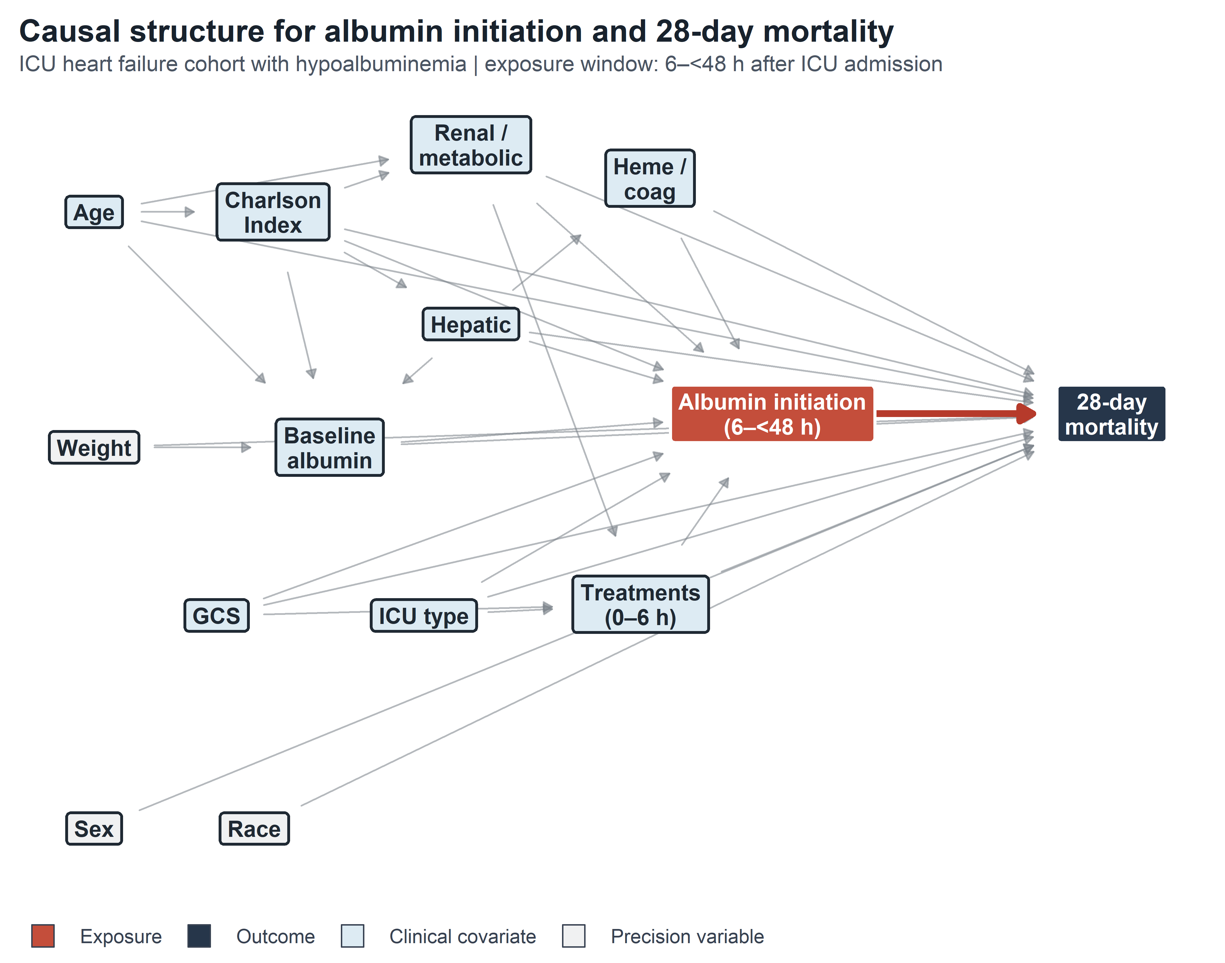
The red arrow represents the causal effect of interest. Gray arrows represent confounding pathways. The minimal sufficient adjustment set identified by the backdoor criterion comprises eight node clusters. Node definitions: Charlson Index = Charlson Comorbidity Index; GCS = Glasgow Coma Scale score; ICU Type = cardiac, surgical/trauma, or medical ICU; Renal/Metabolic = maximum creatinine, BUN, sodium, potassium, chloride, bicarbonate, anion gap, and calcium; Heme/Coag = WBC, hemoglobin, platelets, INR, and aPTT; Hepatic = ALT, AST, ALP, and total bilirubin; Treatments (0–6 h) = furosemide equivalent dose, any diuretic use, vasopressor use and maximum norepinephrine equivalent dose, mechanical ventilation, renal replacement therapy, and urine output rate. Age, glucose, and PT were additional prespecified covariates; sex, race, and weight were precision covariates.

Figure S2. Albumin concentration patterns among patients initiating albumin during 6–<48 hours
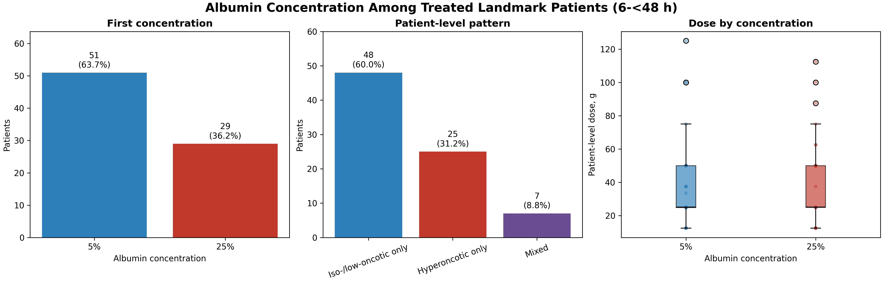
The figure summarizes first albumin concentration, patient-level concentration pattern, and event-level dose/volume distribution among treated patients.
Figure S3. Covariate balance before and after weighting in the 6-hour landmark cohort
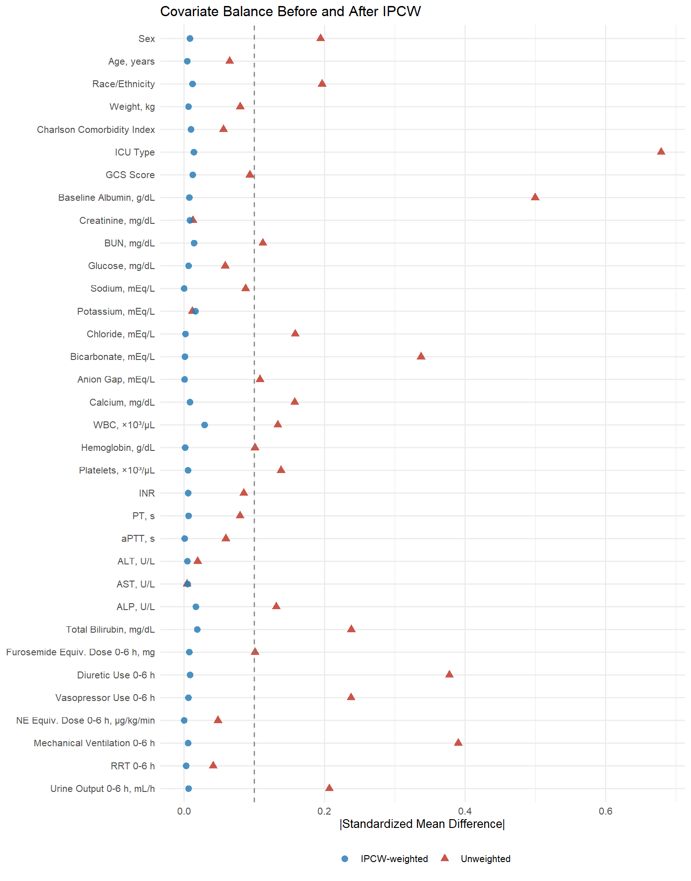

Figure S4. Density Plots Comparing Selected Variables Before and After Imputation
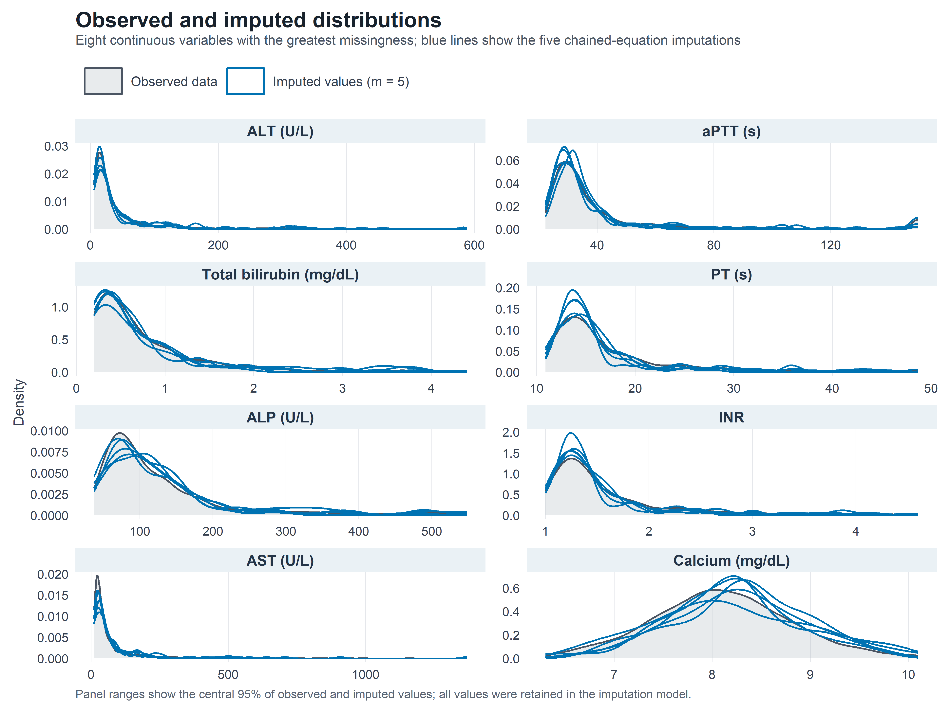
Gray: observed data. Blue: imputed values across the five datasets.

Figure S5. Propensity score density distribution stratified by albumin initiation during 6–<48 hours
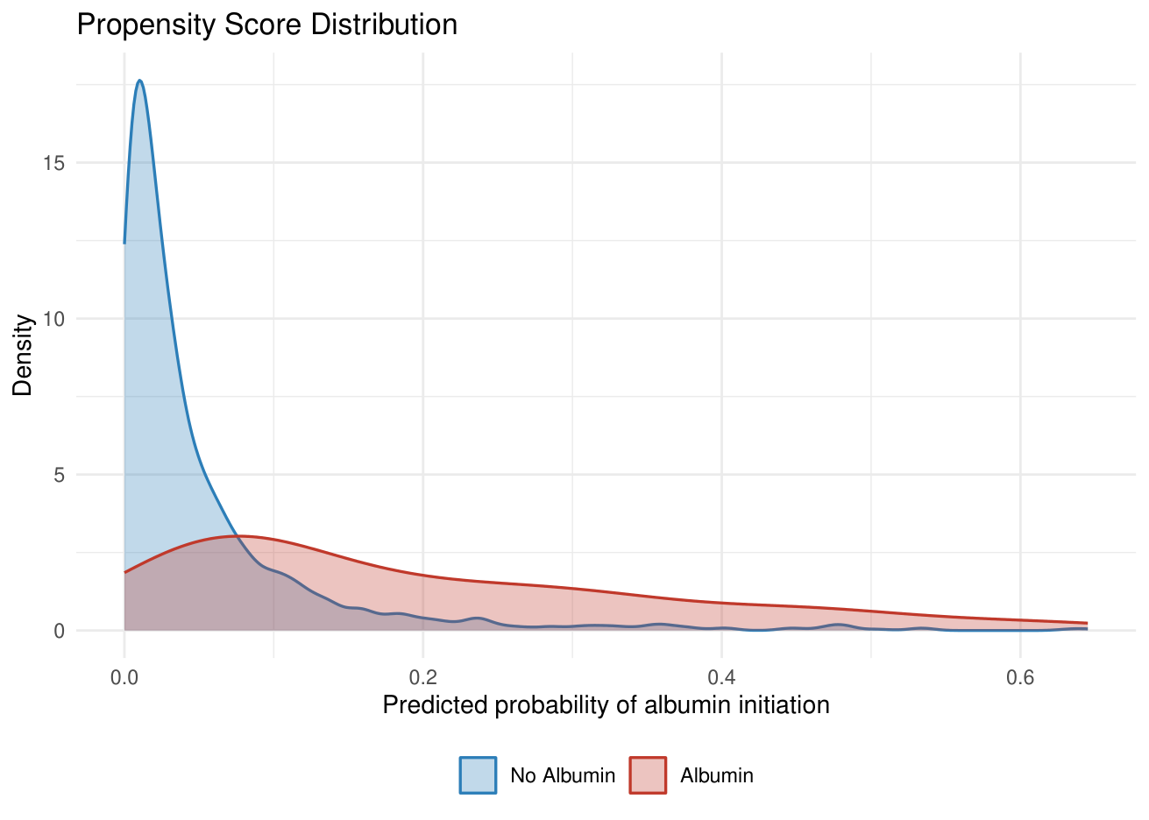
A logistic regression model was fitted with albumin initiation during 6–<48 hours as the dependent variable, adjusting for the prespecified baseline covariates measured before or at the landmark; propensity score distributions showed substantial overall overlap, although selected baseline strata had sparse or no observed exposure (Supplementary Table S9).

Figure S6. Distribution of Artificial Censoring Times Among Strategy B Clones
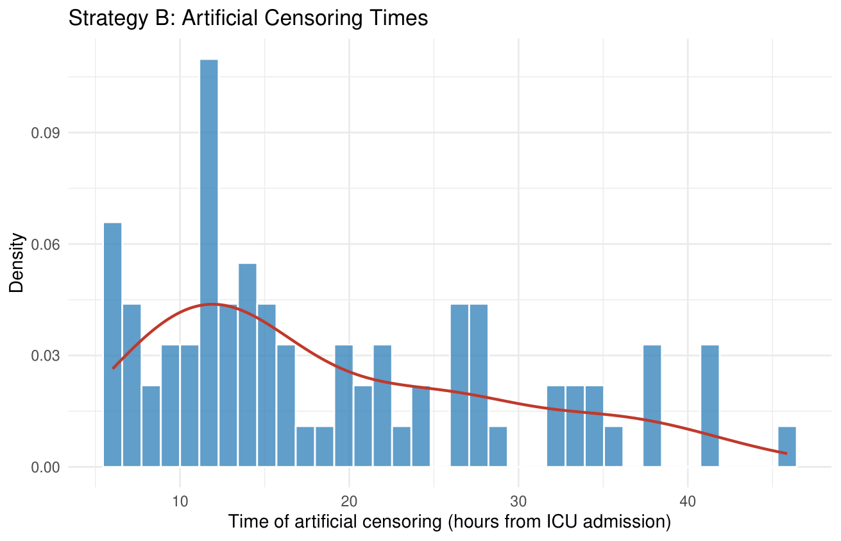

Figure S7. Distribution of Stabilized Inverse Probability of Censoring Weights (Imputed Dataset 1)
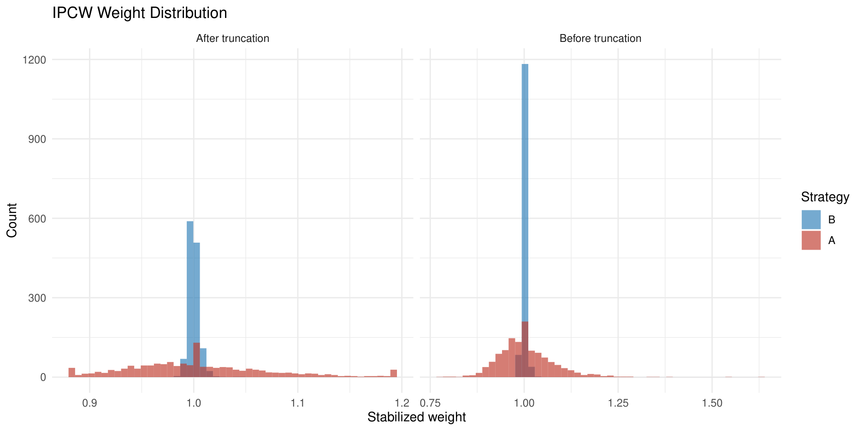
Left panel: after truncation at the 1st/99th percentiles; right panel: before truncation. Red denotes Strategy A (albumin) clones, and blue denotes Strategy B (no albumin) clones. The x-axis represents stabilized weight and the y-axis frequency. In imputed dataset 1, truncation constrained weights to 0.883–1.192. Strategy B weights remained tightly concentrated around 1.0.

Figure S8. Boxplot of Stabilized Weights Stratified by Strategy (Imputed Dataset 1)
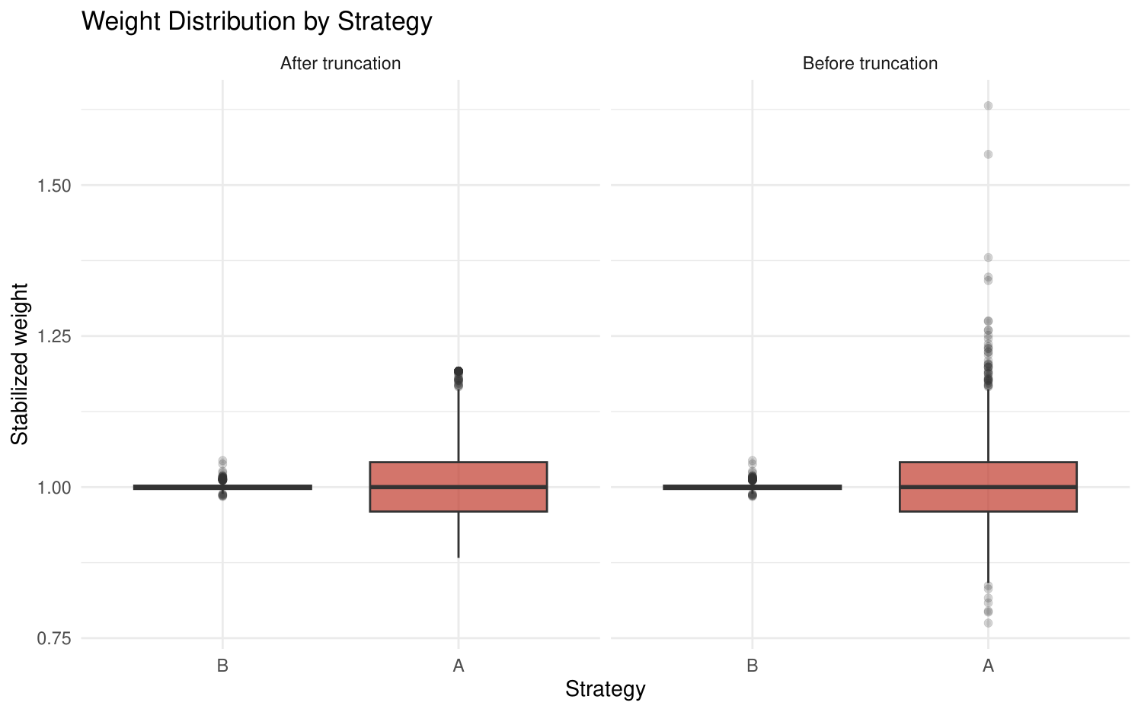
Left panel: after truncation; right panel: before truncation. Boxes represent the interquartile range, horizontal lines denote the median, and individual points indicate outliers. Before truncation, Strategy A showed more extreme outliers; after truncation, these were constrained. Strategy B showed minimal change.

Figure S9. Schoenfeld residual plots for the strategy coefficient at 28 days across five imputed datasets
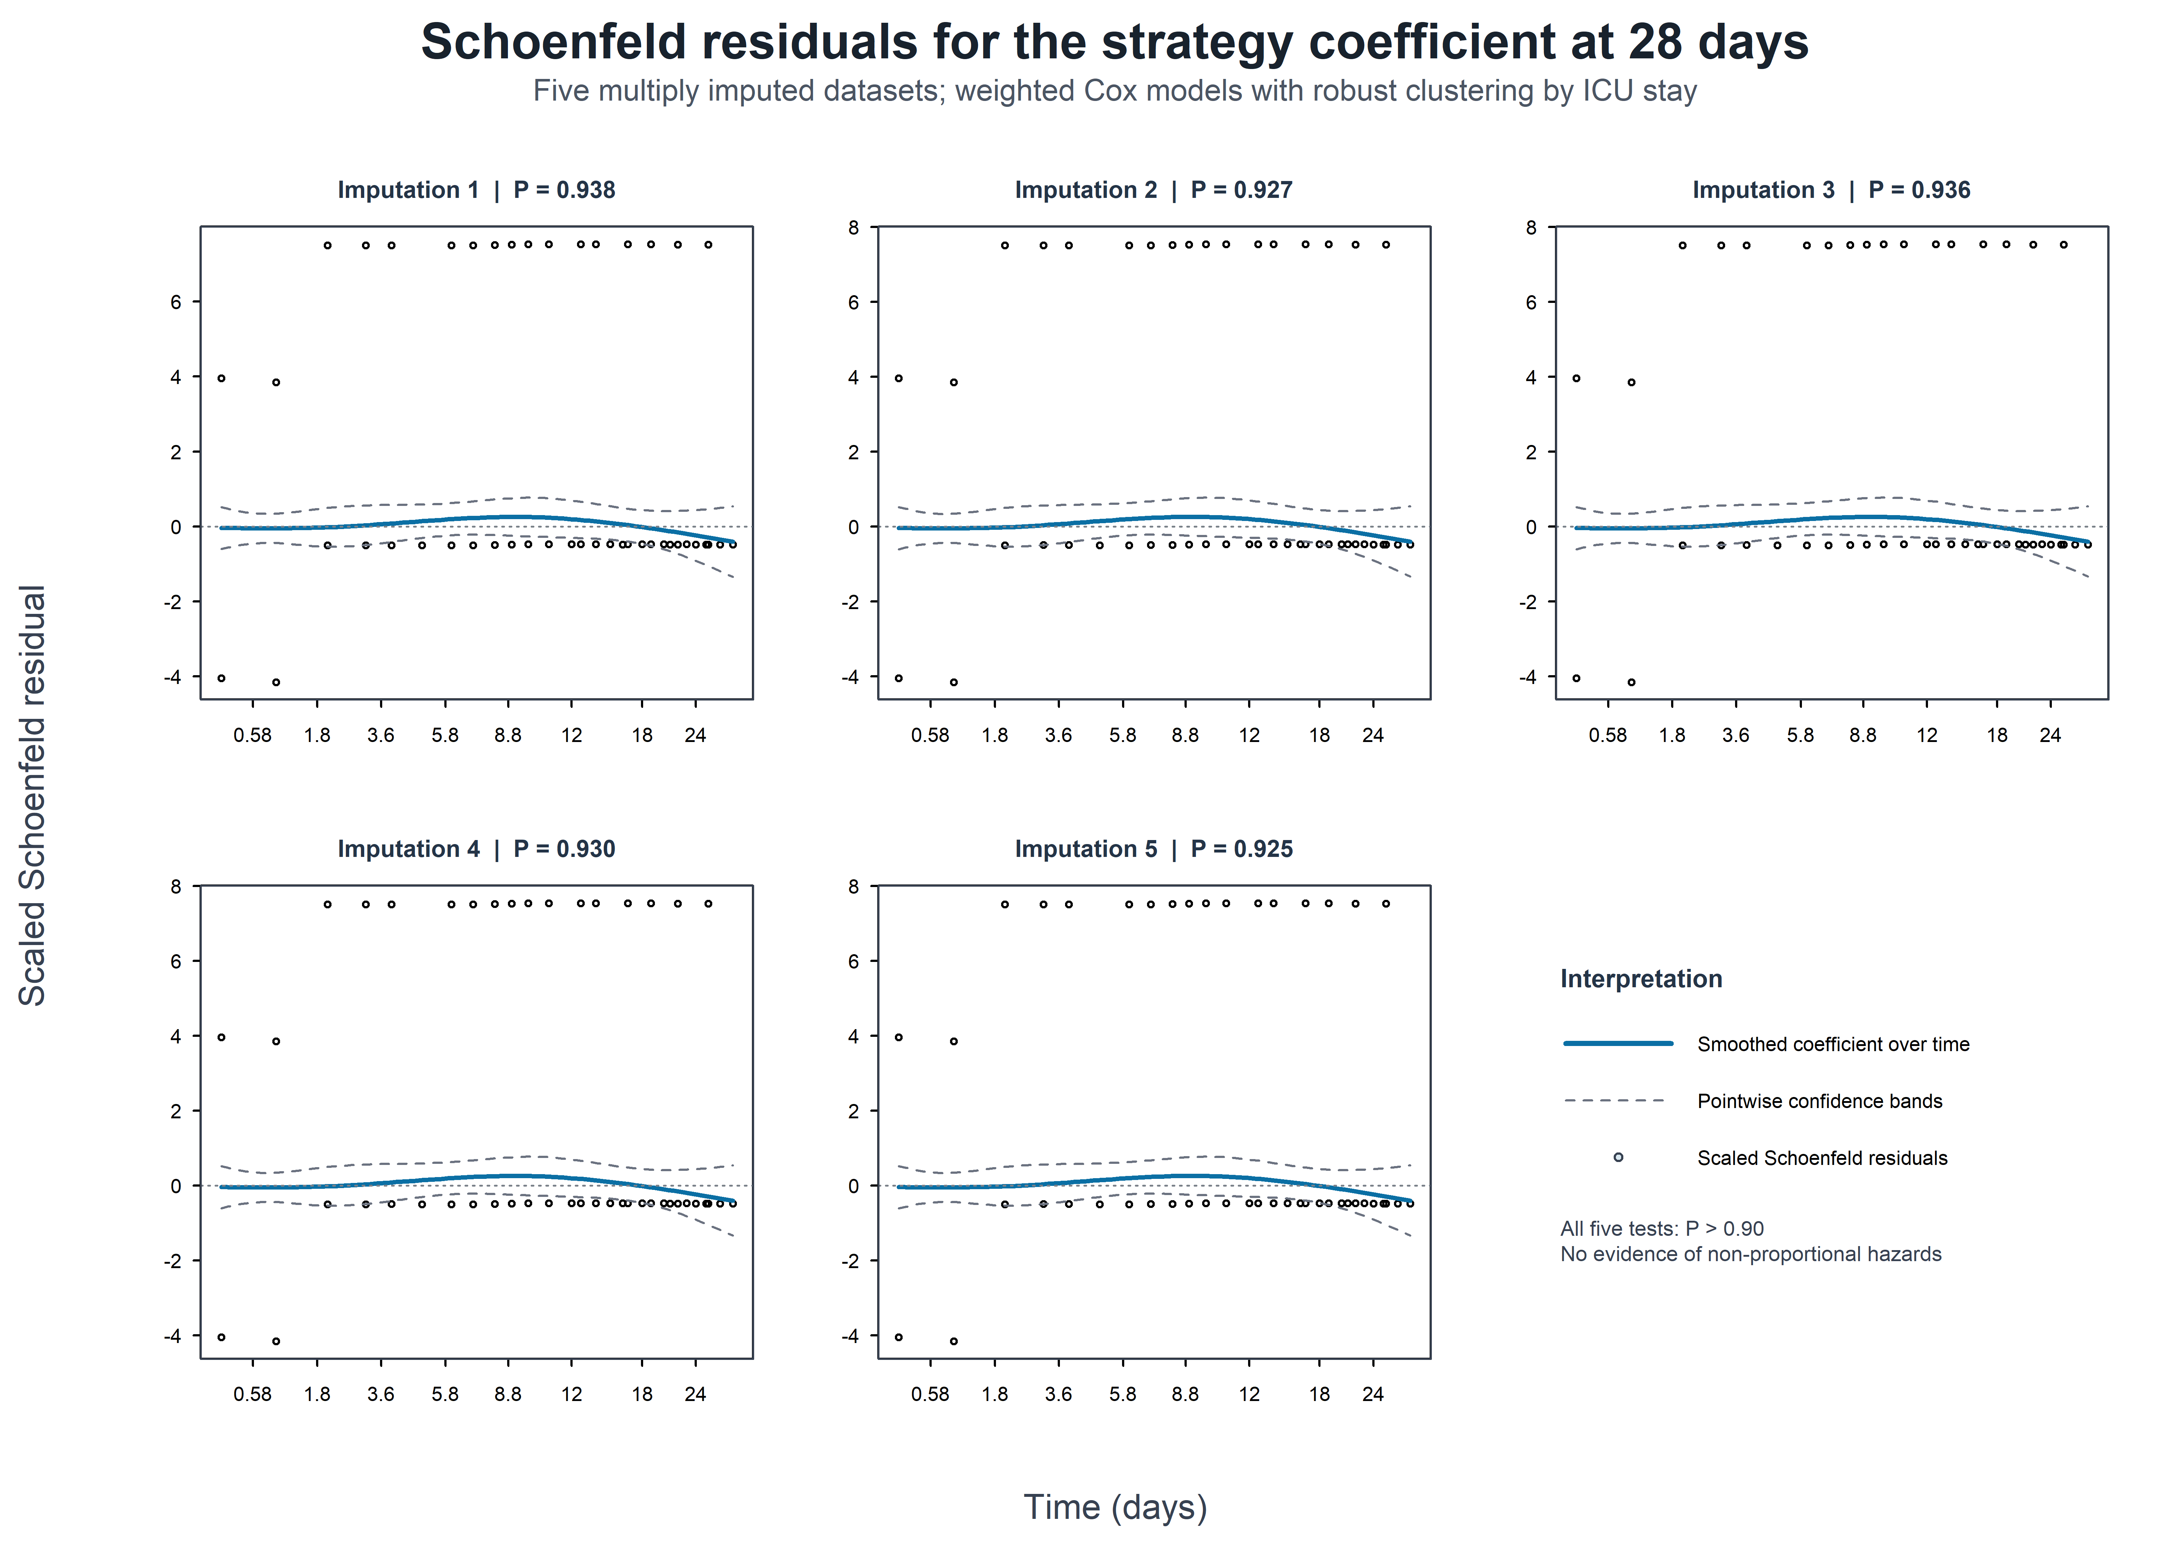
Figure S10. Weighted Kaplan-Meier estimates of 90-day cumulative all-cause mortality in ICU patients with heart failure and hypoalbuminemia: Strategy A (albumin initiation during 6–<48 hours) versus Strategy B (no albumin during 6–<48 hours)
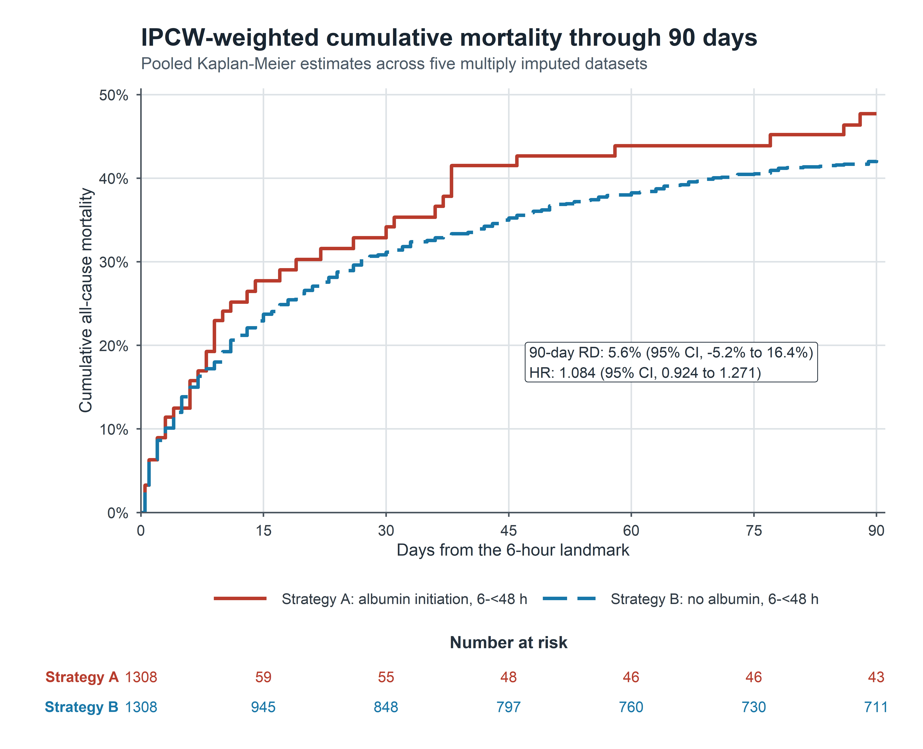

Figure S11. Weighted Kaplan-Meier estimates of 365-day cumulative all-cause mortality in ICU patients with heart failure and hypoalbuminemia: Strategy A (albumin initiation during 6–<48 hours) versus Strategy B (no albumin during 6–<48 hours)
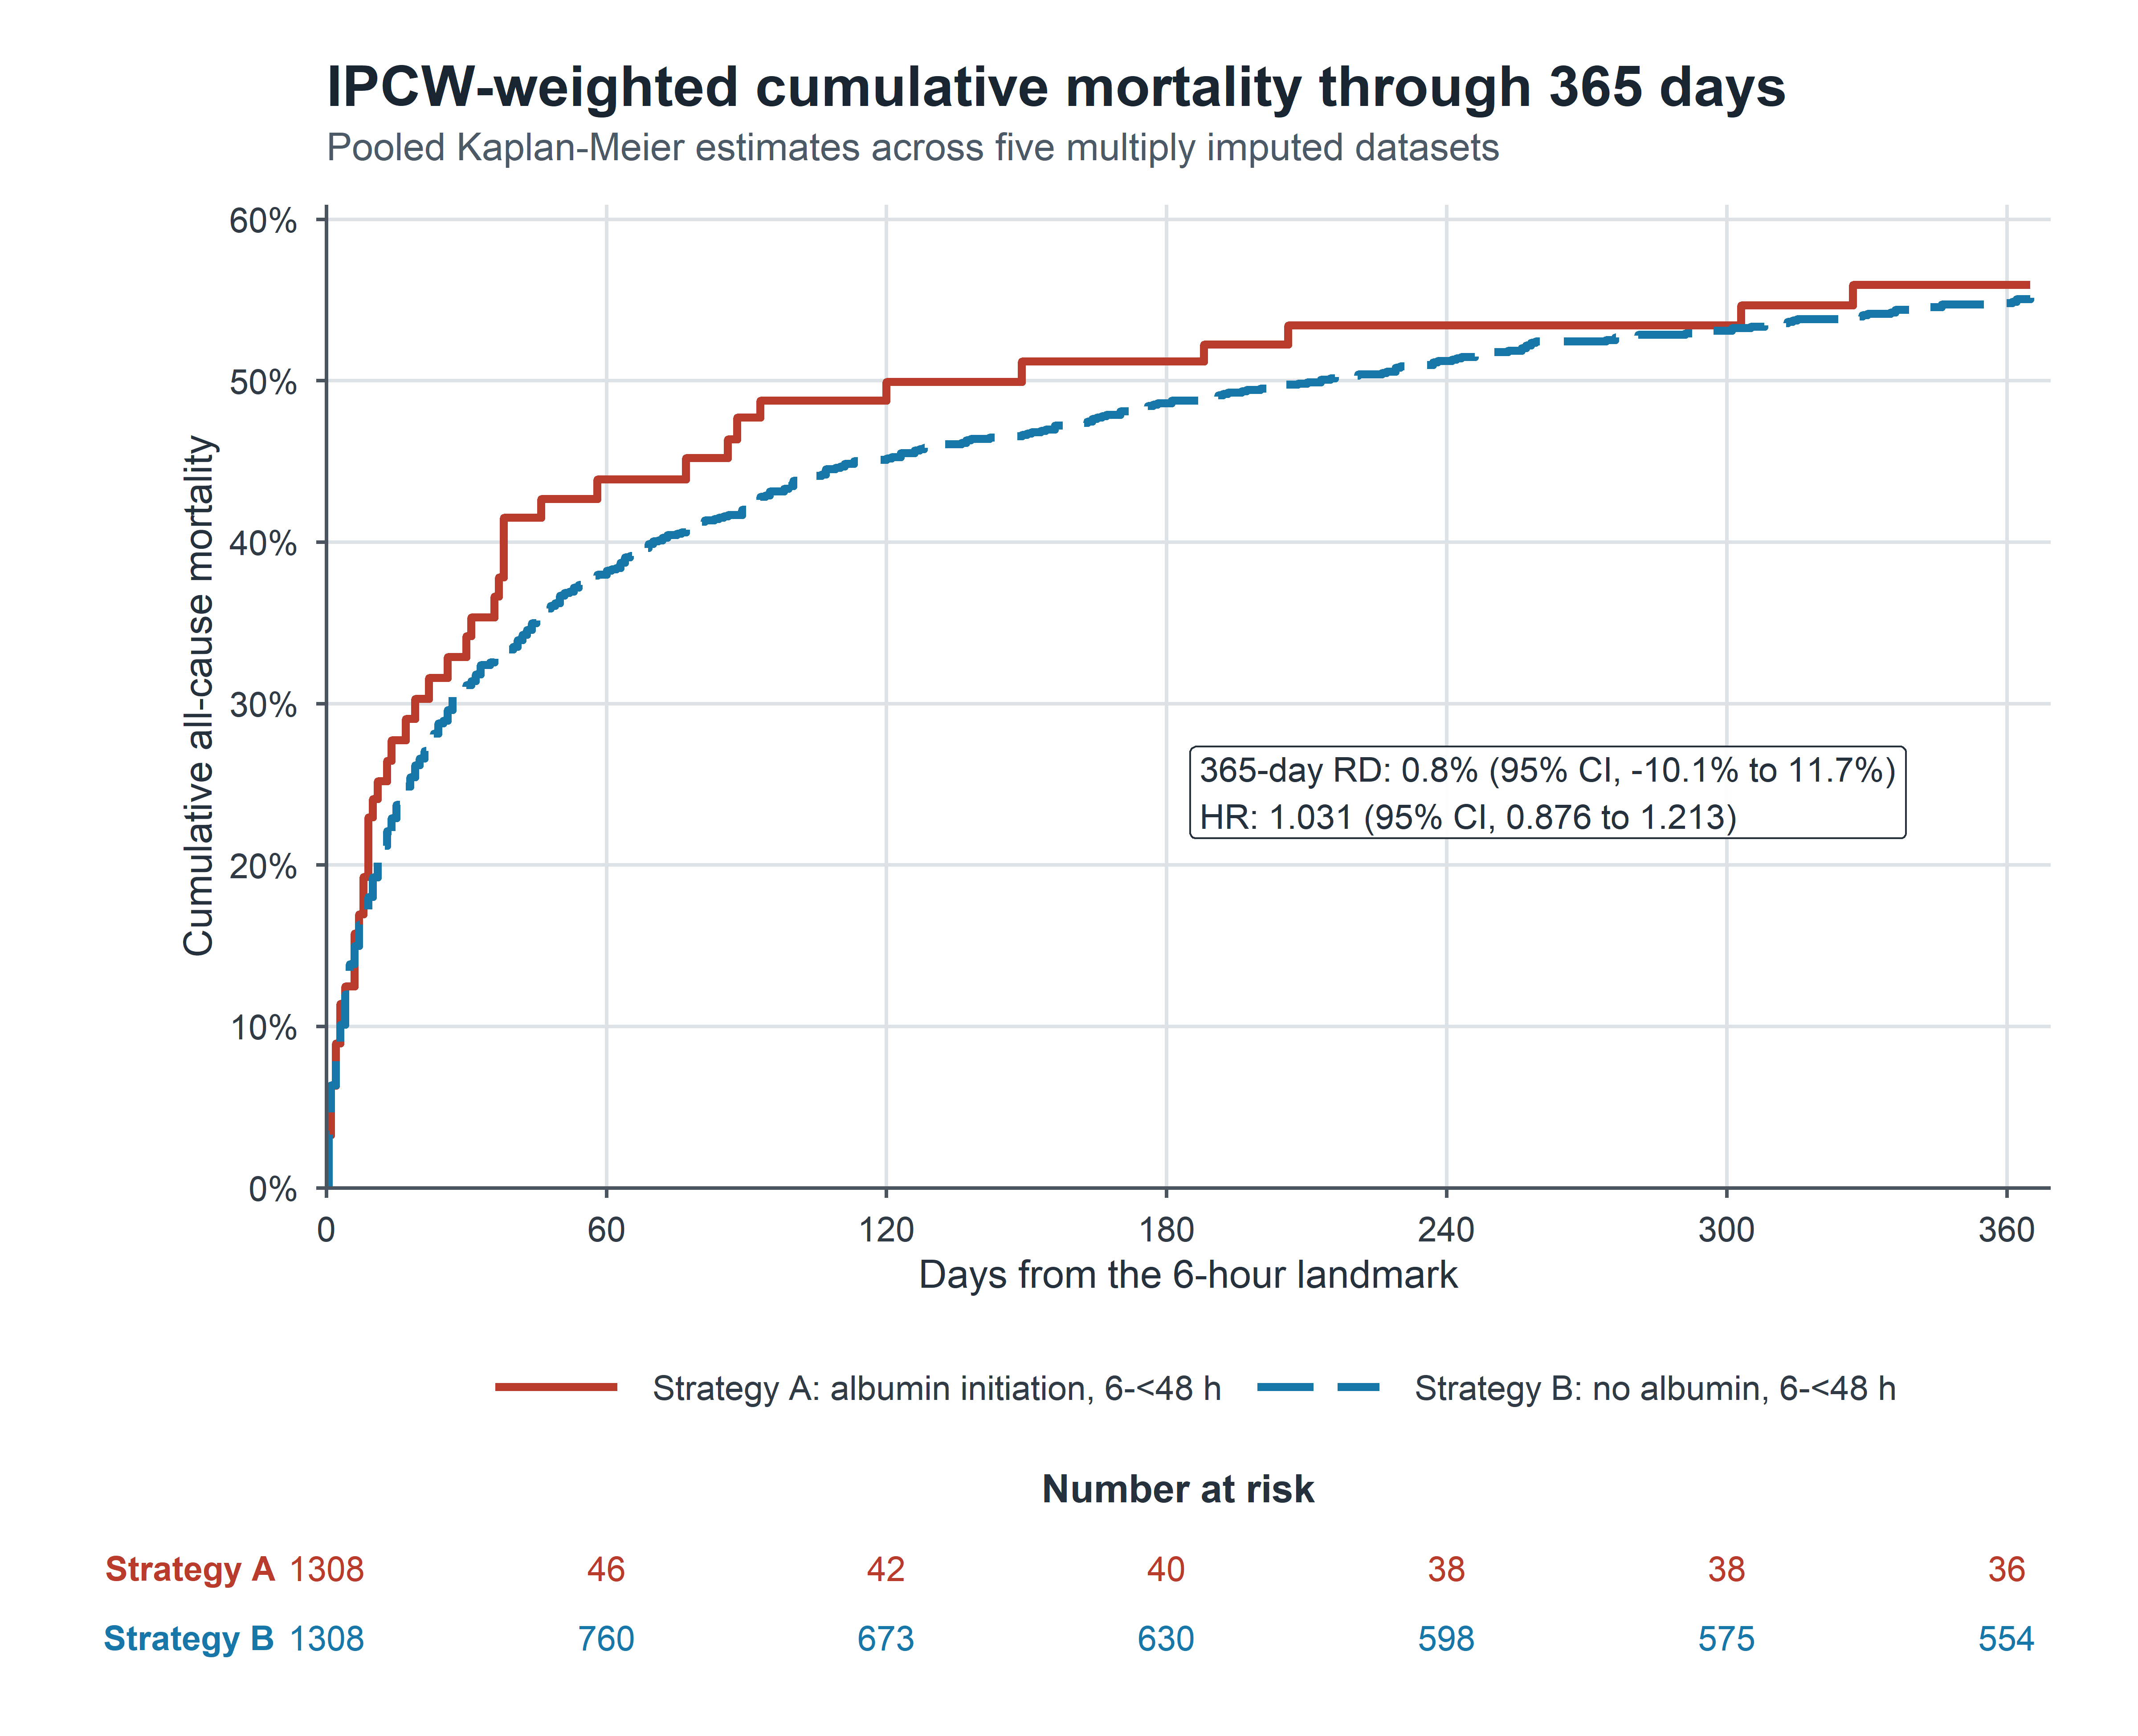

Figure S12. Forest plot of prespecified sensitivity analyses for the 28-day endpoint under the 6-hour landmark design
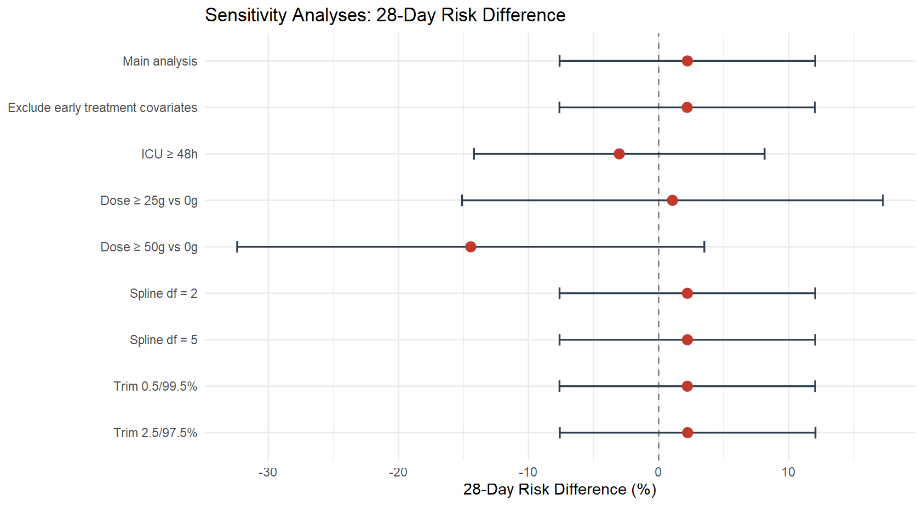

1. Goradia, S., et al., Vasopressor dose equivalence: a scoping review and suggested formula. Journal of Critical Care, 2021. 61: p. 233-240.
2. Jacobs, J.A., et al., Optimal initial intravenous loop diuretic dosing in acute decompensated heart failure. JACC: Advances, 2024. 3(10): p. 101250.
3. Quan, H., et al., Coding algorithms for defining comorbidities in ICD-9-CM and ICD-10 administrative data. Medical care, 2005. 43(11): p. 1130-1139.

