SUPPLEMENTARY MATERIAL

Table S1. Distribution of available Dutch Lipid Clinic Network components
 | Unlikely FH  (n=8174) | Clinically suspected FH
 | Unlikely FH  (n=8174) | Possible  (n=680) | Probable & definite  (n=14)
Premature CAD (2 points) | 2028 (24.8%) | 526 (77.4%) | 13 (92.9%)
Premature stroke/PAD (1 point) | 0 (0.0%) | 72 (10.6%) | 1 (7.1%)
LDL-cholesterol
≥330 mg/dL (8 points) | 0 (0.0%) | 0 (0.0%) | 3 (21.4%)
250–329 mg/dL (5 points) | 0 (0.0%) | 8 (1.2%) | 10 (71.4%)
190–249 mg/dL (3 points) | 0 (0.0%) | 259 (38.1%) | 1 (7.1%)
155–189 mg/dL (1 point) | 545 (6.7%) | 349 (51.3%) | 0 (0.0%)
<155 mg/dL (0 point) | 7629 (93.3%) | 64 (9.4%) | 0 (0.0%)
Total DLCN score | 0 [0, 1] | 3 [3, 4] | 7 [7, 7]
Values are presented as n (%). Data on family history, tendon xanthomas, arcus cornealis, and pathologic variants were not systematically collected and were assigned zero points. FH, familial hypercholesterolemia; CAD, coronary artery disease; PAD, peripheral artery disease, LDL, low-density lipoprotein; DLCN, Dutch Lipid Clinic Network

Table S2. Prevalence of clinically suspected familial hypercholesterolemia after estimation of treatment-naïve low-density lipoprotein cholesterol according to assumed statin intensity among patients with a prior diagnosis of dyslipidemia
 | Unlikely FH | Possible FH | Probable &  definite FH
Unadjusted | 8174 (92.2) | 680 (7.7) | 14 (0.2)
Assuming low-intensity statin use | 7787 (87.8) | 1035 (11.7) | 46 (0.5)
Assuming moderate-intensity statin use | 7600 (85.7) | 1178 (13.3) | 90 (1.0)
Treatment-naïve low-density lipoprotein cholesterol was estimated by dividing measured low-density lipoprotein cholesterol by 0.80 for low-intensity statin therapy and 0.60 for moderate-intensity statin therapy. FH, familial hypercholesterolemia.

Table S3. Baseline characteristics of patients with clinically suspected familial hypercholesterolemia according to the modified Chinese DLCN criteria
Characteristics | Unlikely FH | Clinically suspected FH |  | p-value ª
Characteristics | Unlikely FH | Possible | Probable & definite | p-value ª
Characteristics | (n=5491) | (n=3231) | (n=146) | p-value ª
Age, years | 67.3±10.9 | 56.9±12.7 | 50.0±10.6 | <0.001
Sex |  |  |  | <0.001
Male, n (%) | 3869 (70.5) | 2433 (75.3) | 111 (76.0)
Female, n (%) | 1622 (29.5) | 798 (24.7) | 35 (24.0)
Smoking, n (%) | 2758 (50.2) | 2045 (63.3) | 101 (69.2) | <0.001
Body mass index, kg/m² | 23.8±3.2 | 24.8±3.2 | 25.5±3.1 | <0.001
Hypertension, n (%) | 3134 (57.1) | 1386 (42.9) | 42 (28.8) | <0.001
Diabetes, n (%) | 1881 (34.3) | 811 (25.1) | 28 (19.2) | <0.001
Dyslipidemia, n (%) | 661 (12.0) | 828 (25.6) | 52 (35.6) | <0.001
Statin before admission, n (%) ^{b} | 353 (6.4) | 62 (1.9) | 2 (1.4) | <0.001
Previous MI, n (%) | 273 (5.0) | 74 (2.3) | 3 (2.1) | <0.001
Previous stroke, n (%) | 441 (8.0) | 141 (4.4) | 20 (13.7) | <0.001
Family history of CAD, n (%) ^{b} | 127 (2.3) | 127 (3.9) | 8 (5.5) | <0.001
SBP, mmHg | 127.1±26.3 | 131.5±26.0 | 133.5±27.4 | <0.001
DBP, mmHg | 77.3±16.0 | 80.8±16.3 | 81.6±17.0 | <0.001
Heart rate, n/min | 78.2±19.0 | 78.5±17.2 | 83.4±17.8 | 0.204
WBC count (10⁹/L) | 10.1 [7.8, 12.9] | 10.2 [7.8, 13.1] | 11.0 [8.1, 13.0] | 0.200
Hemoglobin (g/dL) | 13.3±2.1 | 14.3±1.9 | 14.6±2.0 | <0.001
Platelet count (10⁹/L) | 227.8±82.2 | 241.3±61.0 | 256.1±63.3 | <0.001
HbA1c (%) | 6.6±1.5 | 6.6±1.6 | 7.0±1.9 | 0.217
LDL-C (mg/dL) | 93.1±24.8 | 144.0±26.5 | 217.0±42.0 | <0.001
HDL-C (mg/dL) | 40.5±11.3 | 41.7±10.2 | 41.4±10.8 | <0.001
Triglycerides (mg/dL) | 91 [63, 133] | 122 [82, 176] | 142 [104, 200] | <0.001
eGFR (mL/min/1.73m²) | 73.7±23.9 | 84.7±22.4 | 88.9±23.1 | <0.001
Peak CK-MB (ng/mL) | 54.4 [14.5, 164.4] | 73.4 [18.7, 197.2] | 83.0 [19.7, 237.1] | <0.001
LVEF (%) | 53.1±11.4 | 54.5±10.5 | 52.7±11.5 | <0.001
Diagnosis |  |  |  | <0.001
STEMI, n (%) | 2877 (52.4) | 1804 (55.8) | 93 (63.7)
NSTEMI, n (%) | 2614 (47.6) | 1427 (44.2) | 53 (36.3)
Culprit vessel |  |  |  | 0.011
LM or LAD, n (%) | 3269 (59.5) | 2007 (62.1) | 98 (67.1)
LCX, n (%) | 602 (11.0) | 356 (11.0) | 18 (12.3)
RCA, n (%) | 1620 (29.5) | 868 (26.9) | 30 (20.5)
Disease extent |  |  |  | 0.072
1-vessel disease, n (%) | 2543 (46.3) | 1567 (48.5) | 65 (44.5)
2-vessel disease, n (%) | 1833 (33.4) | 1004 (31.1) | 46 (31.5)
3-vessel disease, n (%) | 1115 (20.3) | 660 (20.4) | 35 (24.0)
Multivessel disease, n (%) | 3071 (55.9) | 1709 (52.9) | 85 (58.2) | 0.011
Total stent number, n | 1 [1, 2] | 1 [1, 2] | 1 [1, 2] | 0.114
Total stent length (mm) | 34.2±20.9 | 34.3±20.8 | 37.6±23.5 | 0.662
Mean stent diameter (mm) | 3.0 [2.9, 3.5] | 3.1 [3.0, 3.5] | 3.0 [2.9, 3.5] | <0.001
Complete revascularization, n (%) | 4120 (75.0) | 2506 (77.6) | 116 (79.5) | 0.005
Cardiogenic shock, n (%) | 882 (16.2) | 402 (12.3) | 23 (13.7) | <0.001
Bleeding during admission, n (%) | 213 (3.9) | 78 (2.4) | 5 (3.4) | <0.001
Aspirin, n (%) | 5394 (98.2) | 3187 (98.6) | 143 (97.9) | 0.204
P2Y12 inhibitor, n (%) | 5446 (99.2) | 3210 (99.4) | 145 (99.3) | 0.447
ACEI/ARBs, n (%) | 4262 (77.6) | 2599 (80.4) | 113 (77.4) | 0.003
Beta-blockers, n (%) | 4476 (86.5) | 2762 (88.5) | 142 (86.6) | 0.028
Statins, n (%) | 4824 (95.3) | 3051 (97.3) | 155 (99.4) | <0.001
Statin dose, mg ^{c} | 20 [10, 20] | 20 [10, 20] | 20 [10, 40] | <0.001
High-intensity statins, n (%) | 969 (17.6) | 757 (23.4) | 49 (33.6) | <0.001
Ezetimibe, n (%) | 77 (1.4) | 62 (1.9) | 1 (0.7) | 0.107
a. for comparison between patients with clinically suspected FH and those with unlikely FH. b. patients with unknown status were classified as negative. c. conversion to equivalent doses of atorvastatin. FH, familial hypercholesterolemia; MI, myocardial infarction; SBP, systolic blood pressure; DBP, diastolic blood pressure, HbA1c, glycated hemoglobin; LDL-C, low-density lipoprotein cholesterol; HDL-C, high-density lipoprotein cholesterol; eGFR, estimated glomerular filtration rate; CK-MB, creatine kinase myocardial band; LVEF, left ventricular ejection fraction; STEMI, ST-segment elevation myocardial infarction; NSTEMI, non ST-segment elevation myocardial infarction; LM, left main; LAD, left anterior descending; LCX, left circumflex; RCA, right coronary artery; ACEI, angiotensin-converting-enzyme inhibitor; ARB, angiotensin II receptor blocker.

Table S4. Clinical outcomes according to clinically suspected familial hypercholesterolemia status
 | Unlikely FH | Clinically suspected FH |  | p-value ª
 | Unlikely FH | Possible | Probable & definite | p-value ª
CV death | 1233 (15.1) | 46 (6.8) | 1 (7.1) | <0.001
Recurrent MI | 426 (5.2) | 34 (5.0) | 1 (7.1) | 0.918
Revascularization | 1200 (14.7) | 133 (19.6) | 3 (21.4) | 0.001
Coronary events | 2356 (28.8) | 173 (25.4) | 4 (28.6) | 0.070
CV death or recurrent MI | 1561 (19.1) | 77 (11.3) | 2 (14.3) | <0.001
a. for comparison between patients with FH and unlikely FH. FH, familial hypercholesterolemia; CV, cardiovascular; MI, myocardial infarction

Table S5. Cardiovascular death or recurrent myocardial infarction according to clinically suspected familial hypercholesterolemia
 | HR (95% CI) | p-value
Unadjusted | 0.57 (0.46, 0.72) | <0.001
Model 1ª | 1.05 (0.83, 1.32) | 0.674
Model 2^{b} | 1.13 (0.88, 1.44) | 0.343
Model 3^{c} | 1.26 (0.89, 1.76) | 0.190
Model 4^{d} | 1.34 (0.96, 1.88) | 0.089
Overlap-weighted^{e} | 1.05 (0.82, 1.34) | 0.688
a. adjusted for age, sex, and center. b. further adjusted for smoking, body-mass index, hypertension, diabetes, dyslipidemia, previous myocardial infarction, previous stroke, and family history of coronary artery disease. c. further adjusted for systolic blood pressure, heart rate, hemoglobin, leukocyte count, low-density lipoprotein cholesterol, high-density lipoprotein cholesterol, triglycerides, glycated hemoglobin, estimated glomerular filtration rate, peak creatine kinase myocardial band, left ventricular ejection fraction, cardiogenic shock, and final diagnosis. d. further adjusted for culprit vessel, disease extent, complete revascularization, total stent length, mean stent diameter, use of dual antiplatelets, renin-angiotensin system blockers, and beta-blockers at discharge, and statin dose at discharge. e. Estimated using overlap weights derived from a propensity-score model including age modeled with natural cubic splines, sex, center, smoking, body mass index, hypertension, diabetes, dyslipidemia, previous myocardial infarction, previous stroke, and documented family history of coronary artery disease. Patients with clinically suspected FH were weighted by 1−PS and those with unlikely FH by PS. Robust sandwich standard errors were used. Model 2 was designated as the primary clinical model. Models 3 and 4 were considered conditional sensitivity models because they additionally incorporated low-density lipoprotein cholesterol, which contributed to familial hypercholesterolemia ascertainment, and variables that may lie downstream of the clinically suspected phenotype. HR, hazard ratio; CI, confidence interval.

Table S6. Covariate balance before and after overlap-weighted propensity-score adjustment
Covariate | SMD before | SMD after
Age | -1.025 | <0.001
Male sex | 0.115 | <0.001
Smoking | 0.245 | <0.001
Body mass index | 0.351 | <0.001
Hypertension | -0.420 | <0.001
Diabetes | -0.213 | <0.001
Previous dyslipidemia | 0.537 | <0.001
Previous myocardial infarction | -0.054 | <0.001
Previous stroke | 0.161 | <0.001
Documented family history of coronary artery disease | 0.131 | <0.001
Center: A | 0.051 | <0.001
Center: B | 0.014 | <0.001
Center: C | 0.013 | <0.001
Center: D | -0.135 | <0.001
Center: E | 0.075 | <0.001
Center: F | -0.042 | <0.001
Center: G | 0.017 | <0.001
Center: H | 0.028 | <0.001
Center: I | 0.033 | <0.001

Table S7. Clinical outcomes according to the presence of probable or definite familial hypercholesterolemia after estimation of treatment-naïve low-density lipoprotein cholesterol according to assumed statin intensity among patients with a prior diagnosis of dyslipidemia
 | Composite coronary events |  | Cardiovascular mortality |  | Recurrent MI |  | Revascularization
 | HR (95% CI) | p-value | HR (95% CI) | p-value | HR (95% CI) | p-value | HR (95% CI) | p-value
Unadjusted | 1.30 (0.82, 2.07) | 0.268 | 0.36 (0.12, 1.12) | 0.078 | 1.83 (0.76, 4.42) | 0.179 | 2.06 (1.24, 3.42) | 0.006
Model 1ª | 2.06 (1.29, 3.29) | 0.002 | 1.33 (0.43, 4.14) | 0.623 | 2.04 (0.84, 4.95) | 0.117 | 1.86 (1.11, 3.11) | 0.018
Model 2^{b} | 2.14 (1.34, 3.42) | 0.001 | 1.52 (0.49, 4.74) | 0.472 | 2.06 (0.85, 5.02) | 0.112 | 1.84 (1.10, 3.08) | 0.020
Model 3^{c} | 1.91 (1.18, 3.10) | 0.009 | 1.38 (0.45, 4.29) | 0.575 | 2.14 (0.84, 5.44) | 0.112 | 1.58 (0.92, 2.73) | 0.096
Model 4^{d} | 1.71 (1.07, 2.73) | 0.025 | 1.26 (0.40, 4.01) | 0.697 | 1.96 (0.76, 5.04) | 0.161 | 1.20 (0.69, 2.07) | 0.515
a. adjusted for age, sex, and center. b. further adjusted for smoking, body-mass index, hypertension, diabetes, dyslipidemia, previous myocardial infarction, previous stroke, and family history of coronary artery disease. c. further adjusted for systolic blood pressure, heart rate, hemoglobin, leukocyte count, low-density lipoprotein cholesterol, high-density lipoprotein cholesterol, triglycerides, glycated hemoglobin, estimated glomerular filtration rate, peak creatine kinase myocardial band, left ventricular ejection fraction, cardiogenic shock, and final diagnosis. d. further adjusted for culprit vessel, disease extent, complete revascularization, total stent length, mean stent diameter, use of dual antiplatelets, renin-angiotensin system blockers, and beta-blockers at discharge, and statin dose at discharge. HR, hazard ratio; CI, confidence interval; MI, myocardial infarction.

Table S8. Clinical outcomes according to clinically suspected familial hypercholesterolemia according to the modified Chinese DLCN criteria
 | Composite coronary events |  | Cardiovascular mortality |  | Recurrent MI |  | Revascularization
 | HR (95% CI) | p-value | HR (95% CI) | p-value | HR (95% CI) | p-value | HR (95% CI) | p-value
Unadjusted | 0.76 (0.70, 0.82) | <0.001 | 0.50 (0.44, 0.56) | <0.001 | 0.89 (0.74, 1.08) | 0.248 | 1.06 (0.95, 1.18) | 0.324
Model 1ª | 1.03 (0.95, 1.13) | 0.472 | 0.97 (0.85, 1.10) | 0.627 | 0.97 (0.79, 1.19) | 0.741 | 0.97 (0.86, 1.10) | 0.647
Model 2^{b} | 1.08 (0.99, 1.19) | 0.084 | 1.06 (0.92, 1.21) | 0.418 | 1.03 (0.83, 1.28) | 0.774 | 0.99 (0.87, 1.12) | 0.847
Model 3^{c} | 1.15 (1.02, 1.30) | 0.028 | 1.39 (1.22, 1.57) | <0.001 | 1.13 (0.84, 1.50) | 0.416 | 0.87 (0.74, 1.03) | 0.096
Model 4^{d} | 1.15 (1.01, 1.30) | 0.030 | 1.39 (1.15, 1.68) | <0.001 | 1.15 (0.86, 1.53) | 0.354 | 0.87 (0.74, 1.03) | 0.108
a. adjusted for age, sex, and center. b. further adjusted for smoking, body-mass index, hypertension, diabetes, dyslipidemia, previous myocardial infarction, previous stroke, and family history of coronary artery disease. c. further adjusted for systolic blood pressure, heart rate, hemoglobin, leukocyte count, low-density lipoprotein cholesterol, high-density lipoprotein cholesterol, triglycerides, glycated hemoglobin, estimated glomerular filtration rate, peak creatine kinase myocardial band, left ventricular ejection fraction, cardiogenic shock, and final diagnosis. d. further adjusted for culprit vessel, disease extent, complete revascularization, total stent length, mean stent diameter, use of dual antiplatelets, renin-angiotensin system blockers, and beta-blockers at discharge, and statin dose at discharge. HR, hazard ratio; CI, confidence interval; MI, myocardial infarction.

Table S9. Fine-Gray analysis for clinical outcomes according to clinically suspected familial hypercholesterolemia
 | Composite coronary events |  | Cardiovascular mortality |  | Recurrent MI |  | Revascularization
 | sHR (95% CI) | p-value | sHR (95% CI) | p-value | sHR (95% CI) | p-value | sHR (95% CI) | p-value
Unadjusted | 0.88 (0.76, 1.03) | 0.107 | 0.43 (0.32, 0.57) | <0.001 | 0.98 (0.70, 1.38) | 0.917 | 1.40 (1.17, 1.66) | <0.001
Model 1ª | 1.26 (1.08, 1.48) | 0.004 | 1.01 (0.74, 1.38) | 0.951 | 0.98 (0.69, 1.40) | 0.914 | 1.19 (1.00, 1.43) | 0.056
Model 2^{b} | 1.31 (1.12, 1.54) | <0.001 | 1.12 (0.83, 1.52) | 0.445 | 1.00 (0.70, 1.44) | 0.980 | 1.20 (0.99, 1.44) | 0.060
Model 3^{c} | 1.28 (1.07, 1.54) | 0.008 | 1.20 (0.86, 1.68) | 0.275 | 0.99 (0.65, 1.51) | 0.953 | 1.10 (0.89, 1.37) | 0.385
Model 4^{d} | 1.29 (1.08, 1.55) | 0.006 | 1.22 (0.88, 1.70) | 0.242 | 0.98 (0.64, 1.50) | 0.928 | 1.07 (0.86, 1.33) | 0.544
a. adjusted for age, sex, and center. b. further adjusted for smoking, body-mass index, hypertension, diabetes, dyslipidemia, previous myocardial infarction, previous stroke, and family history of coronary artery disease. c. further adjusted for systolic blood pressure, heart rate, hemoglobin, leukocyte count, low-density lipoprotein cholesterol, high-density lipoprotein cholesterol, triglycerides, glycated hemoglobin, estimated glomerular filtration rate, peak creatine kinase myocardial band, left ventricular ejection fraction, cardiogenic shock, and final diagnosis. d. further adjusted for culprit vessel, disease extent, complete revascularization, total stent length, mean stent diameter, use of dual antiplatelets, renin-angiotensin system blockers, and beta-blockers at discharge, and statin dose at discharge. sHR, subdistribution hazard ratio; CI, confidence interval; MI, myocardial infarction.

Table S10. Baseline characteristics of patients with clinically suspected familial hypercholesterolemia according to coronary artery disease extent
Characteristics | 1-vessel disease | 2-vessel disease | 3-vessel disease | p-value
Characteristics | (n=337) | (n=203) | (n=154) | p-value
DLCN criteria |  |  |  | 0.278
Definite & probable | 4 (1.2) | 5 (2.5) | 5 (3.2)
Possible | 333 (98.8) | 198 (97.5) | 149 (96.8)
Age, years | 50.4±11.3 | 52.9±10.3 | 54.5±12.2 | <0.001
Sex |  |  |  | 0.070
Male, n (%) | 272 (80.7) | 150 (73.9) | 112 (72.7)
Female, n (%) | 65 (19.3) | 53 (26.1) | 42 (27.3)
Smoking, n (%) | 235 (69.7) | 131 (64.5) | 94 (61.0) | 0.138
Body mass index, kg/m² | 25.4±3.2 | 25.2±3.4 | 25.2±3.0 | 0.679
Hypertension, n (%) | 110 (32.6) | 65 (32.0) | 52 (33.8) | 0.940
Diabetes, n (%) | 58 (17.2) | 47 (23.2) | 48 (31.2) | 0.002
Dyslipidemia, n (%) | 147 (43.6) | 79 (38.9) | 42 (27.3) | 0.003
Statin before admission, n (%) ª | 8 (2.4) | 7 (3.4) | 0 (0.0) | 0.080
Previous MI, n (%) | 14 (4.2) | 3 (1.5) | 4 (2.6) | 0.200
Previous stroke, n (%) | 36 (10.7) | 21 (10.3) | 19 (12.3) | 0.817
Family history of CAD, n (%) | 17 (5.0) | 11 (5.4) | 9 (5.8) | 0.933
SBP, mmHg | 133.8±24.0 | 129.5±27.0 | 134.2±25.4 | 0.112
DBP, mmHg | 83.1±15.0 | 79.1±16.3 | 81.0±15.6 | 0.015
Heart rate, n/min | 80.5±16.4 | 79.7±18.9 | 79.9±17.3 | 0.833
WBC count (10⁹/L) | 10.8 [7.8, 13.2] | 10.2 [7.9, 13.5] | 9.5 [7.6, 12.7] | 0.263
Hemoglobin (g/dL) | 14.6±1.8 | 14.4±2.0 | 14.5±1.9 | 0.387
Platelet (10⁹/L) | 253.3±61.7 | 251.7±67.2 | 245.0±58.5 | 0.387
HbA1c (%) | 6.7±1.7 | 6.8±1.7 | 7.0±1.8 | 0.322
LDL-C (mg/dL) | 177.2±35.2 | 183.7±39.4 | 188.8±41.8 | 0.005
HDL-C (mg/dL) | 42.1±10.2 | 42.1±10.9 | 41.2±9.9 | 0.625
Triglycerides (mg/dL) | 140 [94, 198] | 135 [92, 190] | 134 [94, 192] | 0.828
eGFR (mL/min/1.73m²) | 90.7±22.0 | 87.3±22.3 | 80.9±24.0 | <0.001
Peak CK-MB (ng/mL) | 83.1 [20.7, 211.6] | 76.2 [21.2, 200.0] | 81.1 [20.6, 203.3] | 0.876
Left ventricular ejection fraction (%) | 54.7±10.3 | 53.3±11.7 | 52.8±11.5 | 0.154
Diagnosis |  |  |  | 0.722
STEMI, n (%) | 197 (58.5) | 112 (55.2) | 86 (55.8)
NSTEMI, n (%) | 140 (41.5) | 91 (44.8) | 68 (44.2)
Culprit vessel |  |  |  | 0.161
LM or LAD, n (%) | 206 (61.1) | 130 (64.0) | 94 (61.0)
LCX, n (%) | 52 (15.4) | 19 (9.4) | 15 (9.7)
RCA, n (%) | 79 (23.4) | 54 (26.6) | 45 (29.2)
Multivessel disease, n (%) | 15 (4.5) | 203 (100.0) | 154 (100.0) | <0.001
Total stent number, n | 1 [1, 1] | 2 [1, 2] | 2 [1, 3] | <0.001
Total stent length (mm) | 24.3±9.4 | 40.1±21.0 | 51.2±29.2 | <0.001
Mean stent diameter (mm) | 3.2 [3.0, 3.5] | 3.0 [2.9, 3.5] | 3.0 [2.9, 3.2] | <0.001
Complete revascularization, n (%) | 337 (100.0) | 108 (53.7) | 95 (62.9) | <0.001
Cardiogenic shock, n (%) | 37 (11.0) | 22 (10.8) | 19 (12.3) | 0.886
Bleeding during admission, n (%) | 6 (1.8) | 10 (4.9) | 5 (3.2) | 0.116
Aspirin, n (%) | 334 (99.1) | 199 (98.0) | 152 (98.7) | 0.561
P2Y12 inhibitor, n (%) | 336 (99.7) | 202 (99.5) | 153 (99.4) | 0.848
ACEI/ARBs, n (%) | 265 (78.6) | 161 (79.3) | 122 (79.2) | 0.979
Beta-blockers, n (%) | 288 (90.6) | 173 (88.3) | 136 (90.1) | 0.699
Statins, n (%) | 317 (98.4) | 189 (99.0) | 144 (97.3) | 0.486
Statin dose, mg ^{b} | 20 [10, 20] | 20 [10, 40] | 20 [10, 40] | 0.597
High-intensity statins, n (%) | 81 (24.0) | 54 (26.6) | 41 (26.6) | 0.738
Ezetimibe, n (%) | 8 (2.4) | 0 (0.0) | 3 (1.9) | 0.093
a. patients with unknown status were classified as negative. b. conversion to equivalent doses of atorvastatin.
DLCN, Dutch Lipid Clinic Network; MI, myocardial infarction; SBP, systolic blood pressure; DBP, diastolic blood pressure, HbA1c, glycated hemoglobin; LDL, low-density lipoprotein cholesterol; HDL, high-density lipoprotein cholesterol; eGFR, estimated glomerular filtration rate; CK-MB, creatine kinase myocardial band; LVEF, left ventricular ejection fraction; STEMI, ST-segment elevation myocardial infarction; NSTEMI, non ST-segment elevation myocardial infarction; LM, left main; LAD, left anterior descending; LCX, left circumflex; RCA, right coronary artery; ACEI, angiotensin-converting-enzyme inhibitor; ARB, angiotensin II receptor blocker.

Table S11. Factors associated with multivessel coronary artery disease in patients with clinically suspected familial hypercholesterolemia
Characteristics | Univariable |  | Multivariable
Characteristics | OR (95% CI) | p-value | OR (95% CI) | p-value
Age (per 10 years) | 1.07 (1.03, 1.10) | <0.001 | 1.05 (1.01, 1.09) | 0.044
Sex | 0.91 (0.83, 0.99) | 0.022 | 1.00 (0.89, 1.12) | 0.969
Smoking | 0.93 (0.86, 1.00) | 0.062 | 0.99 (0.90, 1.08) | 0.789
BMI (per 1kg/m²) | 1.00 (0.98, 1.01) | 0.379
Hypertension | 1.00 (0.93, 1.08) | 0.970 | 0.97 (0.89, 1.06) | 0.475
Diabetes | 1.15 (1.05, 1.25) | 0.003 | 1.12 (1.02, 1.23) | 0.015
Dyslipidemia | 0.90 (0.84, 0.97) | 0.008 | 0.90 (0.83, 0.97) | 0.008
Family history of CAD | 1.03 (0.87, 1.21) | 0.744
Previous MI | 0.83 (0.69, 1.03) | 0.092
SBP (per 10 mmHg) | 0.99 (0.96, 1.01) | 0.357
Hemoglobin (per 1 g/dL) | 0.99 (0.97, 1.01) | 0.227
HbA1c (per 1 %) | 1.01 (0.99, 1.04) | 0.223
LDL-C (per 50 mg/dL) | 1.08 (1.03, 1.13) | 0.003 | 1.06 (1.01, 1.12) | 0.027
HDL-C (per 10 mg/dL) | 0.99 (0.96, 1.03) | 0.587 | 0.96 (0.93, 1.00) | 0.054
Triglycerides (per 10mg/dL) | 1.00 (0.99, 1.01) | 0.493
eGFR (per 10 mL/min/1.73m²) | 0.97 (0.96, 0.99) | <0.001 | 0.99 (0.97, 1.01) | 0.445
OR, odds ratio; CI, confidence interval; BMI, body-mass index; CAD, coronary artery disease; MI, myocardial infarction; SBP, systolic blood pressure; HbA1c, glycated hemoglobin; LDL-C, low-density lipoprotein cholesterol; HDL-C, high-density lipoprotein cholesterol; eGFR, estimated glomerular filtration rate.

Table S12. Association of multivessel coronary artery disease with coronary events in patients with clinically suspected familial hypercholesterolemia
 | Hazard ratio (95% CI) ª | p-value
Unadjusted | 1.74 (1.28, 2.37) | <0.001
Model 1 ^{b} | 1.54 (1.12, 2.12) | 0.008
Model 2 ^{c} | 1.41 (1.01, 1.96) | 0.044
a. Hazard ratios are expressed relative to patients without multivessel coronary artery disease (reference group). b. adjusted for age, sex, smoking, hypertension, diabetes, dyslipidemia, low-density lipoprotein cholesterol, high-density lipoprotein cholesterol, and estimated glomerular filtration rate. c. further adjusted for left ventricular ejection fraction, final diagnosis, culprit vessel, complete revascularization, total stent length, mean stent diameter, and statin dose at discharge. CI, confidence interval.

Table S13. Direct and indirect effects of low-density lipoprotein cholesterol on coronary events mediated by coronary disease extent
 | Total effect |  | Pure natural direct effect |  | Natural indirect effect
 | HR (95% CI) | p-value | HR (95% CI) | p-value | HR (95% CI) | p-value
Disease extent (per 1 vessel)
Unadjusted | 1.04 (0.59, 1.86) | 0.889 | 0.88 (0.49, 1.55) | 0.649 | 1.19 (1.05, 1.35) | 0.006
Adjusted ª | 1.02 (0.55, 1.90) | 0.947 | 0.90 (0.48, 1.67) | 0.741 | 1.13 (1.01, 1.27) | 0.029
Multivessel disease
Unadjusted | 1.06 (0.60, 1.88) | 0.842 | 0.94 (0.53, 1.67) | 0.833 | 1.13 (1.03, 1.24) | 0.011
Adjusted ª | 1.03 (0.68, 1.56) | 0.877 | 0.98 (0.65, 1.48) | 0.926 | 1.06 (1.01, 1.12) | 0.038
a. adjusted for age, sex, smoking, hypertension, diabetes, dyslipidemia, low-density lipoprotein cholesterol, high-density lipoprotein cholesterol, and estimated glomerular filtration rate.

Figure S1. Selection process of the study population
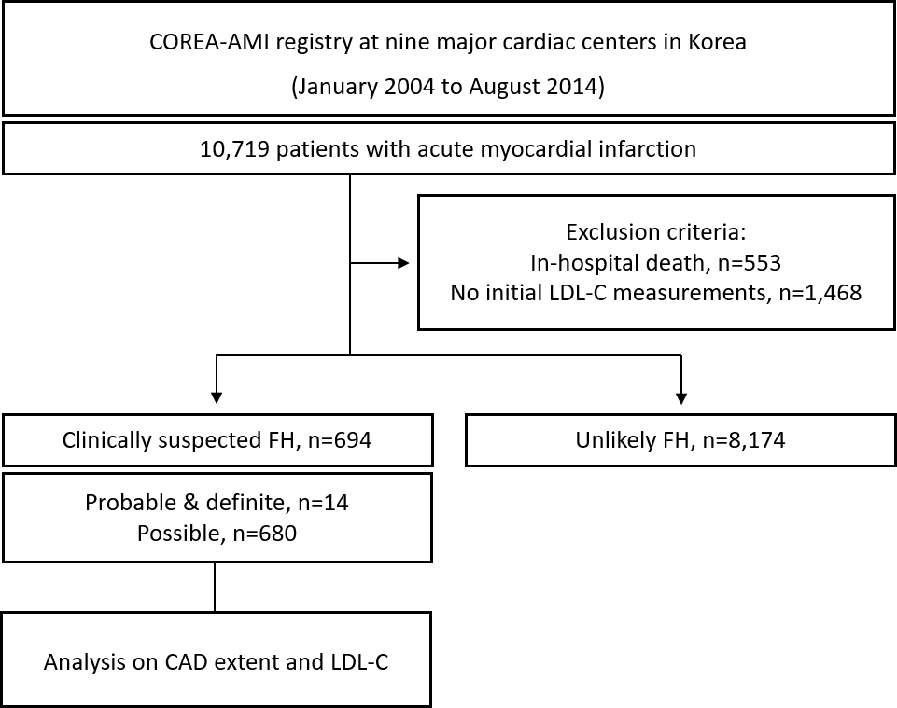
LDL-C, low-density lipoprotein cholesterol; FH, familial hypercholesterolemia; CAD, coronary artery disease

Figure S2. Directed acyclic graph of the hypothesized relations among low-density lipoprotein cholesterol (exposure), coronary artery disease extent (mediator), and composite coronary events (outcome)
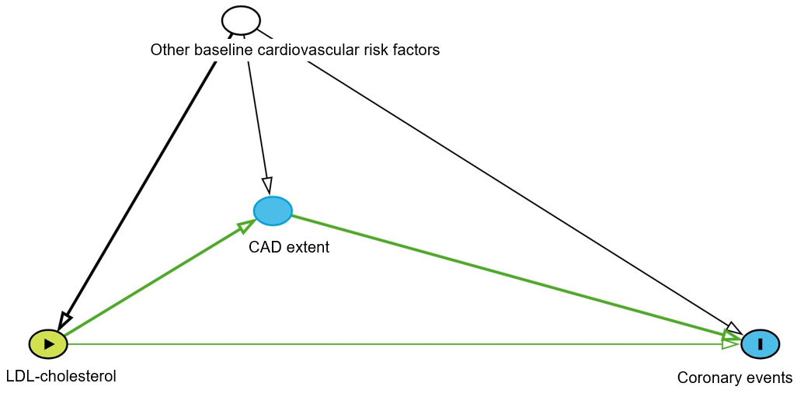
Green arrows depict the causal pathway from low-density lipoprotein cholesterol to coronary events, including the direct path (low-density lipoprotein cholesterol → coronary events) and the indirect path via coronary artery disease extent (low-density lipoprotein cholesterol → coronary artery disease extent → coronary events). Black arrows denote potential confounding by other baseline cardiovascular risk factors. LDL, low-density lipoprotein; CAD, coronary artery disease.

Figure S3. Admission low-density lipoprotein cholesterol distribution
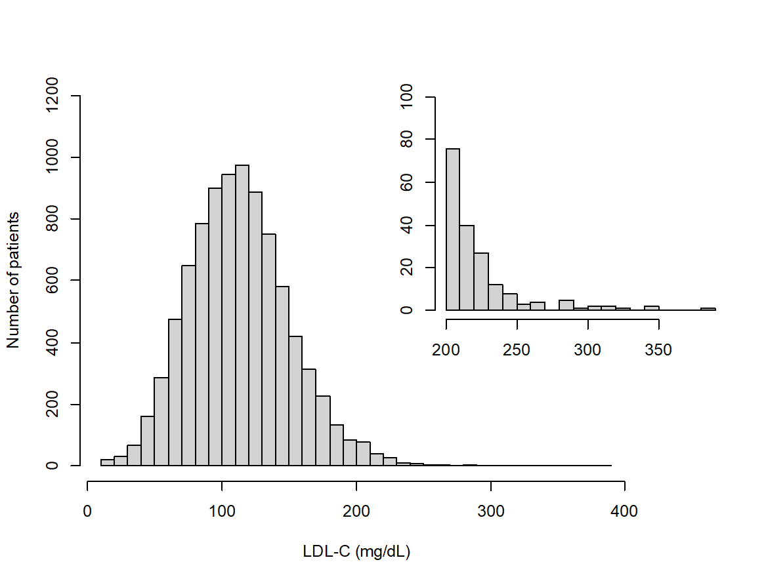
LDL-C, low-density lipoprotein cholesterol.

