Electronic Supplementary Material Contents
Number | Material Page
 | Appendix
1 | Appendix S1. Full search strategies and search results
2 | Appendix S2. Description of the three-level meta-analytic model  Tables
1 | Table S1. Detailed characteristics of included studies
2  3  4  1  2  3  4  5 | Table S2. Methodological quality assessment (PEDro scale)  Table S3. GRADE evidence profile and summary of findings for critical outcomes  Table S4. Sensitivity analysis excluding one Gonçalves comparison at a time  Figures  Figure S1. Risk of bias assessment  Figure S2. Funnel plot for assessment of small-study effects  Figure S3. Contour-enhanced funnel plot for assessment of publication bias  Figure S4. Meta-regression of mean age  Figure S5. Meta-regression of exercise dose (MET·min/week)

Appendix S1. Full search strategies and search results
Data | Query | Results
PUBMED | (("coronary artery disease"[Title/Abstract] OR "coronary heart disease"[Title/Abstract] OR "ischemic heart disease"[Title/Abstract] OR "ischaemic heart disease"[Title/Abstract] OR "CAD"[Title/Abstract] OR "CHD"[Title/Abstract] OR "IHD"[Title/Abstract] OR "myocardial ischem*"[Title/Abstract] OR "acute coronary syndrome"[Title/Abstract] OR "ACS"[Title/Abstract] OR "post PCI"[Title/Abstract] OR "post CABG"[Title/Abstract]) AND ("exercise therap*"[Title/Abstract] OR "exercise training"[Title/Abstract] OR "physical training"[Title/Abstract] OR "aerobic training"[Title/Abstract] OR "aerobic exercise"[Title/Abstract] OR "resistance training"[Title/Abstract] OR "resistance exercise"[Title/Abstract] OR "strength training"[Title/Abstract] OR "interval training"[Title/Abstract] OR "high intensity interval training"[Title/Abstract] OR "HIIT"[Title/Abstract] OR "endurance training"[Title/Abstract] OR "cardiac rehabilitation"[Title/Abstract] OR "rehab*"[Title/Abstract] OR "physical activity"[Title/Abstract] OR "exercise program*"[Title/Abstract] OR "physical exercis*"[Title/Abstract] OR "sports therap*"[Title/Abstract]) AND ("quality of life"[Title/Abstract] OR "health-related quality of life"[Title/Abstract] OR "health-related quality of life"[Title/Abstract] OR "QoL"[Title/Abstract] OR "HRQoL"[Title/Abstract] OR "HRQL"[Title/Abstract] OR ("well-being"[Title/Abstract] OR "wellbeing"[Title/Abstract] OR "life satisfaction"[Title/Abstract] OR "patient reported outcome"[Title/Abstract] OR "patient reported outcome measure"[Title/Abstract] OR "PROM"[Title/Abstract]))) AND ((clinicaltrial[Filter] OR randomizedcontrolledtrial[Filter]) AND (humans[Filter]) AND (english[Filter])) | 271
Web of Science | TS=( ("coronary artery disease" OR "coronary heart disease" OR "ischemic heart disease" OR "ischaemic heart disease" OR CAD OR CHD OR IHD OR "myocardial ischem*" OR "acute coronary syndrome" OR ACS OR "post PCI" OR "post CABG") AND ("exercise therap*" OR "exercise training" OR "physical training" OR "aerobic training" OR "aerobic exercise" OR "resistance training" OR "resistance exercise" OR "strength training" OR "interval training" OR "high intensity interval training" OR HIIT OR "endurance training" OR "cardiac rehabilitation" OR rehab* OR "physical activity" OR "exercise program*" OR "physical exercis*" OR "sports therap*") AND ("quality of life" OR "health-related quality of life" OR "health related quality of life" OR QoL OR HRQoL OR HRQL OR "well-being" OR wellbeing OR "life satisfaction" OR "patient reported outcome*" OR "patient-reported outcome*" OR PROM)AND (random* OR "clinical trial*" OR "controlled trial" OR placebo OR "cross-over" OR crossover)) | 1938
Cochrane | coronary artery disease OR coronary heart disease OR ischemic heart disease OR ischaemic heart disease OR CAD OR CHD OR IHD OR myocardial ischem* OR acute coronary syndrome OR ACS OR post PCI OR post CABG in Title Abstract Keyword AND exercise therap* OR exercise training OR physical training OR aerobic training OR aerobic exercise OR resistance training OR resistance exercise OR strength training OR interval training OR high intensity interval training OR HIIT OR endurance training OR cardiac rehabilitation OR rehab* OR physical activity OR exercise program* OR physical exercis* OR sports therap* in Title Abstract Keyword AND quality of life OR health-related quality of life OR QoL OR HRQoL OR HRQL OR well-being OR wellbeing OR life satisfaction OR patient reported outcome OR patient reported outcome measure OR PROM in Title Abstract Keyword - (Word variations have been searched) | 2709
CNKI | (冠心病 + 冠状动脉疾病 + 缺血性心脏病 + 心脏病)AND(运动 + 体力活动 + 肌肉力量 + 肌力 + 力量训练 + 力量运动 + 抗阻训练 + 抗阻运动 + 耐力训练 + 耐力运动 + 有氧训练 + 有氧运动)AND(生活质量 + 生命质量 + 福祉 + 幸福)AND(随机 + 随机对照 + 随机对照试验 + RCT + 随机分组 + 随机分配) | 77
Appendix S2. Description of the three-level meta-analytic model
Because several included trials contributed more than one effect size (e.g. multiple HR-QoL domains, time points, or intervention comparisons), the assumption of independence required for conventional two-level meta-analysis was not met. To account for the dependency among effect sizes derived from the same study, a three-level random-effects meta-analysis was applied. In this framework, level 1 represents the sampling variance of each observed effect size, level 2 captures the within-study variance between multiple effect sizes from the same study, and level 3 reflects the between-study variance across studies. This approach allows all eligible effect sizes to be retained while appropriately modelling their hierarchical structure and avoiding the loss of information associated with selecting a single outcome per study.
All analyses were performed in R (R Foundation for Statistical Computing, Vienna, Austria), primarily using the metafor package. Three-level models were fitted with restricted maximum likelihood estimation
Table S1. Detailed characteristics of included studies
Study | Country | Sample Size (% Women) | Age (years) | BMI |  | Intervention Type | Duration | HRQoL Instrument | Disease Stage | Exercise dose (MET·min/week)
Chen et al., 2014 | Taiwan, China | 36 (22%) | 69 (R65-80) |  | 25.4 ± 3.0 | Combined training | 12 weeks | SF-36 | Post-ACS / Stable | 1260
Deng et al., 2020 | China | 70 (12%) | 81 ± 3.5 |  | 24.0 ± 3.1 | MICT | 12 weeks | SF-12 | Post-ACS / Stable | 1050
ManoKumar R et al., 2024 | India | 40 (10%) | 57 ± 6 |  | 26.1 ± 2.8 | Combined training | 12 weeks | WHOQOL-BREF | Not classifiable | Not classifiable
Belardinelli et al., 2001 | Italy | 130 (15%) | 57 ± 10 |  | NR | MICT | 24 weeks | SF-36 | Post-ACS / Stable | 630
Kristiansen et al., 2022 | Denmark | 142 (17%) | 67 ± 9 |  | 29.4 ± 4.8 | HIIT | 12 weeks | SF-36 | CCS | 360
Deka et al., 2022 | Spain | 90 (24%) | 69 ± 5 |  | 27.8 ± 4.6 | Combined training | 8 weeks | SF-36 | Post-ACS / Stable | 525
Avila et al., 2018 | Belgium | 90 (11%) | 61 ± 7 |  | 27.5 ± 3.4 | MICT | 12 weeks | SF-36 | Post-ACS / Stable | 1092
Salvetti et al., 2008 | Brazil | 39 (25%) | 53 ± 8 |  | 27.0 ± 3.5 | MICT | 12 weeks | SF-36 | Post-ACS / Stable | 495
Tong Y et al., 2024 | China | 80 (40%) | 59 ± 9 |  | 26.4 ± 3.1 | Combined training | 12 weeks | SF-36 | CCS | 960
Che Q et al., 2024 | China | 100 (25%) | 56 ± 8 |  | 26.8 ± 3.8 | MICT | 12 weeks | SF-36 | CCS | 1124
Ge S et al., 2024 | China | 80 (40%) | 54 ± 7 |  | NR | Combined training | 12 weeks | SAQ | CCS | 925
Mao L et al., 2021 | China | 112 (38%) | 61 ± 7 |  | NR | Combined training | 12 weeks | SAQ | CCS | 672
Yang L et al., 2020 | China | 104 (38%) | 85 ± 4 |  | NR | MICT | 12 weeks | SF-36 | CCS | 455
Wu Y et al., 2019 | China | 200 (32%) | 63 ± 8 |  | NR | Combined training | 12 weeks | SF-36, SAQ | CCS | 1259
Gonçalves et al. | Portugal | 69 (13%) | 56 ± 10 |  | 29.0 ± 4.3 | HIIT, MICT | 6 weeks | SF-36 | Post-ACS / Stable | 480
Note: Supplementary Table S1 summarises the characteristics of the studies included in the meta-analysis, including country, sample size, age, BMI, intervention type, intervention duration, HR-QoL instrument, disease stage, and exercise dose. Data are presented as reported in the original studies. CCS refers to patients with chronic stable angina and no recent history of myocardial infarction or unstable angina; post-ACS stable refers to clinically stable patients with a previous history of myocardial infarction or unstable angina. MET·min/week was used to quantify exercise dose. CCS, chronic coronary syndrome; HR-QoL, health-related quality of life.
HIIT, high-intensity interval training; MICT, moderate-intensity continuous training; NR, not reported; SAQ, Seattle Angina Questionnaire; SF-12, 12-Item Short Form Health Survey; SF-36, 36-Item Short Form Health Survey; WHOQOL-BREF, World Health Organization Quality of Life-BREF.
Table S2. Methodological quality assessment (PEDro scale)
Author, year | D1 | D2 | D3 | D4 | D5 | D6 | D7 | D8 | D9 | D10 | D11 | Total
Chen et al 2014 | Y | 0 | 0 | 1 | 0 | 0 | 0 | 0 | 0 | 1 | 1 | 3
Deng et al 2020 | Y | 1 | 0 | 1 | 0 | 0 | 0 | 1 | 1 | 1 | 1 | 6
ManoKumar R 2024 | Y | 1 | 0 | 1 | 0 | 0 | 1 | 1 | 1 | 1 | 1 | 7
Belardinelli 2001 | Y | 1 | 0 | 1 | 0 | 0 | 1 | 1 | 1 | 1 | 1 | 7
Kristiansen 2022 | Y | 1 | 1 | 0 | 0 | 0 | 0 | 0 | 1 | 1 | 1 | 5
Deka 2022 | Y | 1 | 1 | 1 | 0 | 0 | 1 | 1 | 0 | 1 | 1 | 7
Avila 2018 | Y | 1 | 0 | 1 | 0 | 0 | 0 | 1 | 1 | 1 | 1 | 6
Salvetti 2008 | Y | 1 | 1 | 1 | 0 | 0 | 0 | 1 | 1 | 1 | 1 | 7
Tong Y 2024 | Y | 1 | 0 | 1 | 0 | 0 | 0 | 1 | 1 | 1 | 1 | 6
Che Q 2024 | Y | 1 | 0 | 1 | 0 | 0 | 0 | 1 | 0 | 1 | 1 | 5
Ge S 2024 | Y | 1 | 0 | 1 | 0 | 0 | 0 | 1 | 0 | 1 | 1 | 5
Mao L 2021 | Y | 1 | 0 | 1 | 0 | 0 | 0 | 1 | 0 | 1 | 1 | 5
Yang L 2020 | Y | 1 | 0 | 1 | 0 | 0 | 0 | 1 | 0 | 1 | 1 | 5
Wu Y 2019 | Y | 1 | 0 | 1 | 0 | 0 | 0 | 1 | 0 | 1 | 1 | 5
Gonçalves 2025 | Y | 1 | 0 | 1 | 0 | 0 | 1 | 1 | 1 | 1 | 1 | 7
Note: studies scoring ≥6 are considered high quality, those scoring 4-5 are considered moderate quality, and those scoring ≤3 are considered low quality.
1. eligibility criteria were specified (not included in the total score)
2. subjects were randomly allocated to groups (in a crossover study, subjects were randomly allocated an order in which treatments were received)
3. allocation was concealed
4. the groups were similar at baseline regarding the most important prognostic indicators
5. there was blinding of all subjects
6. there was blinding of all therapists who administered the therapy
7. there was blinding of all assessors who measured at least one key outcome
8. measures of at least one key outcome were obtained from more than 85% of the subjects initially allocated to groups
9. all subjects for whom outcome measures were available received the treatment or control condition as allocated or, where this was not the case, data for at least one key outcome was analysed by “intention to treat”
10. the results of between-group statistical comparisons are reported for at least one key outcome
11. the study provides both point measures and measures of variability for at least one key outcome

Table S3. GRADE evidence profile and summary of findings for critical outcomes
Panel A. Summary of findings
Outcome | Evidence base | Participants | Effect estimate, Hedges’ g (95% CI) | Certainty | Interpretation
Overall HR-QoL | 15 reports / 16 comparisons / 87 effect sizes | N = 1353 | 0.89 (0.46 to 1.33); p < 0.001 | Low | ExCR may improve HR-QoL, but certainty was limited by risk of bias and inconsistency.
HR-QoL after combined aerobic + resistance training | 7 reports / 7 comparisons / 31 effect sizes | N = 639 | 1.17 (0.52 to 1.82); p = 0.0006 | Low | Combined training showed the largest point estimate, but the certainty was low.
HR-QoL after HIIT | 2 reports / 2 comparisons / 10 effect sizes | N = 181 | 0.91 (0.26 to 1.56); p = 0.0068 | Very low | HIIT showed a positive effect estimate, but evidence was very uncertain because of limited studies and wide confidence intervals.
HR-QoL after MICT | 7 reports / 7 comparisons / 46 effect sizes | N = 534 | 0.60 (0.00 to 1.19); p = 0.0480 | Very low | MICT showed a possible benefit, but evidence was very uncertain because the confidence interval touched the null effect.
HR-QoL in post-ACS stable phase | 7 reports / 8 comparisons / 41 effect sizes | N = 502 | 0.87 (0.51 to 1.22); p < 0.001 | Low | Post-ACS stable-phase participants showed a larger point estimate, but certainty was low.
HR-QoL in chronic coronary syndrome / CCS | 7 reports / 7 comparisons / 44 effect sizes | N = 812 | 0.57 (0.24 to 0.90); p = 0.0008 | Low | CCS participants showed a smaller but positive point estimate; certainty was low.

Panel B. GRADE domain judgments
Outcome | Risk of bias | Inconsistency | Indirectness | Imprecision | Publication bias | Final certainty
Overall HR-QoL | Serious | Serious | Not serious | Not serious | Concern noted; not formally downgraded | Low
HR-QoL after combined aerobic + resistance training | Serious | Serious | Not serious | Not serious | Concern noted; not formally downgraded | Low
HR-QoL after HIIT | Serious | Serious | Not serious | Serious | Not formally assessed because of few studies | Very low
HR-QoL after MICT | Serious | Serious | Not serious | Serious | Concern noted; not formally downgraded | Very low
HR-QoL in post-ACS stable phase | Serious | Serious | Not serious | Not serious | Concern noted; not formally downgraded | Low
HR-QoL in chronic coronary syndrome / CCS | Serious | Serious | Not serious | Not serious | Concern noted; not formally downgraded | Low
Abbreviations: ACS, acute coronary syndrome; CCS, chronic coronary syndrome; CI, confidence interval; ExCR, exercise-based cardiac rehabilitation; HIIT, high-intensity interval training; HR-QoL, health-related quality of life; MICT, moderate-intensity continuous training.
GRADE certainty started at high because all included studies were randomized controlled trials. Evidence was downgraded for risk of bias, inconsistency, indirectness, imprecision, and publication bias where appropriate.
Risk of bias was rated as serious because most trials had some concerns or high risk of bias, and HR-QoL was self-reported in exercise interventions where participant blinding was not feasible.
Inconsistency was rated as serious because substantial heterogeneity was observed across effect sizes, and clinical and methodological heterogeneity remained likely within several subgroups.
Indirectness was not downgraded because the included trials directly matched the review question in terms of population, intervention, comparator, and validated HR-QoL outcomes.
Imprecision was judged using the null effect and a small-effect threshold of SMD = 0.20. HIIT was downgraded because of few studies and a wide confidence interval. MICT was downgraded because the confidence interval touched the null effect.
Publication bias was noted as a concern because small-study effects could not be excluded by visual inspection of funnel plots. It was not formally downgraded unless sufficient evidence supported asymmetry.

Table S4. Sensitivity analysis excluding one Gonçalves comparison at a time
Analysis | Reports | Comparisons | Effect sizes | Hedges’ g (95% CI) | p-value | 95% prediction interval
Excluding Gonçalves HIIT comparison | 15 | 15 | 79 | 0.88 (0.45 to 1.31) | <0.001 | −0.88 to 2.64
Excluding Gonçalves MICT comparison | 15 | 15 | 79 | 0.90 (0.46 to 1.35) | <0.001 | −0.90 to 2.71
One included three-arm trial contributed two intervention-control comparisons: HIIT versus control and MICT versus control, using a shared control group. Because this design may introduce additional correlation between comparisons from the same report, we conducted sensitivity analyses by excluding one Gonçalves comparison at a time. The pooled estimates remained similar to the primary overall finding, suggesting that inclusion of both comparisons did not materially change the overall interpretation.
Note: CI, confidence interval; HIIT, high-intensity interval training; MICT, moderate-intensity continuous training. These analyses were performed to examine the influence of the three-arm Gonçalves trial that included two intervention-control comparisons sharing the same control group.

Figure S1. Risk of bias assessment
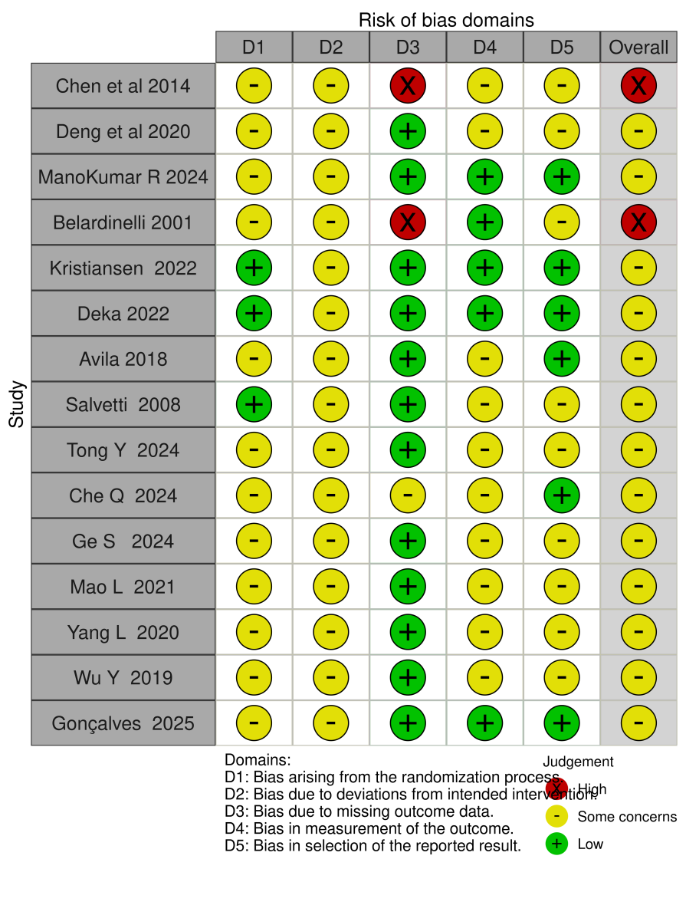

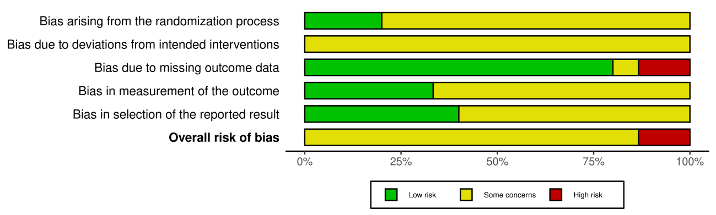

Figure S2. Funnel plot for assessment of small-study effects
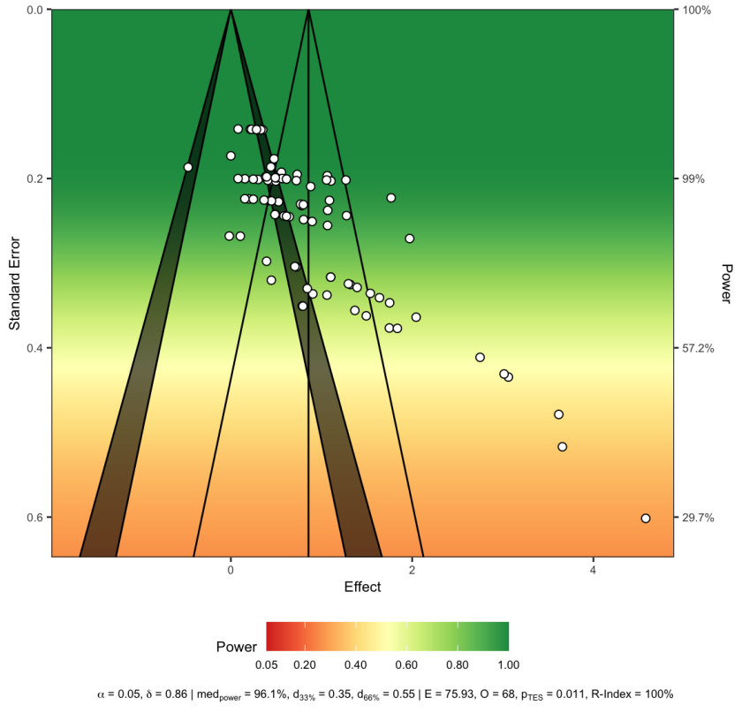

Figure S3. Contour-enhanced funnel plot for assessment of publication bias
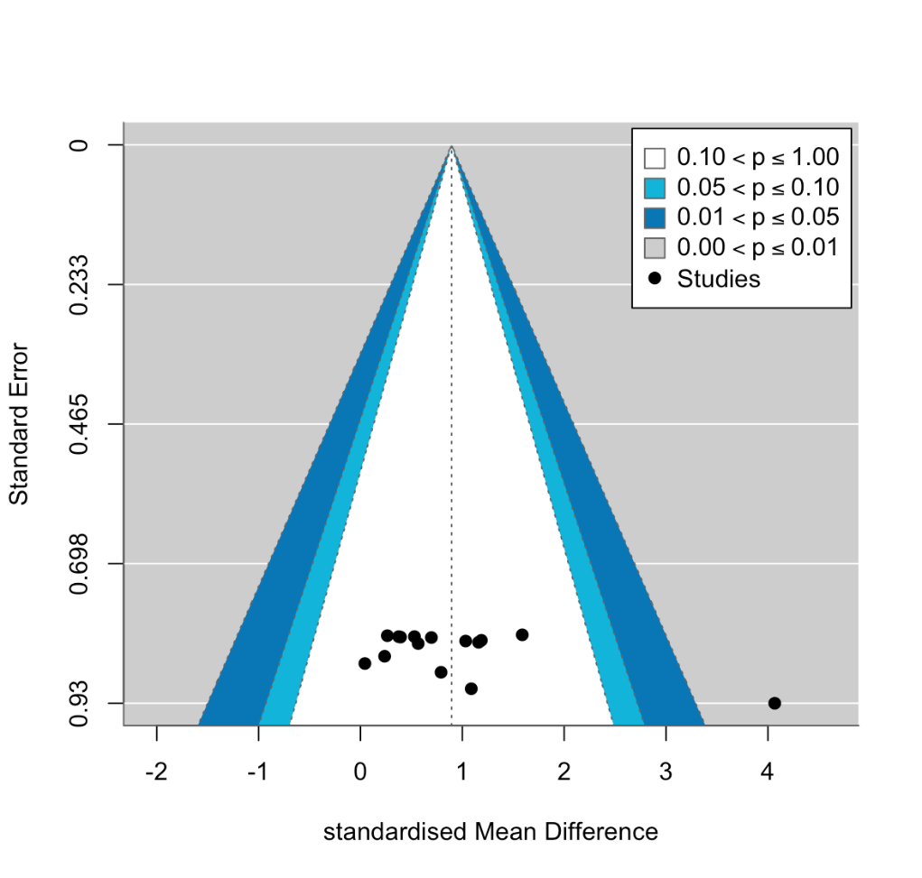

Figure S4. Meta-regression of mean age
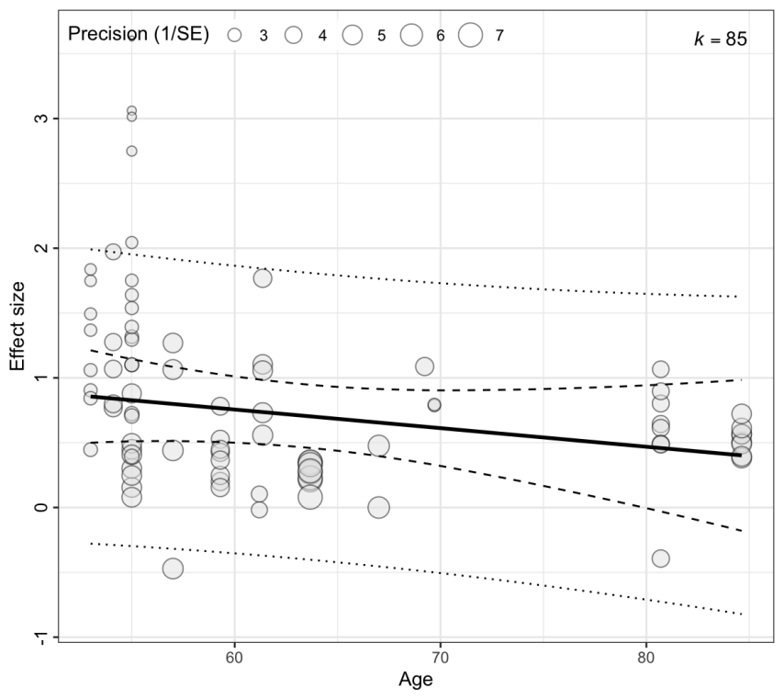
Figure S4. Meta-regression of mean age on HR-QoL outcomes. Each point represents an individual effect size, and point size is proportional to the inverse variance weight.
Figure S5. Meta-regression of exercise dose (MET·min/week)
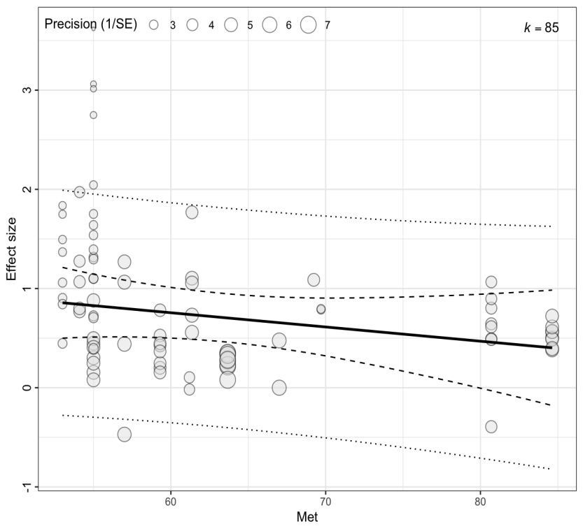
Figure S5. Meta-regression of exercise dose (MET·min/week) on HR-QoL outcomes. Each point represents an individual effect size, and point size is proportional to the inverse variance weight.

