Additional file 3. Supplementary tables and figures
Frailty Index trajectories and health behaviour transitions among middle-aged and older adults with cardiovascular disease: a longitudinal CHARLS study
This file provides supplementary analyses added or retained during revision, including temporally ordered landmark and lagged analyses, multinomial and high-trajectory sensitivity analyses, continuous and ordinal health-behaviour score analyses, intermediate behaviour-change summaries, inverse-probability weighting, multiple imputation, posterior-probability sensitivity analyses, CVD subtype-adjusted analysis, and LCMM sensitivity figures. The FI deficit item dictionary is provided separately as Additional file 2.
Supplementary Table S1. Wave 1–Wave 3 behaviour transition predicting later FI outcomes
Outcome | N | Behavior transition (reference: persistently favorable) | β (95% CI) | P value
Wave 4 FI | 1145 | Improved | 0.0108 (-0.0020, 0.0237) | 0.099
Wave 4 FI | 1145 | Deteriorated | 0.0042 (-0.0087, 0.0170) | 0.524
Wave 4 FI | 1145 | Persistently Unfavorable | 0.0112 (-0.0006, 0.0230) | 0.064
Wave 3-Wave 4 FI change | 1145 | Improved | 0.0108 (-0.0020, 0.0237) | 0.099
Wave 3-Wave 4 FI change | 1145 | Deteriorated | 0.0042 (-0.0087, 0.0170) | 0.524
Wave 3-Wave 4 FI change | 1145 | Persistently Unfavorable | 0.0112 (-0.0006, 0.0230) | 0.064
Models were adjusted for Wave 3 FI, age, sex, education, marital status, rural residence, BMI, heart disease, stroke, hypertension, diabetes, and dyslipidemia. Because Wave 3 FI was included as a covariate, coefficients for Wave 4 FI and Wave 3-Wave 4 FI change were algebraically equivalent for behaviour-transition terms; both outcomes are displayed to show the temporally ordered specification requested by the reviewers. FI, Frailty Index.

Supplementary Table S2. Multinomial logistic regression separating moderate and high FI trajectory classes
Outcome class | Reference outcome | N | Behavior transition | OR (95% CI) | P value
Moderate-level increasing | Low-level slowly increasing | 1258 | Improved | 1.38 (0.85, 2.25) | 0.194
Moderate-level increasing | Low-level slowly increasing | 1258 | Deteriorated | 1.90 (1.21, 3.00) | 0.006
Moderate-level increasing | Low-level slowly increasing | 1258 | Persistently Unfavorable | 1.76 (1.14, 2.69) | 0.01
High-level rapidly increasing | Low-level slowly increasing | 1258 | Improved | 2.95 (1.29, 6.73) | 0.01
High-level rapidly increasing | Low-level slowly increasing | 1258 | Deteriorated | 2.53 (1.15, 5.57) | 0.021
High-level rapidly increasing | Low-level slowly increasing | 1258 | Persistently Unfavorable | 2.93 (1.36, 6.29) | 0.006
The model used the low-level slowly increasing trajectory as the reference outcome and persistently favorable behaviour as the reference exposure category. It was adjusted for the same covariates as the fully adjusted primary logistic regression.

Supplementary Table S3. High-level rapidly increasing trajectory versus low/moderate trajectories
Model | N | Behavior transition | OR (95% CI) | P value
High-level rapidly increasing trajectory versus low/moderate trajectories | 1258 | Improved | 2.19 (1.10, 4.37) | 0.026
High-level rapidly increasing trajectory versus low/moderate trajectories | 1258 | Deteriorated | 1.38 (0.71, 2.68) | 0.342
High-level rapidly increasing trajectory versus low/moderate trajectories | 1258 | Persistently Unfavorable | 1.74 (0.90, 3.34) | 0.099
The high-level rapidly increasing class was contrasted with the low-level and moderate-level classes combined. Persistently favorable behaviour was the reference exposure category.

Supplementary Table S4. Continuous health-behaviour score analyses
Predictor | N | OR (95% CI) | P value
Wave 1 behavior score, per 1-point higher favorable-behavior count | 1258 | 0.90 (0.76, 1.06) | 0.211
Wave 4 behavior score, per 1-point higher favorable-behavior count | 1258 | 0.79 (0.66, 0.95) | 0.01
Wave 4 minus Wave 1 behavior-score change, per 1-point increase | 1258 | 0.91 (0.78, 1.07) | 0.258
Mean behavior score across Waves 1-4, per 1-point higher | 814 | 0.72 (0.52, 0.99) | 0.045
Each model assessed the association between a continuous behaviour-score measure and unfavorable FI trajectory membership, adjusted for the fully adjusted covariate set. ORs are per 1-point higher score or change as specified.

Supplementary Table S5. Ordinal health-behaviour score category analyses
Predictor | Reference category | N | Score category | OR (95% CI) | P value
Wave 1 ordinal behavior score category | 0_1 favorable behaviors | 1258 | 2 favorable behaviors | 1.13 (0.65, 1.96) | 0.66
Wave 1 ordinal behavior score category | 0_1 favorable behaviors | 1258 | 3 favorable behaviors | 0.81 (0.47, 1.39) | 0.437
Wave 1 ordinal behavior score category | 0_1 favorable behaviors | 1258 | 4 favorable behaviors | 0.87 (0.48, 1.59) | 0.653
Wave 4 ordinal behavior score category | 0_1 favorable behaviors | 1258 | 2 favorable behaviors | 1.04 (0.59, 1.82) | 0.905
Wave 4 ordinal behavior score category | 0_1 favorable behaviors | 1258 | 3 favorable behaviors | 0.62 (0.35, 1.10) | 0.104
Wave 4 ordinal behavior score category | 0_1 favorable behaviors | 1258 | 4 favorable behaviors | 0.58 (0.31, 1.11) | 0.102
Behaviour score categories were compared with the 0–1 favorable behaviours category. Models were adjusted for the fully adjusted covariate set.

Supplementary Table S6. Frequency of behaviour-status changes across Waves 1–4
Number of favourable/unfavourable status changes across Waves 1–4 | n | Percent | Interpretation
0 | 424 | 42.8% | Changed no more than once
1 | 256 | 25.9% | Changed no more than once
2 | 245 | 24.7% | Changed more than once
3 | 65 | 6.6% | Changed more than once
This analysis was restricted to participants with behaviour status available at all four waves. More than one change indicates intermediate switching not captured by the baseline-to-final transition category alone.

Supplementary Table S7. Behaviour-status change frequency by Wave 1–Wave 4 transition category
Wave 1–Wave 4 transition category | 0 changes | 1 change | 2 changes | 3 changes
Deteriorated | 0 | 149 | 0 | 34
Improved | 0 | 107 | 0 | 31
Persistently Favorable | 323 | 0 | 146 | 0
Persistently Unfavorable | 101 | 0 | 99 | 0
Cells show participant counts among those with behaviour status available at all four waves.

Supplementary Table S8. Inverse-probability weighted sensitivity analysis
Method | N | Behavior transition | OR (95% CI) | P value
IPW-weighted logistic regression using survey robust standard errors | 1258 | Improved | 1.52 (0.91, 2.53) | 0.107
IPW-weighted logistic regression using survey robust standard errors | 1258 | Deteriorated | 2.09 (1.30, 3.34) | 0.002
IPW-weighted logistic regression using survey robust standard errors | 1258 | Persistently Unfavorable | 1.95 (1.25, 3.04) | 0.003
Weights were estimated for inclusion in the complete behaviour-transition regression sample using baseline variables. Survey robust standard errors were used.

Supplementary Table S9. IPW weight diagnostics
Diagnostic | Value
Complete baseline records for inclusion model | 1,723
Included analytic records in weighted model | 1,258
Stabilizer | 0.730
Weight mean | 0.997
Weight SD | 0.247
Weight minimum | 0.765
Weight 1st percentile | 0.765
Weight median | 0.913
Weight 99th percentile | 2.031
Weight maximum | 2.031
The absence of extreme weights supported the stability of the IPW sensitivity model.

Supplementary Table S10. Lagged behaviour-score model predicting next-wave FI
Method | Participants | Person-wave rows | Predictor | β (95% CI) | P value
Lagged mixed-effects model with participant-level random intercept | 1980 | 4460 | current_behavior_score4 | -0.0047 (-0.0074, -0.0020) | <0.001
The model included participant-level random intercepts and adjusted for current-wave FI, time interval, and baseline covariates. The predictor was the current-wave favourable-behaviour score (0–4).

Supplementary Table S11. Posterior probability distribution diagnostics for assigned classes
Trajectory group | n | Mean | SD | Median | P25 | P75 | Minimum | Maximum
Low-level slowly increasing | 685 | 0.739 | 0.137 | 0.754 | 0.624 | 0.859 | 0.433 | 0.945
Moderate-level increasing | 1,180 | 0.716 | 0.113 | 0.741 | 0.627 | 0.812 | 0.444 | 0.894
High-level rapidly increasing | 212 | 0.768 | 0.162 | 0.754 | 0.624 | 0.934 | 0.455 | 1.000
Values summarize the assigned-class posterior probability among participants assigned to each primary LCMM trajectory group.

Supplementary Table S12. Missingness diagnostics for multiple-imputation analysis
Variable | Missing n | Missing percent | Missing percent formatted
unfavorable_binary | 0 | 0.0 | 0.0%
transition4_w1_w4 | 0 | 0.0 | 0.0%
age | 0 | 0.0 | 0.0%
male | 0 | 0.0 | 0.0%
education_raw | 2 | 0.1 | 0.1%
married | 0 | 0.0 | 0.0%
rural | 0 | 0.0 | 0.0%
bmi | 278 | 17.7 | 17.7%
heart_disease | 2 | 0.1 | 0.1%
stroke_dx | 4 | 0.3 | 0.3%
hypertension | 4 | 0.3 | 0.3%
diabetes | 12 | 0.8 | 0.8%
dyslipidemia | 26 | 1.7 | 1.7%
fi_w1_base | 1 | 0.1 | 0.1%
This table summarizes missingness among participants with valid trajectory class and Wave 1–Wave 4 behaviour transition data.

Supplementary Table S13. Multiple-imputation sensitivity analysis for missing baseline covariates
Analysis | Method | N | Behavior transition | OR (95% CI) | P value
Complete case | Complete-case logistic regression comparator | 1258 | Improved | 1.41 (0.87, 2.30) | 0.162
Complete case | Complete-case logistic regression comparator | 1258 | Deteriorated | 1.92 (1.22, 3.04) | 0.005
Complete case | Complete-case logistic regression comparator | 1258 | Persistently Unfavorable | 1.78 (1.16, 2.73) | 0.008
Multiple imputation | Multiple imputation by chained equations; m = 30 imputations; 20 iterations | 1572 | Improved | 1.58 (1.03, 2.42) | 0.034
Multiple imputation | Multiple imputation by chained equations; m = 30 imputations; 20 iterations | 1572 | Deteriorated | 2.10 (1.40, 3.15) | <0.001
Multiple imputation | Multiple imputation by chained equations; m = 30 imputations; 20 iterations | 1572 | Persistently Unfavorable | 1.82 (1.25, 2.66) | 0.002
Multiple imputation by chained equations used 30 imputations and 20 iterations. The imputed model used the same covariate set as the complete-case fully adjusted logistic regression.

Supplementary Table S14. Multiple-imputation model metadata
Item | Value
MI analytic sample with valid trajectory class and W1-W4 behavior transition | 1572
Complete-case comparator sample | 1258
Number of imputations | 30
Maximum iterations | 20
R package | mice

Supplementary Table S15. Posterior-probability sensitivity analyses
Fractional outcome | Method | N | Behavior transition | OR (95% CI) | P value
Posterior probability of unfavorable trajectory membership | Fractional logistic model using posterior probability of unfavorable trajectory membership (prob2 + prob3) | 1258 | Improved | 1.30 (1.02, 1.66) | 0.035
Posterior probability of unfavorable trajectory membership | Fractional logistic model using posterior probability of unfavorable trajectory membership (prob2 + prob3) | 1258 | Deteriorated | 1.40 (1.12, 1.76) | 0.003
Posterior probability of unfavorable trajectory membership | Fractional logistic model using posterior probability of unfavorable trajectory membership (prob2 + prob3) | 1258 | Persistently Unfavorable | 1.43 (1.16, 1.77) | <0.001
Posterior probability of high-level rapidly increasing trajectory membership | Fractional logistic model using posterior probability of high-level rapidly increasing trajectory membership (prob3) | 1258 | Improved | 0.91 (0.75, 1.10) | 0.328
Posterior probability of high-level rapidly increasing trajectory membership | Fractional logistic model using posterior probability of high-level rapidly increasing trajectory membership (prob3) | 1258 | Deteriorated | 1.09 (0.92, 1.30) | 0.333
Posterior probability of high-level rapidly increasing trajectory membership | Fractional logistic model using posterior probability of high-level rapidly increasing trajectory membership (prob3) | 1258 | Persistently Unfavorable | 1.12 (0.94, 1.33) | 0.197
Fractional logistic models used posterior trajectory probabilities as outcomes to account for LCMM classification uncertainty. Persistently favorable behaviour was the reference exposure category.

Supplementary Table S16. CVD subtype-adjusted sensitivity analysis
Method | N | Behavior transition | OR (95% CI) | P value
CVD subtype-adjusted logistic sensitivity model | 1258 | Improved | 1.41 (0.87, 2.30) | 0.162
CVD subtype-adjusted logistic sensitivity model | 1258 | Deteriorated | 1.92 (1.22, 3.04) | 0.005
CVD subtype-adjusted logistic sensitivity model | 1258 | Persistently Unfavorable | 1.78 (1.16, 2.73) | 0.008
This model adjusted for CVD subtype (heart disease only, stroke only, or both) instead of separate heart disease and stroke indicators.

Supplementary Table S17. Wave 1–Wave 3 landmark analysis of unfavorable FI trajectory membership
Wave 1–Wave 3 behavior transition (reference: persistently favorable) | OR (95% CI) | P value
Improved | 1.68 (1.07, 2.66) | 0.024
Deteriorated | 1.23 (0.78, 1.96) | 0.378
Persistently unfavorable | 1.53 (1.02, 2.31) | 0.042
Binary logistic regression modeled unfavorable FI trajectory membership using Wave 1–Wave 3 behaviour transition as exposure and the low-level slowly increasing trajectory as the reference outcome. The model adjusted for age, sex, education, marital status, rural residence, BMI, heart disease, stroke, hypertension, diabetes, dyslipidemia, and baseline FI.

Supplementary Table S18. Exploratory analyses of individual behaviour components
Individual behavior component | OR (95% CI) | P value
Non-smoking at Wave 1 | 1.03 (0.71, 1.49) | 0.875
Non-drinking at Wave 1 | 0.79 (0.55, 1.13) | 0.193
Normal sleep duration at Wave 1 | 0.75 (0.56, 1.01) | 0.060
Social participation at Wave 1 | 1.03 (0.78, 1.36) | 0.848
The four individual behaviour components were entered in the same adjusted model. ORs compare favorable versus unfavorable status at Wave 1.

Supplementary Table S19. Alternative behaviour-score threshold sensitivity analysis
Behavior transition under alternative threshold (reference: persistently favorable) | OR (95% CI) | P value
Improved | 1.06 (0.57, 1.96) | 0.853
Deteriorated | 1.37 (0.70, 2.70) | 0.360
Persistently unfavorable | 1.19 (0.55, 2.57) | 0.665
Favorable behaviour status was redefined using a less stringent threshold of at least two favorable behaviours; persistently favorable behaviour was the reference category.

Supplementary Table S20. Characteristics of included and excluded participants
Characteristic | Included | Excluded | P value
FI trajectory modeling
Age, years | 61.50 (9.12) | 69.21 (10.76) | <0.001
Male | 869/2077 (41.8) | 172/350 (49.1) | 0.011
Education level | 2.02 (1.08) | 1.95 (1.14) | 0.300
Married/cohabiting | 1684/2077 (81.1) | 248/349 (71.1) | <0.001
Rural residence | 1110/2077 (53.4) | 120/350 (34.3) | <0.001
BMI, kg/m² | 24.51 (4.29) | 23.20 (4.07) | <0.001
Heart disease | 1806/2075 (87.0) | 262/348 (75.3) | <0.001
Stroke | 359/2073 (17.3) | 111/350 (31.7) | <0.001
Hypertension | 1083/2073 (52.2) | 216/348 (62.1) | <0.001
Diabetes | 284/2061 (13.8) | 56/347 (16.1) | 0.243
Dyslipidemia | 484/2041 (23.7) | 74/341 (21.7) | 0.417
Baseline FI | 0.18 (0.09) | 0.20 (0.10) | 0.001
Behavior transition analysis
Age, years | 60.57 (8.71) | 66.38 (10.43) | <0.001
Male | 617/1574 (39.2) | 424/853 (49.7) | <0.001
Education level | 2.02 (1.08) | 1.99 (1.10) | 0.610
Married/cohabiting | 1326/1574 (84.2) | 606/852 (71.1) | <0.001
Rural residence | 889/1574 (56.5) | 341/853 (40.0) | <0.001
BMI, kg/m² | 24.64 (4.35) | 23.71 (4.03) | <0.001
Heart disease | 1379/1571 (87.8) | 689/852 (80.9) | <0.001
Stroke | 260/1570 (16.6) | 210/853 (24.6) | <0.001
Hypertension | 805/1569 (51.3) | 494/852 (58.0) | 0.002
Diabetes | 202/1561 (12.9) | 138/847 (16.3) | 0.024
Dyslipidemia | 366/1547 (23.7) | 192/835 (23.0) | 0.715
Baseline FI | 0.18 (0.09) | 0.19 (0.10) | 0.010
Continuous variables are summarized as mean (SD), and categorical variables as n/N (%). P values were obtained using Welch t tests for continuous variables and chi-square tests for categorical variables.

Supplementary Table S21a. Primary 1- to 4-class LCMM model fit statistics
Classes | AIC | BIC | Entropy | Minimum class % | Participants | FI observations
1 | -16743.3 | -16703.8 | — | — | 2077 | 7257
2 | -16859.1 | -16791.5 | 0.296 | 41.0 | 2077 | 7257
3 | -16895.6 | -16799.8 | 0.426 | 10.2 | 2077 | 7257
4 | -16925.5 | -16801.4 | 0.537 | 1.3 | 2077 | 7257

Supplementary Table S21b. Complete-case LCMM model selection statistics
Classes | Log-likelihood | AIC | BIC | Entropy | Min. class proportion | Participants | FI observations
1 | 6302.3 | -12590.6 | -12554.3 | — | — | 1322 | 5288
2 | 6334.0 | -12644.0 | -12581.8 | 0.317 | 0.462 | 1322 | 5288
3 | 6350.8 | -12667.7 | -12579.5 | 0.486 | 0.070 | 1322 | 5288
4 | 6367.3 | -12690.7 | -12576.6 | 0.532 | 0.011 | 1322 | 5288

Supplementary Table S21c. Class sizes for 2-class and 4-class LCMM sensitivity solutions
Solution | Class | n | %
2-class solution | Class 1 | 851 | 41.0
2-class solution | Class 2 | 1226 | 59.0
4-class solution | Class 1 | 1213 | 58.4
4-class solution | Class 2 | 644 | 31.0
4-class solution | Class 3 | 192 | 9.2
4-class solution | Class 4 | 28 | 1.3

Supplementary Table S21d. Observed baseline and Wave 4 mean FI values for supplementary trajectory figures
Solution | Class | Baseline n | Baseline mean FI | Wave 4 n | Wave 4 mean FI | Change
2-class solution | Class 1 | 814 | 0.246 | 666 | 0.370 | 0.125
2-class solution | Class 2 | 1177 | 0.131 | 990 | 0.208 | 0.077
4-class solution | Class 1 | 1162 | 0.199 | 959 | 0.299 | 0.100
4-class solution | Class 2 | 621 | 0.105 | 521 | 0.161 | 0.057
4-class solution | Class 3 | 181 | 0.298 | 154 | 0.492 | 0.194
4-class solution | Class 4 | 27 | 0.183 | 22 | 0.283 | 0.101
Complete-case 2-class | Class 1 | 611 | 0.123 | 611 | 0.187 | 0.064
Complete-case 2-class | Class 2 | 711 | 0.226 | 711 | 0.345 | 0.119
Complete-case 3-class | Class 1 | 449 | 0.111 | 449 | 0.167 | 0.056
Complete-case 3-class | Class 2 | 93 | 0.256 | 93 | 0.495 | 0.239
Complete-case 3-class | Class 3 | 780 | 0.208 | 780 | 0.306 | 0.098
Complete-case 4-class | Class 1 | 170 | 0.293 | 170 | 0.450 | 0.157
Complete-case 4-class | Class 2 | 778 | 0.192 | 778 | 0.288 | 0.096
Complete-case 4-class | Class 3 | 359 | 0.096 | 359 | 0.155 | 0.058
Complete-case 4-class | Class 4 | 15 | 0.146 | 15 | 0.237 | 0.091

Supplementary Table S22. Random-slope linear mixed-effects sensitivity model for FI progression over time by health behaviour transition pattern
Term | β (95% CI) | P value
Time, years (main effect) | 0.0154 (0.0138, 0.0170) | <0.001
Behavior transition (reference: deteriorated):
Persistently favorable | −0.0080 (−0.0202, 0.0042) | 0.197
Improved | 0.0114 (−0.0038, 0.0267) | 0.142
Persistently unfavorable | 0.0146 (0.0009, 0.0283) | 0.036
Time × behavior transition interaction:
Time × persistently favorable | −0.00251 (−0.00446, −0.00055) | 0.012
Time × improved | −0.00003 (−0.00251, 0.00246) | 0.984
Time × persistently unfavorable | −0.00121 (−0.00336, 0.00093) | 0.268
Age | 0.00001 (−0.00051, 0.00053) | 0.969
Male sex | −0.0255 (−0.0352, −0.0159) | <0.001
Education level | −0.0133 (−0.0177, −0.0089) | <0.001
Married or cohabiting | −0.0085 (−0.0200, 0.0031) | 0.150
Rural residence | 0.0196 (0.0107, 0.0286) | <0.001
BMI | 0.0001 (−0.0009, 0.0011) | 0.811
Heart disease | 0.0549 (0.0312, 0.0786) | <0.001
Stroke | 0.0482 (0.0271, 0.0693) | <0.001
Hypertension | 0.0249 (0.0161, 0.0337) | <0.001
Diabetes | 0.0481 (0.0353, 0.0608) | <0.001
Dyslipidemia | 0.0403 (0.0298, 0.0508) | <0.001
Random-intercept and random-slope model adjusted for age, sex, education, marital status, rural residence, BMI, heart disease, stroke, hypertension, diabetes, and dyslipidemia.

Supplementary Figure S1. Distribution of posterior class-assignment probabilities.
Histograms show the assigned-class posterior probability distribution for each primary 3-class LCMM trajectory group.
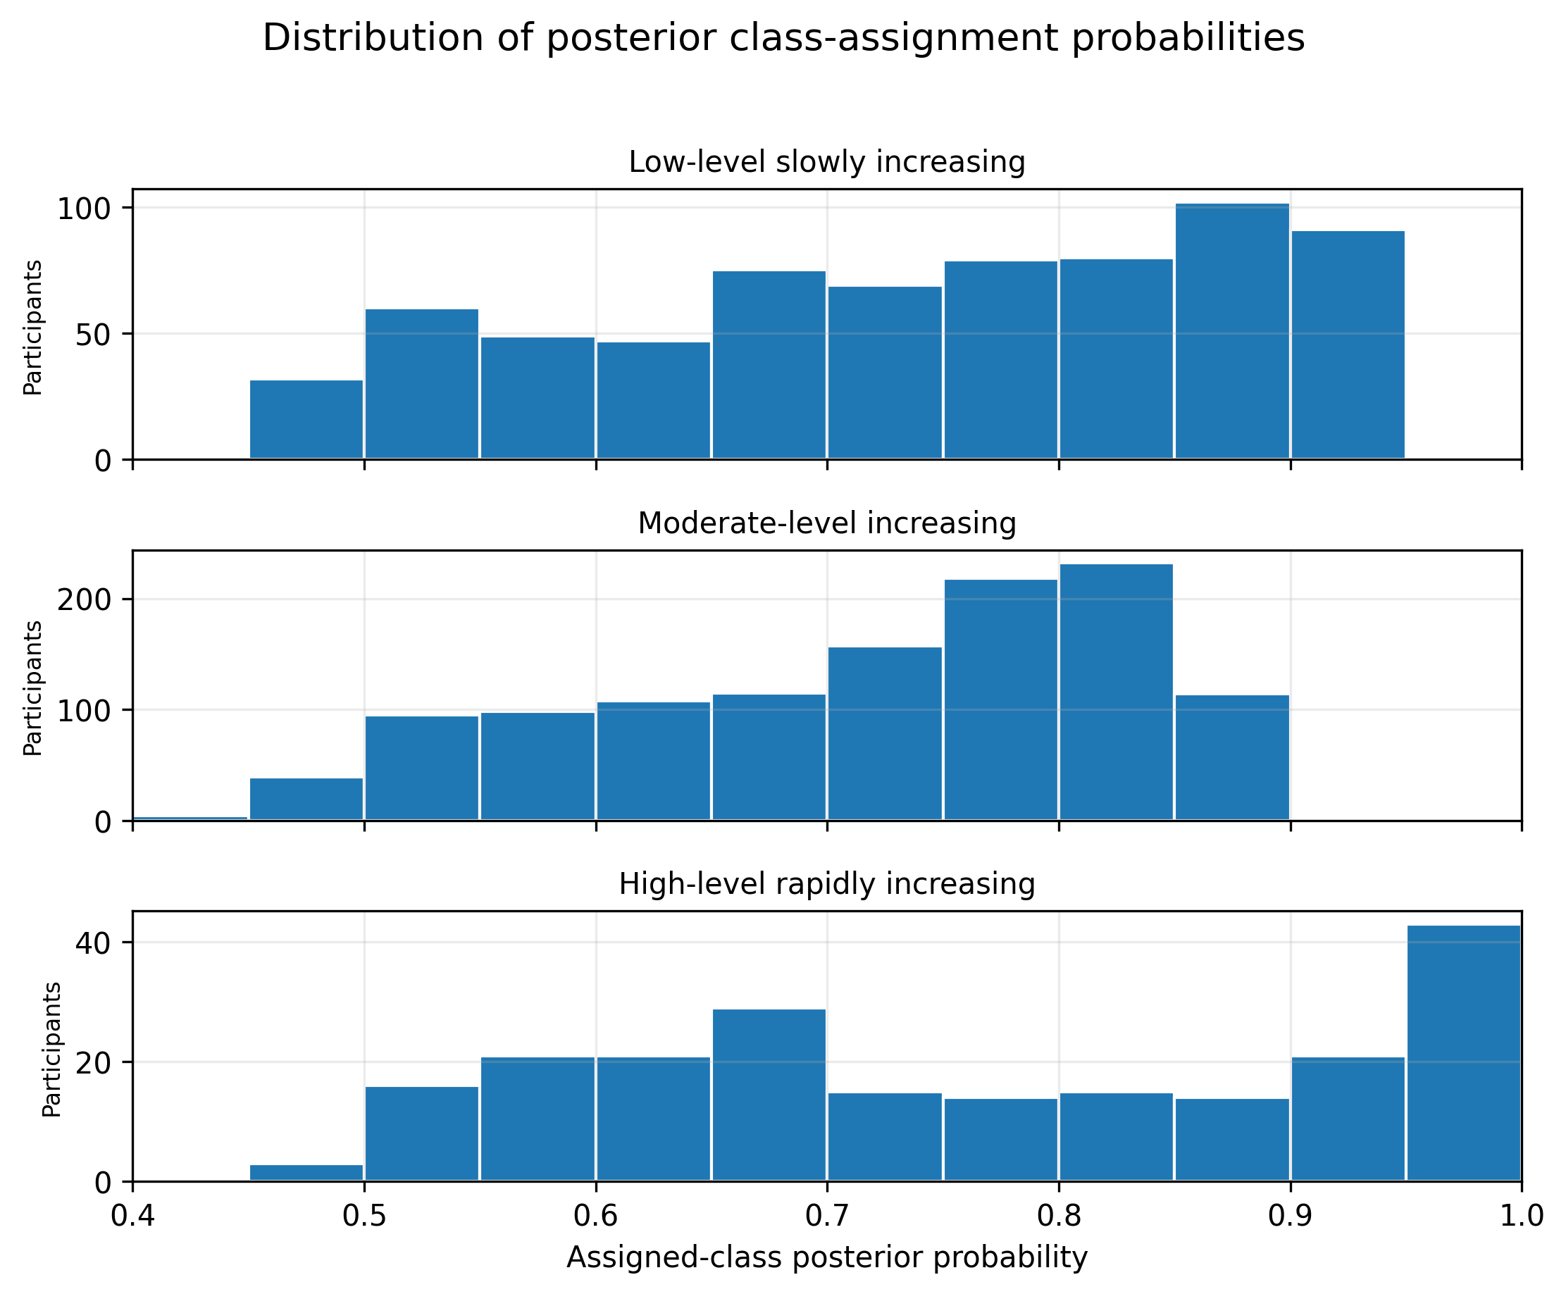
Supplementary Figure S2. Two-class LCMM sensitivity solution.
Observed mean FI values with 95% confidence intervals across Waves 1–4 for the 2-class solution.
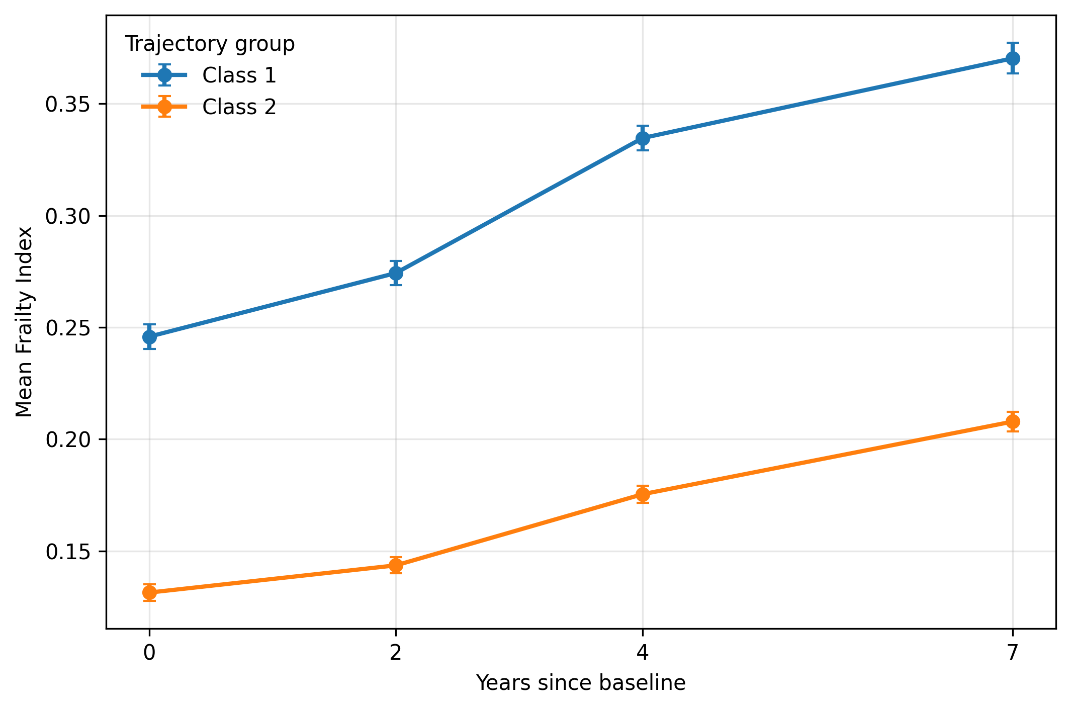

Supplementary Figure S3. Four-class LCMM sensitivity solution.
Observed mean FI values with 95% confidence intervals across Waves 1–4 for the 4-class solution.
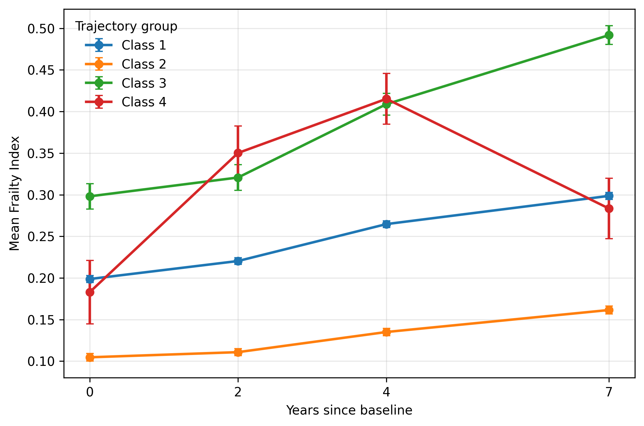

Supplementary Figure S4. Complete-case 3-class LCMM solution.
Observed mean FI values with 95% confidence intervals among participants with valid FI data at all four waves.
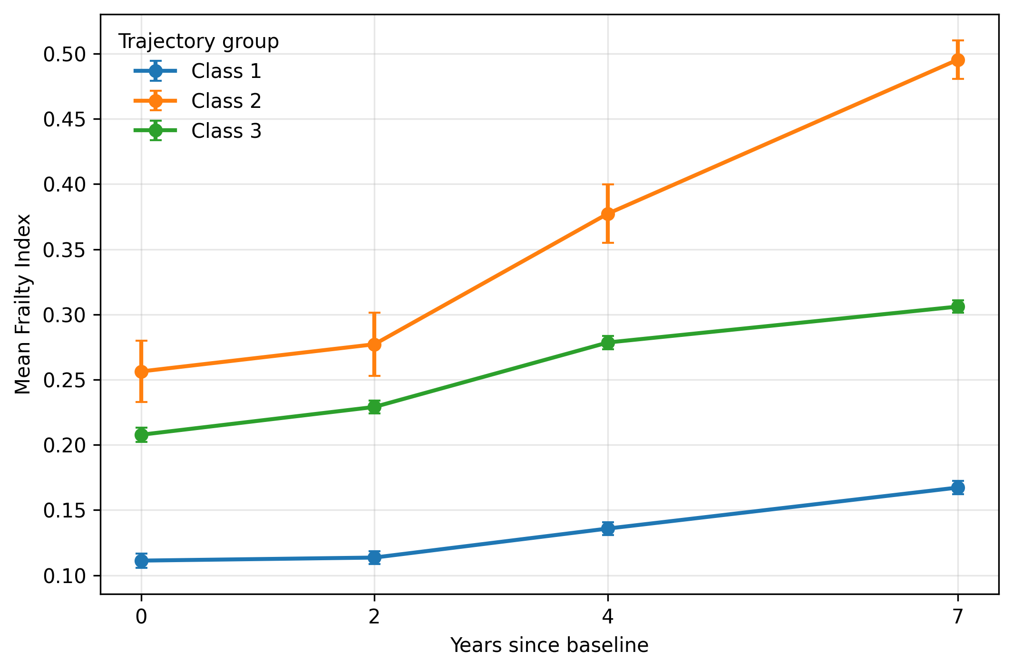

Supplementary Figure S5. Complete-case 2-class LCMM solution.
Observed mean FI values with 95% confidence intervals among participants with valid FI data at all four waves.
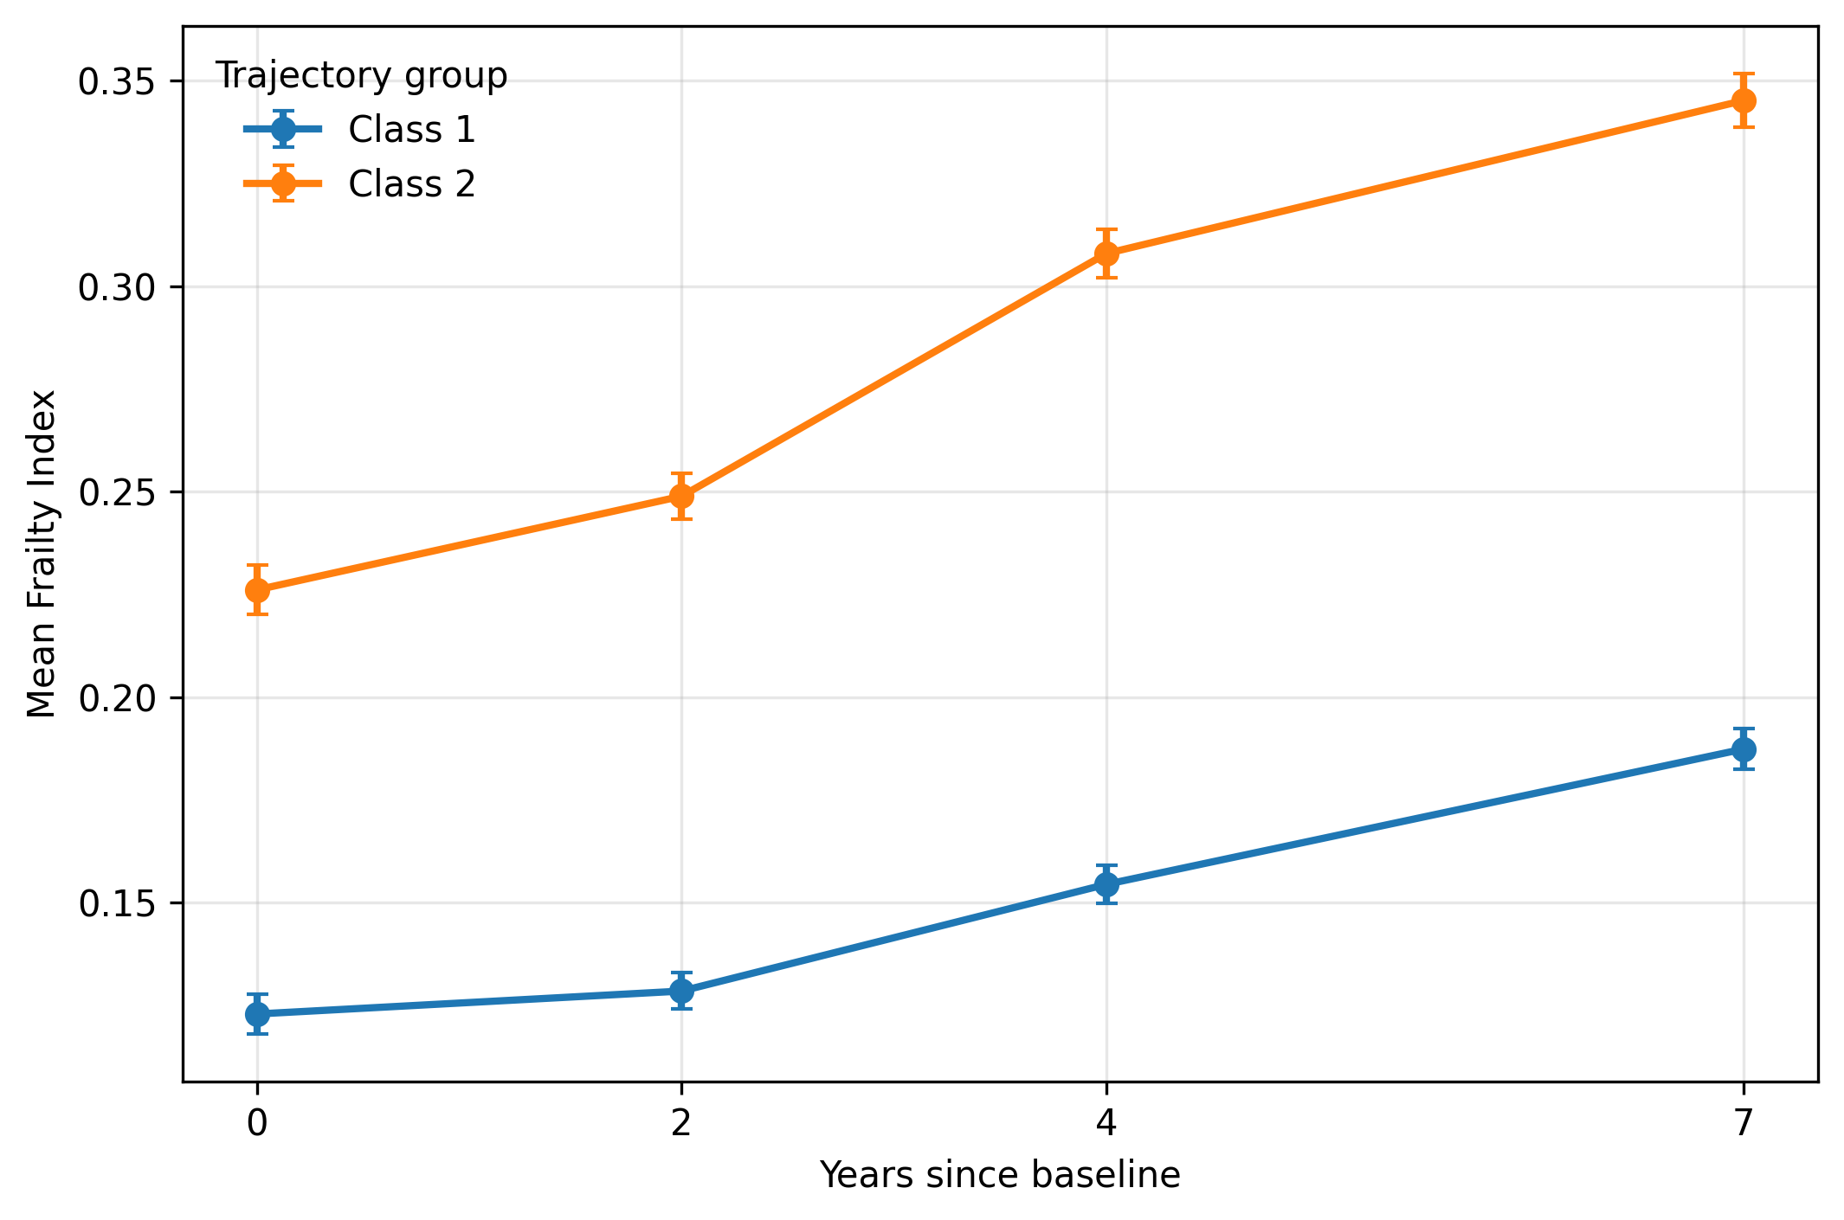

Supplementary Figure S6. Complete-case 4-class LCMM solution.
Observed mean FI values with 95% confidence intervals among participants with valid FI data at all four waves.
