Supplementary tables
Supplementary Table S1. Definition and categorization of covariates in CHARLS and ELSA
Variable | CHARLS | ELSA
Age | Continuous variable (years) | Continuous variable (years)
Gender | Dichotomous: Male, Female | Dichotomous: Male, Female
Education level | Categorized into "Less than lower secondary" and "Secondary or above". | Categorized into "Less than lower secondary" and "Secondary or above".
Marital status | Categorized as "Married" (including cohabiting) and "Non-married" (widowed, divorced, etc.). | Categorized as "Married" (including civil partnership) and "Non-married" (separated, divorced, etc.).
Smoking status | Dichotomous: No (never smoked), Yes (ever smoked) | Dichotomous: No (never smoked), Yes (ever smoked)
Drinking status | Dichotomous: No (never drank), Yes (ever drank) | Dichotomous: No (never drank), Yes (ever drank)
Total cholesterol | Continuous variable | Continuous variable
Low-density lipoprotein cholesterol | Continuous variable | Continuous variable
Notes: All covariates were assessed at baseline. Cohort-specific categorizations were harmonized for pooled analyses. Abbreviations: CHARLS, China Health and Retirement Longitudinal Study; ELSA, English Longitudinal Study of Ageing.

Supplementary Table S2. Cohort-specific participant flow
Stage | Overall | CHARLS | ELSA
Initial extracted participants | 26,348 | 17,705 | 8,643
Complete baseline TyG-BRI | 13,423 | 9,615 | 3,808
No baseline CVD/CMM and complete outcome follow-up | 9,155 | 6,527 | 2,628
Complete Model 3 covariates: primary analysis cohort | 8,747 | 6,496 | 2,251
Notes: Counts are reported separately for each cohort to document derivation of the primary analytical sample. Abbreviations: CHARLS, China Health and Retirement Longitudinal Study; CMM, cardiometabolic multimorbidity; CVD, cardiovascular disease; ELSA, English Longitudinal Study of Ageing; TyG-BRI, triglyceride-glucose body roundness index.

Supplementary Table S3. Cohort-specific associations and cohort interaction tests
Panel A. Cohort-specific Model 3 estimates
Outcome | Cohort | N | Events | HR per SD (95% CI) | P value
CVD | CHARLS | 6,496 | 1,174 | 1.194 (1.128–1.264) | <0.001
CVD | ELSA | 2,251 | 227 | 1.063 (0.930–1.214) | 0.372
Heart disease | CHARLS | 6,496 | 897 | 1.162 (1.089–1.240) | <0.001
Heart disease | ELSA | 2,251 | 200 | 1.086 (0.943–1.250) | 0.253
Stroke | CHARLS | 6,496 | 375 | 1.294 (1.174–1.427) | <0.001
Stroke | ELSA | 2,251 | 37 | 0.895 (0.631–1.268) | 0.532
CMM | CHARLS | 6,496 | 970 | 1.539 (1.456–1.627) | <0.001
CMM | ELSA | 2,251 | 181 | 1.573 (1.394–1.775) | <0.001
Panel B. Global TyG-BRI-by-cohort interaction tests
Outcome | N | Events | LRT χ² | P interaction | BH-FDR P
CVD | 8,747 | 1,401 | 2.817 | 0.093 | 0.186
Heart disease | 8,747 | 1,097 | 0.911 | 0.340 | 0.354
Stroke | 8,747 | 412 | 4.734 | 0.030 | 0.118
CMM | 8,747 | 1,151 | 0.859 | 0.354 | 0.354
Notes: Cohort-specific models used cohort-standardized TyG-BRI and the Model 3 covariates. Interaction tests were global likelihood-ratio tests and were corrected across outcomes with the Benjamini–Hochberg procedure. ELSA subtype estimates are exploratory because of the smaller event counts and wider confidence intervals. Abbreviations: BH-FDR, Benjamini–Hochberg false discovery rate; CI, confidence interval; CMM, cardiometabolic multimorbidity; CVD, cardiovascular disease; HR, hazard ratio; LRT, likelihood-ratio test; SD, standard deviation; TyG-BRI, triglyceride-glucose body roundness index.

Supplementary Table S4. Comparison of two-wave exposure definitions and analysis samples
Panel A. Equivalence of the two-wave average and the fixed-interval rescaling
Check | Value
Spearman correlation: two-wave average vs multiplied-by-4 | 1.000
Pearson correlation: two-wave average vs multiplied-by-4 | 1.000
Identical rank ordering | 1.000
Identical quartile allocation | 1.000
Panel B. Two-wave completeness by cohort
Cohort | Two-wave complete | N | CVD events | CMM events | Median age | Median TyG-BRI
CHARLS | No | 1,854 | 278 | 215 | 56.0 | 33.35
CHARLS | Yes | 4,642 | 896 | 755 | 57.0 | 34.48
ELSA | No | 1,165 | 130 | 112 | 62.0 | 39.92
ELSA | Yes | 1,086 | 97 | 69 | 62.0 | 39.11
Notes: The nominal cumulative exposure was calculated as the two-wave mean multiplied by the fixed four-year interval. This rescaling preserved the correlation, rank order, and quartile assignment exactly; accordingly, the two-wave mean was analyzed without interpreting the rescaled value as a distinct area-under-the-curve exposure. Abbreviations: CMM, cardiometabolic multimorbidity; CVD, cardiovascular disease; TyG-BRI, triglyceride-glucose body roundness index.

Supplementary Table S5. Characteristics of participants by two-wave TyG-BRI level group
Characteristic | Low two-wave level | Intermediate two-wave level | High two-wave level
N | 2,317 | 2,447 | 957
Baseline TyG-BRI | 26.09 (5.50) | 39.86 (6.26) | 58.63 (9.77)
Follow-up TyG-BRI | 26.51 (6.09) | 41.70 (6.24) | 60.73 (10.64)
Change in TyG-BRI | 0.42 (6.74) | 1.84 (8.24) | 2.10 (11.21)
Age, years | 58.35 (8.67) | 58.30 (8.74) | 59.71 (8.41)
Female | 991 (42.8%) | 1459 (59.6%) | 716 (74.8%)
Secondary education or above | 376 (16.2%) | 452 (18.5%) | 157 (16.4%)
Married | 2050 (88.5%) | 2186 (89.3%) | 825 (86.2%)
Smoking | 1173 (50.6%) | 873 (35.7%) | 283 (29.6%)
Drinking | 1229 (53.0%) | 1173 (47.9%) | 389 (40.6%)
TC | 192.43 (39.87) | 201.51 (39.30) | 207.35 (42.39)
LDL-C | 115.45 (33.54) | 122.26 (35.90) | 122.72 (39.04)
BMI | 21.30 (2.64) | 24.94 (3.01) | 29.51 (4.29)
WC | 78.20 (6.66) | 89.27 (7.27) | 101.07 (8.79)
Incident CVD | 344 (14.8%) | 435 (17.8%) | 214 (22.4%)
Incident heart disease | 265 (11.4%) | 332 (13.6%) | 169 (17.7%)
Incident stroke | 104 (4.5%) | 133 (5.4%) | 68 (7.1%)
Incident CMM | 227 (9.8%) | 350 (14.3%) | 247 (25.8%)
Notes: Continuous variables are shown as mean (SD); categorical variables and events are shown as n (%). K-means groups were ordered by the average of the baseline and follow-up TyG-BRI values. Abbreviations: BMI, body mass index; CMM, cardiometabolic multimorbidity; CVD, cardiovascular disease; LDL-C, low-density lipoprotein cholesterol; SD, standard deviation; TC, total cholesterol; TyG-BRI, triglyceride-glucose body roundness index; WC, waist circumference.

Supplementary Table S6. Characteristics of two-wave TyG-BRI level groups by cohort
Panel A. Demographic, lifestyle, and metabolic characteristics
Group | Cohort | N | Baseline | Follow-up | Change | Age | Female | BMI | WC
Low two-wave level | CHARLS | 1,983 | 25.93 (5.47) | 26.56 (6.22) | 0.63 (6.95) | 57.85 (8.92) | 766 (38.6%) | 20.91 (2.48) | 77.43 (6.17)
Low two-wave level | ELSA | 334 | 27.05 (5.56) | 26.20 (5.26) | -0.86 (5.19) | 61.31 (6.22) | 225 (67.4%) | 23.64 (2.33) | 82.78 (7.58)
Intermediate two-wave level | CHARLS | 1,946 | 39.57 (6.28) | 41.84 (6.36) | 2.27 (8.44) | 57.06 (8.85) | 1200 (61.7%) | 24.31 (2.80) | 87.67 (6.30)
Intermediate two-wave level | ELSA | 501 | 41.00 (6.05) | 41.13 (5.69) | 0.13 (7.17) | 63.13 (6.30) | 259 (51.7%) | 27.40 (2.47) | 95.46 (7.50)
High two-wave level | CHARLS | 706 | 57.55 (9.04) | 60.12 (10.59) | 2.58 (11.27) | 58.48 (8.71) | 576 (81.6%) | 28.15 (3.36) | 98.19 (6.73)
High two-wave level | ELSA | 251 | 61.67 (11.06) | 62.44 (10.60) | 0.77 (10.96) | 63.20 (6.33) | 140 (55.8%) | 33.38 (4.32) | 109.20 (8.83)
Panel B. Outcome events
Group | Cohort | N | CVD | Heart disease | Stroke | CMM
Low two-wave level | CHARLS | 1,983 | 315 (15.9%) | 240 (12.1%) | 97 (4.9%) | 214 (10.8%)
Low two-wave level | ELSA | 334 | 29 (8.7%) | 25 (7.5%) | 7 (2.1%) | 13 (3.9%)
Intermediate two-wave level | CHARLS | 1,946 | 388 (19.9%) | 292 (15.0%) | 125 (6.4%) | 316 (16.2%)
Intermediate two-wave level | ELSA | 501 | 47 (9.4%) | 40 (8.0%) | 8 (1.6%) | 34 (6.8%)
High two-wave level | CHARLS | 706 | 193 (27.3%) | 149 (21.1%) | 66 (9.3%) | 225 (31.9%)
High two-wave level | ELSA | 251 | 21 (8.4%) | 20 (8.0%) | 2 (0.8%) | 22 (8.8%)
Notes: Continuous variables are shown as mean (SD); sex and outcome events are shown as n (%). The full harmonized characteristic set is reported in Supplementary Table S5. Abbreviations: BMI, body mass index; CMM, cardiometabolic multimorbidity; CVD, cardiovascular disease; SD, standard deviation; TyG-BRI, triglyceride-glucose body roundness index; WC, waist circumference.

Supplementary Table S7. Prediction sample and model performance in development and external validation
Panel A. Common complete-case prediction sample
Cohort | N | CVD events | CMM events
CHARLS | 6,476 | 1,172 | 968
ELSA | 2,241 | 225 | 179
Overall | 8,717 | 1,397 | 1,147
Panel B. Time-dependent AUC, Uno C, and Brier score
Outcome | Cohort | Model | 4-year AUC (95% CI) | Uno's C (95% CI) | Brier (95% CI)
CVD | CHARLS | Base | 0.620 (0.595–0.644) | 0.604 (0.588–0.621) | 0.072 (0.066–0.077)
CVD | CHARLS | TyG | 0.626 (0.601–0.650) | 0.609 (0.592–0.625) | 0.072 (0.066–0.077)
CVD | CHARLS | BRI | 0.627 (0.602–0.652) | 0.615 (0.599–0.632) | 0.072 (0.066–0.077)
CVD | CHARLS | TyG-BRI | 0.628 (0.604–0.653) | 0.616 (0.600–0.633) | 0.072 (0.066–0.077)
CVD | CHARLS | TyG-BMI | 0.634 (0.609–0.659) | 0.620 (0.604–0.636) | 0.072 (0.066–0.077)
CVD | CHARLS | TyG-WC | 0.632 (0.608–0.657) | 0.620 (0.603–0.636) | 0.072 (0.066–0.077)
CVD | ELSA | Base | 0.571 (0.517–0.625) | 0.563 (0.524–0.602) | 0.057 (0.050–0.064)
CVD | ELSA | TyG | 0.585 (0.532–0.639) | 0.577 (0.538–0.616) | 0.056 (0.049–0.064)
CVD | ELSA | BRI | 0.595 (0.540–0.650) | 0.578 (0.538–0.617) | 0.058 (0.051–0.065)
CVD | ELSA | TyG-BRI | 0.598 (0.543–0.652) | 0.581 (0.541–0.620) | 0.057 (0.050–0.065)
CVD | ELSA | TyG-BMI | 0.598 (0.545–0.652) | 0.582 (0.543–0.621) | 0.059 (0.052–0.066)
CVD | ELSA | TyG-WC | 0.620 (0.567–0.673) | 0.596 (0.557–0.635) | 0.058 (0.051–0.065)
CMM | CHARLS | Base | 0.619 (0.592–0.646) | 0.607 (0.590–0.625) | 0.058 (0.052–0.063)
CMM | CHARLS | TyG | 0.660 (0.633–0.687) | 0.646 (0.628–0.663) | 0.057 (0.052–0.062)
CMM | CHARLS | BRI | 0.689 (0.664–0.714) | 0.666 (0.649–0.683) | 0.057 (0.052–0.062)
CMM | CHARLS | TyG-BRI | 0.698 (0.673–0.723) | 0.673 (0.657–0.690) | 0.056 (0.052–0.061)
CMM | CHARLS | TyG-BMI | 0.707 (0.682–0.732) | 0.681 (0.665–0.698) | 0.057 (0.052–0.062)
CMM | CHARLS | TyG-WC | 0.703 (0.677–0.729) | 0.681 (0.664–0.698) | 0.056 (0.051–0.061)
CMM | ELSA | Base | 0.553 (0.494–0.612) | 0.544 (0.502–0.586) | 0.045 (0.038–0.051)
CMM | ELSA | TyG | 0.689 (0.633–0.745) | 0.647 (0.606–0.688) | 0.042 (0.035–0.048)
CMM | ELSA | BRI | 0.685 (0.631–0.739) | 0.659 (0.619–0.699) | 0.047 (0.041–0.053)
CMM | ELSA | TyG-BRI | 0.701 (0.648–0.754) | 0.670 (0.631–0.710) | 0.046 (0.040–0.052)
CMM | ELSA | TyG-BMI | 0.693 (0.638–0.747) | 0.672 (0.633–0.712) | 0.049 (0.043–0.055)
CMM | ELSA | TyG-WC | 0.727 (0.676–0.778) | 0.689 (0.651–0.728) | 0.048 (0.042–0.054)
Notes: All models used the same complete-case sample. CHARLS values are apparent development performance; ELSA values are external-validation performance with all CHARLS coefficients fixed. Lower Brier scores indicate better overall prediction error. Abbreviations: AUC, area under the time-dependent receiver-operating-characteristic curve; BRI, body roundness index; CHARLS, China Health and Retirement Longitudinal Study; CI, confidence interval; CMM, cardiometabolic multimorbidity; CVD, cardiovascular disease; ELSA, English Longitudinal Study of Ageing; TyG, triglyceride-glucose index; TyG-BMI, triglyceride-glucose body mass index; TyG-BRI, triglyceride-glucose body roundness index; TyG-WC, triglyceride-glucose waist circumference.

Supplementary Table S8. Pairwise AUC contrasts in ELSA external validation
Outcome | Model 1 | Model 2 | ΔAUC | 95% CI lower | 95% CI upper | P value
CVD | TyG | Base | 0.0140 | 0.0034 | 0.0246 | 0.010
CVD | BRI | Base | 0.0238 | -0.0042 | 0.0518 | 0.096
CVD | TyG-BRI | Base | 0.0264 | -0.0022 | 0.0549 | 0.070
CVD | TyG-BMI | Base | 0.0271 | 0.0010 | 0.0531 | 0.042
CVD | TyG-WC | Base | 0.0486 | 0.0166 | 0.0806 | 0.003
CVD | BRI | TyG | 0.0098 | -0.0144 | 0.0339 | 0.428
CVD | TyG-BRI | TyG | 0.0124 | -0.0111 | 0.0359 | 0.302
CVD | TyG-BMI | TyG | 0.0131 | -0.0077 | 0.0338 | 0.217
CVD | TyG-WC | TyG | 0.0346 | 0.0088 | 0.0604 | 0.009
CVD | TyG-BRI | BRI | 0.0026 | -0.0012 | 0.0064 | 0.177
CVD | TyG-BMI | BRI | 0.0033 | -0.0098 | 0.0163 | 0.623
CVD | TyG-WC | BRI | 0.0248 | 0.0126 | 0.0370 | <0.001
CVD | TyG-BMI | TyG-BRI | 0.0007 | -0.0113 | 0.0126 | 0.912
CVD | TyG-WC | TyG-BRI | 0.0222 | 0.0121 | 0.0324 | <0.001
CVD | TyG-WC | TyG-BMI | 0.0216 | 0.0077 | 0.0354 | 0.002
CMM | TyG | Base | 0.1357 | 0.0805 | 0.1908 | <0.001
CMM | BRI | Base | 0.1323 | 0.0731 | 0.1916 | <0.001
CMM | TyG-BRI | Base | 0.1480 | 0.0865 | 0.2096 | <0.001
CMM | TyG-BMI | Base | 0.1395 | 0.0849 | 0.1941 | <0.001
CMM | TyG-WC | Base | 0.1736 | 0.1094 | 0.2378 | <0.001
CMM | BRI | TyG | -0.0034 | -0.0548 | 0.0481 | 0.898
CMM | TyG-BRI | TyG | 0.0124 | -0.0339 | 0.0587 | 0.601
CMM | TyG-BMI | TyG | 0.0038 | -0.0380 | 0.0456 | 0.858
CMM | TyG-WC | TyG | 0.0379 | -0.0014 | 0.0773 | 0.059
CMM | TyG-BRI | BRI | 0.0157 | 0.0070 | 0.0245 | <0.001
CMM | TyG-BMI | BRI | 0.0072 | -0.0202 | 0.0345 | 0.608
CMM | TyG-WC | BRI | 0.0413 | 0.0168 | 0.0658 | <0.001
CMM | TyG-BMI | TyG-BRI | -0.0086 | -0.0341 | 0.0170 | 0.512
CMM | TyG-WC | TyG-BRI | 0.0256 | 0.0077 | 0.0435 | 0.005
CMM | TyG-WC | TyG-BMI | 0.0341 | 0.0078 | 0.0604 | 0.011
Notes: Positive ΔAUC favors Model 1. All comparisons used four-year time-dependent AUCs in ELSA with CHARLS-derived regression coefficients fixed. Abbreviations: AUC, area under the time-dependent receiver-operating-characteristic curve; CHARLS, China Health and Retirement Longitudinal Study; CI, confidence interval; ELSA, English Longitudinal Study of Ageing.

Supplementary Table S9. IDI and continuous NRI in the CHARLS development cohort
Outcome | Comparison | IDI | IDI 95% CI | IDI P | Continuous NRI | NRI 95% CI | NRI P
CVD | TyG vs Base | 0.0019 | 0.0003–0.0049 | <0.001 | 0.1034 | 0.0083–0.1702 | 0.010
CVD | BRI vs Base | 0.0043 | 0.0012–0.0081 | 0.010 | 0.1202 | 0.0410–0.1966 | <0.001
CVD | TyG-BRI vs Base | 0.0047 | 0.0021–0.0099 | <0.001 | 0.1375 | 0.0624–0.2146 | <0.001
CVD | TyG-BMI vs Base | 0.0050 | 0.0021–0.0094 | <0.001 | 0.1085 | 0.0369–0.1678 | <0.001
CVD | TyG-WC vs Base | 0.0062 | 0.0027–0.0113 | <0.001 | 0.1235 | 0.0367–0.1945 | 0.010
CVD | TyG-BRI vs TyG | 0.0028 | -0.0008–0.0062 | 0.169 | 0.0766 | -0.0318–0.1597 | 0.149
CVD | TyG-BRI vs BRI | 0.0004 | -0.0003–0.0011 | 0.199 | 0.0301 | -0.0582–0.1091 | 0.488
CVD | TyG-BRI vs TyG-BMI | -0.0003 | -0.0034–0.0026 | 0.876 | -0.0679 | -0.1508–0.0592 | 0.418
CVD | TyG-BRI vs TyG-WC | -0.0014 | -0.0031–0.0002 | 0.100 | -0.0910 | -0.1664–-0.0001 | 0.040
CMM | TyG vs Base | 0.0146 | 0.0076–0.0234 | <0.001 | 0.1772 | 0.0865–0.2556 | <0.001
CMM | BRI vs Base | 0.0213 | 0.0123–0.0387 | <0.001 | 0.2716 | 0.1907–0.3664 | <0.001
CMM | TyG-BRI vs Base | 0.0250 | 0.0157–0.0411 | <0.001 | 0.3012 | 0.2118–0.3782 | <0.001
CMM | TyG-BMI vs Base | 0.0213 | 0.0129–0.0311 | <0.001 | 0.2835 | 0.1947–0.3668 | <0.001
CMM | TyG-WC vs Base | 0.0302 | 0.0210–0.0442 | <0.001 | 0.2775 | 0.1924–0.3512 | <0.001
CMM | TyG-BRI vs TyG | 0.0104 | 0.0002–0.0236 | 0.030 | 0.1078 | 0.0000–0.1870 | 0.050
CMM | TyG-BRI vs BRI | 0.0036 | 0.0015–0.0063 | <0.001 | 0.1750 | 0.0783–0.2613 | <0.001
CMM | TyG-BRI vs TyG-BMI | 0.0037 | -0.0069–0.0140 | 0.428 | 0.0528 | -0.0948–0.1697 | 0.577
CMM | TyG-BRI vs TyG-WC | -0.0053 | -0.0116–0.0005 | 0.080 | -0.1716 | -0.2780–-0.0894 | 0.010
Notes: IDI and continuous NRI were estimated at four years using 200 perturbation resamples. These indices are supportive measures and were interpreted together with discrimination, calibration, and external validation. Abbreviations: CHARLS, China Health and Retirement Longitudinal Study; CI, confidence interval; IDI, integrated discrimination improvement; NRI, net reclassification improvement.

Supplementary Table S10. External calibration before and after baseline-hazard updating
Panel A. Direct transfer of CHARLS-derived models to ELSA
Outcome | Model | Observed risk | Mean predicted risk | O/E | Calibration slope (95% CI)
CVD | Base | 0.0571 | 0.1112 | 0.514 | 0.564 (0.202–0.927)
CVD | TyG | 0.0571 | 0.1060 | 0.539 | 0.714 (0.347–1.081)
CVD | BRI | 0.0571 | 0.1188 | 0.481 | 0.635 (0.308–0.961)
CVD | TyG-BRI | 0.0571 | 0.1161 | 0.492 | 0.677 (0.347–1.006)
CVD | TyG-BMI | 0.0571 | 0.1272 | 0.449 | 0.613 (0.307–0.919)
CVD | TyG-WC | 0.0571 | 0.1219 | 0.469 | 0.804 (0.478–1.129)
CMM | Base | 0.0437 | 0.0931 | 0.470 | 0.407 (-0.044–0.857)
CMM | TyG | 0.0437 | 0.0741 | 0.590 | 1.332 (0.967–1.698)
CMM | BRI | 0.0437 | 0.1108 | 0.395 | 0.921 (0.695–1.148)
CMM | TyG-BRI | 0.0437 | 0.1061 | 0.412 | 0.956 (0.740–1.172)
CMM | TyG-BMI | 0.0437 | 0.1226 | 0.357 | 0.972 (0.751–1.193)
CMM | TyG-WC | 0.0437 | 0.1209 | 0.362 | 1.037 (0.820–1.253)
Panel B. Baseline-hazard-only updating in ELSA
Outcome | Model | Observed risk | Mean recalibrated risk | O/E | Updated baseline cumulative hazard
CVD | Base | 0.0571 | 0.0562 | 1.017 | 0.0413
CVD | TyG | 0.0571 | 0.0562 | 1.016 | 0.0431
CVD | BRI | 0.0571 | 0.0562 | 1.017 | 0.0359
CVD | TyG-BRI | 0.0571 | 0.0562 | 1.017 | 0.0369
CVD | TyG-BMI | 0.0571 | 0.0561 | 1.018 | 0.0344
CVD | TyG-WC | 0.0571 | 0.0562 | 1.017 | 0.0363
CMM | Base | 0.0437 | 0.0432 | 1.013 | 0.0286
CMM | TyG | 0.0437 | 0.0433 | 1.010 | 0.0333
CMM | BRI | 0.0437 | 0.0431 | 1.014 | 0.0190
CMM | TyG-BRI | 0.0437 | 0.0431 | 1.014 | 0.0195
CMM | TyG-BMI | 0.0437 | 0.0431 | 1.015 | 0.0187
CMM | TyG-WC | 0.0437 | 0.0432 | 1.012 | 0.0183
Notes: Panel A transferred both CHARLS coefficients and baseline risk. Panel B retained every CHARLS regression coefficient and updated only the ELSA baseline cumulative hazard. Baseline-hazard updating corrected average calibration but did not guarantee perfect calibration across risk deciles. Abbreviations: CHARLS, China Health and Retirement Longitudinal Study; CI, confidence interval; ELSA, English Longitudinal Study of Ageing; KM, Kaplan–Meier; O/E, observed-to-expected ratio.

Supplementary Table S11. Sensitivity analyses using alternative definitions of CMM
Outcome definition | N | Events | HR per SD (95% CI) | P value
Original CMM | 8,747 | 1,151 | 1.580 (1.501–1.663) | <0.001
CMM excluding diabetes component | 8,154 | 788 | 1.395 (1.308–1.487) | <0.001
Heart disease plus stroke only | 8,184 | 98 | 1.292 (1.066–1.565) | 0.009
Notes: Models used the Model 3 covariates and cohort stratification. Alternative definitions were used to evaluate structural overlap between TyG-BRI and the diabetes component of the primary CMM definition. Abbreviations: CI, confidence interval; CMM, cardiometabolic multimorbidity; HR, hazard ratio; SD, standard deviation; TyG-BRI, triglyceride-glucose body roundness index.

Supplementary Table S12. Additional adjustment for metabolic covariates and exposure VIF
Panel A. Additional-adjustment sensitivity models
Outcome | Analysis | Model | N | Events | HR per SD (95% CI) | P value
CVD | Additional BMI adjustment | Model 3 covariates (same sample) | 8,717 | 1,397 | 1.189 (1.128–1.253) | <0.001
CVD | Additional BMI adjustment | Model 3 + BMI | 8,717 | 1,397 | 1.098 (1.010–1.193) | 0.027
CVD | Additional baseline hypertension adjustment | Model 3 covariates (same sample) | 8,711 | 1,396 | 1.188 (1.127–1.252) | <0.001
CVD | Additional baseline hypertension adjustment | Model 3 + baseline hypertension | 8,711 | 1,396 | 1.127 (1.068–1.190) | <0.001
CVD | Additional baseline diabetes adjustment | Model 3 covariates (same sample) | 8,692 | 1,395 | 1.191 (1.130–1.255) | <0.001
CVD | Additional baseline diabetes adjustment | Model 3 + baseline diabetes | 8,692 | 1,395 | 1.189 (1.128–1.253) | <0.001
CVD | Additional fasting glucose adjustment | Model 3 covariates (same sample) | 8,747 | 1,401 | 1.190 (1.129–1.254) | <0.001
CVD | Additional fasting glucose adjustment | Model 3 + fasting glucose | 8,747 | 1,401 | 1.193 (1.131–1.258) | <0.001
CVD | Combined metabolic overadjustment | Model 3 covariates (same sample) | 8,640 | 1,389 | 1.188 (1.127–1.253) | <0.001
CVD | Combined metabolic overadjustment | Model 3 + BMI + baseline hypertension + baseline diabetes + fasting glucose | 8,640 | 1,389 | 1.073 (0.983–1.171) | 0.117
CMM | Additional BMI adjustment | Model 3 covariates (same sample) | 8,717 | 1,147 | 1.584 (1.504–1.668) | <0.001
CMM | Additional BMI adjustment | Model 3 + BMI | 8,717 | 1,147 | 1.414 (1.302–1.535) | <0.001
CMM | Additional baseline hypertension adjustment | Model 3 covariates (same sample) | 8,711 | 1,151 | 1.578 (1.499–1.661) | <0.001
CMM | Additional baseline hypertension adjustment | Model 3 + baseline hypertension | 8,711 | 1,151 | 1.424 (1.348–1.505) | <0.001
CMM | Additional baseline diabetes adjustment | Model 3 covariates (same sample) | 8,692 | 1,151 | 1.580 (1.501–1.663) | <0.001
CMM | Additional baseline diabetes adjustment | Model 3 + baseline diabetes | 8,692 | 1,151 | 1.559 (1.481–1.642) | <0.001
CMM | Additional fasting glucose adjustment | Model 3 covariates (same sample) | 8,747 | 1,151 | 1.580 (1.501–1.663) | <0.001
CMM | Additional fasting glucose adjustment | Model 3 + fasting glucose | 8,747 | 1,151 | 1.528 (1.450–1.610) | <0.001
CMM | Combined metabolic overadjustment | Model 3 covariates (same sample) | 8,640 | 1,147 | 1.583 (1.503–1.666) | <0.001
CMM | Combined metabolic overadjustment | Model 3 + BMI + baseline hypertension + baseline diabetes + fasting glucose | 8,640 | 1,147 | 1.237 (1.134–1.350) | <0.001
Panel B. Exposure VIF
Analysis | N | Exposure R² | Exposure VIF
Additional BMI adjustment | 8,717 | 0.661 | 2.950
Additional baseline hypertension adjustment | 8,711 | 0.114 | 1.128
Additional baseline diabetes adjustment | 8,692 | 0.078 | 1.085
Additional fasting glucose adjustment | 8,747 | 0.093 | 1.103
Combined metabolic overadjustment | 8,640 | 0.684 | 3.164
Notes: Each sensitivity analysis was evaluated on its corresponding complete-case sample and included a same-sample Model 3 estimate for comparison. The combined metabolic model was treated as an overadjustment sensitivity analysis because several added variables are closely related to components or potential pathways of TyG-BRI. Abbreviations: BMI, body mass index; CI, confidence interval; HR, hazard ratio; SD, standard deviation; TyG-BRI, triglyceride-glucose body roundness index; VIF, variance inflation factor.

Supplementary Table S13. Competing-risk analyses and age-specific estimates
Panel A. Overall competing-risk and cause-specific estimates
Outcome | Model | N | Events | Competing deaths | HR or sHR per SD (95% CI) | P value
CVD | Fine-Gray subdistribution hazards | 10,193 | 1,572 | 1,218 | 1.199 (1.143–1.258) | <0.001
CVD | Cause-specific Cox | 10,193 | 1,572 | 1,218 | 1.203 (1.145–1.264) | <0.001
CMM | Fine-Gray subdistribution hazards | 10,130 | 1,252 | 1,241 | 1.585 (1.509–1.665) | <0.001
CMM | Cause-specific Cox | 10,130 | 1,252 | 1,241 | 1.603 (1.526–1.684) | <0.001
Panel B. Age-specific Fine–Gray estimates
Outcome | Age group | N | Events | Competing deaths | sHR per SD (95% CI) | P value
CVD | <60 years | 5,464 | 697 | 519 | 1.294 (1.199–1.396) | <0.001
CVD | ≥60 years | 4,729 | 875 | 699 | 1.137 (1.068–1.210) | <0.001
CMM | <60 years | 5,430 | 560 | 527 | 1.786 (1.666–1.916) | <0.001
CMM | ≥60 years | 4,700 | 692 | 714 | 1.460 (1.367–1.560) | <0.001
Panel C. Age interaction in Fine–Gray models
Outcome | N | Events | Competing deaths | Interaction HR (95% CI) | P interaction | BH-FDR P
CVD | 10,193 | 1,572 | 1,218 | 0.899 (0.822–0.982) | 0.019 | 0.019
CMM | 10,130 | 1,252 | 1,241 | 0.836 (0.766–0.912) | <0.001 | <0.001
Notes: Competing-death analyses used an earlier eligible risk set that retained participants with ascertainable death status. Death timing was approximated using the available wave intervals. Interaction HRs below 1 indicate weaker TyG-BRI associations among participants aged 60 years or older. Abbreviations: BH-FDR, Benjamini–Hochberg false discovery rate; CI, confidence interval; HR, hazard ratio; SD, standard deviation; sHR, subdistribution hazard ratio; TyG-BRI, triglyceride-glucose body roundness index.

Supplementary Table S14. Sex-specific estimates and sex interaction tests
Panel A. Sex-specific Model 3 estimates
Outcome | Sex | N | Events | HR per SD (95% CI) | P value
CVD | Female | 4,803 | 804 | 1.140 (1.067–1.218) | <0.001
CVD | Male | 3,944 | 597 | 1.229 (1.122–1.347) | <0.001
CMM | Female | 4,803 | 656 | 1.535 (1.440–1.636) | <0.001
CMM | Male | 3,944 | 495 | 1.640 (1.497–1.796) | <0.001
Panel B. Global sex interaction tests
Outcome | N | Events | LRT χ² | P interaction | BH-FDR P
CVD | 8,747 | 1,401 | 4.433 | 0.035 | 0.070
CMM | 8,747 | 1,151 | 1.835 | 0.176 | 0.176
Notes: Models adjusted for the Model 3 covariates other than sex and included cohort handling. Interaction tests were global likelihood-ratio tests and were corrected across the two outcomes using the Benjamini–Hochberg procedure. Abbreviations: BH-FDR, Benjamini–Hochberg false discovery rate; CI, confidence interval; HR, hazard ratio; LRT, likelihood-ratio test; SD, standard deviation; TyG-BRI, triglyceride-glucose body roundness index.

Supplementary Table S15. RCS tests and time-varying TyG-BRI association with CMM
Panel A. RCS tests
Outcome | N | Events | Reference median | P overall | P nonlinear | BH-FDR P nonlinear
CVD | 8,747 | 1,401 | 35.63 | <0.001 | 0.622 | 0.622
CMM | 8,747 | 1,151 | 35.63 | <0.001 | 0.001 | 0.003
Panel B. Time-varying HRs for CMM
Time, years | N | Events | HR per SD (95% CI)
1 | 8,747 | 1,151 | 1.990 (1.696–2.336)
2 | 8,747 | 1,151 | 1.792 (1.628–1.974)
4 | 8,747 | 1,151 | 1.614 (1.532–1.701)
6 | 8,747 | 1,151 | 1.518 (1.432–1.610)
Panel C. Time-varying coefficient test
Term | Estimate | SE | Statistic | P value
TyG_BRI_z_sens | 0.6883 | 0.0816 | 8.430 | <0.001
tt(TyG_BRI_z_sens) | -0.1510 | 0.0515 | -2.936 | 0.003
Notes: RCS models used four knots and the median reference. Because the CMM proportional-hazards test indicated a time-varying association, HRs are shown at selected follow-up times; the association remained positive and statistically significant throughout the displayed period. Abbreviations: BH-FDR, Benjamini–Hochberg false discovery rate; CI, confidence interval; CMM, cardiometabolic multimorbidity; HR, hazard ratio; RCS, restricted cubic spline; SD, standard deviation; SE, standard error; TyG-BRI, triglyceride-glucose body roundness index.

Supplementary Table S16. Subgroup estimates and global interaction tests
Panel A. Subgroup-specific estimates
Outcome | Subgroup | Level | N | Events | HR per SD (95% CI) | P value
CVD | Age_group | <60 years | 4,848 | 635 | 1.276 (1.174–1.387) | <0.001
CVD | Age_group | ≥60 years | 3,899 | 766 | 1.138 (1.063–1.219) | <0.001
CVD | Gender | female | 4,803 | 804 | 1.140 (1.067–1.218) | <0.001
CVD | Gender | male | 3,944 | 597 | 1.229 (1.122–1.347) | <0.001
CVD | Country | CHARLS | 6,496 | 1,174 | 1.210 (1.139–1.287) | <0.001
CVD | Country | ELSA | 2,251 | 227 | 1.055 (0.938–1.188) | 0.372
CVD | Smoking | No | 5,095 | 847 | 1.164 (1.089–1.244) | <0.001
CVD | Smoking | Yes | 3,652 | 554 | 1.240 (1.138–1.352) | <0.001
CVD | Drinking | No | 4,140 | 764 | 1.179 (1.096–1.270) | <0.001
CVD | Drinking | Yes | 4,607 | 637 | 1.204 (1.116–1.299) | <0.001
CMM | Age_group | <60 years | 4,848 | 533 | 1.790 (1.654–1.938) | <0.001
CMM | Age_group | ≥60 years | 3,899 | 618 | 1.453 (1.357–1.557) | <0.001
CMM | Gender | female | 4,803 | 656 | 1.535 (1.440–1.636) | <0.001
CMM | Gender | male | 3,944 | 495 | 1.640 (1.497–1.796) | <0.001
CMM | Country | CHARLS | 6,496 | 970 | 1.591 (1.498–1.689) | <0.001
CMM | Country | ELSA | 2,251 | 181 | 1.496 (1.344–1.665) | <0.001
CMM | Smoking | No | 5,095 | 705 | 1.536 (1.440–1.638) | <0.001
CMM | Smoking | Yes | 3,652 | 446 | 1.677 (1.537–1.829) | <0.001
CMM | Drinking | No | 4,140 | 607 | 1.588 (1.474–1.710) | <0.001
CMM | Drinking | Yes | 4,607 | 544 | 1.567 (1.458–1.683) | <0.001
Panel B. Global interaction tests
Outcome | Subgroup | N | Events | LRT χ² | P interaction | BH-FDR P
CVD | Age_group | 8,747 | 1,401 | 2.323 | 0.128 | 0.213
CVD | Gender | 8,747 | 1,401 | 4.433 | 0.035 | 0.176
CVD | Country | 8,747 | 1,401 | 2.817 | 0.093 | 0.213
CVD | Smoking | 8,747 | 1,401 | 0.847 | 0.357 | 0.447
CVD | Drinking | 8,747 | 1,401 | 0.108 | 0.743 | 0.743
CMM | Age_group | 8,747 | 1,151 | 12.019 | <0.001 | 0.003
CMM | Gender | 8,747 | 1,151 | 1.835 | 0.176 | 0.375
CMM | Country | 8,747 | 1,151 | 0.859 | 0.354 | 0.443
CMM | Smoking | 8,747 | 1,151 | 1.471 | 0.225 | 0.375
CMM | Drinking | 8,747 | 1,151 | 0.463 | 0.496 | 0.496
Notes: Subgroup estimates are per 1-SD increment in baseline TyG-BRI. Models adjusted for Model 3 covariates except the stratification variable. All interaction P values are from global likelihood-ratio tests; multiple testing was handled consistently with the Benjamini–Hochberg false-discovery-rate procedure. Abbreviations: BH-FDR, Benjamini–Hochberg false discovery rate; CI, confidence interval; HR, hazard ratio; LRT, likelihood-ratio test; SD, standard deviation; TyG-BRI, triglyceride-glucose body roundness index.

Supplementary Table S17. Additional sensitivity analyses
Sensitivity Analysis | Outcome | HR (95% CI) | P-value
Landmark analysis at 2 years
 | CVD | 1.013 (1.007-1.020) | <0.001
 | CMM | 1.034 (1.027-1.041) | <0.001
Discrete-time Cox model
 | CVD | 1.014 (1.009-1.020) | <0.001
 | CMM | 1.037 (1.031-1.043) | <0.001
Excluding events within the first year
 | CVD | 1.015 (1.009-1.021) | <0.001
 | CMM | 1.037 (1.031-1.043) | <0.001
Notes: HRs are reported per one-unit increment in baseline TyG-BRI. Models adjusted for age, sex, education, marital status, smoking, drinking, total cholesterol, and low-density lipoprotein cholesterol. Abbreviations: CI, confidence interval; CMM, cardiometabolic multimorbidity; CVD, cardiovascular disease; HR, hazard ratio; TyG-BRI, triglyceride-glucose body roundness index.

Supplementary Table S18. Baseline characteristics of participants included in the primary analysis and those excluded because of missing baseline TyG-BRI data
Characteristic | Included | Excluded | Absolute  SMD | P value
Age, years | 58.00 [53.00, 65.00] | 60.00 [53.00, 70.00] | 0.278 | <0.001
Female | 54.9% | 51.8% | 0.062 | <0.001
Secondary education or above | 20.0% | 25.4% | 0.131 | <0.001
Married | 88.0% | 81.4% | 0.184 | <0.001
Ever smoked | 41.8% | 48.8% | 0.143 | <0.001
Ever drank alcohol | 52.7% | 55.7% | 0.060 | <0.001
Total cholesterol, mg/dL | 197.22 [171.26, 225.77] | 197.94 [169.14, 229.25] | 0.003 | 0.992
LDL cholesterol, mg/dL | 118.69 [96.68, 143.08] | 113.66 [88.94, 139.21] | 0.155 | <0.001
BMI, kg/m² | 23.91 [21.43, 26.80] | 25.39 [22.30, 29.00] | 0.320 | <0.001
Waist circumference, cm | 86.20 [79.00, 94.30] | 90.20 [81.00, 100.60] | 0.203 | <0.001
CHARLS cohort | 74.3% | 62.6% | 0.254 | <0.001
Notes: Values are median [interquartile range] or percentage. Percentages use nonmissing observations; denominators vary by characteristic. No imputation was performed. The excluded group comprises participants with missing baseline TyG-BRI before subsequent eligibility screening. Differences reflect the overall selection process and may partly reflect cohort composition. Non-CHARLS participants are from ELSA. Two-sided, unadjusted P values use Wilcoxon rank-sum tests for continuous variables and Pearson’s chi-squared tests for categorical variables. Absolute SMDs are based on means or proportions, not medians.Abbreviations: BMI, body mass index; CHARLS, China Health and Retirement Longitudinal Study; ELSA, English Longitudinal Study of Ageing; LDL, low-density lipoprotein; SMD, standardized mean difference; TyG-BRI, triglyceride–glucose body roundness index.

Supplementary figures

Supplementary Figure S1. External calibration after baseline-hazard updating in ELSA
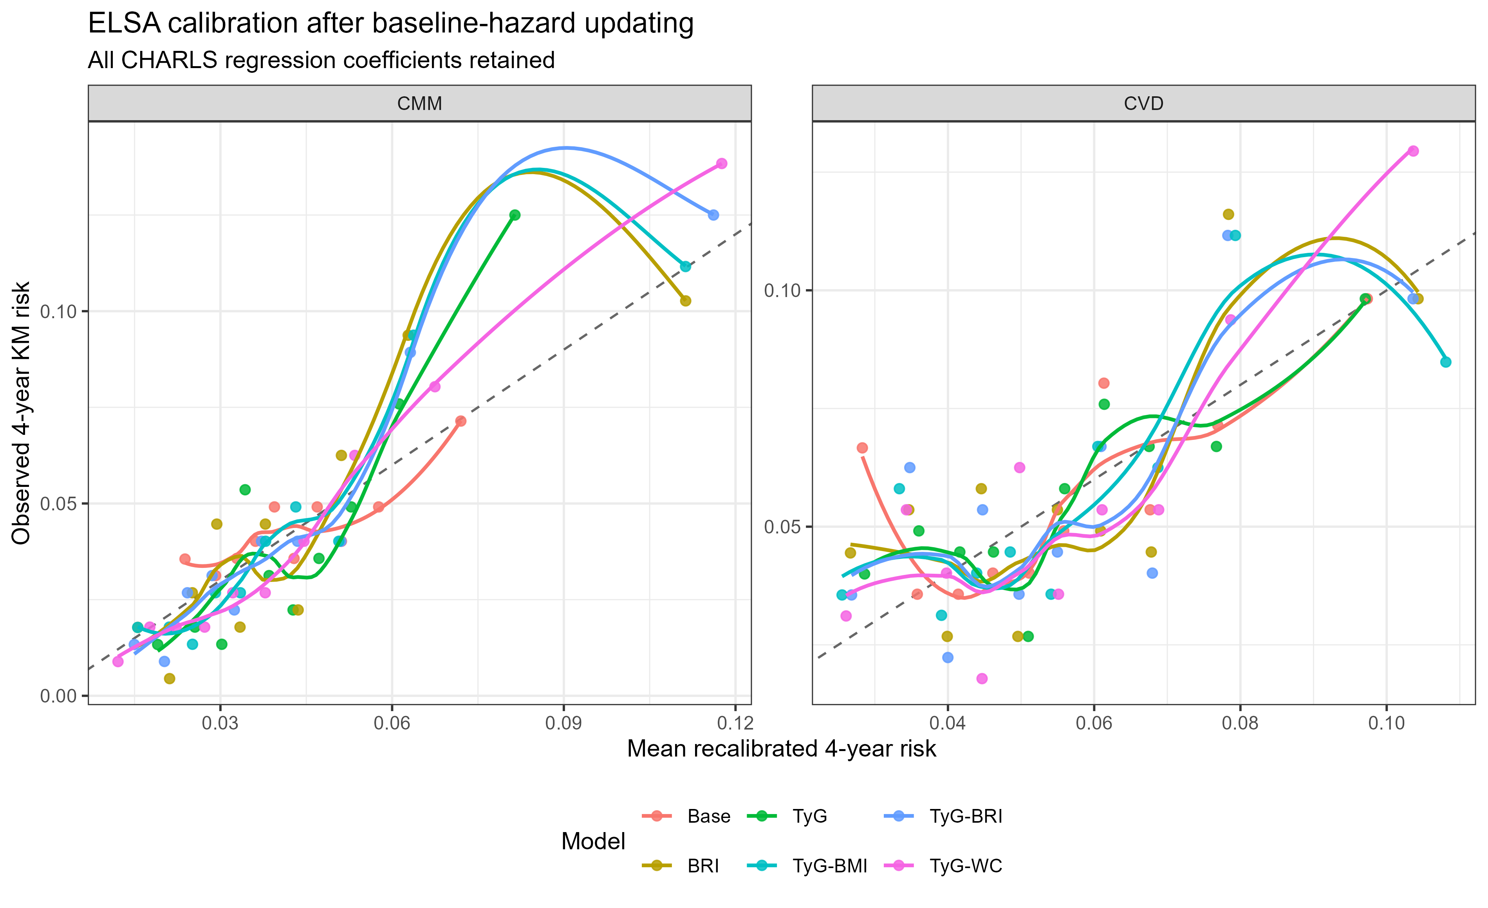
Notes: All CHARLS regression coefficients were retained and only the ELSA baseline cumulative hazard was updated. The procedure corrected calibration-in-the-large; deviations across risk deciles remained. Abbreviations: BRI, body roundness index; CHARLS, China Health and Retirement Longitudinal Study; CMM, cardiometabolic multimorbidity; CVD, cardiovascular disease; ELSA, English Longitudinal Study of Ageing; KM, Kaplan–Meier; TyG, triglyceride-glucose index; TyG-BMI, triglyceride-glucose body mass index; TyG-BRI, triglyceride-glucose body roundness index; TyG-WC, triglyceride-glucose waist circumference.

Supplementary Figure S2. Decision-curve analysis of directly transported four-year risk models in ELSA
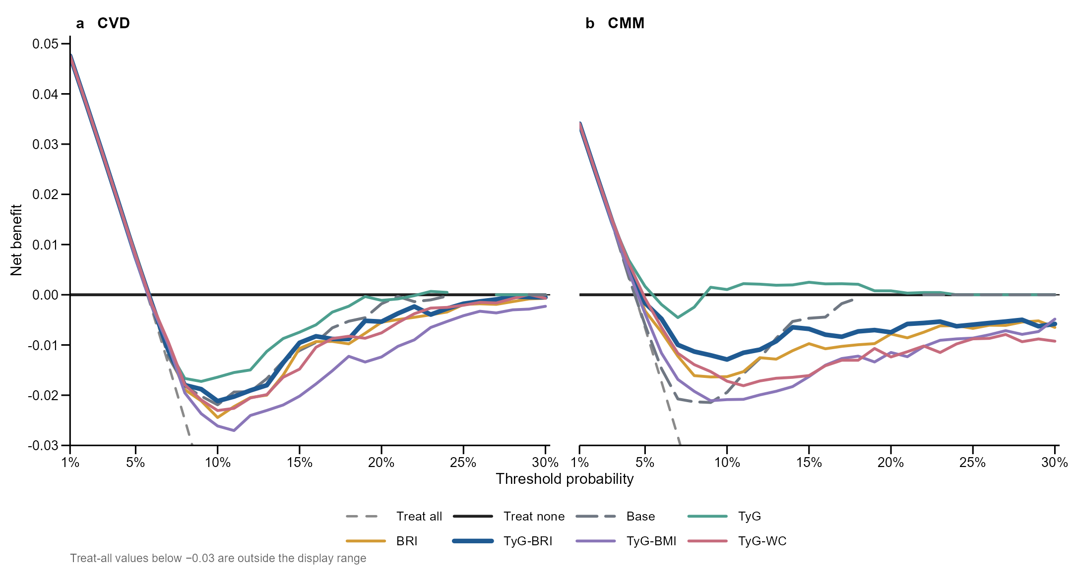
Notes: Panel a shows CVD and panel b shows CMM. All six candidate CHARLS-developed Cox models were evaluated in ELSA without updating their regression coefficients or baseline hazards. Curves display the original threshold-specific net-benefit estimates without smoothing. TyG-BRI is shown with a thicker line for identification, while all competing models are retained. Negative net benefit indicates performance below the treat-none strategy at that threshold. The y-axis includes every model-based curve; only treat-all values below −0.03 fall outside the displayed range. Decision curves should be interpreted together with discrimination and calibration. Abbreviations: BRI, body roundness index; CHARLS, China Health and Retirement Longitudinal Study; CMM, cardiometabolic multimorbidity; CVD, cardiovascular disease; DCA, decision-curve analysis; ELSA, English Longitudinal Study of Ageing; TyG, triglyceride-glucose index; TyG-BMI, triglyceride-glucose body mass index; TyG-BRI, triglyceride-glucose body roundness index; TyG-WC, triglyceride-glucose waist circumference.

Supplementary Figure S3. Decision-curve analysis after baseline-hazard updating in ELSA
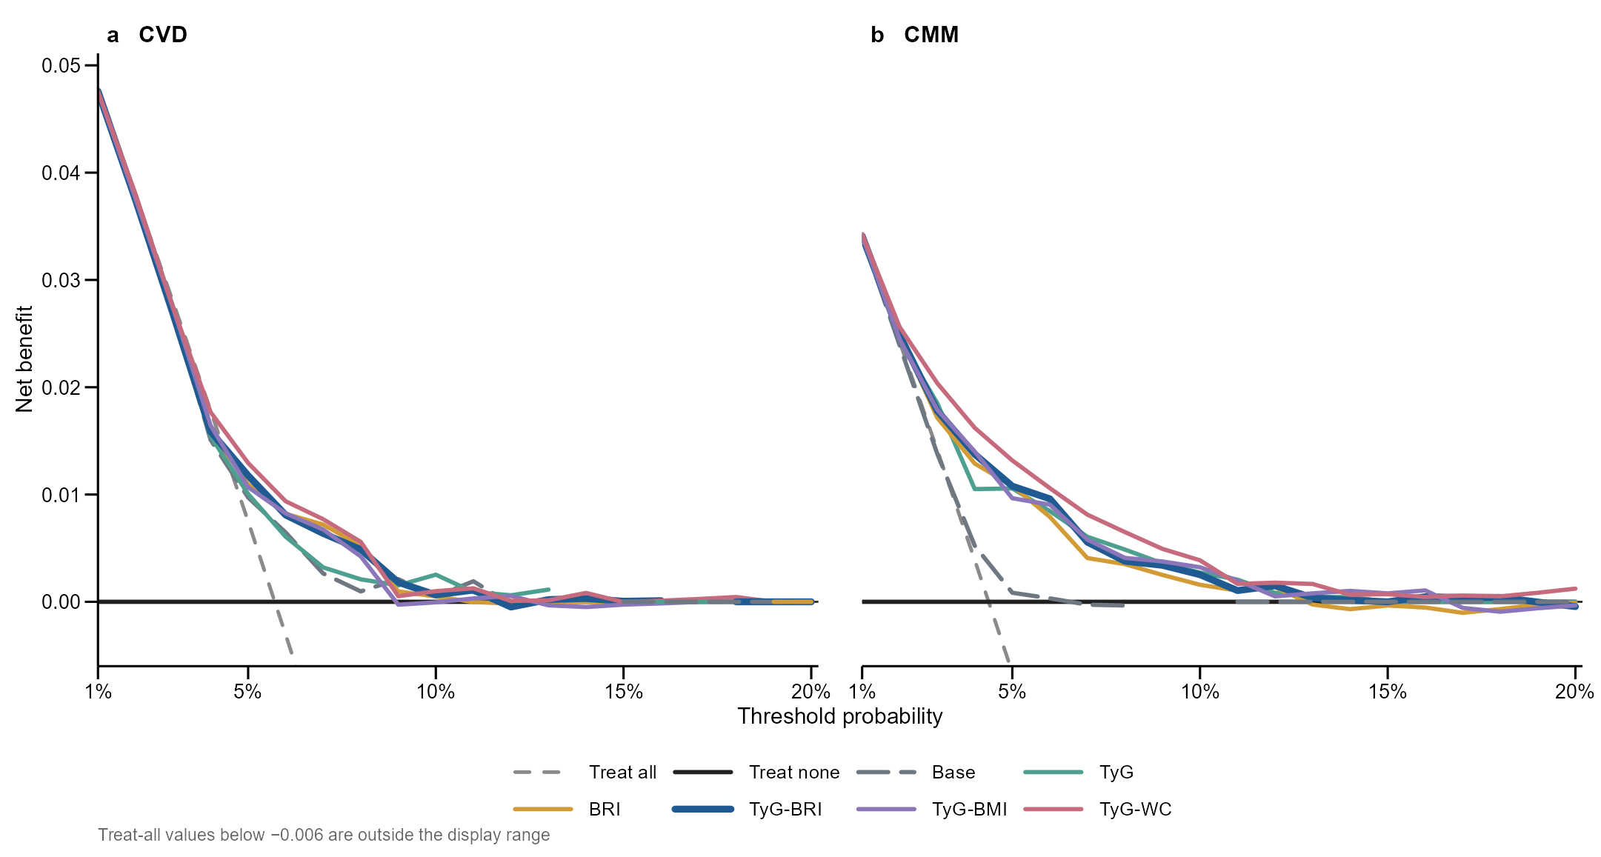
Notes: Panel a shows CVD and panel b shows CMM. All CHARLS regression coefficients were fixed; only the ELSA baseline cumulative hazard was updated before recalculating four-year risks and net benefit. Curves display the original threshold-specific estimates without smoothing. This analysis evaluates a model-updating scenario and does not replace the primary direct external validation. The y-axis includes every model-based curve; only treat-all values below −0.006 fall outside the displayed range. Abbreviations: BRI, body roundness index; CHARLS, China Health and Retirement Longitudinal Study; CMM, cardiometabolic multimorbidity; CVD, cardiovascular disease; DCA, decision-curve analysis; ELSA, English Longitudinal Study of Ageing; TyG, triglyceride-glucose index; TyG-BMI, triglyceride-glucose body mass index; TyG-BRI, triglyceride-glucose body roundness index; TyG-WC, triglyceride-glucose waist circumference.

