Supplementary Materials for
Multi-omics profiling reveals coordinated metabolic and immuno-inflammatory remodeling in a high-fat diet and single-dose streptozotocin-induced mouse model of diabetic cardiomyopathy
Feng Zhang ^{1, 2}, Chunbo Ai ³, Hao Zhang ^{1, 4}, Xiaoqiang Sun ², Li Wang ², Chao Li ², Wei Cai⁵, Xuemei Yin ², Yanxin Wang ^{1, 2}, Yanwei Li ⁶, Chengzhi Lu ^{1, 2, 7}, *, Zhuqing Li ^{2, 3, 7, *}
¹ First Central Hospital of Tianjin Medical University, Tianjin Medical University, Tianjin 300070, China
² Department of Cardiology, Tianjin First Central Hospital, Tianjin 300192, China
³ Department of Physiology and Biomedical Engineering, Mayo Clinic, Scottsdale, AZ 85259, USA
⁴ Department of Chronic Disease, Center for Disease Control and Prevention in Hanzhong, 723000 Hanzhong, Shaanxi, China
⁵ Institute of Cardiovascular Disease, Characteristic Medical Center of People’s Armed Police Force, 300000 Tianjin, China
⁶ Chronic Disease Management Center, The First Affiliated Hospital of Jinzhou Medical University, Jinzhou Medical University, Jinzhou 121001, Liaoning, China
⁷ School of Medicine, Nankai University, Tianjin, 300071, China

- mail addresses: fengzhang0222@163.com (F. Zhang), Ai.Chunbo@mayo.edu (C. Ai), 308716585@qq.com (H. Zhang), sxqmed@163.com (X. Sun), wangliquniy@126.com (L. Wang), 874433965@qq.com (C. Li), weiwei.well@163.com (W. Cai), yinxuemei0214@163.com (X. Yin), kent1997wyx@163.com (Y. Wang), liyw@jzmu.edu.cn (Y. Li), 5020200072@nankai.edu.cn (C. Lu), dinger326@126.com (Z. Li).

Table of contents

Fig. S1. Experimental design for HFD+STZ-induced DCM model establishment and multi-omics profiling 3
Fig. S2. Supplementary transcriptomic and integrated proteomic–transcriptomic analyses for DCM. 4
Fig. S3. Multi-omics KEGG pathway maps integrating transcriptomic, proteomic, and metabolomic changes.. 6
Fig. S4. General and cardiac morphometric characteristics of mice with diabetic cardiomyopathy.. 6
Fig. S5. Glucose tolerance and insulin sensitivity at week 6 of diabetic cardiomyopathy model induction.. 7
Fig. S6. Quality assessment of transcriptomic and proteomic datasets.. 8
Fig. S7. Independent validation of NDRG4 and GVIN2 and clarification of the GVIN2 annotation in the transcriptome–proteome integrated analysis.. 9
Table. S1. Compositions of normal chow and high-fat diets... 10
Table. S2. Primer sequences used for quantitative real-time PCR in this study.... 10

Supplemental figures
Fig. S1. Experimental design for HFD+STZ-induced DCM model establishment and multi-omics profiling. Type 2 diabetes was induced in mice by a high-fat diet (HFD) combined with single-dose streptozotocin (STZ). Diabetic cardiomyopathy (DCM) was documented by echocardiography, histology, transmission electron microscopy and systemic metabolic and inflammatory assessments. Left ventricular tissue was subjected to RNA sequencing, quantitative proteomics and untargeted metabolomics, followed by integrated pathway and network analyses.
Fig. S2. Supplementary transcriptomic and integrated proteomic–transcriptomic analyses for DCM. (A) Clustering Analysis of Coordinated Proteome and Transcriptome Expression Patterns. (B) Correlation between Significantly Differentially Expressed Proteins and Genes.

A Zhang et al, Fig. S3
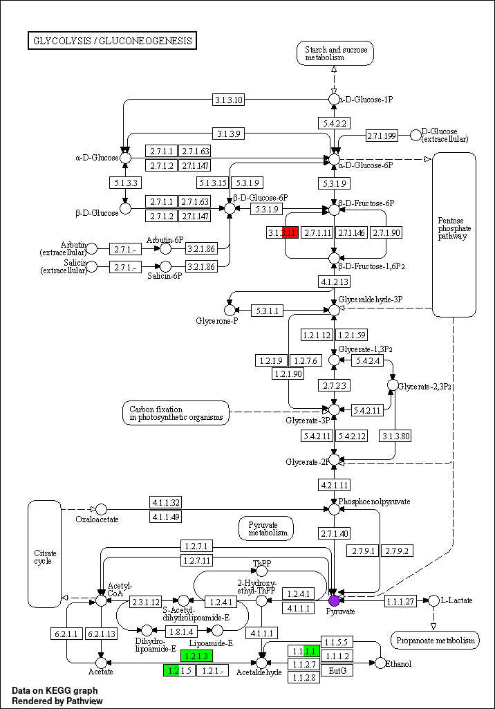

down
up unchanged
up down unchanged

B
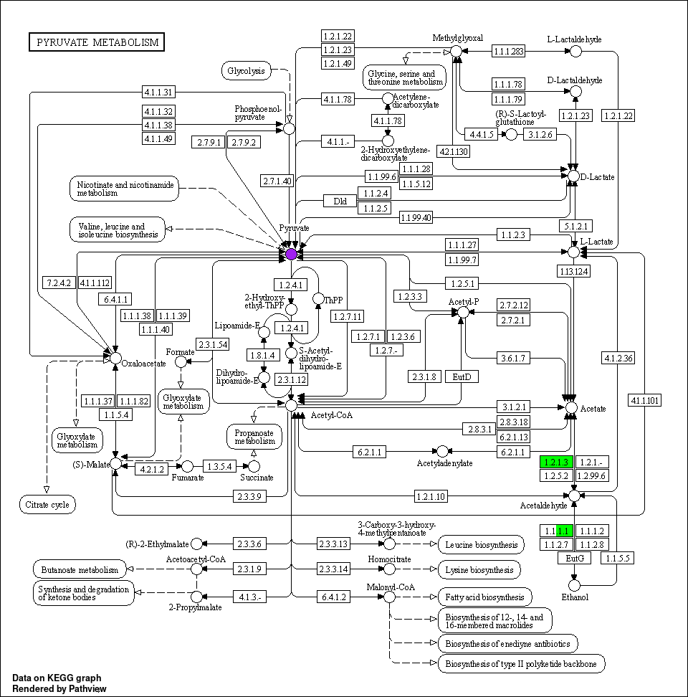
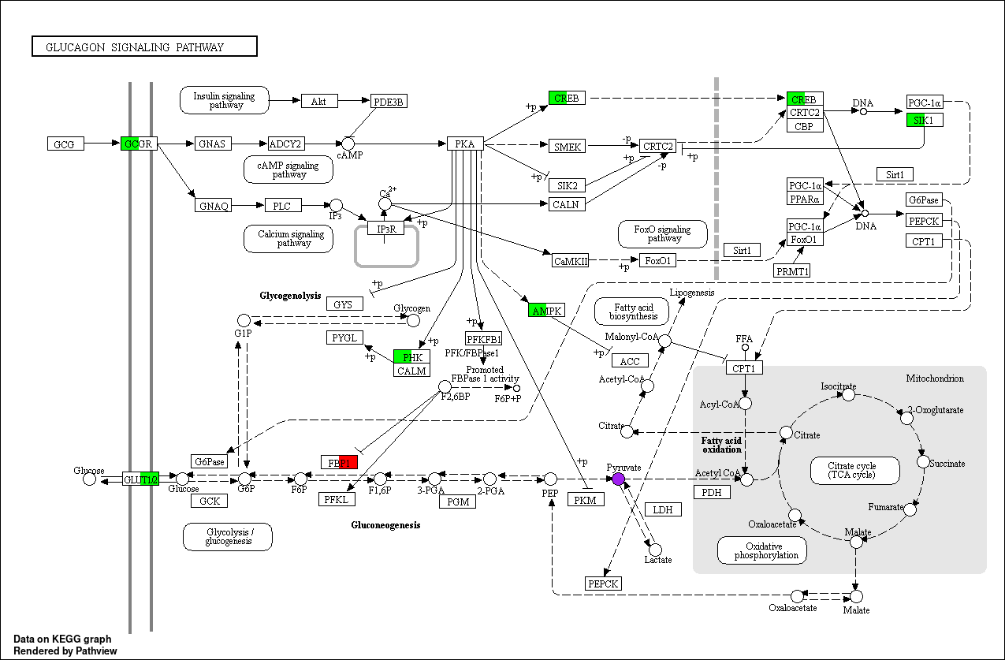
C

Fig. S3. Multi-omics KEGG pathway maps integrating transcriptomic, proteomic, and metabolomic changes. Pathview-rendered KEGG maps integrating transcriptomics, proteomics and metabolomics changes in DCM versus control myocardium. Rectangles indicate gene/protein nodes, and circles indicate metabolite nodes. For rectangles, red indicates upregulation, green indicates downregulation, and white indicates no change. For circles, purple indicates an increase, blue indicates a decrease, and white indicates no change. (A) Glycolysis/gluconeogenesis pathway map. (B) Pyruvate metabolism pathway map. (C) Glucagon signaling pathway map.

Fig. S4. General and cardiac morphometric characteristics of mice with diabetic cardiomyopathy.(A) Final body weight; (B) heart weight (HW); (C) tibial length (TL); and (D) heart weight-to-tibial length ratio (HW/TL) in control (CT) and diabetic cardiomyopathy (DCM) mice. Data are presented as mean±SD (n = 6 mice per group). Statistical comparisons between the two groups were performed using an unpaired Student’ s t-test. *P < 0.05, **P < 0.01; ns, not significant.

Fig. S5. Glucose tolerance and insulin sensitivity at week 6 of diabetic cardiomyopathy model induction. (A) Intraperitoneal glucose tolerance test (IPGTT) performed at week 6 of model induction: (a) blood glucose levels at 0, 15, 30, 60, and 120 min after glucose administration; (b) corresponding area under the curve (AUC). (B) Intraperitoneal insulin tolerance test (IPITT) performed at week 6 of model induction: (a) blood glucose levels at 0, 15, 30, 60, and 120 min after insulin administration; (b) corresponding AUC. CT, control; DCM, diabetic cardiomyopathy. Data are presented as mean±SD (n = 6 mice per group). Statistical comparisons between the two groups were performed using an unpaired Student’ s t-test. *P < 0.05; ns, not significant.

Fig. S6. Quality assessment of transcriptomic and proteomic datasets.
(A) Principal component analysis (PCA) of transcriptomic samples. (B) Pairwise Pearson correlation analysis of transcriptomic profiles. (C) PCA of proteomic samples. (D) Pairwise Pearson correlation analysis of proteomic profiles. Each sample represents an independent biological replicate (n = 3 per group).

Fig. S7. Independent validation of NDRG4 and GVIN2 and clarification of the GVIN2 annotation in the transcriptome-proteome integrated analysis.
(A) Representative immunofluorescence images of NDRG4 (green) and GVIN2 (red) in myocardial sections from CT and DCM mice; nuclei were counterstained with DAPI (blue). Scale bar, 20μm. (B, C) Quantification of the mean fluorescence intensity (MFI) of NDRG4 and GVIN2, respectively. (D, E) qPCR analysis of the relative mRNA expression levels of Ndrg4 and Gvin2 in myocardial tissue from CT and DCM mice. (F) Original transcriptome-proteome integrated analysis generated before correction of the annotation. Data are presented as mean±SD (n = 4 per group). For panels B–E, data are presented as mean ± SD (n = 4 per group), and statistical comparisons between CT and DCM groups were performed using an unpaired two-tailed Student’ s t-test. For panel F, Spearman correlation analysis was used to assess the correlation between transcript and protein expression. *P < 0.05, **P < 0.01, ***P < 0.001, ns, not significant.

Table. S1. Compositions of normal chow and high-fat diets.
Ingredients | High-fat diet |  | Normal chow
Ingredients | gm (%) | kcal (%) | gm (%) | kcal (%)
Protein | 26.2 | 20.0 | 19.2 | 20
Carbohydrate | 26.3 | 20.0 | 67.3 | 70
Fat | 34.9 | 60.0 | 4.3 | 10
Cholesterol | 0 | 0 | 0 | 0
Total |  | 100.0 |  | 100.0
kcal/g | 5.24 | - | 3.85 | -

Table. S2. Primer sequences used for quantitative real-time PCR in this study.
Primer | sequences
ChAT-F | CCATTGTGAAGCGGTTTGGG
ChAT-R | GCCAGGCGGTTGTTTAGATACA
AChE-F | CTCCCTGGTATCCCCTGCATA
AChE-R | GGATGCCCAGAAAAGCTGAGA
SLC5A7-F | ATGTCTTTCCACGTAGAAGGACT
SLC5A7-R | TTGCCGCTGTTTTTGGTTTTC
CAV3-F | GGATCTGGAAGCTCGGATCAT
CAV3-R | TCCGCAATCACGTCTTCAAAAT
PDK4-F | AGGGAGGTCGAGCTGTTCTC
PDK4-R | GGAGTGTTCACTAAGCGGTCA
MYH7-F | ACTGTCAACACTAAGAGGGTCA
MYH7-R | TTGGATGATTTGATCTTCCAGGG
Cacna2d2-F | TGGGTGCCTATAAGGAGTACC
Cacna2d2-R | TTGCTGATTGGCAACTTGACC
Hprt1-F | TCAGTCAACGGGGGACATAAA
Hprt1-R | GGGGCTGTACTGCTTAACCAG
ACTB-F | GGCTGTATTCCCCTCCATCG
ACTB-R | CCAGTTGGTAACAATGCCATGT

