Additional Material
Additional Methods
Surgical Procedures
All patients underwent Sun’s procedure, consisting of ascending aortic replacement with TAR + FET implantation into the descending aorta. The need for concomitant aortic valve or aortic root procedures was determined based on preoperative imaging findings and intraoperative assessment. Concomitant coronary artery bypass grafting (CABG) was conducted in patients with significant coronary artery stenosis or coronary artery involvement due to dissection. All procedures were performed by two experienced cardiovascular surgeons from the same surgical team. CPB was established using axillary artery cannulation, femoral artery cannulation, or a combination of both, depending on the extent of peripheral vascular involvement. All surgeries were conducted under DHCA, with antegrade cerebral perfusion for cerebral protection. The FET stent graft size was selected intraoperatively according to the descending aortic diameter. Recorded surgical variables included operative time, stent graft type, arterial cannulation strategy, and concomitant aortic root procedures.
Additional Figure S1
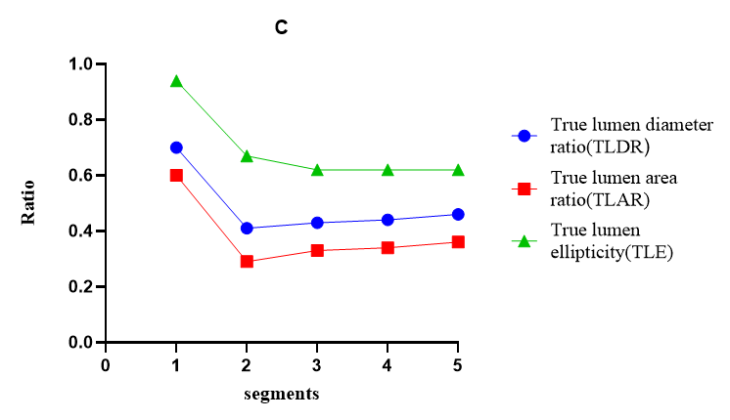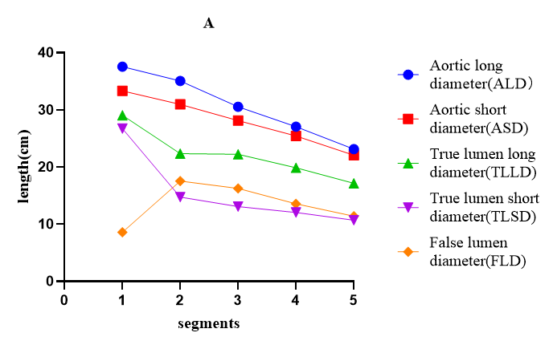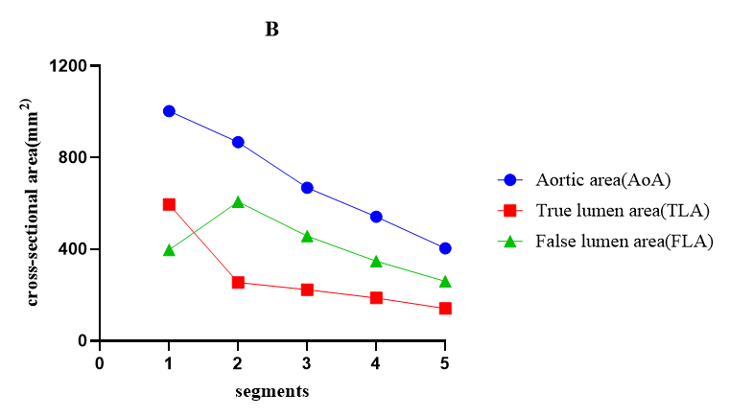
Title: Early postoperative imaging features of residual distal aorta
Legend: All patients underwent early postoperative CTA during hospitalization. Morphological analysis showed a distinct segmental gradient along the aorta. Regarding diameter-based parameters (Figure S1A), both the aortic and TL diameters were largest in S1 and progressively decreased toward the distal segments. Conversely, the FL diameter was relatively small in S1 but increased substantially in S3–S5. Similar patterns were noted for cross-sectional area measurements (Figure S1B). Aortic and TL areas decreased progressively along the aorta, whereas the FL area was relatively small in S1, peaked in S2, and remained relatively high in distal segments. Ratio-based parameters further highlighted these segmental differences (Figure S1C). The TL diameter ratio (TLDR) and TLAR were highest in S1, decreased markedly in S2, and remained relatively stable across S3–S5.
Additional Table S1
S1 | Univariate Cox regression
Variables | HR | 95% CI | P value
CPB time | 1.012 | (1.002,1.023) | 0.023
Aortic cross-clamping time | 1.022 | (1.007,1.037) | 0.004
FET types | 2.284 | (1.173,4.49) | 0.015
INR | 3.950 | (1.386,11.259) | 0.01
Aortic long diameter (ALD) | 1.066 | (1.018,1.116) | 0.006
Aortic short diameter (ASD) | 1.099 | (1.035,1.167) | 0.002
True lumen short diameter (TLSD) | 0.82 | (0.748, 0.898) | 0.001
False lumen diameter (FLD) | 1.078 | (1.035, 1.167) | 0.001
Aortic area (AoA) | 1.001 | (1.001,1.002) | 0.002
True lumen area (TLA) | 0.996 | (0.993,0.999) | 0.007
False lumen area (FLA) | 1.001 | (1.001,1.002) | 0.001
Patent |  |  | 0.001
Partial thrombosis | 0.902 | (0.326,2.494) | 0.842
Complete thrombosis | 0.156 | (0.056,0.436) | 0.001
Complete occlusion | 0.045 | (0.005,0.387) | 0.005
Endoleak | 8.384 | (4.076,17.246) | 0.001
True lumen diameter ratio (TLDR) ≤0.65 |  |  | 0.029
0.65＜True lumen diameter ratio (TLDR) ＜0.75 | 0.455 | (0.204,1.013) | 0.054
0.75≤True lumen diameter ratio (TLDR) | 0.365 | (0.158,0.842) | 0.018
True lumen area ratio (TLAR) ≤0.54 |  |  | 0.108
0.54＜True lumen area ratio (TLAR) ＜0.66 | 0.506 | (0.225,1.134) | 0.098
0.66≤True lumen area ratio (TLAR) | 0.475 | (0.212,1.068) | 0.072
True lumen ellipticity (TLE) ≤0.91 |  |  | 0.003
0.91＜True lumen ellipticity (TLE) ＜0.96 | 0.455 | (0.214,0.968) | 0.041
0.96≤True lumen ellipticity (TLE) | 0.175 | (0.06,0.512) | 0.001
S2
CPB time | 1.013 | (1.007，1.018) | 0.001
Aortic cross-clamping time | 1.018 | (1.01,1.025) | 0.001
DHCA time | 1.062 | (1.007,1.12) | 0.027
gender | 0.526 | (0.291,0.952) | 0.034
True lumen long diameter (TLLD) | 0.914 | (0.874,0.957) | 0.001
True lumen short diameter (TLSD) | 0.913 | (0.886,0.941) | 0.001
False lumen diameter (FLD) | 1.057 | (1.037,1.077) | 0.001
True lumen area (TLA) | 0.996 | (0.994,0.997) | 0.001
False lumen area (FLA) | 1.001 | (1.000,1.001) | 0.001
Patent |  |  | 0.001
Partial thrombosis | 0.892 | (0.611,1.304) | 0.555
complete thrombosis | 0.374 | (0.232,0.604) | 0.001
Endoleak | 1.944 | (1.116,3.385) | 0.019
S2 Residual Entry tear | 1.802 | (1.264,2.568) | 0.001
True lumen diameter ratio (TLDR) ≤0.35 |  |  | 0.001
0.35＜True lumen diameter ratio (TLDR) ＜0.47 | 0.768 | (0.53,1.112) | 0.163
0.47≤True lumen diameter ratio (TLDR) | 0.24 | (0.144,0.4) | 0.001
True lumen area ratio (TLAR) ≤0.23 |  |  | 0.001
0.23＜True lumen area ratio (TLAR) ＜0.36 | 0.817 | (0.567,1.176) | 0.277
0.36≤True lumen area ratio (TLAR) | 0.228 | (0.135,0.386) | 0.001
True lumen ellipticity (TLE) ≤0.35 |  |  | 0.001
0.35＜True lumen ellipticity (TLE) ＜0.47 | 0.77 | (0.531,1.115) | 0.166
0.47≤True lumen ellipticity (TLE) | 0.264 | (0.161,0.434) | 0.001
S3
CPB time | 1.014 | (1.009,1.019) | 0.001
Aortic cross-clamping time | 1.019 | (1.012,1.027) | 0.001
DHCA time | 1.057 | (1.005，1.112) | 0.03
Preoperative creatinine | 1.001 | (1.000,1.002) | 0.044
True lumen short diameter (TLSD) | 0.927 | (0.892，0.964) | 0.001
False lumen diameter (FLD) | 1.044 | (1.013,1.076) | 0.006
True lumen area (TLA) | 0.997 | (0.995，0.999) | 0.001
Patent |  |  | 0.002
Partial thrombosis | 0.526 | (0.328，0.845) | 0.008
complete thrombosis | 0.215 | (0.079，0.582) | 0.002
S5 Residual Entry tear | 1.917 | (1.184,3.106) | 0.008
True lumen diameter ratio (TLDR) ≤0.37 |  |  | 0.006
0.37＜True lumen diameter ratio (TLDR) ＜0.47 | 0.85 | (0.588,1.229) | 0.389
0.47≤True lumen diameter ratio (TLDR) | 0.512 | (0.338,0.774) | 0.002
True lumen area ratio (TLAR) ≤0.28 |  |  | 0.025
0.28＜True lumen area ratio (TLAR) ＜0.38 | 0.815 | (0.565,1.177) | 0.275
0.38≤True lumen area ratio (TLAR) | 0.564 | (0.372,0.853) | 0.007
True lumen ellipticity (TLE) ≤0.54 |  |  | 0.009
0.54＜True lumen ellipticity (TLE) ＜0.65 | 0.902 | (0.624,1.303) | 0.582
0.65≤True lumen ellipticity (TLE) | 0.531 | (0.35,0.805) | 0.003
S4
CPB time | 1.016 | (1.01,1.021) | 0.001
Aortic cross-clamping time | 1.02 | (1.012，1.028) | 0.001
DHCA time | 1.067 | (1.015，1.123) | 0.011
True lumen short diameter (TLSD) | 0.917 | (0.874，0.963) | 0.001
False lumen diameter (FLD) | 1.049 | (1.016，1.083) | 0.003
True lumen area (TLA) | 0.995 | (0.993,0.998) | 0.001
False lumen area (FLA) | 1.001 | (1.000,1.002) | 0.028
Endoleak | 1.861 | (1.05，3.297) | 0.033
S5 Residual entry tear | 1.750 | (1.093，2.804) | 0.02
True lumen diameter ratio (TLDR) ≤0.40 |  |  | 0.001
0.40＜True lumen diameter ratio (TLDR) ＜0.49 | 0.829 | (0.557,1.191) | 0.310
0.49≤True lumen diameter ratio (TLDR) | 0.451 | (0.296,0.689) | 0.001
True lumen area ratio (TLAR) ≤0.29 |  |  | 0.01
0.29＜True lumen area ratio (TLAR) ＜0.39 | 0.747 | (0.515,1084) | 0.125
0.39≤True lumen area ratio (TLAR) | 0.537 | (0.359,0.805) | 0.003
True lumen ellipticity (TLE) ≤0.57 |  |  | 0.030
0.57＜True lumen ellipticity (TLE) ＜0.66 | 0.778 | (0.536,1.128) | 0.185
0.66≤True lumen ellipticity (TLE) | 0.579 | (0.386,0.869) | 0.008
S5
CPB time | 1.016 | (1.01，1.022) | 0.001
Aortic cross-clamping time | 1.023 | (1.015，1.031) | 0.001
DHCA time | 1.081 | (1.025，1.141) | 0.004
Aortic short diameter (ASD) | 1.054 | (1.000,1.112) | 0.05
True lumen long diameter (TLLD) | 0.927 | (0.869，0.989) | 0.022
True lumen short diameter (TLSD) | 0.906 | (0.858，0.957) | 0.001
False lumen diameter (FLD) | 1.065 | (1.028，1.102) | 0.001
True lumen area (TLA) | 0.994 | (0.991,0.998) | 0.001
False lumen area (FLA) | 1.001 | (1.001,1.002) | 0.001
Endoleak | 2.003 | (1.128，3.559) | 0.018
S5 Residual entry tear | 2.631 | (1.485，4.663) | 0.001
True lumen diameter ratio (TLDR) ≤0.42 |  |  | 0.018
0.42＜True lumen diameter ratio (TLDR) ＜0.50 | 0.783 | (0.528,1.162) | 0.225
0.50≤True lumen diameter ratio (TLDR) | 0.546 | (0.36,0.83) | 0.005
True lumen area ratio (TLAR) ≤0.32 |  |  | 0.002
0.32＜True lumen area ratio (TLAR) ＜0.41 | 0.683 | (0.462,1.01) | 0.056
0.41≤True lumen area ratio (TLAR) | 0.46 | (0.3,0.704) | 0.001
True lumen ellipticity (TLE) ≤0.61 |  |  | 0.262
0.61＜True lumen ellipticity (TLE) ＜0.67 | 0.755 | (0.499,1.14) | 0.182
0.67≤ True lumen ellipticity (TLE) | 0.748 | (0.503,1.112) | 0.151

Title: Univariable Cox regression analysis for segment-specific NAR
Legend: Univariable Cox proportional hazards models were used to evaluate potential risk factors for negative aortic remodeling in each distal aortic segment (S1–S5). Variables analyzed included preoperative demographics, comorbidities, laboratory values, operative characteristics (CPB time, cross-clamp time, DHCA time), and early postoperative imaging features (TL diameter, TL area ratio, FL patency, residual entry tears). Hazard ratios (HR), 95% confidence intervals (CI), and P values are presented. Variables with P < 0.1 were considered for multivariate analysis.

