Supplementary material S4

Subgroup analysis.
1.MSC type
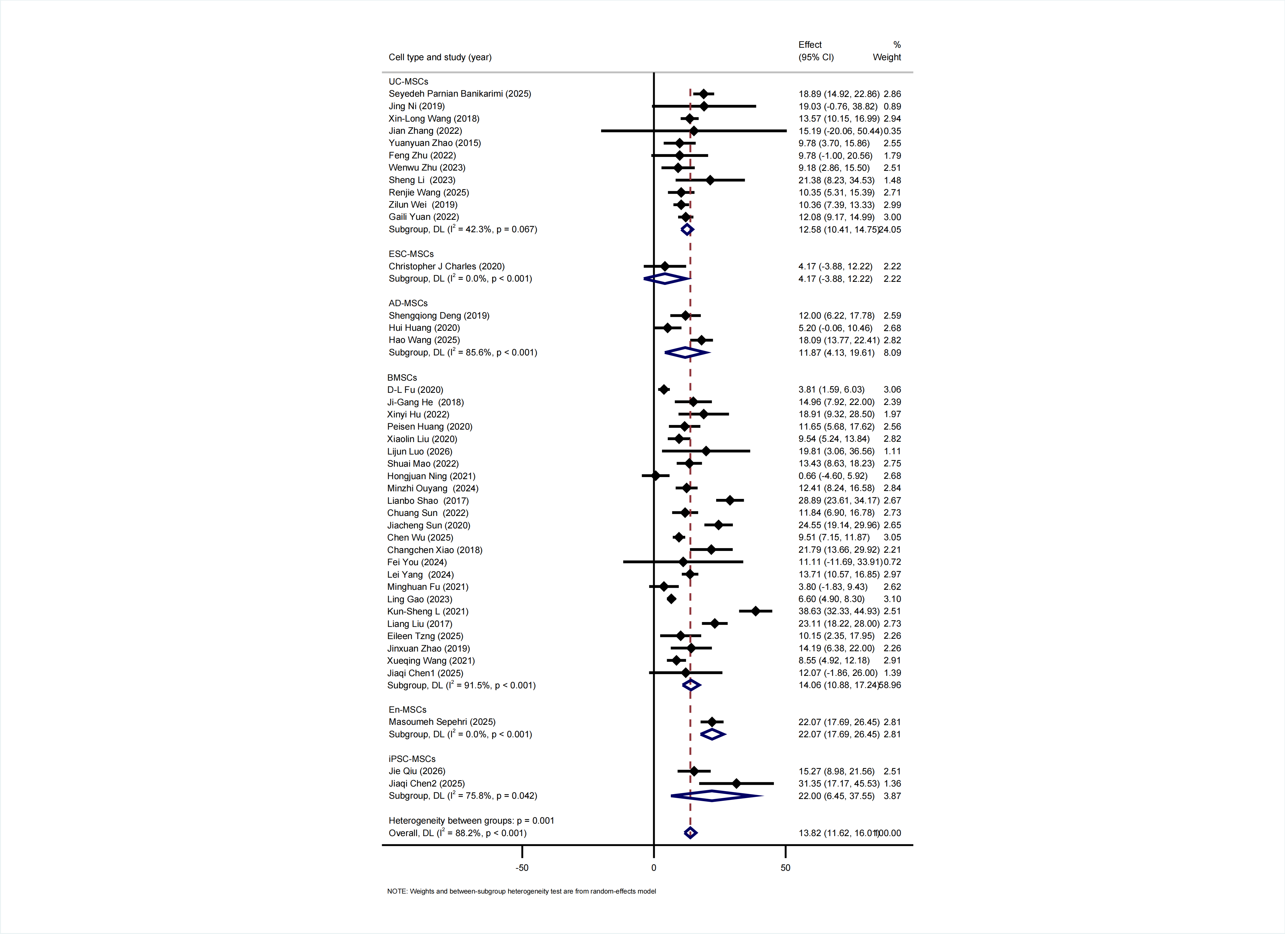
UC-MSC, umbilical cord-derived mesenchymal stem cell; ESC-MSC, embryonic stem cell-derived mesenchymal stem cell; BMSC, bone marrow-derived mesenchymal stem cell; iPSC-MSC, induced pluripotent stem cell-derived mesenchymal stem cell; AD-MSC, adipose-derived mesenchymal stem cell; En-MSC, endometrial mesenchymal stem cell

2.Exosome dose
A,Mice B,Rat

3.Animal model category

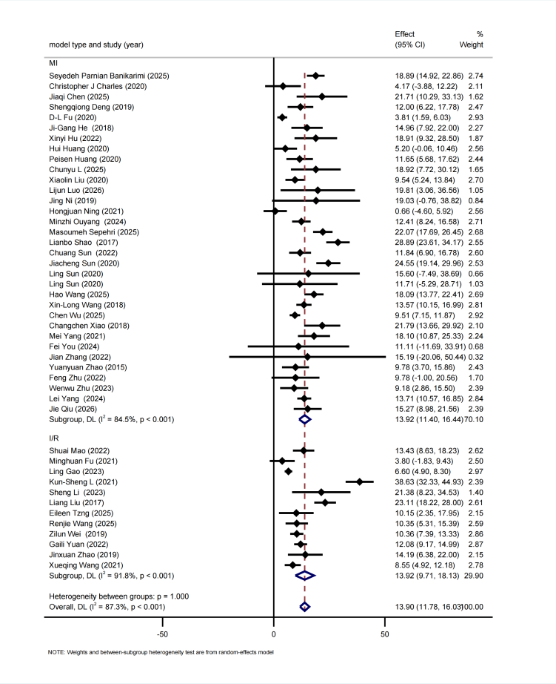
MI, permanent ligation; I/R, ischemia-reperfusion injury.

4.Time window
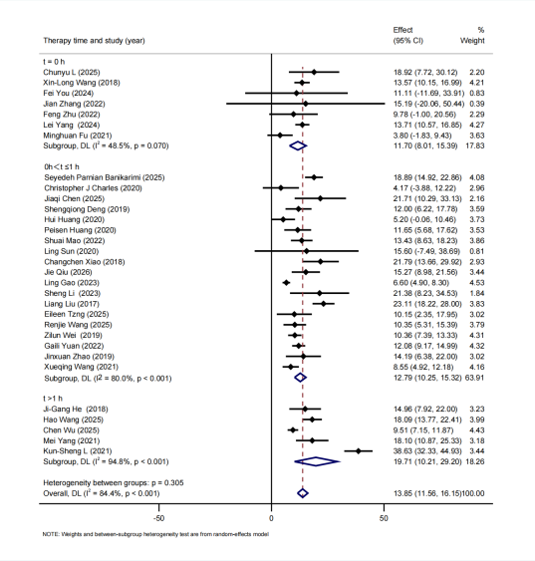

Trim-and-fill analysis.

