Supplements:
Supplementary Table 1. Peak Frequency area counts
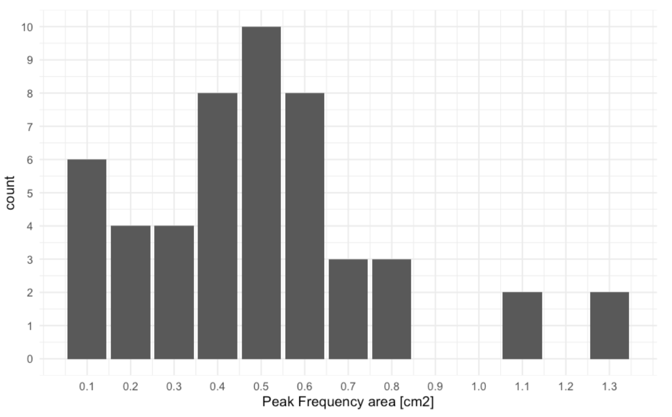
Supplementary Table 2. Low voltage bridge area counts
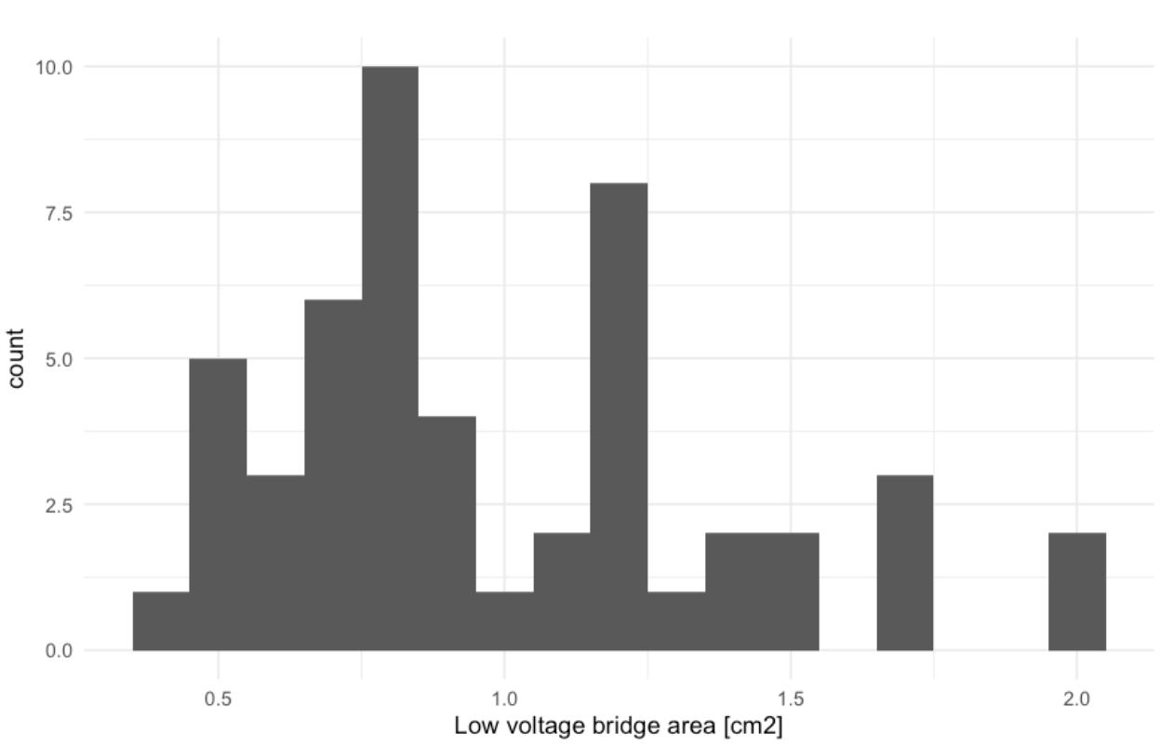

Supplementary Table 3. Frequency values on the slow pathway
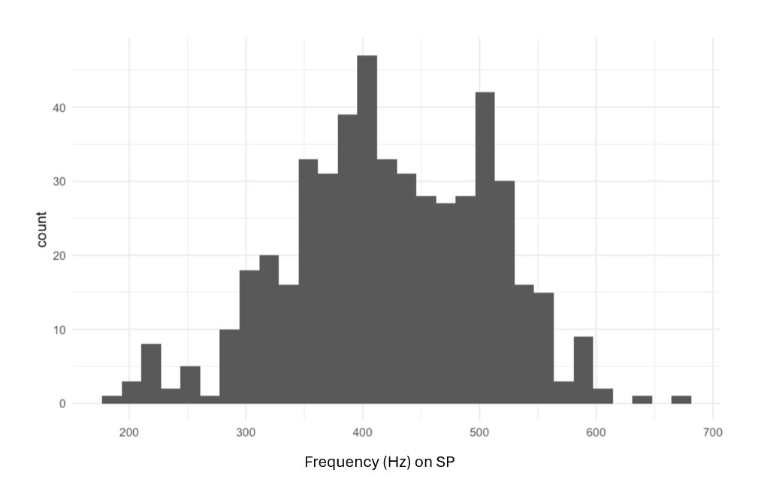
Supplementary Table 4. Frequency values around the slow pathway
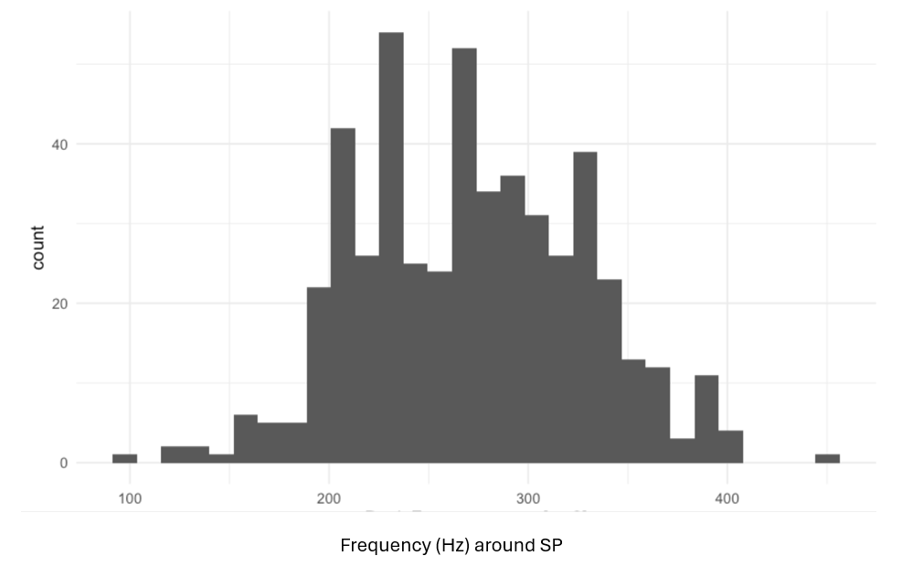
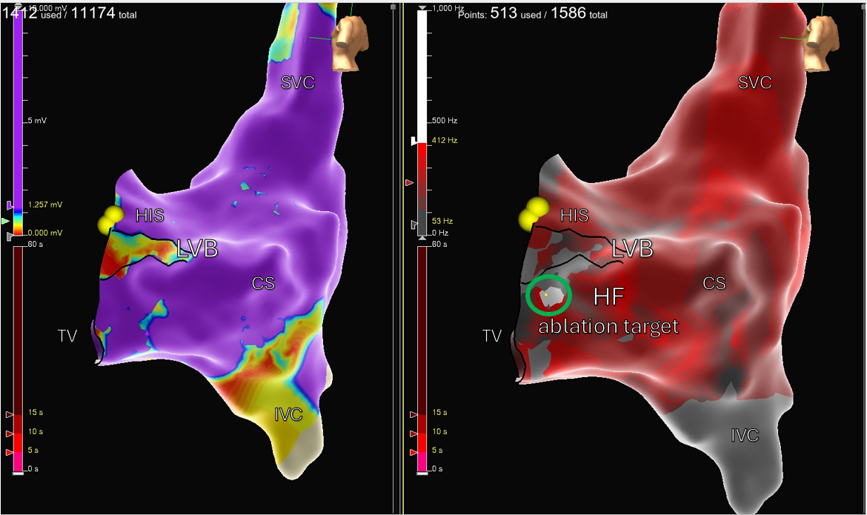

Supplementary Figure 1. High-resolution mapping of the Koch triangle in Left Lateral views during sinus rhythm. The image displays on the left the omnipolar voltage map ranging from 0.00 to 1.257 mV showing the LVB area. The right panel shows the Peak Frequency map, with the highest frequency highlighted in white, using a cutoff above 410 Hz within the slow pathway region. This figure illustrates LVB mapping with PF overlays for identification of junctional beats.

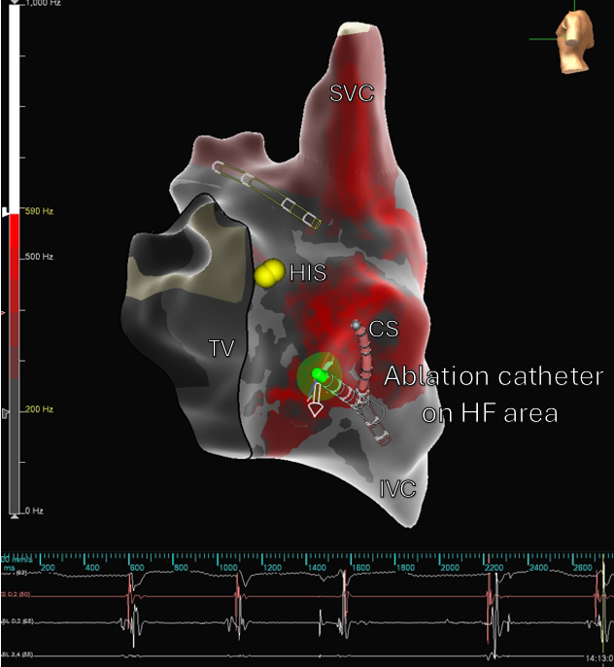

Supplementary Figure 2. High-resolution mapping of the Koch triangle in Left Lateral view during ablation with Tactiflex catheter. The image displays the Peak Frequency (mixed-effects models) map, with the highest frequency highlighted in white, using a cutoff > 590 Hz within the slow pathway region. This figure illustrates how the Peak Frequency map guides the ablation strategy by indicating sites where junctional beats are elicited during the procedure.

