Supplementary materials

Supplementary Figure S1: The post-PCI clinic workflow
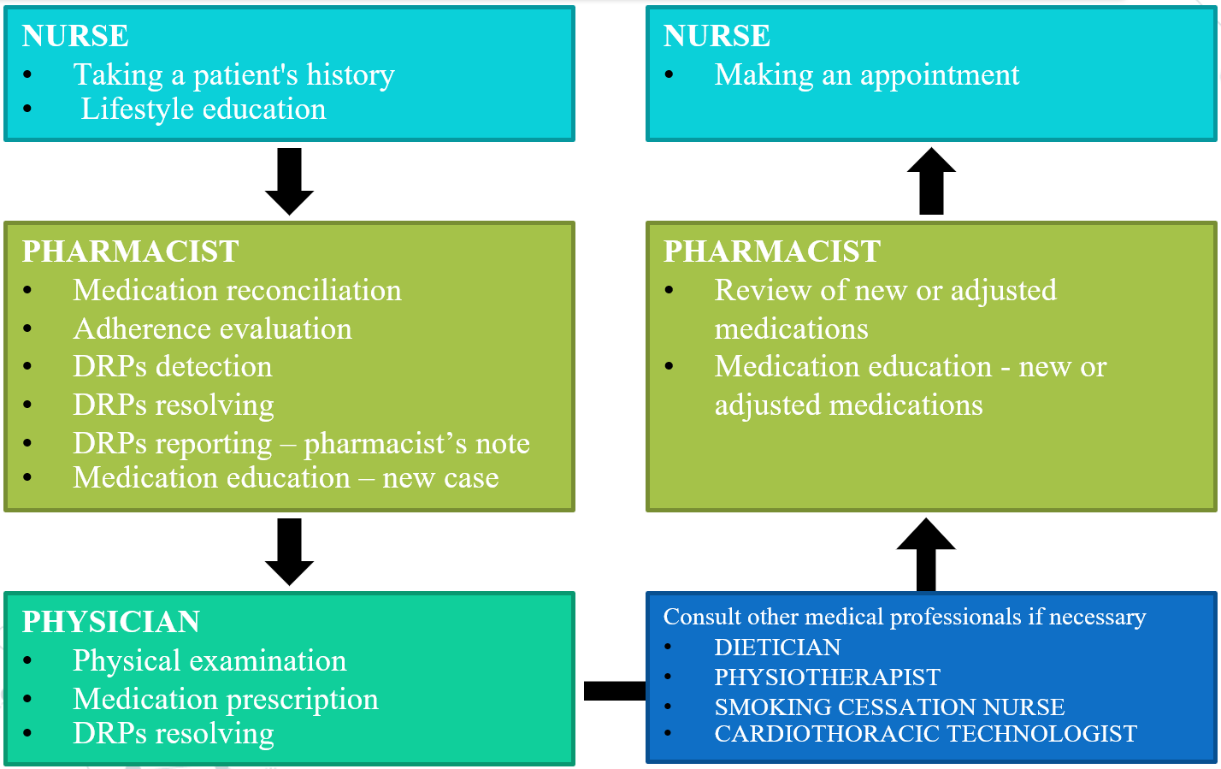
DRPs, drug related problems; PCI, percutaneous coronary intervention

Supplementary Figure S2: Detail of patient flow
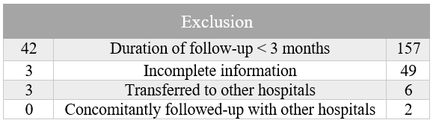
PCI, percutaneous coronary intervention

Supplementary Figure S3 Proportion of MRAs use

**
aOR 4.500 (1.013-19.995)
*
*
*
*
*
*
*
*in-group
**between group
*significantly different for in-group
** significantly different for between group
aOR, adjusted odds ratio; MRAs, mineralocorticoid receptor antagonists

Supplementary Figure S4 Types of drug-related problems

Supplementary Table S1 Definition and classification of DRPs

Definition
A drug therapy problem is any undesirable event experienced by a patient that involves, or is suspected to involve, drug therapy, and that interferes with achieving the desired goals of therapy and requires professional judgment to resolve.

Categories of DRPs | Description
Unnecessary drug therapy | The drug therapy is unnecessary because the patient does not have a clinical indication at this time.
Needs additional drug therapy | Additional drug therapy is required to treat or prevent a medical condition  in the patient
Ineffective drug | The drug product is not being effective at producing the desired response  in the patient.
Dosage too low | The dosage is too low to produce the desired response in the patient.
Adverse drug reaction | The drug is causing an adverse reaction in the patient.
Dosage too high | The dosage is too high, resulting in undesirable effects experienced by the  patient.
Nonadherence | The patient is not able or willing to take the drug therapy as intended.

DRPs, drug related problems

Supplementary Table S2 Blood pressure and LDL-C outcomes

 | Post-PCI clinic (N=1050) | Control (N=273) | p-value
SBP at 12 months (mmHg) | 126.19 ± 16.29 | 127.01 ± 17.61 | 0.176
Difference of SBP at 12 months (mmHg) | -4.48 ± 20.36 | -2.7106 ± 21.38 | 0.206
DBP at 12 months (mmHg) | 76.13 ± 11.63 | 76.37 ± 10.96 | 0.287
Difference of DBP at 12 months (mmHg) | -3.08 ± 13.07 | -2.38 ± 12.06 | 0.428
LDL-C at 12 months (mg/dL) | 82.48 ± 26.72 | 87.26 ± 27.86 | 0.585

DBP, diastolic blood pressure; LDL-C, low density lipoprotein cholesterol; PCI, percutaneous coronary intervention; SBP, systolic blood pressure

Supplementary Table S3 DRPs in secondary prevention medications
DRPs | DRPs at baseline | Resolved DRPs at 12 months | % Resolved DRPs
Need for additional drug therapy  -Beta blockers  -ACEIs/ARBs  -MRAs | 124  68  50  6 | 114  64  46  4 | 91.94 %
Dosage too low  -Beta blockers  -ACEIs/ARBs | 175  94  81 | 135  75  60 | 77.14%
Adverse drug reaction  -ACEIs/ARBs  -Beta blockers  -Statins  -MRAs | 259  138  60  45  16 | 219  104  56  44  15 | 84.56 %
Noncompliance  -Statins  -ACEIs/ARBs  -Antiplatelets  -Beta blockers  -MRAs | 274  86  62  61  56  9 | 234  74  51  58  44  7 | 85.40 %
Total | 832 | 702 | 84.38 %
ACEIs, angiotensin-converting enzyme inhibitors; ARB, angiotensin receptor blockers; DRPs, drug related problems; MRAs, mineralocorticoid receptor antagonists

Supplementary Table S4 Medication contraindications during data extraction

Medication | Contraindications
Antiplatelets | Hypersensitivity to antiplatelets, active pathological bleeding
Beta-blockers | Hypersensitivity to beta-blockers, bradycardia (heart rate < 50 bpm), second- or third-degree heart block, active bronchospasm.
ACEIs/ARBs | Hypersensitivity to ACEIs/ARBs, idiopathic or hereditary angioedema, concomitant use with aliskiren, bilateral renal artery stenosis
High-intensity statins | Hypersensitivity to high-intensity statins, active liver disease (serum transaminases > 3 times the upper limit of normal)
MRAs | Acute renal insufficiency, severe renal impairment (eGFR <30 ml/min/1.73m²), hyperkalemia (serum potassium > 5 mEq/mL)
ACEIs, angiotensin-converting enzyme inhibitors; ARB, angiotensin receptor blockers; DRPs, drug related problems; eGFR, estimated Glomerular Filtration Rate; MRAs, mineralocorticoid receptor antagonists

