Supplementary material
Troponin–Echocardiography Prognostic Discordance in Selected ICU Patients With Sepsis: A MIMIC-IV-ECHO Cohort Study

Supplementary methods
Temporal ordering and phenotype construction. Follow-up began at the index TTE. The primary exposure was the maximum troponin T measured from 24 hours before through the TTE; no post-TTE troponin contributed. Both LVEF and qualitative RV function had to be evaluable. Echo-negative required LVEF ≥50% and an RV category of Nl RV function, Low normal function, or Hyperdynamic. Echo-positive required LVEF <50% or one of six abnormal structured RV categories. Free-text parsing was not used. TAPSE was available in 363/2,523 admissions (14.4%), and fractional area change was not available as a structured field.
Covariate availability and missing data. The primary model used age, sex, race, a modified Charlson score excluding age, congestive heart failure, and renal disease, coded chronic heart failure and renal disease, Sepsis-3 SOFA anchored at or before TTE, maximum lactate from ICU admission through TTE, and invasive ventilation and vasoactive exposure beginning before TTE. Seventy-two post-TTE SOFA anchors were set missing. Pre-index lactate was missing in 517 admissions. Median imputation plus missingness indicators was used, with complete-case lactate and pre-index creatinine analyses as sensitivities.
Time origin and censoring. Event time was the day difference between the index TTE date and death date. Same-day deaths were assigned 0.5 day because MIMIC provides day-level death dates. Patients without death were administratively censored at 28 or 90 days.
Repeated admissions. Subject-clustered robust standard errors accounted for repeated admissions. Seventy-eight admissions exceeded the number of unique patients. Twenty-one pairs of 90-day windows overlapped among 17 patients (36 admissions); a first-eligible-admission analysis removed duplicate risk windows.
Restricted cubic spline. Pre-index troponin was modeled as log2(ULN multiple+1) with knots at the 5th, 35th, 65th, and 95th percentiles. The spline interacted with echo status; likelihood-ratio tests compared the full model with no-troponin, linear, and no-interaction models. Figure 4 includes the observed-value rug plot.
Subgroups, diagnostics, and sensitivity analyses. Interaction models retained all four phenotypes and omitted only the subgroup-defining covariate; Benjamini–Hochberg q values controlled the false discovery rate across seven tests. Scaled Schoenfeld residuals were evaluated against rank-transformed event time. A nominal 28-day violation for Tn-low/Echo-positive was characterized with 0–7-day and 7–28-day Cox models. Sensitivities varied troponin threshold and timing, chamber evaluability, admission selection, lactate handling, creatinine adjustment, and comorbidity exclusions.

Table S1 Restricted cubic spline tests
Test | χ² | df | P value
Overall troponin spline association | 24.45 | 6 | <0.001
Nonlinearity beyond linear interaction | 4.86 | 4 | 0.302
Troponin spline-by-echo interaction | 5.54 | 3 | 0.136
Knots were approximately 1×, 5.7×, 15×, and 113×ULN. The nonlinearity test compared the full spline-by-echo model with the linear troponin-by-echo model.

Table S2 Exploratory subgroup associations for double-positive versus double-negative status
Subgroup | Level | n | Deaths | Adjusted HR (95% CI) | P value | P interaction | BH q
Age | <65 years | 859 | 310 | 1.23 (0.87–1.73) | 0.234 | 0.064 | 0.178
Age | ≥65 years | 1,664 | 803 | 1.77 (1.45–2.16) | <0.001 | 0.064 | 0.178
Sex | Female | 1,074 | 475 | 1.41 (1.10–1.81) | 0.006 | 0.048 | 0.178
Sex | Male | 1,449 | 638 | 1.99 (1.56–2.54) | <0.001 | 0.048 | 0.178
Chronic heart failure | No | 1,116 | 497 | 1.83 (1.43–2.35) | <0.001 | 0.423 | 0.556
Chronic heart failure | Yes | 1,407 | 616 | 1.58 (1.23–2.04) | <0.001 | 0.423 | 0.556
Renal disease | No | 1,493 | 671 | 1.48 (1.19–1.84) | <0.001 | 0.076 | 0.178
Renal disease | Yes | 1,030 | 442 | 2.06 (1.52–2.79) | <0.001 | 0.076 | 0.178
SOFA severity | SOFA <8 | 2,334 | 995 | 1.68 (1.40–2.02) | <0.001 | 0.988 | 0.988
SOFA severity | SOFA ≥8 | 189 | 118 | 1.68 (0.93–3.01) | 0.083 | 0.988 | 0.988
Vasoactive therapy before TTE | No | 1,281 | 485 | 1.58 (1.24–2.02) | <0.001 | 0.477 | 0.556
Vasoactive therapy before TTE | Yes | 1,242 | 628 | 1.78 (1.40–2.26) | <0.001 | 0.477 | 0.556
Invasive ventilation before TTE | No | 1,176 | 433 | 1.48 (1.15–1.90) | 0.002 | 0.195 | 0.341
Invasive ventilation before TTE | Yes | 1,347 | 680 | 1.84 (1.45–2.33) | <0.001 | 0.195 | 0.341
Interaction P values are nominal; q values use the Benjamini–Hochberg procedure across seven subgroups. No q value was <0.05.

Table S3 Sensitivity analyses for double-positive versus double-negative status
Scenario | n | Deaths | Adjusted 90-day HR (95% CI) | P value
Primary: pre-TTE troponin; both chambers | 2,523 | 1,113 | 1.68 (1.41–2.01) | <0.001
Pre-TTE troponin threshold 1×ULN | 2,523 | 1,113 | 2.09 (1.41–3.09) | <0.001
Pre-TTE troponin threshold 3×ULN | 2,523 | 1,113 | 1.79 (1.46–2.20) | <0.001
Pre-TTE troponin threshold 10×ULN | 2,523 | 1,113 | 1.66 (1.40–1.95) | <0.001
Index TTE within 24 h | 2,129 | 942 | 1.63 (1.34–1.98) | <0.001
Pre-TTE troponin within 12 h | 2,058 | 910 | 1.56 (1.29–1.90) | <0.001
Troponin maximum within ±24 h; both chambers | 2,801 | 1,240 | 1.65 (1.40–1.96) | <0.001
Original ±24-h one-chamber-permitted definition | 3,074 | 1,357 | 1.61 (1.37–1.89) | <0.001
First eligible admission per patient | 2,445 | 1,079 | 1.71 (1.43–2.04) | <0.001
Complete-case pre-index lactate | 2,006 | 945 | 1.65 (1.36–2.01) | <0.001
Additional pre-index creatinine adjustment | 2,437 | 1,071 | 1.71 (1.42–2.05) | <0.001
Exclude chronic heart failure | 1,116 | 497 | 1.73 (1.36–2.20) | <0.001
Exclude renal disease | 1,493 | 671 | 1.52 (1.22–1.89) | <0.001

Table S4 Proportional-hazards diagnostics for phenotype terms
Horizon | Phenotype term | Scaled-residual correlation | P value | Events
28 | Tn-high/Echo-negative | -0.031 | 0.354 | 894
28 | Tn-low/Echo-positive | -0.082 | 0.014 | 894
28 | Tn-high/Echo-positive | -0.057 | 0.087 | 894
90 | Tn-high/Echo-negative | -0.043 | 0.154 | 1113
90 | Tn-low/Echo-positive | -0.057 | 0.058 | 1113
90 | Tn-high/Echo-positive | -0.044 | 0.140 | 1113
The Tn-low/Echo-positive term showed a nominal 28-day violation (P=0.014); piecewise estimates are reported in Table S10. Phenotype terms satisfied proportional hazards at 90 days.

Table S5 Pairwise 90-day log-rank tests
Group 1 | Group 2 | Nominal P | Holm-adjusted P
TnLo/Echo- | TnHi/Echo- | 0.106 | 0.317
TnLo/Echo- | TnLo/Echo+ | 0.171 | 0.343
TnLo/Echo- | TnHi/Echo+ | <0.001 | <0.001
TnHi/Echo- | TnLo/Echo+ | 0.991 | 0.991
TnHi/Echo- | TnHi/Echo+ | <0.001 | <0.001
TnLo/Echo+ | TnHi/Echo+ | <0.001 | 0.003

Table S6 Descriptive outcomes by ventricular subtype
Ventricular subtype | n | 28-day mortality | 90-day mortality
Biventricular dysfunction | 589 | 237 (40.2%) | 296 (50.3%)
LV-only dysfunction | 364 | 126 (34.6%) | 162 (44.5%)
No systolic dysfunction | 1219 | 387 (31.7%) | 475 (39.0%)
RV-only dysfunction | 351 | 144 (41.0%) | 180 (51.3%)

Table S7A Prior-echo chronicity and mortality
Category | n | 90-day mortality
New systolic dysfunction | 127 | 63 (49.6%)
No current systolic dysfunction | 303 | 128 (42.2%)
Pre-existing systolic dysfunction | 259 | 135 (52.1%)

Table S7B Repeat-LVEF recovery among echo-positive admissions
Troponin stratum | n | LVEF change, percentage points | Recovery to LVEF ≥50%, n (%)
Tn-high | 186 | 5.0 [-1.0, 15.0] | 77 (41.4%)
Tn-low | 49 | 3.0 [-5.0, 14.0] | 22 (44.9%)

Table S8 Subject-grouped cross-validated incremental performance
Horizon | Model | n | Events | AUC | Brier score
28 | Clinical covariates | 2523 | 894 | 0.715 | 0.200
28 | Clinical + troponin + echo | 2523 | 894 | 0.718 | 0.198
28 | Increment (extended minus clinical) | 2523 | 894 | 0.003 | -0.002
90 | Clinical covariates | 2523 | 1113 | 0.694 | 0.219
90 | Clinical + troponin + echo | 2523 | 1113 | 0.700 | 0.217
90 | Increment (extended minus clinical) | 2523 | 1113 | 0.006 | -0.002
The increment rows report extended minus clinical performance. Negative Brier differences favor the extended model. These exploratory metrics quantify incremental information and do not establish a deployment-ready prediction model.

Table S9 Repeated-admission and overlapping-window audit
Measure | Value
Primary admissions | 2,523
Unique patients | 2,445
Additional admissions beyond first per patient | 78
Overlapping 90-day risk-window pairs | 21
Patients contributing an overlap | 17
Admissions involved in an overlap | 36

Table S10 Piecewise Cox estimates for 28-day mortality
Interval | Phenotype | n at risk | Deaths | Adjusted HR (95% CI) | P value
0-7 days | TnHi/Echo- | 2523 | 532 | 1.40 (1.06–1.85) | 0.018
0-7 days | TnLo/Echo+ | 2523 | 532 | 1.67 (1.19–2.35) | 0.003
0-7 days | TnHi/Echo+ | 2523 | 532 | 1.93 (1.46–2.53) | <0.001
7-28 days | TnHi/Echo- | 1991 | 362 | 0.98 (0.72–1.34) | 0.898
7-28 days | TnLo/Echo+ | 1991 | 362 | 0.98 (0.66–1.44) | 0.903
7-28 days | TnHi/Echo+ | 1991 | 362 | 1.35 (1.01–1.81) | 0.041

Supplementary figures

Supplementary Figure S1 Phenotype distribution and mortality
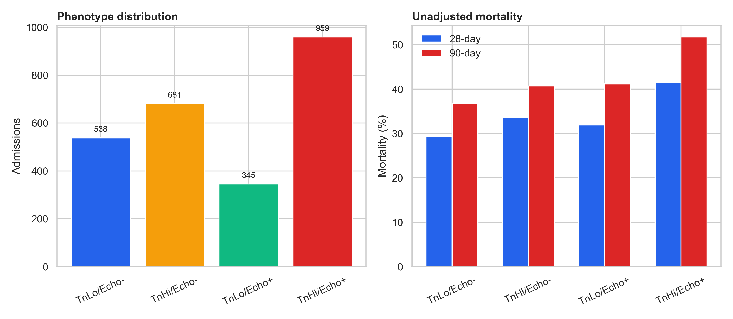
Phenotype distribution and unadjusted 28- and 90-day mortality in the primary cohort.

Supplementary Figure S2 Sensitivity analyses
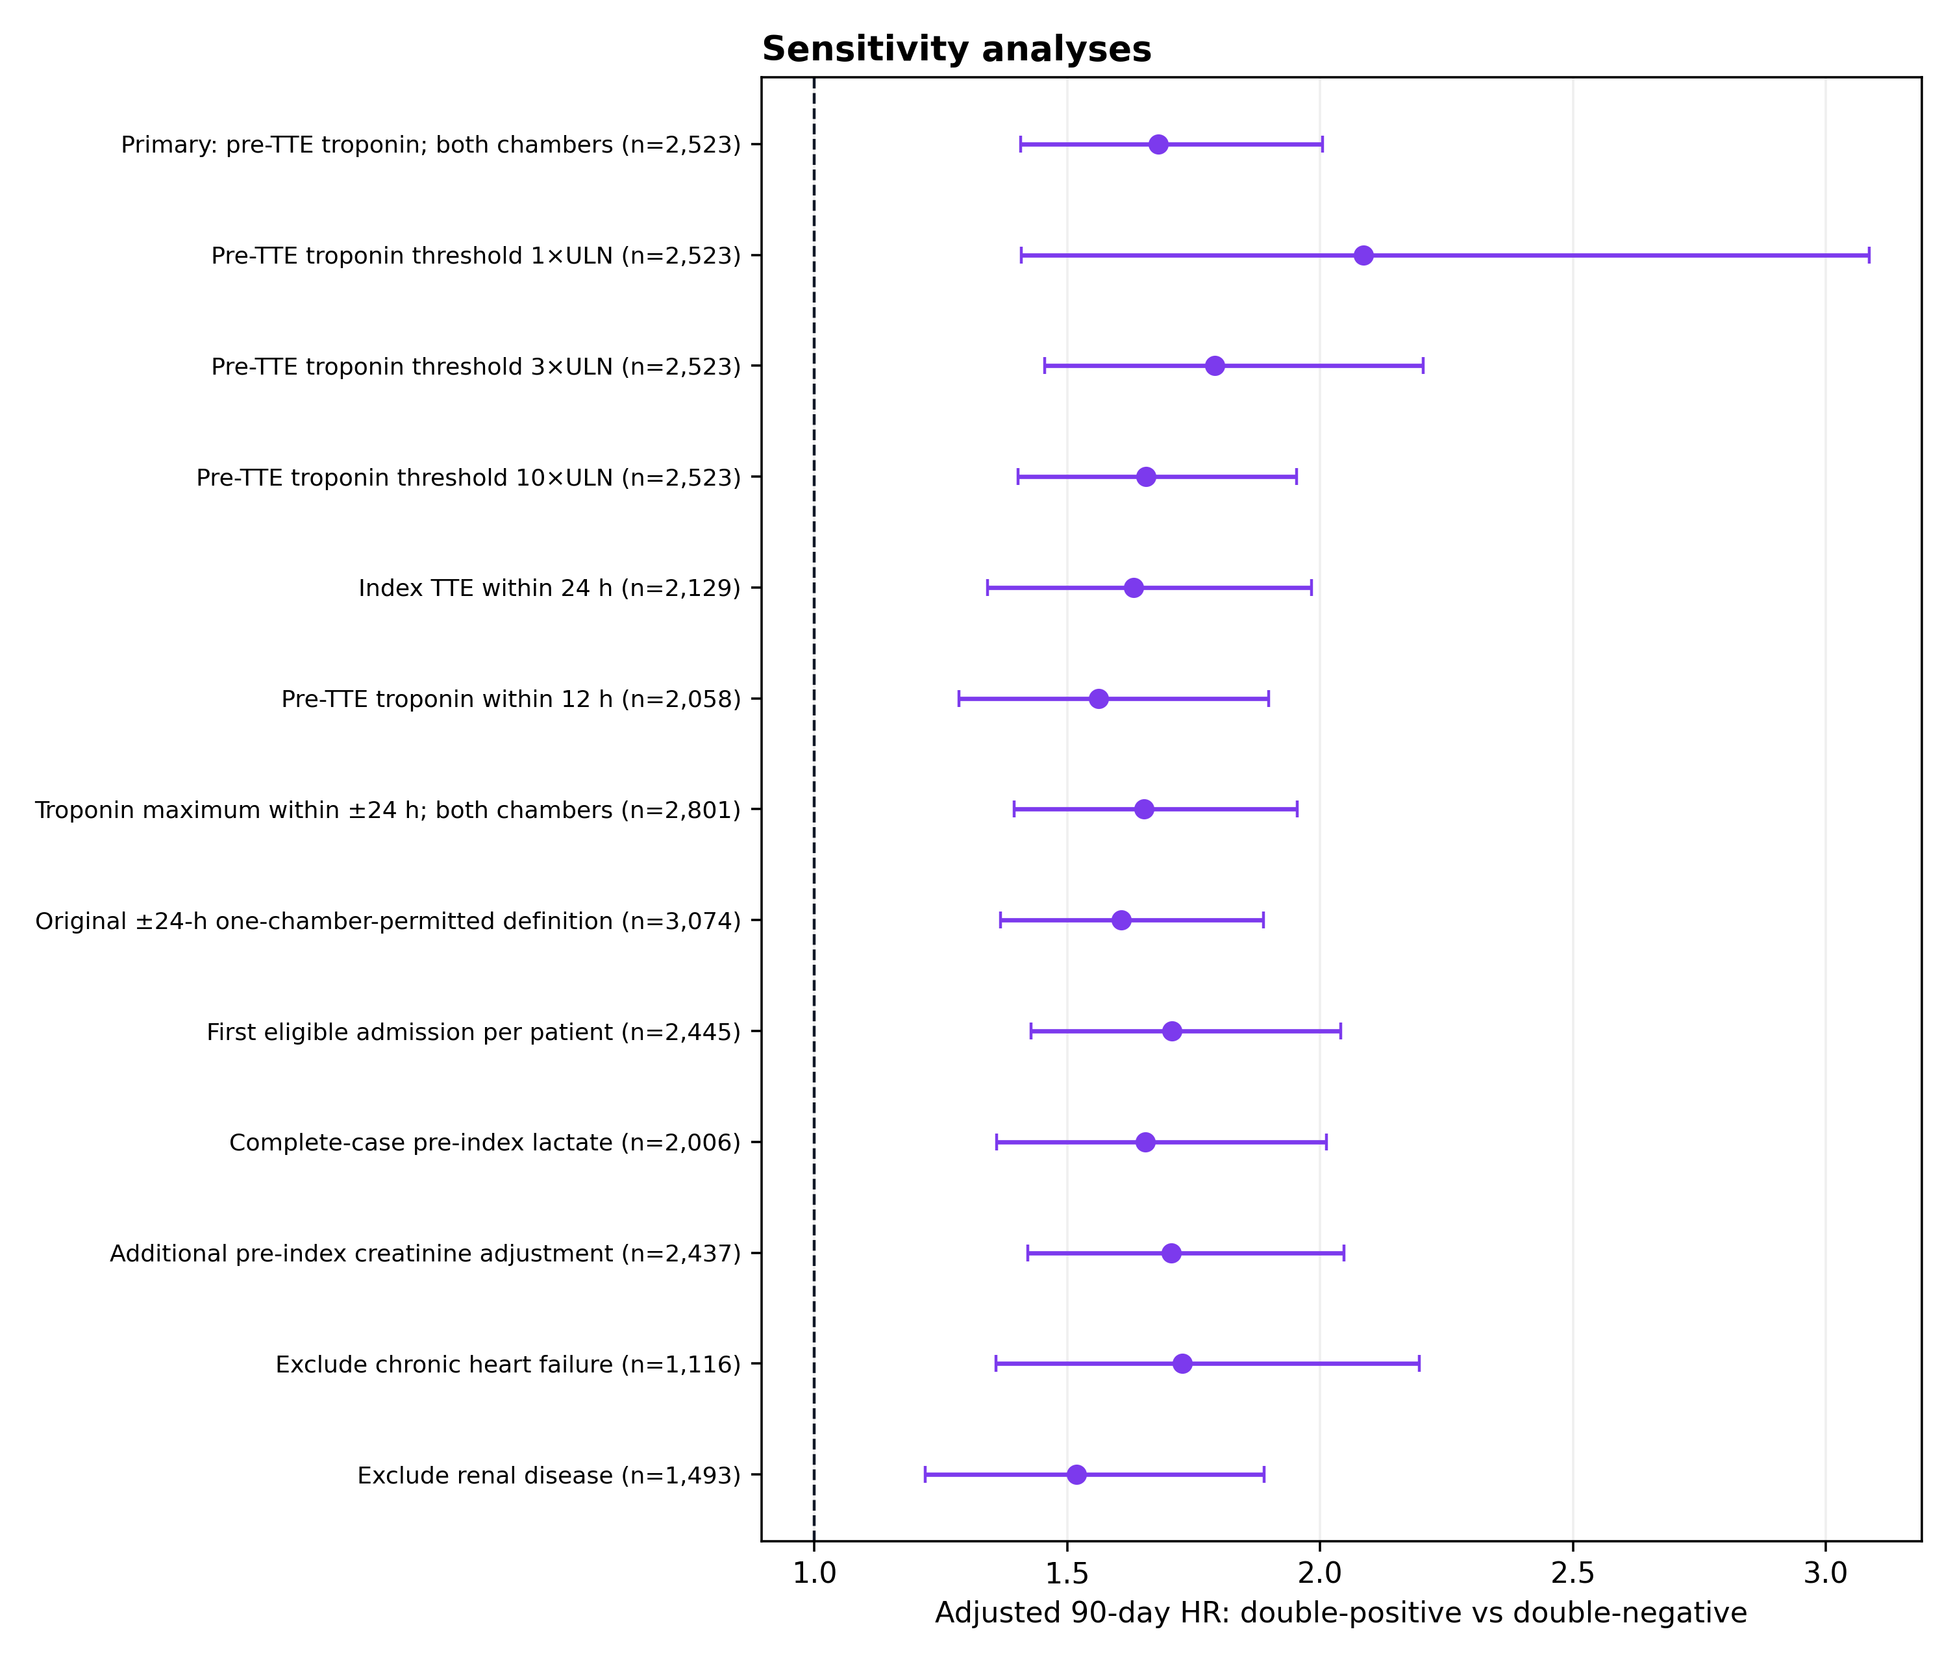
Adjusted 90-day association of double-positive versus double-negative status across alternative definitions and analytic restrictions.

