Supplementary Materials
Supplementary Table S1. Associations of combined admission NLR-CAR categories with clinical outcomes and bootstrap stability of the both-high category
Panel A. Multivariable Cox analyses of combined NLR-CAR categories
Outcome | NLR-CAR category | n/events | Adjusted HR (95% CI) | P value
12-month all-cause  mortality | Low NLR and low CAR | 348/26 | 1.00 (Reference) | —
12-month all-cause  mortality | NLR-high only | 41/8 | 1.95 (0.88–4.36) | 0.102
12-month all-cause  mortality | CAR-high only | 73/20 | 2.79 (1.51–5.16) | 0.001
12-month all-cause  mortality | Both-high | 26/15 | 4.55 (2.30–9.00) | <0.001
90-day unplanned  readmission | Low NLR and low CAR | 348/17 | 1.00 (Reference) | —
90-day unplanned  readmission | NLR-high only | 41/10 | 5.30 (2.37–11.85) | <0.001
90-day unplanned  readmission | CAR-high only | 73/21 | 5.65 (2.89–11.05) | <0.001
90-day unplanned  readmission | Both-high | 26/16 | 11.85 (5.55–25.29) | <0.001
Panel B. Bootstrap stability of the both-high category
Outcome | Both-high  n/events | Conventional adjusted  HR (95% CI) | Bootstrap HR, median  (95% percentile interval) | Successful resamples,  n (%)
12-month all-cause mortality | 26/15 | 4.55 (2.30–9.00) | 4.43 (2.06–9.74) | 2000 (100%)
90-day unplanned readmission | 26/16 | 11.85 (5.55–25.29) | 12.41 (5.47–29.96) | 2000 (100%)
Notes: Exploratory cut-offs were NLR >8.97 and CAR >0.49. The four mutually exclusive categories were defined as low NLR and low CAR (NLR ≤8.97 and CAR ≤0.49), NLR-high only (NLR >8.97 and CAR ≤0.49), CAR-high only (NLR ≤8.97 and CAR >0.49), and both-high (NLR >8.97 and CAR >0.49). The low NLR and low CAR group served as the reference. In Panel A, the four-level NLR-CAR category variable was entered into a multivariable Cox model adjusted for age, sex, New York Heart Association functional class, Charlson Comorbidity Index, hemoglobin, and body mass index. Complete-case analysis was used, and tied event times were handled using the Breslow method. In Panel B, the stability of the both-high estimate was assessed using 2,000 patient-level bootstrap resamples, with the same adjusted four-level Cox model refitted in each resample. Bootstrap estimates are presented as the median HR with the 2.5th and 97.5th percentiles of the bootstrap distribution. All 2,000 resamples were successfully fitted for both outcomes. CAR, C-reactive protein-to-albumin ratio; CI, confidence interval; HR, hazard ratio; NLR, neutrophil-to-lymphocyte ratio.

Supplementary Table S2. Interaction and robustness analyses of continuous NLR and CAR
Panel A. Median-centered interaction models
Outcome | Term | n/events | Adjusted HR (95% CI) | P value
12-month mortality | log₂(NLR), median-centered | 488/69 | 0.92 (0.69–1.23) | 0.580
 | log₂(CAR), median-centered | 488/69 | 1.21 (1.07–1.38) | 0.003
 | NLR × CAR interaction | 488/69 | 1.09 (0.98–1.21) | 0.128
90-day readmission | log₂(NLR), median-centered | 488/64 | 1.93 (1.47–2.54) | <0.001
 | log₂(CAR), median-centered | 488/64 | 1.49 (1.27–1.74) | <0.001
 | NLR × CAR interaction | 488/64 | 0.88 (0.80–0.98) | 0.018
Panel B. Robustness analyses for the 90-day readmission interaction
Inference method | n/events | Interaction HR (95% CI) | P value
Conventional Cox inference | 488/64 | 0.88 (0.80–0.98) | 0.018
Jackknife robust inference | 488/64 | 0.88 (0.78–1.00) | 0.055
Patient-level bootstrap inference | 488/64 | 0.88 (0.78–1.00) | 0.056
Notes: NLR and CAR were log₂-transformed and median-centered before construction of the multiplicative interaction term. In Panel A, the main-effect HRs represent the effect per doubling of each biomarker when the other biomarker is at its median level. All models were adjusted for age, sex, New York Heart Association functional class, Charlson Comorbidity Index, hemoglobin, and body mass index and used complete-case analysis. Tied event times were handled using the Breslow method. Panel B evaluated the 90-day readmission interaction using conventional Cox inference, delete-one jackknife inference, and 2,000 patient-level bootstrap resamples. For the jackknife and bootstrap analyses, confidence intervals and P values were based on normal-approximation standard errors. CAR, C-reactive protein-to-albumin ratio; CI, confidence interval; HR, hazard ratio; NLR, neutrophil-to-lymphocyte ratio.
Supplementary Table S3. Competing-risk analyses for 90-day unplanned readmission
Panel A. Continuous NLR and CAR
Model / biomarker | n/readmissions | Fine–Gray adjusted sHR (95% CI) | P value | Cause-specific adjusted HR (95% CI) | P value
NLR-only model / NLR | 489/64 | 1.68 (1.35–2.09) | <0.001 | 1.62 (1.32–1.99) | <0.001
CAR-only model / CAR | 490/64 | 1.38 (1.23–1.56) | <0.001 | 1.42 (1.26–1.60) | <0.001
NLR + CAR model / NLR | 488/64 | 1.57 (1.23–1.99) | <0.001 | 1.49 (1.20–1.85) | <0.001
NLR + CAR model / CAR | 488/64 | 1.34 (1.18–1.52) | <0.001 | 1.37 (1.21–1.55) | <0.001
Panel B. Combined NLR-CAR categories
NLR-CAR category | n/readmissions | Fine–Gray adjusted sHR (95% CI) | P value | Cause-specific adjusted HR (95% CI) | P value
Low NLR and low CAR | 348/17 | 1.00 (Reference) | — | 1.00 (Reference) | —
NLR-high only | 41/10 | 5.30 (2.28–12.33) | <0.001 | 4.65 (2.08–10.41) | <0.001
CAR-high only | 73/21 | 5.65 (2.83–11.29) | <0.001 | 5.64 (2.91–10.95) | <0.001
Both-high | 26/16 | 11.85 (5.39–26.08) | <0.001 | 11.51 (5.41–24.50) | <0.001
Notes: Death before the first unplanned readmission was treated as a competing event. Fine–Gray subdistribution hazard models were used for the primary competing-risk analysis, with cause-specific Cox models as sensitivity analyses. All models were adjusted for age, sex, New York Heart Association functional class, Charlson Comorbidity Index, hemoglobin, and body mass index and used complete-case analysis. In Panel A, NLR and CAR were log₂-transformed and analyzed as continuous variables. In Panel B, exploratory cut-offs of NLR >8.97 and CAR >0.49 were used, with the low NLR and low CAR group serving as the reference. There were 64 readmissions and 17 competing deaths within 90 days. Tied event times in the cause-specific Cox models were handled using the Breslow method. CAR, C-reactive protein-to-albumin ratio; CI, confidence interval; HR, hazard ratio; NLR, neutrophil-to-lymphocyte ratio; sHR, subdistribution hazard ratio.
Supplementary Table S4. Comparison of CAR with its component biomarkers, CRP and albumin
Panel A. Component-level associations and model performance
Outcome | Model | Biomarker | n/events | Adjusted HR (95% CI) | P value | C-index | AIC
12-month mortality | Base model | — | 490/69 | — | — | 0.847 | 716.5
 | + CRP | CRP | 490/69 | 1.25 (1.12–1.41) | <0.001 | 0.855 | 703.6
 | + albumin | Albumin | 490/69 | 1.14 (0.89–1.45) | 0.313 | 0.852 | 717.5
 | + CAR | CAR | 490/69 | 1.27 (1.13–1.43) | <0.001 | 0.857 | 702.5
 | + CRP + albumin | CRP | 490/69 | 1.27 (1.13–1.43) | <0.001 | 0.862 | 703.1
 | + CRP + albumin | Albumin | 490/69 | 1.21 (0.95–1.55) | 0.115 | 0.862 | 703.1
90-day readmission | Base model | — | 490/64 | — | — | 0.744 | 746.8
 | + CRP | CRP | 490/64 | 1.37 (1.21–1.54) | <0.001 | 0.801 | 721.5
 | + albumin | Albumin | 490/64 | 1.22 (0.94–1.60) | 0.136 | 0.758 | 746.6
 | + CAR | CAR | 490/64 | 1.38 (1.23–1.56) | <0.001 | 0.804 | 719.6
 | + CRP + albumin | CRP | 490/64 | 1.39 (1.23–1.56) | <0.001 | 0.805 | 719.5
 | + CRP + albumin | Albumin | 490/64 | 1.31 (1.01–1.71) | 0.045 | 0.805 | 719.5
Panel B. Direct comparison of model performance between CAR and component-based models
Outcome | Comparison | Comparator C-index | CAR C-index | ΔC-index (CAR − comparator) | ΔAIC (CAR − comparator)
12-month mortality | CAR vs CRP | 0.8552 | 0.8572 | +0.0020 | −1.10
 | CAR vs albumin | 0.8517 | 0.8572 | +0.0055 | −15.00
 | CAR vs CRP + albumin | 0.8622 | 0.8572 | −0.0050 | −0.62
90-day readmission | CAR vs CRP | 0.8011 | 0.8041 | +0.0030 | −1.90
 | CAR vs albumin | 0.7580 | 0.8041 | +0.0461 | −27.01
 | CAR vs CRP + albumin | 0.8051 | 0.8041 | −0.0010 | +0.15
Notes: All models were evaluated in the same 490 complete cases to allow direct comparison of model performance. The base model included age, sex, New York Heart Association functional class, Charlson Comorbidity Index, hemoglobin, and body mass index. CRP and CAR were log₂-transformed, with HRs expressed per doubling. Albumin HRs were expressed per 5-g/L decrease. Tied event times in the Cox models were handled using the Breslow method. C-index values are Harrell’s concordance indices, and lower AIC values indicate better relative model fit within the common sample. In Panel B, ΔC-index was calculated as the CAR C-index minus the comparator C-index, such that positive values favor CAR. ΔAIC was calculated as the CAR AIC minus the comparator AIC, such that negative values favor CAR. Because CAR is mathematically derived from CRP and albumin, the primary component assessment used head-to-head common-sample model comparisons rather than a saturated model containing CAR, CRP, and albumin simultaneously. These comparisons were intended to assess relative model performance and parsimony rather than to imply that CAR provides information independent of its mathematical components. AIC, Akaike information criterion; CAR, C-reactive protein-to-albumin ratio; CI, confidence interval; CRP, C-reactive protein; HR, hazard ratio; NYHA, New York Heart Association.

Supplementary Table S5. Extended covariate-adjustment sensitivity analyses of admission NLR and CAR with clinical outcomes
Outcome | Additional adjustment | n/events | NLR adjusted HR (95% CI) | P value | CAR adjusted HR (95% CI) | P value
12-month all-cause  mortality | Joint NLR+CAR model | 488/69 | 1.05 (0.84–1.31) | 0.673 | 1.26 (1.12–1.42) | <0.001
12-month all-cause  mortality | + eGFR and serum sodium | 478/68 | 1.03 (0.81–1.29) | 0.834 | 1.26 (1.12–1.42) | <0.001
12-month all-cause  mortality | + LVEF phenotype | 488/69 | 1.03 (0.83–1.28) | 0.794 | 1.24 (1.10–1.40) | <0.001
12-month all-cause  mortality | + HF medications | 488/69 | 1.05 (0.84–1.32) | 0.649 | 1.26 (1.11–1.42) | <0.001
12-month all-cause  mortality | + BNP | 289/36 | 0.96 (0.69–1.34) | 0.818 | 1.29 (1.08–1.54) | 0.004
90-day unplanned  readmission | Joint NLR+CAR model | 488/64 | 1.57 (1.26–1.94) | <0.001 | 1.34 (1.18–1.51) | <0.001
90-day unplanned  readmission | + eGFR and serum sodium | 478/63 | 1.54 (1.24–1.92) | <0.001 | 1.35 (1.19–1.52) | <0.001
90-day unplanned  readmission | + LVEF phenotype | 488/64 | 1.50 (1.22–1.86) | <0.001 | 1.35 (1.19–1.53) | <0.001
90-day unplanned  readmission | + HF medications | 488/64 | 1.57 (1.26–1.96) | <0.001 | 1.34 (1.19–1.52) | <0.001
90-day unplanned  readmission | + BNP | 289/31 | 1.81 (1.31–2.48) | <0.001 | 1.40 (1.17–1.68) | <0.001
Notes: All sensitivity models included the base covariates—age, sex, New York Heart Association functional class, Charlson Comorbidity Index, hemoglobin, and body mass index—with log₂-transformed NLR and CAR entered simultaneously. Each sensitivity model additionally included the covariate(s) shown. LVEF phenotype was modeled categorically as HFrEF, HFmrEF, or HFpEF. HF medications comprised beta-blocker, ACEI/ARB, mineralocorticoid receptor antagonist, and loop diuretic use. BNP was log₂-transformed and was available in 295 participants. BNP-adjusted analyses were restricted to complete cases. HRs for NLR and CAR are expressed per doubling of the biomarker value. Complete-case analysis was used for the covariates included in each model. Tied event times were handled using the Breslow method. ACEI/ARB, angiotensin-converting enzyme inhibitor/angiotensin receptor blocker; BNP, B-type natriuretic peptide; CAR, C-reactive protein-to-albumin ratio; CI, confidence interval; eGFR, estimated glomerular filtration rate; HF, heart failure; HFmrEF, heart failure with mildly reduced ejection fraction; HFpEF, heart failure with preserved ejection fraction; HFrEF, heart failure with reduced ejection fraction; HR, hazard ratio; LVEF, left ventricular ejection fraction; NLR, neutrophil-to-lymphocyte ratio.
Figure S1. Restricted cubic spline analyses of admission NLR and CAR with 12-month mortality and 90-day unplanned readmission.
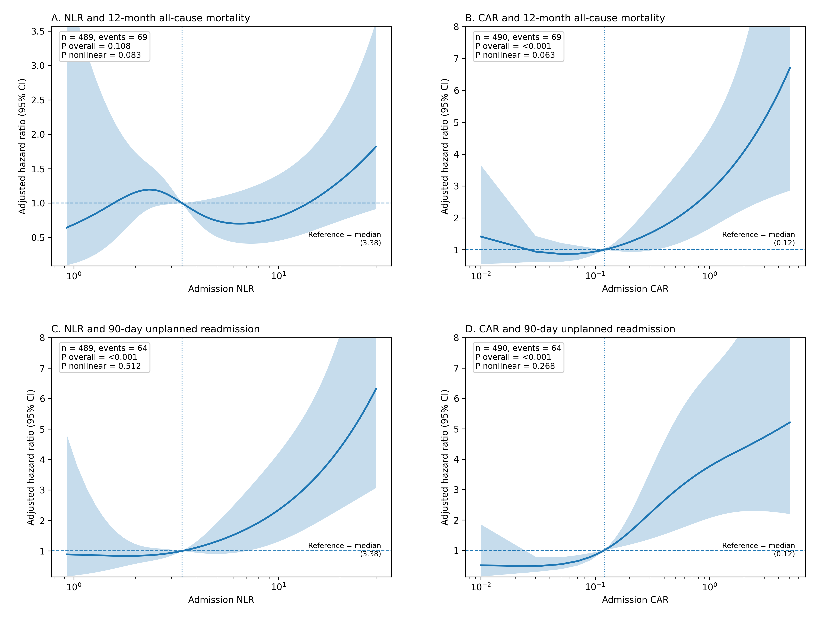
Panels A–D show the associations of NLR with 12-month all-cause mortality, CAR with 12-month all-cause mortality, NLR with 90-day unplanned readmission, and CAR with 90-day unplanned readmission, respectively. NLR and CAR were log₂-transformed and modeled using restricted cubic splines with four knots placed at the 5th, 35th, 65th, and 95th percentiles. The median biomarker value was used as the reference. Models were adjusted for age, sex, New York Heart Association functional class, Charlson Comorbidity Index, hemoglobin, and body mass index. P values for overall association and nonlinearity were obtained using likelihood-ratio tests. There was no statistically significant evidence of nonlinearity for any association. NLR, neutrophil-to-lymphocyte ratio; CAR, C-reactive protein-to-albumin ratio.
Figure S2. ROC curves and performance of the exploratory cut-offs for admission NLR and CAR.
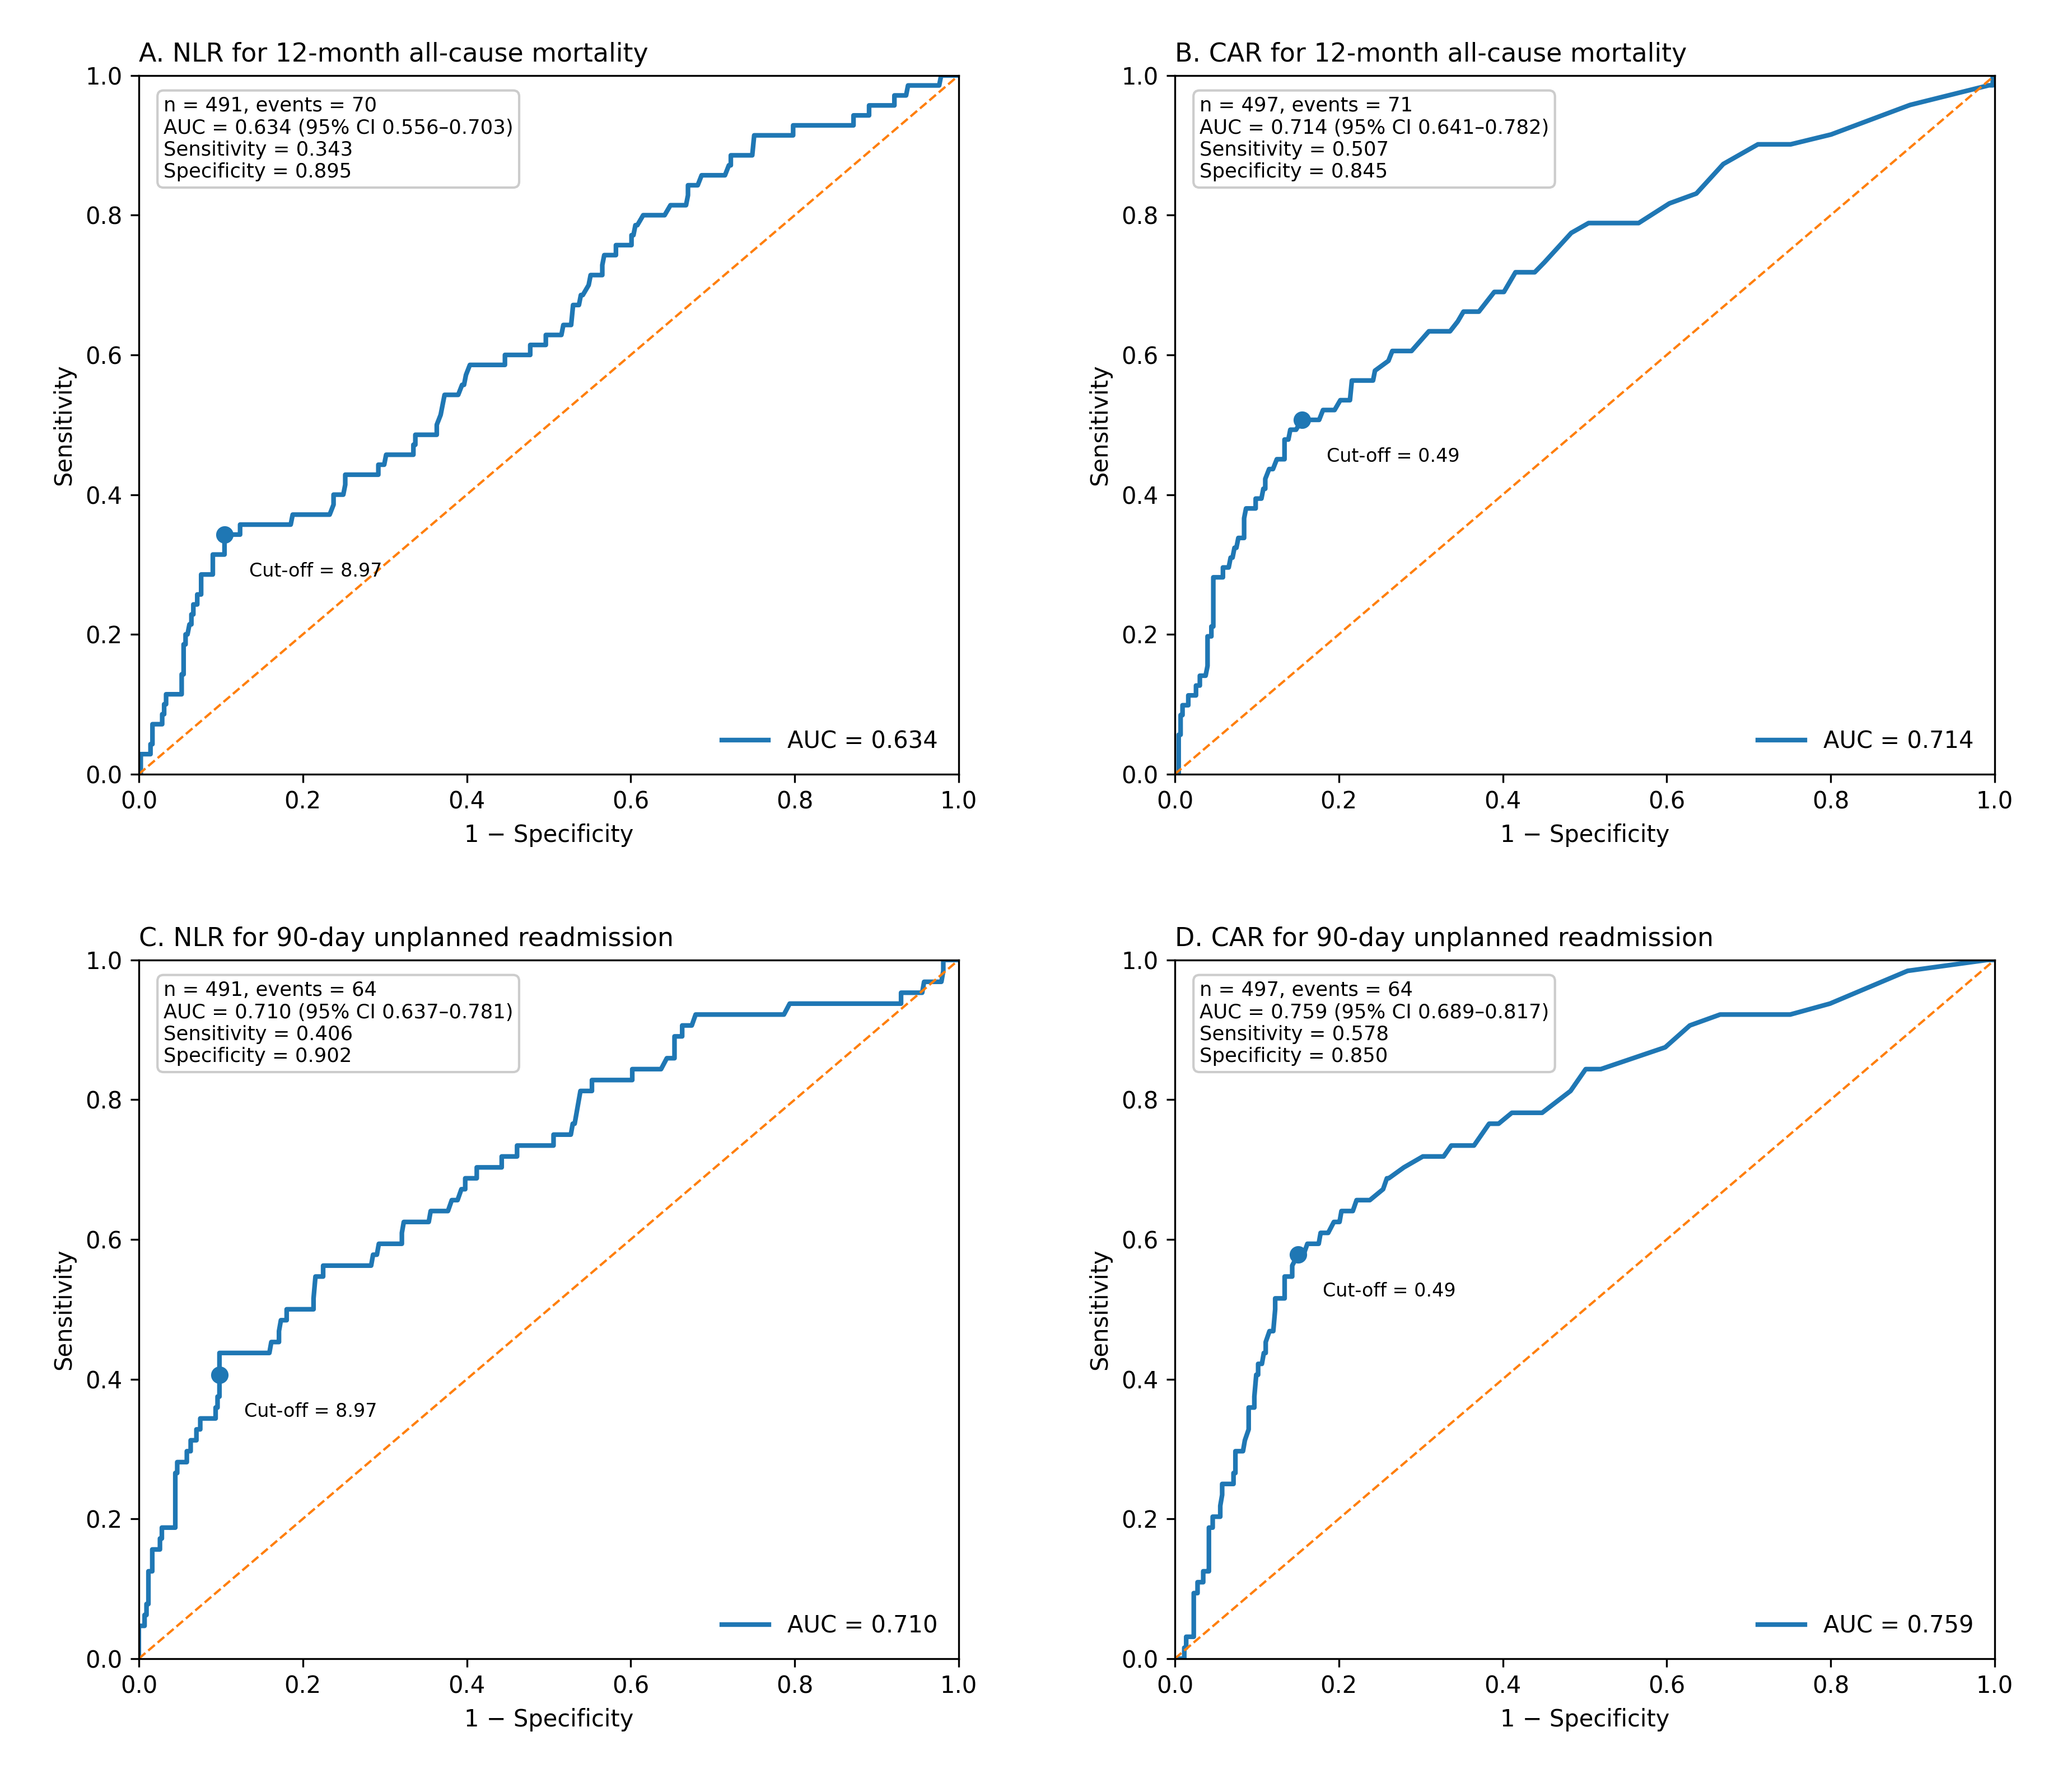
Panels A and B show ROC curves for NLR and CAR, respectively, for 12-month all-cause mortality. Panels C and D show ROC curves for NLR and CAR, respectively, for 90-day unplanned readmission. The exploratory cut-offs used for categorical analyses were NLR >8.97 and CAR >0.49. The corresponding AUCs for NLR and CAR were 0.634 and 0.714 for mortality and 0.710 and 0.759 for readmission, respectively. These cut-offs were internally derived and should be considered exploratory rather than externally validated clinical thresholds. NLR, neutrophil-to-lymphocyte ratio; CAR, C-reactive protein-to-albumin ratio; AUC, area under the curve; ROC, receiver operating characteristic.

